Internship Presentation
Master of Computer Applications · VTU · 2025–2026
Veenith Kumar S
USN: 1BI24MC159
Bangalore Institute of Technology
Department of MCA · Master of Computer Applications · 4th Semester MCA
Presented by Veenith Kumar S — USN 1BI24MC159
- Autonomous institution under Visvesvaraya Technological University (VTU)
- Internship sub code: MINT483 · Academic year 2025–2026
- Hands-on industry internship with structured weekly progress and assessments
Bangalore Institute of Technology · Bengaluru

Internship Overview
Junior Software Development Intern
Organization: Edutainer (PAT Technologies Private Limited) — edutainment & skill-based learning, Bengaluru
Internship role: Junior Software Developer Intern — assist in design, coding, testing, and maintaining software under mentor guidance
Internal guide: Prof. Seema Nagaraj, Assistant Professor, Department of MCA, BIT
External guide: Bunty Deb, Program Manager, Edutainer
- 12-week program: web development, React JS, Python, networking & cybersecurity
- Weekly assignments, quizzes, activities, and mini projects
- Goal: bridge academic knowledge with industry-ready software skills
Partial fulfillment · MCA degree · VTU

Work Done During Internship
Technical modules and practical tasks completed at Edutainer:
- Month 1: Web development fundamentals + React JS (components, hooks, APIs, routing)
- Month 2: Python programming (loops, functions, OOP, multithreading, mini projects)
- Month 3: Networking fundamentals + enterprise cybersecurity practices
- Web & React — HTML, CSS, Bootstrap, React Hooks, Router, API fetch/CRUD, forms & validation
- Python — OOP, data structures, multithreading; Student Management & Banking mini projects
- Networking & security — topologies, wireless security, VPN, firewalls, IPS, malware & DLP concepts
- Tools used — VS Code, Node.js, Python, Git; documentation & weekly progress tracking
Source: Internship report · Edutainer program curriculum

Major Project — Slick-Compress
Capstone work during internship: Slick-Compress — a format-aware file compression web app (Next.js, TypeScript, ffmpeg, Ghostscript, Brotli).
- Demonstrated PDF (86% saved), video HEVC (67.6%), CSV Brotli (83.3%) in testing
- 35 test cases documented for upload, compression, UI, and security
- Following slides detail the compression platform architecture & results
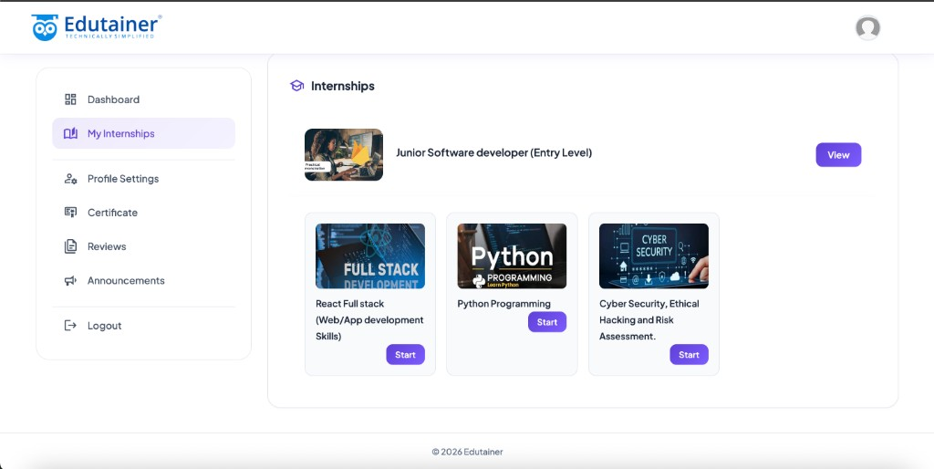
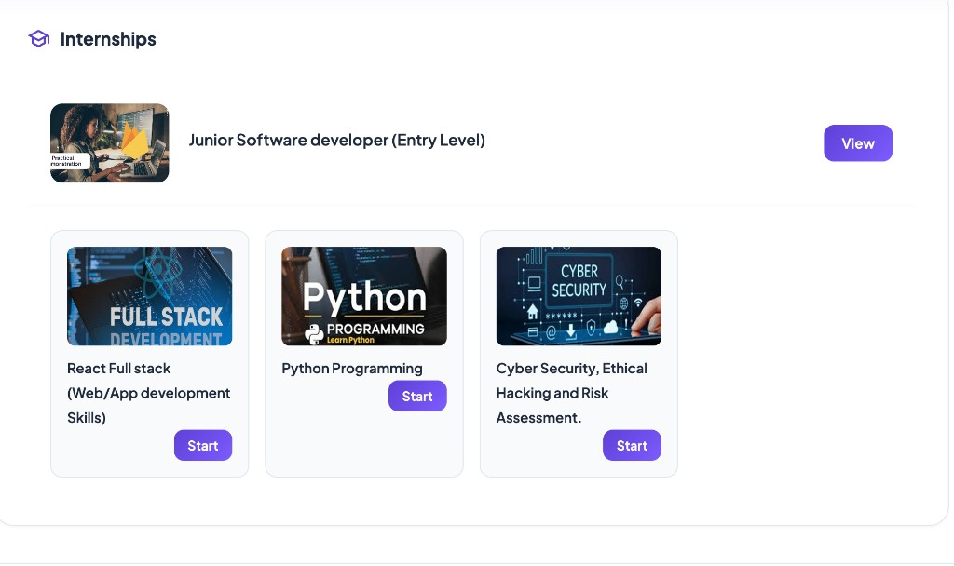
Edutainer internship portal (left) · Slick-Compress built as the Smart Data Compression Platform
• Student: Veenith Kumar S · 1BI24MC159
• College: Bangalore Institute of Technology
Internship + project presentation · Slick-Compress

Slick-Compress
Smart compression platform for every file type
A format-aware web platform that shrinks video, PDF, images, and documents using the right algorithm per file — not a generic zip tool.
Built as a full-stack Next.js application with a public marketing site, compression workbench, and downloadable project materials.
Who it's for: Students, creators, remote workers, and teams who need smaller files fast.
Core promise: Pick the best codec per format — HEVC for video, Ghostscript for PDF, Brotli for text.
Privacy angle: Browser and local-server processing — no third-party compression API required.
- Target ~40% savings with honest reporting when files are already dense
- Three modes: Target 40%, High impact local, Strict lossless
- Real-world proof: 26 MB WhatsApp video → 5.15 MB (80.5% saved, QuickTime-safe)
- Pages: Home · Capabilities · Compress · How it works · About · Downloads
Slick-Compress · Intelligent Compression Platform · Project deck

The problem
Every day, people struggle with files that are too big for email attachments, LMS uploads, messaging apps, and cloud storage limits.
Most online compressors use one algorithm for everything — ZIP or basic Gzip — which barely touches video, PDF, or pre-compressed archives.
- Share & upload limits block WhatsApp videos, email attachments, and form uploads.
- Generic tools save 0–5% on MP4, JPG, and PDF that are already optimized.
- Cloud-only services require uploading sensitive docs, photos, and coursework.
- Broken output — aggressive encoding can ruin QuickTime playback or document layout.
- No clear target — users want ~40% reduction but tools only say "done" without metrics.
- Wrong trade-off — lossy vs lossless is confusing; people need guided modes.
By the numbers: 26+ MB (Typical phone video before compress) · <6 MB (After Slick-Compress (demo run)) · 40% (Minimum savings target we aim for)
The gap: users need format-specific, trustworthy compression — not another generic zipper.
Why Slick-Compress exists

Our solution
Slick-Compress routes each upload through a specialized pipeline:
- Target 40%: Re-encode when needed to hit size goals (recommended).
- High impact local: ffmpeg + Ghostscript on your machine for video & PDF.
- Strict lossless: Brotli, Gzip, RLE, LZW — exact byte restore.
Browser-first for images & text · Native engines for heavy media

What we compress
Type | Method | Typical savings
Video (MP4, MOV…) | H.264 / H.265 (hvc1) + AAC | 40–80%
PDF | Ghostscript /ebook + /screen | 30–50%
Images | WebP / JPEG quality sweep | 35–60%
Office & text | Brotli Q11 / Gzip | 20–90%
Dispatcher picks the smallest valid output (e.g. H.264 vs H.265 for QuickTime).

How it works
End-to-end pipeline — from file selection to a verified, downloadable result:
Upload: User opens the Compression workbench and selects a file.
Choose goal (Target 40%, High impact local, Strict lossless), mode (Fast / Balanced / Max), and profile (Smart, Text, Media).
Analyze: The dispatcher reads MIME type, extension, and file structure.
Detects video, PDF, image, Office ZIP, .br/.gz wrappers, and plain text — then picks candidate engines.
Compress: The best engine runs for that file type.
Browser: Brotli-wasm, canvas WebP/JPEG, fflate. Native: ffmpeg (H.264 + H.265 hvc1), Ghostscript /ebook + /screen.
Validate: Outputs are checked before the user downloads.
ffprobe on video, round-trip on lossless, QuickTime-safe tags — smallest valid file wins.
Download: User gets the optimized file plus a results panel.
Shows method name, original vs compressed size, savings %, and whether the 40% target was hit.
- Browser path → images, text, JSON, CSV, strict-lossless archives
- Native path → MP4/MOV video, PDF, JPEG/PNG via ffmpeg & Ghostscript
- Fallback → ffmpeg.wasm in-browser if native ffmpeg is unavailable
Large uploads supported (up to 100 MB) for server-action video compression.
Simple UX on the surface · specialized engines underneath

Result snapshot — Video
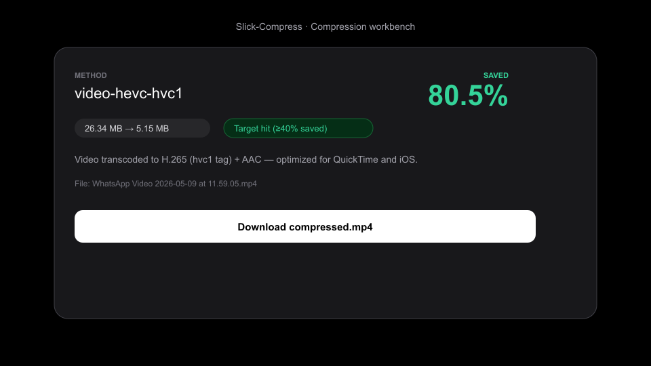
Real test: WhatsApp video (26.34 MB → 5.15 MB)
• 80.5% saved
• QuickTime-safe H.265 (hvc1)
• Target ≥40% hit

Platform snapshot — Workbench
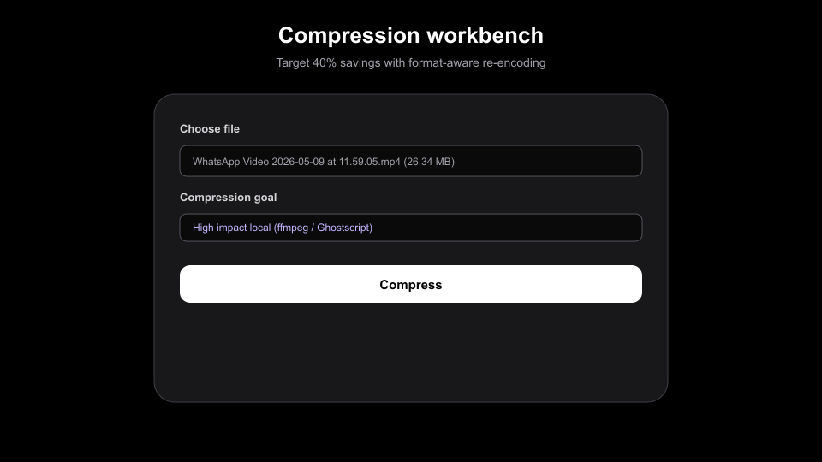
Upload UI with goal selection and one-click compress
• High impact local mode
• Media / text / smart profiles

Platform snapshot — Home
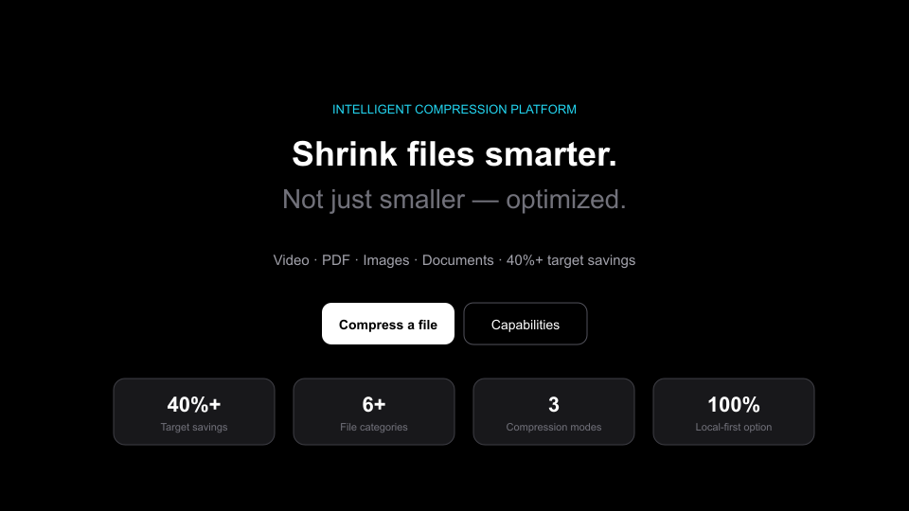
Marketing home with stats and capability overview
• 40%+ target savings
• 6+ file categories

Technology & summary
- Multi-page site: Home, Capabilities, Compress, How it works, About, Downloads
- 100 MB server-action limit for large video uploads
- Honest metrics when files are already optimal
Stack: Next.js, TypeScript, brotli-wasm, fflate, ffmpeg, Ghostscript
Goal: Make large files smaller, playable, and shareable — simply.

