**Windows Phone App: PickFavPic**

This application provides users the ability to change the lock screen wallpaper by choosing picture from the list of pictures provided by Flicker API.

**GOAL:**

The goal of working on this application project was to get some hands on experience with Windows phone application development.

**HIGH LEVEL ARCHITECTURE:**

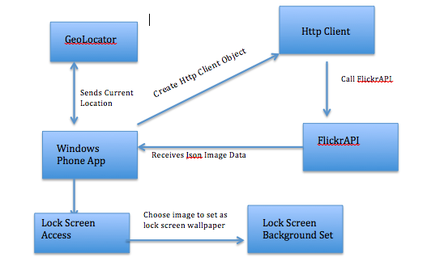

**ABOUT THE APPLICATION AND SCREENSHOTS:**

The application is location aware application as well as social in nature. So, the application takes the current location of the user and makes a call to Flicker API to fetch the pictures, which were taken at user’s current location. Also, you can provide an extra informative text related to your search. On next screen of the application, the user is provides a plethora of images, and the user can set their lock screen background.

On top of the first screen, there is a progress indicator, which indicates that application is retrieving the current GPS location.

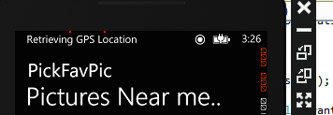

1. In the screenshot given below, after, current location has been fetched; it is plotted on a map.

2. The application takes default current location stored in Windows phone emulator for now.

3. The user can also enter search text in order to get images from Flickr API.

4. The request is made using Http Client to Flicker API. The Flicker API sends you Json image data, which is De serialized using JsonConvert library into Images.

5. Images are populated on screen, and then user can choose multiple images.

6. The user is required application to access the lock screen.

7. The user can see image on phone’s lock screen

