**INSY 6112 Exam**

Student number: ST10439435

Name: Tasveer Bhoola

**Question 1**

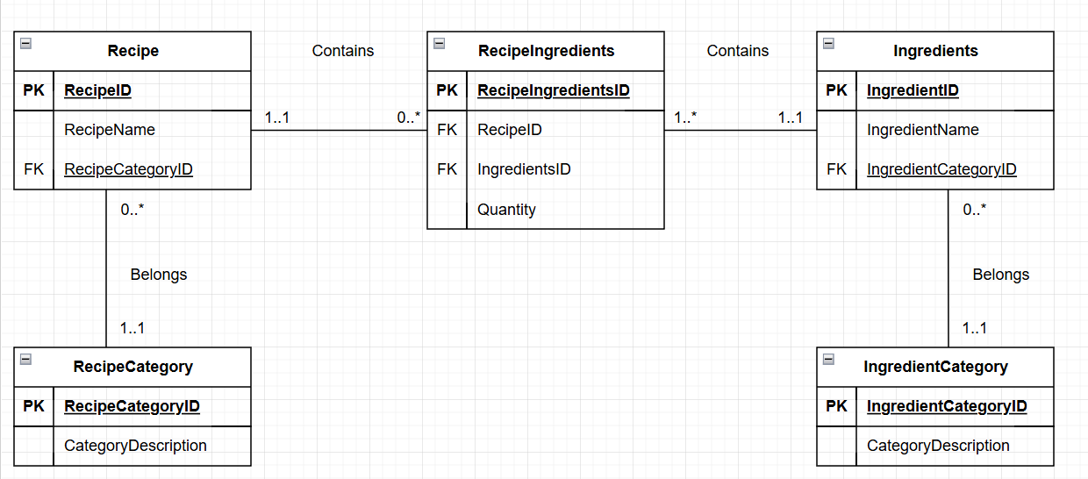ERD

**Question 2**

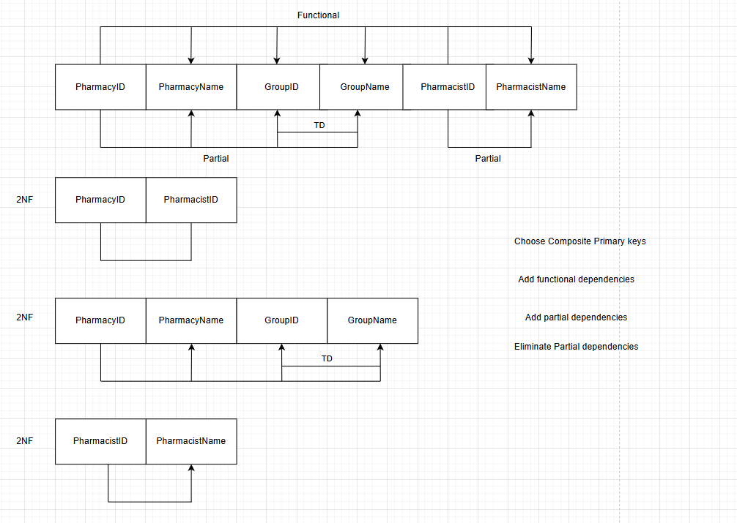**Q 2.1**

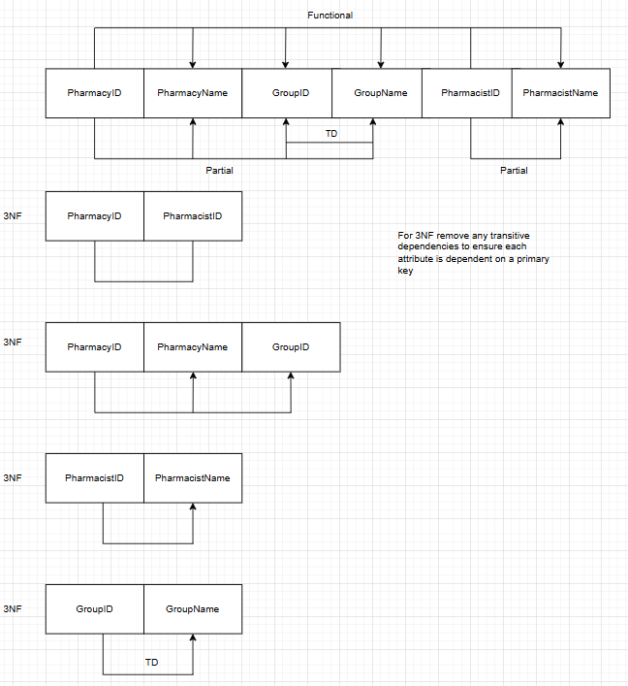Q 2.2

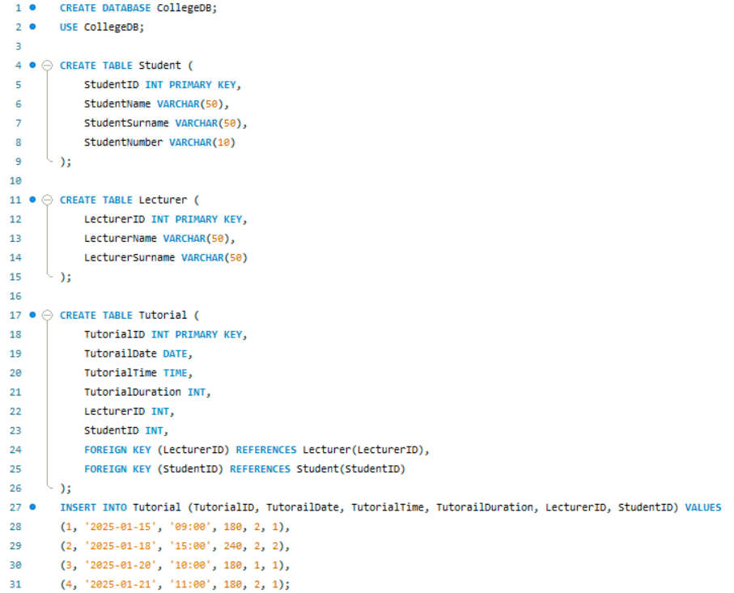Question 3

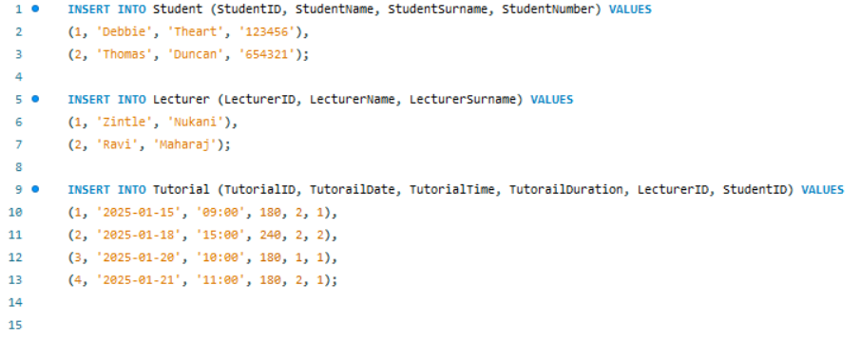

3.5

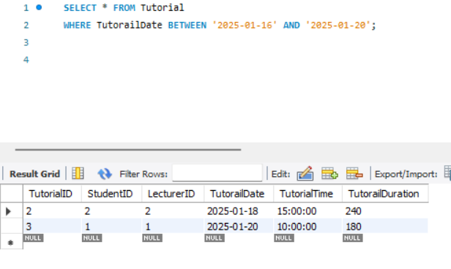

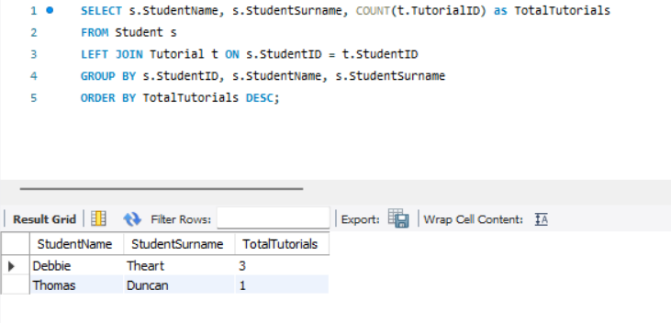3.6

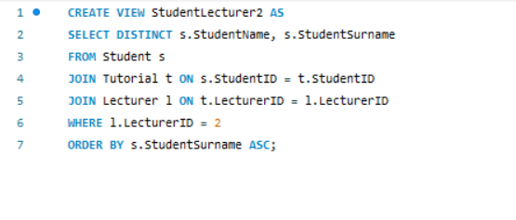3.7

Question 4

4.1



4.2

4.3

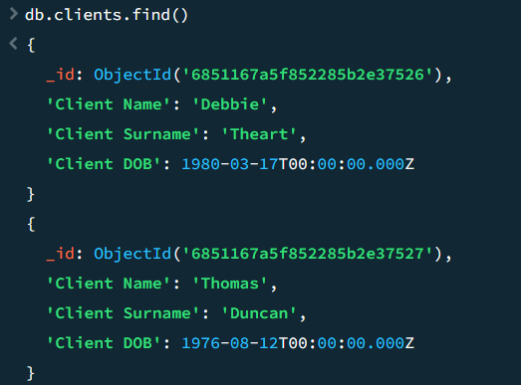

4.4

