HOT ENGINES AND FIRE PREVENTION
Veer Sanghvi,^{1,*} Shuaib Ibraheem,¹ Jack McGonagle,¹ Syed Irtiza Ali Shah¹
¹School of Engineering, Wentworth Institute of Technology, Boston, USA
ABSTRACT
Skin left in the summer sun does not need a flame to burn. Heat alone is enough. An engine surface works the same way: once it crosses a certain temperature, fuel that touches it can ignite with no spark and no open flame anywhere nearby. This paper looks at the heat transfer behind that ignition, and asks a practical question: can the surface temperature driving it be predicted, and controlled, before ignition happens? Conduction, convection, and radiation across a running engine are modeled together to find where surface temperatures cross the autoignition limits of common flammable fluids. Most fire-safety approaches today wait. They sense a fire, then suppress it, using fixed insulation, manual inspection, or reactive suppression systems, and each one accepts some damage as the price of doing business. The approach here is different. It treats the hot surface itself as something to design around, catching high-risk zones on paper before a vehicle ever reaches service. Predictive thermal mapping gives earlier warning and finer spatial detail than inspection or suppression manage on their own. The finished work links engine operating conditions to surface temperature fields, and from there to an actual measurable margin against ignition, so fire prevention becomes something engineers specify and test rather than something they discover after the fact. That reasoning should hold anywhere hot surfaces and flammable fluids share a tight space, not just under a hood, which puts automotive, aerospace, and power generation all in scope.
Keywords: hot-surface ignition, thermal management, engine fire prevention, surface temperature prediction, autoignition, heat transfer analysis, predictive thermal design
NOMENCLATURE
A | surface area | (m²) | Rcond,s | conduction resistance, substrate | (m²·K/W)
h | convection heat transfer coeff. | (W/m²·K) | Rcond,TBC | conduction resistance, TBC layer | (m²·K/W)
hout | convection heat transfer coeff., outer surface | (W/m²·K) | Rcomb,o | combined outer convective/radiative resistance | (m²·K/W)
hrad | linearized radiation heat transfer coeff. | (W/m²·K) | Rconv,i | convection resistance, inner (combustion) side | (m²·K/W)
k | thermal conductivity | (W/m·K) | Rtotal | total thermal resistance | (m²·K/W)
ksubstrate | thermal conductivity, substrate metal | (W/m·K) | Ts | surface temperature | (°C)
kTBC | thermal conductivity, thermal barrier coating | (W/m·K) | Tsurr | surrounding (radiative exchange) temperature | (°C)
LTBC | thickness, thermal barrier coating | (m) | T∞ | ambient / free-stream temperature | (°C)
qtotal | total heat flux | (W/m²) | ε | surface emissivity | (–)
 |  |  | σ | Stefan-Boltzmann const. (5.67×10⁻⁸) | (W/m²·K⁴)

1. INTRODUCTION
Engine compartments put flammable fluids right next to dangerously hot surfaces. That is a persistent fire hazard across automotive, aerospace, and power generation industries, and fire safety has traditionally dealt with it the same way every time: manual inspection, fixed insulation, chemical suppression, all of which only kick in after ignition, accepting the initial damage as a given. There is a more proactive option. A flammable fluid can ignite on contact with a surface above its autoignition temperature with no spark needed at all, so treating hot surfaces as something to design around, rather than a static hazard, makes understanding that surface heating the key to breaking the path to ignition before a flame ever forms.
That is the framework this paper builds, around thermal mapping. Conduction, convection, and radiation are combined to locate the specific zones where an operating engine's surface temperature is likely to reach the autoignition limits of common flammable fluids. The goal is a measurable design parameter, something engineers can act on before the system is ever deployed.
2. LITERATURE REVIEW
2.1 Hot-Surface Ignition and Surface Temperature Prediction
This category gathers the work that treats the hot surface itself as the thing to understand and predict, because fuel will not ignite on a surface that stays below its autoignition temperature. The studies below move from measuring temperatures, through fitting probability models, to simulating ignition before it occurs.
[6] pairs high-speed imaging with statistical analysis to fit a probability model of ignition versus surface temperature, giving this project its working 311 to 407°C risk range.
[1] measured how flame height above a heated plate drops as surface temperature rises, showing that surface temperature governs where a flame anchors, not just whether it ignites.
Prediction need not be experimental: [15] models oil-droplet pre-ignition with CFD, resolving droplet-gas heat exchange to reproduce ignition numerically rather than waiting to measure it.
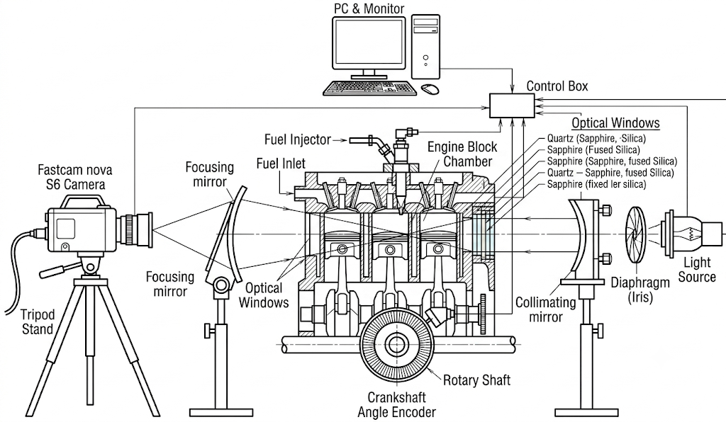
Fig. 1 Droplet-ignition test rig schematic, redrawn from the configuration described in Ullal & Ra [15].
[5] traces ignition to thermal decomposition: TG-FTIR shows the lowest ignition temperatures align with the range where fuel is already releasing combustible gas, so predicting ignition means predicting that gas release, not just reading surface temperature.
[2] uses image analysis and a fractal-dimension method to bound a "possible-ignition zone" between 311 and 450°C with R² above 95 percent, a usable rule for flagging risky temperatures.
The same risk applies in the air: [17] finds the 50 percent ignition-probability temperature for leaked RP-3 kerosene, giving a quantitative basis for judging when a hot aircraft or engine surface becomes an ignition source.
2.2 Bridging Simulation and Reality Through Strict Design Tolerances
To effectively prevent engine fires through predictive thermal mapping, the physical manufacturing of engine components must strictly adhere to their original design specifications. A predictive model is only as reliable as the physical system it represents. For example, applying a thermal optimization design method to aluminum alloy pistons in diesel engines relies on precise dimensional and material specifications to properly manage heat distribution [13]. If these optimized specifications are not strictly maintained during manufacturing, the base metal may fail to dissipate heat effectively, leading to localized hot spots that pose a severe ignition risk.
The same tolerance sensitivity applies to coatings: [14] shows that deviations from specified microstructure let corrosive byproducts degrade a TBC prematurely, and a spalled coating suddenly exposes bare metal to extreme temperature, a sudden ignition hazard.
[10]'s shock-tube experiments show ignition delay and autoignition threshold are governed by precise local temperature and pressure, so an unplanned thermal hotspot from a manufacturing defect can turn a minor leak into a fire.
[4] predicts under-hood component temperatures with 1D-network simulations during design, but that accuracy collapses if built parts deviate from the digital network's assumed dimensions.
The same precision matters for active cooling: [8] shows oil-cooler heat dissipation depends on exact internal flow-path geometry, so manufacturing flaws there leave oil dangerously hot before it ever leaks.
Finally, passive components matter once active cooling stops entirely: [16] shows parts near hot manifolds keep climbing for several minutes after shutdown, and correctly placed heat shields block that radiated heat through the vulnerable soak window.
2.3 Thermal Barriers and Surface Cooling for Ignition Prevention
Category A covered how hot a surface must get before fuel ignites; this category covers keeping the surface from getting that hot. [13] runs a finite element model comparing a bare and TBC-coated diesel piston, finding a measured 55.54°C (15 percent) peak temperature drop, a sizeable, real number given the margins this project targets.
[9] runs a low thermal inertia TBC through a 100-hour durability cycle with cold starts; nothing flaked or failed, which matters as much for fire safety as the emissions benefit it also delivered.
A coating safe at idle can behave differently under load, so [11] models performance across a full drive cycle instead of one fixed point: a margin measured at one snapshot does not guarantee the same margin under acceleration.
[7] finds turbine-blade coating thickness and surface roughness both significantly swing cooling performance, a manufacturing sensitivity likely present in engine-bay coatings too.
Cooling need not be one strategy for the whole engine: [12]'s AI-controlled dual-loop coolant treats different zones differently, matching how a thermal map should probably treat the much hotter manifold and turbo separately from cooler zones.
What happens once airflow shuts off is its own problem: [16] finds parts near a hot manifold keep climbing for ten minutes post-shutdown as radiation takes over, and a heat shield measurably keeps nearby parts cooler through that window, the riskiest moment for a leak, since air has stopped moving but stored heat is still radiating. Coating performance also depends on the fuel itself: [3] pairs a TBC with ethanol-blended fuel, adding fuel chemistry as another variable alongside the geometry and duty-cycle questions above.
Table 1 Literature Review Summary: Approaches and Key Results
Ref | Approach | Key Result
Bai et al. [1] | Heated-plate experiment | Ignition core height falls as surface nears 480°C
Bai et al. [2] | Image analysis, edge detection, fractal-dimension method, automotive | 450°C marked as a turning point; possible-ignition zone boundaries fit with R² above 95%
Cesur [3] | Paired a thermal barrier coating with ethanol-blended fuel in a gasoline engine | Adds fuel chemistry as a variable alongside coating geometry and duty cycle in TBC performance
Chang & Malipeddi [4] | 1D-network simulations for predictive under hood thermal management | Accurately predicts component temperatures and cooling airflows proactively
Chen et al. [5] | TG-FTIR with hot-surface tests | Ignition probabilistic; lowest temps align with gas generation range
Deng et al. [6] | High-speed imaging test rig | Lowest ignition 311°C; probability rises sharply above 407°C
Du et al. [7] | TBC thickness/roughness on turbine blade cooling | Both significantly changed cooling sensitivity
Fu [8] | 3D flow modeling, oil cooler optimization | Heat dissipation relies on optimized internal geometry
Gandolfo et al. [9] | Low thermal inertia TBC, 100hr durability run | Survived durability test; cut cold-start emissions
Khasawneh et al. [10] | Shock tube ignition experiments, various oils | Ignition delay strictly governed by local temperature
Koutsakis & Ghandhi [11] | TBC performance across a full drive cycle | Behavior shifts significantly with load and speed
Kula et al. [12] | AI dual-loop coolant, zone-specific targeting | Reduced fuel use while holding target temperatures
Liu et al. [13] | TBC thickness/material optimized on diesel piston | Peak surface temperature reduced by 55.54°C (15.08%) versus the bare aluminum piston
Stanescu et al. [14] | Corrosion resistance assessment of engine TBCs | Longevity depends on resisting thermo-chemical degradation
Ullal & Ra [15] | CFD droplet-stripping simulation | Reproduced pre-ignition mechanism numerically
Vdovin & Kadri Sathiyan [16] | Simplified rig, 100min soak, with/without heat shield | Shielded parts cooler; unshielded parts kept rising 10min post-shutdown
Zhu et al. [17] | High-speed imaging, RP-3 kerosene on hot wall | Critical temp for 50% ignition probability; vapor plume model

3. SIGNIFICANT METHODOLOGIES
Three papers from the literature review, [7, 11, 13], are worth examining more closely because together they expose a gap this paper's methodology is built to fill. Each relaxes one assumption the others hold fixed: [13] proves a coating lowers surface temperature but only at a single fixed operating point; [11] lets that operating point vary across a full drive cycle but still assumes an undamaged, as-designed coating; [7] lets the coating's manufactured thickness and roughness vary but does so on a turbine blade, not an engine bay surface. No single study combines a full duty cycle with realistic manufacturing tolerance, which is exactly the space Section 4's proposed methodology targets.
[13] built a finite element model of a diesel piston, comparing a bare aluminum piston against the same piston with a thermal barrier coating, using the same conduction and composite-wall resistance relationships developed in Section 4.2. A multi-objective optimization over coating thickness and material, validated against an instrumented four-cylinder diesel test rig, found a peak surface temperature reduction of 55.54°C (15.08 percent) versus the bare piston, a meaningful margin given the 311°C autoignition threshold this paper targets. The limitation: every term in the resistance network, including both convection coefficients, was held fixed at one steady operating point.
[11] addresses exactly that limitation by letting the convection coefficients update continuously across a simulated drive cycle instead of one snapshot. The result is a temperature history rather than a single number, and it shows that a coating margin measured at cruise does not guarantee the same margin holds under hard acceleration, when heat input can spike faster than the coating's resistance can spread it. The paper still assumes the coating itself stays geometrically as-designed throughout, an assumption [7] goes on to question.
[7] shifts the question to manufacturing fidelity: does the coating's own thickness and surface roughness, not just its presence, change cooling performance. Surface roughness alters the effective convection coefficient at the outer boundary by disturbing the fluid boundary layer, so two coatings with identical design thickness can still behave differently once built. Both thickness and roughness significantly changed cooling performance in their tests, on a turbine blade rather than an engine surface, meaning the finding needs translation to this project's geometry.
4. PROPOSED METHODOLOGY
4.1 Proposed Computational Mapping Approach and Justification
To systematically prevent hot-surface engine fires during the design phase, we propose a multi-dimensional, predictive computational thermal mapping framework. Rather than relying on physical trial-and-error, this approach simulates the coupled effects of conduction, convection, and radiation across high-risk under hood components (such as the exhaust manifold and turbocharger housing) [16]. By mapping these surface temperatures, we can proactively assess the structural margin against the autoignition thresholds of common volatile fluids (such as lubricating motor oil [6]).
The process starts with the system geometry and material thermal properties, then applies convective and radiative boundary conditions drawn from realistic engine operating loads. From there the numerical solver resolves the steady-state and transient heat transfer equations, and the resulting localized thermal map isolates which components run hottest. The safety margin follows directly: Tmargin = Tauto − TS. This sequence matters because it catches design defects, unshielded zones prone to post-shutdown heat soak [16] being the clearest example, long before anything reaches a prototype shop.
4.2 Governing Equation and Analytical Derivations
The physics governing this predictive framework is rooted in the classical conservation of energy: a composite engine wall coated with a thermal barrier coating [13] is modeled as a series-and-parallel network of conduction and convection resistances, with the radiation term linearized so the whole system can be solved for the local outer surface temperature Ts analytically. Increasing the resistance of the barrier layer directly decreases Ts, keeping it further below the fluid's autoignition threshold [6]. The full derivation and resulting equations are given in Section 6.1, where they are applied directly to the exhaust manifold case.
4.3 Verification and Validation Protocol
To guarantee the mathematical and physical accuracy of our predictive framework, a rigorous verification and validation (V&V) protocol will be implemented.
Verification: Numerical verification will be performed via a grid convergence index (GCI) study. We will run the model at three progressively finer node densities to ensure that the calculated temperature fields are independent of spatial discretization errors.
Validation: The computational model will be validated by direct comparison against empirical benchmark data. Specifically, the predicted outer surface temperatures will be cross-referenced with the experimental under hood soak data from Vdovin and Kadri Sathiyan [16] ensuring that the transient temperature rise observed during post-shutdown heat soak matches physical test-rig measurements.
5. IMPLEMENTATION
Two coordinated tracks implement the methodology from Section 4: a computational track building and solving the composite-wall thermal model in Simscape, and a physical track, a low-cost benchtop hot-surface rig, that validates the simulation before its predictions get trusted. This section describes the software toolchain, the proposed hardware, the solution algorithm, and the proposed experimental setup.
5.1 Software
The thermal model is built in Simscape rather than a general scripted solver or a commercial CAD-linked finite element package. Simscape's Foundation Library ships thermal components, conductive and convective heat transfer blocks, and thermal mass blocks, that map directly onto this problem: the manifold cross-section reduces cleanly to a 1D network of exhaust gas, TBC layer, substrate, and ambient air, so each layer becomes its own physical block instead of a hand-coded discretized equation. It also solves both the steady-state and transient post-shutdown cases from the same governing equations in Section 4.2; for the transient soak, a fixed-step ode4 (fourth-order Runge-Kutta) solver is used, matching the manually coded RK4 integration in Section 6.1 step for step, so the two implementations cross-check each other instead of one simply standing in for the other. And because each physical layer is its own block, the model stays traceable to the governing equations, so swapping in a different coating, substrate, or convection correlation doesn't mean rewriting solver code. That's the same practical motivation behind the finite-difference approach Liu et al. used to optimize TBC designs in diesel engines [13].
Material properties (k, ρ, cp) are assigned in the model for aluminum alloy, gray cast iron, and steel; convection coefficients are entered from textbook correlations; and surface emissivities are taken from published tables. Grid independence is enforced with the convergence procedure described in Section 4.3.
Two supporting programs complete the toolchain. The Arduino IDE (C/C++) is used to write the data acquisition (DAQ) firmware that polls the thermocouple converters at 1 Hz, and Python (pandas and Matplotlib) is used on the logging laptop to time-align thermocouple and infrared (IR) camera data, plot heat-soak curves, and compute the predicted-versus-measured error against the ±10% acceptance criterion. All predicted surface temperatures are ultimately screened against the 311–450 °C autoignition band reported for lubricating oils [2, 6].
Hardware. The proposed validation hardware is the benchtop hot-surface rig shown in Figure 2(b). It is modeled after the hot-plate ignition experiments used throughout the literature [1, 17] and the simplified test-rig philosophy of Vdovin and Kadri Sathiyan, who showed that a reduced-scale rig can reproduce under hood thermal behavior at a fraction of the cost of a full-vehicle test [16]. An electric hot plate rated to approximately 500 °C drives the sample above the full 311–450 °C ignition band of interest [2, 6]. The heated sample plates are 6061 aluminum and gray cast iron, matching the material families assigned in the simulation. Three K-type thermocouples placed at the center, mid-radius, and edge of the sample capture the in-plane temperature gradient; each is read by a MAX31855 cold-junction-compensated converter connected to an Arduino Uno, and the data stream is logged on a laptop. An IR thermal camera aimed at the sample provides a full-field surface temperature map directly comparable to the simulated surface plots; emissivity error is controlled by painting a high-emissivity reference patch on each sample and calibrating the camera against the center thermocouple. No fuel or oil is ever introduced onto the rig; measured temperatures are compared only against published ignition thresholds, which keeps the experiment safe for a standard laboratory setting.
Solution Flow Chart. Figure 2(a) presents the complete solution algorithm. The engine component CAD model (exhaust manifold, block section, and adjacent shielding surfaces) is built or imported, materials are assigned, and the thermal boundary conditions are applied. The mesh is then refined until the peak predicted temperature changes by less than 2% between refinements. A steady-state study simulates the engine at operating load, followed by a transient study of the 0–100 minute post-shutdown heat soak, during which forced convection is removed and radiation dominates [16]. Peak surface temperatures are extracted per zone and compared against the autoignition thresholds [6] with the safety margin
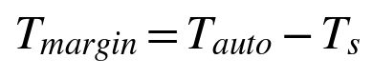
The algorithm contains two feedback loops. In the mitigation loop, any zone exceeding its limit triggers a design change; a TBC layer [9, 11], a heat shield, or an added cooling path [12], and the analysis is re-run on the modified geometry. In the validation loop, if the predicted temperatures disagree with rig measurements by more than ±10%, the convection coefficients and mesh are refined and the model is re-solved. The procedure terminates only when the design both clears the ignition margin and matches experiment.
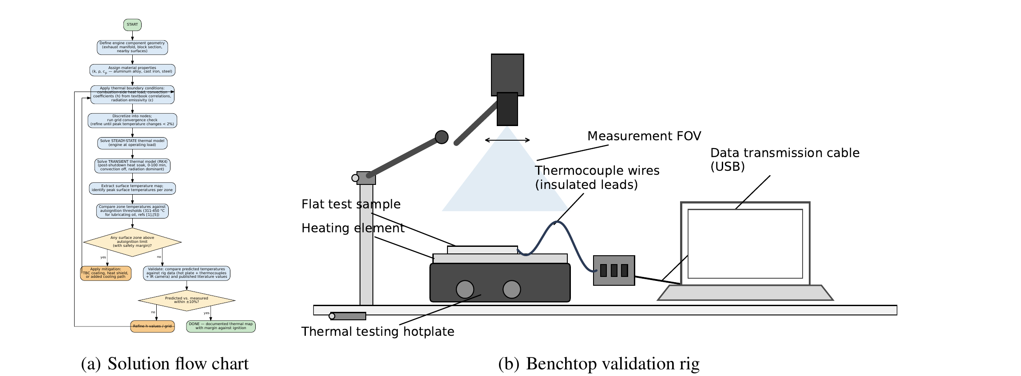
Fig. 2 (a) Solution flow chart of the proposed Simscape thermal mapping and validation algorithm; (b) proposed benchtop hot-surface validation rig (side view): electric hot plate, instrumented sample plate, K-type thermocouples with Arduino/MAX31855 DAQ, and IR thermal camera providing a full-field surface temperature map.
Proposed Experimental Setup. Figure 2(b) shows the proposed test configuration in side view. The test procedure mirrors the two simulation studies. For the steady-state comparison, the hot plate is stepped through 150, 250, 350, and 450 °C setpoints and held at each until the thermocouple readings drift by less than 1 °C per minute; the settled readings and IR map at each setpoint provide four steady-state validation points. For the transient comparison, the plate is then switched off and the natural cool-down is logged for 100 minutes, reproducing the radiation-dominated heat-soak decay observed in under hood measurements [16]. Finally, the rig itself is replicated as a simple Simscape thermal-network model, so that measured and simulated values are compared on identical geometry isolating solver accuracy from the geometric uncertainty of the full engine model.
6. RESULTS AND ANALYSIS
6.1 Governing Equations and Analytical Solution
Section 4's composite-wall model gets applied here to one specific piece of the engine: a section of exhaust manifold wall, modeled as two resistive layers, the thin ceramic TBC and the much thicker gray cast iron beneath it, plus convective resistance at each surface, in series exactly like resistors in a circuit:
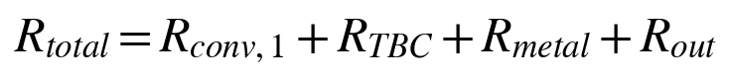
The outer surface loses heat by convection and radiation in parallel:
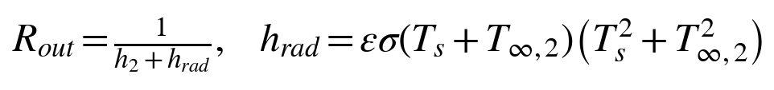
Since hrad depends on the surface temperature being solved for, Ts = T∞,2 + q̇Rout is iterated until it changes by less than 10⁻⁸K, then compared against the 311°C autoignition threshold [6] using the margin from Section 4, Tmargin = Tauto,low − Ts. A positive margin is safe; a negative margin is not.
Table 2 lists the values used, chosen to represent a real exhaust manifold rather than round numbers, with each layer acting as a resistor in series, exactly the circuit implied by the equations above.
Table 2 Base-case parameters for the exhaust manifold reference case
Parameter | Value
T∞,1, exhaust gas | 650 °C
h1, gas side convection | 180 W/m²·K
kTBC, YSZ coating [13] | 0.9 W/m·K
LTBC, coating thickness [13] | 350 μm
kmetal, gray cast iron | 52 W/m·K
Lmetal, wall thickness | 6 mm
T∞,2, under hood air (running) | 80 °C
T∞,2, under hood air (soaked) | 45 °C
h2, outer forced convection (running) | 35 W/m²·K
hnat, outer natural convection (soaked) | 8 W/m²·K
ε, surface emissivity | 0.85
ρmetal, gray cast iron density | 7870 kg/m³
cp,metal, gray cast iron specific heat | 447 J/kg·K
Ceff, effective areal thermal mass (soak model) | ≈ 21,107 J/m²·K

The lumped post-shutdown soak model above requires an effective areal thermal mass, Ceff, not given directly by the steady-state parameters in Table 2. It is derived physically as Ceff = ρmetal·cp,metal·Lmetal, using the same gray cast iron property table (Cengel & Ghajar) that supplies kmetal = 52 W/m·K above: ρmetal = 7870 kg/m³, cp,metal = 447 J/kg·K, giving Ceff ≈ 21,107 J/m²·K. A Biot number of about 0.005 and a Fourier number near 2,460 over the 100-minute soak window both confirm that lumping the full wall thickness into a single thermal mass is valid here.
Once the engine shuts off, forced convection stops and the wall cools by weak natural convection and radiation alone, modeled as a single lumped mass following the 100-minute window [16] used in their own soak test. Because the T⁴ radiation term makes this hard to solve by hand, two approaches are compared: a linearized shortcut assuming the radiation coefficient stays fixed at its hottest value,
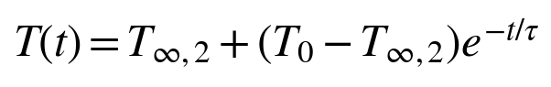
against a numerical RK4 solution that recalculates the radiation term as temperature actually changes.
6.2 Solution Algorithm
The solution proceeds exactly as laid out in Figure 2(a): build the geometry, apply the boundary conditions from Table 2, solve for the temperature field, check whether the mesh has converged, check whether every zone clears its safety margin, run the shutdown soak study, and check the prediction against rig data once that data exists. The same two feedback loops apply here, mitigation if a zone fails its margin check, and model refinement if predictions disagree with measurements by more than 10 percent.
6.3 Figures and Discussion
The bare wall reaches a steady-state 484.14°C, and the TBC-coated wall 477.50°C, against a 311 to 450°C autoignition band: only a 6.64°C (1.4 percent) drop, both still well above the band, smaller than the Section 3 win and not enough alone to make this surface safe.
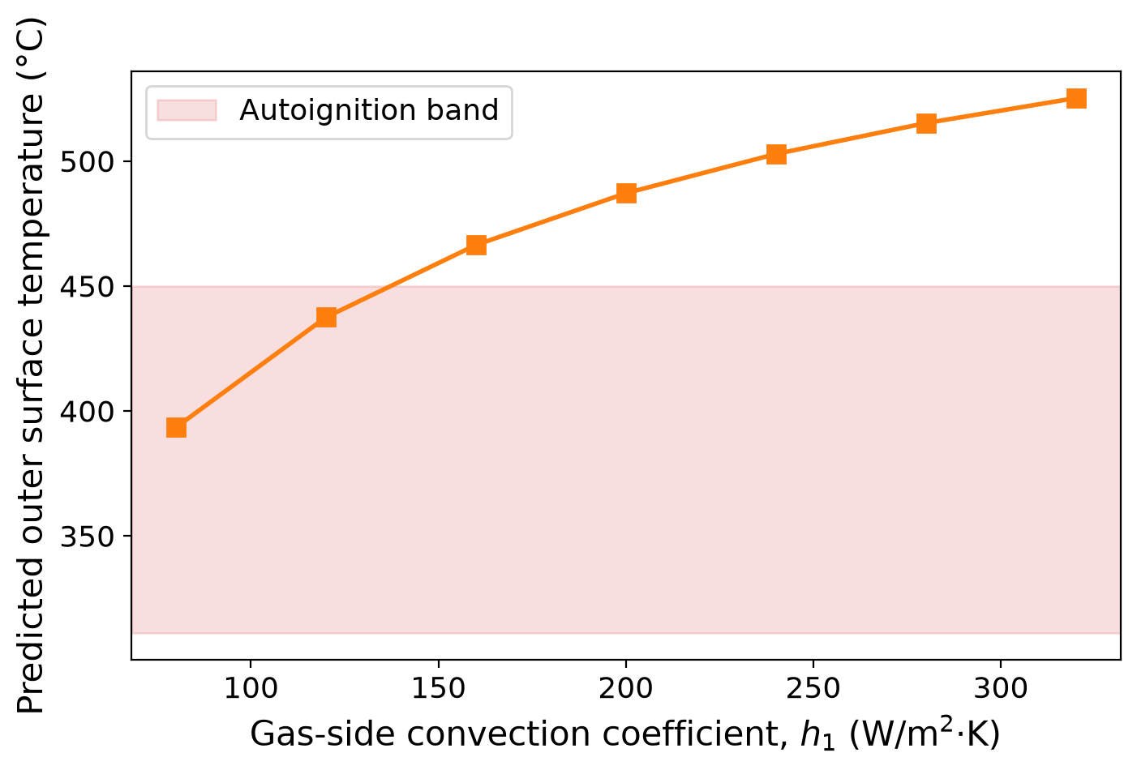 | 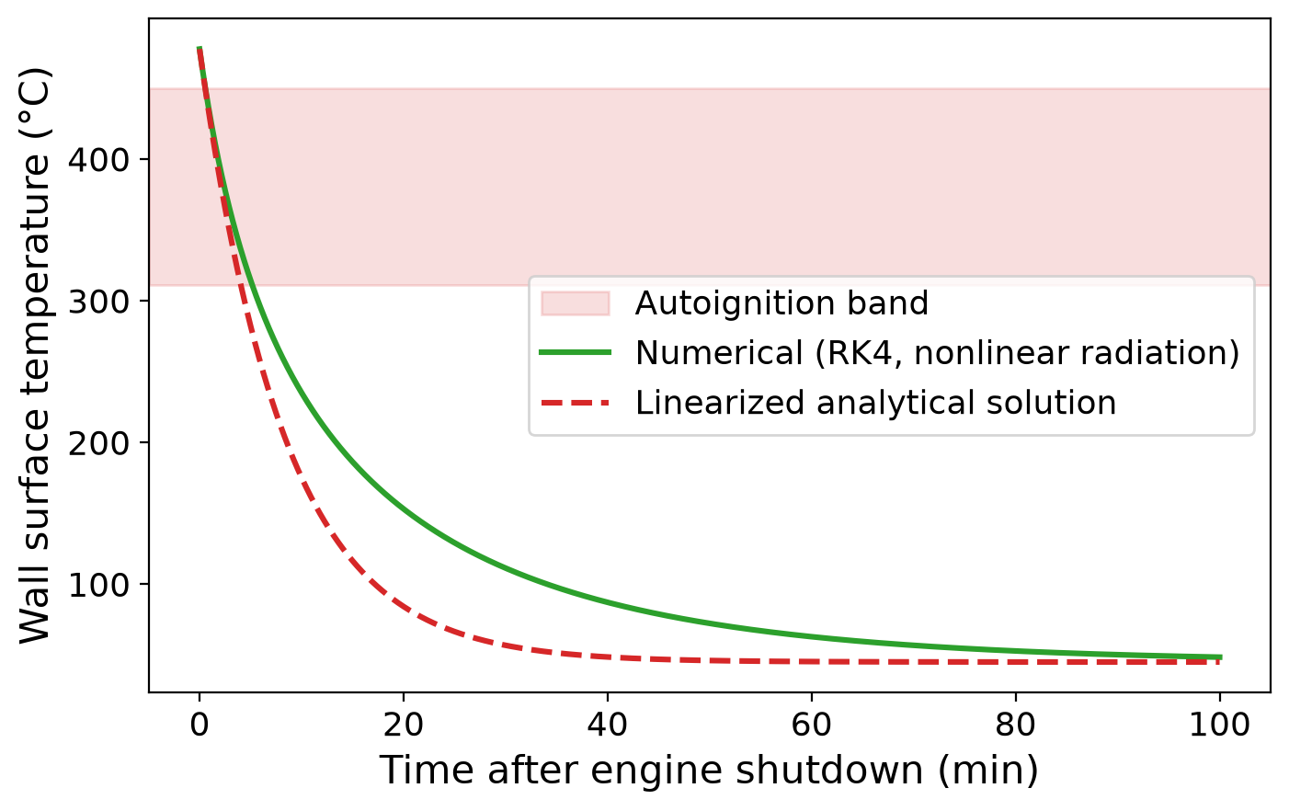
Fig. 3 (a) Sensitivity of predicted surface temperature to local gas-side convection coefficient, consistent with the duty-cycle dependent margin shift reported by [11]; (b) post-shutdown heat-soak decay, numerical vs. linearized analytical solution, following the 100-minute soak protocol used by [16].
Sweeping TBC thickness up to 1000 μm, three times practical limits before cracking risk, only reaches 465.94°C, an 18.2°C best case with fast diminishing returns, compared against [7, 13]. Figure 3(a) instead sweeps the gas-side convection coefficient h1, which alone moves the surface from 393.4 to 525.1°C, swinging across the entire autoignition band. Airflow at a given spot matters more than coating thickness there, pointing design effort toward shielding hot spots rather than uniform thicker coatings.
Figure 3(b) covers post-shutdown cooling from 477.50°C toward the 45°C ambient: the trustworthy numerical solution drops below the 450°C threshold within about a minute but stays above 311°C until roughly five minutes post-shutdown, a window the quick linearized shortcut underestimates since it assumes a constant radiation cooling rate, diverging from the numerical solution by 68 to 70°C at its peak, 12 to 20 minutes after shutdown, before converging again.
Since that numerical solution drives the danger-window estimate, it needs its own check: shrinking the time step confirms the error drops at close to the expected fourth-power rate, confirming the RK4 integrator is working correctly, the consistency check every numerical result here depends on.
This addresses the same manufacturing-variation worry [7] raised in Section 3: 20,000 Monte Carlo samples with ±10 percent random variation in thickness and conductivity cluster tightly at 477.4°C (spread under 1°C), none dropping below 311°C. Manufacturing variation is not why this surface is unsafe; the location's physics is.
6.4 Analysis
Verification. The numerical solver was tested against itself. Shrink the time step, and the error shrinks at the expected fourth-power rate. The steady-state iteration always settles to a residual below 10⁻⁸, and setting the coating thickness to zero reproduces the bare-wall answer exactly, a basic sanity check that the equations were coded correctly.
Validation. Full validation is still waiting on the benchtop rig from Section 5. For now, the predicted cool-down shape matches published soak-test behavior [16]: a fast drop followed by a slow radiation-dominated tail on a similar timescale. Their rig showed something this model misses, nearby parts kept heating for several minutes after shutdown as stored heat worked outward, which a single lumped block cannot represent. That gap is what physical testing will confirm.
Limitations. The soak model is a single lumped block, and every convection coefficient in it is held fixed, even though [11] showed those shift across a drive cycle. A piston crown in direct combustion flux also sees a larger benefit than this radiation-choked wall does.
Applications. The composite-wall equations solve almost instantly, so dozens of zones or materials can be screened in the time one finite-difference run would take. The h1 sensitivity result is probably the most useful thing here: shield fast-flow hot spots instead of defaulting to thicker coatings everywhere, and let the soak-time results decide which manifold zones get tested first. The RK4 step size should always use the same convergence check described above, since a coarse step only gets away with it here because this equation behaves smoothly.
6.5 Comparative Summary
Table 3 Comparison against the papers reviewed in Section 3
Ref | System studied | Key reported result | Comparison
[13] | Diesel piston, bare vs. TBC, FE model | 55.54 °C drop, about 15% cut | Same idea, bigger payoff; piston sees more heat flux
[11] | TBC performance over a full drive cycle | Margin shifts as convection coefficients change through the cycle | Confirmed; Figure 3(a) shows margin sliding across the band
[7] | TBC thickness and roughness on turbine blade cooling | Both thickness and roughness measurably affect cooling performance | Matches; thickness helps a bit, not enough alone
[16] | Under hood soak rig, 100 minute cooldown | Radiation-dominated decay after shutdown; heat shield keeps parts cooler | Same decay behavior shown here (Figure 3(b)); their early rise is what this lumped model misses

7. CONCLUSION
Engine fires from hot-surface ignition are still a real hazard across the automotive and aerospace industries. Fire safety has mostly leaned on reactive suppression and manual inspection, accepting initial damage as a baseline. This paper takes a different starting point: treat hot engine surfaces as controllable variables, and build a predictive thermal mapping framework that catches high-risk hotspots during the design phase, before anything gets built.
The framework models steady-state and transient heat transfer through a composite exhaust manifold wall, predicting localized surface temperature Ts from conduction, convection, and radiation acting in parallel. A ceramic TBC increases the total thermal resistance Rtotal and lowers the outer surface temperature by 6.64°C. That is real, but partial, and not enough on its own to bring this surface below the 311°C autoignition threshold. Which is exactly the point: coating thickness, cooling path, and heat-shield placement have to be treated as one combined design problem, not three separate fixes. The transient soak analysis backs this up, radiation dominates once forced convection stops, and that is where optimized passive heat shields earn their keep.
The Simscape-based thermal model lets engineers test geometry and coating changes without building anything first, and the benchtop validation rig keeps those predictions honest. None of this is a finished answer, though. The static resistance model cannot capture chaotic multiphase behavior like a pressurized oil spray, and its reliability leans on manufacturing tolerances that, left uncontrolled, quietly eat into the calculated safety margin. Put predictive thermal mapping and empirical validation together, though, and fire prevention stops being something discovered after the fact. It becomes a design parameter, addressed computationally before manufacturing ever begins.
8. RECOMMENDATIONS
The sensitivity analysis sets a clear priority. Gas-side convection moved the predicted surface temperature across the entire 311 to 450°C band on its own, while tripling coating thickness only managed to shave off twenty degrees. So design effort belongs on convective shielding at hot spots from the thermal map, not on uniformly thicker coatings, and that lines up with the load-dependent shifts [11] already reported.
Coatings should be one layer of a defense-in-depth strategy, not the whole plan. This manifold's 6.64°C reduction is well short of the 55.54°C reported for a piston crown in direct combustion flux [13], so heat shields and cooling paths need to combine with coatings, letting cumulative resistance carry the surface below threshold rather than any single layer. Radiation dominates the post-shutdown soak [16], so shield placement deserves first-order attention. Before production, the benchtop rig from Section 5 needs to validate predictions against the ±10% criterion, and coating finish has to stay tightly controlled, since roughness alone is enough to shift the convection coefficient [7]. Future work should push the model toward the transient, multiphase behavior it still cannot capture, coupling it with CFD treatment of oil spray, boiling, and evaporation [2, 15].
GENERATIVE AI DISCLOSURE
During the preparation of this work, the author(s) used Claude (Anthropic) to assist with proofreading and checking the validity of reported data and calculations. After using this tool, the author(s) reviewed and edited the content as needed and take full responsibility for the content of the publication.
REFERENCES
[1] Bai, L., Cheng, F., and Dong, Y., (2024) “Ignition characteristics and flame behavior of automotive lubricating oil on hot surfaces,” Processes, 12(11), pp. Art. no. 2522.
[2] Bai, L., Liu, C., and Wang, L., (2025) “Analysis of ignition and flame geometric characteristics of lubricating oil leaking from automotive engine onto hot surfaces,” PLOS ONE, 20(3), pp. Art. no. e0319934.
[3] Cesur, I., (2027) “Experimental investigation of the combined effects of thermal barrier coatings and ethanol blends on gasoline engine performance,” Fuel.
[4] Chang, J. and Malipeddi, M., (2003) “Under hood thermal management of off-highway machines using 1d-network simulations,” Tech. Rep. 2003-01-3405, SAE Technical Paper.
[5] Chen, J., Wang, Z., Zhang, Y., Li, Y., Tam, W. C., Kong, D., and Deng, J., (2024) “New insights into the ignition characteristics of liquid fuels on hot surfaces based on tg-ftir,” Applied Energy, 360, pp. Art. no. 122827.
[6] Deng, J., Yang, W., Zhang, Y.-N., Chen, J., Li, Y., Ji, X., and Shu, C.-M., (2024) “Experimental study on hot surface ignition and flame characteristic parameters of lubricating oil,” Journal of Thermal Analysis and Calorimetry, 149, pp. 10213–10225.
[7] Du, Z., Li, H., You, R., and Huang, Y., (2023) “Effects of thermal barrier coating thickness and surface roughness on cooling performance sensitivity of a turbine blade,” Case Studies in Thermal Engineering, 52, pp. Art. no. 103727.
[8] Fu, J., (2022) “Numerical study and structural optimization of vehicular oil cooler based on 3d impermeable flow model,” Sustainability, 14(13), pp. 7757.
[9] Gandolfo, J., Gainey, B., Yan, Z., Jiang, C., Kumar, R., Jordan, E. H., Filipi, Z., and Lawler, B., (2023) “Low thermal inertia thermal barrier coatings for spark ignition engines: An experimental study,” International Journal of Engine Research.
[10] Khasawneh, M. K., (2023) “Ignition of various lubricating oil compositions using a shock tube,” Journal of Engineering for Gas Turbines and Power, 146(3), pp. 031003.
[11] Koutsakis, G. and Ghandhi, J. B., (2023) “Optimization of thermal barrier coating performance and durability over a drive cycle,” International Journal of Engine Research.
[12] Kula, S., Bulut, E., Altay, E., Sumer, O., and Öztürk, F., (2022) “Smart cooling design using dual loop cooling to increase engine efficiency and decrease fuel emissions with artificial intelligence,” Case Studies in Thermal Engineering, 40, pp. Art. no. 102351.
[13] Liu, Y., Lei, J., Deng, X., Liu, Y., Sun, D., and Zhang, Y., (2023) “Research and analysis of a thermal optimisation design method for aluminium alloy pistons in diesel engines,” Case Studies in Thermal Engineering, 52, pp. Art. no. 103667.
[14] Stanescu, R., (2024) “Assessment of the corrosion resistance of thermal barrier coatings on internal combustion engine components,” Coatings.
[15] Ullal, A. and Ra, Y., (2023) “Numerical study of lubricant oil drop induced pre-ignition in engines,” International Journal of Engine Research, 24(5), pp. 1860–1876.
[16] Vdovin, A. and Kadri Sathiyan, T., (2023) “Vehicle under hood environment investigations using a simplified test rig,” Energies, 16(24), pp. Art. no. 8028.
[17] Zhu, N., Wang, X., Wei, X., Ding, C., and Wang, J., (2022) “Experimental study on the ignition characteristics of leaking rp-3 aviation kerosene on a horizontal hot wall,” ITM Web of Conferences, 47, pp. Art. no. 03027.

