Inspection and Quality Control Robots

Veer Sanghvi
School of Engineering
Wentworth Institute of Technology
Boston, MA, USA
sanghviv@wit.edu
Tyler Fong
School of Engineering
Wentworth Institute of Technology
Boston, MA, USA
fongt@wit.edu
Syed Irtiza Ali Shah
School of Engineering
Wentworth Institute of Technology
Boston, MA, USA
shahs10@wit.edu

Abstract
Inspection decides how reliable a finished product actually is, and human inspectors run into a hard limit: they get tired, they miss things, and they cannot always physically reach complicated geometry. Prior work chips away at pieces of this problem instead of solving the whole thing: fixed-mount vision systems break down once defects or geometry get varied, mobile platforms add positional uncertainty, and learning-based methods need labeled defect data that is expensive to collect for low-volume parts. This paper proposes an inspection and quality control framework that puts adaptive sensing and kinematic control on one robotic platform, so a single six-degree-of-freedom arm can do both surface defect detection and dimensional verification across one workspace. Forward and inverse kinematics for a reference arm are verified in MATLAB against the manufacturer’s own rigid-body model, using both a general-purpose numerical solver and a generated closed-form solver, across a reproducible study of over two hundred target poses. All reported errors are solver residuals under an ideal rigid-body model, not measurement accuracy of a physical system. The study also characterizes when and why each solver fails: every non-convergence in the numerical solver traces to a target with no joint-limit-feasible solution, which the closed-form solver certifies directly, while the closed-form solver itself shows one demonstrated false-infeasible verdict caused by floating-point branch loss. These results are used to argue that kinematic feasibility screening belongs in the inspection planner of any manufacturing cell where dimensional and visual inspection still run as separate stations.
Keywords—robotic inspection, quality control automation, defect detection, kinematic modeling, dimensional verification, autonomous manufacturing systems

Introduction
Inspection and quality control keeps getting harder as products get more complicated and production cycles get shorter. Two systems changed the field in the late twentieth century: the coordinate measuring machine (CMM), which probes part dimensions precisely, and machine vision, which catches surface defects automatically. Both had a built-in weakness: a CMM means pulling the part off the line, and early vision systems were bolted down in one spot, so neither could adjust to a new product or a hidden surface.
Robotic inspection got around that by putting sensors, vision systems, and probes on an arm that moves through the workspace, which is basically a mobile CMM and a mobile vision system combined. This paper looks at where robotic inspection stands today, points out where vision-based and contact-based approaches each fall short, and proposes a kinematic and sensing framework meant to close that gap on one platform.

Literature Review

Vision-Based Surface Defect Inspection
Vision-based detectors make up most of the recent inspection literature, and most of the accuracy gains come from adapting the network to the specific defect domain instead of reusing a general-purpose detector off the shelf. Akhyar et al. built the Forceful Defect Detector this way, adapting a detection backbone to the low-contrast texture of steel surface flaws, and it beat general-purpose networks on precision [1]. Zhao et al. took a similar approach with RDD-YOLO, building on YOLOv5 with a Res2Net backbone and a decoupled detection head, and it beat baseline YOLO variants on accuracy and recall, especially on small defects [2]. Bagherzadeh et al. surveyed dataset labeling quality instead of model architecture and concluded that labeling consistency matters at least as much as which architecture gets used [3]. A 2024 systematic review that normalized train/test splits across published detectors reported that performance gaps shrink once comparison conditions are standardized, that supervised detection still dominates despite its labeling cost, and that dataset imbalance is still the field’s most persistent open problem [4]. Chen et al. paired a coaxial melt-pool camera, an acoustic microphone, and a thermal camera on one robotic deposition arm and showed that single-mode vision misses defects that only show up thermally or acoustically [5].

Modern Inspection and Quality Control Robotic Systems
Industry 4.0 has pushed artificial intelligence, cloud computing, and machine vision into inspection lines together instead of as separate tools [6][7][9]. Six-axis arms carrying cameras, laser scanners, ultrasonic sensors, and CMM probes can run a programmed inspection plan from several angles in a single cycle, and purpose-built platforms like RIPTIDE aim the same idea specifically at part inspection [8]. Collaborative robots extend that reach into shared workspaces without a safety cage [12], rail-mounted and mobile robots inspect places too hazardous to send a person [10], sensor fusion gives a more complete picture of a part’s condition than any one sensor could [11], and letting a robot revise its own inspection program is an active research area [13]. The obstacles that keep showing up are the volume of labeled data deep learning needs and the up-front cost of a full robotic cell. Where [11] fuses multiple sensors on a dedicated metrology platform and [12] targets manipulation of metallic surfaces with a purpose-built cobot, the system proposed here differs by folding defect detection and dimensional measurement into the motion plan of one general-purpose arm, so the same kinematic model that positions the camera also positions the laser probe; and unlike the self-revising inspection programs surveyed in [13], viewpoint re-planning here is triggered only by a candidate defect, keeping the baseline cycle deterministic.

Force-Controlled and Collaborative Robots for Contact-Based Inspection
Contact-based inspection solves a different problem than vision: a probe has to touch the surface accurately, and in some cases stay in contact with it. ACES is a teleoperated, force-controlled six-degree-of-freedom arm built for inspecting the inside of pipes, and it sets up the geometric idea this project leans on in Section III: five contact points, as long as no four are coplanar, fully determine a cylinder [14]. A robotic ultrasound scanner combines a passive spring-like mechanism with active force control to keep its probe in consistent contact with skin [15], and a co-robotic mammography system holds a target contact force under proportional-integral-derivative (PID) control while tracking surface curvature [16]. A 2024 paper on automatic contact-based 3D scanning uses an open-loop six-degree-of-freedom arm with a digitizer probe and closed-form inverse kinematics, validated against ASME B89.4.22 with sub-millimeter repeatability [17]. Reviews of collaborative robots in quality control describe a sharp shift toward in-process inspection and tie it to zero-defect manufacturing under Industry 5.0 [18][19]. The force-controlled scanners in [15] and [16] hold a probe against a compliant surface, and the ACES arm [14] carries its contact sensor into confined pipe geometry, while the system proposed here inspects rigid manufactured parts in an open cell and can therefore trade continuous contact force control for non-contact laser and depth sensing, which removes the 7 mm class of positional repeatability those systems accept. Against [17] and the cobot deployments surveyed in [18] and [19], the difference is scope rather than mechanism: those systems perform dimensional capture or generic in-process checks as dedicated tasks, whereas the framework here schedules dimensional measurement and visual defect screening inside one inspection cycle on one arm.

Significant Methodologies
Three of the contact-based papers end up anchoring the proposed methodology, mostly because each one relaxes an assumption the other two hold fixed. Reference [17] solves inverse kinematics in closed form to drive a touch probe to a contact point: the end effector’s pose is a $4×4$ homogeneous transform, the wrist center is solved first since the last three joint axes meet at one point, the first three joint angles come from treating the arm as a two-link planar mechanism, and the last three come from the residual rotation matrix. Tested against a calibrated sphere under ASME B89.4.22, it hit a 0.036 mm average diameter error, but it is open loop, so nothing senses the small elastic deflection when the probe makes contact.
Reference [14] (ACES) asks a narrower geometric question: touch five points on a cylindrical wall, no four of them coplanar, and that is enough to solve for the axis direction $\hat{a}$, an axis point $q$, and the radius $r$, five unknowns from five point-to-axis distance constraints. The coplanarity condition doubles as a built-in error check, so a real implementation must verify the calibration points are not degenerate before trusting the fit.
Reference [16] picks up something [14] and [17] both skip over: a surface that is not rigid. The probe velocity splits into a tangential piece that holds a fixed scan speed and a normal piece driven by a PID law reacting to the gap between measured and target contact force,
$$v=v_{τ}\hat{τ}+v_{n}\hat{n}, v_{n}=K_{p}(F^{*}−F)+K_{i}​∫(F^{*}−F) dt,$$
where $v$ is the commanded probe velocity, $v_{τ}$ and $v_{n}$ are its tangential and normal components, $\hat{τ}$ and $\hat{n}$ are the unit tangent and unit normal of the scanned surface, $F$ is the measured contact force, $F^{*}$ is the force setpoint, and $K_{p}$ and $K_{i}$ are the proportional and integral gains. That law held contact force to $5.18±0.23$ N against a 5 N target across twenty trials, with about 7 mm of positional repeatability, too coarse for dimensional work but good enough to keep the probe in stable contact. Together the three anchors point toward a design that borrows [17]’s closed-form kinematics and [16]’s tolerance for an imperfect contact surface, but applied to a rigid manufactured part instead of skin.

Proposed Methodology
The proposed system puts a high-definition camera, a depth camera, and a laser displacement sensor on a six-degree-of-freedom arm, so the sensor cluster can reach angles a stationary camera never could. A part trips a proximity sensor, the arm swings to an initial viewing pose, and a convolutional neural network screens the image for dents, scratches, cracks, missing features, and surface marring. Parts that pass go straight to dimensional measurement with the laser and depth sensor; parts that trip a possible defect send the arm to a couple more viewpoints first, which cuts down on false positives from shadows or glare.
The arm’s motion follows the Denavit–Hartenberg (DH) convention, so each joint transform is a homogeneous matrix and the tool-frame pose comes out as the product of all six,
$$T_{6}^{0}(q)=A_{1}(θ_{1})A_{2}(θ_{2})A_{3}(θ_{3})A_{4}(θ_{4})A_{5}(θ_{5})A_{6}(θ_{6}),$$
with each individual link transform written as
$$A_{i}=\left[\begin{matrix}cθ_{i} & −sθ_{i}cα_{i} & sθ_{i}sα_{i} & a_{i}cθ_{i} \\ sθ_{i} & cθ_{i}cα_{i} & −cθ_{i}sα_{i} & a_{i}sθ_{i} \\ 0 & sα_{i} & cα_{i} & d_{i} \\ 0 & 0 & 0 & 1\end{matrix}\right].$$
In Eqs. (2) and (3), $θ_{i}$, $d_{i}$, $a_{i}$, and $α_{i}$ are the DH joint angle, link offset, link length, and link twist of joint $i$; $cθ_{i}$ and $sθ_{i}$ abbreviate $cosθ_{i}$ and $sinθ_{i}$, and likewise for $α_{i}$; $q=[θ_{1},…,θ_{6}]$ collects the six joint angles; and $T_{6}^{0}$ is the tool-frame transform in the base frame. Forward kinematics, Eq. (2), gives the sensor’s pose from the joint angles; inverse kinematics recovers the joint angles $q$ that put the sensor cluster at a desired inspection pose $T^{*}$, $q=f^{−1}(T^{*})$. Section VI applies both to a reference arm in MATLAB, numerical and generated closed-form solvers side by side.
The fusion step works as follows. Every CNN detection is a bounding box in image coordinates with a class label and a confidence score. The pixel center of each detection is back-projected through the camera’s intrinsic matrix and combined with the depth camera’s range value at that pixel, which gives the defect a 3D position in the camera frame; multiplying through the calibrated camera-to-flange transform and the arm’s forward kinematics, Eq. (2), expresses that position in the part’s coordinate system. That 3D point becomes the target for re-inspection: the planner requests a pose that puts the laser displacement sensor normal to the surface at the defect location, and inverse kinematics converts it to joint angles, with the feasibility screening of Section VI deciding whether the pose is reachable before the arm ever moves. At the measurement stage, the laser reading provides a single high-accuracy range sample, the depth camera provides a lower-accuracy patch around it, and the two are combined by confidence weighting, with the laser value dominating at its spot. The pass/fail decision compares the fused surface deviation against the tolerance band the part’s CAD model assigns to that feature, and the report recording defect type, location, dimensions, and image evidence gets written to a quality-control database. Comparing the robot’s results against a CMM and manual inspection on parts with known defects is how we would find out whether the robotic result is statistically as good as the methods it is meant to replace.

Implementation
The proposed platform is a six-degree-of-freedom industrial arm, something like the ABB IRB 120 or the FANUC LR Mate 200iD; both share the six-revolute, spherical-wrist layout used in Section VI. A custom bracket holds the sensor cluster at the end effector, a conveyor feeds parts to a proximity sensor that kicks off the cycle, and a programmable logic controller routes accepted parts back to the line and diverts rejects for rework.
CAD models get built in SolidWorks and imported into robot simulation software, FANUC RoboGuide or ABB RobotStudio, for collision checking, reachability analysis, and path optimization before anything gets built physically. MATLAB verifies the forward and inverse kinematics, which is exactly what Section VI does; Python with OpenCV handles image processing, and a convolutional neural network classifies defects. The controller, vision system, and PLC talk over Ethernet, and the cycle runs: detect part arrival, move to the inspection pose, capture and classify, revisit extra viewpoints if a defect looks likely, take laser and depth measurements, fuse, compare against CAD tolerance, sort the part, log the result. The architecture is built to take on more sensing later, such as ultrasonic or thermal probes, without a redesign.

Results and Analysis
This section takes the kinematic model from Section III and applies it to a reference six-degree-of-freedom arm, verified computationally in MATLAB R2026a with the Robotics System Toolbox. Instead of retyping DH parameters from a secondary source, loadrobot(’abbIrb120’) pulls a rigidBodyTree built straight from ABB’s own kinematic description, so the forward-kinematics chain, joint limits, and inverse-kinematics results below all trace back to that model directly. The ABB IRB 120 got picked because its last three joint axes intersect at a single point, the property the literature relies on to derive closed-form inverse kinematics for this class of arm [20]; the FANUC LR Mate 200iD shares that layout, so the results carry over to either candidate from Section III. Two solvers run side by side throughout: the toolbox’s general-purpose numerical solver (damped least squares on the manipulator Jacobian, random restart enabled) and a closed-form solver generated for this arm by the toolbox’s analyticalInverseKinematics tool. Every experiment uses a recorded random seed and archives the full joint vectors, so all results below are reproducible from the published scripts and result files.
One correction from the original submission needs stating up front. The original verification script read joint limits from the first six bodies of the loaded model, but the model’s first body is a fixed base link, so that indexing froze the base joint at zero and shifted each remaining joint’s limits onto its neighbor, letting targets come from configurations a few degrees outside the true joint range. Sections VI-A and VI-B sample each joint’s own published limits; Section VI-C deliberately retains the original recipe as a stress test, because it reproduces, and explains, the non-convergent case from the original submission.

Verification on feasible targets
Eight target poses were generated by running forward kinematics on joint angles drawn uniformly from within 70% of each joint’s published limits (seed rng(7)), with the numerical solver starting from a guess perturbed $±{7.5}^{∘}$ per joint away from the true solution. All eight converged, with final position residuals between $2.9×{10}^{−7}$ and $3.1×{10}^{−5}$ mm in 21–37 iterations (Table I). The closed-form solver returned 2 to 6 joint-limit-feasible branches per pose, and its best branch reproduced each target at or below $2.3×{10}^{−12}$ mm, machine-precision agreement with the forward-kinematics ground truth.
- Feasible-target verification, 8 poses, seed rng(7): numerical vs. closed-form (CF)
Case | Num. (mm) | Ori. (deg) | Iter. | Conv. | CF br. | CF (mm)
1 | $3.05×{10}^{−5}$​ | $1.7×{10}^{−6}$​ | 21 | yes | 2 | $1.61×{10}^{−12}$​
2 | $8.30×{10}^{−7}$​ | 0 | 25 | yes | 4 | $1.84×{10}^{−12}$​
3 | $6.12×{10}^{−7}$​ | 0 | 28 | yes | 4 | $2.17×{10}^{−12}$​
4 | $3.90×{10}^{−7}$​ | 0 | 34 | yes | 3 | $1.83×{10}^{−12}$​
5 | $2.43×{10}^{−6}$​ | 0 | 25 | yes | 2 | $2.15×{10}^{−12}$​
6 | $2.94×{10}^{−7}$​ | $1.2×{10}^{−6}$​ | 37 | yes | 6 | $2.27×{10}^{−12}$​
7 | $4.19×{10}^{−6}$​ | $1.2×{10}^{−6}$​ | 24 | yes | 2 | $1.50×{10}^{−12}$​
8 | $2.62×{10}^{−6}$​ | 0 | 25 | yes | 4 | $1.55×{10}^{−12}$​

Batch statistics over 100 random poses
To move beyond hand-count sample sizes, 100 additional targets were generated with the same recipe under a second recorded seed (rng(11)). The numerical solver converged on 100 of 100, with a median of 28 iterations, a range of 22 to 214, and a maximum final position residual of $2.1×{10}^{−5}$ mm; the single 214-iteration case is one where the solver’s random restart engaged and then recovered. The closed-form solver found at least one joint-limit-feasible branch for all 100 targets, with best-branch residuals at or below $1.4×{10}^{−10}$ mm. One scope note applies to every convergence statistic in this paper: initial guesses sit within $±{7.5}^{∘}$ per joint of a known solution, matching the original protocol, so these results say nothing about convergence from cold starts or distant seeds, and the failure classification in Section VI-C is a statement about this initialization regime. Figure 1 shows the iteration-count and residual distributions across the converged batch.
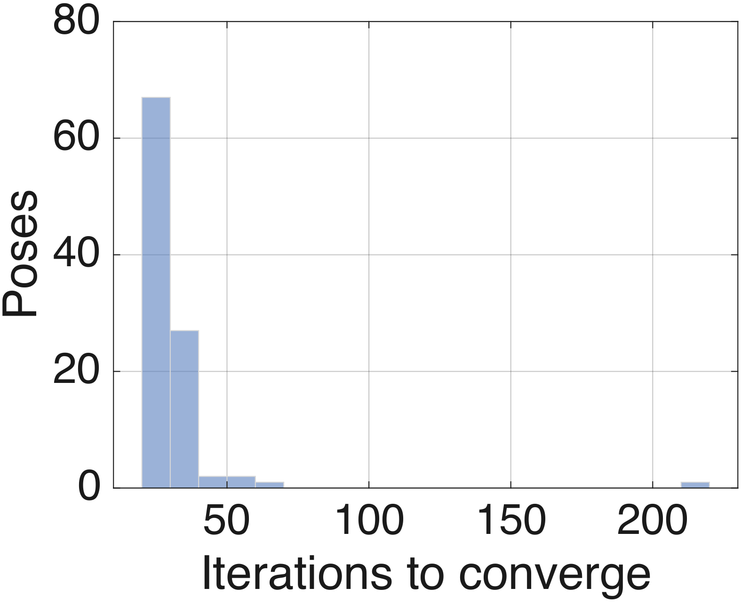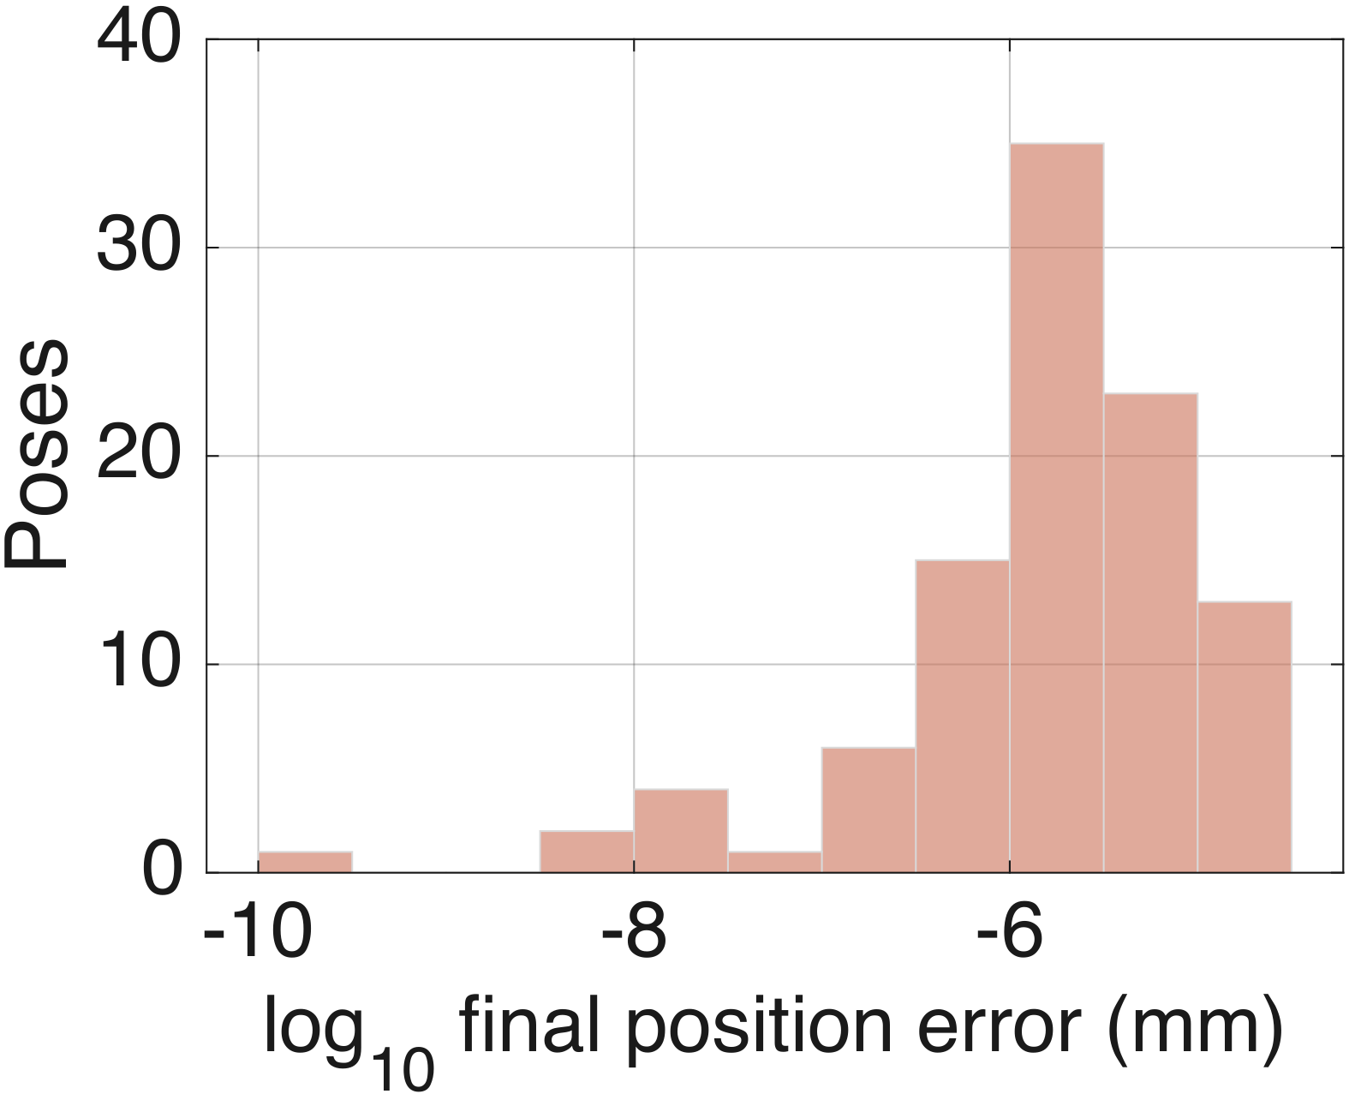
- The 100-pose batch, seed rng(11): iteration counts (left) and final position residuals, $\log_{10}$ mm (right).

Failure study: infeasible targets and the original case 8
The original submission reported one non-convergent pose out of eight: 32.658 mm of position error and ${0.111}^{∘}$ of orientation error after 1500 iterations. The reviewer asked for its root cause, and finding it required reproducing the sampling recipe that generated it. A third experiment therefore ran 100 targets under the original submission’s limit indexing (seed rng(13)), the recipe described in the correction note above. Figure 2 reproduces the original submission’s per-pose chart from its archived results, so the case being analyzed stays visible exactly as it was reported.
The results separate cleanly. Six of the 100 targets came from configurations that violate the true joint limits, by margins between ${0.13}^{∘}$ and ${6.33}^{∘}$. The closed-form solver returned zero joint-limit-feasible branches for five of them, certifying them as infeasible, and exactly those five are the poses on which the numerical solver failed to converge. Every failure shows the same signature as the original case 8: the solver runs to its 1500-iteration cap, the orientation error stays below ${0.13}^{∘}$, the position error lands between 0.5 and 30 mm, and the returned configuration sits pinned against a joint limit. In all five failures the pinned joint is the one whose generating value violated its limit, joint 2 at $−{110}^{∘}$ or joint 3 at $+{70}^{∘}$ (Table II). Across these five cases the residual position error also tracks the size of the limit violation, from 0.53 mm at a ${0.13}^{∘}$ violation to 29.7 mm at ${6.33}^{∘}$. Figure 3 plots the five failed targets on the reachable envelope: all five sit inside the position workspace, which rules out workspace exclusion. The failure class the reviewer asked to identify is joint-limit infeasibility: the requested position is reachable, but the full pose has no solution inside the joint range, so the solver presses the offending joint against its stop and stalls. The original case 8 came from this same sampling recipe and carries this same signature, so the analysis classifies it the same way. Its exact joint vectors cannot be recovered because the original run predates joint-vector archiving and the toolbox’s random stream is not bit-stable across releases, which is itself the reason every experiment in this revision records seeds and archives joint vectors.
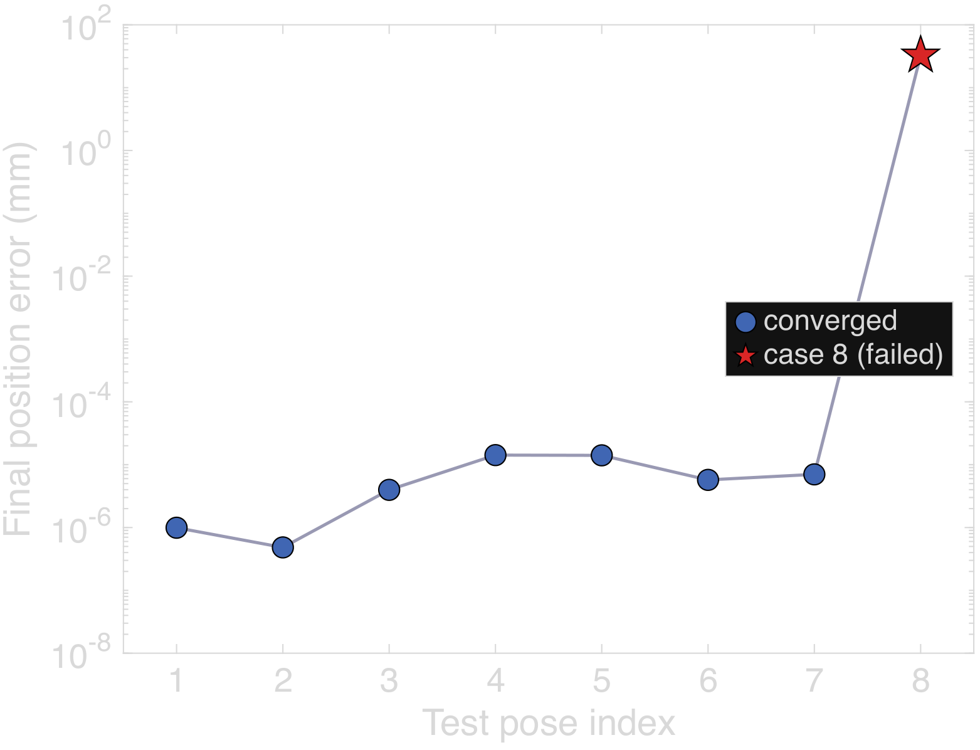
- The original submission’s eight-pose run, regenerated as vector graphics from its archived results: seven poses converge below $1.5×{10}^{−5}$ mm while case 8 stalls 32.7 mm off target.
- Failed cases in the infeasible-target study, seed rng(13)
Case | Viol. (deg) | Pos. err. (mm) | Ori. err. (deg) | CF br. | Pinned joint
23 | 5.67 | 26.69 | 0.046 | 0 | $θ_{3}$ at $+{70}^{∘}$
63 | 1.77 | 5.04 | 0.020 | 0 | $θ_{2}$ at $−{110}^{∘}$
74 | 0.13 | 0.53 | 0.002 | 0 | $θ_{2}$ at $−{110}^{∘}$
90 | 6.33 | 29.68 | 0.121 | 0 | $θ_{3}$ at $+{70}^{∘}$
92 | 0.70 | 2.46 | 0.009 | 0 | $θ_{2}$ at $−{110}^{∘}$
The sixth zero-branch target is the counterexample. Its generating configuration lies fully inside the true joint limits, and the numerical solver converged on it to $1.4×{10}^{−7}$ mm, yet the closed-form solver returned no feasible branch: at full floating-point precision the generated function drops the entire elbow branch family containing the generating configuration, and re-evaluating the same pose after a machine-precision round-trip restores the missing branches. The closed-form verdict is therefore not infallible either; it has a demonstrated false-infeasible failure mode caused by numerical branch loss near an internal tolerance, observed once in this 100-pose study.
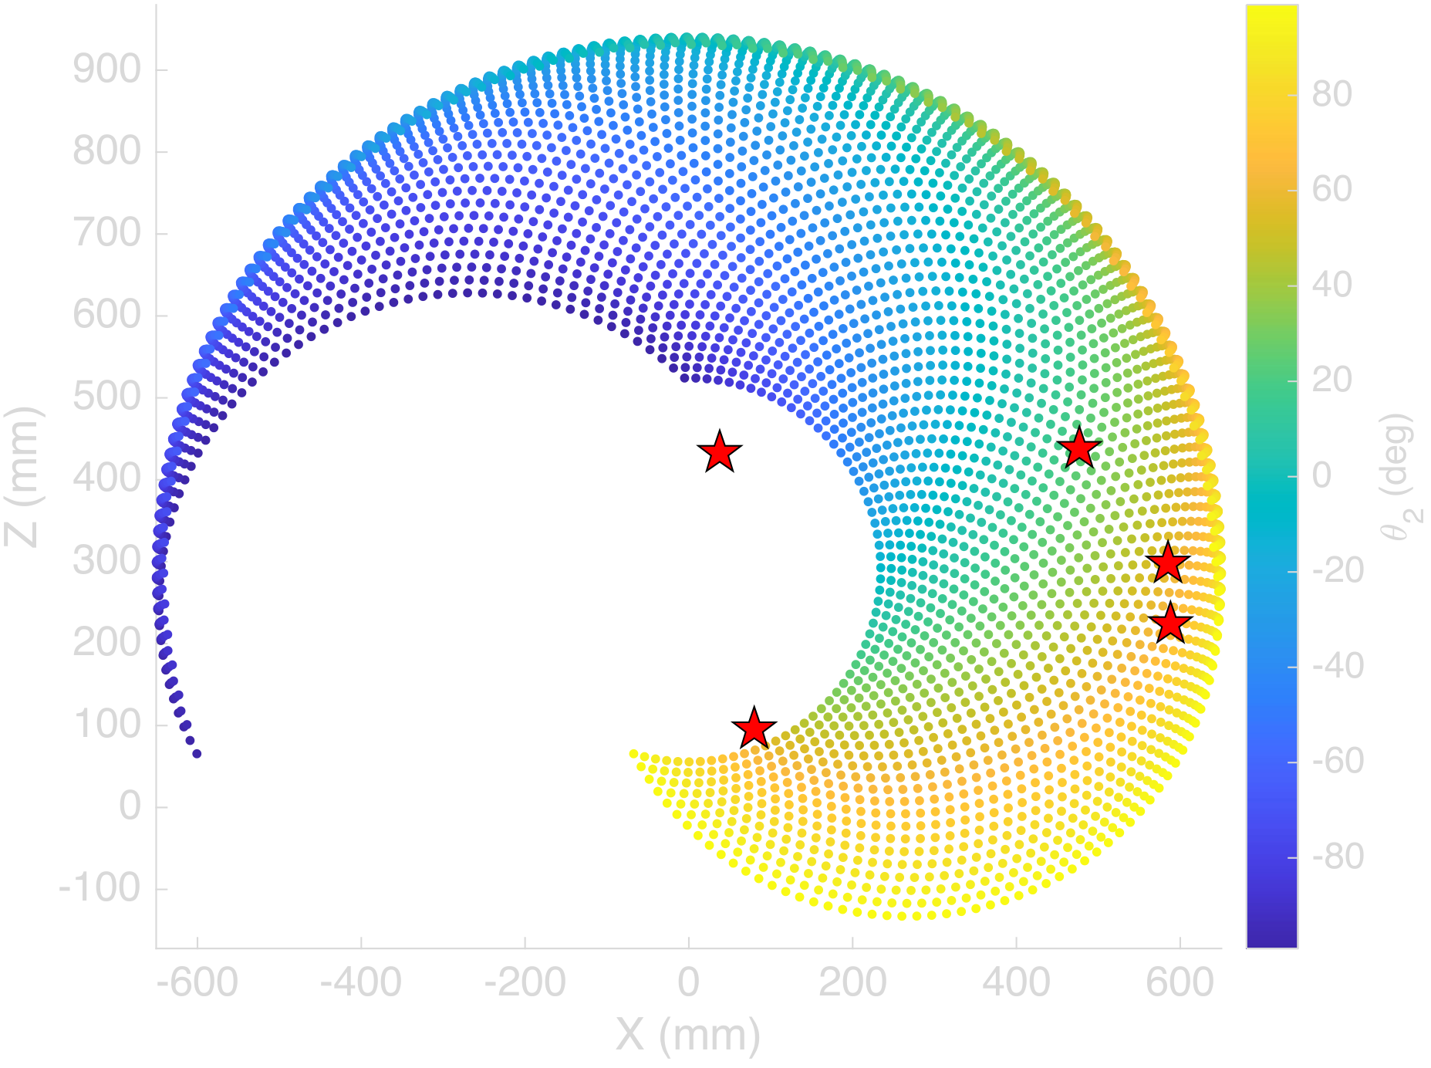
- Reachable workspace envelope, X–Z plane, colored by shoulder angle $θ_{2}$. Red stars mark the five infeasible targets from Table II: all five lie inside the position envelope, so their infeasibility is a joint-limit property of the full pose.

Analysis
Verification here means the loaded model and the solvers agree with each other, and the three experiments back that up from different directions. On feasible targets the numerical solver is reliable and cheap: 108 of 108 convergences across Sections VI-A and VI-B, a median of 28 iterations, and worst-case residuals five orders of magnitude below any practical inspection tolerance. The closed-form solver reproduces the same targets at machine precision and, more usefully, enumerates every joint-limit-feasible branch, which a local iterative search cannot do.
The failure study is where running both solvers pays off. A numerical solver that hits its iteration cap reports only that it failed; an inspection cell cannot tell from that whether the pose was unreachable, blocked by a joint limit, or a bad initial guess. The closed-form solver answers that question by construction, because enumerating all branches and finding none inside the joint limits is a certificate of infeasibility rather than a failed search, and that certificate was correct for all five numerical failures here. The converse case matters just as much: one feasible pose lost its entire elbow branch family to floating-point sensitivity inside the generated closed-form function, producing a false infeasible verdict on a target the numerical solver handled without trouble. Neither solver is sufficient alone. A production controller should run the closed-form solver first, for a fast feasibility verdict and branch solutions to seed from, fall back to the numerical solver for refinement, and treat disagreement between the two as a flag for the tolerance-boundary case rather than trusting either verdict blindly.
The practical takeaway for the proposed inspection cell is that kinematic feasibility screening needs to happen at planning time, not at execution time. The five certified-infeasible targets in Section VI-C are exactly the kind of pose an inspection planner could request after back-projecting a defect detection into a re-inspection viewpoint. Wall-clock cost makes the argument concrete: on an Apple M-series laptop CPU, a converged numerical solve takes a median of 4.0 ms, a stalled 1500-iteration solve takes 0.11 s and returns no diagnosis, and one closed-form call takes 0.38 ms, so screening every candidate viewpoint costs an order of magnitude less than one successful numerical solve and roughly 300 times less than discovering an infeasible request the hard way. The near-proportional relationship between limit violation and residual error also gives an operator a usable diagnostic: a stalled solve pinned at a joint limit with millimeters of residual points at an infeasible request, not at a solver bug.
The limits of these results need stating plainly. Every error figure in this section is a solver residual computed under an ideal rigid-body model: rigid links, ideal revolute joints, exact encoder readings, an exact tool-frame calibration, and no thermal effects. These numbers say nothing about the measurement accuracy of a physical inspection cell. A real arm adds gearbox backlash, joint compliance, encoder quantization, tool-center-point calibration error, thermal drift, and fixturing error on top of everything reported here, and each of those terms is orders of magnitude larger than the solver residuals in Table I. No measurement-accuracy claim for the proposed system can be made until the framework is validated on hardware against a coordinate measuring machine, as Section III describes.

Conclusion
This project looked at the shift away from manual and fixed-station inspection and proposed a framework that puts vision-based defect detection and dimensional verification on the same six-degree-of-freedom platform instead of splitting them across two systems. Forward and inverse kinematics for a reference arm got verified in MATLAB R2026a using the Robotics System Toolbox’s own rigid-body-tree model of the ABB IRB 120, with a numerical and a generated closed-form solver run side by side across 208 seeded, reproducible target poses. On feasible targets the numerical solver converged 108 times out of 108 with solver residuals no worse than $3.1×{10}^{−5}$ mm, and the closed-form solver reproduced the same targets at machine precision while enumerating every joint-limit-feasible branch. The failure study explained the non-convergent case from the original submission: targets generated without joint-limit feasibility checking can demand poses no in-limit configuration reaches, the numerical solver responds by pinning a joint against its stop and stalling, and the closed-form solver certifies the infeasibility directly, while carrying a demonstrated false-infeasible failure mode of its own. These residuals are rigid-body model agreement, not measurement accuracy. Combined with the sensor-fusion pipeline of Section III, this backs up the paper’s central argument, that adaptive sensing and kinematic control belong on one platform with feasibility screening in the planner, while leaving physical validation against a coordinate measuring machine as the necessary step before any accuracy claim about the system itself.

Recommendations
The first priority is building an actual physical work cell, since only hardware testing will show how much gearbox backlash, joint compliance, encoder quantization, tool-center-point calibration error, thermal drift, and fixturing error add on top of the solver residuals in Table I; validation against a coordinate measuring machine on parts with known defects is the concrete test. The dual-solver architecture from Section VI, closed-form first for a feasibility certificate and branch seeds, numerical refinement second, and solver disagreement flagged rather than trusted, should be implemented on the real controller. The single false-infeasible verdict the closed-form solver produced deserves its own follow-up, since characterizing how often generated analytical solvers lose solution branches near internal tolerances matters to anyone using them as a feasibility oracle. The defect-detection network needs a bigger, more varied training set, which [3] and [4] both point out, and later versions should add ultrasonic or thermal sensing for internal defects and feed inspection data into predictive maintenance instead of a log nobody looks at.
Acknowledgment
This research received no external funding. During the preparation of this work, the author(s) used Claude (Anthropic) to assist with proofreading and checking the validity of reported data and calculations. After using this tool, the author(s) reviewed and edited the content as needed and take full responsibility for the content of the publication.
References
[1] F. Akhyar, Y. Liu, C.-Y. Hsu, T. K. Shih, and C.-Y. Lin, “FDD: a deep learning-based steel defect detector,” Int. J. Adv. Manuf. Technol., vol. 126, no. 3, pp. 1093–1107, 2023.
[2] C. Zhao, X. Shu, X. Yan, X. Zuo, and F. Zhu, “RDD-YOLO: A modified YOLO for detection of steel surface defects,” Measurement, vol. 214, p. 112776, 2023.
[3] F. Bagherzadeh, T. Shafighfard, R. M. A. Khan, P. Szczuko, and M. Mieloszyk, et al., “A systematic review of deep learning approaches for surface defect detection in industrial applications,” Eng. Appl. Artif. Intell., 2023.
[4] Y. Ma et al., “Surface defect inspection of industrial products with object detection deep networks: a systematic review,” Artif. Intell. Rev., 2024.
[5] L. Chen, G. Bi, X. Yao, C. Tan, J. Su, N. P. H. Ng, Y. Chew, K. Liu, and S. K. Moon, “Multisensor fusion-based digital twin for localized quality prediction in robotic laser-directed energy deposition,” Robot. Comput.-Integr. Manuf., vol. 84, p. 102581, 2023.
[6] K. G. Amin, M. Patidar, P. K. Patidar, N. K. R. Rafaliya, J. Joshi, and D. Mishra, “A review on robotics and automation techniques for quality inspection in Industry 4.0,” in 2025 IEEE Int. Conf. Adv. Comput. Res. Sci. Eng. Technol. (ACROSET), Indore, India, 2025, pp. 1–5.
[7] A. Villalonga, Y. J. Cruz, D. Alfaro, R. E. Haber, J. L. Martínez-Lastra, and F. Castaño, “Enhancing quality inspection in zero-defect manufacturing through robotic-machine collaboration,” in 2024 7th Iberian Robotics Conf. (ROBOT), Madrid, Spain, 2024, pp. 1–6.
[8] A. E. Duron, B. A. C. Stiles, and D. A. Torck, “RIPTIDE: Robot inspecting parts to increase development efficiency,” in 2025 22nd Int. Conf. Ubiquitous Robots (UR), College Station, TX, USA, 2025, pp. 333–339.
[9] T. Brito, J. Queiroz, L. Piardi, L. A. Fernandes, J. Lima, and P. Leitão, “A machine learning approach for collaborative robot smart manufacturing inspection for quality control systems,” Procedia Manuf., vol. 51, pp. 11–18, 2020.
[10] M. Zhou, C. Ge, and X. Xiong, “Research on a rail-mounted concrete quality inspection robot system for aerial building machine,” in 2025 10th Int. Conf. Autom. Control Robot. Eng. (CACRE), 2025, pp. 9–16.
[11] S. Discepolo and P. Castellini, “Neural network to retrieve features of a mechanical component acquired by a robotic inspection system,” in 2024 IEEE Int. Conf. Metrology for Extended Reality, Artif. Intell. Neural Eng. (MetroXRAINE), 2024, pp. 325–330.
[12] T. Czimmermann, M. Chiurazzi, M. Milazzo, S. Roccella, M. Barbieri, P. Dario, C. M. Oddo, and G. Ciuti, “An autonomous robotic platform for manipulation and inspection of metallic surfaces in Industry 4.0,” IEEE Trans. Autom. Sci. Eng., vol. 19, no. 3, pp. 1691–1706, 2022.
[13] D. Irvine and M. Narayanan, “Inspection and quality control - an overview,” in IEEE Tech. Appl. Conf. Workshops (Northcon/95), 1995, pp. 376–380.
[14] “ACES: A teleoperated robotic solution to pipe inspection from the inside,” arXiv:2405.09925, 2024.
[15] Z. Wu et al., “Robotic ultrasound scanning end-effector with adjustable constant contact force,” Cyborg Bionic Syst., 2025.
[16] “Enabling mammography with co-robotic ultrasound,” arXiv:2312.10309, 2023.
[17] “Automatic contact-based 3D scanning using articulated robotic arm,” presented at Int. Conf. Interactive Design Manuf., 2024.
[18] “Collaborative robots for quality control: an overview of recent studies and emerging trends,” J. Intell. Manuf., 2025.
[19] M. Al-Amin, “Cobotics: the evolving roles and prospects of next-generation collaborative robots in Industry 5.0,” J. Robot., vol. 2024, Art. no. 2918089, 2024.
[20] O. F. Seven and A. Ankarali, “Inverse kinematic analysis of IRB120 robot arm,” SETSCI Conf. Proc., vol. 4, no. 1, pp. 383–390, ISAS2019, Ankara, Turkey, 2019.

Scripts, archived joint vectors, and result CSVs: github.com/Veer-Sanghvi/IQCR.

