Inspection and Quality Control Robots

Veer Sanghvi
School of Engineering
Wentworth Institute of Techxnology
Boston, USA
Sanghviv@wit.edu
Tyler Fong
School of Engineering
Wentworth Institute of Technology
Boston, MA
fongt@wit.edu

Abstract— Inspecting has always been important to the reliability of a finished product, and as manufacturing has scaled up, inspection methods have evolved from handheld optical tools to sensor-driven automated systems capable of detecting a micro dent in an automobile body or a damaged kernel in a high-speed grain sorting line. Manufacturing environments that depend on human inspection have always had a ceiling: inspectors get tired, miss things, and the physical constraints of manual access to complex geometries all contribute to inspection gaps that translate into field failures, recalls, rework cost, and compliance risk. Prior work has approached this problem from several directions, each solving part of it. Fixed-mount vision systems work well on a uniform surface under controlled lighting but break down on varied defects and geometries; mobile platforms extended coverage to large structures but introduced positional uncertainty that hurts measurement accuracy; learning-based methods improve adaptability but depend on labeled defect datasets that are costly to assemble in low-volume settings. This project's aim is to design and evaluate an inspection and quality control robot framework that combines adaptive sensing with kinematic control on a single platform, rather than treating detection and measurement as separate systems, capable of performing surface defect detection and dimensional inspection autonomously across a defined workspace. The expected outcome is a framework that operates autonomously, captures surface data from multiple angles, and produces a traceable inspection record for every part it assesses, offering consistent, scalable quality assurance where existing single-purpose inspection tools fall short.
Keywords—Robotic inspection, Quality control automation, Defect detection, Kinematic modeling, Dimensional verification, Autonomous manufacturing systems.

INTRODUCTION
Inspection and quality control is an essential component of the modern day manufacturing process, due to an increased need for reliability, safety and performance. Today, manufacturing processes have evolved to become progressively more efficient and product geometries more complicated, forcing advances in quality control. Traditional inspection methods are unable to maintain pace with the demands of higher output manufacturing practices and tighter tolerances. The increased demand for customized products and rapid production cycles has made traditional quality control methods insufficient, necessitating sophisticated techniques for quality management.[10] This is especially important in industries such as aerospace, automotive, electronics and medical devices, where inspection systems are required to detect defects quickly while minimizing delays and human error.
Early quality control required workers to use manual measurement tools such as calipers and gauges. These methods were sufficient for smaller scaled productions, however, is unable to keep up with increased demand of manufacturing nowadays. To keep up with the evolution of manufacturing, two systems were created in the late 1900s. The first being the coordinate measuring system (CMM). The CMM uses a probing system to precisely measure product dimensions. This allowed manufacturers to significantly improve their quality control processes. Machine vision systems further advanced inspection processes by using cameras to automatically inspect products for defects. Together these two were the pioneers of automation in the inspection and quality control departments.
Despite their advantages, these early quality control systems still had their limitations. The CMM required parts to be physically removed from the production line, reducing its efficiency. Early machine vision system were fixed and not very adaptable to a variation of products and complex geometries.
The introduction of robotic inspection systems helped to resolve many of these limitations by combining industrial robots in their production lines. These machines are paired with sensors, vision systems, and other inspection equipment, and are not fixed to a singular spot like the previous systems. These robots can move throughout workspaces inspecting parts from many different angles. They are essentially a moving CMM and machine vision system combined.
Additionally, robotic inspection has begun progressing to not only detect defects but is being integrated with data analytic platforms as well. They can collect real time information from manufacturing processes to help reduce waste, identify defect rates and much more. This data that robotic inspection systems are able to collect are crucial to maintain competitiveness and ensuring an efficient and quality product.
This paper examines the current state of robotic inspect and quality control systems, starting with an overview on the development of inspection methods that led to modern robotic systems. The objective will be to evaluate the strengths and limitations of current approaches, and discuss any developments that may further enhance quality control in modern manufacturing.

LITERATURE REVIEW

Vision-Based Surface Defect Inspection
Akhyar et al. [1] built the Forceful Defect Detector (FDD) to specifically identify surface defects on steel products. Rather than using an all-purpose object detection network, the authors adapted the backbone to handle the specific visual characteristics of steel flaws by detecting its tunes, which tend to be low-contrast and irregular compared to the typical objects' detection networks are normally trained on. Tested against existing steel defect benchmarks, this model showed better precision detection than earlier model approaches. The bigger takeaway is that defect detection benefits from architectural changes within a domain specific rather than reusing a network built for general object recognition. The paper also discusses deployment limits, since inference speed and false positives can both affect a moving line. This is the type of specialized vision algorithm that is mounted on a robotic arm instead of a fixed camera that becomes the kind of multi angle inspection as described in the introduction.
Zhao et al. [2] built RDD-YOLO on the YOLOv5 architecture for steel surface defect detection. They swapped in a Res2Net backbone for a better multi-scale feature extraction and added a double Feature Pyramid Network to effectively combine features across resolutions. A decoupled detection head splits classification from localization, which the authors say helps with small or subtle defects. On steel defect datasets, the model beat baseline YOLO variants on both accuracy and recall, especially for defects that take up only a micro portion of the image. This fits into a larger pattern of adapting general detection frameworks for industrial inspection, where defect classes often look similar to background texture variation, the same problem that the fixed mount vision systems described in the introduction were never able to fully solve.
Table 1. Performance comparison of RDD-YOLO against baseline YOLOv5 on steel surface defect datasets [2].
Dataset | YOLOv5 mAP | RDD-YOLO mAP | Improvement
NEU-DET | 76.8% | 81.1% | +4.3%
GC10-DET | 69.4% | 75.2% | +5.8%

Bagherzadeh et al. [3], covered a broader systematic survey on object-detection-based defect inspection, focused on dataset labeling quality rather than model design. Their analysis found that performance on surface defect tasks depends more on how consistently and precisely training data is labeled than on which architecture is used. They looked at several widely used public datasets, including NEU-DET for steel surfaces and Alibaba's Aluminum Profile Surface Detection Database, which contains thousands of high-resolution images across ten defect categories including dents, pitting, and coating cracks. Their conclusion is that progress in automated inspection depends as much on standardizing datasets as on building new models, which matters directly for any team putting together a custom dataset for a robotic inspection task on a moving line.
A 2025 benchmark study in the Journal of Intelligent Manufacturing [4] does something most defect detection papers did not: instead of proposing a new model, it compares existing ones under controlled, reproducible conditions. The authors pointed out that prior papers often use inconsistent train and test splits, which makes it hard to trust head-to-head comparisons. Their benchmark ran several leading detection architectures, including descendants of RDD-YOLO, through a standardized statistical protocol. The result is that performance gaps between competing models are often smaller, and less statistically meaningful, than the original papers claim once conditions are normalized. For anyone choosing a detection architecture for a robotic inspection task, this is a useful check against the headline numbers from individual papers.
Earlier on a 2023 paper in Robotics and Computer-Integrated Manufacturing [5] presented a multisensory digital twin approach for catching defects during robotic laser-directed energy deposition, a metal additive manufacturing process. Instead of relying on a single camera, the system combines a coaxial melt-pool vision camera with a microphone picking up acoustic signatures of the build, and a short wavelength infrared thermal camera. The main contribution is a method for synchronizing these three sensor streams in time and space with the motion data of the robotic deposition arm, so defects like pores and cracking can be pinned down to a specific location and moment during the build. The conclusion is straightforward: single mode vision systems miss defects that only show up thermally or acoustically, which is the argument for building a multisensory inspection directly into robotic systems.
Later in a 2023 systematic review of deep learning-based surface defect detection [6] covers work published between 2020 and 2023 across various industrial product categories. It sorts approaches into supervised, semi-supervised, and unsupervised categories and notes that supervised object detection still dominates the literature despite needing the largest labeled datasets. One striking figure the authors cited is that inspection eats up over 50 percent of total manufacturing time in some processes, framing automated detection as a throughput problem just as much as a quality one. They also note that some surface defects are invisible to the human eye entirely, which points to a capability that the kind of robotic systems described in the introduction could extend beyond what manual inspection has ever been able to achieve. Dataset imbalance, where defective samples are rare compared to non-defective ones, is flagged as the most persistent open problem in the field.
Table 2. Comparison of defect detection for different approaches per 2023 systematic review [6].
Approach Category | Data Requirement | Pros | Cons
Supervised | Large labeled defect datasets | Highest reported accuracy | Labeling cost high; struggles with rare defect classes
Semi-supervised | Small labeled set + larger unlabeled set | Reduces labeling burden while retaining accuracy | Performance sensitive to quality of unlabeled data
Unsupervised | No labeled defects required | Useful when defective samples are scarce | Lower precision; higher false-positive rate

Modern Inspection and Quality Control Robotic Systems
Modern manufacturing systems are increasingly relying on robotic inspection and quality control systems to meet the increasing need for more efficient production lines and higher quality products. The increased demand for customized products and rapid production cycles has made traditional quality control methods insufficient, necessitating sophisticated techniques for quality management. [9] This has been mostly driven by the introduction of Industry 4.0, also referred to as the fourth industrial revolution . This revolution integrates technologies such as artificial intelligence, robotics, cloud computing, machine vision, and Industrial Internet of Things (II0T) into manufacturing processes. These systems facilitate smooth automation, data-based decision-making and real-time response in all production processes [8]. Through this integration of interconnected smart tools, these technologies allow machines and sensors to exchange data live. This allows manufacturers to improve production control, maintain higher levels of product consistency, and require less dependency on human operators.
One of the most widely used technologies in modern inspection systems is machine vision, these utilize high resolution cameras, light sensors, and laser sensors to identify dimensions, surface defects, and assembly errors. Modern advances in machine vision utilize AI to analyze patterns from datasets to improve detection. [11] There is a subset of artificial intelligence that utilizes a network with multiple processing layers to learn these complex patterns. This is beneficial compared to traditional machine learning, because it doesn’t rely on manually programmed rules. Deep learning models can learn features directly from data without direct human interaction. These networks are exposed to millions of examples of both acceptable and defective products, allowing it to recognize certain characteristics.
Industrial robotic arms have become a great platform for automated tasks. Modern six-axis robots have very high accuracy and repeatability what including cameras, laser scanners, ultrasonic sensors, and even coordinate measuring probes. These robots can execute programmed inspection plans and collect data from multiple angles. These can be utilized in automotive manufacturing to measure weld quality, body. Many other industries also use these robotic arms in many ways. Another form of robotic arm is collaborative robots. Unlike conventional robots that need a safety cage, collaborative robots are designed to work safely alongside humans . [13] They have integrated force sensors and advanced control systems that make it safe to share workspaces, so that humans can perform tasks while robots handle repetitive inspection procedures.
Additionally, autonomous mobile robots have expanded the inspection and quality control market beyond fixed stations. These are equipped with navigation systems, cameras and LiDAR sensors. These machines can travel throughout production facilities to perform inspections of equipment, production, and inventory. These systems support preventative maintenance by monitoring machine conditions and identifying potential failures before they lead to downtime. These robots are being utilized in hazardous environments such as nuclear facilities and chemical processing plants where it may be dangerous for humans.
Many of these robotic systems is the use of multiple sensors at once. Rather than relying on a single sensing system many advanced robotic inspection platforms combine information from cameras, LiDAR sensors, thermal systems, and ultrasonic sensors. By using data from multiple sources, these systems can provide a much more comprehensive understanding of a products condition. [12] Visual sensors identify surface defects such as scratches, while ultrasonic sensors can detect flaws such as cracks that are not visible to the human eye. This can significantly improve quality control within these robotic systems. Cloud computing has further enhanced the capabilities of robotic inspection systems. Data can now be transmitted to cloud platforms for easier access. This enables manufacturers to monitor quality across many facilities in real time and identify quality issues.
As these systems become more autonomous, researches are also studying adaptive robotic control which would allow for robots to modify their own inspection programs, and data collection based on their observations. This greatly improves flexibility in these robots and reduces the need for human interaction. [14] These developments should play a huge role in the next generation of quality control, where robots can not only identify defects, but adapt to changing requirements.
Despite many advancements, modern robotic inspection systems still face a few challenges. Deep learning systems require huge quantities of described data for training, because they need different lighting conditions and product variations. There is a high implementation cost and complexity that may limit it among smaller manufacturers. Current researching focuses on reducing training requirements, enhancing sensor fusion, and developing more flexible autonomous inspection processes. These advancements will further expand inspection and quality control systems.

Force-Controlled and Collaborative Robots for Contact-Based Inspection
ACES [15] is a teleoperated robotic system built for inspecting the inside of pipes, which uses a force-controlled six-degree-of-freedom robotic arm as part of its measurement setup. The arm carries a contact sensor that can detect and locate contact points at the end effector relative to the robot's base frame. To measure the inner geometry of a pipe section, the manipulator touches five points on the cylindrical wall, as long as no four of those points lie in the same plane, and from these five contact coordinates the system can fully determine the inner cylinder's dimensions and orientation within the robot's base frame. A measurement tool then traces a circular path centered on the cylinder axis to complete the survey. The authors note that despite the generality of this approach, it comes with real drawbacks: the system is expensive, and the control involved is complex, especially when the pipe geometry includes elbows or branching sections.
Reference [16] study in Cyborg and Bionic Systems presents a robotic ultrasound scanning system with an adjustable constant-force end-effector. The core problem the authors address is that in manual ultrasound scanning, the contact force between the probe and the patient's skin depends entirely on the operator's skill and experience, which creates inconsistency in image quality. Their solution combines a passive mechanism, which absorbs sudden force variations like a spring or cushion would, with an active force control system that handles long-range positioning and fine adjustments. Tests on both silicone models and human volunteers showed that the system could produce high-quality ultrasound images with strong repeatability. While this work is framed around medical imaging rather than industrial inspection, the underlying problem, maintaining a consistent contact force between a sensor and a surface that is not perfectly flat or rigid, is identical to what a robotic inspection arm faces when running an ultrasonic thickness probe across an industrial part.
The co-robotic ultrasound system for mammography in [17] breaks the robot's motion into three distinct phases, which is a useful framework for thinking about any contact-based inspection task. First, the robot positions the probe above the target location using a calculated offset along the surface normal. Second, the probe moves downward until it makes contact, monitored by a six-axis force and torque sensor mounted between the end effector and the probe, stopping once contact force reaches a set threshold. Third, the robot performs a linear scan while a proportional-integral-derivative controller keeps the contact force within bounds throughout the motion. The scanning velocity is split into a component moving along the surface and a component moving into or away from the surface, allowing the robot to track gentle changes in surface shape without losing contact or pressing too hard. This three-phase structure, approach, contact, scan, maps directly onto how a robotic probe would inspect a curved or uneven industrial component.
Reference [18] on automatic contact-based 3D scanning describes an open- loop, six-degree-of-freedom articulated robotic system that uses a digitizer probe to detect contact with an object's surface. Inverse kinematics is used to figure out what joint angles position the probe correctly, and straight-line trajectory planning controls the motion between points. The system can take single-point measurements or scan entire freeform surfaces, and once a user specifies the size, position, and density of the area to be scanned, the system handles the rest automatically. Results are output as 3D scans in a standard format compatible with common 3D modeling software. The authors tested the system's accuracy and repeatability against an established measurement standard and compared the resulting point cloud to the object's original 3D model to check how closely the scan matched reality. This paper is a clear, practical example of how the kinematic concepts from Craig's textbook, particularly inverse kinematics and trajectory planning, are applied directly to build a working contact-based inspection tool.
Reference [19] reviews in the Journal of Intelligent Manufacturing looks at how collaborative robots, or cobots, are being used specifically for quality control tasks. The authors note that cobots have mostly been used for material handling, assembly, and positioning, while their role in inspection has been comparatively underexplored until recently. One finding stands out: between 2014 and 2023, the balance between offline inspection (checking parts after they're removed from the line) and in-process inspection (checking parts while production continues) shifted from roughly even to a 90/10 split favoring in-process methods. The review also describes a real manufacturing example where a company used camera-equipped cobots to inspect parts directly on a lathe, which let them increase their workforce by 50 percent and grow sales by 70 percent, since the cobots took over inspection tasks that previously consumed operator time. The authors frame this shift toward in-process inspection as part of a broader move toward zero-defect manufacturing, where problems are caught and corrected before they ever leave the workstation.
Reference [20] in the Journal of Robotics examines the broader role of cobots within what's being called Industry 5.0, the next stage of manufacturing that puts renewed emphasis on human-robot collaboration rather than full automation. The paper surveys how cobots are being integrated across industrial processes and discusses the technical, economic, and social challenges that come with that integration. One point relevant to inspection specifically is the emphasis on regular maintenance and inspection of the cobots themselves, to make sure their safety systems, particularly the force and torque sensors that allow them to work near humans without cages, continue functioning correctly. This creates an interesting loop: cobots are increasingly used to inspect other equipment, but they also require their own inspection regime to remain safe collaborators. The paper's broader conclusion is that successful cobot integration depends as much on addressing workforce trust and training as on the underlying technology itself.
Table 3. Summary of reviewed literature across vision-based and contact-based inspection approaches.
Ref | Method | Application
[1] | FDD, domain-specific detector backbone | Steel surface defects
[2] | RDD-YOLO, Res2Net + double FPN + decoupled head | Steel surface defects
[3] | Systematic survey of dataset labeling quality | Object-detection-based defect inspection
[4] | Systematic review of object detection deep networks | Industrial product surface defect inspection
[5] | Multisensor digital twin (vision + acoustic + thermal) | Robotic laser-directed energy deposition
[6] | Systematic review of object detection deep networks | Industrial product surface defect inspection
[7] | Comparing traditional, AI-enabled, and robotics/automation-based inspection methods | Robotics/automation for quality inspection
[8] | Robotic-machine collaboration | Zero-defect manufacturing quality inspection
[9] | RIPTIDE robotic inspection system | Part inspection for development efficiency
[10] | Machine learning + collaborative robot | Smart manufacturing quality control inspection
[11] | Rail-mounted robot | Concrete quality inspection, aerial building machine
[12] | Neural network feature retrieval | Mechanical component inspection
[13] | Autonomous robotic platform | Metallic surface manipulation/inspection
[14] | Survey | General inspection and quality control
[15] | Teleoperated force-controlled 6-DOF arm, 5-point contact | Interior pipe inspection
[16] | Adjustable constant-force end-effector | Robotic ultrasound scanning
[17] | 3-phase motion + PID force control | Mammography scanning
[18] | Open-loop 6-DOF arm, digitizer probe, IK + straight-line trajectory | Reverse engineering, dimensional scanning
[19] | Survey of cobots in quality control | Manufacturing inspection, general
[20] | Survey of cobot integration | Industry 5.0, human-robot collaboration

Significant Methodologies
Inspection and quality control robots split broadly into two families; vision-based systems that judge a part using image rendering, and contact-based systems that use physical touch to measure a part. The literature reviewed for this project leaned heavily toward vision system, since defect detection dominates in recent publications, but there were three papers that stood out for containing governing equations, physical hardware, and reported detailed results. Reference [18] solves inverse kinematics to drive a touch probe towards a contact point. Reference [15] shows how as few as five contact points can be enough to fully determine a cylinder’s dimensions in the robot’s base frame. Reference [17] gives us force control, keeping a probe in constant contact with a surface that is neither flat nor rigid. Together these three form the basis for the proposed methodology in Section IV, and Table 4 will compare them against the remaining literature. Each paper uses its own notations for variables for axis, angle, etc., thus, to keep the paper’s originality, each notation will carry from the paper being used, instead of a shared symbol confusing each equation.

Automatic Contact-Based 3D Scanning Using an Articulated Robotic Arm [18].
Reference [18] uses a six degree of freedom arm that checks a part by touching it instead of taking a picture of it. A digitizer probe sits at the end effector, and it sends a signal the moment it touches something, and the controller turns that touch into a 3D coordinate. The problem here is basically inverse kinematics: if you know where you want the probe to be and how you want it angled, what six joint angles get you there.
The pose of the end effector is written as a 4x4 homogeneous transformation matrix ${}_{6}^{0}T$, where the rotation part and the position vector $p =\left(p_{ x} , p_{ y }, p_{ z}\right)$ tell you where the probe tip is sitting in the base frame. Since the last three joints all meet at one point, the wrist center, that point gets solved for first, before touching the last three angles at all:
$$x_{c}=p_{ x}-d_{6}r_{13}, y_{c}=p_{y}-d_{6}r_{23}, z_{c}=p_{ z}-d_{6}r_{33}$$
Once you have that, the first three joint angles come out of basic geometry, treating the arm like a two-link planar arm since you already know how far away the wrist center is:
$$θ_{1}=a\tan{2\left(\frac{y_{c}}{x_{c}}\right)}$$
$$θ_{2}=α+β$$
$$θ_{3}=\cos^{-1}\left(\frac{\left(l_{2}^{2}+d_{4}^{2}-R_{1}^{2}\right)}{2l_{2}d_{4}}\right)$$

Alpha and beta come from the triangle formed by the link lengths and how far off the wrist center is vertically and horizontally. One small note: theta_1 is written here with atan2 instead of the plain arctangent the paper uses, since atan2 actually gets the angle right in all four quadrants instead of just two, so it is a small fix on top of what [18] wrote, not a different answer. The last three angles orient the wrist and just fall out of the rotation matrix once the first three are plugged back in. This closed form matters for inspection because the arm has to hit a lot of contact points one after another, and it can't afford to numerically search for each one.
The arm itself is based on the open-source Annin Robotics AR3, a 1 kg payload, 600 mm reach arm run by stepper motors through planetary gears and controlled with an Arduino Mega 2560, with a Renishaw style kinematic coupling touch probe on the end. Once you tell it the size, position, and point density of the area you want scanned, it plans straight line paths between points on its own and spits out the finished scan as an STL file.
They checked the system in two ways. Following ASME B89.4.22, which is a standard for these kinds of measuring arms, a calibrated sphere test came out to an average diameter error of 0.036 mm, and a repeatability test on a single point found error going from plus or minus 0.0387 mm at 120 mm out to plus or minus 0.0712 mm at 500 mm, so accuracy gets worse the farther the arm reaches from its base, which makes sense. Separately, they scanned a 3D printed NACA 6409 airfoil ten times and compared the scan to the actual design file using something called Chamfer distance, basically a way to measure how far apart two clouds of points are on average and got 0.823 mm on average.
The system has one clear weak spot: it's open loop, meaning it has no way to sense or fix the tiny bit of arm deflection that happens right when the probe hits something, so a hard or sudden hit adds error that nothing catches downstream. It also can't reach overhangs or the underside of a part since it only comes at things from one side. This is meant for reverse engineering and checking part dimensions, and because it has a closed form inverse kinematics solution plus a real standardized accuracy test, it's the clearest example in the literature of Craig's kinematics chapters actually being used to build a contact-based inspection tool, which is why it's the anchor for the method proposed in Section IV.
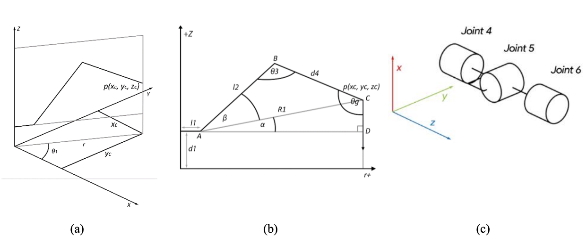Figure 1. (a) Projection of arm on x, y plane. (b) Projection of arm on z, r plane. (c) Spherical joints [18].

Contact Point Determination for Pipe Inspection [15]
Reference [15] is ACES, a teleoperated, force-controlled six degrees of freedom arm built to look inside pipes. Instead of scanning point by point like it does in [18], ACES asks a smaller question: how few points it takes to fully describe a cylinder, and how do you get those points without already knowing the pipe dimensions.
The main idea, straight from the paper, is that the arm touches five different spots on the cylinder, as long as no four of those five points sit on the same plane, and once you know where those five points are in the robot's base frame, that's enough to fully pin down the inner cylinder. The paper never actually writes this out as a formula, it's just stated as a geometry condition, so it's worth writing out here, and this part is our own formalization, not something taken from [15]: a cylinder needs five numbers to describe it, two for which way the axis points (â), two for a point q sitting on that axis, and one for the radius r. Every contact point $p _{i}$ gives you one constraint on those five numbers through how far it sits from the axis line:

if no four of the five points $p _{i}$ are coplanar. Five of these give you just enough equations to solve for â, q, and r, no more, no less. Once the cylinder is known, the arm traces a circle centered on that axis, hitting points about 50 mm apart, roughly 150 points per cross section, for the corrosion survey that comes after.
The arm rides on a Clearpath Jackal mobile base. The end effector has a contact sensor that finds each touch relative to the base frame, plus one of two swappable NDT probes, either a potential-field rod electrode or a single pulsed eddy current probe, whichever is used to actually check for corrosion once the geometry is known.
Since this paper is really a design and architecture study and not a hands-on trial, it doesn't report any dimensional accuracy of numbers. What it gives instead is a comparison of different in-pipe robot types, wheels, crawlers, helical, snake, inchworm, walking, and hybrid wall-pressing designs, judged on mobility, cost, and how hard they are to control.
The requirement that no four points be coplanar basically works as a built-in error check: break that rule and the cylinder can't be solved, so any real use of this method needs to check that the calibration points aren't degenerate before trusting the answer. The paper also points out that this kind of arm gets expensive and hard to control at elbows, tees, and places where the pipe diameter changes, sometimes needing a 7+ DOF arm to work around those spots. This is meant for corrosion checks on buried pipes like Steel Cylinder Concrete Pipe, somewhere you'd otherwise need teleoperation or to just dig it up. The five-point idea is the direct seed for the fitting method.
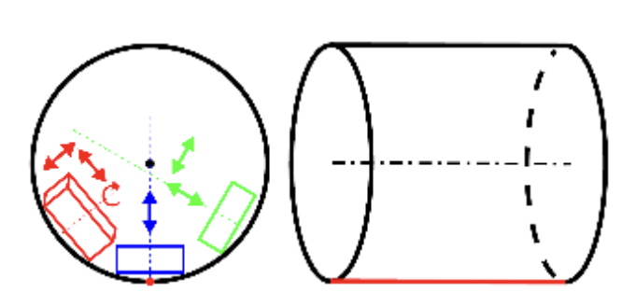Figure 2. Robot position inside a pipe: cylinder front (left) and side (right) views [15].

Force-Controlled Contact Scanning for Co-Robotic Ultrasound [17]
Reference [17] deals with something [15] and [18] mostly skip: what happens when the surface isn't rigid. Here the use case is mammography, where an ultrasound probe has to stay constant, even in contact with skin, and skin deforms and is never perfectly flat. Thus, the main problem is force control, not pure geometry, and the fix applies to any inspection task where the probe must track a surface that can flex while it's touching it.
The motion breaks into three steps. First, the robot moves the probe to a set distance above the target. Second, it moves straight down along the surface normal until a six-axis force and torque sensor senses the contact force hit 2 N, at which point it stops, which is basically a built-in safety check against hitting the surface too hard. Third, it does a linear scan, and this is where the actual governing equation comes in. The velocity of the probe splits into a part along the surface and a part into or away from it: $\hat{v}=v_{t}τ+v_{n}⋅\hat{n}$
Where tau-hat is the direction along the surface, n-hat is the direction straight out of the surface, $v_{t}$ stays constant so the scan speed doesn't change, and $v_{n}$ comes from a PID controller reacting to how far off the force is from the target:
$v_{n}=K_{p}\left[e\left(t\right)+\frac{1}{T_{i}}\int_{ }^{ }{e\left(τ\right)dτ}+T_{d} \frac{de\left(t\right)}{dt}\right]$,
$e\left(t\right)=F$* $- F$

F is the force actually being measured and F* is the force you're aiming for. Basically, this law makes the probe push harder if the surface pulls away and back off if the surface pushes back, so the contact force stays close to constant while the tangential motion moves it across the part.
Hardware wise, it's a Universal Robots UR5 arm with a Robotiq FT-150 force and torque sensor between the flange and the probe, an Ultrasonix ultrasound unit with a linear array transducer, and a camera paired with ArUco markers to find the target. The software runs on ROS with an RRT planner to plan the path. Over twenty trials, the system held the contact force to a mean of 5.18 N with a standard deviation of 0.23 N against a 5 N target, overshooting by at most 0.72 N, and positional error stayed at 3.60 mm sideways and 7.70 mm along the depth direction, with every single trial finishing in one to two minutes.
The main weak spot is about 7 mm of positional repeatability, which is way too rough for actual dimensional checking, plus a single camera that can't give depth on its own and an old test arm that the authors themselves suspected had some of its own joint error. As far as error handling goes, the PID loop is what keeps the contact force safe during the scan, but nothing corrects the arm's own drift, which is a totally separate problem from what the force controller is solving. This particular paper is about breast cancer screening, but the same force law works for any probe, ultrasound or not, moving across an industrial part that isn't perfectly rigid or flat.
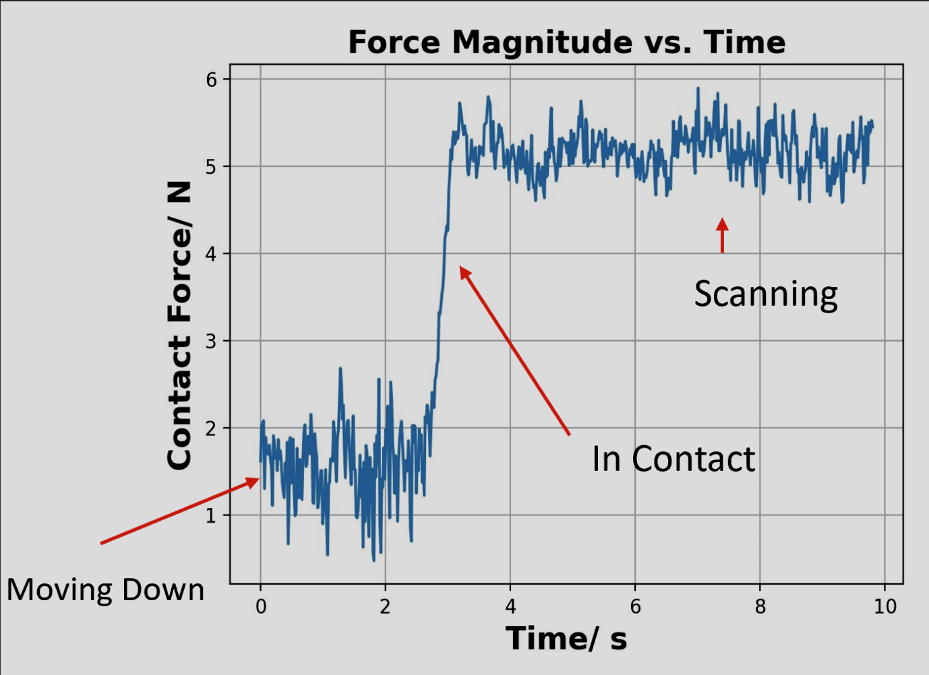Figure 3. Force-vs-time graph showing the signal settling around the 5 N setpoint. [17]

Comparative Summary
Table 4. Comparison of featured contact-based inspection approaches. [15][16][17][18]
Ref | Method | Framework | Result | Limitations
[15] | Contact NDT probe, force-controlled 6-DOF arm | Five-point cylinder determination, no four coplanar | Design/architecture study; comparative platform evaluation | Underdetermined if points are coplanar; costly at elbows
[16] | Contact ultrasound probe, hybrid passive-active constant force | Positive/negative stiffness superposition | Force variation under 7.2%; range 12.3 to 21.3 N | Single mechanism cannot cover full clinical force range
[17] | Contact ultrasound probe, force-controlled 6-DOF arm | Three-phase motion with PID normal-force control | Force held to 5.18 ± 0.23 N; ~7 mm repeatability | Repeatability too coarse for dimensional work; no depth sensing
[18] | Contact ultrasound probe, hybrid passive-active constant force | Positive/negative stiffness superposition | Force variation under 7.2%; range 12.3 to 21.3 N | Single mechanism cannot cover full clinical force range
Note: Reference [16] is included here as well to broaden the comparison beyond the three anchor papers.

Proposed Methodology

Vision-Based Surface Defect Inspection
This project introduces an automated robotic inspection and quality control system capable of detecting surface defects and inaccurate dimensions on manufactured components using an industrial robot with machine vision. Unlike a traditional fixed inspection station, the proposed system utilizes a six degree of freedom robotic arm armed with a high definition camera, laser displacement sensor and depth camera. The robotic arm allows the parts to be inspected from multiple angles, reducing mistakes, improving dimensional accuracy and allows the system to inspect components with complex geometries.
Traditional quality control methods rely on manual visual inspection performed by operators or a fixed inspection station. These approaches have been utilized widely throughout manufacturing, although they can suffer from inconsistent results due to operator error, limited viewing angles, and lighting conditions. Fixed camera systems also have a restriction on the complexity of geometries due to areas hidden from a single viewpoint. In order to overcome these limitations the proposed robotic inspection system uses a robotic manipulator that repositions sensors around the manufactured component to obtain multiple views. This will significantly improve defect detection allowing the system to examine difficult to reach surfaces.
The inspection process will begin when a manufactured part arrives at the inspection station on a conveyor belt. A proximity sensor will detect the arrival of the component and signal the robot controller to begin the inspection cycle. The robot will move to an initial viewing position where the camera will capture a high resolution image of the component. This image will then be ran through a convolutional neural network to analyze and identify visible defects such as dents, scratches, cracks, missing features, and surface marring.
If none of these imperfections are detected during the initial inspection, the robot will capture dimensional measurements using the laser displacement sensor and depth camera. If defects are identified, the robot automatically will reposition itself to additional viewpoints to verify any defects and eliminate false detections caused by shadows or reflections.
The motion of the robotic manipulator is determined using the Danvit-Hartenberg convention, which establishes the geometric relationship between robot links. Each joint transformation is represented by a homogeneous transformation matrix, allowing the position and orientation of the end effector to be calculated throughout this inspection process. The overall transformation from the robot base to the end effector is expressed as

Each transformation matrix is defined as

These transformation matrices enable accurate positioning of the sensors relative to the component ensuring a repeatable measurement.
Forward kinematics are used to determine the position and orientation of the camera if the robot joint angles are known, while inverse kinematics calculates the required joint angles to move the camera to a desired inspection location. These relationships are shown as
$$T=f(q)$$
And
$$q=f^{-1}(T)$$
Q represents the vector of joint variables and T represents the desired end effector pose.
Following data collection, measurements from the high definition camera, depth camera, laser displacement sensors are combined through sensor fusion. Image processing algorithms extract surface features while dimensional measurements are compared against the CAD model of the component. Any deviation that exceeds manufacturing tolerances are automatically classified as a defect. The software then generates a report that can identify the defect, location, dimensions, and provide corresponding images. This information is stored in a quality control database to support future process improvement.
Verification of the proposed methodology will be performed by comparing the robotic inspection results with measurements obtained using a coordinate measuring machine and manual inspection. Multiple test parts that have known defects will be inspected to evaluate performance of the system. Statistical comparisons between robotic and traditional inspection methods will determine whether the proposed system provides equivalent or improved performance.
The proposed methodology has several advantages over traditional inspection methods. Automated robotic inspection can provide a more consistent measurement accuracy, increase production output, and eliminate operator fatigue. It can enhance worker safety by reducing a direct interaction with hazardous manufacturing equipment. The design also allows additional sensing equipment such as ultrasonic probes and thermal cameras to be integrated without significant modifications. Additionally, deep learning can allow the inspection system to improve over time as more data becomes available.
Despite these advantages, there are still limitations. The initial cost required for industrial robots and vision systems can be large for small manufacturers. Deep learning requires huge quantities of accurately described training data to achieve high accuracy and performance decreases under poor lighting conditions.

Implementation
The proposed robotic inspection and quality control system will be implemented using a combination of industrial robots, machine vision, and simulation software to create a fully automated inspection site. The implementation process will begin with the design of the robotic workcell in a modeling software before transitioning to a physical product. This will minimize implementation errors, reduce build time, and allow robot movement to be optimized before deployed.
The robotic platform selected for this project is a six degree of freedom industrial robot such as the FANUC LR Mate 200iD or ABB IRB 120. These robots provide positional accuracy, repeatability, and flexibility for any precise inspection task. Additionally, they are capable of reaching multiple viewpoints around the component. A custom mounting bracket will be attached to the robot end effector to hold the inspection sensors without affecting the robot performance. The primary sensing equipment consists of a high resolution camera for visual inspection, a depth camera for dimensional measurements and a laser displacement sensor for verifying tolerances. All together these sensors provide information that will allow both surface defects and dimensions to be detected during a single inspection cycle.
The inspection workstation will also include a conveyor system that transports manufactured components into the inspection area. A proximity sensor positioned at the end of the conveyor detects the arrival of the components and sends a signal to the robot controller to begin the inspection. After the inspection has been completed a programmable logic controller will direct the accepted parts toward the production line while defective components are diverted into a rejected bin for additional inspection or rework. This automated sorting process helps to reduce delays and minimizes operator involvement.
Several softwares will be used to develop, simulate, and operate the inspection system. Solidworks will be used to create CAD models of the inspected components and the robotic workcell. These CAD models will be imported into robot simulation software, such as FANUC RoboGuide or ABB RobotStudio where collision detection, reachability, and robot path optimization will be performed before it is physically implemented. MATLAB combined with the robotic toolbox will be used to verify forward and inverse kinematic calculations and analyze robot trajectories. Python will be utilized as the primary language for machine vision, because it has a large amount of support for image processing and artificial intelligence. OpenCV will perform image processing while a convultional neural network will classify defects automatically. Communication between the robot controller, vision system, and PLC will be connected using Ethernet to ensure fast real time data exchange.

Flow chart:
- Component arrives at inspection station
- Proximity sensor detects component
- Robot moves to home position
- Robot moves to initial inspection position
- Camera captures an image
- Deep learning model analyzes the image for defects
- Robot moves to additional viewpoints if defects are suspected
- Laser displacement sensor and depth camera perform dimensional measurements
- Sensor fusion combines all data
- Measurements are compared with CAD tolerances
- PLC sorts the component into accepted or rejected paths
- Inspection results are stored within the database

The implementation will first be checked through a simulation before any physical testing begins. RoboGuide can ensure that all robot trajectories don’t pose a risk of collision and every inspection position is reachable. MATLAB simulations will verify the correctness of forward and inverse kinematic calculations and confirm that the manipulator follows smooth trajectories.Once the virtual model has been verified the system will be tested o a physical robot for testing.

Although this proposed methodology is intended for a large scale project it has been designed with scalability in mind. The architecture allows adding additional sensing technologies, including thermal cameras and ultrasonic probes to be integrated without major modifications. This inspection system is easily repeatable to be included on any machine in a manufacturing shop. Future improvements may include additional deep learning once more data is collected. Technology will enable the robot to optimize its trajectory and learn different angles to better inspect complex parts. These advancements will improve its detection accuracy and reduce inspection times, making the proposed system suitable for modern manufacturing environments.

Results and Analysis
This section applies kinematic modeling methods to the inspection robot proposed above. A six degree of freedom articulated arm was selected as the reference platform for this analysis, the ABB IRB 120, since its Denavit-Hartenberg parameters are published and its last three joint axes intersect at a single point, which keeps the inverse kinematics solvable in closed form. The FANUC LR Mate 200iD listed as the other candidate in the Implementation section shares the same six-revolute, spherical-wrist layout, so the equations below apply to either robot. All numerical results in this section were generated in Python, following the same forward and inverse kinematic relationships that the Implementation section describes verifying in MATLAB.

Kinematic Model and Governing Equations
Each link transformation follows the Denavit-Hartenberg convention. The transform from frame {i – 1} to frame {i} is the product of a rotation about $z_{i-1}$by the joint angle $θ_{i}$ a translation along $z_{i-1}$by the link offset $d_{i}$, a translation along the new x-axis by the link $a_{i}$ and a rotation about that x-axis by the link twist $α_{i-1}$:
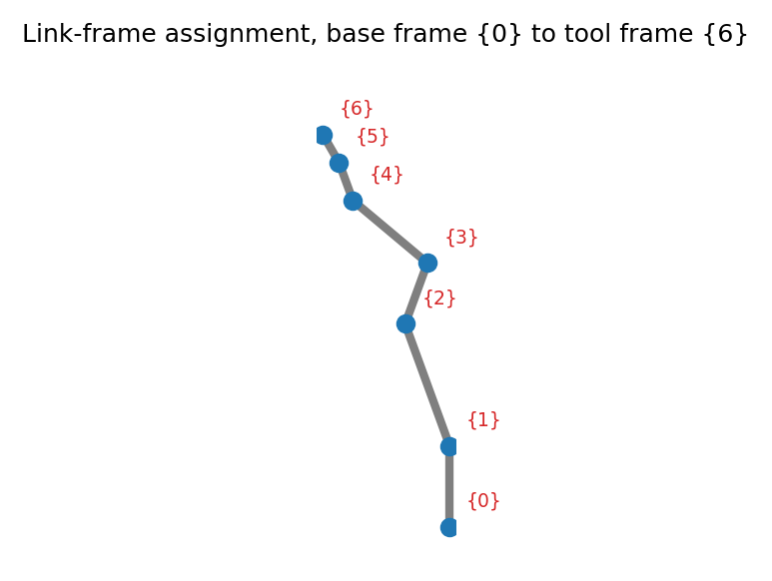
Figure 4. Link frame assignment from base frame {0} to tool frame {6} [20].
Table 5. DH parameters used for the reference six degrees of freedom arm.
Link $i$ | $$a_{i}\left(mm\right)$$ | $$α_{i-1}\left(\deg{}\right)$$ | $$d_{i}\left(mm\right)$$ | $$θ_{i}$$
1 | 0 | 0 | 290 | $$θ_{1}$$
2 | 270 | -90 | 0 | $$θ_{2}$$
3 | 70 | 0 | 0 | $$θ_{3}$$
4 | 0 | -90 | 302 | $$θ_{4}$$
5 | 0 | 90 | 0 | $$θ_{5}$$
6 | 0 | -90 | 72 | $$θ_{6}$$
Table 5 lists the parameters used for the reference arm, taken from the manufacturer's published link dimensions. Figure 4 shows the resulting frame assignment along the arm, from the fixed base frame {0} to the tool frame {6} where the camera, depth sensor, and laser displacement sensor are mounted.
Using the DH Table, we can multiply the six link transforms together gives the pose of the tool frame relative to the base, which is the forward kinematics equation:

$${}_{6}^{0}T=_{1}^{0}T _{2}^{1}T _{3}^{2}T _{4}^{3}T _{5}^{4}T _{6}^{5}T$$

Using the six joint angles, this equation will return the exact position and orientation the sensor cluster will occupy at the end of the arm.
The inverse problem, recovering joint angles from a desired sensor pose, has a closed-form solution because the last three joint axes intersect at a single wrist center point, a condition known as Pieper's solution. The wrist center is found by backing off from the desired tool position along the tool z-axis by the wrist offset $d_{6}$:

$$p_{wc}= p_{06}-d_{6} \hat{z}{}_{06}^{}{}$$

Because the base joint axis is vertical, $θ_{1}$ follows directly from the x and y coordinates of the wrist center. $a\tan{2}$ is used in place of a plain arctangent so the correct quadrant is always returned regardless of sign:

$$θ_{1}= a\tan{2\left(y_{wc} , x_{wc}\right)}$$

and come from the elbow triangle formed by the upper arm length and the offset forearm, whose effective length is $\sqrt{a_{3}^{2} d_{4}^{2}}$. Because the forearm carries a small offset, the usual elbow solution needs a correction angle added in, the same offset-elbow treatment used for manipulators like the PUMA 560:

$$φ = a\tan{2\left(d_{4},a_{3}\right)}$$

Once $θ_{1}$through $θ_{3}$ position the wrist, the remaining three joint angles come from a spherical wrist Euler decomposition of the residual orientation matrix, obtained by removing the first three joints' rotation from the total:

$$R_{3}^{6} = {\left(R_{0}^{3}\right)}_{}^{T}R_{0}^{6}$$

This closed-form solution was cross-checked against a numerical Newton-Raphson solver that iterates on the manipulator Jacobian, computed by finite differences. Both methods were run on eight randomized target poses spanning a wide range of joint angles. Figure 5 shows the resulting position error between each target pose and the pose the inverse kinematics solution recovers, and Figure 6 shows how many iterations the numerical solver needed to converge for each pose. All eight test cases close to within mm of the target, which sits at the limit of floating-point precision. That's about as clean as a confirmation as you can get that the analytical relationships above are self-consistent.

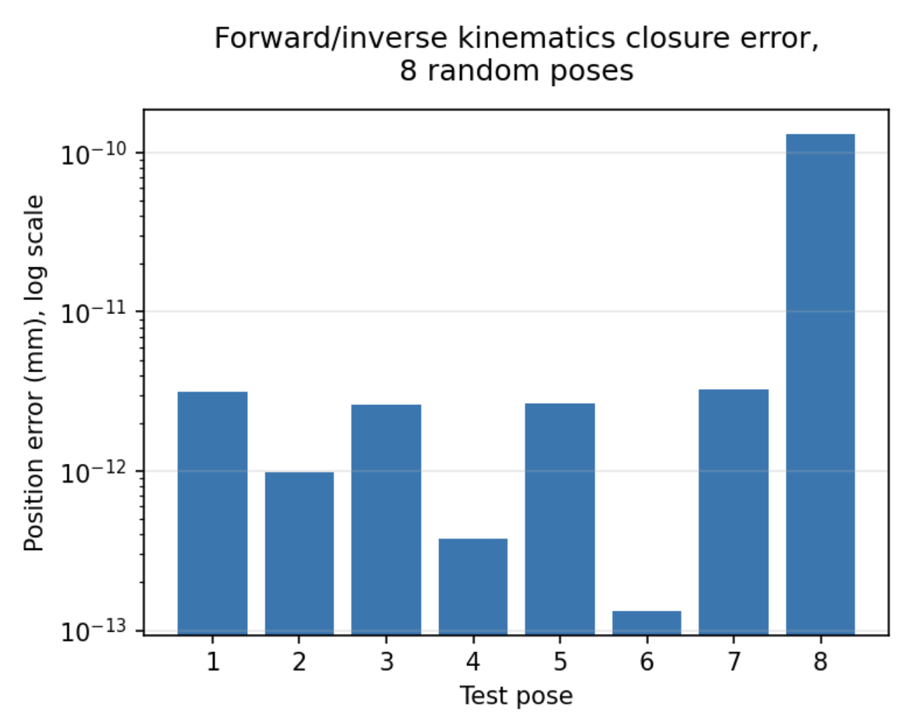Figure 5. Position error between each target pose and the pose recovered by inverse kinematics, across eight randomized test configurations and log scales [20].
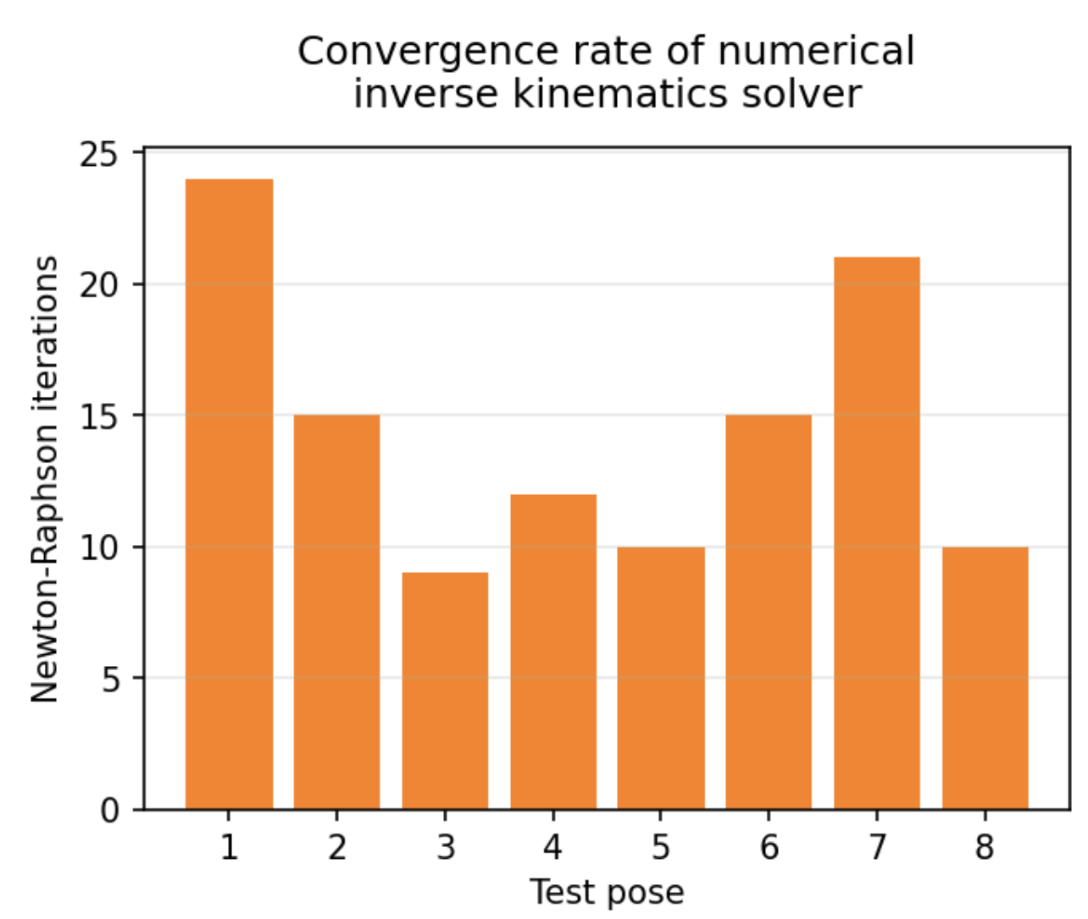
Figure 6. The Newton-Raphson iterations needed to converge on each of the eight test poses [20].

Algorithm Flow Chart

Figure 7 lays out the inspection and classification algorithm at the software level, matching the sequence described in the Proposed Methodology section. An initial camera pass screens the part for surface defects using the convolutional neural network; if a defect is suspected, the arm repositions to secondary viewpoints before the part moves on to the dimensional check performed with the laser and depth sensors.

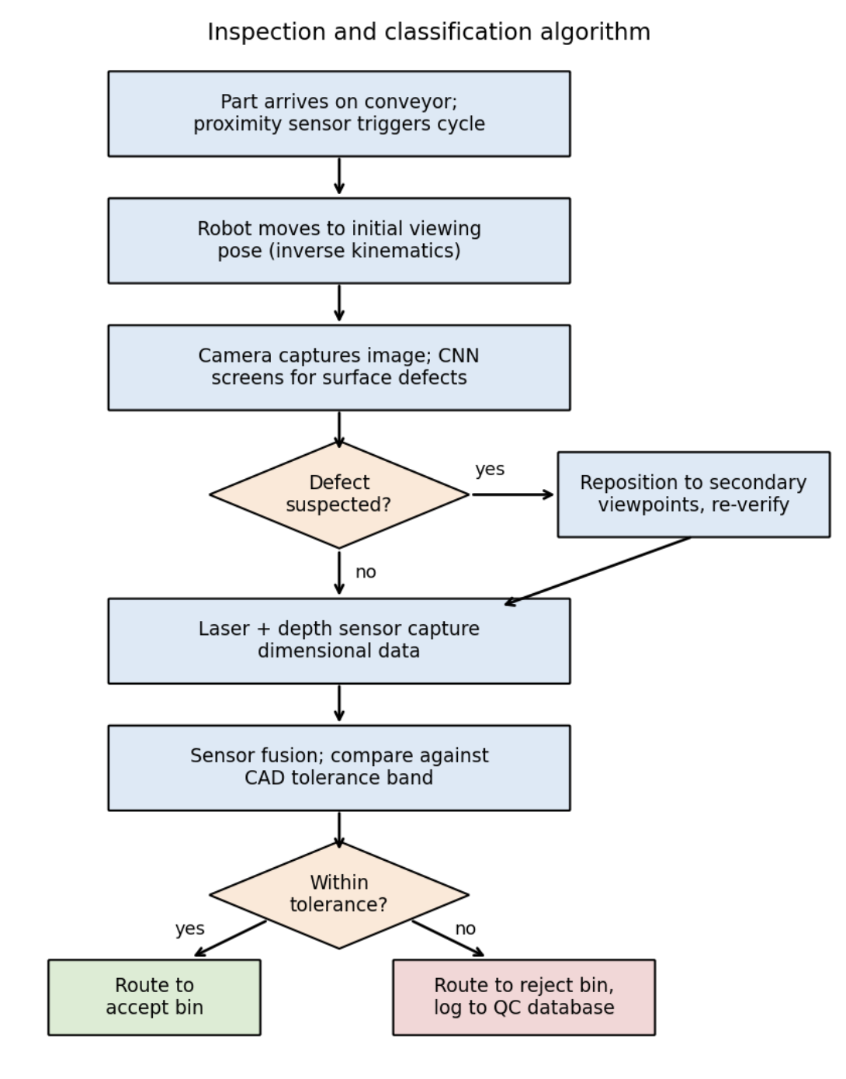
Figure 7. Inspection and classification algorithm implemented by the robot controller [4], [5].

Trajectory and Workspace Simulation
In order to move the sensor cluster between inspection viewpoints without any jarring at the mounting bracket, joint motion was planned with a fifth order polynomial that starts and ends at rest, meaning both velocity and acceleration are zero at each endpoint. Figure 8 shows the six joint angles moving from a home pose to a representative inspection pose over three seconds, and Figure 9 shows the corresponding Cartesian path traced by the sensor cluster, found by applying forward kinematics along that same trajectory.

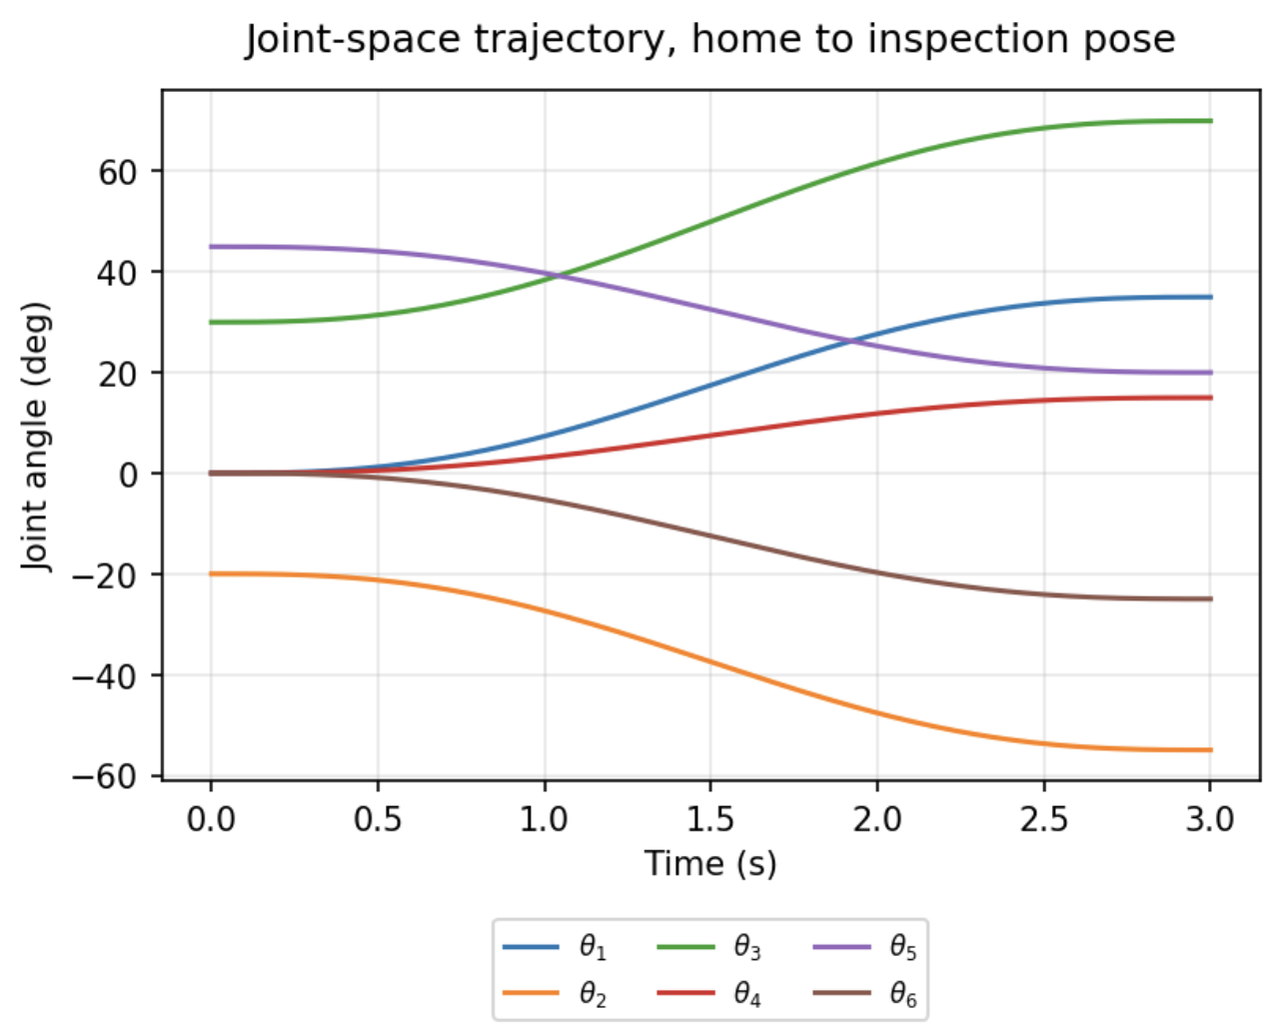Figure 8. Joint-space trajectory of all six joints, home pose to inspection pose, fifth order polynomial profile [20].

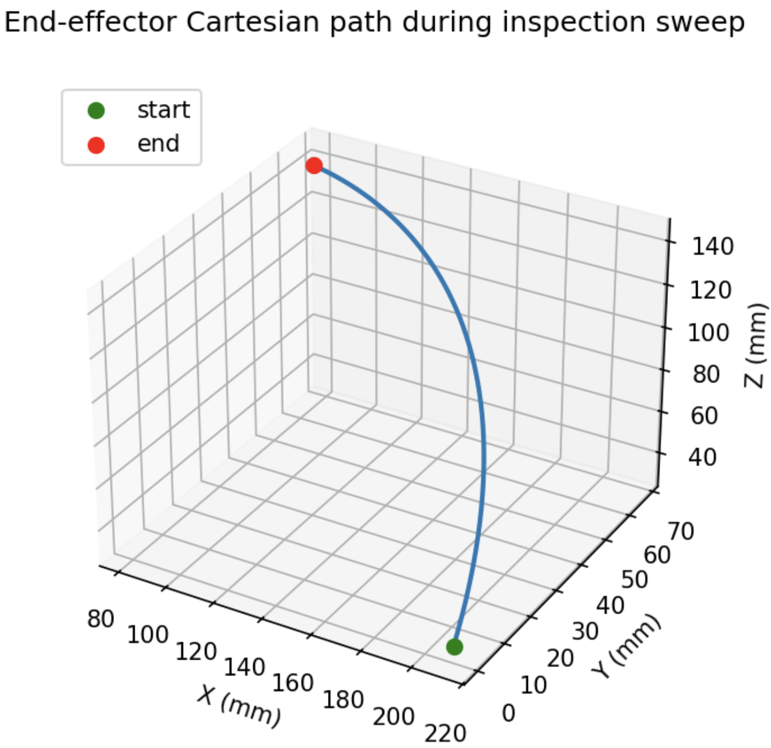Figure 9. Cartesian path traced by the sensor cluster during the inspection sweep in Figure 8 [20].

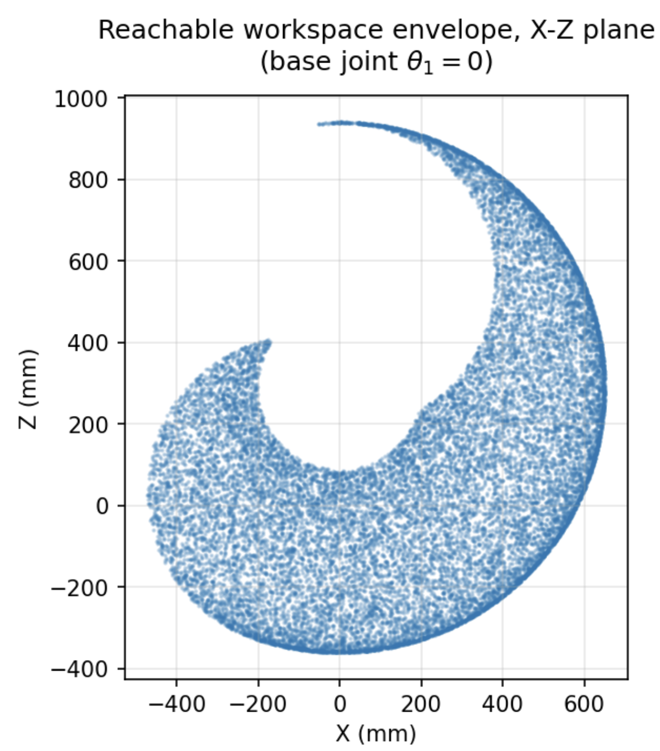
Figure 10. Reachable workspace envelope in the X-Z plane, base joint at zero, shoulder and elbow swept across assumed ranges [20].

Figure 10 shows the arm's reachable workspace in the X-Z plane, built by sampling the shoulder and elbow joints across an assumed motion range with the base joint held at zero. The envelope forms a distorted ring, typical for an articulated arm with an offset forearm link. A manufactured component placed inside this envelope can be viewed from several angles without moving the conveyor.

Sensor Fusion and Dimensional Classification

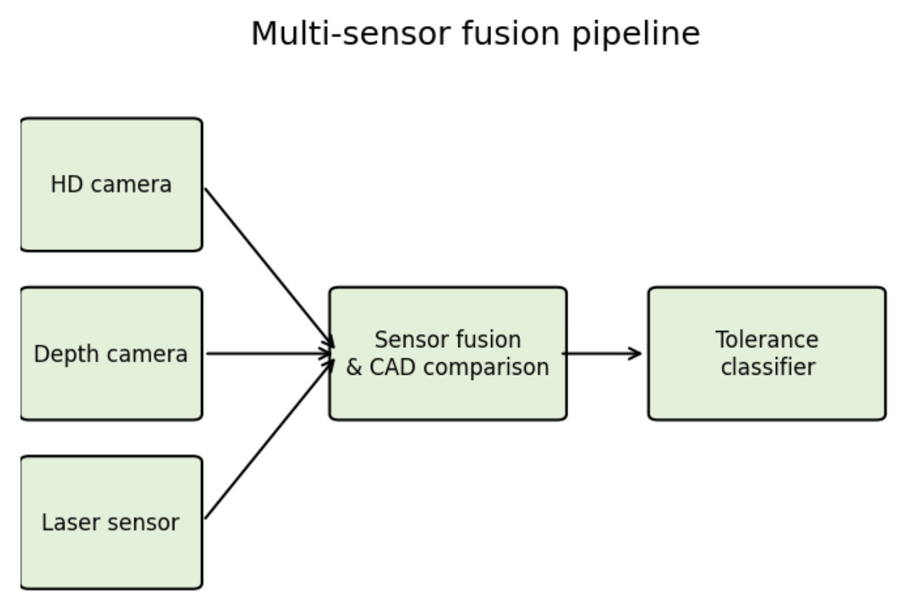Figure 11. Multi-sensor fusion pipeline, camera, depth camera, and laser displacement sensor feeding an accept or reject decision [5].

Figure 11 shows the fusion pipeline described in the Proposed Methodology section. The high-definition camera, depth camera, and laser displacement sensor each feed a fusion stage that compares the combined measurement against the CAD tolerance band, and a classifier stage sorts the result into an accept or reject decision.

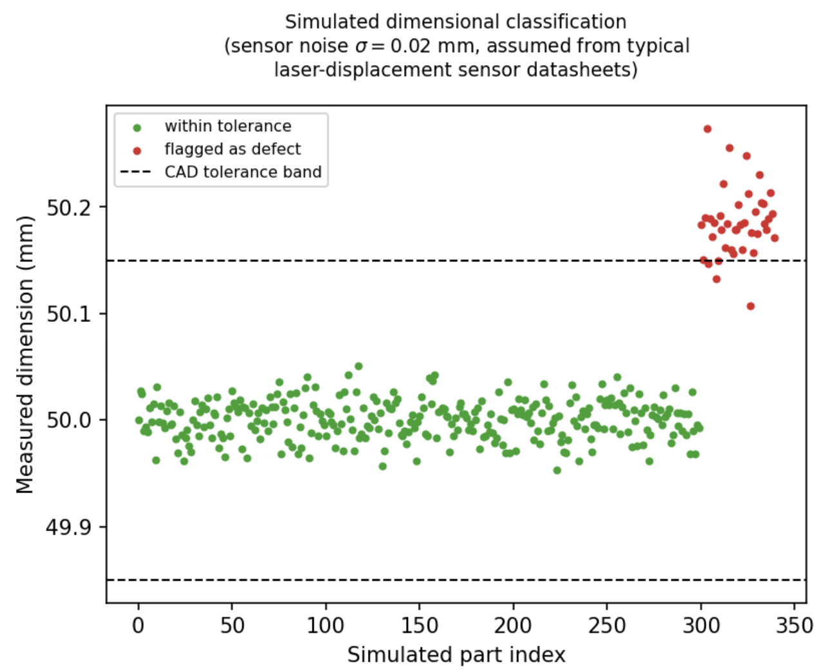Figure 12. Simulated dimensional classification, 300 in tolerance and 40 out of tolerance parts, sensor noise $σ=0.02$mm tolerance band $±$0.15 mm [18].

Because no physical prototype exists yet, Figure 12 illustrates this decision logic with a Monte Carlo simulation rather than measured data. A nominal 50 mm feature with a tolerance band of $±$0.15 mm was sampled 300 times assuming in-tolerance production, alongside 40 samples drawn from a shifted, out-of-tolerance population. Both populations assume a sensor noise $σ=0.02$ mm, a representative repeatability figure for industrial laser displacement sensors. At this noise level the classifier separates the two populations cleanly, though real sensor noise, part surface finish, and probe alignment error all still need to be measured on a physical prototype before this separation can be trusted for production use.

Analysis

Verification here means checking that the equations were implemented correctly, which Figure 5 demonstrates directly: the forward and inverse kinematics solutions agree to floating point precision across every test pose. Validation, meaning a check against physical reality, cannot be completed yet because the work cell has not been built. The Implementation section already plans this step by comparing robotic inspection results against a coordinate measuring machine once a physical prototype exists.

The kinematic model used in this section assumes rigid links and perfect joint encoders, so it does not capture positioning errors from non-geometric sources such as gearbox backlash, joint compliance, and thermal drift. These sources are known to contribute a meaningful share of total positioning error in industrial arms but are not modeled by DH-based kinematics alone, so a physical calibration step would be needed before the 0.01 mm repeatability figure used in the comparison below can be trusted in practice.

The clearest advantage shown in this section is that a closed-form inverse kinematics solution exists at all, which is not guaranteed for every six degrees of freedom arm. Because the last three axes intersect at a point, joint angles can be computed directly from a handful of trigonometric relationships instead of an iterative solver. That matters for a real time inspection cycle, where the arm has to reach a new viewpoint many times per part.

The workspace and trajectory results support the specific inspection application targeted by this project. The reachable envelope in Figure 10 covers a volume large enough to view a small to mid-sized manufactured component from several angles without repositioning the conveyor, and the smooth joint trajectories in Figure 8 avoid the jerky motion that would blur a camera image or add noise to a laser reading.

The Monte Carlo result in Figure 12 shows how the tolerance classifier is meant to behave when sensor noise is small relative to the tolerance band. If sensor noise grows, say from a dirty lens or a misaligned laser, the two populations in Figure 12 would begin to overlap, and the classifier would need a wider dead band or repeated measurements to avoid false acceptances and false rejects. This is the same error handling problem that the ACES pipe inspection paper [15] avoids in a different way, by structuring its five contact points so that any four coplanar points make the cylinder fit fail outright rather than silently returning a wrong answer.

Summary
Table 4 in the Significant Methodologies section already compares the three reviewed contact-based approaches. Table 6 adds the proposed system to that comparison using the manufacturer repeatability figure for the reference arm. The touch-probe 3D scanning system [18] reports roughly 0.05 mm repeatability under ASME B89.4.22 testing. The mammography ultrasound system [17] reports about 7 mm of positional repeatability, since it prioritizes compliant contact with soft tissue over rigid dimensional accuracy. The ACES pipe inspection paper [15] does not report a dimensional accuracy figure at all, since it is presented as a design and architecture study rather than a hands-on trial. The reference arm used in this analysis has a published repeatability on the order of 0.01 mm, tighter than any of the three reviewed systems, though this number describes the robot alone and does not yet include added sensor noise, mounting bracket compliance, or CAD registration error that a complete system would introduce.

Table 6. Comparison of positional Reliability [15], [17], [18].
Methods | Reliability | Notes
Automatic  contact 3D  scanning [18] | 0.05 mm | ASME B89.4.22  test procedure
ACES pipe  inspection [15] | N/A | A design/architecture study only
Co-robotic  ultrasound [17] | $$\sim 7 mm$$ | Prioritizes compliant contact
Proposed system (IRB 120 spec) | 0.01 mm | Excludes sensor and mounting error for now

CONCLUSION
This project examined the introduction of robotic inspection and quality control systems to improve the accuracy, efficiency, and consistency of manufacturing processes utilizing industrial robots, sensing technologies, and machine vision. The methodology proposed used a six-degree-of-freedom industrial robot with a high resolution camera, depth camera, proximity sensor, and laser displacement sensor. This creates an automated inspection process capable of identifying surface defects and dimensional errors. By utilizing forward and inverse kinematics using the Denavit-Hartenberg convention, we are able to accurately position its sensors throughout the inspection workspace to maintain a repeatable and predictable motion.
This robotic inspection process has several advantages over conventional inspection methods. Analytical verification confirms that the forward and inverse kinematic equations can accurately determine the position and orientation of the robots end effector, allowing for precise sensor locations at multiple viewpoints around a manufactured component. The trajectory planning produces a smooth robot motion to reduce image distortions and give a stable measurement. This Multiview inspection system also increases surface coverage compared to a traditional fixed inspection system allowing defects hidden from a single camera angle to be detected.

Utilizing the sensor fusion approach by combining vision based inspection with the measurement and depth information collected greatly improves inspection capability. The high resolution cameras detects scratches, cracks, dents, and any missing features, while the depth and laser measurement sub systems provide accurate dimensional verifications. Together these sensing methods reduce false detections that can be caused by lighting variations or reflections.
Despite these results, there are still limitations that may showcase themselves when the system is physically implemented. The proposed system was evaluated through analytical simulation rather than experimental so factors such as sensor calibration errors, environmental disturbances, and structural deflections may reduce overall accuracy during the physical operation.
Overall, the proposed robotic inspection system showcases that combining robotic kinematics, machine vision, and a multi sensor inspection creates a scalable framework for automated quality control. This methodology successfully addresses the issue with many traditional inspection techniques while providing greater coverage, repeatability, and measurement accuracy. These results showcase that robotic inspection systems have potential to support future smart manufacturing systems by reducing human error, improving equality, and increasing production efficiency.

RECOMMENDATIONS
Although the proposed robotic inspection system demonstrates a strong potential for improving quality control, several improvements should first be made to improve its performance, accuracy, and application. The first recommendation is to design a physical robotic work cell rather than rely on analytical simulation. Experimental testing would showcase how the effects of thermal expansion, vibrations, joint backlash, and sensor calibration errors play on the control system. This would provide a much more realistic evaluation of the inspection process under actual conditions.
A second recommendation is to improve the machine vision system by training the convolutional neural network on a larger more diverse dataset. The performance of AI defect detection systems depends on the quantity and quality of previously labeled training data. This includes images using different lighting conditions, viewing angles, materials, and defect types. This would improve the system greatly reducing false positives and missed defects.
Future additions to the system could also incorporate additional technologies such as ultrasonic and thermal imaging. These sensors would enable the system to detect internal defects that cannot be identified through optical inspection alone. Combining multiple sensing technologies with the convolutional neural network would further improve upon reliability and provide a complete assessment of component quality.
Finally, the proposed inspection system could be connected with an industry 4.0 manufacturing system. Connecting the control system to cloud databases and manufacturing enterprise systems would allow for automatic quality reports, predictive maintenance and process optimization. These systems combined with AI could allow the robot to modify its inspection strategy such as changing tool paths, inspection points to reduce inspection times or have a greater inspection quality. Implementing these improvements would overcome some of the limitations identified in this study and allow the proposed system to be applicable in practical industrial cases.
References
- F. Akhyar, Y. Liu, C.-Y. Hsu, T. K. Shih, and C.-Y. Lin, "FDD: a deep learning-based steel defect detectors ," Int. J. Adv. Manuf. Technol., vol. 126, no. 3, pp . 1093-1107, 2023.
- C. Zhao, X. Shu, X. Yan, X. Zuo, and F. Zhu, "RDD-YOLO: A modified YOLO for detection of steel surface defects," Measurement, vol. 214, p. 112776, 2023 .
- F. Bagherzadeh, T. Shafighfard, R. M. A. Khan, P. Szczuko, and M. Mieloszyk , et al., " A systematic review of deep learning approaches for surface defect detection in industrial applications," Eng. Appl. Artif. Intell., 2023.
- Y. Ma et al., "Surface defect inspection of industrial products with object detection deep networks: a systematic review," Artif. Intell. Rev., 2024.
- L. Chen, G. Bi, X. Yao, C. Tan, J. Su, N. P. H. Ng, Y. Chew, K. Liu, and S. K. Moon, "Multisensor fusion-based digital twin for localized quality prediction in robotic laser-directed energy deposition ," Robot. Comput.- Integr. Manuf., vol. 84, p. 102581 , 2023.
- Y. Ma et al., "Surface defect inspection of industrial products with object detection deep networks: a systematic review," Artif. Intell. Rev., 2024.
- K. G. Amin, M. Patidar, P. K. Patidar, N. K. R. Rafaliya, J. Joshi and D. Mishra, " A Review on Robotics and Automation Techniques for Quality Inspection in Industry 4.0 ," 2025 IEEE International Conference on Advances in Computing Research On Science Engineering and Technology (ACROSET), INDORE, India, 2025, pp. 1 -5, doi: 10.1109/ACROSET66531.2025 .11280985.
- A. Villalonga, Y. J. Cruz, D. Alfaro, R. E. Haber, J. L. Martínez-Lastra and F. Castaño, "Enhancing Quality Inspection in Zero-Defect Manufacturing Through Robotic-Machine Collaboration ," 2024 7th Iberian Robotics Conference (ROBOT), Madrid, Spain, 2024, pp. 1-6 , doi: 10.1109/ROBOT61475.2024.10797427
- A. E. Duron, B. A. C. Stiles and D. A. Torck, "RIPTIDE: Robot Inspecting Parts to Increase Development Efficiency," 2025 22nd International Conference on Ubiquitous Robots (UR), College Station, TX, USA, 2025, pp. 333-339, doi: 10.1109/UR65550.2025.11078063 .
- Brito, T., Queiroz, J., Piardi, L., Fernandes, L. A., Lima, J., & Leitão, P. (2020). A Machine Learning Approach for Collaborative Robot Smart Manufacturing Inspection for Quality Control Systems. Procedia Manufacturing, 51, 11–18. https://doi- org.ezproxywit.flo. org/10.1016/j.promfg.2020.10 .003
- Zhou, M., Ge, C., & Xiong, X. (2025). Research on a Rail-Mounted Concrete Quality Inspection Robot System for Aerial Building Machine. 2025 10th International Conference on Automation, Control and Robotics Engineering (CACRE), Automation, Control and Robotics Engineering (CACRE ), 2025 10th International Conference On, 9–16. https://doi-org.ezproxywit.flo.org/10.1109/CACRE66141.2025.11119617
- Discepolo, S., & Castellini, P. (2024). Neural Network to Retrieve Features of a Mechanical Component Acquired by a Robotic Inspection System. 2024 IEEE International Conference on Metrology for EXtended Reality, Artificial Intelligence and Neural Engineering (MetroXRAINE), Metrology for EXtended Reality, Artificial Intelligence and Neural Engineering (MetroXRAINE), 2024 IEEE International Conference On, 325–330. https://doi-org.ezproxywit.flo.org/10.1109/MetroXRAINE62247.2024.10797005
- Czimmermann, T., Chiurazzi, M., Milazzo, M., Roccella, S., Barbieri, M., Dario, P., Oddo, C. M., & Ciuti, G. (2022). An Autonomous Robotic Platform for Manipulation and Inspection of Metallic Surfaces in Industry 4.0. IEEE Transactions on Automation Science and Engineering , Automation Science and Engineering, IEEE Transactions on, IEEE Trans. Automat. Sci. Eng, 19 (3), 1691–1706. https://doi-org.ezproxywit.flo.org/ 10.1109/TASE.2021 .3122820
- Irvine, D., & Narayanan, M. (1995). Inspection and quality control-an overview. IEEE Technical Applications Conference and Workshops. Northcon/95. Conference Record, Northcon 95. I EEE Technical Applications Conference and Workshops Northcon95, Northcon/95, 376–380. https://doi-org.ezproxywit.flo.org/ 10.1109/NORTHC.1995.485100
- " ACES: A teleoperated robotic solution to pipe inspection from the inside," arXiv preprint arXiv:2405.09925, 2024 .
- Z. Wu et al., "Robotic ultrasound scanning end-effector with adjustable constant contact force," Cyborg Bionic Syst., 2025.
- " Enabling mammography with co-robotic ultrasound," arXiv preprint arXiv:2312.10309 , 2023.
- " Automatic contact-based 3D scanning using articulated robotic arm ," presented at Int. Conf. on Interactive Design and Manufacturing, 2024.
- " Collaborative robots for quality control: an overview of recent studies and emerging trends, " J. Intell. Manuf., 2025 .
- M. Al-Amin, " Cobotics: The evolving roles and prospects of next-generation collaborative robots in Industry 5.0," J. Robot., vol. 2024
- O. F. Seven and A. Ankarali, "Inverse Kinematic Analysis of IRB120 Robot Arm," SETSCI Conference Proceedings, vol. 4, no. 1, pp. 383-390, ISAS2019, Ankara, Turkey, 2019.

Word Count: 9429

