1. Configure 2 slave machines in jenkins master.

Slave machine 1

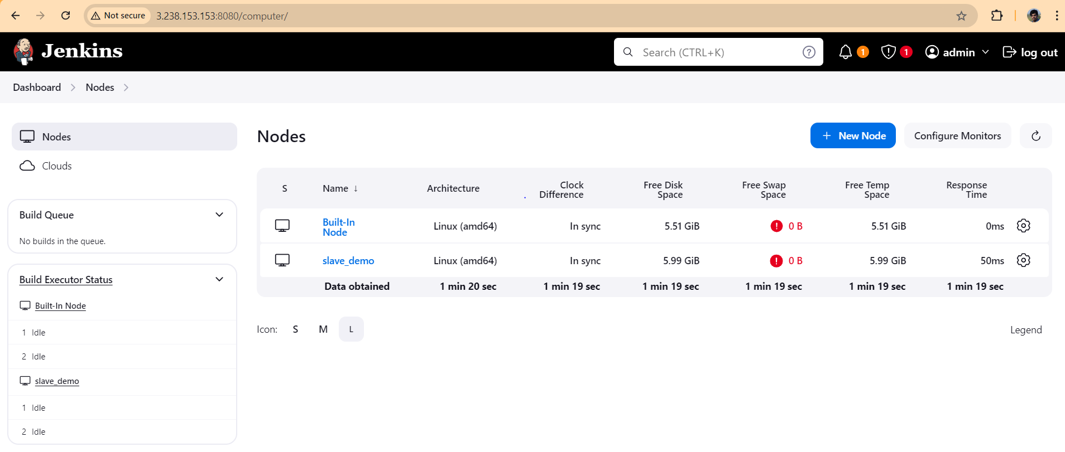

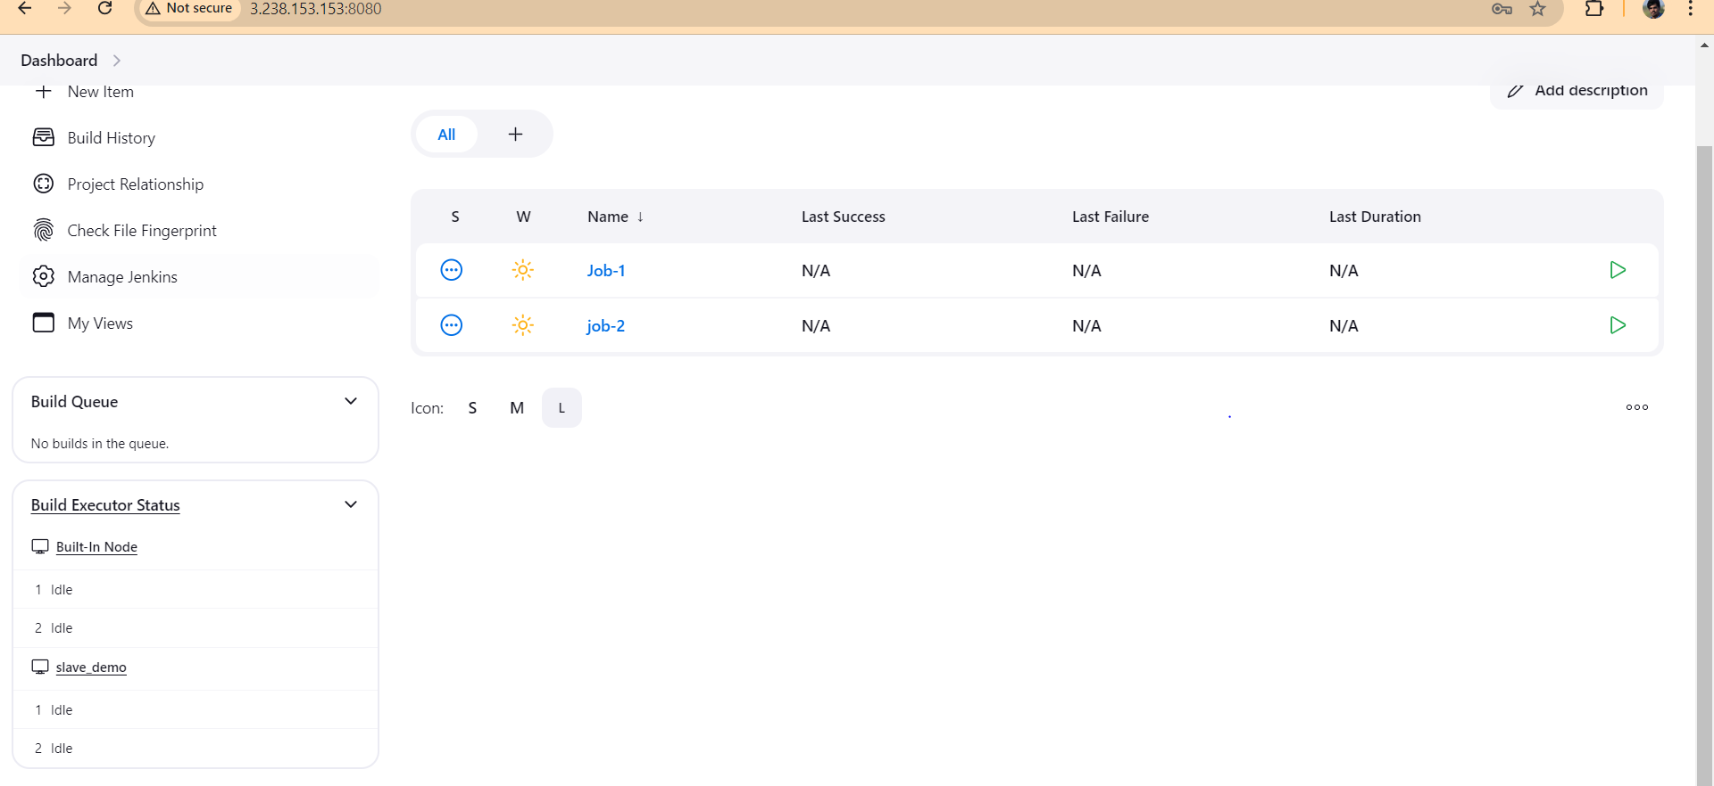

Slave machine 2

1. Configure webhooks to jenkins job.

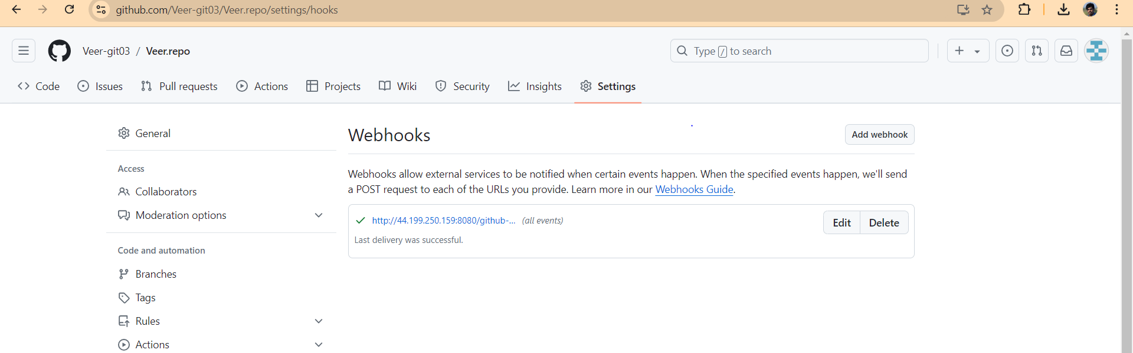

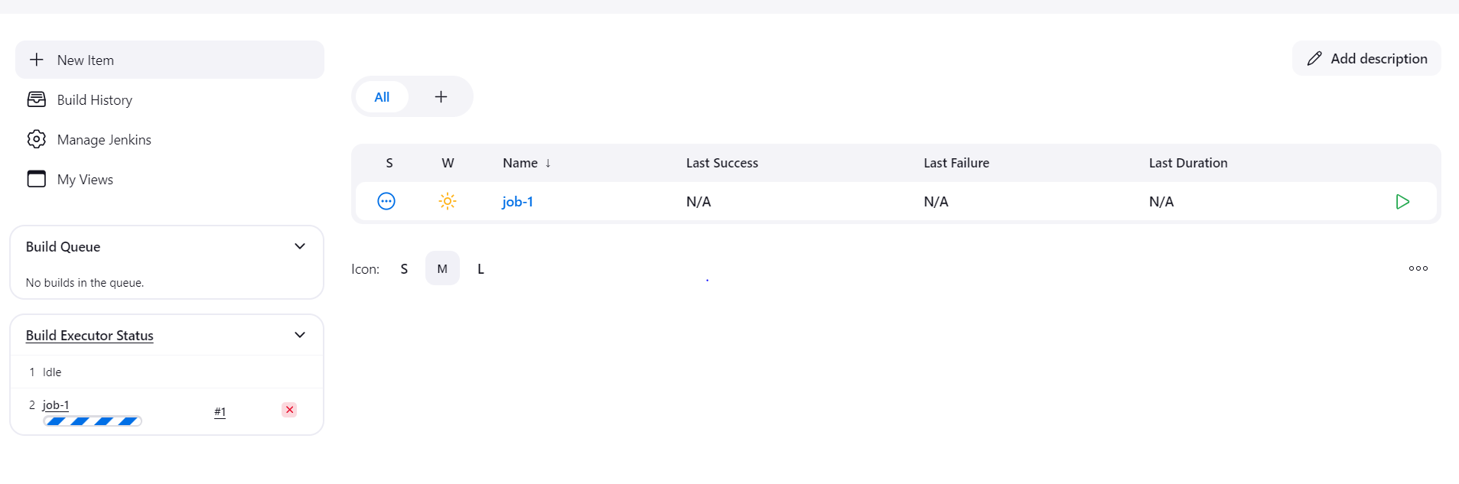

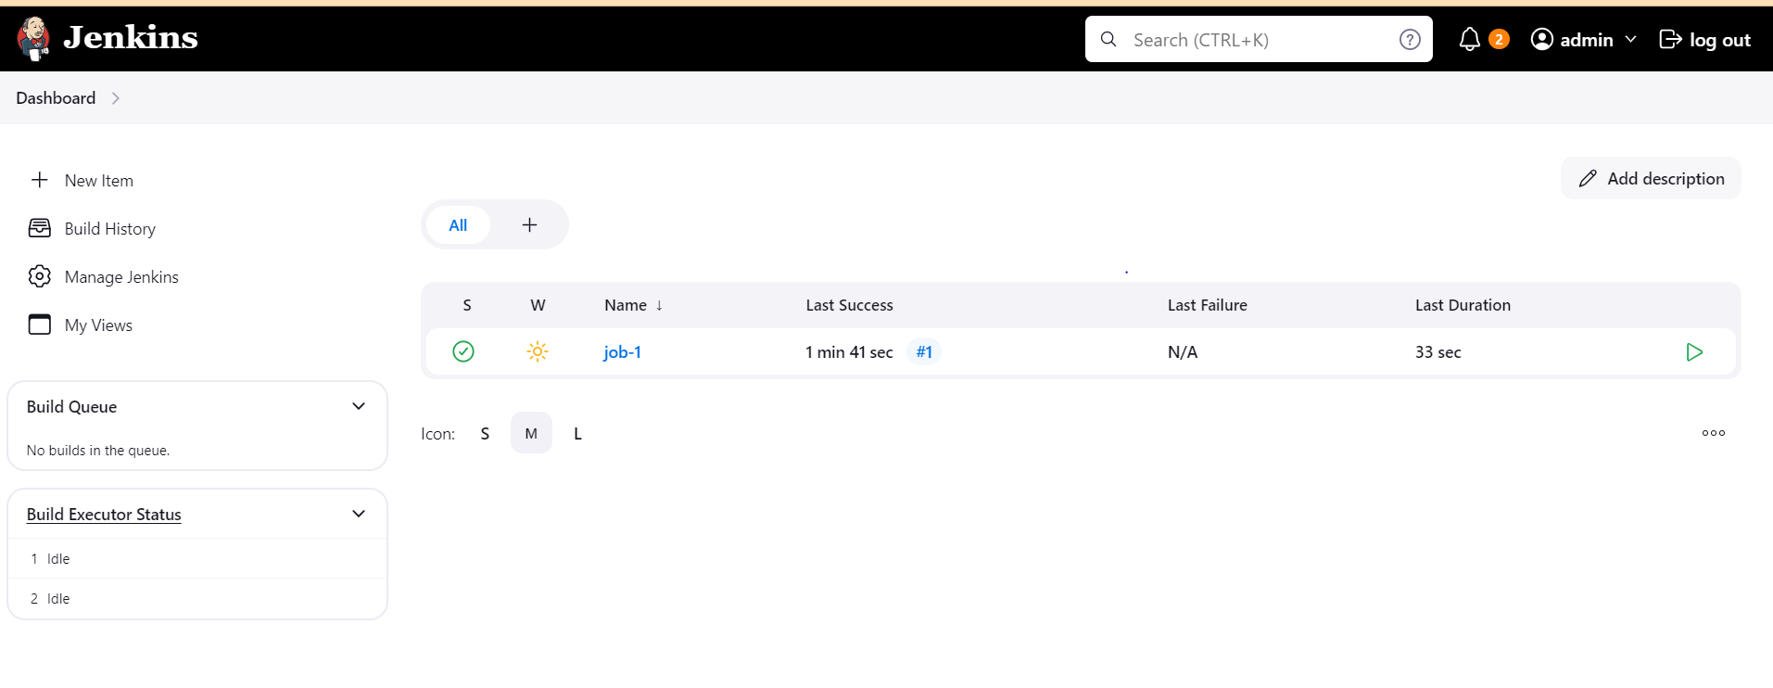

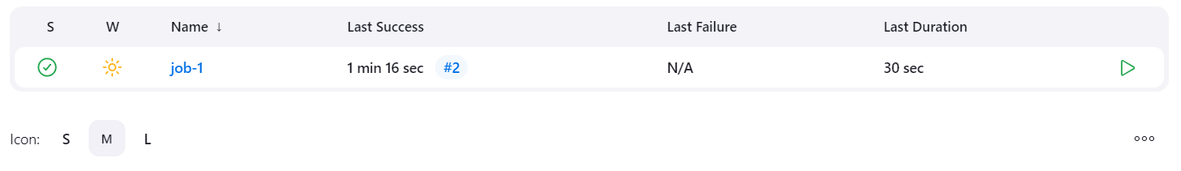

1. Configure poll scm and build periodical options in jenkins job.

Poll scm

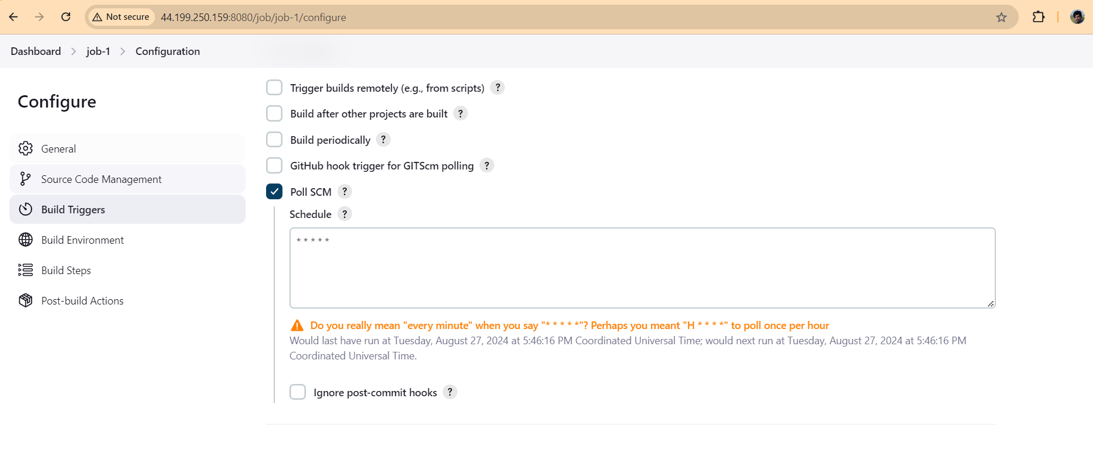

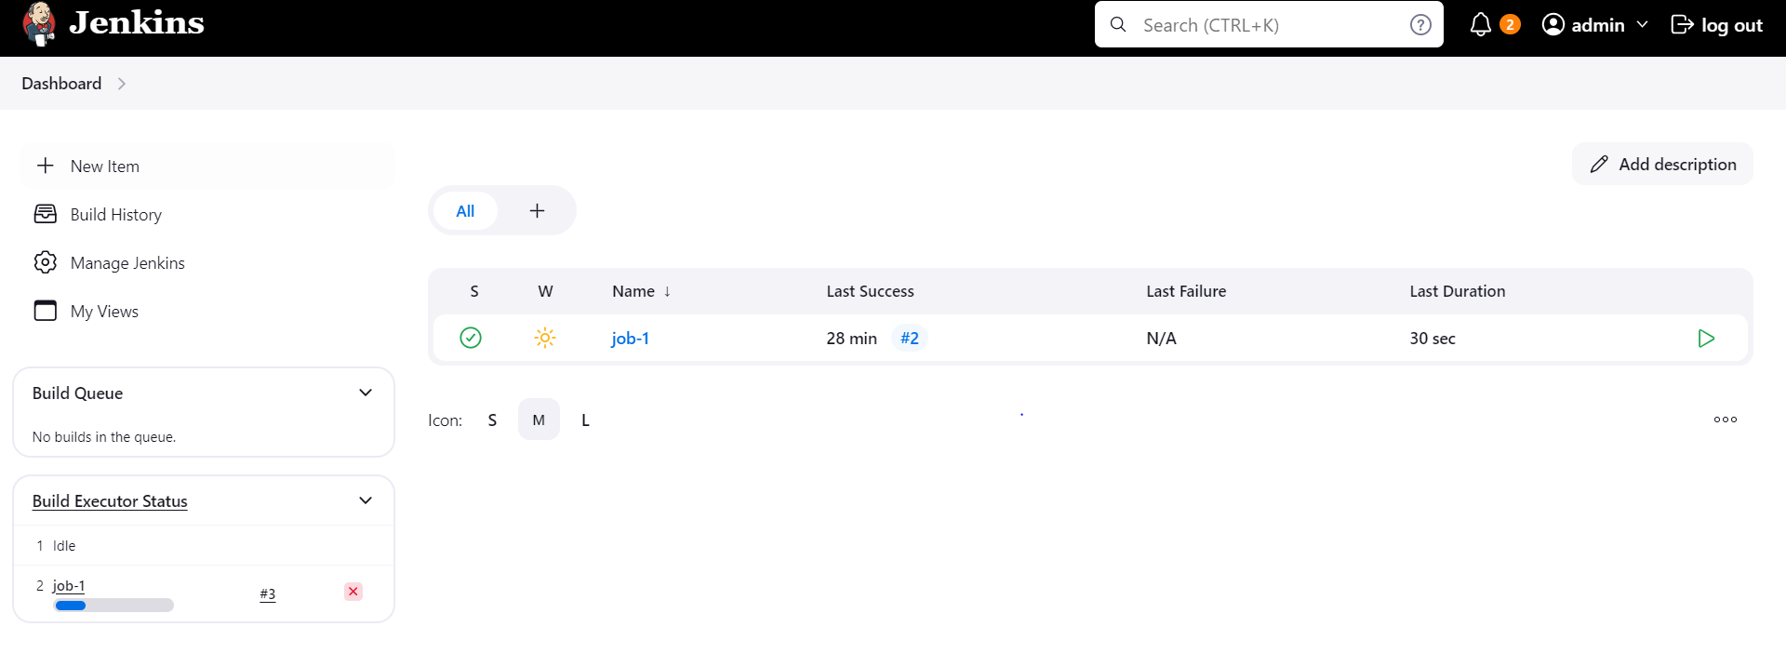

Build periodical

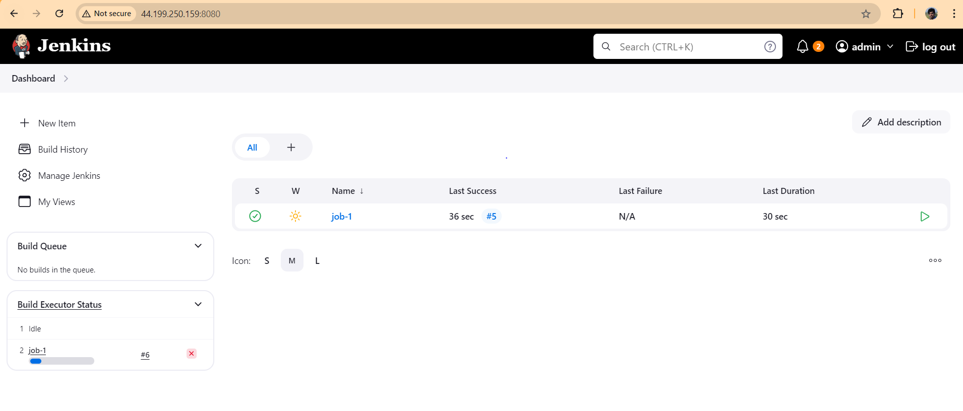

1. Take backup of Jenkins server by using bash script.

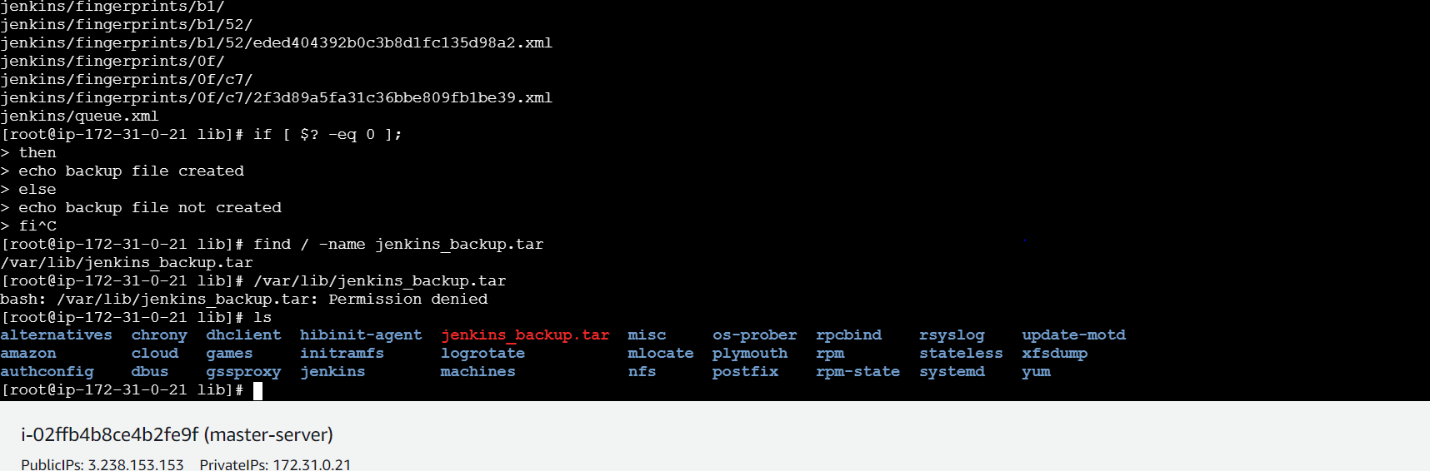

1. Take backup of Jenkins using rethin backup plugin.mS
2. Setup a new Jenkins server and dump the backup taken in task4.

