PROJECT: PIZZA SALES REPORT
Project Title: Pizza Sales
Author: Veer
Tools: Excel, SQL, Power BI
Role: Data Analyst, Business Analyst, Business Intelligence
Objective: To analyze pizza sales revenue, identify trends, and provide insights to improve sales.
PIZZA SALES SQL QUERIES
- KPI’s
- Total Revenue:
SELECT SUM(total_price) AS Total_Revenue FROM pizza;
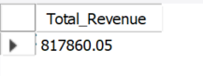
- Average Order Value:
SELECT SUM(total_price) / COUNT(DISTINCT(order_id)) AS Avg_Order_Value
FROM pizza;
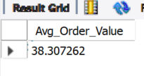
- Total Pizza’s Sold:
SELECT SUM(quantity) AS Total_Pizza_Sold FROM pizza;
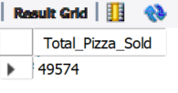
- Total Orders:
SELECT COUNT(DISTINCT(order_id)) AS Total_Orders FROM pizza;
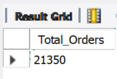
- Average Pizza’s Per Order:
SELECT SUM(quantity) / COUNT(DISTINCT(order_id)) AS Avg_pizzas_Per_Order
FROM pizza;
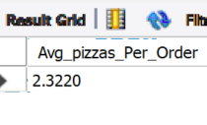

- CHARTS
- Daily Trend For Total Orders:
SELECT DAYNAME(order_date) AS Order_Days, COUNT(DISTINCT(order_id)) AS Total_Orders
FROM pizza
GROUP BY DAYNAME(order_date);
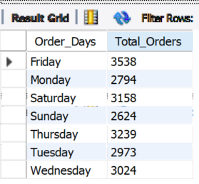
- Monthly Trend For Total Orders:
SELECT MONTHNAME(order_date) AS Order_Months, COUNT(DISTINCT(order_id)) AS Total_Orders
FROM pizza
GROUP BY MONTHNAME(order_date);
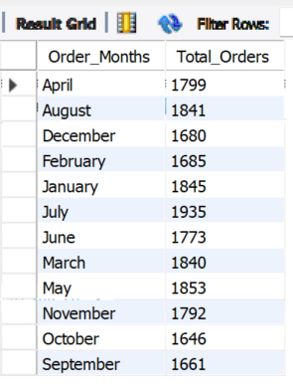
- Percentage of Sales By Pizza Category:
SELECT pizza_category,
ROUND(SUM(total_price) / (SELECT SUM(total_price) FROM pizza) *100,2) AS Percentage_Total_Sales
FROM pizza
GROUP BY pizza_category;
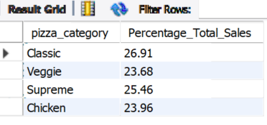
- Percentage of Sales By Pizza Size:
SELECT pizza_size,
ROUND(SUM(total_price) / (SELECT SUM(total_price) FROM pizza) *100,2) AS Percentage_Total_Sales
FROM pizza
GROUP BY pizza_size;
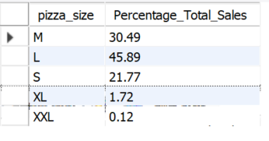
- Top 5 Best Sellers By Revenue, Total Quantities and Total Orders
- By Total Revenue
SELECT pizza_name, SUM(total_price) AS Total_Revenue
FROM pizza
GROUP BY pizza_name
ORDER BY Total_Revenue DESC
LIMIT 5;
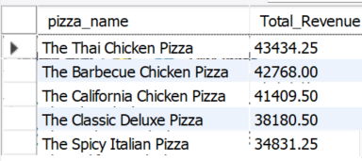
- By Total Quantities
SELECT pizza_name, SUM(quantity) AS Total_Quantity
FROM pizza
GROUP BY pizza_name
ORDER BY Total_Quantity DESC
LIMIT 5;
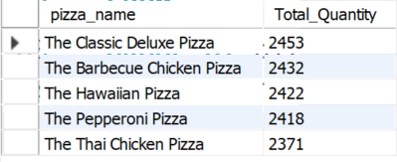
- By Total Orders
SELECT pizza_name, COUNT(DISTINCT(order_id)) AS Total_Orders
FROM pizza
GROUP BY pizza_name
ORDER BY Total_Orders DESC
LIMIT 5;
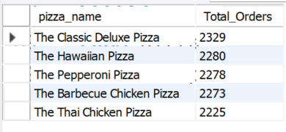
- Bottom 5 Best Sellers By Revenue, Total Quantities and Total Orders
- By Total Revenue
SELECT pizza_name, SUM(total_price) AS Total_Revenue
FROM pizza
GROUP BY pizza_name
ORDER BY Total_Revenue
LIMIT 5;
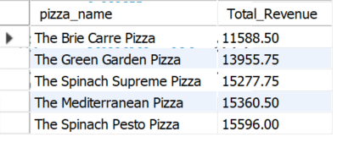
- By Total Quantities
SELECT pizza_name, SUM(quantity) AS Total_Quantity
FROM pizza
GROUP BY pizza_name
ORDER BY Total_Quantity
LIMIT 5;
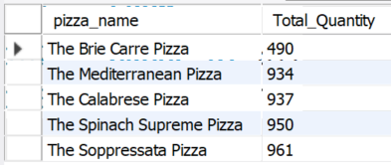
- By Total Orders
SELECT pizza_name, COUNT(DISTINCT(order_id)) AS Total_Orders
FROM pizza
GROUP BY pizza_name
ORDER BY Total_Orders
LIMIT 5;
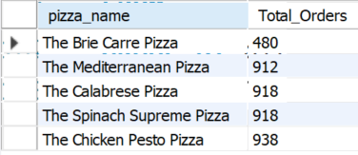

Note:
If you want to apply the pizza_category or pizza_size filters to the above queries you can use WHERE clause. Follow some of below examples
SELECT pizza_name, COUNT(DISTINCT order_id) AS Total_Orders FROM pizza_sales
WHERE pizza_category = 'Classic' GROUP BY pizza_name ORDER BY Total_Orders ASC LIMIT 5;

Preparing Dashboard
PIZZA SALES DASHBOARD (POWER BI)
- Dashboard KPI’s:
- Total Revenue
- Total Orders
- Total Pizzas Sold
- Average Order Value
- Average Pizzas Per Order
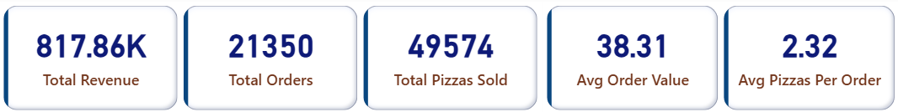

- Dashboard Preview:

- Home Page
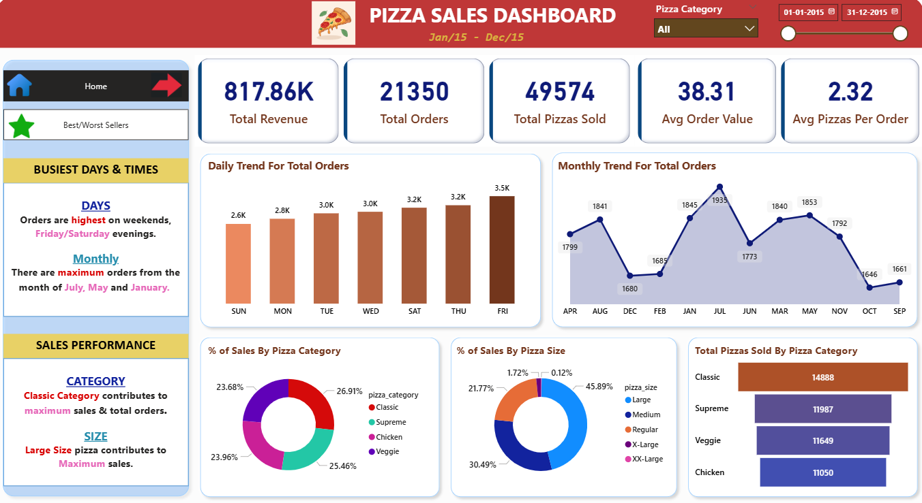

- Best And Worse Seller’s Page
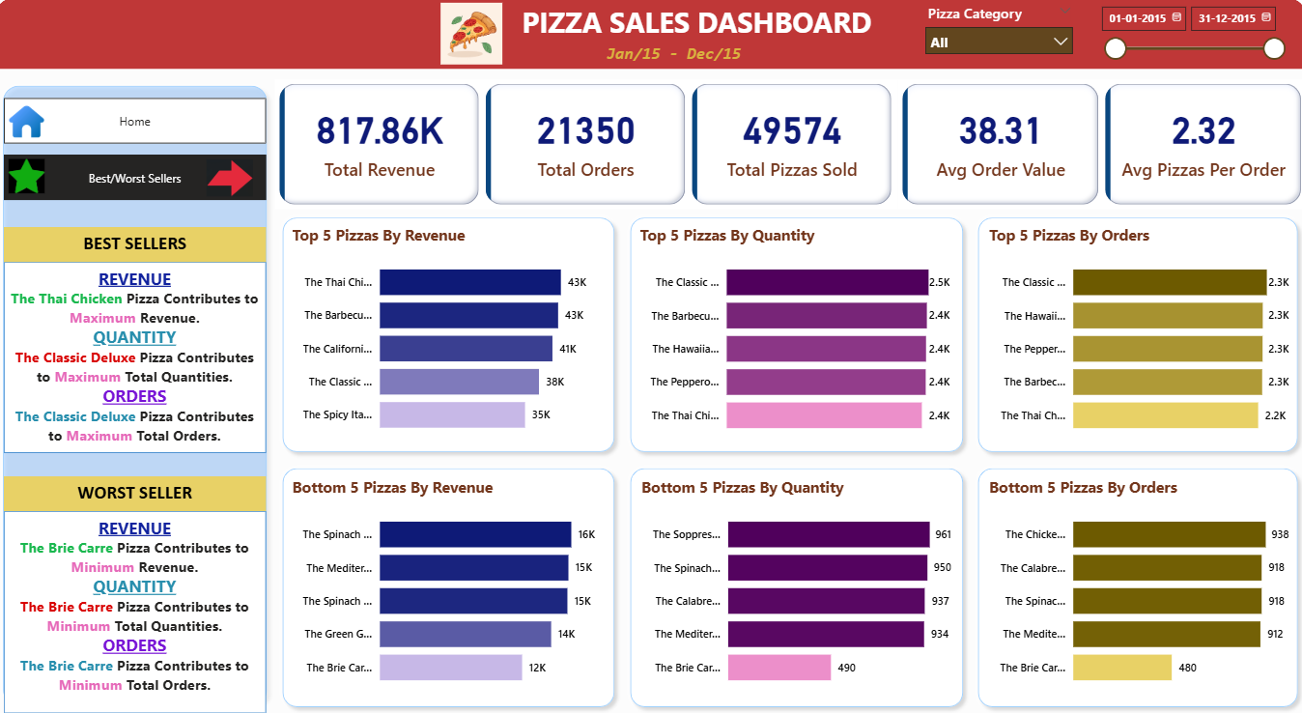

- Insights:
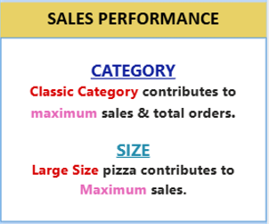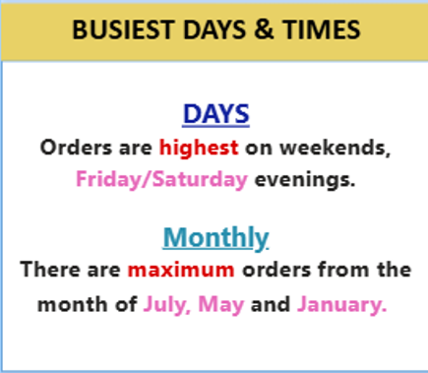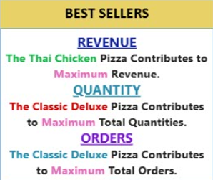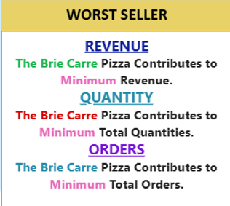

- Project Link:

Project Link On GitHub (URL)

- References:

Dataset: Pizza_Sales
URL of Dataset
Accessed on: November 2025

-----------------------------

