Chapter 3: Latitude, Longitude & Time
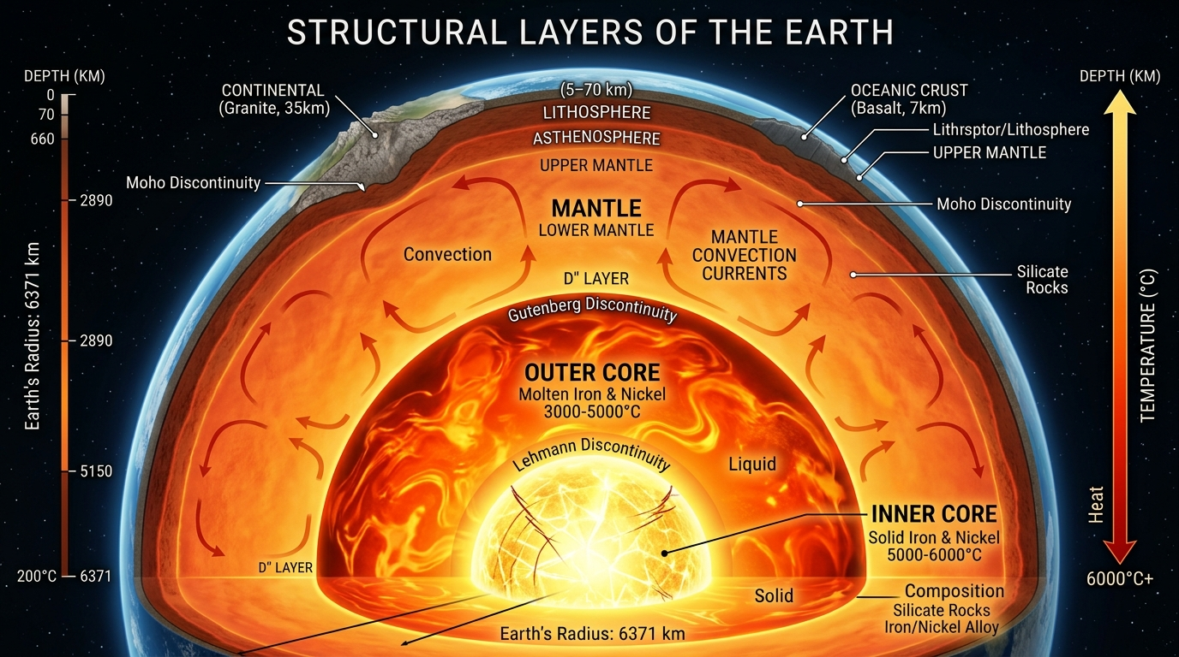

Meaning and Concept of Longitude
Longitude is the angular distance of a place measured east or west of the Prime Meridian. Longitudes are imaginary semi-circles that run from the North Pole to the South Pole. Unlike latitudes, longitudes are not parallel and they converge at the poles. The Prime Meridian, assigned a value of 0° longitude, passes through Greenwich in England. It divides the Earth into the Eastern Hemisphere and the Western Hemisphere. Longitudes are measured up to 180° east and 180° west.

Importance of Longitude
The primary importance of longitude lies in the calculation of time. Because the Earth rotates from west to east, places located to the east of the Prime Meridian experience sunrise earlier and are ahead in time, while places to the west experience sunrise later and are behind in time.
Therefore, longitude is directly linked with local time and standard time.

Relationship Between Longitude and Time
The Earth completes one rotation of 360° in 24 hours. This means that the Earth rotates 15° in one hour. Therefore, for every 15° change in longitude, there is a difference of one hour in time. Similarly, for every 1° change in longitude, there is a difference of 4 minutes in time. This relationship forms the basis of all time calculations used in geography.

Time Zones and Reference Meridians

Indian Standard Time (IST)
India follows a single time standard known as Indian Standard Time. IST is calculated based on the longitude of 82½° East, which passes near Mirzapur in Uttar Pradesh. IST is 5 hours and 30 minutes ahead of Greenwich Mean Time. Although India extends over a large longitudinal range, a single time zone is followed to maintain administrative efficiency and national unity.

Greenwich Mean Time (GMT)
Greenwich Mean Time is the mean solar time at the Prime Meridian (0° longitude). It is used as the global reference time for all countries. All standard times of the world are calculated by adding or subtracting time from GMT.

International Date Line (IDL)
The International Date Line is an imaginary line that roughly follows the 180° longitude in the Pacific Ocean. It is not a straight line and bends to avoid cutting through countries and island groups. When a person crosses the International Date Line from east to west, one day is added, and when crossing from west to east, one day is subtracted. This adjustment is necessary to maintain consistency in dates across the world.

Importance of Latitude, Longitude and Time
Latitude and longitude together form the global grid system that helps in accurately locating places on Earth. Latitude helps in understanding climate, vegetation, and heat distribution, while longitude is essential for time calculation, navigation, and communication. Modern technologies such as GPS, aviation, shipping, and satellite communication are all based on this coordinate system.

Memorising Tips for SSC
Parameter / Concept | Key Rule / Relation
Latitude | Controls heat and climate
Longitude | Controls time
Full Rotation | 360° rotation = 24 hours
Hourly Rate | 15° longitude = 1 hour
Minute Rate | 1° longitude = 4 minutes
Indian Standard Time | IST = 82½° East = GMT + 5:30
International Date Line | IDL ≈ 180° longitude

💡 NOTE: Remember concepts in flow rather than isolated facts for better retention.

Core Concept & Formulas
The Earth rotates from west to east. Because of this rotation, places to the east see the Sun earlier and their clocks show a later time. Places to the west see the Sun later and their clocks show an earlier time. This single concept is the key to solving all longitude–time numericals.

Formulas with Logic
- Earth rotates 360° in 24 hours.
- Rotation per hour = $360^\circ \div 24 = 15^\circ$.
- 15° longitude difference = 1 hour time difference.
- Dividing further: 1° longitude = 4 minutes.
💡 NOTE: Always remember: East → Add time | West → Subtract time.

Worked Examples
Ex. 1 What is the time difference between two places having a longitude difference of 30°?
Sol.
Step 1: Understand what is given. Longitude difference = 30°.
Step 2: Recall the basic rule: 15° longitude = 1 hour.
Step 3: Divide the longitude difference by 15: $30^\circ \div 15^\circ = 2\text{ hours}$.
Step 4: Since only time difference is asked, direction is not needed.
Final Answer: Time difference is 2 hours.
💡 NOTE: Common Mistake: Students try to convert into minutes unnecessarily.
Ex. 2 Find the time difference for 1° longitude.
Sol.
Step 1: Earth rotates 360° in 24 hours.
Step 2: Convert hours into minutes: $24 \times 60 = 1440\text{ minutes}$.
Step 3: Divide total minutes by total degrees: $1440 \div 360 = 4\text{ minutes}$.
Final Answer: 1° longitude corresponds to 4 minutes.
💡 NOTE: Exam Tip: This is the MOST IMPORTANT value in SSC numericals.
Ex. 3 If the local time at Greenwich is 10:00 AM, what will be the local time at 30° East?
Sol.
Step 1: Identify reference point: Greenwich (0°).
Step 2: Identify target longitude: 30° East.
Step 3: Calculate longitude difference = 30°.
Step 4: Convert degrees into time: $30^\circ \div 15 = 2\text{ hours}$.
Step 5: Decide direction. East means ahead in time.
Step 6: Add time to Greenwich time: 10:00 AM + 2 hours = 12:00 Noon.
Final Answer: Local time = 12:00 PM.
💡 NOTE: Common Mistake: Students subtract instead of adding.
Ex. 4 If the local time at 45° West is 6:00 AM, what is the time at Greenwich?
Sol.
Step 1: Identify given place: 45° West.
Step 2: Greenwich is east of this place.
Step 3: Longitude difference = 45°.
Step 4: Convert into time: $45^\circ \div 15 = 3\text{ hours}$.
Step 5: West is behind, so Greenwich time will be ahead.
Step 6: Add time: 6:00 AM + 3 hours = 9:00 AM.
Final Answer: Greenwich time = 9:00 AM.
Ex. 5 When it is 12:00 noon GMT, what is the time in India (IST)?
Sol.
Step 1: Remember IST relation: $\text{IST} = \text{GMT} + 5\text{ hours } 30\text{ minutes}$.
Step 2: Add 5 hours 30 minutes to 12:00 noon: $12:00 + 5:30 = 5:30\text{ PM}$.
Final Answer: IST = 5:30 PM.
💡 NOTE: Exam Tip: Never change date unless IDL is mentioned.
Ex. 6 A place is located at 97½° East longitude. If the time at Greenwich is 6:00 AM, find the local time.
Sol.
Step 1: Identify longitude difference = 97.5°.
Step 2: Convert degrees to hours: $97.5 \div 15 = 6.5\text{ hours}$.
Step 3: Convert decimal into minutes: 0.5 hour = 30 minutes.
Step 4: Direction is East, so add time: 6:00 AM + 6 hours 30 minutes = 12:30 PM.
Final Answer: Local time = 12:30 PM.
Ex. 7 A ship crosses the International Date Line from West to East on Monday. What will be the day?
Sol.
Step 1: Recall IDL rule: West to East crossing means subtract one day.
Step 2: Given day = Monday.
Step 3: Subtract one day: $\text{Monday} - 1 = \text{Sunday}$.
Final Answer: Day will be Sunday.
💡 NOTE: Common Mistake: Students add a day incorrectly.

Final Exam Strategy
- First convert longitude into time.
- Then decide direction (East/West).
- Only then add or subtract time.
- For IDL, change date separately.
If this order is followed, mistakes will never happen.

Chapter 4: Interior of the Earth
The interior of the Earth refers to the internal structure that lies beneath the Earth’s surface. Although humans live on the surface of the Earth, most geological processes such as earthquakes, volcanoes, mountain building, and plate movements originate deep inside the Earth. Since it is impossible to directly observe the deep interior, scientists rely on indirect methods to study it.
This chapter is extremely important for SSC examinations because many questions are asked from Earth’s layers, seismic waves, composition, and physical state of different layers.

Sources of Information About Earth’s Interior
Our knowledge about the Earth’s interior comes from two types of sources: direct and indirect. Each source provides different kinds of information and has its own limitations.

Direct Sources
Direct sources include deep mining operations, drilling projects, and volcanic eruptions. Mining activities allow humans to study rocks found beneath the surface, but only up to a limited depth. The deepest mines and boreholes extend only a few kilometres below the surface, which is negligible when compared to the Earth’s radius of about 6371 km. Volcanic eruptions bring molten magma from the Earth’s interior to the surface, providing valuable information about the composition of deeper layers. However, these sources cannot give complete information about the mantle and core.

Indirect Sources
Indirect sources are the most important means of studying the Earth’s interior. The behaviour of seismic waves during earthquakes is the most reliable indirect source. Other indirect evidences include meteorites, variations in gravity, and the Earth’s magnetic field. These sources help scientists estimate the density, composition, and physical state of different layers.

Seismic Waves
Seismic waves are vibrations produced due to earthquakes, volcanic eruptions, or explosions. These waves travel through the Earth in all directions. By recording the speed, path, and refraction of seismic waves, scientists can determine the internal structure of the Earth.

Types of Seismic Waves
Seismic waves are broadly classified into body waves and surface waves based on their path of travel.

Body Waves
Body waves travel through the interior of the Earth and originate from the earthquake focus. They are of two types: P-waves and S-waves.
- P-Waves (Primary Waves): P-waves are the fastest seismic waves and therefore reach seismic stations first. They are compressional waves in which particles move parallel to the direction of wave travel. P-waves can pass through solids, liquids, and gases. Their ability to travel through liquid layers indicates that some parts of the Earth’s interior are liquid.
- S-Waves (Secondary Waves): S-waves are slower than P-waves and are transverse waves in which particles move perpendicular to the direction of wave travel. S-waves can travel only through solid materials and cannot pass through liquids. The disappearance of S-waves beyond the mantle provides strong evidence that the outer core of the Earth is liquid.

Surface Waves
Surface waves travel along the Earth’s surface and have the largest amplitude. They are slower than body waves but cause maximum destruction during earthquakes because their energy is concentrated near the surface.

Layers of the Earth
Based on chemical composition, density, and physical condition, the Earth is divided into three main concentric layers: crust, mantle, and core.

Crust
The crust is the outermost and thinnest layer of the Earth. It forms the continents and ocean floor on which humans live. The thickness of the crust varies significantly from place to place. Under the oceans, the crust is about 5 km thick, whereas under continents it can be as thick as 35–40 km.

Types of Crust
- Continental Crust (SIAL): The continental crust is mainly composed of silica and aluminium and is therefore called SIAL. It is lighter and thicker than oceanic crust.
- Oceanic Crust (SIMA): The oceanic crust is composed mainly of silica and magnesium and is known as SIMA. Oceanic crust is denser and thinner than continental crust, which explains why ocean basins are lower than continental regions.

Mantle
The mantle lies below the crust and extends up to a depth of about 2900 km. It is the thickest layer of the Earth and constitutes nearly 84 percent of the Earth’s total volume. The mantle is composed mainly of silicate minerals rich in iron and magnesium.

Upper Mantle and Asthenosphere
The upper mantle includes a special zone called the asthenosphere. The asthenosphere is semi-molten and has plastic properties, which means it can flow slowly under pressure. Tectonic plates of the lithosphere float and move over the asthenosphere, making it responsible for plate tectonic movements.

Core
The core is the innermost layer of the Earth and is extremely dense and hot. It is composed mainly of iron and nickel and is therefore referred to as NIFE. The temperature of the core may reach several thousand degrees Celsius.
- Outer Core: The outer core is in a liquid state due to extremely high temperatures. The movement of molten iron in the outer core generates the Earth’s magnetic field, which protects the Earth from harmful solar radiation.
- Inner Core: The inner core is solid despite very high temperatures because of immense pressure. It is believed to be one of the densest parts of the Earth.

Lithosphere and Asthenosphere
The lithosphere is the rigid outer shell of the Earth consisting of the crust and the uppermost mantle. It is broken into tectonic plates of varying sizes. Below the lithosphere lies the asthenosphere, which is semi-molten and allows these plates to move.

Temperature, Pressure and Density Inside the Earth
As we move deeper inside the Earth, temperature, pressure, and density increase continuously. This gradual increase explains the change in physical state of Earth’s materials from solid crust to semi-molten mantle and liquid outer core.

Importance of Studying Earth’s Interior
The study of the Earth’s interior helps us understand earthquakes, volcanoes, plate tectonics, mountain building, and the Earth’s magnetic field. It also explains the distribution of minerals and energy resources.

Memorising Tips (SSC Friendly)
Feature / Term | Description / Key Fact
Crust | Outermost and thinnest layer
Mantle | Thickest layer, maximum volume (~84%)
Core | Innermost and heaviest layer
SIAL | Continental crust (Silica + Aluminium)
SIMA | Oceanic crust (Silica + Magnesium)
P-Waves | Travel through solids, liquids, and gases
S-Waves | Travel only through solids
Outer Core | Liquid state (generates Earth's magnetic field)
Inner Core | Solid state (due to extreme pressure)

Chapter 5: Rocks & Rock Cycle
Rocks are naturally occurring solid masses that make up the Earth’s crust. They are composed of one or more minerals and form the foundation of all landforms on Earth. The study of rocks is known as petrology. Rocks play a vital role in shaping relief features, soil formation, availability of minerals, and understanding the geological history of the Earth. In SSC and other competitive examinations, questions from this chapter are asked both directly and indirectly, especially from rock types, characteristics, examples, and the rock cycle.

Minerals and Rocks – Basic Concept
Minerals are naturally occurring inorganic substances with a definite chemical composition and a specific crystalline structure. They are the basic building blocks of rocks. Examples of minerals include quartz, feldspar, mica, and calcite. Rocks, on the other hand, are aggregates of one or more minerals. For example, granite is a rock composed of quartz, feldspar, and mica.

Classification of Rocks
On the basis of origin and mode of formation, rocks are classified into three main types: Igneous rocks, Sedimentary rocks, and Metamorphic rocks. This classification is universal and forms the basis of geological studies.

Igneous Rocks (Primary Rocks)
Igneous rocks are formed by the cooling and solidification of molten magma or lava. They are known as primary rocks.

