**ARDUINO BASED POTHOLE FILLER**

**A report submitted in partial fulfilment of the Academic requirements for the award of the degree of**

**Bachelor of Technology**

Submitted by

**Veera Vardhan (21H51A66H0)**

**Sai Sruthi (21H51A66F9)**

**Sameer (21H51A66J4)**

**Kavyanjali (21H51A66F1)**

**Sai Shivanth (21H51A66G0)**

**UNDER THE COURSE**

**ENGINEERING EXPLORATION & PRACTICE**

**CENTRE FOR ENGINEERING EDUCATION RESEARCH**

**CMR COLLEGE OF ENGINEERING & TECHNOLOGY**

**(Autonomous)**

**(NAAC Accredited with ‘A+’ Grade & NBA Accredited)**

**(Approved by AICTE, Permanently Affiliated to JNTU Hyderabad)**

**KANDLAKOYA, MEDCHAL ROAD, HYDERABAD-501401**

**2021-2022.**

**CENTRE FOR ENGINEERING EDUCATION RESEARCH**

**CMR COLLEGE OF ENGINEERING & TECHNOLOGY**

**(Autonomous)**

**(NAAC Accredited with ‘A+’ Grade & NBA Accredited)**

**(Approved by AICTE, Permanently Affiliated to JNTU Hyderabad)**

**KANDLAKOYA, MEDCHAL ROAD, HYDERABAD-501401**



**CERTIFICATE**

This is to certify that the report entitled **“ARDUINO BASED POTHOLE FILLER”**

is a bonafide work done by Veera Vardhan(21H51A66H0), Sai Sruthi(21H51A66F9),

Sameer(21H51A66J4), Kavyanjali(21H51A66F1), Sai Shivanth(21H51A66G0) of I year B.Tech, in partial fulfilment of the requirements for the award of the degree of Bachelor of Technology, submitted to Centre for Engineering Education Research, CMR College of Engineering & Technology, Hyderabad during the Academic year 2021-2022.

**(Names of the project coordinators) Mr. B. Sureshram**

**HOD-CEER**

**1.** Mrs. Ch.Neelima Asst-Prof (ECE/CEER)

**2.** Mr. Priyaranjan Asst-Prof(CSE/CEER)

**3.** Mr. K.Ravi Naik Asst-Prof(CSE/CEER)

**4.** Md. Asma Asst-Prof(CSE/CEER)

**DECLARATION**

We, the students of I year B. Tech II semester of Centre of Engineering Education Research, **CMR COLLEGE OF ENIGNEERING & TECHNOLOGY**, Kandlakoya, Hyderabad, hereby declare, that under the supervision of our course coordinators, we have independently carried out the project titled “**ARDUINO BASED POTHOLE FILLER**” and submitted the report in partial fulfilment of the requirement for the award of Bachelor of Technology in by Jawaharlal Nehru Technological University, Hyderabad (JNTUH) during the academic year 2021-2022

**Name Roll numbers Signature**

**1. Veera Vardhan (21H51A66H0)**

**2. Sai Sruthi (21H51A66F9)**

**3. Sameer (21H51A66J4)**

**4. Kavyanjali (21H51A66F1)**

**5. Sai Shivanth (21H51A66G0)**

**ACKNOWLEDMENT**

We are obliged and grateful to thank **B. Suresh Ram** (Head CEER), CMRCET, for his cooperation in all respects during the course.

We would like to the Principal of CMRCET, **Dr. V. A. Narayana**, for his support in the course of this project work.

Finally, we thank all our faculty members and Lab Assistants for their valid support.

We own all our success to our beloved parents, whose vision, love and inspiration has made us reach out for these glories.

**ABSTRACT**

One of the major issues of developing countries is the conditions of the roads. Potholes are one of the main reasons behind poor road conditions and has caused a large number of accidents, thereby causing loss of lives. Potholes can generate damage such as flat tire and wheel damage, impact and damage of lower vehicle, vehicle collision, and major accidents. Thus, accurately and quickly detecting potholes is one of the important tasks for determining proper strategies in ITS (Intelligent Transportation System) service and road management system. Several efforts have been made for developing a technology which can automatically detect and recognize potholes. Detection of potholes will therefore benefit people for safer commutation. The previously proposed system had their focus on image processing to detect the potholes, which was not very accurate. In our system, the use of Ultrasonic sensors has minimized the problem of accuracy which was faced previously. The sensor that is attached below the truck will sense the data that is depth of the pothole and sends the data to Arduino. The truck contains concrete. With the help of the information stored in the Arduino the pothole is filled automatically with concrete present in the truck according to the requirement.

**TABLE OF CONTENTS**

|  |  |  |
| --- | --- | --- |
| **CHAPTERS** | **DESCRIPTION** | **PAGE NO** |
|  | Abstract | 5 |
| 1 | Introduction | 7 |
| 2 | Literature review | 8-10 |
| 3 | Problem Definition |  |
| 3.1 | Community interaction with the concerned project team | 11 |
| 3.2 | Problem statement | 11 |
| 3.3 | Objective | 11 |
| 3.4 | Requirement analysis | 12-15 |
| 3.5 | Methodology | 16 |
| 4 4.1 | Conceptual Design | 17 |
| 4.2 | Block Diagram | 18 |
| 4.3 | Design Description | 19 |
| 5 | Implementation |  |
| 5.1 | Results and Discussions | 20 |
| 5.2 | Conclusion | 21 |
| 6 | Appendix |  |
| 6.1 | References | 22 |

**CHAPTER-1**

**INTRODUCTION**

India has difficult road and traffic conditions. Traffic jam, safety issues, rash driving and increasing load of vehicular traffic are decreasing the quality of road. Pothole identification techniques have been produced to give a cost-effective solution to identify the potholes on roads. Ultrasonic sensors are utilized to recognize the potholes and also to measure their depth, width and height respectively, along with the location coordinates. In the proposed framework, we have built a truck with ultrasonic sensor, servo motor, L298N driver motor attached below it, dc motor attached to the wheels and Arduino microcontroller placed. The truck contains concrete. The ultrasonic detects the depth of the pothole and sends information to the Arduino. With the help of that information the pothole is filled with concrete present in the truck automatically according to the requirement.

**CHAPTER-2**

**LITERATURE REVIEW**

* + - We have came across many problems faced by the society and tried to find out the solutions for it.
    - Our project is selected in such a manner that it could help people from causing a large number of accidents, thereby causing loss of lives.

Some of the existing solutions for our project are

**Existing solutions:**

1. **350ml hot melt kettle asphalt road crack sealing crack filler machine**

* Cost:7.02 Lakh rupees
* Weight:1 ton
* Drawback: Man required

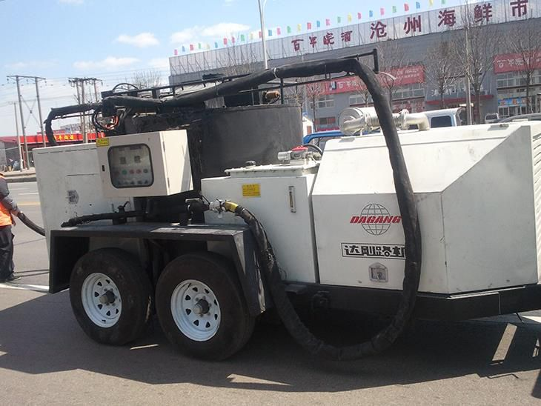

**Fig 2.1 Road crack sealing crack filling machine**

1. **Road Roller**

* Cost:12.27 Lakh rupees
* Drawbacks: Noise pollution, When driver motor spoils the conveyor stops turning.

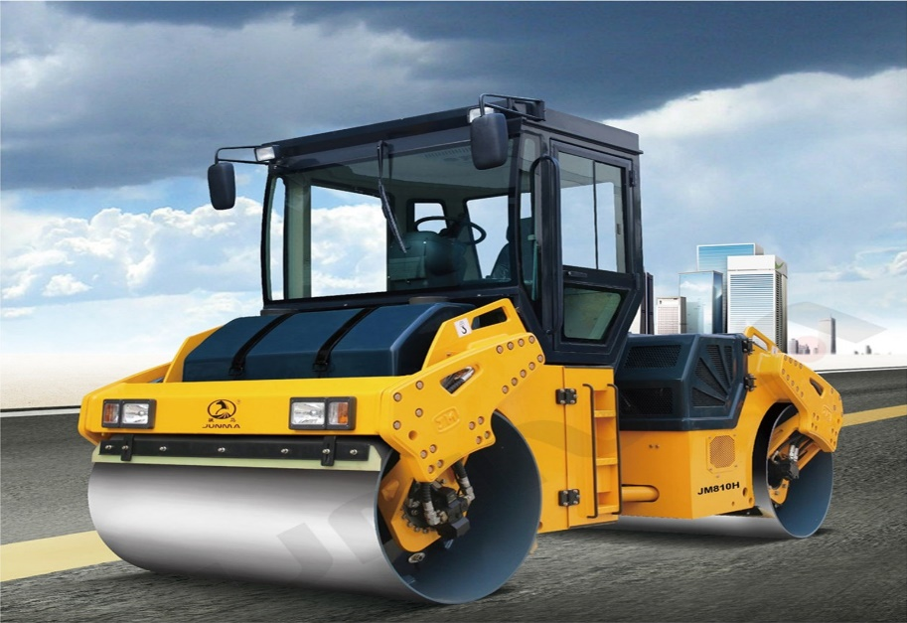

**Fig 2.2 Road roller**

1. **Detection of potholes in autonomous vehicle**

Sachin Bharadwaj, et al [8], proposed a model that makes use of a 2D vision-based approach to detect potholes. A properly mounted camera captures images of the road surface. To detect the presence of potholes, the captured images are process using MATLAB.

Drawbacks: This model works under uniform lighting conditions only and it doesn't include any sort of warning system. It is constrained only to the reorganization of a pothole and does not give any guide to the driver to avoid mishaps because of potholes.

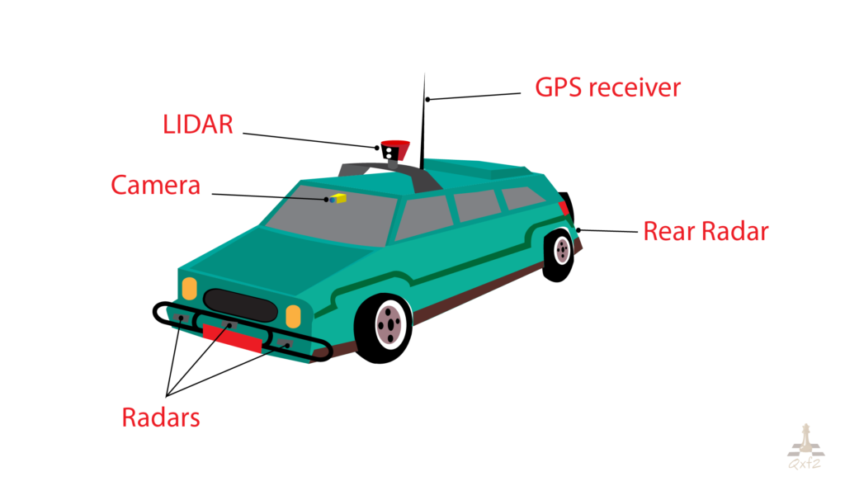

**Fig 2.3 Autonomous vehicle**

**CHAPTER-3**

**PROBLEM DEFINITION**

**3.1 Community interaction with the concerned project team**

With the aim of social innovation, we initially set our sights to a solution to a pesky problem that can turn out to be fruitful to many of the people. But, after visiting the community, we came across many problems. After discussing with our concerned project team we decided to work on detection and filling of pothole. Then we came across the idea of our project Arduino based pothole filler .

* 1. **Problem statement**

One of the major issues of developing countries is the conditions of the roads. Potholes are one of the main reasons behind poor road conditions and has caused a large number of accidents, thereby causing loss of lives. Detection of potholes will therefore benefit people for safer commutation. The previously proposed system had their focus on image processing to detect the potholes, which was not very accurate.

Our aim in this project is to propose a system that has to be measure the depth of the pothole and pothole has to be filled with concrete according to the requirement.

**3.3 Objective**

* We consider this project as a boon to many people as it could help people from preventing a large number of accidents, thereby causing loss of lives.
* The previously proposed system had their focus on image processing to detect the potholes, which was not very accurate. In our system, the use of Ultrasonic sensors has minimized the problem of accuracy which was faced previously.
* The project will be designed in such a way that, it can detect and fill the pothole automatically.

**3.4 Requirement Analysis**

The required materials for this project are :-

1. **Arduino UNO:**

It is a microcontroller, which has 14 digital I/O pins, a power jack, 6 analog I/O pins, a USB connection through which input can be given. It takes input values after it is connected to a power supply and gets executed according to the program stored in it.

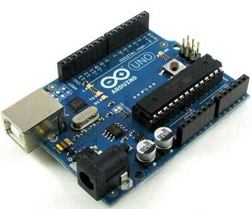

**Fig 3.4.1 Arduino UNO**

1. **Ultrasonic sensor**

As the name indicates, ultrasonic sensors measure distance by using ultrasonic waves. The sensor head emits an ultrasonic wave and receives the wave reflected back from the target. Ultrasonic Sensors measure the distance to the target by measuring the time between the emission and reception.

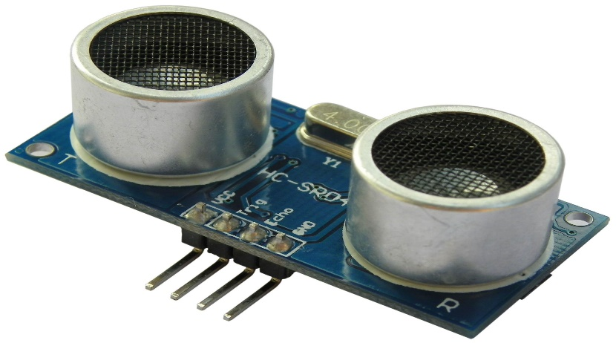

**Fig 3.4.2 Ultrasonic sensor**

1. **Jumper Wires:**

With these wires, the connections are given. This make the connection of modules to the Arduino, so that correct functioning of the project or modules takes place. The whole project is connected using jumper wires.

1. **Male-to-Male jumper wires:**

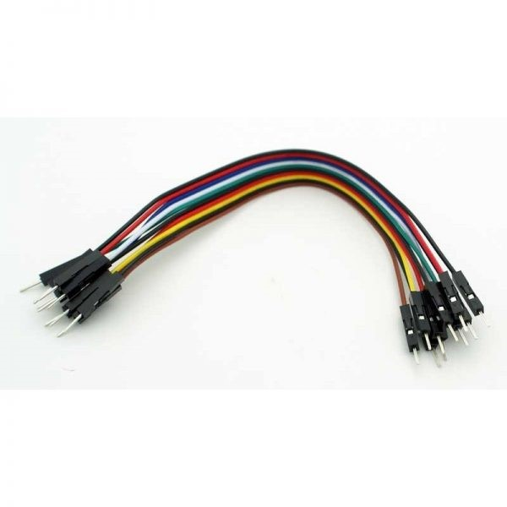

**Fig 3.4.3 Male-to-Male jumper wires**

1. **Male-to-Female jumper wires:**

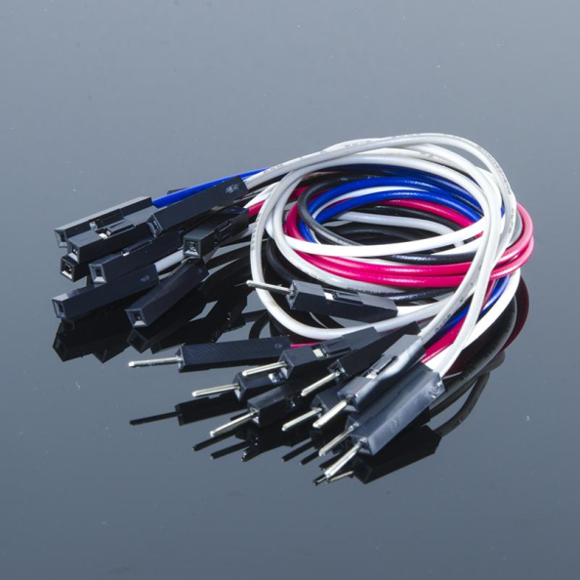

**Fig 3.4.4 Male-to-Female jumper wires**

1. **Servo motor**

**Servo** refers to an error sensing feedback control which is used to correct the performance of a system. Servo or RC **Servo Motors** are DC motors equipped with a servo mechanism for precise control of angular position. The RC servo motors usually have a rotation limit from 90° to 180°. Some **servos** also have rotation limit of 360° or more. But servos do not rotate continually. Their rotation is restricted in between the fixed angles.

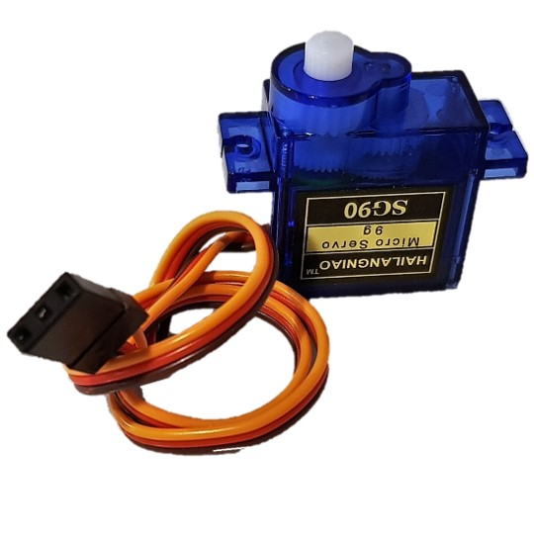

**Fig 3.4.5 Servo motor**

1. **9v HW battery**

The hw battery are**small in size** for the perfect portability and convenience of use. They are designed to have the optimal shapes and sizes to ensure that they fit perfectly into the devices they are meant to power. The hw battery do not self-discharge even when left for a long period which gives them a long shelf life.

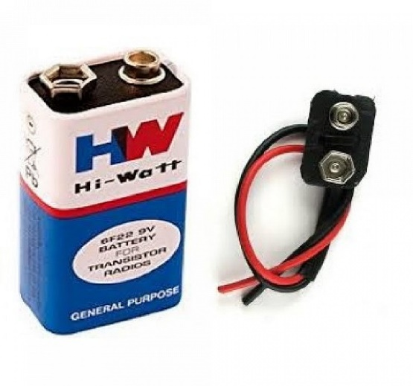

**Fig 3.4.6 9v HW battery**

1. **Dc motor**

**A DC motor is defined as a class of electrical motors that convert direct current electrical energy into mechanical energy.**

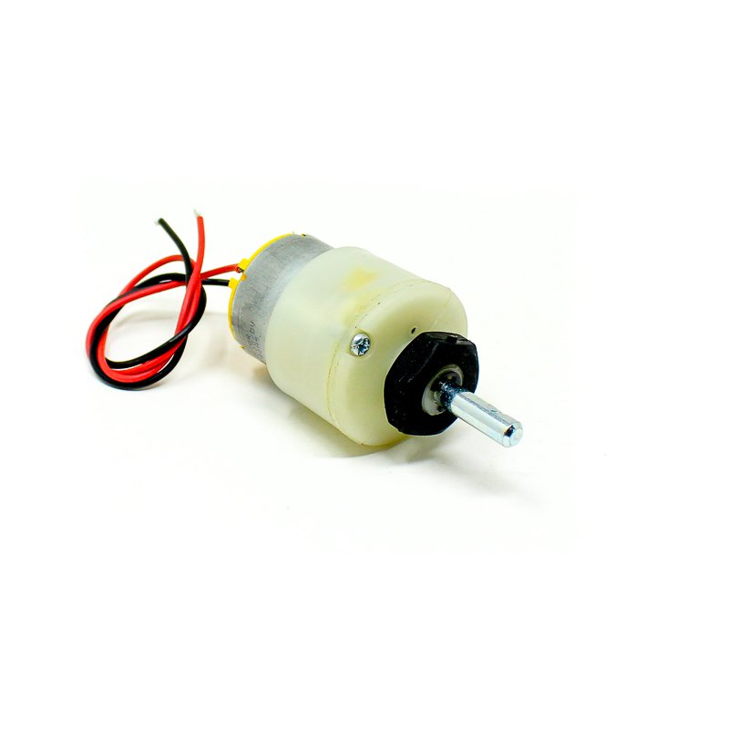

**Fig 3.4.7 Dc motor**

1. **L298N driver motor**

L298N module is a high voltage, high current dual full-bridge motor driver module for controlling DC motor and stepper motor. It can control both the speed and rotation direction of two DC motors. This module consists of an L298 dual-channel H-Bridge motor driver IC. These modules can control two DC motor or one stepper motor at the same time.

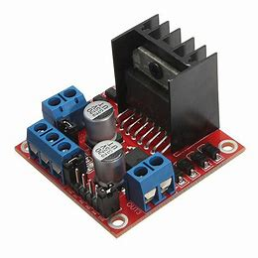

**Fig 3.4.8 L298N driver motor**

* 1. **METHODOLOGY**

This project is completely depend upon the code we write and the sensors we use. In the project Ultrasonic sensors are utilized to recognize the potholes and also to measure their depth, width and height respectively, along with the location coordinates. In the proposed framework, we have built a truck with ultrasonic sensor, servo motor, L298N driver motor attached below it, dc motor attached to the wheels and Arduino microcontroller placed . The truck contains concrete. The ultrasonic detects the depth of the pothole and sends information to the Arduino. With the help of that information the pothole is filled with concrete present in the truck automatically according to the requirement.

**CHAPTER-4**

**4.1 Conceptual Design**

This prototype helps a to detect the depth of the pothole and it fills the pothole according to the requirement of the pothole.

Ultrasonic sensor is attached below the truck such that ultrasonic sensor detects the depth of the pothole and send information to the Arduino.

According to the information stored in the Arduino the pothole is filled with concrete present in the truck according to the requirement.

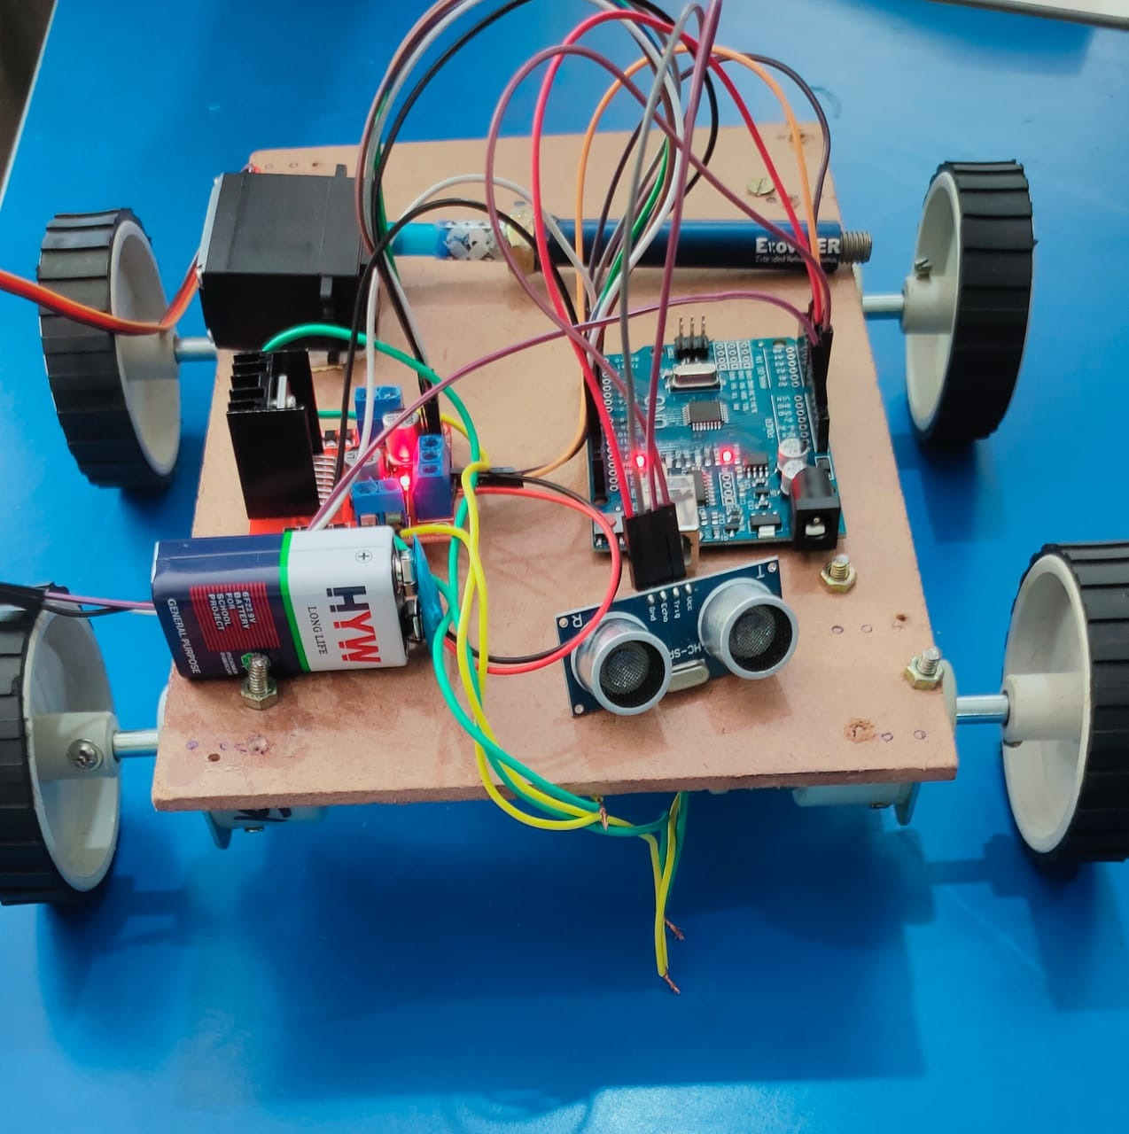

**Fig 4.1.1** **Conceptual design**

**4.2 Block Diagram**

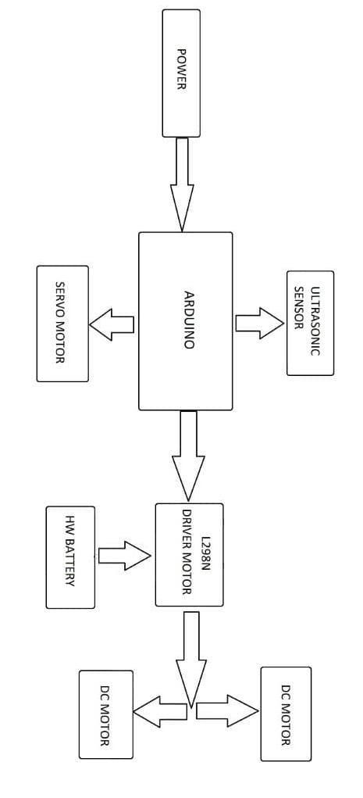

**Fig 4.2.1 Block diagram**

Temperature

Conductivity

**4.3 Design Description**

A truck with ultrasonic sensor, servo motor, L298N driver motor attached below it, dc motor attached to the wheels and Arduino microcontroller placed. The truck contains concrete. The ultrasonic detects the depth of the pothole and sends information to the Arduino. With the help of that information the pothole is filled with concrete present in the truck automatically according to the requirement.

**Advantages**

* Man work is not required
* Cost efficient
* High sustainability
* Easy to use
* Low maintenance

**Disadvantages**

* Sometimes vechile stops on even roads due to small readings of ultrasonic sensor.
* High voltage batteries are used for the movement of tires.
* Battery drain will be more.

**CHAPTER-5**

**IMPLEMENTATION**

**5.1 Results And Discussions**

When the problem was identified, the immediate solution was Arduino based pothole filler which can be easily help to detect the depth of the pothole and fills the pothole automatically. This helps recover the pothole easily. The final model with all the mentioned features was implemented using necessary hardware and softwares. In the proposed framework, we have built a truck with ultrasonic sensor, servo motor, L298N driver motor attached below it, dc motor attached to the wheels and Arduino microcontroller placed Ultrasonic sensor is attached below the truck such that ultrasonic sensor detects the depth of the pothole and send information to the Arduino. The ultrasonic detects the depth of the pothole and sends information to the Arduino. With the help of that information the pothole is filled with concrete present in the truck automatically according to the requirement.

**5.2 CONCLUSION**

By this project, Thus, in this paper, we have discussed about the working of ultrasonic sensor for detection of depth of the potholes and filling of the pathole according to the requirement. The main reason behind the use of ultrasonic sensor was to overcome the disadvantages caused by the systems using image processing for pothole detection. The implementation of the prototype was done after comprehensive study on the existing systems. The drawbacks of other existing systems which used ultrasonic, IR sensors and image processing is overcome by this system. It has been successfully tested practically by placing this prototype. The potholes which are removed from the roads get updated in the database. Thus it is said to be an interactive system. Hence, It can be concluded that idea of this system will help in maintenance of roads and providing safety to the people.

**CHAPTER-6**

**APPENDIX**

**6.1 References**

1. Rajeshwari Madli, Santosh Hebbar, Praveenraj Pattar, and Varaprasad Golla “Automatic Detection and Notification of Potholes and Humps on Roads to Aid Drivers” in IEEE sensors journal on August 2015, pp. 4313-4318

2. Wantanee Viriyasitavat, Fan Bai and Ozan K. Tonguz “Dynamics of network connectivity in urban vehicular network” on 22nd February 2016, pp. 515-533.

3. Chih-Hung King, Tiffany L. Chen and Advait Jain “Crowdsourcing based road surface monitoring” in International Conference on 12 June 2014, pp. 13-15.

4. Byeong-ho Kang and Su-il Choi “Pothole detection system using 2D LiDAR and camera” in Ubiquitous and Future Networks (ICUFN), 2017 Ninth International Conference on 27 July 2017, pp. 4-7.

5. J. S. Miller and W. Y. Bellinger, “Distress identification manual for the long-term pavement performance program,” *FHWA* RD-03-031, Federal Highway Administration, Washington, DC, USA, 2003.View at: [Google Scholar](https://scholar.google.com/scholar_lookup?title=Distress%20identification%20manual%20for%20the%20long-term%20pavement%20performance%20program&author=J.%20S.%20Miller%20&author=W.%20Y.%20Bellinger&publication_year=2003)

6. MOLIT (Ministry of Land and Infrastructure and Transport in Korea), Datafor Inspection of Government Agencies, 2013.

7. B. X. Yu and X. Yu, “Vibration-based system for pavement condition evaluation,” in Proceedings of the 9th International Conference on Applications of Advanced Technology in Transportation, pp. 183–189, August 2006.View at: [Publisher Site](https://doi.org/10.1061/40799(213)31) | [Google Scholar](https://scholar.google.com/scholar_lookup?title=Vibration-based%20system%20for%20pavement%20condition%20evaluation&author=B.%20X.%20Yu%20&author=X.%20Yu)

8. K. De Zoysa, C. Keppitiyagama, G. P. Seneviratne, and W. W. A. T. Shihan, “A public transport system based sensor network for road surface condition monitoring,” in Proceedings of the 1st ACM SIGCOMM Workshop on Networked Systems for Developing Regions (NSDR '07), Tokyo, Japan, August 2007.View at: [Publisher Site](https://doi.org/10.1145/1326571.1326585) | [Google Scholar](https://scholar.google.com/scholar_lookup?title=A%20public%20transport%20system%20based%20sensor%20network%20for%20road%20surface%20condition%20monitoring&author=K.%20De%20Zoysa&author=C.%20Keppitiyagama&author=G.%20P.%20Seneviratne&author=&author=W.%20W.%20A.%20T.%20Shihan)

9. J. Eriksson, L. Girod, B. Hull, R. Newton, S. Madden, and H. Balakrishnan, “The pothole patrol: using a mobile sensor network for road surface monitoring,” in Proceedings of the 6th International Conference on Mobile Systems, Applications, and Services (MobiSys '08), pp. 29–39, June 2008.View at: [Publisher Site](https://doi.org/10.1145/1378600.1378605) | [Google Scholar](https://scholar.google.com/scholar_lookup?title=The%20pothole%20patrol:%20using%20a%20mobile%20sensor%20network%20for%20road%20surface%20monitoring&author=J.%20Eriksson&author=L.%20Girod&author=B.%20Hull&author=R.%20Newton&author=S.%20Madden&author=&author=H.%20Balakrishnan)

10. C. P. Kelvin, “Automated pavement distress survey through stereovision,” Technical Report of Highway IDEA Project 88, Transportation Research Board, 2004.View at: [Google Scholar](https://scholar.google.com/scholar_lookup?title=Automated%20pavement%20distress%20survey%20through%20stereovision&author=C.%20P.%20Kelvin&publication_year=2004)