Classroom Assignments

1) Linear Regression Algortihm
----Chennai House pricing
a) Select the high loclait points
b) Select low locality point diabling metro and east facing
Check the Calculation for price 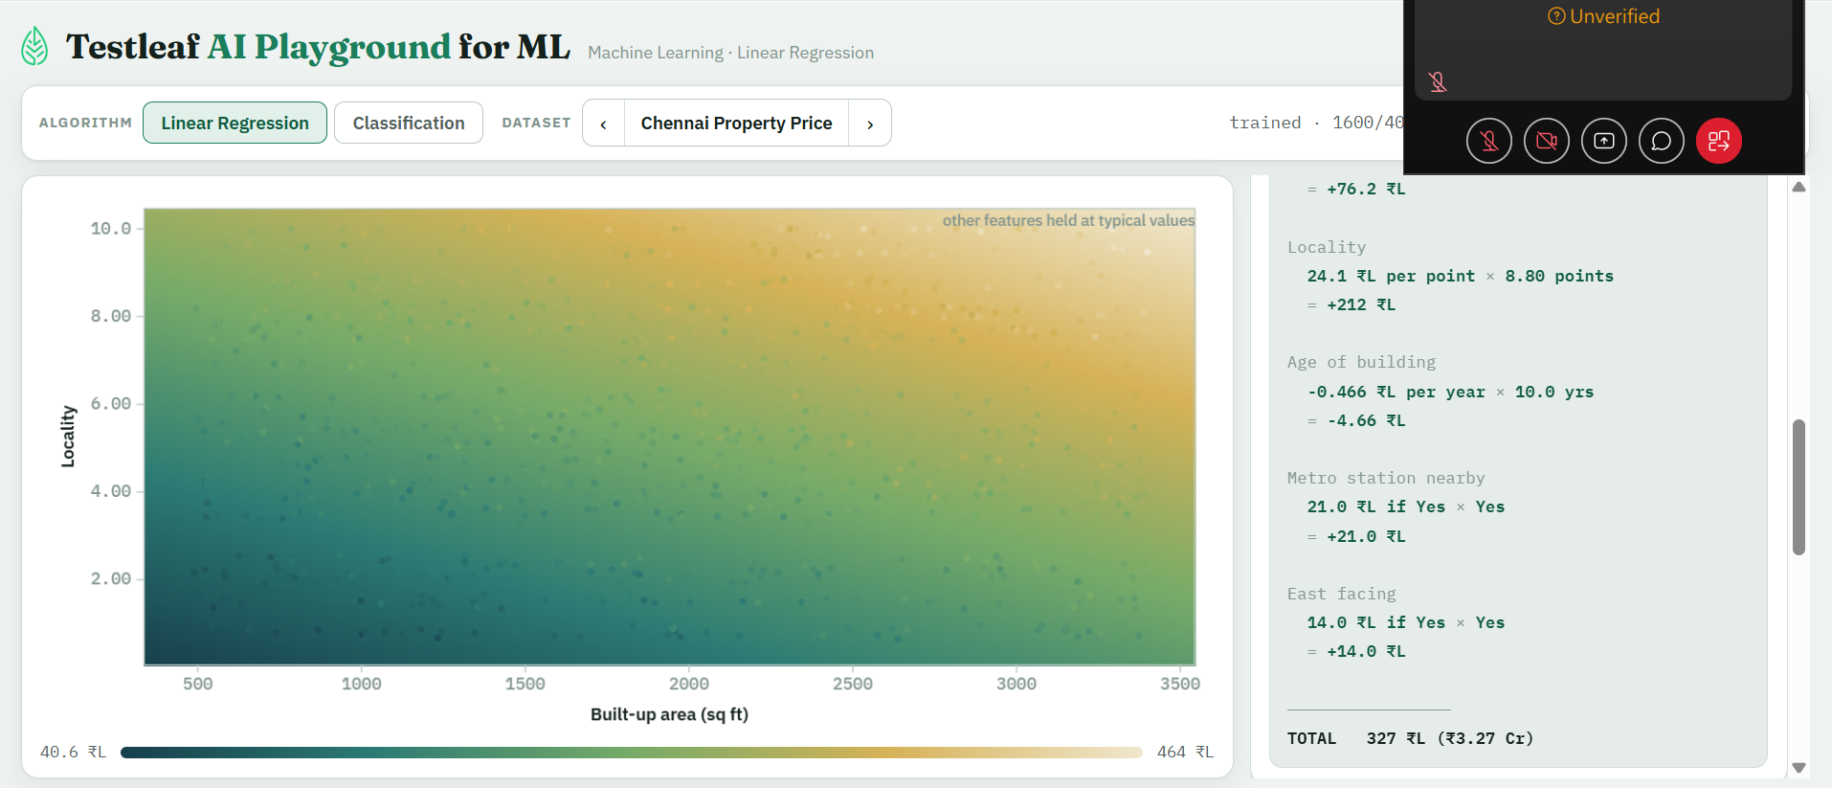 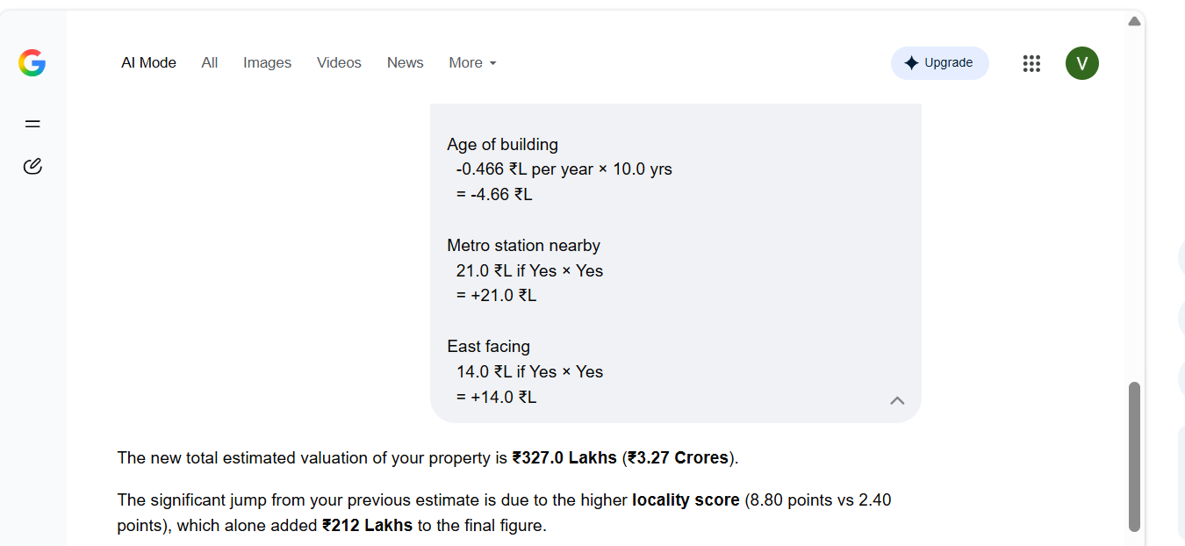
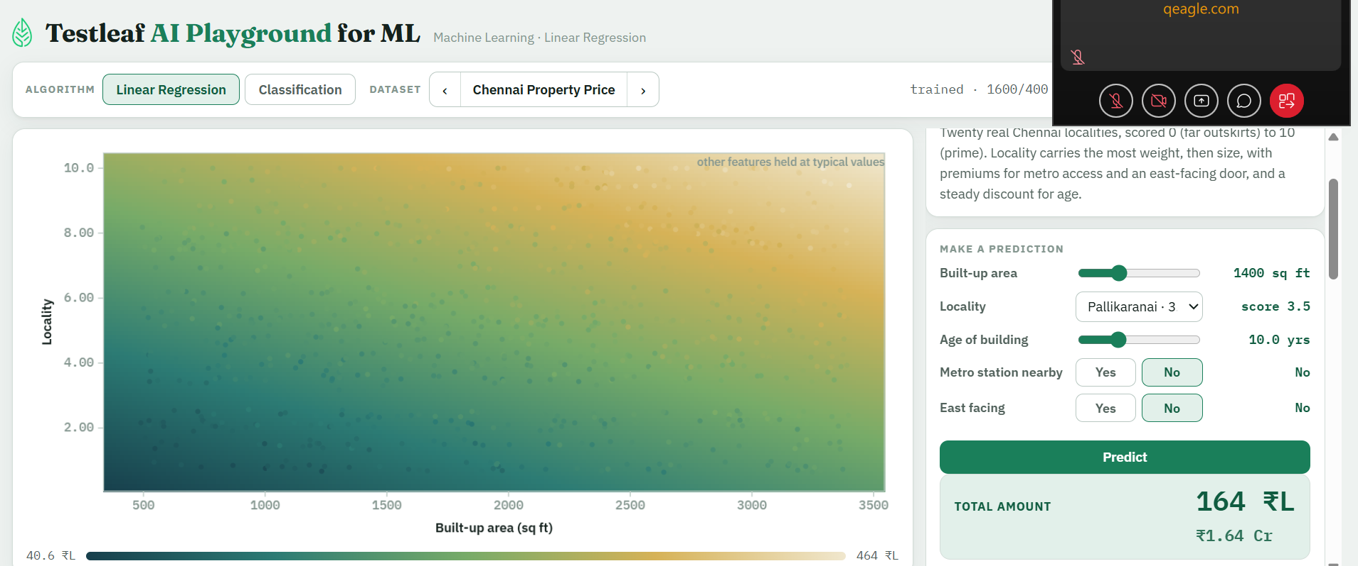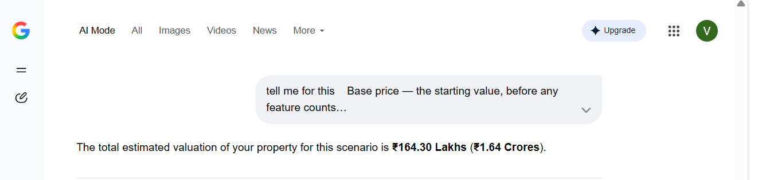
2) Classification Algorithm
1) Age <30 and Govt satisfaction less ,urban
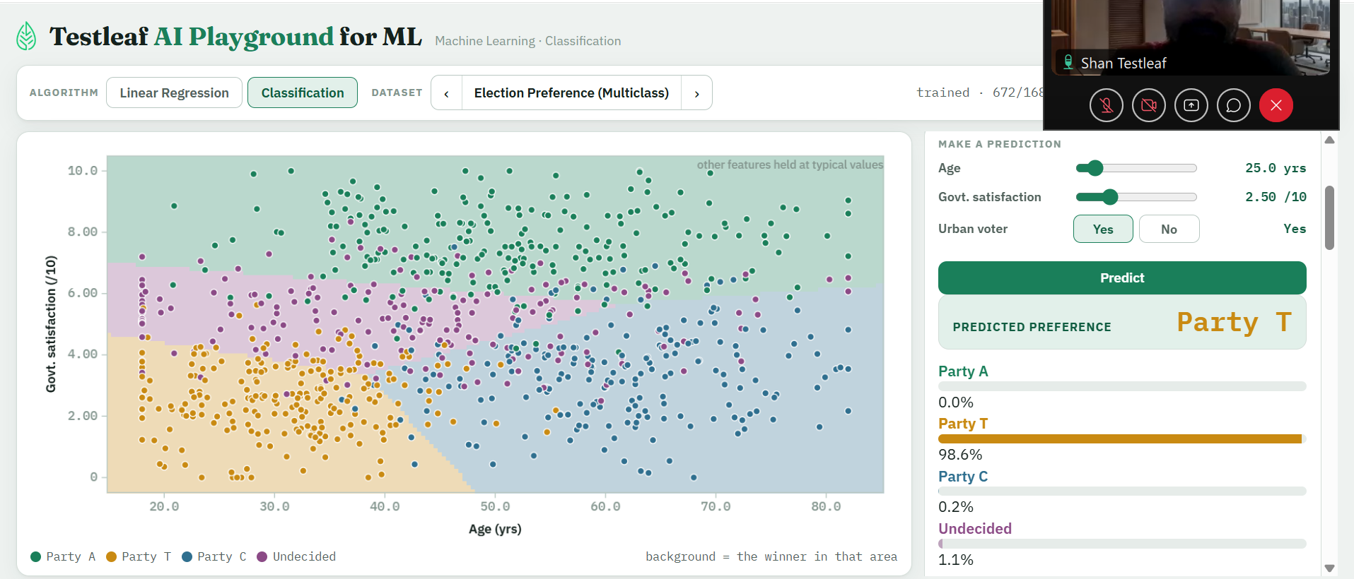
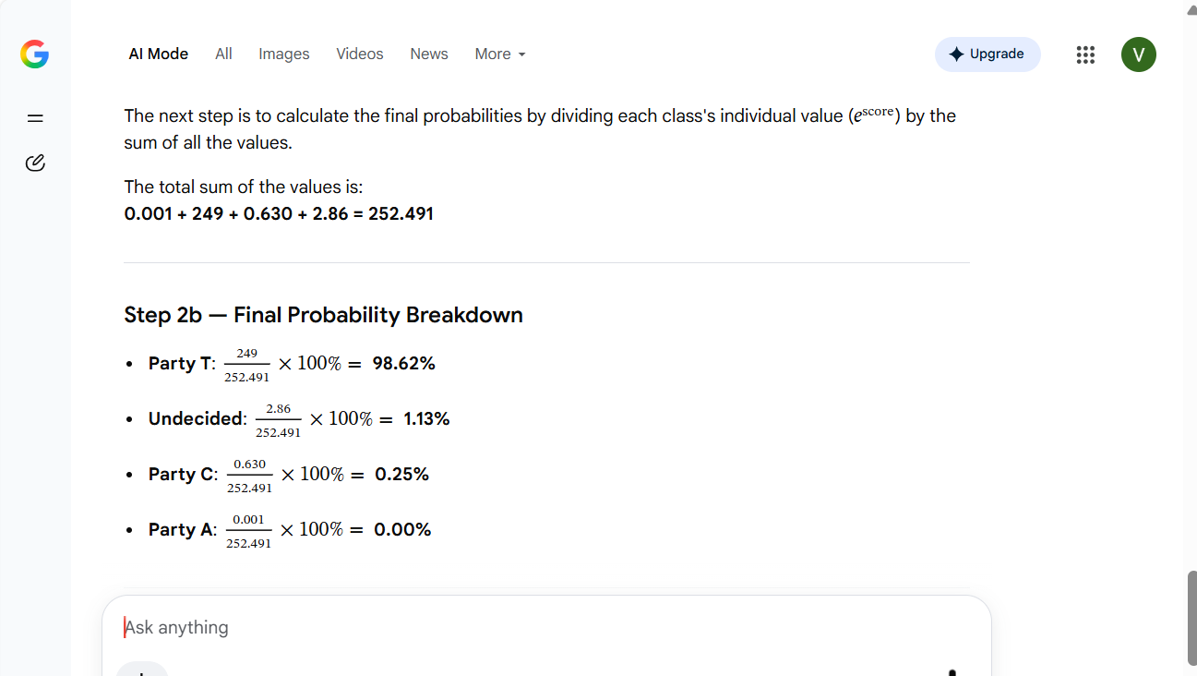
2) Age >50 and Govt statisfaction less ,non urban
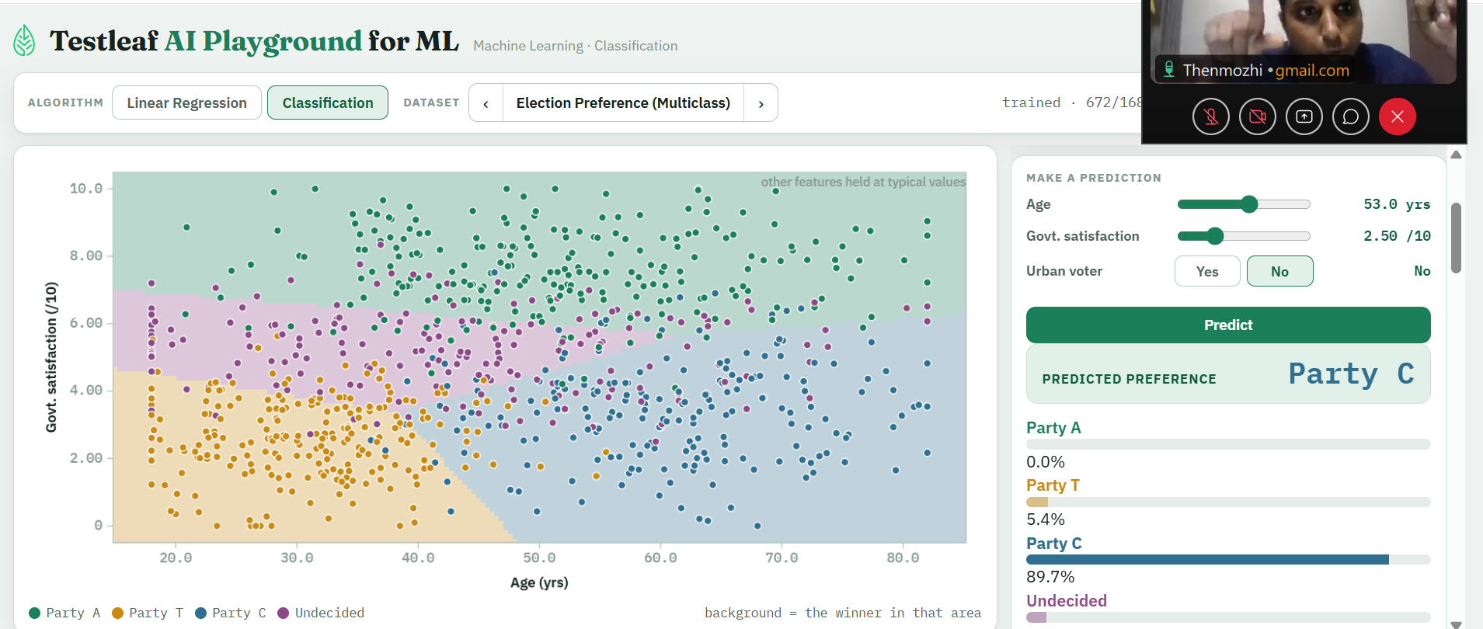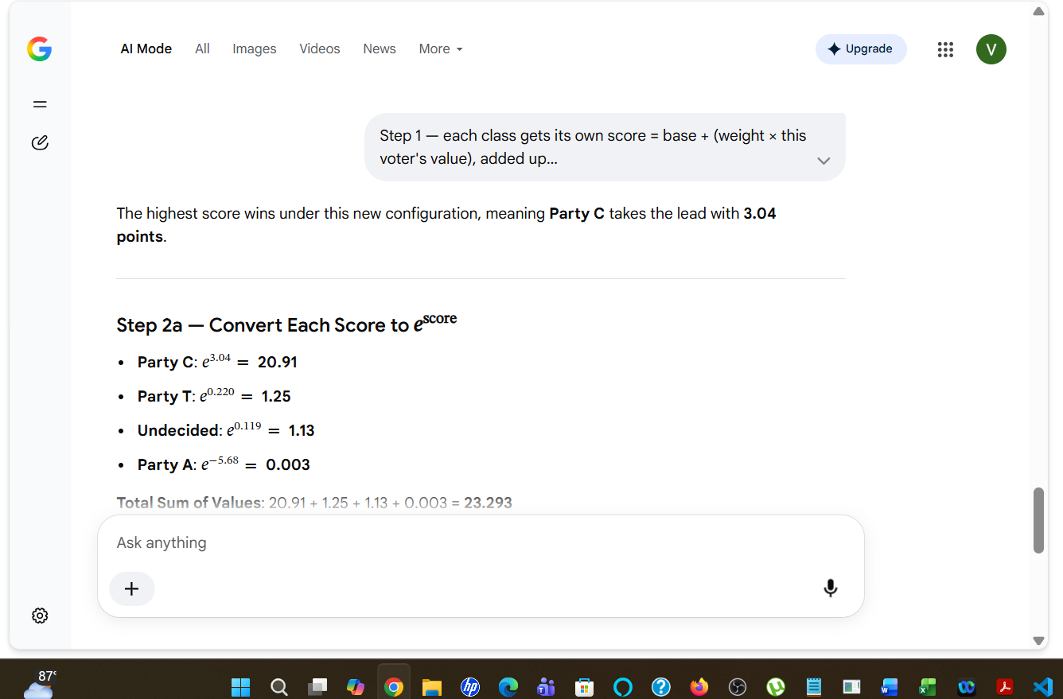
Check the points for classification

Home Assignment-week1day1
1) Classification Algorithm
a) Age <30 and Govt satisfaction less ,urban
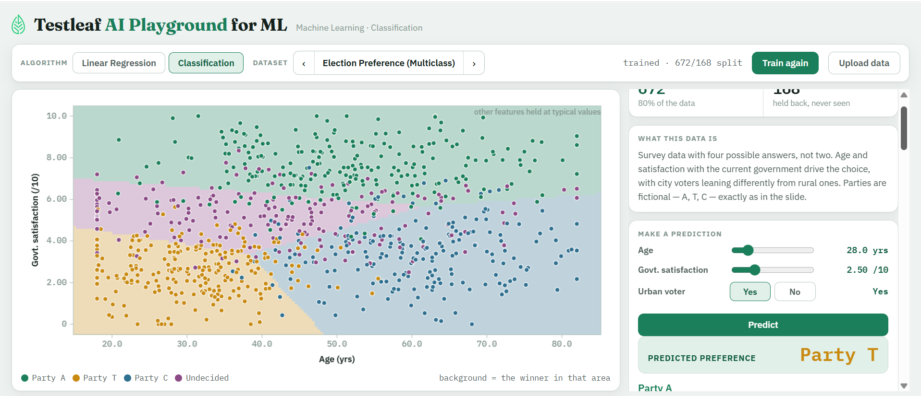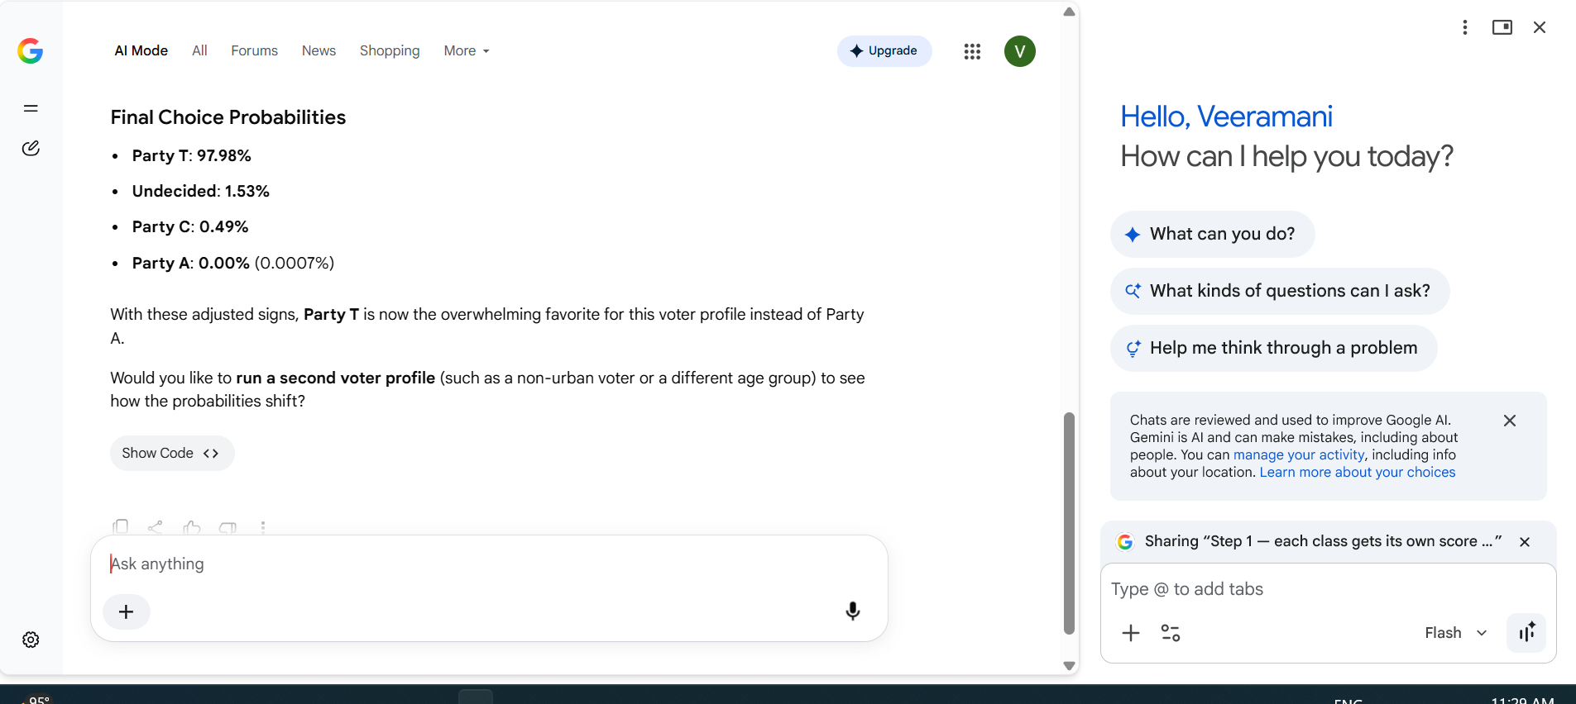
b) Age >50 and Govt statisfaction less ,non urban
validate the percentage
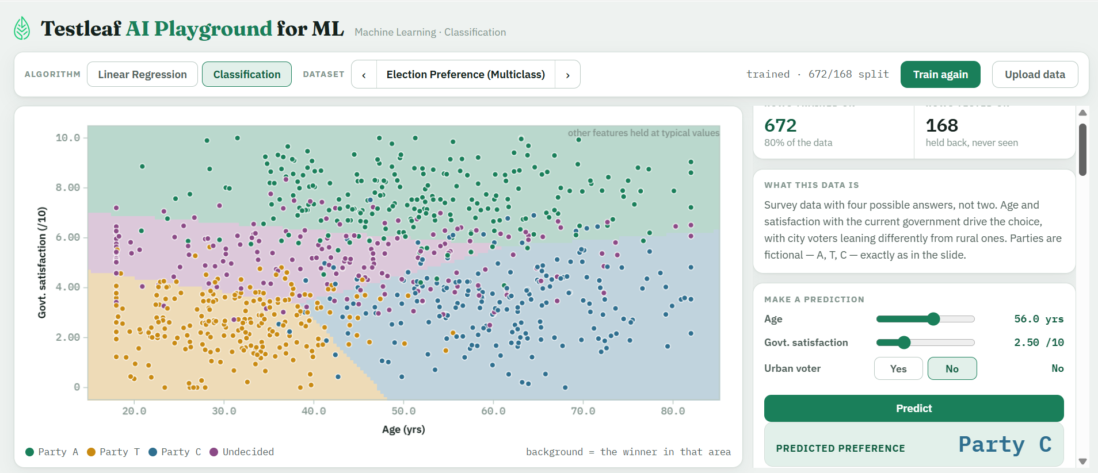
2)Linear regerssion
a) QA Salary
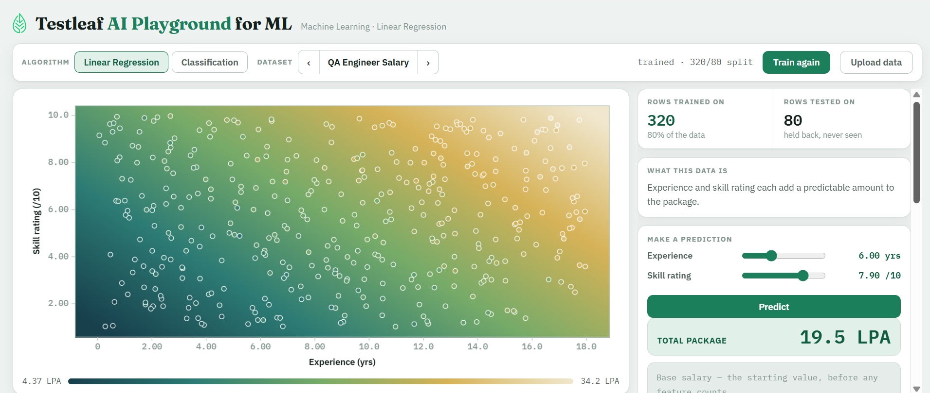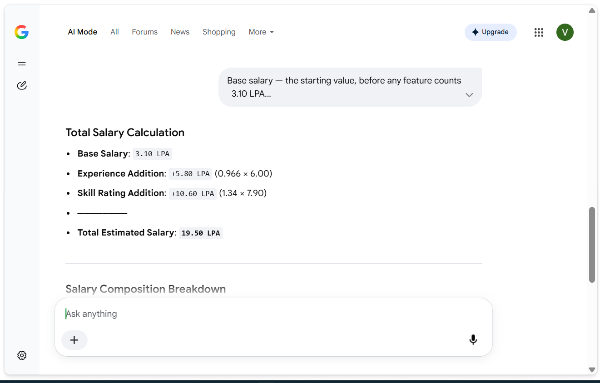
b) Food Delivery time
Check the Calculation for price and time
