**Home**

NOTE

Students will be able to open a few navbar links when they click on the website link; we'll limit the button accordingly. They can access all of the resources specified in the problem statement after fully logging in.

Figma Link

https://www.figma.com/proto/ehLNp3UXiBqpxfP5oy5sg9/Home?node-id=1%3A2&scaling=min-zoom&page-id=0%3A1&starting-point-node-id=1%3A2

There are three different features on the home page.

1. Carousel
2. Student’s Login Button
3. 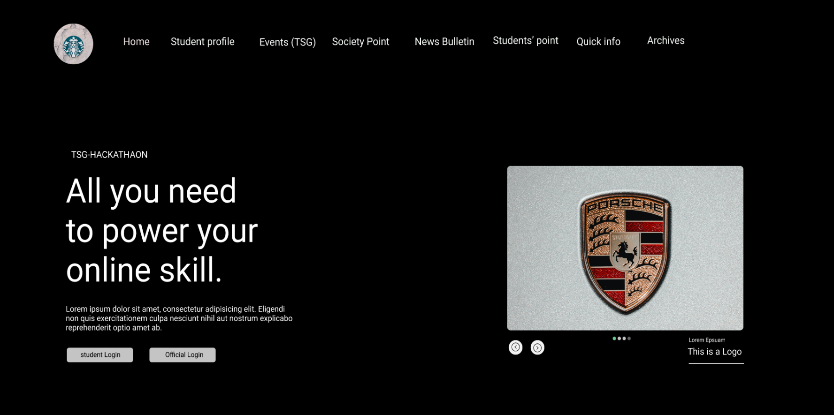Official’s Login Button

Carousel

On the right bottom of the home page, there is a carousel area that displays all of the current events.

Student’s Login Button

There is a student’s login button on the left bottom of the home page.

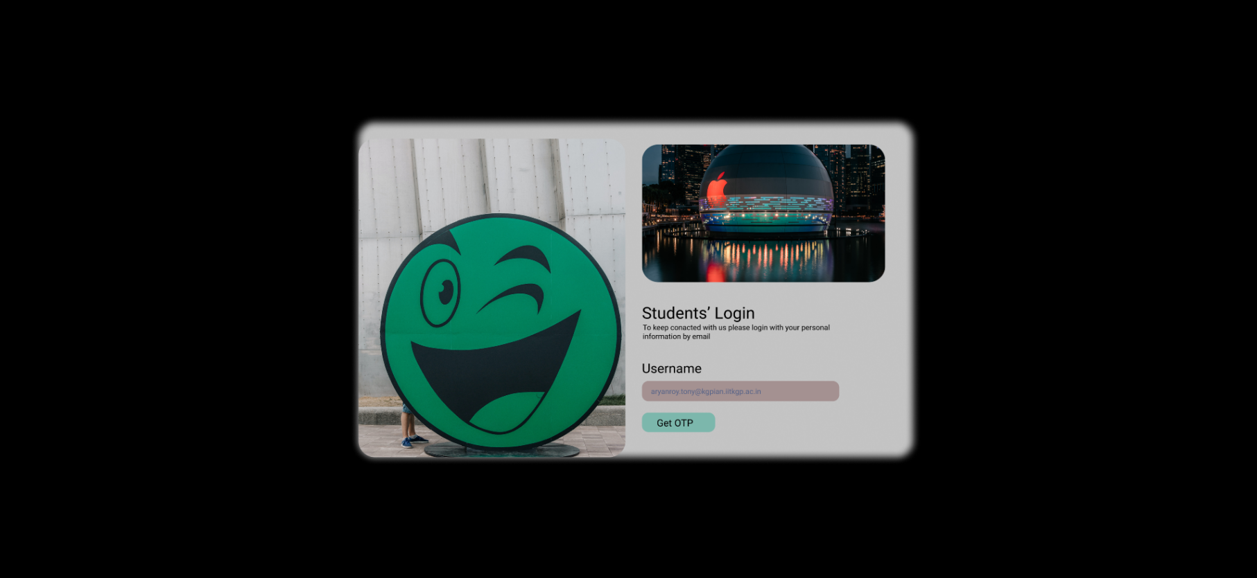

When you click the student logging option, you'll be taken to a page where you must enter your institute email address as a username. There is a demo of the institute email id in the username placeholder, which helps the student figure out whose email id webpage is asking for.

Get OTP Button

When you click the Get OTP button, you'll be taken to a page where students must enter the OTP that was issued to their username as their institute email id.

There is a one-fix timeframe; if someone is unable to fill out the OTP within the time restriction, they can click the resend button to receive the OTP once more.

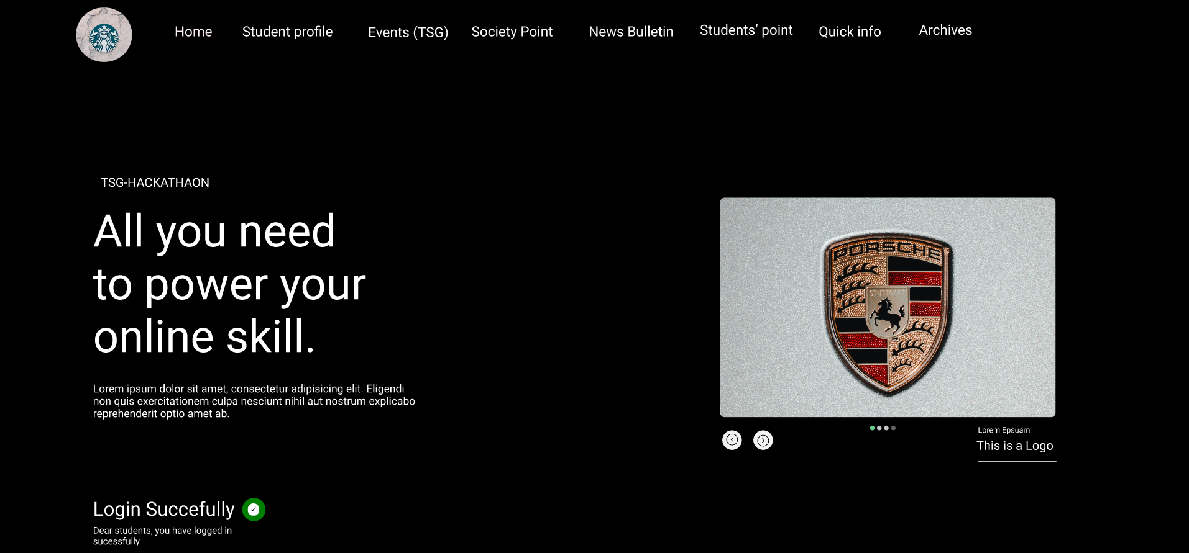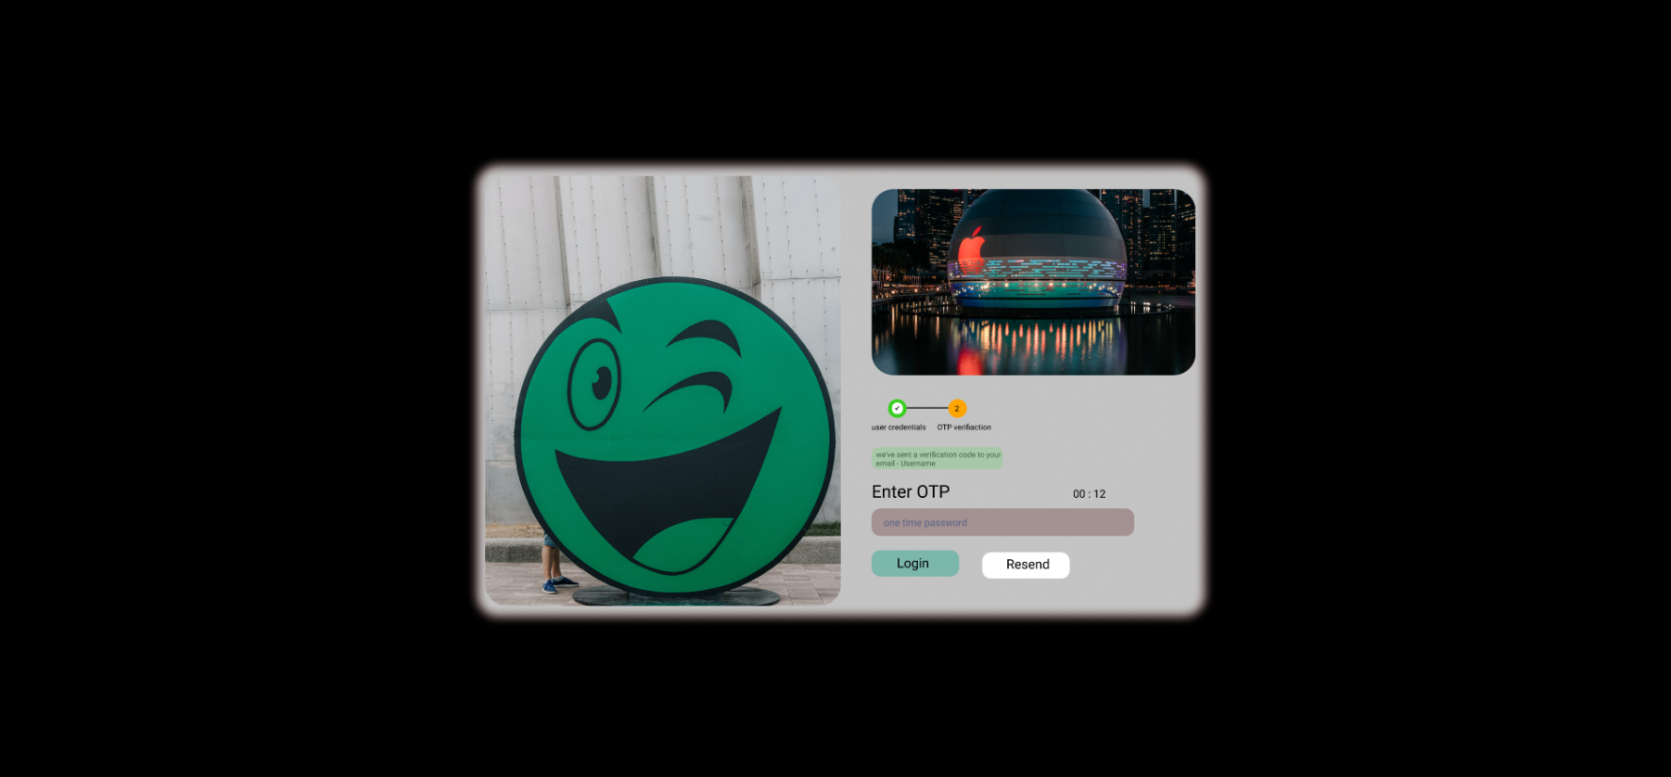Login Button

You'll see a Homepage that indicates “Dear Student, you've logged in successfully” and can now use the restricted navbar link if your OTP is correct; otherwise, you'll receive the error message "your OTP is not matching."

Official’s Login Button

There is an Official’s login button on the left bottom of the home page.

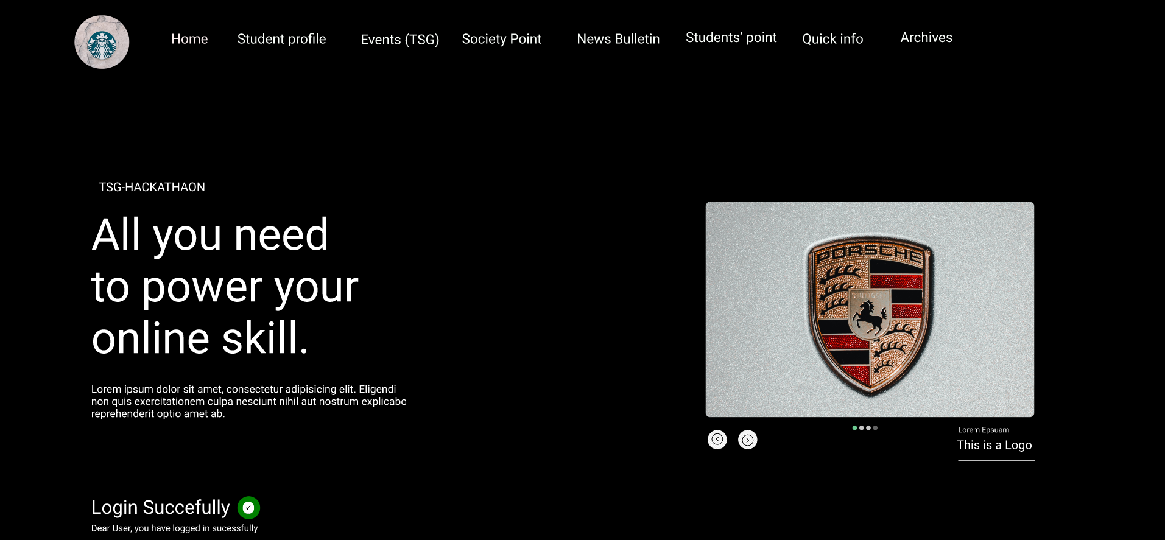When we click the official's login button, we'll be taken to a page where officials must enter their username and password; if they don't match with the database, the error "username and password are not matched" will appear; otherwise, we'll be taken to the homepage, where it says “Dear User, you've logged in successfully” and can now access the restricted navbar links.