WEEK 1 TASK REPORT
Data Acquisition, Cleaning, and Exploratory Data Analysis
Iris Flower Dataset | Python, Pandas, NumPy, Matplotlib, Scikit-learn
Prepared for Data Science Internship – Week 1

Student: Naguru Veera Lahari

1. Executive Summary
This Week 1 project demonstrates a complete data preparation workflow using the Iris flower dataset. The objective was to simulate the practical steps followed at the beginning of a data science project: acquiring a public dataset, inspecting its structure, checking data quality, handling duplicates, validating data types, performing exploratory analysis, creating visualizations, and documenting findings. The Iris dataset contains 150 observations from three iris species and four continuous measurements: sepal length, sepal width, petal length, and petal width. The dataset is publicly documented by the UCI Machine Learning Repository and is also distributed through scikit-learn.
The analysis found no missing values. One exact duplicate row was identified and removed so that repeated records would not influence descriptive statistics or visual interpretation. Numeric columns were explicitly converted to numeric data types, while the species column was converted to a categorical type. Exploratory analysis showed that petal measurements provide strong separation between the three species, while sepal measurements overlap more. The correlation analysis also showed strong positive relationships between petal length and petal width. These findings demonstrate why data cleaning and EDA are important before applying statistical or machine-learning models.

2. Project Objective
The main objective is to simulate the data preparation stage of a real-world data science project. The work focuses on data acquisition, data-quality assessment, cleaning, preprocessing, summary statistics, visual exploration, and interpretation of patterns. No predictive model is built in this week because the task is specifically focused on preparing and understanding the data.

3. Dataset Acquisition
The selected dataset is the classic Iris dataset. It is appropriate for this task because it is small, structured, well documented, and contains multiple numeric features that make exploratory analysis straightforward. The UCI Machine Learning Repository records 150 instances, four continuous features, three flower classes, and no missing values. The dataset is credited to R. A. Fisher and is licensed under CC BY 4.0.
Primary public source: https://www.archive.ics.uci.edu/dataset/53/iris
Python distribution used for reproducible analysis: scikit-learn load_iris()
Acquisition code used in the project environment:
from sklearn.datasets import load_iris
import pandas as pd
iris = load_iris(as_frame=True)
df = iris.frame.copy()
df.columns = [
"sepal_length_cm",
"sepal_width_cm",
"petal_length_cm",
"petal_width_cm",
"target"
]
df["species"] = df["target"].map(
dict(enumerate(iris.target_names))
)
df = df.drop(columns=["target"])
print(df.head())

4. Dataset Description
Column | Type | Description
sepal_length_cm | Continuous | Sepal length in centimeters
sepal_width_cm | Continuous | Sepal width in centimeters
petal_length_cm | Continuous | Petal length in centimeters
petal_width_cm | Continuous | Petal width in centimeters
species | Categorical | Iris species: setosa, versicolor, virginica
The initial dataset contains 150 rows and 5 columns after adding the readable species label. There are four numeric measurements and one categorical target column.

5. Initial Data Inspection
print(df.head())
print(df.shape)
print(df.info())
print(df.describe())
print(df.isnull().sum())
print(df.duplicated().sum())
Check | Result
Rows | 150
Columns | 5
Missing values | 0
Exact duplicate rows | 1
Numeric feature columns | 4
Categorical target column | 1

6. Data Cleaning and Preprocessing

6.1 Missing-value check
A column-wise null-value check was performed using isnull().sum(). All five columns contained zero missing values. Therefore, no imputation was applied. This decision avoids introducing artificial values into an already complete dataset. The result is consistent with the UCI documentation, which states that the Iris dataset has no missing values.
missing_values = df.isnull().sum()
print(missing_values)

6.2 Duplicate-row check
The duplicate check identified 1 exact duplicate row in the scikit-learn version used for this analysis. The duplicate was removed because it represented a repeated observation across all measured fields and the target label. Removing exact duplicates prevents a repeated record from receiving extra influence during descriptive analysis.
duplicate_count = df.duplicated().sum()
print("Duplicate rows:", duplicate_count)
df = df.drop_duplicates().reset_index(drop=True)

6.3 Data-type validation
The four measurement columns were explicitly converted to numeric values using pandas.to_numeric(). The species column was converted to a categorical data type. Explicit type validation improves reliability for summary statistics, correlations, grouping, and future machine-learning workflows.
numeric_cols = [
"sepal_length_cm",
"sepal_width_cm",
"petal_length_cm",
"petal_width_cm"
]
for col in numeric_cols:
df[col] = pd.to_numeric(df[col], errors="coerce")
df["species"] = df["species"].astype("category")
print(df.dtypes)

6.4 Cleaning summary
Quality Step | Action | Result | Rationale
Missing values | Checked | 0 missing values | No imputation required
Duplicate rows | Checked | 1 exact duplicate removed | Avoid repeated observations
Numeric types | Validated | 4 measurement columns numeric | Supports mathematical analysis
Categorical type | Validated | species converted to category | Efficient grouping and interpretation

7. Exploratory Data Analysis

7.1 Descriptive statistics
Descriptive statistics were calculated for all four numeric measurements. The mean values show that petal length and petal width vary substantially across the dataset, while sepal width has a comparatively smaller spread.
Feature | Mean | Std. Dev. | Min | Max
sepal length cm | 5.84 | 0.83 | 4.30 | 7.90
sepal width cm | 3.06 | 0.44 | 2.00 | 4.40
petal length cm | 3.75 | 1.77 | 1.00 | 6.90
petal width cm | 1.19 | 0.76 | 0.10 | 2.50

7.2 Class distribution
The dataset contains three species with 50 observations per class before the duplicate-cleaning step. After removing one exact duplicate, the cleaned dataset contains 149 rows. The class distribution remains nearly balanced, so there is no major class imbalance problem for exploratory analysis.
Species | Cleaned Count
setosa | 50
versicolor | 50
virginica | 49
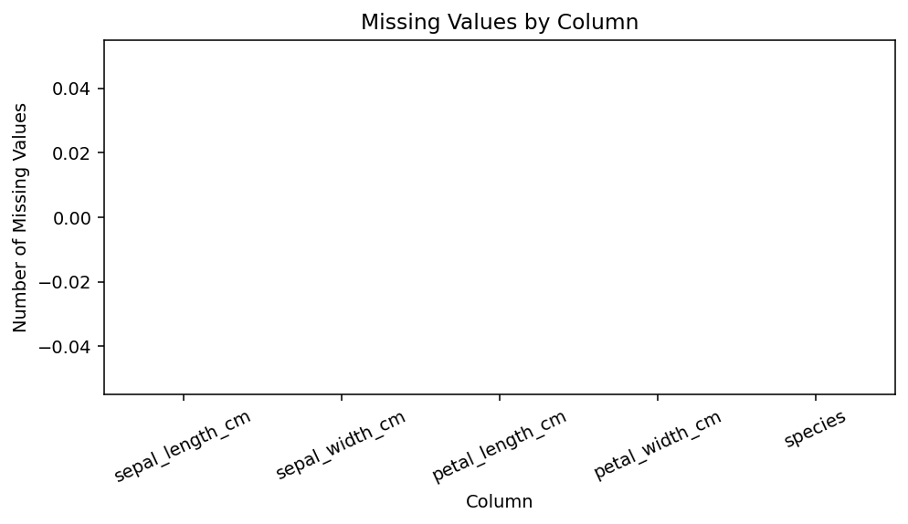
Figure 1. Missing-value check. All columns contain zero missing values.
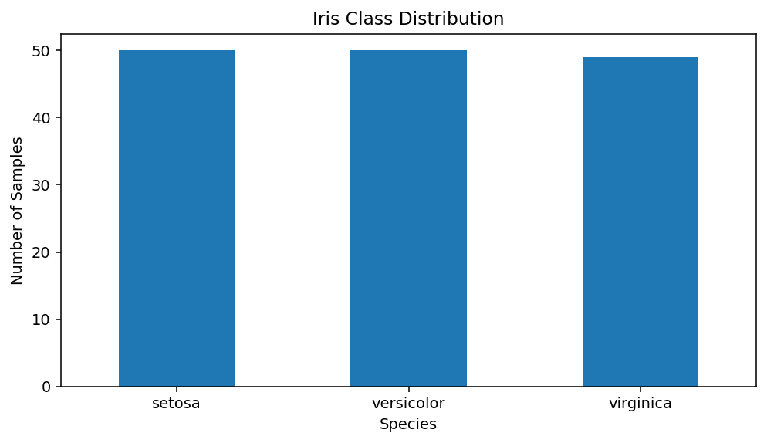
Figure 2. Class distribution after duplicate removal.

7.3 Relationship between petal measurements
The petal length versus petal width scatter plot shows a clear separation pattern. Setosa observations occupy a compact region with much smaller petal measurements. Versicolor and virginica occupy larger measurement ranges and show some separation, although their observations are closer to each other than to setosa.
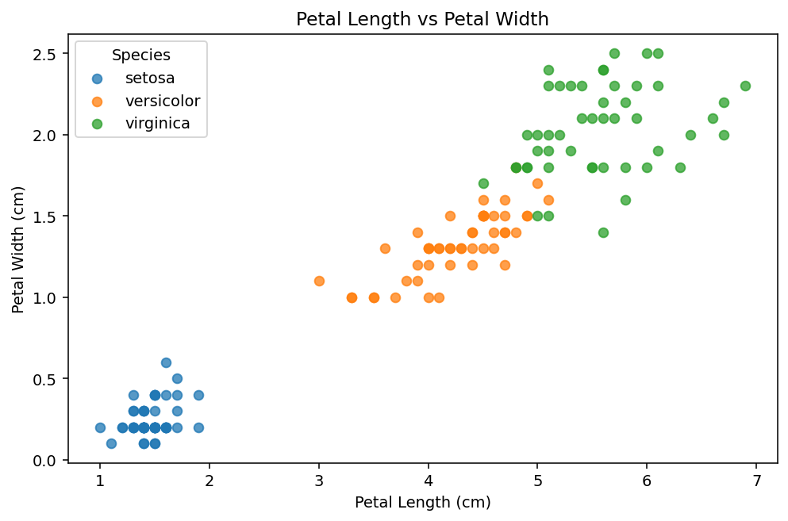
Figure 3. Petal length and petal width relationship by species.

7.4 Distribution and potential outliers
Box plots were used to compare the distributions of the four numeric measurements. The plots help identify the median, spread, and possible extreme observations. Some features show observations farther from the central range; however, an observation is not automatically an error simply because it is an outlier. Domain context would be required before removing any such value.
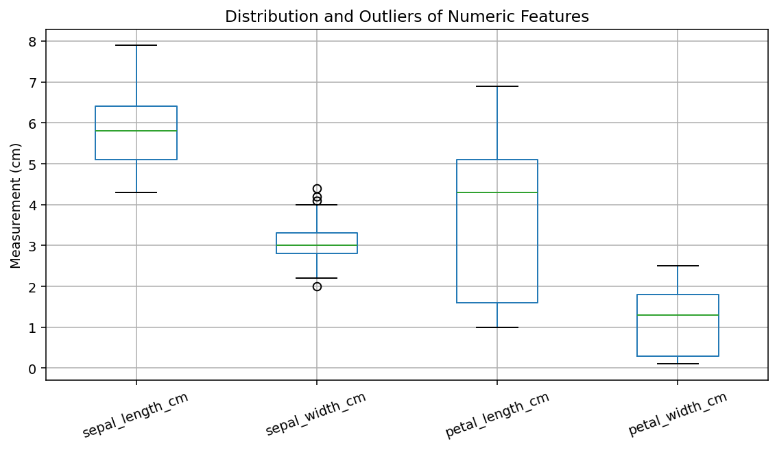
Figure 4. Box plots for numeric measurements.

7.5 Correlation analysis
Pearson correlation coefficients were calculated between numeric features. Petal length and petal width show a strong positive relationship. Sepal length also has a strong positive relationship with the two petal measurements. Sepal width shows weaker and partly negative relationships with the other features. Strong correlation can be useful for understanding feature relationships, although correlation alone does not establish causation.
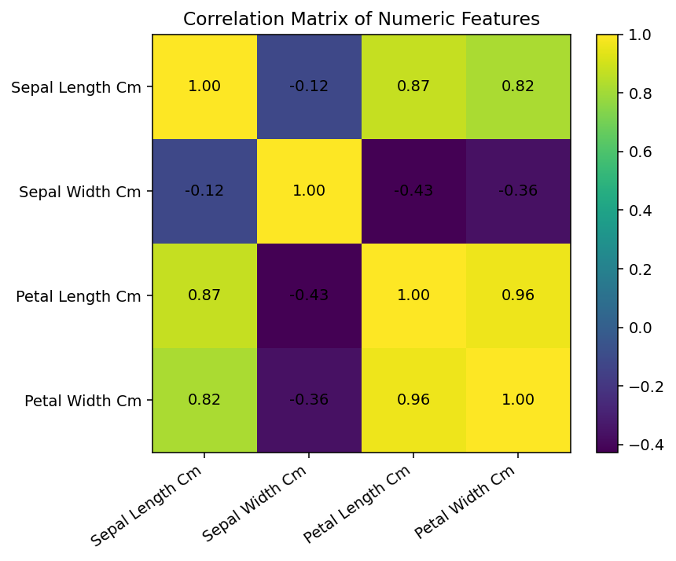
Figure 5. Correlation matrix of numeric features.

8. Key Insights
- The dataset is small and structured, containing four continuous measurements and three flower classes.
- No missing values were present, so imputation was unnecessary.
- 1 exact duplicate row was detected and removed during cleaning.
- Petal length and petal width provide strong visual separation among the species, particularly for Setosa.
- Petal length and petal width are strongly positively correlated, indicating that larger petals tend to occur with larger values of the other petal measurement.
- The class distribution is approximately balanced, which reduces the risk of a simple class-frequency imbalance in later classification work.
- Box plots provide a useful first check for unusual observations, but potential outliers should be investigated rather than automatically deleted.

9. Potential Areas for Further Analysis
- Perform feature scaling and compare classification algorithms such as Logistic Regression, K-Nearest Neighbors, Decision Tree, and Random Forest.
- Use train-test splitting and cross-validation to evaluate generalization.
- Compare model performance using all four features versus selected feature subsets.
- Investigate whether dimensionality reduction methods such as PCA provide a useful two-dimensional representation.
- Analyze misclassified observations and examine whether feature overlap explains classification errors.

10. Reproducible End-to-End Code
import pandas as pd
import matplotlib.pyplot as plt
from sklearn.datasets import load_iris
# Acquisition
iris = load_iris(as_frame=True)
df = iris.frame.copy()
# Rename columns
df.columns = [
"sepal_length_cm",
"sepal_width_cm",
"petal_length_cm",
"petal_width_cm",
"target"
]
# Add readable target labels
df["species"] = df["target"].map(dict(enumerate(iris.target_names)))
df = df.drop(columns=["target"])
# Inspection
print(df.head())
print(df.shape)
print(df.info())
print(df.isnull().sum())
print("Duplicates:", df.duplicated().sum())
# Cleaning
df = df.drop_duplicates().reset_index(drop=True)
numeric_cols = [
"sepal_length_cm",
"sepal_width_cm",
"petal_length_cm",
"petal_width_cm"
]
for col in numeric_cols:
df[col] = pd.to_numeric(df[col], errors="coerce")
df["species"] = df["species"].astype("category")
# EDA
print(df.describe())
print(df.groupby("species")[numeric_cols].mean())
# Correlation
print(df[numeric_cols].corr())
# Example visualization
df.plot.scatter(
x="petal_length_cm",
y="petal_width_cm"
)
plt.title("Petal Length vs Petal Width")
plt.show()

11. Estimated Work Plan (30–35 Hours)
Activity | Estimated Time
Dataset selection and source verification | 3 hours
Data acquisition and environment setup | 3 hours
Initial inspection and data-quality checks | 5 hours
Cleaning and preprocessing | 6 hours
Exploratory analysis and summary statistics | 6 hours
Visualization development and interpretation | 5 hours
Report preparation, review, and reproducibility checks | 4 hours
Total planned effort | 32 hours
The time allocation above is an estimated project plan aligned with the task's requested 30–35 hour timeframe; it is not a claim about automatically recorded working time.

12. Conclusion
This Week 1 project completed the core data-preparation workflow required before deeper data science analysis. The dataset was identified from a public repository, inspected with Pandas, checked for missing values and duplicates, validated for appropriate data types, and explored using descriptive statistics and multiple visualizations. The analysis demonstrated clear relationships among the measurements, especially the strong relationship between petal length and petal width. The cleaned dataset is now suitable for a future classification-focused analysis. The project also emphasizes an important data-science principle: cleaning decisions should be justified using the structure and meaning of the data rather than applying automatic rules without inspection.

13. References
1. UCI Machine Learning Repository – Iris Dataset: https://www.archive.ics.uci.edu/dataset/53/iris
2. Scikit-learn – load_iris documentation: https://scikit-learn.org/stable/modules/generated/sklearn.datasets.load_iris.html
3. Fisher, R. A. (1936), The use of multiple measurements in taxonomic problems.

