WEEK 2 TASK
ADVANCED DATA VISUALIZATION AND STORYTELLING WITH PYTHON
Iris Dataset – Visual Exploration and Data Storytelling

1. Introduction
This Week 2 project focuses on advanced data visualization and storytelling with Python. The goal is to transform a structured dataset into a clear visual narrative that can be understood by both technical and non-technical audiences. The Iris dataset was selected because it is publicly accessible, well documented, and contains multiple numerical measurements that support meaningful comparisons, distributions, relationships, and patterns.

2. Objective
The objectives were to develop a series of sophisticated visualizations, explain why each visual was selected, identify important trends and differences, and connect the individual charts into a coherent data story. The analysis emphasizes clear captions, readable charts, comparisons between species, and practical scientific implications.

3. Dataset and Acquisition
The analysis uses the publicly available Iris dataset provided through the scikit-learn Python library. It contains 150 observations from three iris species: setosa, versicolor, and virginica. Four numerical measurements are included: sepal length, sepal width, petal length, and petal width. The dataset can be reproduced in Python using sklearn.datasets.load_iris().

4. Methodology
- Loaded the public Iris dataset using Python.
- Converted the data into a Pandas DataFrame and assigned readable feature names.
- Grouped observations by species for comparisons.
- Calculated correlations between numerical measurements.
- Created six complementary visualizations using Seaborn, Matplotlib, and Pandas.
- Added titles, axis labels, legends, and captions.
- Interpreted the charts in sequence so the visuals form a coherent story.

5. Visual Analysis and Storytelling

Figure 1: Pair Plot
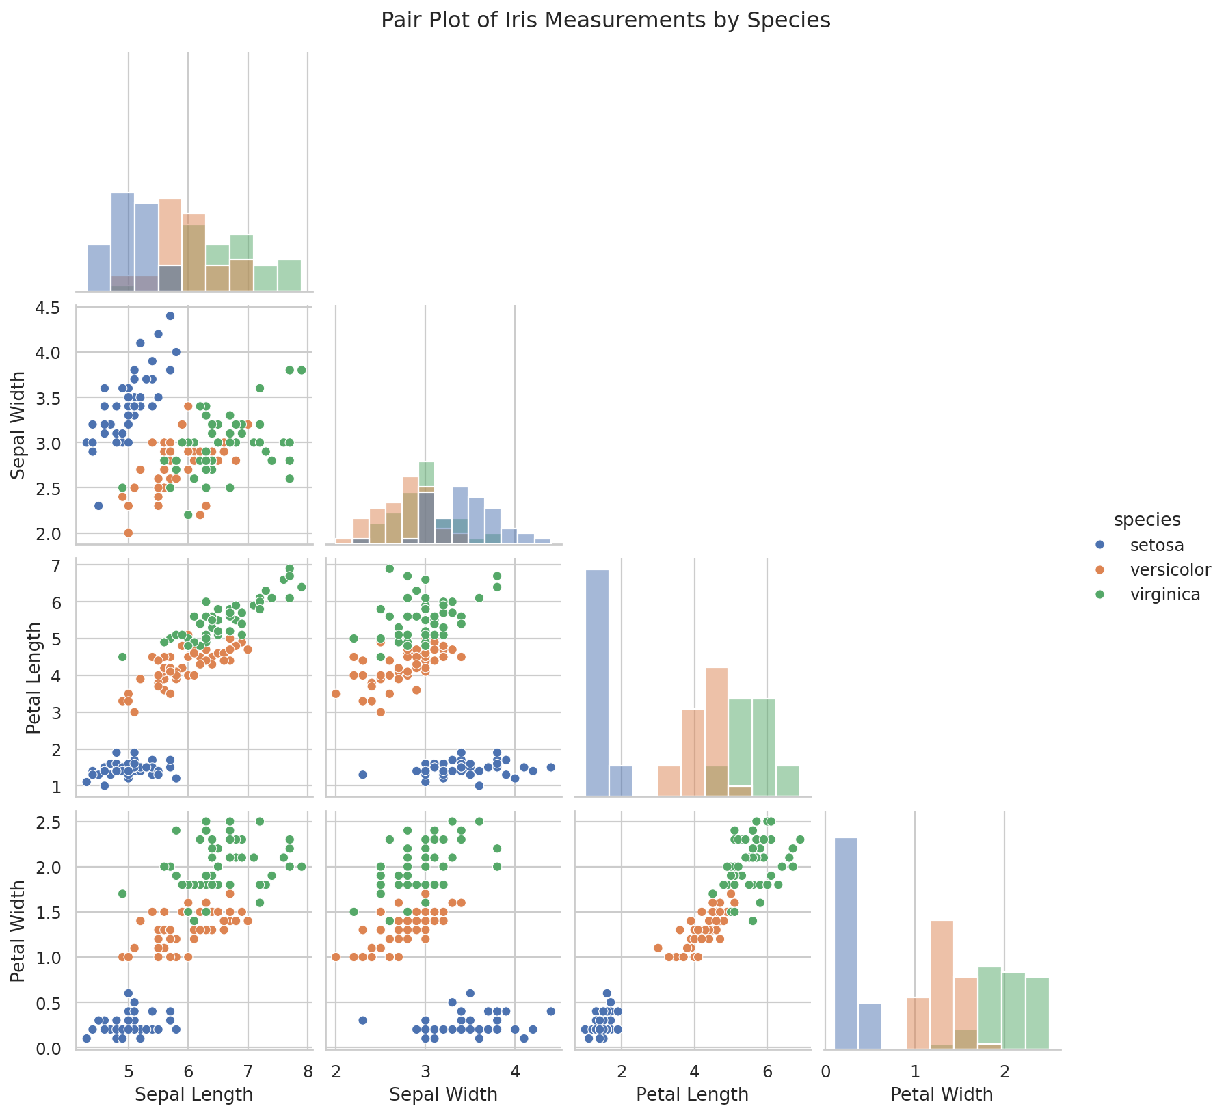
Figure 1: Pair Plot
The pair plot gives an overall view of relationships between every pair of numerical measurements while separating observations by species. It was selected as the opening visualization because it quickly shows which measurements create clear groups. Petal measurements show stronger separation than sepal measurements.
Story contribution: This establishes the overall structure of the dataset and identifies measurements that deserve deeper investigation.

Figure 2: Violin Plot – Petal Length Distribution
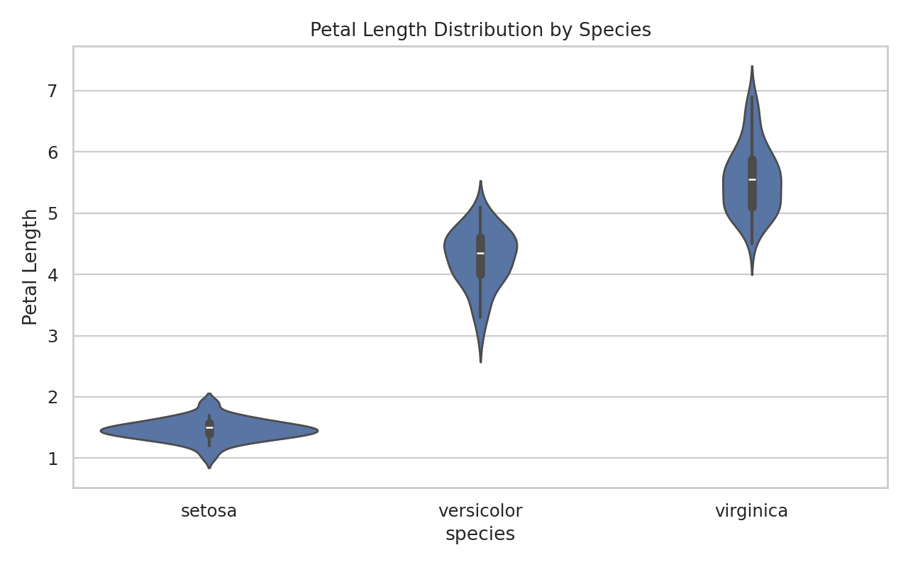
Figure 2: Violin Plot – Petal Length Distribution
The violin plot shows the distribution and density of petal length for each species. Setosa has much smaller petal lengths, virginica generally has the largest values, and versicolor lies between them.
Story contribution: This turns the initial pattern into a focused comparison of distributions.

Figure 3: Correlation Heatmap
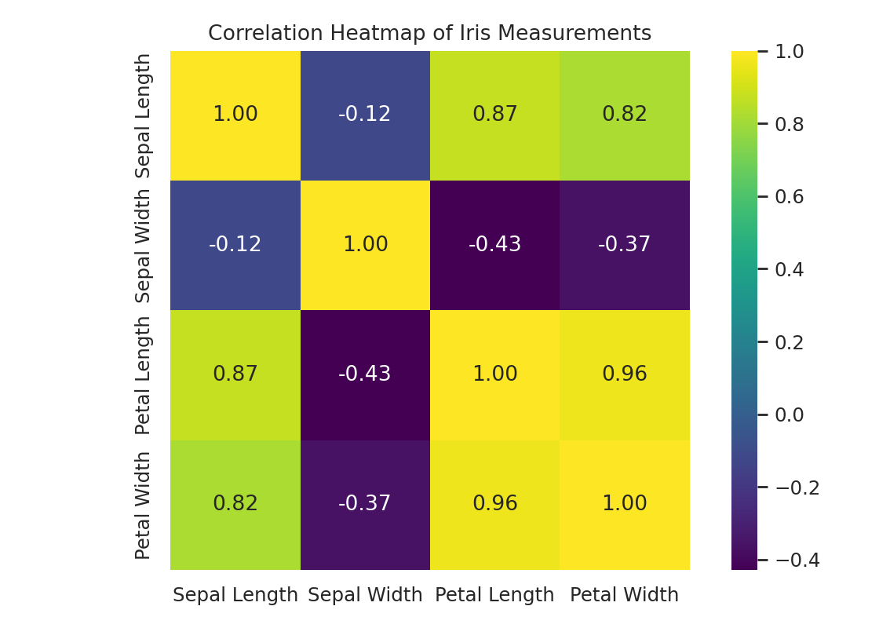
Figure 3: Correlation Heatmap
The heatmap summarizes pairwise linear relationships among the four measurements. Petal length and petal width have a strong positive correlation, supporting the repeated visual pattern.
Story contribution: This provides a statistical foundation for the relationships seen in the other charts.

Figure 4: Box Plot – Variation by Species
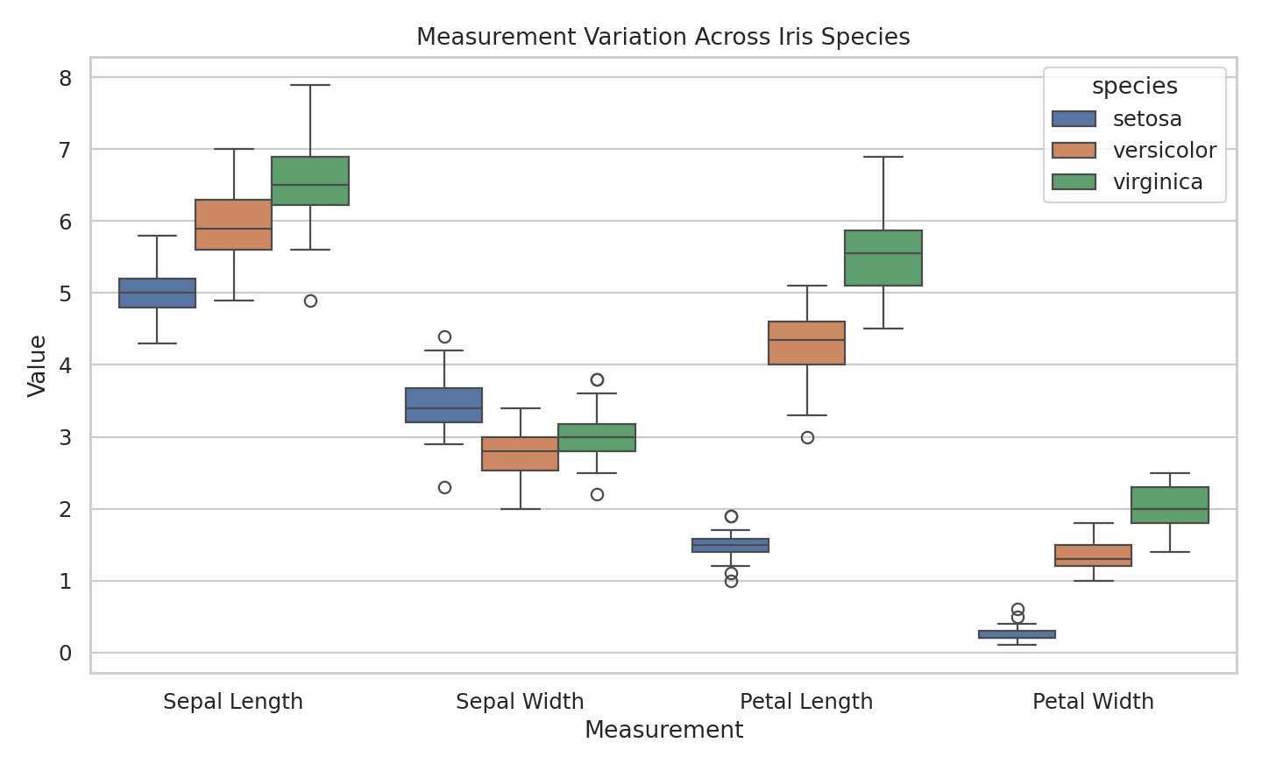
Figure 4: Box Plot – Variation by Species
The grouped box plot compares central tendency, spread, and potential extreme observations for each measurement across species. Petal measurements show clearer separation than sepal measurements.
Story contribution: This adds information about variation rather than only average values.

Figure 5: Scatter Plot with Trend
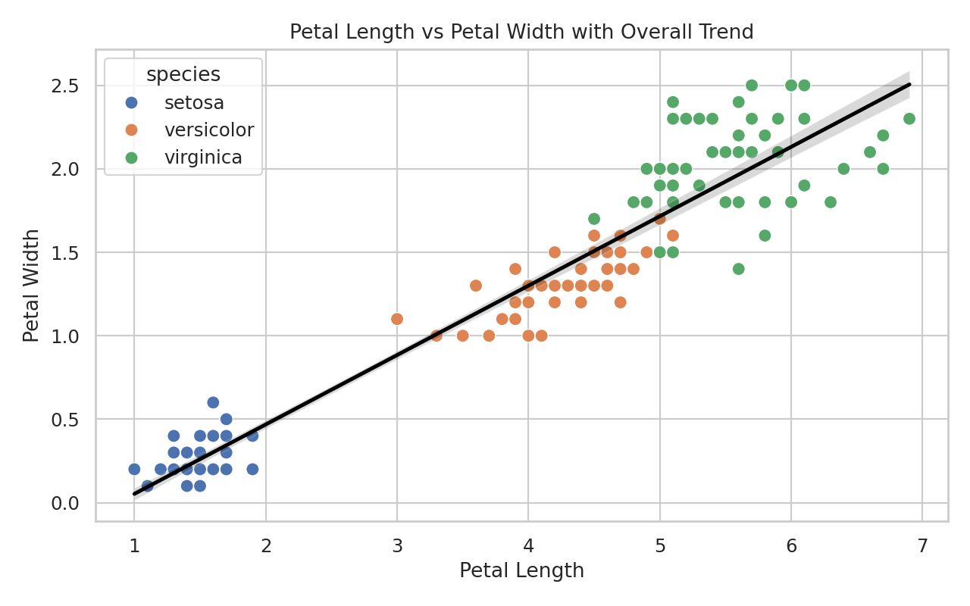
Figure 5: Scatter Plot with Trend
The scatter plot compares petal length and petal width, separates points by species, and adds an overall trend line. The upward trend shows that larger petal lengths generally correspond to larger petal widths.
Story contribution: This is a central part of the story because it combines correlation, clustering, and species comparison.

Figure 6: Parallel Coordinates – Standardized Profiles
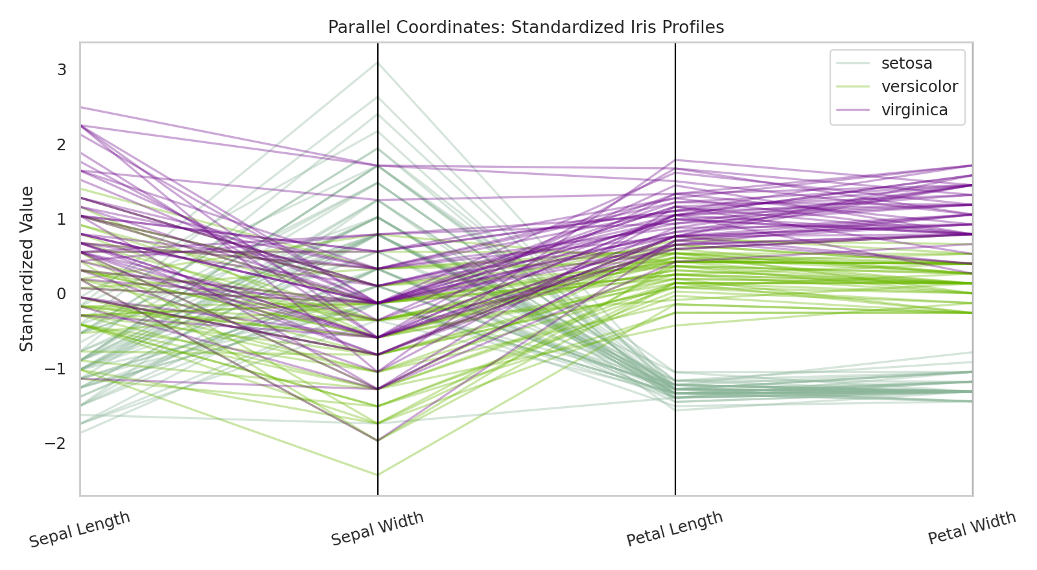
Figure 6: Parallel Coordinates – Standardized Profiles
The parallel coordinates chart compares all four measurements on a common standardized scale. It allows each species to be viewed as a complete multivariate profile.
Story contribution: This final visualization brings the individual findings together into one overall comparison.

6. Key Insights
- Petal length and petal width show a strong positive relationship and are particularly informative for distinguishing species.
- Setosa forms a comparatively distinct group, especially in petal measurements.
- Versicolor and virginica show more overlap in some measurements, but petal dimensions still provide useful separation.
- Sepal measurements show more overlap across species than petal measurements.
- Using several chart types reveals more information than relying on a single visualization.
- Standardized parallel coordinates allow comparison of complete species profiles across variables with different numerical scales.

7. Scientific and Practical Implications
The analysis demonstrates how visualization can support scientific exploration and classification problems. The clear separation created by petal measurements suggests that these variables can be useful inputs when building a classification model for iris species. More broadly, the same storytelling approach can be applied to scientific datasets where researchers need to compare groups, identify relationships, understand variation, and communicate findings to audiences without a statistical background. In practical analytics, selecting an appropriate chart can help stakeholders understand patterns quickly and focus on important findings.

8. Visualization Design Choices
Different chart types were deliberately used because no single visualization communicates every aspect of a dataset. The pair plot provides breadth, violin and box plots show distributions and variation, the heatmap summarizes correlations, the scatter plot explains a key relationship, and the parallel coordinates chart provides a final multivariate view. Titles, labels, legends, and captions were included to make the visuals understandable without advanced technical knowledge.

9. Estimated 32-Hour Work Plan
Activity | Estimated Time
Dataset selection and objective definition | 3 hours
Data preparation and exploratory review | 4 hours
Visualization planning and chart selection | 4 hours
Development of six visualizations | 10 hours
Chart refinement, labels, captions and storytelling | 4 hours
Insight interpretation and implications | 3 hours
Documentation, code organization and final review | 4 hours
Total | 32 hours

10. Tools and Technologies
Python, Pandas, Matplotlib, Seaborn, scikit-learn, and VS Code/Jupyter Notebook are suitable for reproducing the analysis.

11. Reproducibility
The accompanying Python script contains the visualization workflow. The analysis can be reproduced by installing the required Python libraries and running the script. The dataset is obtained programmatically through scikit-learn.

12. Conclusion
This project demonstrates how advanced visualization can turn a structured dataset into a coherent data story. Starting with an overall pair plot, the analysis moves through distributions, correlations, variation, a key feature relationship, and complete standardized profiles. The combined visuals show that petal measurements provide strong separation among Iris species and illustrate why thoughtful visual selection is important when communicating data-driven findings to a non-technical audience.

13. References
Scikit-learn documentation – Iris dataset (load_iris).
Seaborn documentation – statistical data visualization.
Matplotlib documentation – plotting and chart customization.
Pandas documentation – DataFrame analysis and parallel coordinates.

