COMPREHENSIVE DATA SCIENCE PROJECT
From Data Analysis to Machine Learning and Strategic Recommendations
Week 5 Final Internship Report

1. Executive Summary
This final project integrates the major data science skills developed during Weeks 1–4 into one cohesive workflow.
The work covers data acquisition and cleaning, exploratory data analysis, advanced visualization, statistical hypothesis testing,
machine learning model development, model evaluation, and interpretation of results. The final report focuses on turning
technical findings into practical strategic recommendations for stakeholders. Python and its data science ecosystem were used
throughout the internship, including Pandas, NumPy, Matplotlib, Seaborn, SciPy, and Scikit-learn.

2. Introduction
Data Science combines data preparation, statistical reasoning, visualization, machine learning, and communication of results.
The objective of this final-week project is to synthesize the work completed during the internship and demonstrate an end-to-end
data-driven approach. Instead of treating each weekly task as an isolated exercise, the final report connects the skills and
methods into a common analytical framework.

3. Internship Objectives
- Understand and perform data acquisition, cleaning, and exploratory analysis.
- Create meaningful visualizations to communicate patterns and relationships.
- Apply statistical tests and interpret hypothesis-testing results.
- Develop and evaluate a machine learning classification model.
- Translate analytical findings into strategic recommendations.
- Identify limitations and propose realistic future improvements.

4. Project Synthesis: Weeks 1–4
Week 1 established the foundation through data acquisition, data cleaning, descriptive statistics, and exploratory data analysis.
Week 2 extended the work through advanced visualizations and data storytelling. Week 3 introduced statistical inference through
hypothesis testing and interpretation of statistical significance. Week 4 applied supervised machine learning using Logistic
Regression on the Breast Cancer Wisconsin Diagnostic Dataset and evaluated the model using classification metrics, a confusion
matrix, and an ROC curve.
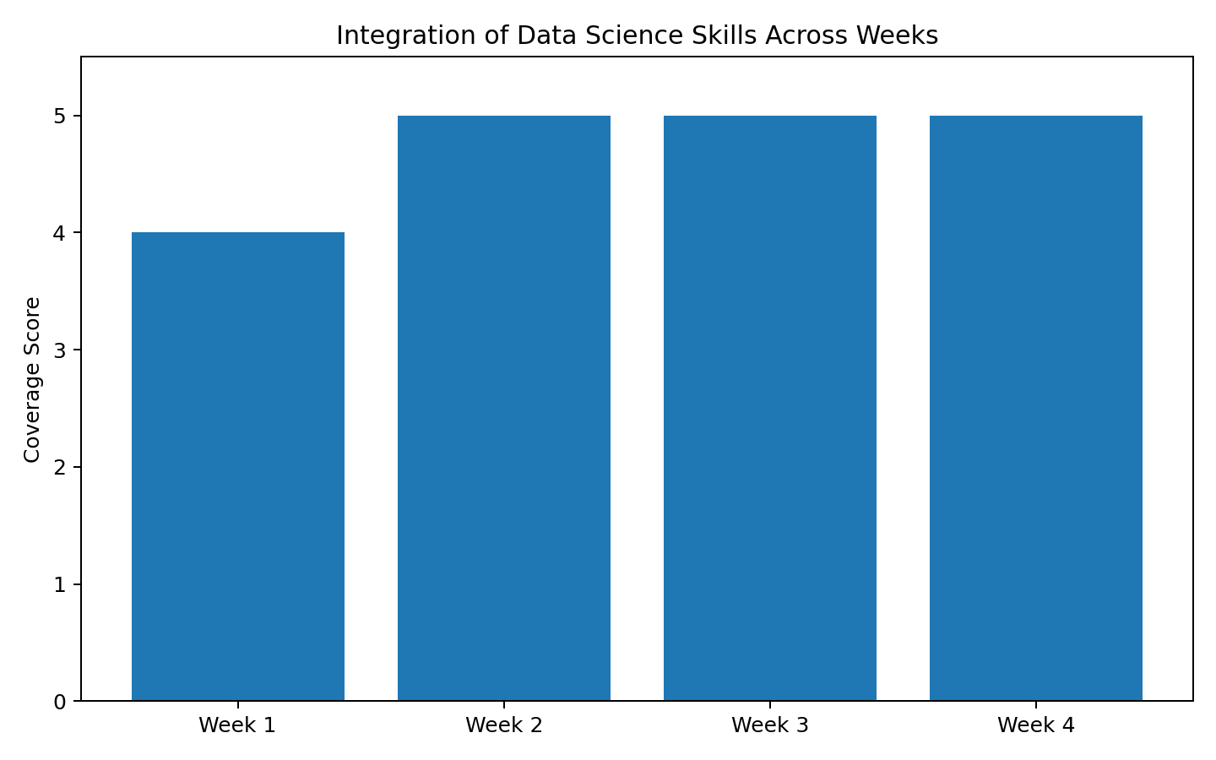
Figure 1. Integration of major data science skills across the internship.

5. Methodology
- Data understanding: identify variables, observations, target information, and analytical objectives.
- Data preparation: inspect missing values, data types, distributions, and potential quality issues.
- Exploratory analysis: use descriptive statistics and visualizations to identify patterns and relationships.
- Statistical analysis: apply suitable hypothesis tests and interpret p-values and confidence intervals.
- Machine learning: split data into training and testing sets, standardize features, and train Logistic Regression.
- Evaluation: calculate accuracy, precision, recall, F1-score, and ROC-AUC and inspect the confusion matrix and ROC curve.
- Interpretation: convert technical results into findings, recommendations, impacts, limitations, and future actions.

6. Machine Learning Component
The machine learning component uses the Breast Cancer Wisconsin Diagnostic Dataset available through Scikit-learn.
It contains 569 observations and 30 numerical features describing cell nuclei characteristics. The target is binary,
representing malignant and benign cases. An 80:20 stratified train-test split was used with random_state=42.
StandardScaler was fitted only on the training data and then applied to the test data to avoid data leakage.
Logistic Regression was selected because it is appropriate for binary classification and provides an interpretable baseline model.

7. Model Evaluation Results
Metric | Score
Accuracy | 0.9825
Precision | 0.9861
Recall | 0.9861
F1-score | 0.9861
ROC-AUC | 0.9954
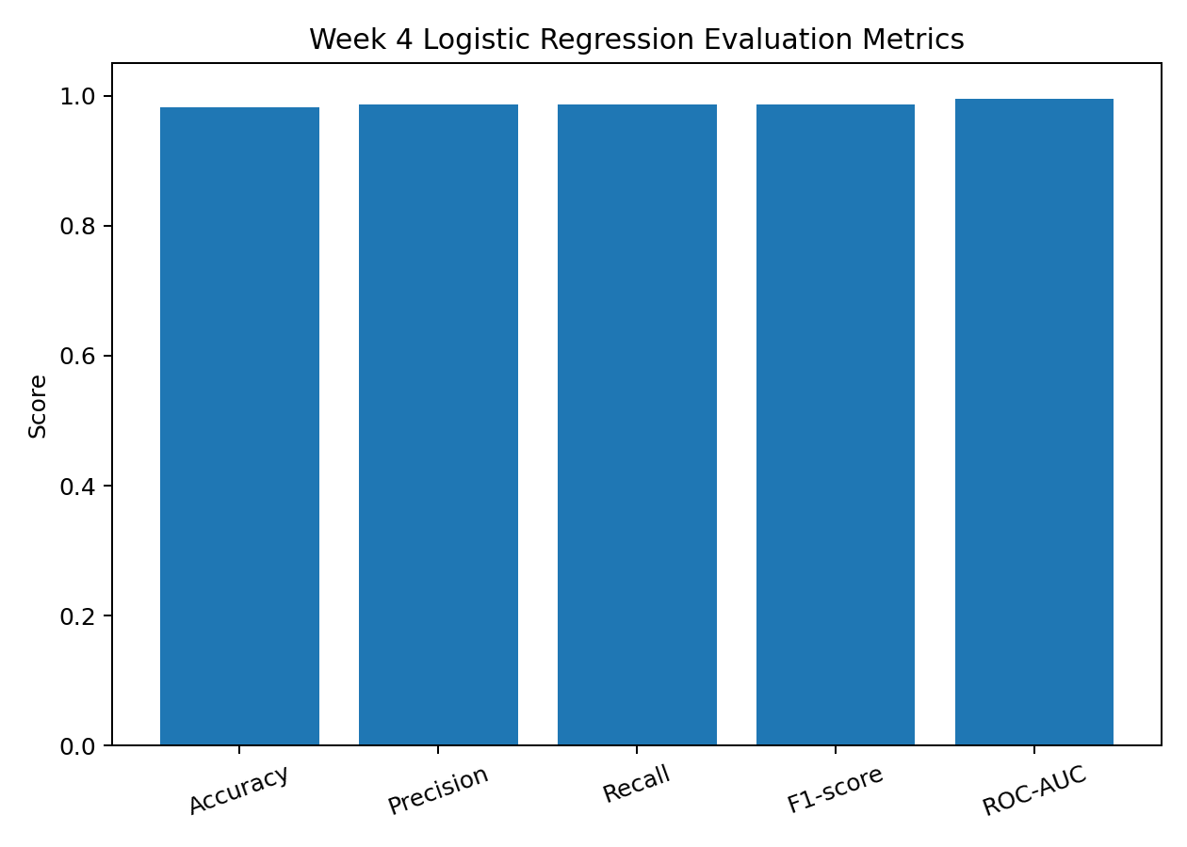
Figure 2. Logistic Regression performance metrics.

8. Confusion Matrix Analysis
The confusion matrix provides a detailed view of correct and incorrect classifications. True positives and true negatives
represent correct predictions, while false positives and false negatives represent classification errors. In a classification
problem related to medical screening, false negatives deserve particular attention because a missed positive case can have a
greater practical consequence than a false positive. Therefore, recall should be monitored alongside overall accuracy.
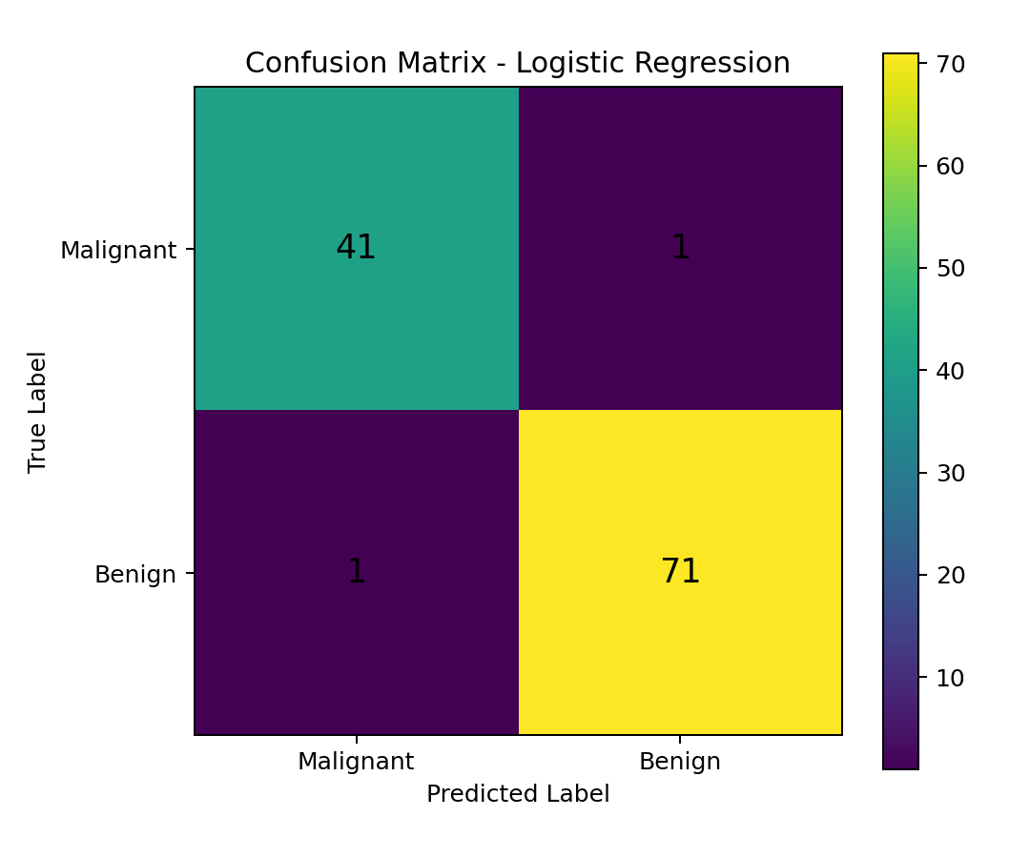
Figure 3. Confusion matrix for the Logistic Regression model.

9. ROC Curve Analysis
The ROC curve illustrates the trade-off between true-positive rate and false-positive rate across classification thresholds.
The ROC-AUC value summarizes the model's ability to distinguish between the two classes. A value closer to 1 indicates stronger
discriminative performance, while a value near 0.5 indicates performance close to random classification.
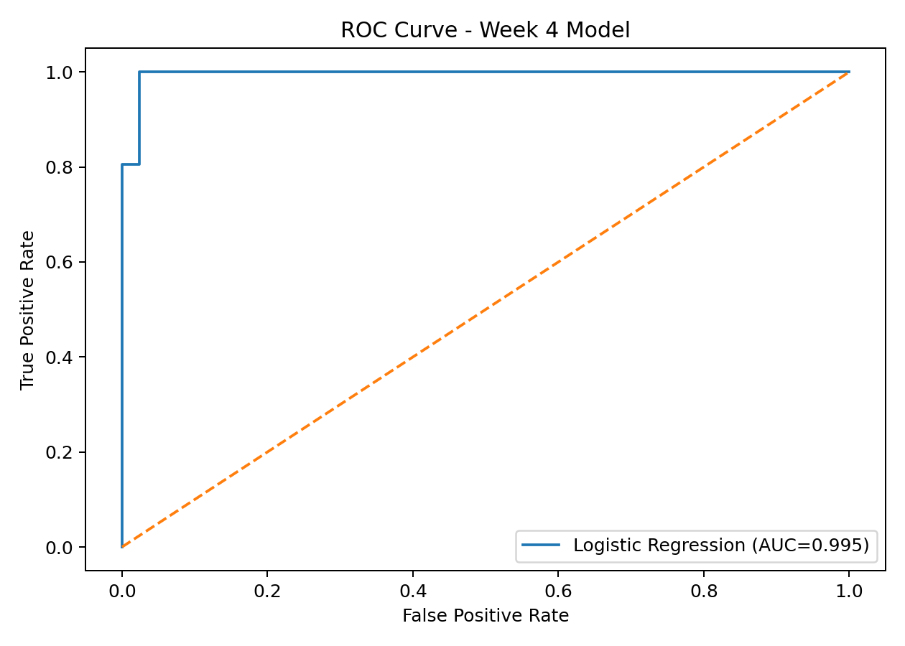
Figure 4. ROC curve for the Logistic Regression model.

10. Key Findings
- Data preprocessing is an essential step because inconsistent scales can affect machine learning algorithms.
- Visualization makes patterns, distributions, and relationships easier to interpret than raw tables alone.
- Statistical testing provides evidence for deciding whether observed differences or associations are likely to be meaningful.
- Logistic Regression provides a clear and interpretable baseline for binary classification.
- Multiple evaluation metrics should be considered rather than relying only on accuracy.
- The confusion matrix helps identify the types of errors that may require attention.
- The ROC curve provides a threshold-independent view of classification discrimination.

11. Strategic Recommendations
Use a structured data preparation pipeline. Standardize preprocessing, validate input quality, and prevent data leakage before model training.
Monitor class-specific performance. Track recall, precision, and the confusion matrix instead of using accuracy alone, especially when error costs differ.
Compare multiple models. Use Logistic Regression as a baseline and compare it with Decision Trees, Random Forest, Support Vector Machines, or other suitable methods.
Use cross-validation and tuning. Apply cross-validation and controlled hyperparameter tuning to obtain more reliable estimates of model performance.
Improve data quality and coverage. Collect larger and more diverse observations to improve generalization and reduce sampling-related limitations.
Communicate findings visually. Use concise charts and clear explanations so technical findings can support stakeholder decision-making.

12. Business and Research Impact
A structured data science workflow can improve decision-making by replacing assumptions with measurable evidence.
In a business setting, the same workflow can be used for customer analytics, risk assessment, forecasting, quality monitoring,
and operational optimization. In research-oriented applications, reproducible preprocessing, statistical validation, and model
evaluation can improve the credibility and repeatability of analytical findings. The key impact is not only the predictive model
itself but also the ability to explain what the data indicates and how stakeholders can act on it.

13. Error Analysis
Errors can arise from noisy observations, limited sample size, overlapping feature distributions, class imbalance, measurement
variation, or model assumptions. False positives and false negatives should be reviewed separately because their practical costs
may differ. Error analysis should therefore be connected to the actual decision context rather than interpreted only as a numerical
score.

14. Overfitting and Underfitting
Overfitting occurs when a model learns patterns that are too specific to the training data and performs poorly on unseen data.
Underfitting occurs when the model is too simple to capture useful patterns. The use of a separate test set, scaling based only on
training data, and future use of cross-validation can help assess and control these risks.

15. Code Documentation
Representative code used in the project:
X_train, X_test, y_train, y_test = train_test_split(
X, y, test_size=0.20, stratify=y, random_state=42
)
scaler = StandardScaler()
X_train_scaled = scaler.fit_transform(X_train)
X_test_scaled = scaler.transform(X_test)
model = LogisticRegression(max_iter=5000, random_state=42)
model.fit(X_train_scaled, y_train)
y_pred = model.predict(X_test_scaled)
y_prob = model.predict_proba(X_test_scaled)[:, 1]
accuracy = accuracy_score(y_test, y_pred)
f1 = f1_score(y_test, y_pred)
auc = roc_auc_score(y_test, y_prob)

16. Limitations
- The project combines educational datasets and exercises, so findings should not automatically be treated as production conclusions.
- The machine learning section uses a single primary classification algorithm as the baseline.
- The available dataset may not represent every real-world population or operating condition.
- Model performance can change when the data distribution changes.
- Statistical significance does not by itself establish practical or causal significance.

17. Future Improvements
- Perform cross-validation and systematic hyperparameter tuning.
- Compare Logistic Regression with additional classification algorithms.
- Perform feature selection and investigate feature importance.
- Test the workflow on larger and more diverse datasets.
- Add model calibration and threshold analysis where decision costs differ.
- Develop a reproducible pipeline for preprocessing, training, evaluation, and reporting.

18. 33-Hour Work Plan
Activity | Hours
Review and project synthesis | 4
Data preparation and quality checks | 5
Exploratory analysis and visualization | 5
Statistical interpretation | 4
Machine learning integration | 5
Evaluation and error analysis | 4
Strategic recommendations | 3
Report preparation and final review | 3
Total | 33

19. Conclusion
This final project demonstrates an end-to-end data science workflow by integrating the major concepts developed during the
internship. The work progresses from data preparation and visualization to statistical reasoning, machine learning, evaluation,
and strategic interpretation. The project also emphasizes that successful data science is not limited to building a model; it
requires reliable preparation, appropriate evaluation, clear communication, and recommendations that stakeholders can understand
and act upon.

20. References
- Scikit-learn documentation – classification, preprocessing, model evaluation, and datasets.
- Pandas documentation – data manipulation and analysis.
- Matplotlib and Seaborn documentation – data visualization.
- SciPy documentation – statistical testing.

