Shopping Cart f— Continue Shopping
20 items in your cart

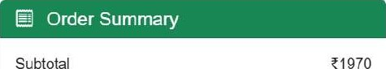
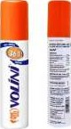
Volini Pain Relief Spray
Subtotal
Sun Pharma Consumer Healthcare e In Stock
Dalivcry by Tomorrow Discount
Delivery FREE

080
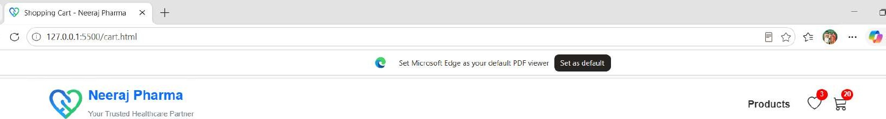
GST egg
Total 0069
Dolo 650 Tablet Have a coupon?
Micro Laos Ltd_
Apply
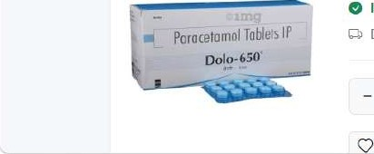
Enter coupon code
In
Stock
Delivery
by
Tomorrow
14
+
Sa
v
e
for
L
ater
Q490 
Q Secure checkout

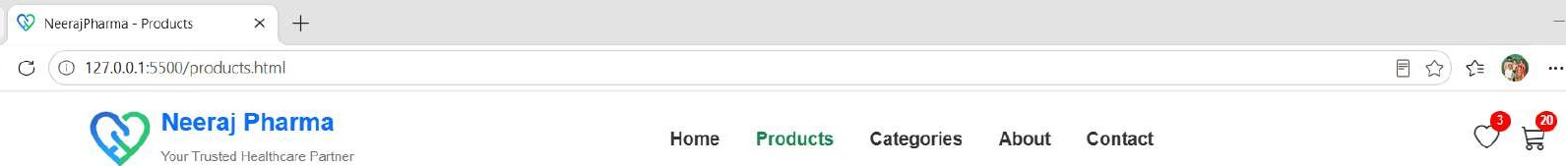
Our Products
Browse our healthcare products
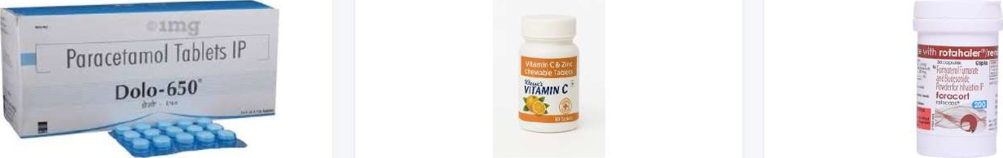
Dolo 650 Tablet | (0 | Vitamin C Tablets | Foracort 200 Rotacaps
Micro Labs Ltd. |  | Heeltt«art | Cipla Ltd.
Z35 |  | e250 | ?185
Back to Products

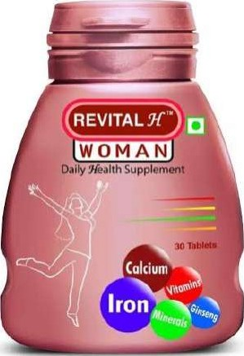

Revital H
Sun Pharma Consumer Healthcare
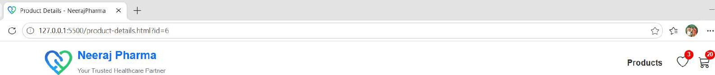
e In Stock

010

Product Description
Revital H is a daily health supplement containing vitamins and minerals.

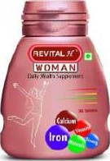

Revital H
Sun Pharma Consumer Healthcare
fi
010
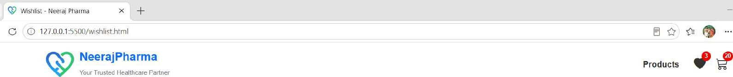
My Wishlist
Products you have saved for later
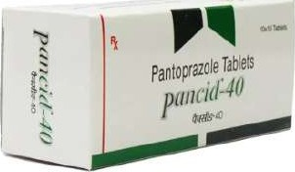

Pantocid 40mg Tablet
Sun Pharmaceutical Industries Ltd
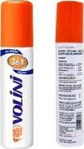

Volini Pain Relief Spray

Sun Pharma Consumer Healthcare

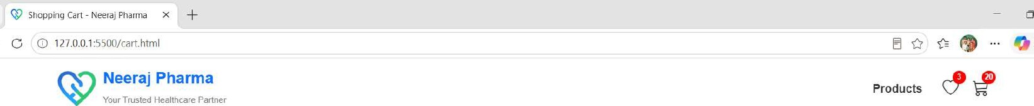Chat V


Shopping Cart
20 items in your cart

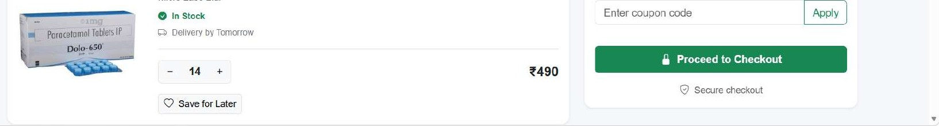
Volini Pain Relief Spray
Micro
Labs
Ltd.
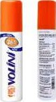
Sun Pharma Consumer Healthcare

Subtotal e1970
e In Stock
Delivery by Tomorrow Discount
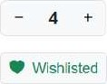
Delivery FREE
CST

080
Total 0069
Dolo 650 Tablet Have a coupon?

