FIVE:

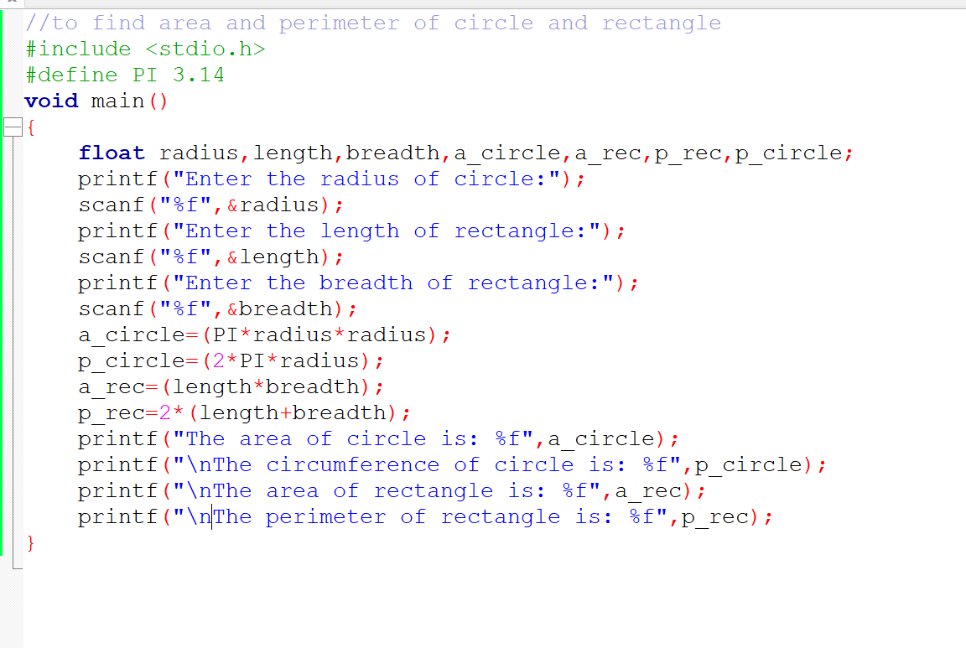To find area and perimeter of rectangle anf area and circumference of a circle

