BANK LOAN ANALYTICS DASHBOARD
Project Report
Tool: Microsoft Power BI Desktop (DAX), with a Python companion script
Dataset: financial_loan, 38,576 loan applications
Prepared for: Renalysis Consultants Pvt Ltd
Prepared by: [veera

1. Introduction
Banks earn from lending but lose money when borrowers default. To manage that trade-off, a lending team needs to see, in one place, how many loans were issued, how much money went out, how much has come back, and which kinds of loans tend to go bad.
This project builds an interactive Power BI dashboard on a bank loan dataset of 38,576 applications. It answers those questions through headline KPIs, a good-versus-bad loan split, and breakdowns by loan status, month, term, home ownership and purpose.

Objectives
- Track the core lending KPIs: applications, funded amount, amount received, average interest rate and average debt-to-income (DTI) ratio.
- Separate good loans from bad loans and measure the financial impact of each.
- Identify borrower and loan characteristics linked to higher risk.
- Give users slicers so they can filter the whole report by loan purpose and grade.

2. Data and Tools
The report uses a single table, financial_loan, with one row per loan application. The fields used are loan ID, state, grade, home ownership, issue date, loan status, purpose, term, DTI, interest rate, loan amount and total payment.
Tool | Use
Power BI Desktop | Data model, DAX measures, report pages and interactivity
DAX | KPI measures such as Total Loan Application, Good Loan % and Bad Loan %
Python (pandas, matplotlib) | Companion script that reproduces the KPIs and charts from the raw file

3. KPI Definitions
KPI | Definition
Total Loan Application | Number of loan applications (count of loan IDs)
Total Funded Amount | Sum of the loan amounts issued
Total Amount Received | Sum of the payments received from borrowers
Average Interest Rate | Mean interest rate across loans
Average DTI Ratio | Mean debt-to-income ratio of borrowers
Good Loan % | Share of applications with status Fully Paid or Current
Bad Loan % | Share of applications with status Charged Off

4. Dashboard Design
The report has two pages in a dark theme with gold accents. Both pages share the same header, KPI strip and navigation.

Summary page
- Good Loan and Bad Loan panels, each with a donut chart showing the share of applications, plus that group's applications, funded amount and amount received.
- Four column charts by loan status: funded amount vs repayment, loan applications, average interest rate and average DTI ratio.

Overview page
- Monthly Loan Applications line chart.
- Loan Applications by Term (donut), Home Ownership (bar) and Purpose (treemap).
- A map of applications by state, built with the Azure Maps visual.

Interactivity
- Grade buttons (A to G) and loan purpose buttons filter every visual on the page.
- A Reset Filters button and Summary / Overview navigation buttons.

5. Key Findings

5.1 Portfolio headline numbers
Metric | Value
Total loan applications | 38,576
Total funded amount | 435.8M
Total amount received | 473.1M
Average interest rate | 12.05%
Average DTI ratio | 13.33%
The bank has received 37.3M more than it lent out, a net return of about 8.6% on funded amount. The average loan is roughly 11,300 (435.8M across 38,576 loans).

5.2 Good loans versus bad loans
Measure | Good loans | Bad loans | Total
Share of applications | 86.18% | 13.82% | 100%
Applications | 33,243 | 5,333 | 38,576
Funded amount | 370.2M | 65.5M | 435.8M
Amount received | 435.8M | 37.3M | 473.1M

- Good loans drive the profit. They returned 435.8M on 370.2M funded, a gain of about 17.7% (65.6M).
- Bad loans lose money. Charged-off loans returned 37.3M on 65.5M funded, recovering about 57% and leaving a shortfall of roughly 28.2M.
- Bad loans are a minority by count. About 1 in 7 applications (13.82%) is charged off, yet these loans hold 15% of the money lent.

5.3 Loan status
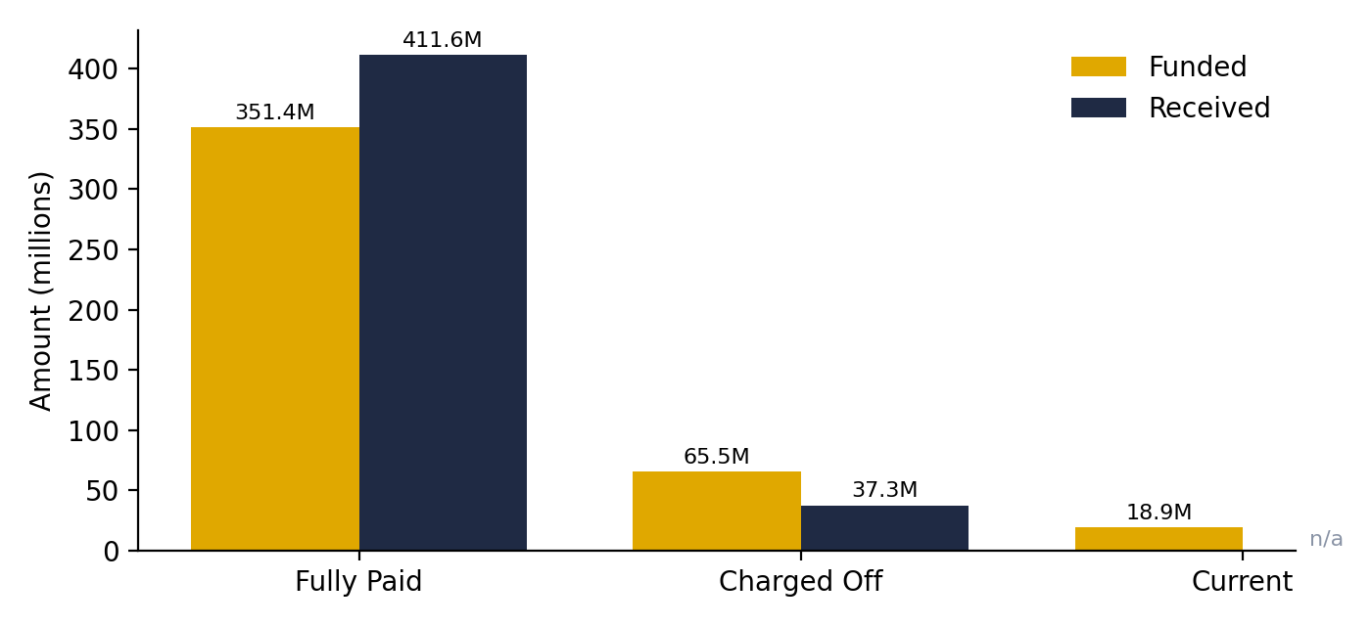
Figure 1. Funded vs received amount by loan status (Current loans are still being repaid)
Fully Paid loans account for about 32.1K applications and 351.4M funded, and returned 411.6M. Charged Off loans account for 5.3K applications and 65.5M funded. Current loans are a small group of about 1.1K applications and 18.9M funded.

5.4 Interest rate and DTI by loan status
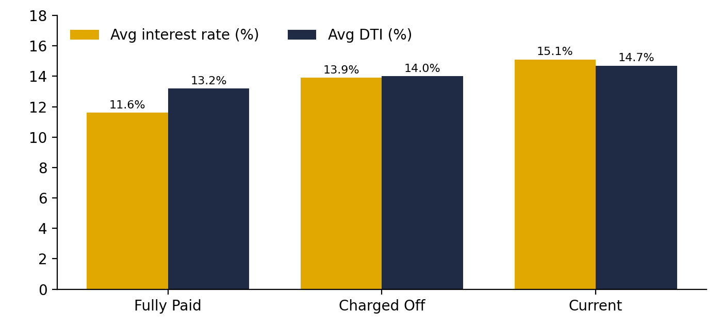
Figure 2. Average interest rate and DTI ratio by loan status
- Charged Off loans carry an average interest rate of 13.9%, compared with 11.6% for Fully Paid loans, a gap of 2.3 percentage points. Current loans have the highest average rate at 15.1%.
- Average DTI is also higher for Charged Off loans (14.0%) than for Fully Paid loans (13.2%). The gap is small, so DTI alone is a weak warning signal.
- Higher-rate loans are likely riskier loans priced accordingly, but the higher rate does not fully protect the bank against losses.

5.5 Application trend
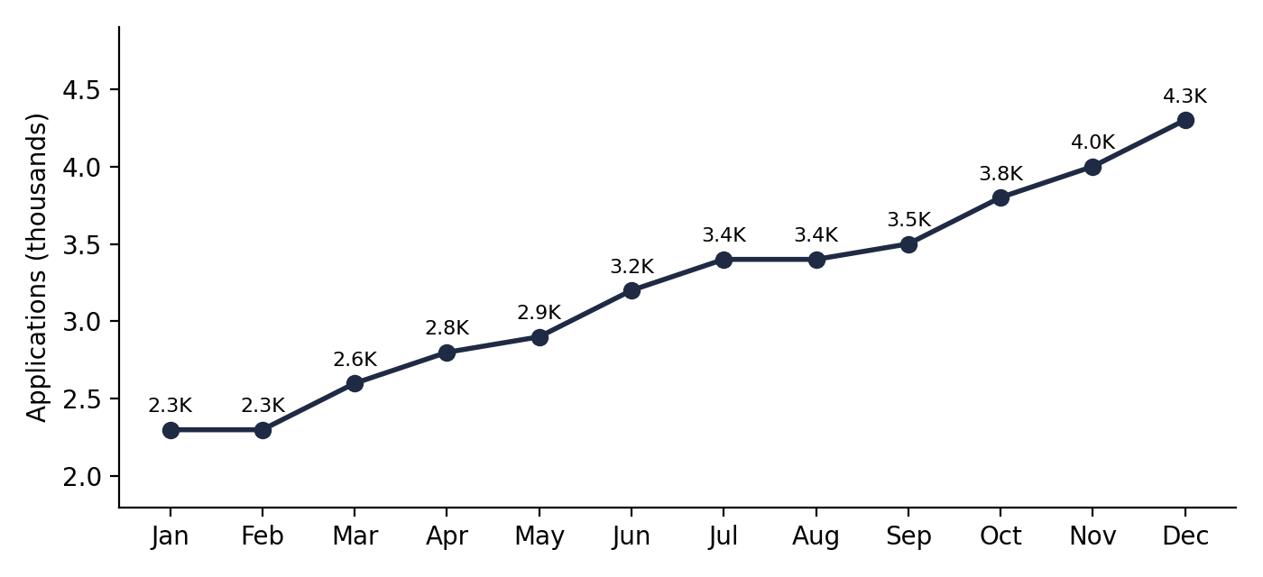
Figure 3. Monthly loan applications
Applications grew almost every month, from 2.3K in January to 4.3K in December, an increase of about 87%. Growth was steady rather than seasonal, which points to expanding demand or wider marketing reach.

5.6 Borrower and loan profile
Segment | Applications | Share
Term: 36 months | about 28K | 73.2%
Term: 60 months | about 10K | 26.8%
Home ownership: Rent | 18,439 | 47.8%
Home ownership: Mortgage | 17,198 | 44.6%
Home ownership: Own | 2,838 | 7.4%
Home ownership: Other / None | 98 / 3 | under 0.3%

- Nearly three in four loans are 36-month loans, so most exposure is short to medium term.
- Renters and mortgage holders make up over 92% of borrowers.
- Debt consolidation is by far the largest purpose at about 18K applications (close to half the total), followed by credit card (about 5K), other (about 4K) and home improvement (about 3K).

6. Recommendations
- Monitor the bad loan rate as a headline KPI. Set a target below the current 13.82% and track it monthly.
- Review risk-based pricing. Charged-off loans average a higher rate than Fully Paid loans, so pricing appears to reflect risk but not enough to cover the losses. Test whether the highest-risk grades need tighter approval rules.
- Look closer at grade and purpose. Use the slicers to compare bad loan % across grades A to G and across purposes, especially debt consolidation, which is the largest group.
- Watch the growth in applications. Rapid growth can bring weaker credit quality, so check whether the newest months have a higher bad loan share once they mature.
- Improve recovery. Recovering about 57% of funded amount on charged-off loans leaves room for earlier collection and follow-up.

7. Limitations and Future Work
- The figures in this report are read from the dashboard and are rounded as displayed. Chart values marked "about" are approximate.
- The state map could not be displayed on the machine used for this report because the Azure Maps visual needs a tenant setting that was disabled. State-level findings are therefore not covered.
- The findings describe patterns in the data. They show association, not cause, and Current loans have not reached their final outcome yet.
- Future work: add a grade-level and purpose-level bad loan % view, month-to-date and month-over-month KPIs, and a predictive default model in Python.

8. Conclusion
The dashboard gives a clear view of a 38,576-loan portfolio that funded 435.8M and received 473.1M. The portfolio is healthy overall, with 86.18% good loans and a net gain of 37.3M, but the 13.82% of bad loans leave a shortfall of about 28.2M. Tracking that share by grade, purpose and month is the most useful next step for managing lending risk.

