AgroVeda: Deep Learning Based Crop Disease Prediction and Adaptive Recommendation System

Dr. J. Jeya A Celin
Department of Information Technology
Kalasalingam Academy of Research and Education
Krishnankoil, Tamil Nadu, India
jeyacelin@klu.ac.in
I.P. Prabarani
Department of Information Technology
Kalasalingam Academy of Research and Education
Krishnankoil, Tamil Nadu, India
9922008113@klu.ac.in
Rajkumar Pandiarajan
Department of Information Technology
Kalasalingam Academy of Research and Education
Krishnankoil, Tamil Nadu, India
p.rajkumar@klu.ac.in
Soundariyan TV
Department of Information Technology
Kalasalingam Academy of Research and Education
Krishnankoil, Tamil Nadu, India
9922008173@klu.ac.in
Veeralakshmi U
Department of Information Technology
Kalasalingam Academy of Research and Education
Krishnankoil, Tamil Nadu, India
9922008182@klu.ac.in
Mathiswaran P
Department of Information Technology
Kalasalingam Academy of Research and Education
Krishnankoil, Tamil Nadu, India
9922008227@klu.ac.in

Abstract— The conventional approaches that are adopted for the diagnosis of plant diseases are highly dependent on the inspection of the plant and laboratory examination of the same. Not only is it a time-consuming task, but it also requires the expertise of a specialist in the field. The hindrances in obtaining qualitative diagnosis of the plant are also contributing to the delay in the diagnosis of the health of the crop. Even though some digital models have been initiated for assisting in the diagnosis of diseases in plants, it is still facing some challenges in terms of the rigid rule applied in it, lack of representation of diversity in it, lack of facility for real-time analysis, and lack of guidance for corrective measures. To overcome all these limitations, this paper introduces a mobile prediction and recommendation system for plant disease management using deep learning algorithms. The proposed method is highly dependent on the CNN algorithm for plant disease prediction by analyzing the leaf of the plant using the smartphone camera. After prediction, it also gives accurate recommendations for crops, such as treatment procedure, dosage, and prevention, to avoid or reduce the occurrence of diseases. In this technology, predictive analysis and a highly advanced recommendation engine will enable you to make more informed decisions at your earliest convenience and to have the ability to intervene at your convenience as well. The experimental analysis of this method is efficient in predicting diseases and giving accurate recommendations for crops, which reduces losses in agriculture.
Keywords—sustainable agriculture, plant disease prediction, precision farming, deep learning, computer vision, smart farming systems, crop health monitoring, food security, decision support systems, convolutional neural network, algorithm

Introduction
Plant diseases have been one of the most challenging issues that have been affecting, agricultural production and food security worldwide. Early and correct diagnosis of plant diseases is extremely important in reducing the effects of diseases on crops and enhancing the quality of the produce. Conventional methods of disease diagnosis have been carried out by human vision or expert opinion, which is often time-consuming and not easily available to farmers, especially in rural areas. These drawbacks have resulted in increasing interest in the use of automated systems for plant disease prediction. Machine learning algorithms have been recently explored extensively for plant disease diagnosis using leaf image analysis. Soni V K and Soni P [1] showed the potential use of classical machine learning algorithms for plant disease prediction; however, these algorithms are highly dependent on hand-engineered features and are not robust for complex visual patterns. To overcome the disadvantages, deep learning algorithms have gained considerable attention in plant disease prediction because of their ability to automatically learn discriminative features from images. Akshai and Anitha [2] used CNNs for plant disease classification and obtained better results than traditional and conventional methods. In the same way, Islam et al. [3] also developed a deep learning-based crop disease prediction system with a web interface, specifically focusing on CNN-based systems for real-time systems. Nevertheless, in spite of such advancements, the existing systems are found to be focused mainly on disease prediction, whereas solutions are not being provided for disease severity estimation and post-prediction recommendation. From the review of studies by Sharma and Shrivastava [4] and Nandhini and Ashokkumar [5], it is found that most of the existing systems lack the ability to provide a comprehensive decision-support system, which is very much required in agriculture applications.
In this regard, this paper proposes the design of an intelligent plant health analysis system using a novel deep learning framework, named AgroVeda, which not only predicts plant diseases from images of leaves but also provides solutions for disease severity estimation and recommendation systems.

Related Works
Recent research work has focused on employing various machine learning and deep learning techniques to resolve the challenges in plant disease identification and plant crop recommendation and decision-making in the agricultural domain. Research work is diverse based on the data used and the models developed for the domain of interest. It includes machine learning and complex deep learning techniques with recommendation system capabilities. This section is focused on the existing research work to understand the level of advancement and challenges in the domain that the proposed AgroVeda system is trying to resolve.
Wang et al. [6] in their research work have explained the extensive review of the application of deep learning models in plant disease and pest identification, especially the efficiency of CNN in image processing. In the research work, the authors have explained the usage of complex models in agricultural observation as well as the challenges faced in the application of the models in real-time scenarios.
A detailed analysis on the use of ML models in crop disease and pest classification was provided by Domingues et al. [7]. They discussed the use of traditional ML and DL models. They stated that the use of DL models is more accurate; however, the majority of the models are only able to perform the identification task and are not able to provide a decision support system.
Isinkaye et al. proposed the integration of DL models and content-based filtering models for the improvement of the identification and treatment of plant diseases[8]. The proposed model was successful in improving the content-based filtering model's performance in providing recommendations; however, the model was highly dependent on the content.
A novel model for the recommendation of prescriptions for plant diseases was proposed by Ding et al. [9] using sentence embedding and retrieval-based model. The model was based on the electronic medical record model. The model was highly dependent on text-based data rather than the visual symptoms of the plants.
Islam et al. [10] developed a DL-based system known as PlantCareNet. It was able to identify the diseases and provide advice on prevention. The authors were successful in demonstrating the use of the identification and advice-giving method; however, the method for advice-giving was limited in the predefined advice provided.
Choudhary et al. [11] developed a precision agriculture system based on the integration of crop recommendation and plant disease classification using ML algorithms. The authors were successful in developing the system; however, the system was limited in its use for the macro-agricultural severity analysis and feature extraction from the images of the leaves.
Isinkaye and Erute [12] developed a smartphone app for the diagnosis and recommendation of the treatment of the diseases in the plants. Although the app was developed for the mobile device and was user-friendly, the algorithms were based on the traditional ML algorithms and were ineffective in the complex visual environment.
Revathi and Arivuselvam [13] developed the ML algorithm for the prediction and diagnosis of the diseases in the crops and provided personalized recommendations. Although the app was personalized in nature, it was not based on the DL algorithm and the visual analysis platform.
Gosai et al. [14] presented a crop recommendation system based on ML algorithms for soil and environmental conditions. Although the application was not directly related to disease diagnosis or prediction, it was still a supporting application for leaf image-based disease prediction.
A review of DL algorithms used in the context of plant disease diagnosis was presented by Khalid and Karan [15]. The authors compared the efficacy of different DL algorithms and concluded that CNN-based models are more accurate than traditional models. However, they also emphasized the importance of integrating disease prediction and recommendation.
One of the pioneering works related to DL algorithms in the context of image-based plant disease diagnosis was presented by Mohanty et al. [16]. Although the authors did not emphasize disease severity prediction, they successfully demonstrated the potential of CNNs in agricultural applications.
The recent advancements in DL algorithms used in the context of plant disease diagnosis were discussed by Shoaib et al. [17]. The authors focused on ensemble models, including hybrid models. Although they did not emphasize disease severity prediction, they highlighted the importance of developing explainable models as well as multi-task models.
Hasan et al. [18] presented an ensemble ML model based recommendation system for crop growth prediction. Though the system was effective in crop recommendation, the specific aspects of disease prediction, as well as image-based diagnosis, were not considered.
Ibrahimpatnam et al. [19] presented a system that incorporated fertilizer recommendation and disease prediction using DL models. Though the system incorporated various aspects of agriculture, the specific aspects of attention, as well as disease severity-based treatment, were not considered.
Selvi and Poornima [20] presented a soil-based fertilizer recommendation system, along with a crop disease prediction system. Though the system was effective, the specific aspects of image-based disease diagnosis using DL models were not considered.

Proposed System
The proposed system, AgroVeda, is an intelligent image based plant health assessment system that aims to identify plant diseases and provide recommendations based on their severity. Unlike the traditional plant disease identification systems, which are only concerned with classification, AgroVeda integrated visual reasoning with DL algorithms and a knowledge driven recommendation system to provide interpretable and explainable outputs. The existing plant disease prediction systems are likely to have low adaptability to real-world scenarios for farmers and agricultural experts.
AgroVeda addresses the above issues by using a new DL architecture called AgroVeda-Net, which combines multi branch feature extraction, attention refinement, dual prediction heads, and a rule based recommendation system. The system also allows for continuous user interaction and feedback, which can be used for future improvements. The entire architecture is designed to ensure correct plant disease identification, valid severity analysis and useful agricultural advice.

Key Features of AgroVeda

Multi-Branch Feature Learning:

The general models for plant disease diagnosis would normally require a single CNN model for the extraction of features from the leaf images. However, the ability of this model to learn different biological features is limited since plant diseases can be modeled using a wide range of visual features such as texture, color and structure changes.
The AgroVeda model is able to overcome the limitation of the above model by using a multi-branch CNN model. In this model, each branch is designed to learn a specific type of visual feature, which includes texture-related features such as spots and lesions, color-related features such as chlorosis and discoloration and structure-related features such as leaf curling and edge damage.

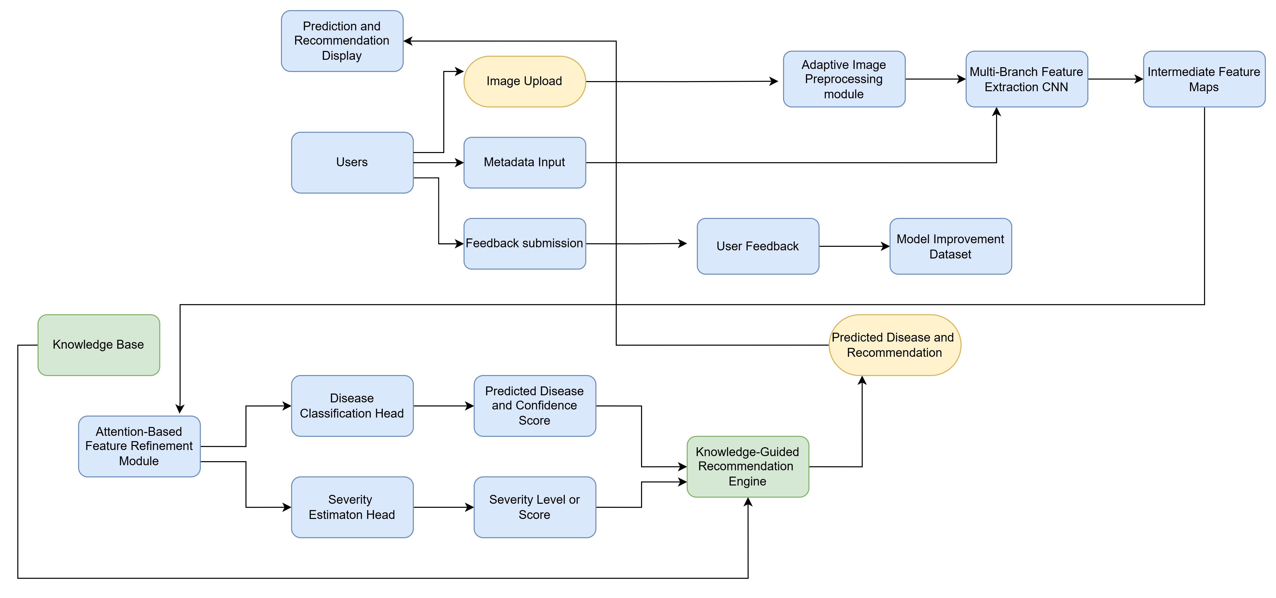
- Architecture Diagram of our AgroVeda-Net. (The figure illustrates the overall architecture of the proposed deep learning–based crop disease prediction and adaptive recommendation system. The framework integrates image preprocessing, multi-branch CNN feature extraction, attention-based refinement, disease classification, severity estimation, and a knowledge-guided recommendation engine with user feedback for continuous improvement.)

Attention-Based Region Focus
Most of the deep learning models are prone to treating the whole image equally, including the background sections of the images that do not contribute to the identification of the disease. This normally results in noise in the predictions. In order to reduce the problem of noise in the predictions, AgroVeda has employed an attention mechanism for feature refinement. This feature of the model utilizes the spatial and channel attention mechanisms in order to focus on the leaf that has been affected by the disease, thereby ignoring the irrelevant background information. This ensures that the model is focused on the relevant sections of the images. The attention feature of the model is also beneficial in improving the interpretability of the model since it is based on visually interpretable sections of the images, such as leaf curling and edge damage.

Severity Aware Disease Assessment
Most of the existing systems for plant disease identification are limited to providing outputs in the form of names of the diseases without taking into consideration the level and severity of the disease. The severity of the disease is an important factor in determining the level of treatment required.
The AgroVeda system provides a solution for this by including a separate module for severity estimation in addition to the module for disease classification. The severity estimation module estimates the severity of infection and classifies it into different levels such as mild, moderate, etc.

Confidence Driven Prediction
For most cases involving AI-based systems in agricultural prediction, the predictions are carried out without giving any idea about the reliability of the prediction. This influences the level of trust that can be placed in the prediction and can cause incorrect decisions.
AgroVeda makes the prediction reliable through the generation of confidence scores along with the predicted class of the disease. This confidence score gives the user an idea about the reliability of the prediction carried out.

Knowledge Guided Recommendation System
The platforms available might give recommend-ations in the form of generalized information, which might not vary with the severity of the disease or the condition of the plant. It might not be an effective or suitable approach. AgroVeda has an engine of knowledge-guided recommendations, which translates predictions into Agri-recommendations.

Deep Learning Model Architecture (AgroVeda-Net)
The intelligence of the AgroVeda application is based on the DL architecture that has been designed particularly for the application and is named AgroVeda-Net architecture. AgroVeda Net is particularly designed for plant disease analysis in real-field conditions. The design of the proposed architecture is such that it can handle the different visual symptoms of the disease. The proposed architecture is based on the conventional single-stream CNN architecture. However, in the proposed architecture, a module of multi-task learning is used in order to ensure accurate disease prediction as well as severity estimation.
The design of the proposed architecture is such that multiple modules are used in the proposed architecture. Each module is designed in such a way that it can solve the problem related to plant disease detection.

Input Layer
The input layer of AgroVeda-Net is designed in a way that it can take images in RGB format of the plant leaf. The images can be captured using a camera or a mobile phone and the images of the leaf can vary significantly in resolution, illumination, background, and noise, etc. These images can vary significantly because of the uncontrolled environment in which they are captured. Hence, the architecture of AgroVeda-Net is designed in a way that it can process images without any constraints.
The images can have some context as well. The context can be related to the type of crop, crop stage, and conditions of cultivation, etc. This is not necessarily required for the prediction process and can be utilized by other modules of the architecture as well. The other modules of the architecture that can utilize this information are the recommendation engine.

Adaptive Image Preprocessing Module
The images received as input are processed through an adaptive image preprocessing module. This module aims at improving the quality of the images received as input and it is a crucial part of the architecture of AgroVeda-Net.
The preprocessing module of AgroVeda-net is different from other traditional static image processing techniques, as the normalization operation is dynamically adjusted according to the characteristics of the image.

Multi-Branch Feature Extraction CNN
The feature learning capability of the AgroVeda-Net is based on the multi-branch feature extraction CNN model.
Unlike other networks, in the AgroVeda-Net, instead of using a single convolutional layer for feature extraction, multiple branches of convolutional layers are used, each designed specifically for the feature extraction of certain features:

Texture Feature Branch: This branch is designed to learn different features such as fungal growth, speckles, lesions, and abnormal textures, amongst others. This is achieved by using small convolutinal filters that are able to detect minute differences in texture, which may be attributed to infection.

Color and Vein Pattern Branch: This branch is designed to learn various features such as color changes and vein abnormalities. It is also able to learn features such as yellows, browns, chloroses, and vein discolorations, amongst others, which are normally attributed to infections and nutrient deficiencies.
Each branch works on the pre-processed image and the corresponding feature maps for the individual branches are computed. Finally, the overall feature map is developed through the concatenation of the features of all the individual branches.

Attention Based Feature Refinement Module
This combined feature representation is then used as input to the attention-based feature refinement module to enhance the discriminative ability of the suggested model, i.e., AgroVeda-Net. In complex field images, the features of the background, such as soil, stems, and illumination, might interfere during the prediction process.
To improve the prediction results, the suggested model applies attention mechanisms to complex field images:

Spatial Attention: Focuses on the disease affected areas of the leaves and ignores the background.

Channel Attention: Gives higher weights to the channels that play an important role in disease discrimination.
Therefore, the proposed model can focus on the important areas of the leaves and improve the results.

Dual Prediction Heads (Multi-Task Learning)
After the application of the attention-based refinement mechanism, the obtained feature maps are subjected to simultaneous processing via two parallel prediction heads.

Disease Classification Head: The head of the disease classification is the combination of fully connected layers and the softmax activation function. This is used to classify the probable disease that is related to the input image of the leaf. The softmax function is also used to calculate the values required to compute the confidence score values.

Severity Estimaton Head: Parallelly, the severity estimation head is used for the evaluation of the severity of the infection. The head classifies the level of the disease as mild, moderate, or severe. The level of the disease is a critical factor in the evaluation of the level of progression of the disease.
Thus, the application of multi-task learning enables the AgroVeda-Net model to be efficient as well as effective.

Recommendation Algorithm
The importance of the recommendation algorithm in AgroVeda should be highlighted in its ability to translate results from disease prediction to useful recommendations for agriculture.

Inputs to the Recommendation Algorithm
To make it more accurate and flexible, the AgroVeda recommendation engine takes various inputs from different modules of the systems:

Predicted Disease: The disease class detected by the disease classification head of AgroVeda-Net acts as the first input to the engine. Each disease class has a set of pre-defined treatment and prevention protocols stored in its knowledge base.

Severity Level: The severity estimation head identified the severity. It affects the urgency and type of suggested actions based on the dosage.

Confidence Score: The score, which is the reliability of the prediction is used to adjust the recommendations based on the confidence.

Agricultural Knowledge Base: The knowledgebase will consist of rules that have already been verified by experts.

Knowledge Base Structure
A knowledge base is a dataset that follows a rule-based structure in order to guarantee transparency and safety of decisions made from it. A knowledge base included the following datasets:

Disease Treatment Mapping Dataset: This dataset maps diseases and their suitable chemical, biological, or cultural treatments.

Preventive Practice Dataset: This dataset comprises the appropriate practices to prevent the recurrence of the disease, which may include irrigation control, sanitation, and crop rotation.

Crop Care and Nutrient Guidelines: This data set includes the nutrient guidelines to assist the recovery process of the plant. Each rule in the knowledge base follows a structured format:
If Disease  D AND Severity  S 
Then
Then Apply Recommendation Set R 2)

Recommendation Generation Process
The recommendation engine follows the following process during the inference process:

Disease Identification Validation: The identified disease is validated based on the application of the confidence threshold. If the confidence level is less than the threshold limit, the recommendation might include careful consideration.

Severity-Based Rule Selection: The identified disease severity level is used to classify the steps to be taken:
- Mild level: Preventive and monitoring steps.
- Moderate level: Regulated treatment and corrective steps.
- Severe level: Immediate steps and damage control steps.

Contextual Filtering: The metadata provided for the crop is used to filter the recommendations to maintain the specificity of the steps to be taken for the crop.

Recommendation Assembly
An aggregate of selected rules is assembled to form a coherent recommendation set.

Example Scenario

- Acquired Results According To The Input Leaf
Input  (Leaf Image) | 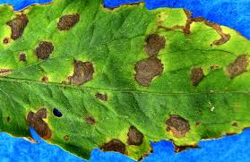
Type of Crop | Tomato
Type of Disease | Leaf Blight
Severity Level | Moderate
Confidence Level | High
Generated Recommendation Set | Pathogen: Fungal (Phytophthora infestans),  Chemical: Mancozeb 75% WP,  Dosage: 2.5 g per liter,  Spray_volume_per_acre: 220 liters,  phi_days: 14,  Frequency": "Every 7 days,  Organic: Copper fungicide.
- AgroVeda Disease Prediction and Recommendation Results for Tomato Leaf (Table I presents the prediction output generated by the AgroVeda system for a tomato leaf image exhibiting visible disease symptoms. The system identifies the disease type, estimates its severity level, and provides confidence scores along with recommended treatment measures.)
The picture of the tomato leaf, showing the existence of spots, was input into the AgroVeda system. According to the input picture of the leaf, the model was able to predict the disease as "Leaf Blight," which has a moderate level of severity along with a high level of confidence, implying that the prediction was done in a reliable manner. Once the disease has been predicted, a list of recommendations regarding the effective management of the disease is presented by the system. The recommendations are related to the effective management of the disease, which includes the effective application of the required fungicide at a controlled rate, not watering the leaves, disposing of the leaves, and checking the health of the crop at intervals of a week.

Adaptability and Dynamic Updating
Unlike the static nature of the existing recommendation algorithms, the proposed recommendation mechanism for the AgroVeda system provides the following advantages:
- Periodic updating of the knowledge base for the recommendation process.
- Incorporation of the feedback provided by the users to be used during the refinement of the recommendation mechanism in the future.
- Scalability of the recommendation mechanism to accommodate the increase in the number of crops, diseases, and treatment options.

Methodology

Dataset Description
The data set used for the training and testing of the AgroVeda-Net model comprises labeled images of leaves of plants, which are obtained from publicly accessible sources like the PlantVillage data set. The data set includes images of various crops, including tomato, apple, and other crops, which have a wide range of diseases. The dataset consists of 15 classes with a total of over 185,000 images, including both healthy and diseased leaf samples. The dataset is divided into 80% for training, 10% for validation, and 10% for testing. The dataset is balanced across classes to ensure unbiased learning and improved generalization. The number of classes is adequately filled with data points, making the learning process balanced. The images of the leaves of plants are captured in various environmental conditions, making the learning process generalizable.

Evaluation Metrics
- Performance Evaluation Metric of AgroVeda-Net
Metric | Value
Accuracy | 97.84 %
Precision | 97.21 %
Recall | 96.89 %
F1-Score | 97.05 %
mAP | 96.5 %
- Metrics Evaluation (Table II represents the performance of the AgroVeda model, was evaluated using Accuracy, Precision, Recall, F1-score which demonstrate the model’s reliability and consistent performance across multiple disease classes.)
The performance of the proposed AgroVeda-Net model is tested and evaluated using Precision, Recall, and F1-Score. Precision and Recall is used to evaluate the correctness of the predictions made by the model. F1-score is the weighted average of Precision and Recall. The model shows high scores in all metrics. The model is strong and reliable for plant disease classification problems. The Average Precision is considered to evaluate the performance of the model.

Comparison with the Existing Models
- Comparison with Existing CNN Models
Model | Accuracy
MobileNet | 91.45 %
ResNet50 | 93.87 %
EfficientNet | 95.62 %
AgroVeda-Net (Proposed) | 97.84 %
- Comparison Table (Table III represents the comparative analysis, was conducted with standard CNN architectures such as MobileNet, ResNet50 and EfficientNet. The proposed AgroVeda-Net model achieved superior performance due to its multi-branch feature extraction and attention-based refinement.)

Model Training
The AgroVeda-Net model follows a supervised learning approach based on the image of the leaves of the plants. The model follows the categorical cross-entropy loss function and the Adam optimizer. The early stopping and checkpointing techniques are used in the model to prevent overfitting and improve the generalization performance.

Results
From the experimental results, it is evident that the AgroVeda-Net model is capable of detecting plant diseases from leaf images under diverse conditions.
The feature extraction model with the help of the multi-branch strategy helped the model to understand the complex patterns in the image, and the attention mechanism helped the model to focus on the area of the plant where the disease is present. Moreover, the severity estimation helped the model to make better decisions in distinguishing the severity of the disease from the early stage to the severe stage.
The results clearly indicate that the AgroVeda model is effective in providing accurate plant disease detection and agricultural recommendations.
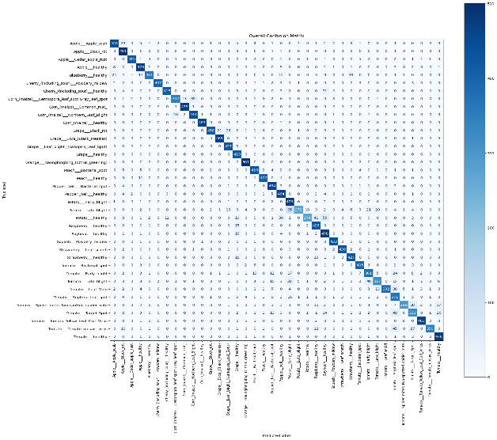
- Confusion Matrix. (This figure 5 represents the confusion matrix of the proposed model, illustrating the classification performance across multiple crop disease classes. The strong diagonal dominance indicated high prediction accuracy with minimal misclassification between disease categories.)
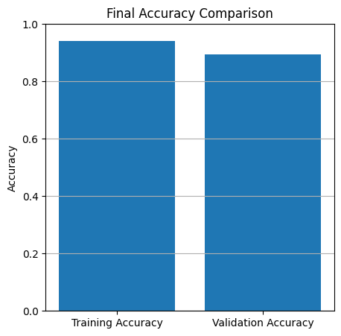

- Accuracy Comparison. (This figure 6 compares the final training and validation accuracy of the proposed model. The close alignment between both accuracies indicates effective learning and good performance.)
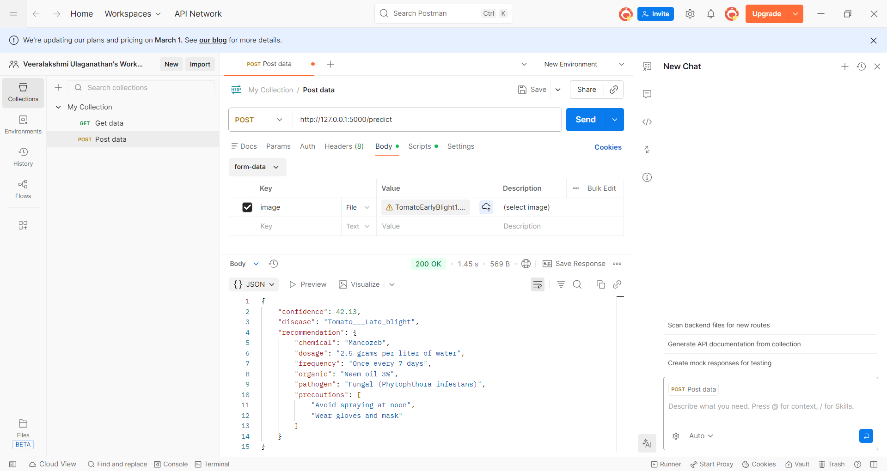

- POSTMAN API Response. (This figure 7 demonstrates the successful integration of the trained model with a REST API for real-time disease prediction. The system returns the predicted disease, confidence score and knowledge based treatment recommendations.)

- AgroVeda Application Home Interface (This figure 8 demonstrates the home interface of the AgroVeda mobile application designed for plant disease prediction and pest recommendation. This screen allows the crop scanning process and it is designed to be simple and user-friendly, enabling farmers to quickly capture plant images and begin analysis. The navigation bar also provides access to history and user profile sections.)
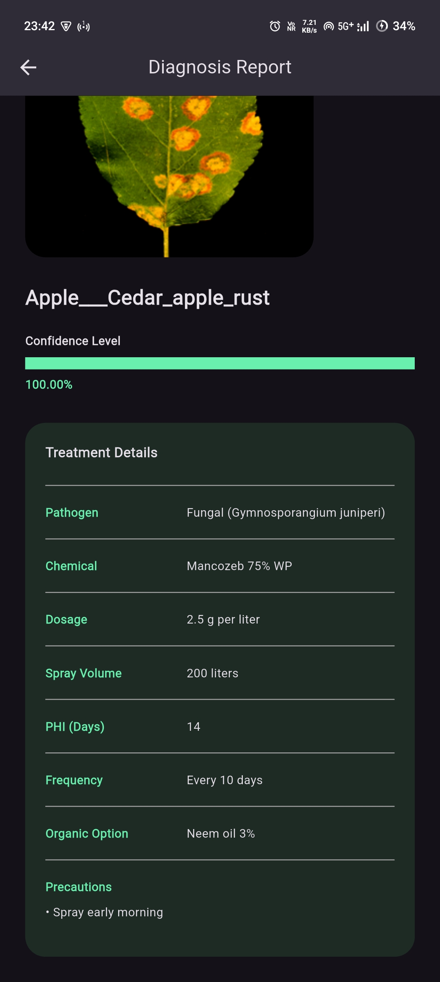
- AgroVeda Diagnosis Report (This figure 9 illustrates the diagnosis report generated by the AgroVeda system after analyzing a plant leaf image. The report displays the predicted disease class, confidence level and detailed treatment recommendations including pathogen information, chemical dosage, spray volume and preventive measures.)
The model is also validated using real-field images captured through mobile devices under varying environmental conditions such as lighting variations and background noise. The results demonstrate consistent and reliable performance, indicating the robustness of the proposed system in practical agricultural scenarios.

Conclusion
In this paper, an intelligent plant disease prediction and recommendation system, named "AgroVeda" using deep learning, is proposed. The plant disease prediction and recommendation system, which is proposed in this paper, is based on the concepts of multi-branch feature extraction, refinement using attention, estimation, and recommendation using knowledge.
The plant disease prediction and recommendation system, which is proposed in this paper, can solve the main issues faced by plant disease prediction systems. From the experimental results, it is observed that the proposed method is effective in plant disease prediction.

Future Work
As future work, AgroVeda will be developed as a standalone smart device for use in agriculture, where AgroVeda-Net will be implemented in hardware to be deployed in the field in real-time without any need for constant internet access. This will be useful for farmers in rural areas to detect diseases in their crops.
Future enhancements to AgroVeda may involve incorporating IoT sensors for environmental detection, expanding to other crops, and incorporating real-world data to improve its accuracy and adaptability.

References
- Mohanty, S. P., Hughes, D. P., & Salathé, M. (2016). Using deep learning for image-based plant disease detection. Frontiers in plant science, 7, 215232.
- Akshai, K. P., & Anitha, J. (2021, May). Plant disease classification using deep learning. In 2021 3rd International Conference on Signal Processing and Communication (ICPSC) (pp. 407-411). IEEE.
- Islam, M. M., Adil, M. A. A., Talukder, M. A., Ahamed, M. K. U., Uddin, M. A., Hasan, M. K., ... & Debnath, S. K. (2023). DeepCrop: Deep learning-based crop disease prediction with web application. Journal of Agriculture and Food Research, 14, 100764.
- Sharma, G., & Shrivastava, G. (2022). Crop disease prediction using deep learning techniques—a review. SSRG International Journal of Computer Science and Engineering, 9(4), 23-28.
- Nandhini, S., & Ashokkumar, K. (2022). Machine learning technique for crop disease prediction through crop leaf image. Appl. Math. Inf. Sci, 16(2), 149-158.
- Wang, S., Xu, D., Liang, H., Bai, Y., Li, X., Zhou, J., ... & Wei, W. (2025). Advances in deep learning applications for plant disease and pest detection: A review. Remote Sensing, 17(4), 698.
- Domingues, T., Brandão, T., & Ferreira, J. C. (2022). Machine learning for detection and prediction of crop diseases and pests: A comprehensive survey. Agriculture, 12(9), 1350.
- Isinkaye, F. O., Olusanya, M. O., & Singh, P. K. (2024). Deep learning and content-based filtering techniques for improving plant disease identification and treatment recommendations: A comprehensive review. Heliyon, 10(9).
- Ding, J., Qiao, Y., & Zhang, L. (2023). Plant disease prescription recommendation based on electronic medical records and sentence embedding retrieval. Plant Methods, 19(1), 91.
- Islam, M., Azad, A. K. M., Arman, S. E., Alyami, S. A., & Hasan, M. M. (2025). PlantCareNet: an advanced system to recognize plant diseases with dual-mode recommendations for prevention. Plant Methods, 21(1), 52.
- Choudhary, M., Sartandel, R., Arun, A., Ladge, L., Hiranwal, S., & Mathur, G. (2022). Crop recommendation system and plant disease classification using machine learning for precision agriculture. Artificial Intelligence and Communication Technologies, SCRS, 1(1), 39-49.
- Isinkaye, F. O., & Erute, E. D. (2022). A smartphone-based plant disease detection and treatment recommendation system using machine learning techniques. Trees, 10(1), 1-18.
- Revathi, M. K., & Arivuselvam, B. (2024). Machine Learning Approaches for Crop Prediction and Disease Detection System with Personalized Recommendations.
- Gosai, D., Raval, C., Nayak, R., Jayswal, H., & Patel, A. (2021). Crop recommendation system using machine learning. International Journal of Scientific Research in Computer Science, Engineering and Information Technology, 7(3), 558-569.
- Khalid, M. M., & Karan, O. (2024). Deep learning for plant disease detection. International Journal of Mathematics, Statistics, and Computer Science, 2, 75-84.
- G. Eason, B. Noble, and I. N. Sneddon, “On certain integrals of Lipschitz-Hankel type involving products of Bessel functions,” Phil. Trans. Roy. Soc. London, vol. A247, pp. 529–551, April 1955.
- Shoaib, M., Shah, B., Ei-Sappagh, S., Ali, A., Ullah, A., Alenezi, F., ... & Ali, F. (2023). An advanced deep learning models-based plant disease detection: A review of recent research. Frontiers in Plant Science, 14, 1158933.
- Hasan, M., Marjan, M. A., Uddin, M. P., Afjal, M. I., Kardy, S., Ma, S., & Nam, Y. (2023). Ensemble machine learning-based recommendation system for effective prediction of suitable agricultural crop cultivation. Frontiers in Plant Science, 14, 1234555.
- Ibrahimpatnam, H., Varma, S., Student, C. S. E., & Siiet, S. (2021). Crop and fertilizers recommendation and disease prediction using deep learning. Dogo Rangsang Research Journal, UGC Care Group I Journal, 8(14), 846-854.
- Selvi, D. P., & Poornima, P. (2021). Soil based fertilizer recommendation system for crop disease prediction system. International Journal of Engineering Trends and Applications (IJETA), 8(2).

