Day 05 Lab Verification: Claude API Call

Execution Screenshot
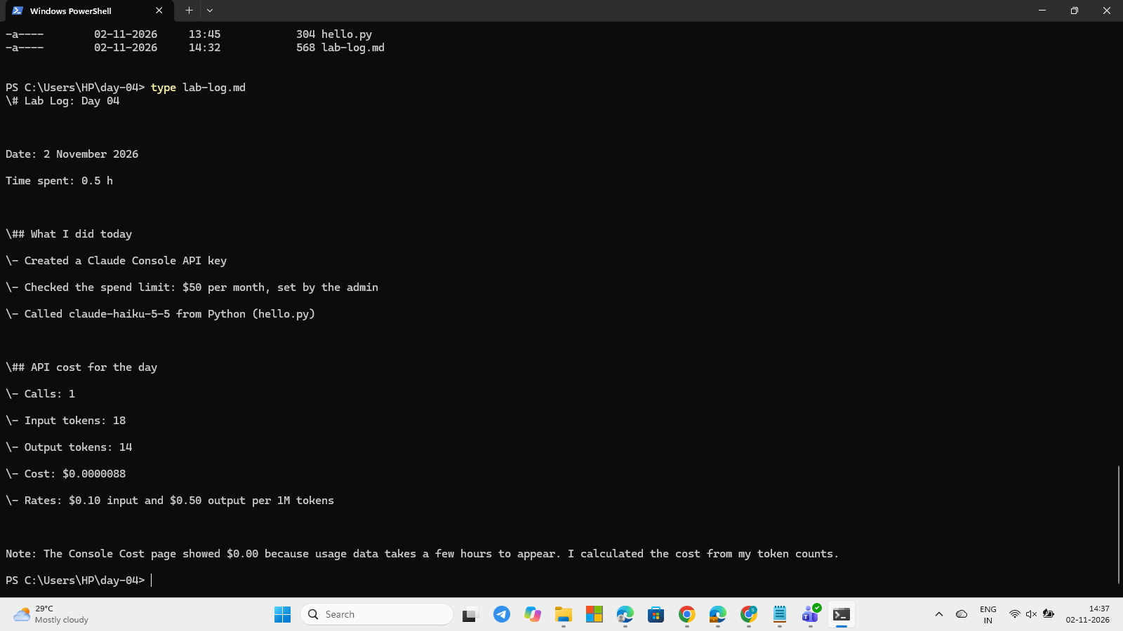

Python Script (hello.py)
import anthropic
client = anthropic.Anthropic()
msg = client.messages.create(
model="claude-haiku-5-5",
max_tokens=200,
messages=[{"role": "user", "content": "Say hello in one sentence."}],
)
print(msg.content[0].text)
print(msg.usage.input_tokens, msg.usage.output_tokens)

