Case Study Report

# Data Analytics with Power BI

**“Anlaysis of Unemployment in**

**Republic of india”**



**Tech Saksham**

**“Govt arts and science college”**

|  |  |
| --- | --- |
| **NM ID** | **NAME** |
| asbdu369cb21s206522 | Veeramanikandan. P |

# ABSTRACT



The latest data indicates a glimmer of hope, as India's unemployment rate has recently declined. According to the the unemployment rate for individuals aged 15 years and above in urban areas decreased to 6.8 percent during January-March 2023 from 8.2 percent a year ago. This positive development suggests a potential turnaround in the job market amidst the prevailing economic complexities. However, continued vigilance and effective policy measures remain crucial to foster sustainable job growth and secure the nation's future prosperity.

The Current Unemployment Rate in India:The unemployment rate witnessed a sharp decrease in January 2024. According to the latest data from the [,](https://www.cmie.com/kommon/bin/sr.php?kall=warticle&dt=20240202185251&msec=886) an independent think-tank, the unemployment rate in India stood at 6.8 percent in January. The unemployment rate in India saw a decrease of 1.9 percent in a month, as it stood at 8.7 percent in December last year.



## INDEX

|  |  |  |
| --- | --- | --- |
| **Sr. No.** | **Table of Contents** | **Page No.** |
| 1 | Chapter 1: Introduction | 4 |
| 2 | Chapter 2: Services and Tools Required | 6 |
| 3 | Chapter 3: Project Architecture | 7 |
| 4 | Chapter 4: Modeling and Result | 9 |
| 5 | Conclusion | 18 |
| 6 | Future Scope | 19 |
| 7 | References | 20 |
| 8 | Links | 21 |



**CHAPTER 1**

## INTRODUCTION

### 1.1 Problem Statement

1. The unemployment rate in India, amidst lockdown and restrictions on mobility, is 12.81% as of June 8th 2021 based on the data provided by the CMIE. Earlier, the unemployment rate in India shot up from 6.5 per cent in March 2021 to 8 per cent in April 2021, to 14.7% by May end, while the employment rate fell from 37.6 per cent in March to 36.8 per cent in April, says the report of CMIE – Centre For Monitoring Indian Economy.
2. In 2020, the unemployment rate in India fell to 7% in September 2020 from the record high of 29% since the country went into lockdown from March 2020, However, it later increased to 9.1% in December 2020.
3. The unemployment rate again declined to 6.5 per cent in January 2021 from 9.1 per cent in December 2020, while the employment rate surged to 37.9 per cent as compared to 36.9 per cent.
4. The lockdown to contain the coronavirus outbreak has forced many industries to shut down thus increasing unemployment across the country.

### 1.2 Proposed Solution

1. Unemployment means a person willing to work but unable to find a qualified job. Our country is facing many problems but one of the serious problem is of unemployment. Many graduates, doctors, engineers, scientist are unemployed or working underemployed. Due to unemployment we are wasting our country’s human resource.
2. The unemployed rate in between age group 15- 29 has been increased since 2009-2010. According to the Global Employment

Trends 2014 the unemployment rate has raised to 3.8%, last year.

### 1.2 Feature

* **Real-Time Analysis**: The dashboard will provide real-time analysis of customer data.
* **Customer Segmentation**: It will segment customers based on various parameters like age, income, transaction behavior, etc.
* **Trend Analysis**: The dashboard will identify and display trends in customer behavior. • **Predictive Analysis**: It will use historical data to predict future customer behavior.

### 1.3 Advantages

To provide unemployment benefits, various countries have policies and programs in place. The US enacted policies qua unemployment insurance as far back as 1935. The basic unemployment insurance program is run by various states which provide most of the funding and pay for the actual benefits given to workers. A person is from the state where the person was last employed at, even if the person now lives in a different state.

### 1.4 Scope

The scope of this project extends to all banking institutions that aim to leverage data for decision-making and customer engagement. The project can be further extended to incorporate more data sources and advanced analytics techniques, such as machine learning and artificial intelligence, to provide more sophisticated insights into customer behavior. The project also has the potential to be adapted for other sectors, such as retail, healthcare, and telecommunications, where understanding customer behavior is crucial. Furthermore, the project contributes to the broader goal of digital transformation in the banking sector, promoting efficiency, innovation, and customercentricity.

**CHAPTER 2**

## SERVICES AND TOOLS REQUIRED

### 2.1 Services Used

* **Data Collection and Storage Services**: Banks need to collect and store customer data in real-time. This could be achieved through services like Azure Data Factory, Azure Event Hubs, or AWS Kinesis for real-time data collection, and Azure SQL Database or AWS RDS for data storage.

* **Data Processing Services**: Services like Azure Stream Analytics or AWS Kinesis Data Analytics can be used to process the real-time data.

* **Machine Learning Services**: Azure Machine Learning or AWS SageMaker can be used to build predictive models based on historical data.

### 2.2 Tools and Software used

**Tools**:

* **PowerBI**: The main tool for this project is PowerBI, which will be used to create interactive dashboards for real-time data visualization.

* **Power Query**: This is a data connection technology that enables you to discover, connect, combine, and refine data across a wide variety of sources.

**Software Requirements**:

* **PowerBI Desktop**: This is a Windows application that you can use to create reports and publish them to PowerBI.

* **PowerBI Service**: This is an online SaaS (Software as a Service) service that you use to publish reports, create new dashboards, and share insights.

* **PowerBI Mobile**: This is a mobile application that you can use to access your reports and dashboards on the go.

**CHAPTER 3**

## PROJECT ARCHITECTURE

### 3.1 Architecture



**USER**

**FRONTEND**

**BACKEND**

**HTML 5**

**NODEJS 14.0**

**Database**



Here’s a high-level architecture for the project:

1. **Data Collection**: Real-time customer data is collected from various sources like bank transactions, customer interactions, etc. This could be achieved using services like Azure Event Hubs or AWS Kinesis.
2. **Data Storage**: The collected data is stored in a database for processing. Azure SQL Database or AWS RDS can be used for this purpose.
3. **Data Processing**: The stored data is processed in real-time using services like Azure Stream Analytics or AWS Kinesis Data Analytics.
4. **Machine Learning**: Predictive models are built based on processed data using Azure Machine Learning or AWS SageMaker. These models can help in predicting customer behavior, detecting fraud, etc.
5. **Data Visualization**: The processed data and the results from the predictive models are visualized in real-time using PowerBI. PowerBI allows you to create interactive dashboards that can provide valuable insights into the data.
6. **Data Access**: The dashboards created in PowerBI can be accessed through PowerBI Desktop, PowerBI Service (online), and PowerBI Mobile.

This architecture provides a comprehensive solution for real-time analysis of bank customers. However, it’s important to note that the specific architecture may vary depending on the bank’s existing infrastructure, specific requirements, and budget. It’s also important to ensure that all tools and services comply with relevant data privacy and security regulations.



















**CHAPTER 4**

## MODELING AND RESULT

### Manage relationship

The “disp” file will be used as the main connector as it contains most key identifier (account id, client id and disp id) which can be use to relates the 8 data files together. The “district” file is use to link the client profile geographically with “districtd” 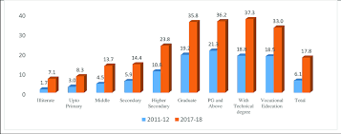

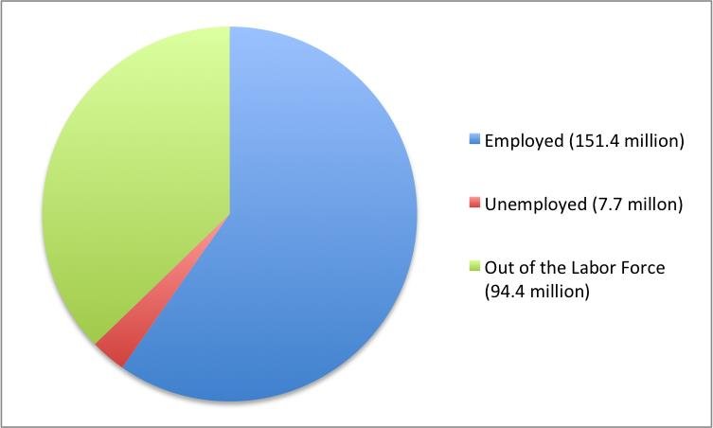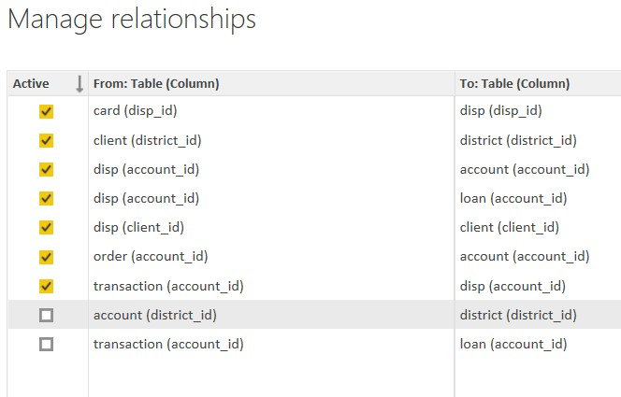

For birthday, we need to reduce the birth month of the female by 50 and then

change

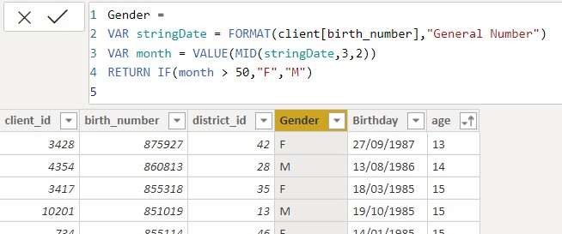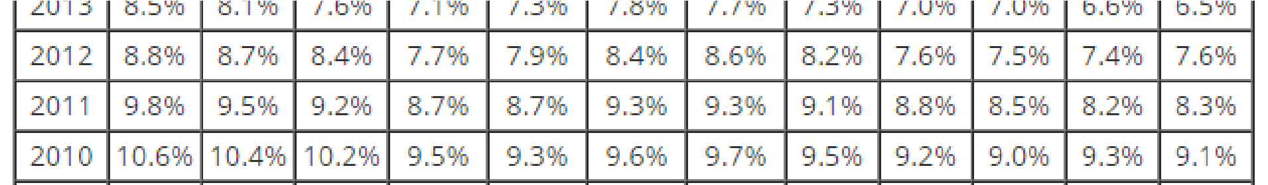

the date format to DD/MM/YYYY adding 1900 to the year.

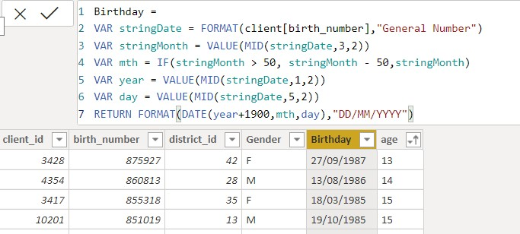

For Age, we shall assume it is year 1999 as explain previously and use it to minus from the birth year.

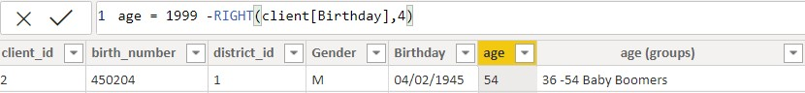

#### Replacing values

Set some fields to English for easy understanding, we replace values to English with the Power Query Editor.

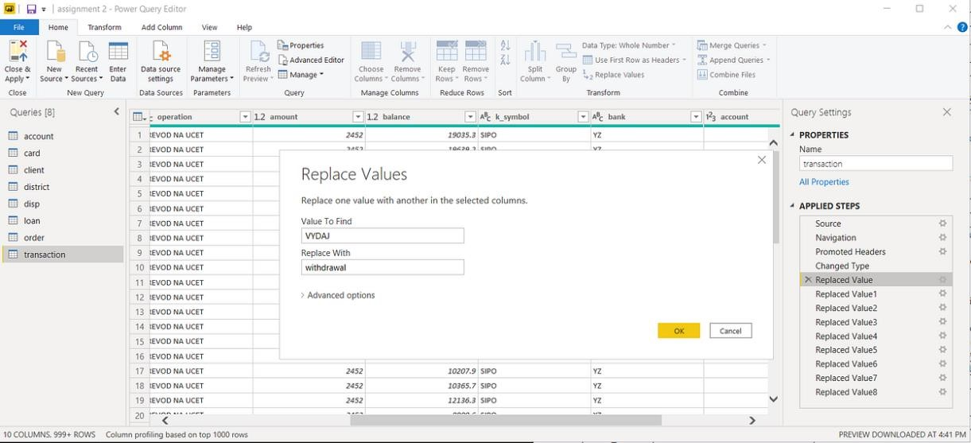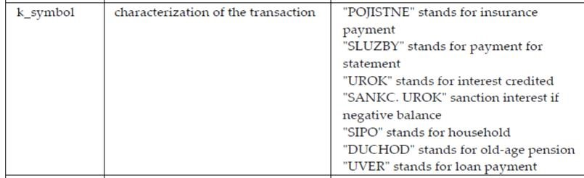

Changing the order of Region name at Power Query

Duplicate the “district /region” then split column using space as delimiter.

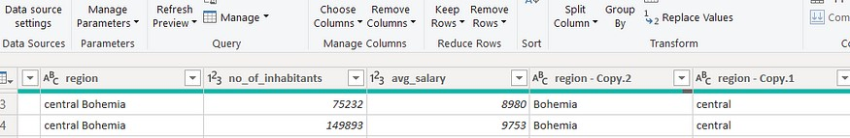

Then merge column by Region and direction. Refer to applied steps for details.

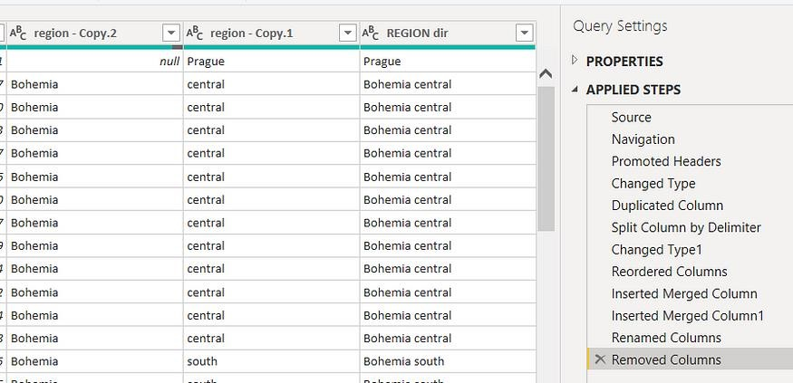

#### Grouping of age by ranges

As the customers’ age ranges from 12 to 88, we shall group them into different generation age range for easier profiling, we will group the ages into 5 groups.

The Gen Y are youths,

Gen X are young working adults, some starting their families Baby Boomer are working adults with families.

The silent Generations some are working and retired, living on pensions.

The greatest Generation, retired elderly living on pensions.

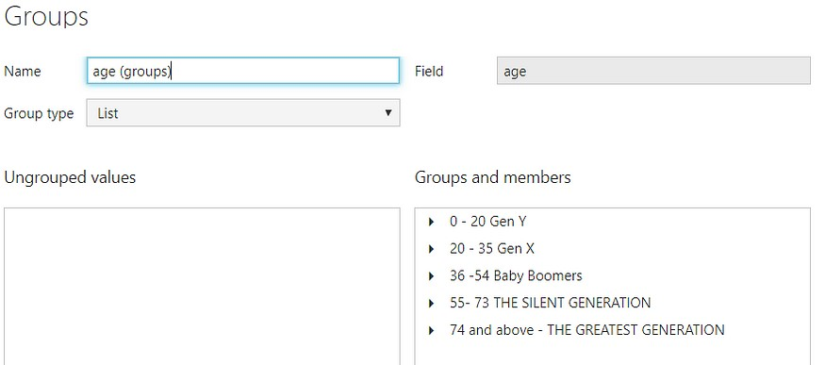

#### Credit Rating and Loan Status

As the Loan status uses A, B, C, D which are not reader friendly. We can add a column to represent what it stands for, we also simplify the classification of those with late or default on payment as bad credit, refer to the table below for details on the new columns added.

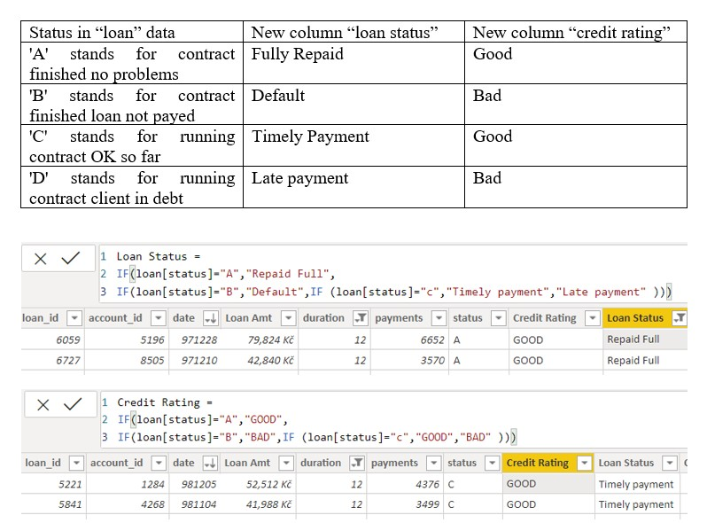

Values of such as “account Id” have also been set as Text.

And District name have been categorized as place to be use for the map to show the sum of the inhabitants in each region.

## Dashboard

### CONCLUSION

The project real time analysis of “unemployment” using Power Bi has successfully demonstrated the potential of data analysis in the unemployment sector. The real time analysis of unemployment data has provided valuable insights into unemployment preference and trends thereby foliating informed decision making the interactive dashboards and reports have offered a comprehensive view of unemployment data enabling the identification of patterns correlations this has not only improved the efficiency of data analysis but also enhanced unemployment ability to provided unemployed.

### FUTURE SCOPE

The future scope of this project is vast. With the advent of advanced analytics and machine learning, Power BI can be leveraged to predict future trends based on historical data. Integrating these predictive analytics into the project could enable the bank to anticipate customer needs and proactively offer solutions. Furthermore, Power BI’s capability to integrate with various data sources opens up the possibility of incorporating more diverse datasets for a more holistic view of customers. As data privacy and security become increasingly important, future iterations of this project should focus on implementing robust data governance strategies. This would ensure the secure handling of sensitive customer data while complying with data protection regulations. Additionally, the project could explore the integration of real-time data streams to provide even more timely and relevant insights. This could potentially transform the way banks interact with their customers, leading to improved customer satisfaction and loyalty.

**REFERENCES**

### LINK