# Weather Recordings and Suggestion Bot

### A PROJECT REPORT

***Submitted by***

**Veeraragahavn M (220701313)**

***in partial fulfillment for the course***

### OAI1903 - INTRODUCTION TO ROBOTIC PROCESS AUTOMATION

***for the degree of***

## BACHELOR OF ENGINEERING

### in

**COMPUTER SCIENCE AND ENGINEERING**



## RAJALAKSHMI ENGINEERING COLLEGE RAJALAKSHMI NAGAR THANDALAM

**CHENNAI – 602105**

**NOVEMBER 2024**

# RAJALAKSHMI ENGINEERING COLLEGE CHENNAI - 602105

## BONAFIDE CERTIFICATE

Certified that this project report **“Weather Recordings and Suggestion BOT”** is the bonafide work of **“Veeraragahavan M(220701313)”** who carried out the project work for the subject OAI1903- Introduction to Robotic Process Automation under my supervision.

MS. U. Farjana, M. Tech

SUPERVISOR

Assistant Professor

Department of Computer Science and Engineering

Rajalakshmi Engineering college

Rajalakshmi Nagar

Thandalam

Chennai - 602105

Submitted to Project and Viva Voce Examination for the subject OAI1903- Introduction to Robotic Process Automation held on .

Internal Examiner External Examiner

### ABSTRACT

The goal of this project is to create an UiPath automation workflow for comparing weather data from several sources, such as Weather.com, AccuWeather, and OpenWeatherMap. To collect important meteorological data from these platforms, including temperature, humidity, wind speed, and forecasts, the process will make use of UiPath's web scraping and API features.

The automation will save the data in variables for comparison when it has been extracted. In order to assist users in determining the dependability of various weather platforms, the process will employ conditional logic to compare and contrast the weather data from each source. Key meteorological metrics and a synopsis of the platform comparisons will be included in the comparison findings, which will be saved in an easy-to-read format, like an Excel report.

Error handling procedures will be included to handle problems like API outages or modifications to webpage architecture in order to guarantee robustness. To further clarify the comparison, the procedure might also use visualizations like line graphs or bar charts. By automating the process of comparing weather data, this project hopes to empower people to base their judgments on compiled meteorological data from dependable sources.

### ACKNOWLEDGEMENT

Initially we thank the Almighty for being with us through every walk of our life and showering his blessings through the endeavour to put forth this report. Our sincere thanks to our Chairman **Mr. S.Meganathan, B.E, F.I.E.,** our Vice Chairman **Mr. Abhay Shankar Meganathan, B.E., M.S.,** and our respected Chairperson **Dr. (Mrs.) Thangam Meganathan, Ph.D.,** for providing us with the requisite infrastructure and sincere endeavouring in educating us in their premier institution.

Our sincere thanks to **Dr. S.N.Murugesan, M.E., Ph.D.,** our beloved Principal for his kind support and facilities provided to complete our work in time. We express our sincere thanks to **Dr. P. Kumar, M.E., Ph.D.,** Professor and Head of the Department of Computer Science and Engineering for his guidance and encouragement throughout the project work. We convey our sincere and deepest gratitude to our internal guides, **Mrs. Roxanna Samuel, M.E.,** Associate Professor, **Ms. Farjana, M.E.,** Assistant Professor (SG), **Ms. Vinothini, M.E.,** Assistant Professor (SG), Department of Computer Science and Engineering, Rajalakshmi Engineering College for their valuable guidance throughout the course of the project. We arevery glad to thank our Project Coordinators, **Dr.P. Revathy, M.E., Ph.D., Dr.N.Durai Murugan,M.E., Ph.d.,** Professor and **Mr.B.Bhuvaneswaran, M.E.,** Assistant Professor (SG), Department of Computer Science and Engineering for his useful tips during our reviewto build our project.

### Veeraraghavan M (220701313)

**TABLE OF CONTENTS**

**CHAPTER NO. TITLE PAGE NO.**

|  |  |
| --- | --- |
| **ABSTRACT** | **iii** |
| **LIST OF FIGURES** | **vi** |
| **LIST OF ABBREVIATIONS** | **vii** |
| **1.INTRODUCTION** | **1** |
| 1.1 INTRODUCTION | 1 |
| 1.2 OBJECTIVE | 3 |
| 1.3 EXISTING SYSTEM | 3 |
| 1.4 PROPOSED SYSTEM | 4 |
| **2.LITERATURE REVIEW** | **5** |
| **3.SYSTEM DESIGN** | **11** |
| 3.1 ARCHITECTURE DIAGRAM | 12 |
|  |  |
| **4.PROJECT DESCRIPTION** | **14** |
| 4.1 MODULES | 14 |
| 4.1.1 Web automation Module | 14 |
| 4.1.2 Data Extraction Module | 14 |
| 4.1.3 Decision making Module | 15 |
| 4.1.4 Notification Module | 16 |
| **5.OUTPUT SCREENSHOTS** | **17** |
| **6.CONCLUSION** | **19** |
| **APPENDIX** | **20** |
| **REFERENCES** | **32** |

## LIST OF FIGURES

|  |  |  |
| --- | --- | --- |
| **Figure No** | **Figure Name** | **Page No.** |
| 3.1 | Architecture Diagram | 11 |
| 3.2 | Sequence Diagram | 12 |
| 5.1 | Output 1 | 17 |
| 5.2 | Output 2 | 17 |
| 5.3 | Output 3 | 18 |
| 5.4 | Output 4 | 18 |

**LIST OF ABBREVIATIONS**

|  |  |
| --- | --- |
| **ABBREVIATION** | **ACCRONYM** |
| RPA | Robotic Process Automation |
| OTA | Online Travel Agency |
| UI | User interface |
| HTTP | Hyper text transfer protocol |
| GPS | Global positioning system |
| PNR | Passenger Name Record |
| OS | Operating system |
| DB | Database |
| HTML | Hyper Text Markup Language |
| CCV | Card Verification value |

# CHAPTER 1

## INTRODUCTION

### INTRODUCTION

### 

People in the modern world use a range of weather platforms to make well-informed judgments regarding their daily schedules. However, it might be difficult to sort through contradicting data when several sources are providing various projections. In order to streamline the procedure, this project compares weather data from three well-known platforms: OpenWeatherMap, AccuWeather, and Weather.com, using UiPath, a top robotic process automation (RPA) technology. Every platform forecasts weather using a different methodology, offering a variety of viewpoints. AccuWeather focuses on hyper-local forecasts, OpenWeatherMap provides global coverage with real-time data, and Weather.com prioritizes easily navigable weather reports for both short- and long-term forecasts. By automating the extraction and comparison of key weather metrics—such as temperature, humidity, and wind speed—UiPath will enable a comprehensive analysis of weather patterns from multiple sources. This project aims to provide users with a more reliable and nuanced understanding of weather forecasts, streamlining information retrieval and empowering them to make better decisions. As weather forecasting continues to evolve, leveraging UiPath ensures an efficient, automated solution for comparing data across various platforms.

### OBJECTIVE

Developing an UiPath automation system that effectively compare weather data from many sources, such as OpenWeatherMap, AccuWeather, and Weather.com, is the aim of this project. In order to facilitate rapid analysis and comparison of forecasts from various providers, this will entail automating the extraction of important meteorological data from the corresponding platforms, such as temperature, humidity, and wind speed. By improving weather data retrieval accuracy, consistency, and efficiency, the automation will give consumers a more efficient way to base their decisions on thorough weather data. The system will enable users to develop a more sophisticated understanding of weather patterns by automating the comparison process, which will ultimately enable them to confidently plan their activities.

### EXISTING SYSTEM

The existing UiPath-based system for comparing weather forecasts from websites such as Weather.com, AccuWeather, and OpenWeatherMap consists of automated processes that traverse various websites, gathering and extracting meteorological data for effective side-by-side comparison.

Robotic process automation (RPA) from UiPath improves data extraction by guaranteeing accuracy and doing away with manual labor. This solution makes weather forecasts easily accessible, allowing for flexible website structure adaptation and well-informed decision-making. All things considered, UiPath offers a practical and automatic way to compare weather forecasts in-depth.

### PROPOSED SYSTEM

Using UiPath automation, the suggested system seeks to effectively compare weather forecasts from several sources, including Weather.com, AccuWeather, and OpenWeatherMap. The system will include a number of essential parts:

1. Data Retrieval Module: Navigate and extract data from Weather.com, AccuWeather, and OpenWeatherMap using UiPath processes (either by web scraping or APIs).Compile important meteorological data, including wind speed, temperature, humidity, and likelihood of precipitation.Plan regular retrievals to guarantee current and correct data.2. Data Processing and Normalization: To guarantee consistency, convert units (such as Fahrenheit to Celsius and miles per hour to kilometers per hour).For comparison, standardize measures such as numerical scales and probability percentages.To manage these conversions dynamically depending on the source, use UiPath workflows.3. User Input Interface: Create an UiPath dashboard or input form that allows users to:Enter the place or locations.Choose from a daily, hourly, or current forecast.Using user inputs, start the automated data retrieval and comparison procedure.4. Comparison Algorithm: Create an UiPath procedure to examine platform differences.To find the best accurate forecast, compute weighted metrics or averages.Draw attention to notable variations in important parameters, such precipitation or temperature.5. Result Presentation: Use UiPath and integrated tools (like Excel and Power BI) to create reports or dashboards.To summarize metrics, use visual aids like tables, line graphs, and bar charts.Give an overview of the most important findings, including significant predicted differences.6. Error Handling and Logging: Use error handling procedures to deal with problems like missing data, website modifications, and API rate constraints.For the purpose of troubleshooting and system enhancement, record errors, warnings, and discrepancies.Alert users about any significant delays or problems.

## CHAPTER 2 LITERATURE REVIEW

1. In order to extract attitudes and trends regarding weather conditions, weather review mining entails examining user-generated content, such as reports, reviews, and social media posts. It emphasizes subjective insights over empirical data, in contrast to traditional weather prediction. The tourism, event, catastrophe, and urban planning sectors all gain from this approach' insightful input on how the general public views the weather. For instance, unfavorable opinions during severe weather can assist companies in modifying their offerings or promotional plans. Furthermore, during extreme weather occurrences, real-time sentiment analysis aids authorities in improving their reaction.By revealing discrepancies between public perception and weather forecasts, weather review mining also enhances communication. Clearer forecasts might result from reviews' insights, which can expose misunderstandings or false information. This approach offers a more comprehensive view of weather conditions and public experiences when paired with meteorological data. However, the analysis is made more difficult by issues like metaphorical language and unstructured data. The entire potential of weather review mining requires sophisticated natural language processing (NLP) algorithms to handle context and sarcasm.
2. People frequently utilize weather reports on websites or social media platforms to plan their activities or get ready for bad weather. People currently rely on reviews and forecasts, but it would be wiser to examine the emotional substance of these reviews. We can make an emotion map by combining feelings like exhilaration or frustration and connecting them to particular weather occurrences. Through improved communication and decision-making based on people's emotional responses to the weather, meteorologists, corporations, and governments can better understand how the public reacts to the weather.
3. With the vast amount of weather data available today, "information overload" and "data fragmentation" can be major challenges. Weather recommender systems can help address these issues by efficiently filtering and analyzing relevant data. We propose a *Weather Forecast Rating (WFR)* algorithm that uses user feedback and weather conditions to select the most relevant data, improving the accuracy of weather predictions by reducing errors like RMSE (Root Mean Square Error) and MAE (Mean Absolute Error). Building on this, the *MCBF-WVD* algorithm combines explicit weather data (e.g., temperature) and implicit data (e.g., user preferences) to predict future weather conditions more accurately..
4. Traditional weather forecasting models often face challenges in accurately capturing the temporal dynamics of weather events. The *link stream paradigm* provides a solution by extending graphs to include evolving data over time, ensuring that crucial information is not lost. In this context, we propose using *link stream features* to enhance weather prediction systems. These features capture the underlying patterns and trends in weather data, offering a more detailed view of how weather conditions change over time.By combining link stream features with *content-based methods* (such as historical weather data), we apply a machine learning algorithm, like *gradient boosting* (e.g., XGBoost), to predict future weather conditions. Our approach shows that integrating link stream features significantly improves prediction accuracy compared to using only content-based methods.This method not only boosts prediction accuracy but also offers a more interpretable model, which is essential as transparency in forecasting algorithms becomes increasingly important. Additionally, this approach opens the door for further exploration of how link streams and other forecasting techniques, such as *tensor factorization methods*, can work together. By using link streams, we can create more accurate, dynamic, and transparent weather prediction systems, which can lead to better decision-making in weather-dependent industries.
5. The study conducted surveys with 250 and 420 respondents across China, India, Vietnam, and Indonesia, analyzing the impact of online weather ratings on consumer behavior. Using analysis of variance, the results revealed that lower ratings and less frequent weather updates led to higher risk perceptions and decreased trust in weather forecasts. These effects were more pronounced among conservative consumers, while values such as self-enhancement had minimal impact on decision-making. Additionally, Indian consumers were found to be more skeptical about online weather ratings compared to their Southeast Asian counterparts, suggesting regional variations in consumer trust and engagement with weather predictions. Overall, the research highlights how online weather ratings, individual values, and regional differences shape how consumers in emerging Asian markets perceive and rely on weather forecasts. This underscores the complex interaction between online weather ratings and cultural attitudes in influencing weather-related decision-making.

# CHAPTER 3 SYSTEM DESIGN

### ARCHITECTURE DIAGRAM

An architecture diagram is a graphical representation of a set of concepts, that are part of an architecture, including their principles, elements and components.

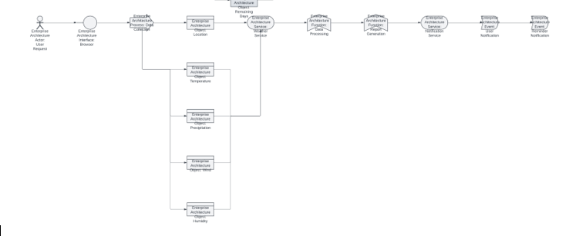

Fig 3.2 Architecture Diagram

**CHAPTER 4 PROJECT DESCRIPTION**

### MODULES

**4.1.1**

**Data Retrieval Module:**

|  |  |  |
| --- | --- | --- |
| • | **Weather Data Retrieval:** | Weather.com Data Retrieval: Use UiPath to automate web scraping from the Weather.com website to extract relevant weather data, such as temperature, humidity, precipitation, and weather forecasts. |
| * **AccuWeather Data Retrieval:** Similarly, automate web scraping from the AccuWeather platform to gather weather ratings, forecasts, and detailed meteorological information for specific locations. * **OpenWeatherData Retrieval:** Employ UiPath to collect weather-related data from the OpenWeather website, including real-time weather updates, forecasts, and other atmospheric conditions across various regions. | | |

### 4.1.2

**Data Normalization Module:**

The *Data Normalization Module* standardizes weather data collected from different sources like Weather.com, AccuWeather, and OpenWeather to ensure consistency. This involves converting various units, such as temperature from Celsius to Fahrenheit, wind speed from meters per second to miles per hour, and normalizing precipitation levels across platforms. Additionally, time synchronization is implemented to align the data to a common time frame (e.g., hourly or daily forecasts), ensuring fair comparisons of weather conditions. This normalization process ensures that weather data from different platforms can be accurately compared and analyzed on a consistent scale

### 4.1.3

**Comparison Module:**

Develop an algorithm using UiPath that compares the normalized weather data from multiple platforms (Weather.com, AccuWeather, OpenWeather) by considering factors such as temperature, humidity, precipitation, and wind speed. The algorithm should generate a comprehensive comparison by analyzing these factors across the different sources. Additionally, allow for customization, such as giving different weights to each weather attribute (e.g., prioritizing temperature over humidity) or adjusting the importance of each weather platform based on user preferences. This enables users to tailor the comparison to their specific needs, ensuring a more relevant and personalized weather analysis.

**4.1.4 Reporting Module:**

Create a user-friendly interface using UiPath to input the location or weather parameters for comparison, such as city names or specific weather conditions. Present the comparison results in a clear and visually appealing format, which could include graphical representations (e.g., temperature charts, precipitation graphs), a summary of key weather metrics (e.g., average temperature, wind speed, humidity), and any notable differences between the weather platforms. Implement error handling and logging mechanisms to ensure the reliability and transparency of the comparison process, ensuring that any discrepancies or issues in data retrieval or processing are properly captured and addressed

## CHAPTER 5 OUTPUTSCREENSHOTS

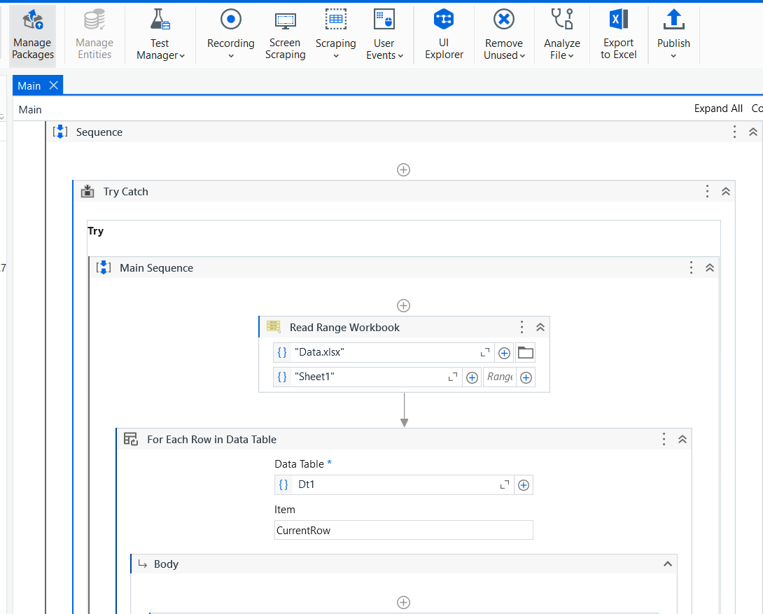

Fig 5.1 Creating the project by creating the work flow for reading the locations from an excel sheet.

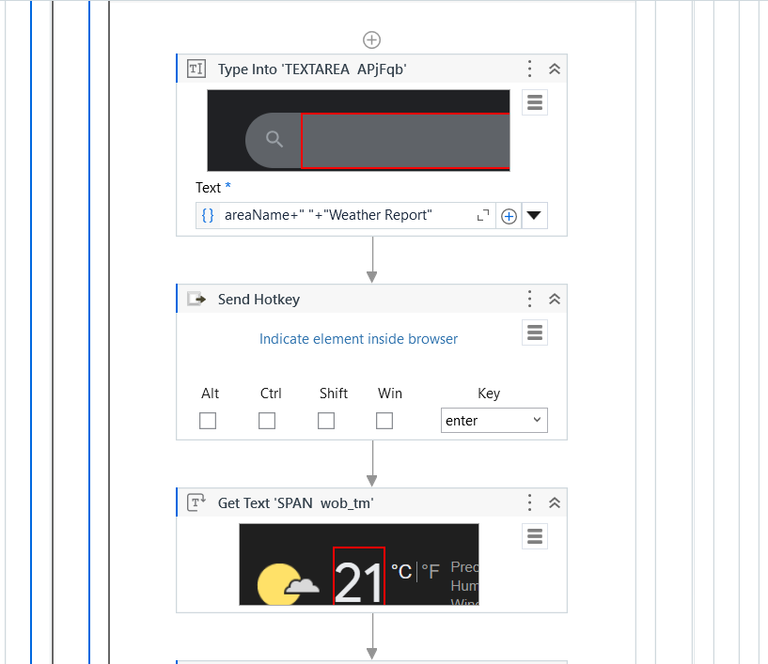

Fig 5.2 Using the websites the Weather Details are obtained.

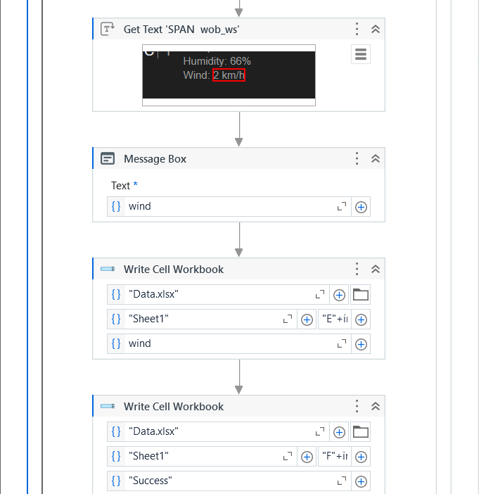

Fig 5.3 Reading the details of each states weather and notifying it in a popup message box.

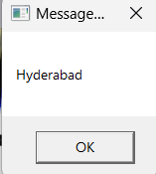 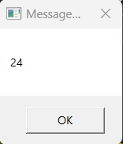 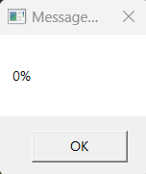 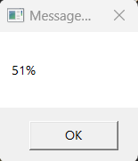 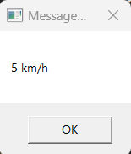

Location Temperature Precipitatiom Humidity Wind

Fig 5.4 Thus the output is obtained explain which weather details.

## CHAPTER 6 CONCLUSION

In conclusion, UiPath's comparative study of weather data from websites such as Weather.com, AccuWeather, and OpenWeather provides important information on the precision and reliability of weather forecasts from various sources. The investigation emphasized the significance of taking into account numerous weather platforms to achieve a more accurate and dependable forecast by highlighting disparities in weather predictions, especially in areas like temperature, precipitation, and wind speed. A thorough picture of weather conditions from many sources was made possible by the smooth extraction and comparison of weather data made possible by UiPath automation.Additionally, analyzing these systems' forecasts and real-time weather circumstances revealed the different strengths of each in predicting particular weather aspects. AccuWeather provides comprehensive severe weather warnings, OpenWeather delivers worldwide coverage with customisable data, and Weather.com is excellent at delivering precise neighborhood forecasts. With the help of UiPath automation, this multidimensional approach enables users to base their judgments on the most pertinent and accurate meteorological data.In the end, the UiPath automation process not only made it easier to compare meteorological data from different platforms, but it also highlighted the necessity of a thorough strategy that takes into account the advantages of different sources. Weather forecasts are more reliable due to UiPath's efficiency and accuracy in data extraction and processing, which provides a more nuanced picture of weather conditions across many geographies.

## REFERENCES

1. **Automated weather details:**

**{** https://medium.com/@priyaskulkarni99/automating-weather-data-collection-with-bash-a-practical-guide-8739dad1efcb**}**

1. **Youtube references {** https://youtu.be/kpnXIWh2T58?si=3E8lkEO4aWI7qPMT**}**
2. **Research on Weather details:**

{ https://www.visualcrossing.com/weather-api}