Screenshots:

Stacks created for Netwoks and servers:

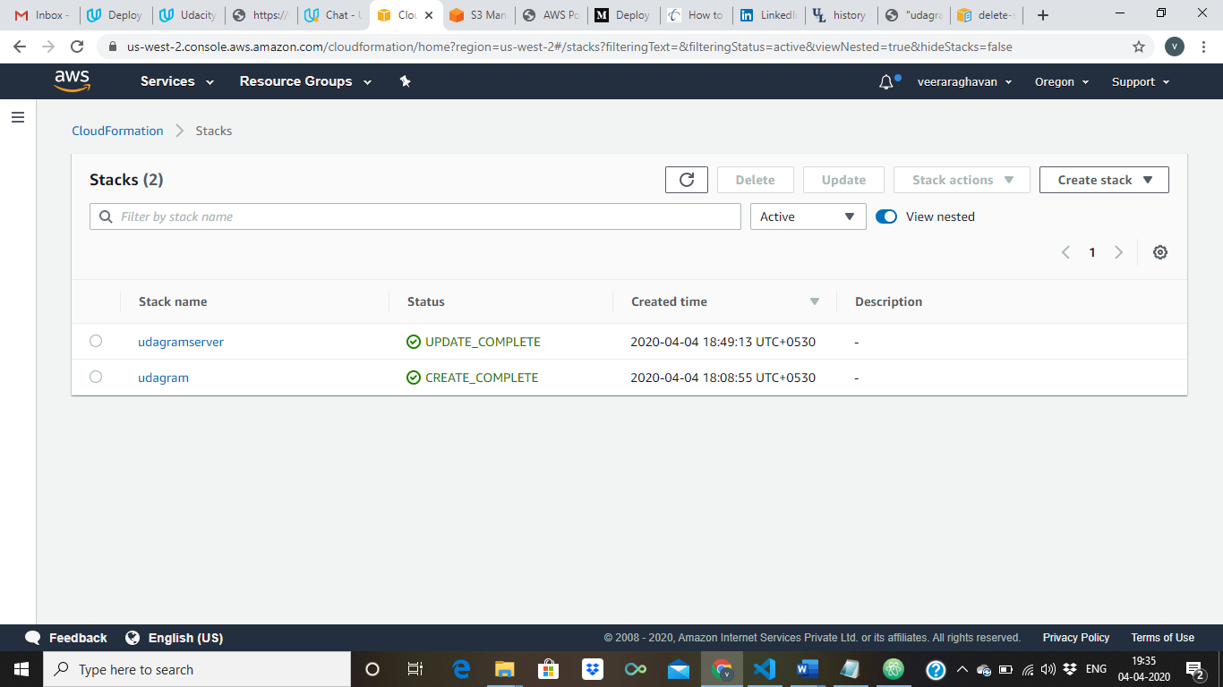

Running Instances:

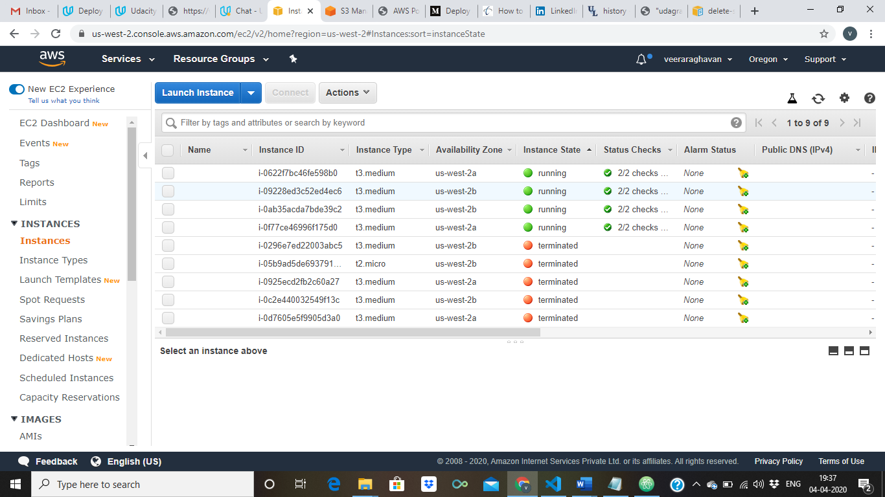

Loadbalancer:

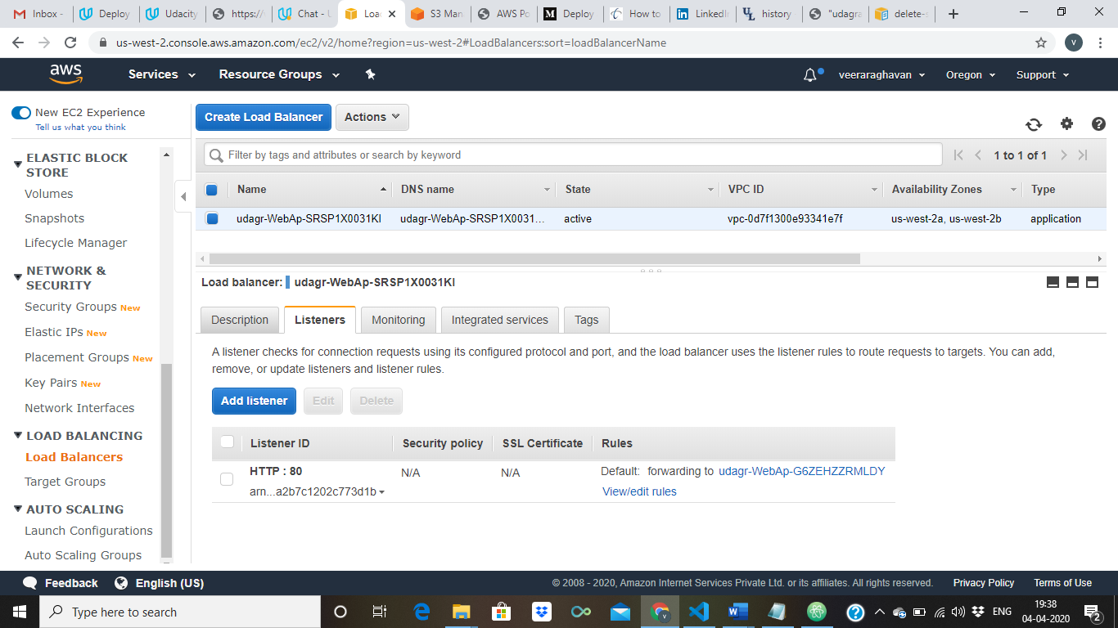

Target Group:

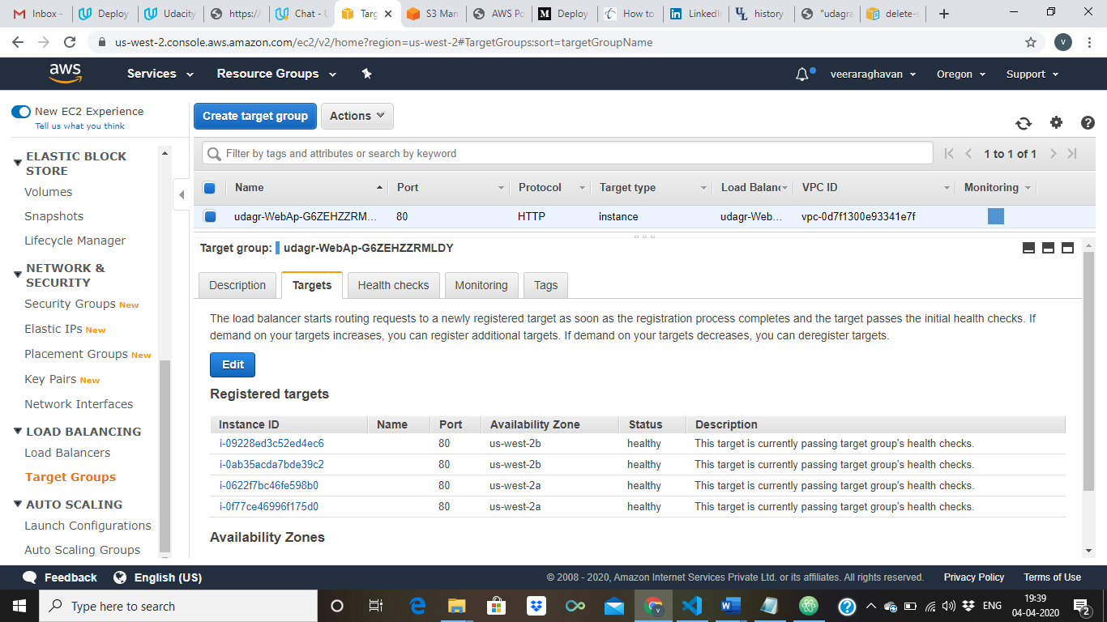

Final screenshot:

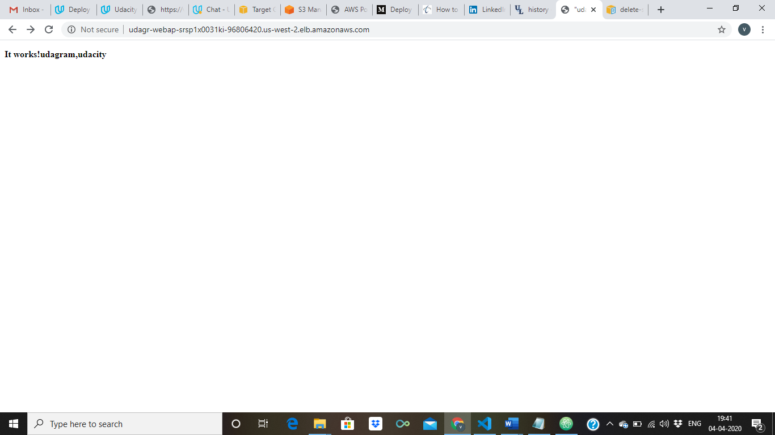

LB -URL: udagr-WebAp-SRSP1X0031KI-96806420.us-west-2.elb.amazonaws.com

