VISVESVARAYA TECHNOLOGICAL UNIVERSITY
“Jnanasangama”, Belagavi-590018, Karnataka



BANGALORE INSTITUTE OF TECHNOLOGY
K.R. Road, V.V.Puram, Bangalore-560 004



DEPARTMENT OF COMPUTER SCIENCE & ENGINEERING

DATABASE MANAGEMENT SYSTEM MINI PROJECT
18CSL58

“SPORTS STORE MANAGEMENT SYSTEM”

Submitted By

NAME: Veerasathvik Kottapalli
USN: 1BI19CS183

for the academic year 2021-22

Department of Computer Science & Engineering
Bangalore Institute of Technology
K.R. Road, V.V.Puram, Bangalore-560 004

VISVESVARAYA TECHNOLOGICAL UNIVERSITY
“Jnanasangama”, Belagavi-590018, Karnataka

BANGALORE INSTITUTE OF TECHNOLOGY
K.R. Road, V.V.Puram, Bangalore-560 004

Department of Computer Science & Engineering

Certificate

This is to certify that the implementation of DBMS MINI PROJECT entitled
“Sports Store Management System ” has been successfully completed by
USN:1BI19CS183 Name:Veerasathvik Kottapalli
of V semester B.E. for the partial fulfillment of the requirements for the
Bachelor’s degree in Computer Science and Engineering of the Visvesvaraya
Technological University during the academic year 2021-2022

Prof. Dr SUNEETHA K R Dr. J Girija
Associate Professor Professor and Head
Dept. of CS&E Dept. of CS&E
Bangalore Institute of Technology Bangalore Institute of Technology
Bangalore Bangalore

Examiners: 1) 2)

ACKNOWLEDGEMENT
I express my profound thanks to our respected Principal Dr. ASHWATH for always being the most supportive in the course of this project.

I extend my sincere gratitude to our respected Dr.J. GIRIJA, Head of the Department, for providing us with valuable information and also help me to coordinate my project.

Special thanks to Dr SUNEETHA K R, Associate Professor for her valuable assistance, cooperation and guidance throughout the building of this project.

I would like to thank our Database - Management System subject teacher
Professor PRATHIMA G for providing us with all the knowledge required for the completion of my project. I would also like to thank the whole faculty of the college for their cooperation and support. Further I would like to give special thanks to other teaching and non-teaching staff for their constant support in the course of the project.

Name: Veerasathvik Kottapalli
USN:1BI19CS183

INDEX
CHAPTER  NO. | SECTIONS | CONTENTS | PAGE  NO
1. |  | INTRODUCTION | 8
1. | 1.1 | Introduction | 9
1. | 1.2 | Problem Statement | 9
2. |  | BACK-END DESIGN | 10
2. | 2.1 | Conceptual Design | 11
2. | 2.2 | Logical Design | 12
2. | 2.3 | Normalization | 13
 |  | FRONT-END DESIGN | 15
3. | 3.1 | Front end technology | 16
 | 3.2 | Back end technology | 16
4. |  | MAJOR MODULES | 17
4. | 4.1 | Login Module | 18
4. | 4.2 | Registration Module | 18
4. | 4.3 | Recent Orders Module | 18
4. | 4.4 | Manage Products Module | 18
4. | 4.5 | New Orders Module | 18
4. | 4.6 | Order Details Module | 18
5. |  | IMPLEMENTATION | 19
5. | 5.1 | Create Tables | 20
 | 5.2 | HTML,CSS, PHP | 21
 |  | SNAPSHOTS | 51
6. | 6.1 | Snapshots | 52
7. |  | APPLICATIONS | 55
7. | 7.1 | Applications | 56
8. |  | CONCLUSION | 57
8. | 8.1 | Conclusion | 58

LIST OF FIGURES
CHAPTER NO | SECTIONS | FIGURE NAME | PAGE NO
2. | 2.1.1 | ER Diagram | 11
2. | 2.2.1 | ER Mapping | 12
 | 6.1.1 | Login page | 52
 | 6.1.2 | Registration portal | 52
 | 6.1.3 | HOME | 53
6. | 6.1.4 | CRICKET PAGE | 53
6. | 6.1.5 | BADMINTON PAGE | 54
6. | 6.1.6 | CART | 54

CHAPTER 1

INTRODUCTION

INTRODUCTION

1. Introduction
Sports complex will sell the latest and most popular name-brand sporting goods, apparel, and accessories. Consumers will be educated as to the proper size, style, fit, and design needed for their particular use. Initially these sporting goods will be for the sports of baseball, softball, volleyball, basketball, and football, with the focus primarily on softball and baseball.
The products are purchased from the top manufacturers in the world, such as Adidas, Nike, Carlton, Everlast, Yonex,. Inventory is tracked through our POS cash register and computerized tracking system. Each day we will be aware of the style, size, and quantity of every item sold in the retail and internet stores. sport products have several unique features: first, a high level of emotional involvement; second, a sense of community; and third, constantly changing and unpredictable preferences. Furthermore, trends have an influence on sports retail customers and their behaviour. They have become a considerable line of business. An excellent examples is the athleisure trend clothing designed for workouts and other athletic activities is worn in different settings, such as at the workplace, at school or at other casual or social occasions. Over the last decade, online retailers' promotional efforts, such as price discounts and free shipping, have significantly increased their competitiveness relative to traditional offline retailers. Apparently, every business associated with the sports industry is migrating on to the eCommerce domain to realize better sales and profit margins. This has essentially helped manufacturers and business houses to knock out the prevalent geographical barriers and the middlemen (third-party retailers). Now, a brand selling sports apparel and merchandise can facilitate product deliveries all-round the year that too directly shipped to its customer. This helps them deliver a better customer experience and also engage with a newer audience base by letting them select from a variety of their products conveniently.

- Problem Statement

To automate and digitalize the process of placing an order in a sports store.

CHAPTER 2

BACK-END DESIGN

BACK-END DESIGN
2.1 Conceptual Design
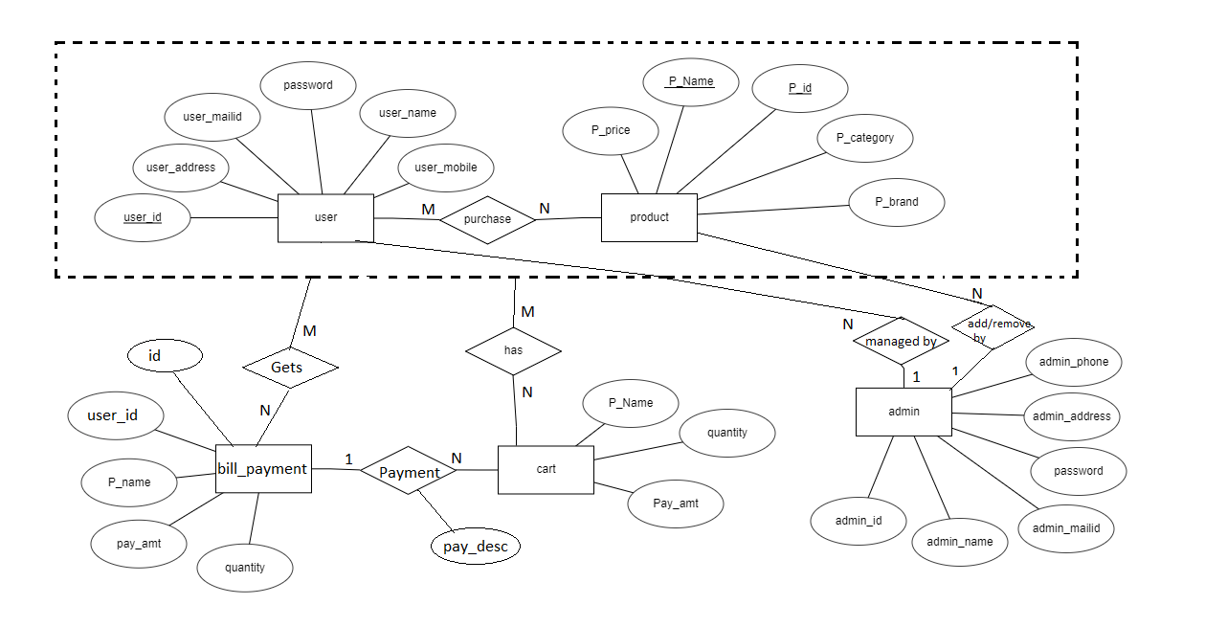

Figure 2.1.1: ER Diagram for sports store management

2.2 Logical Design

ER MAPPING:
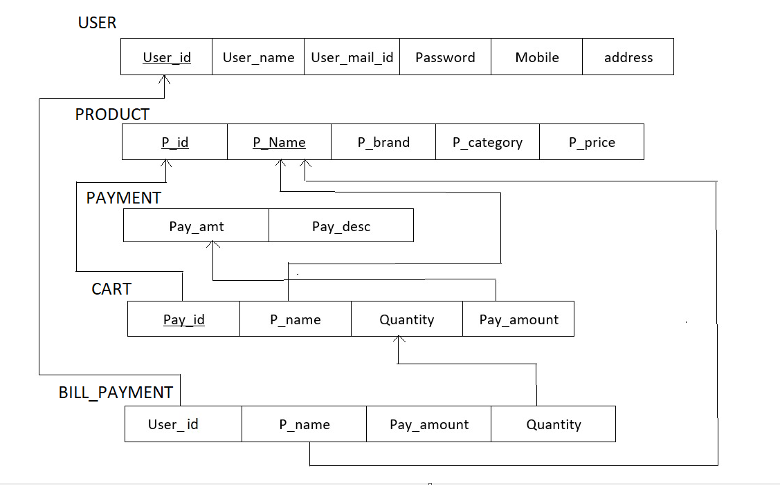

Fig 2.2.1 : ER mapping

2.3 Normalization

USER

R(User_ID,User_Name,User_Mobile,User_Mailid,User_Address)

The functional dependancies on the above relation:
FD1 = { User _ID} -> { User_Name,User_Mobile,User_Mailid,User_Address }

Set of key attributes:{ User _ID, User_Name }
Set of non key attributes:{User_Mobile,User_Mailid,User_Address }

1. The relation is in 1NF as all attributes are atomic.
2. The relation is in 2NF as all the non_prime attributes are fully functionally dependant on the prime attributes.
3. The relation is in 3NF as there exists no transitive dependency between prime and non prime attributes.

PAYMENT

R(Pay_Id,Pay_Amt,Pay_Desc)

The functional dependancies on the above relation:
FD1 = { Pay_id } -> { Pay_Amt,Pay_Desc }

Set of key attributes:{ Pay_id , Pay_Amt }
Set of non key attributes:{Pay_Desc }

1. The relation is in 1NF as all attributes are atomic.
2. The relation is in 2NF as all the non_prime attributes are fully functionally dependant on the prime attributes.
3. The relation is in 3NF as there exists no transitive dependency between prime and non prime attributes.

CART

R(Product_Name,Pay_Amt,Quantity)

The functional dependancies on the above relation:
FD1 = { Product_Name,Pay_Amt } -> {Quantity}

Set of key attributes:{ Product_Name,Pay_Amt}
Set of non key attributes:{Quantity}

1. The relation is in 1NF as all attributes are atomic.
2. The relation is in 2NF as all the non_prime attributes are fully functionally dependant on the prime attributes.
3. The relation is in 3NF as there exists no transitive dependency between prime and non prime attributes.

BILL PAYMENT

R(Product_Name,Pay_Amt,Quantity,User_Name)

The functional dependancies on the above relation:
FD1 = { Product_Name,Pay_Amt } -> { Quantity }

Set of key attributes:{ Product_Name,Pay_Amt,User_Name }
Set of non key attributes:{ Quantity }

1. The relation is in 1NF as all attributes are atomic.
2. The relation is in 2NF as all the non prime attributes are fully functionally dependant on the prime attributes.
3. The relation is in 3NF as there exists no transitive dependency between prime and non prime attributes.

PRODUCT

R(Category,P_id,P_Name,Pay_Amt)

The functional dependancies on the above relation:
FD1 = { P_id } -> { Category, P_Name,Pay_Amt }

Set of key attributes:{ P_id }
Set of non key attributes:{ Category, P_Name,Pay_Amt }

1. The relation is in 1NF as all attributes are atomic.
2. The relation is in 2NF as all the non_prime attributes are fully functionally dependant on the prime attributes.
3. The relation is in 3NF as there exists no transitive dependency between prime and non prime attributes.

CHAPTER 3

FRONT-END DESIGN

FRONT END DESIGN

3.1 Front End Technology

The technologies that we have used for our front end design are HTML, CSS,PHP JAVASCRIPT

HTML: Hypertext Markup Language is the standard markup language for documents designed to be displayed in a web browser. It can be assisted by technologies such as Cascading Style Sheets and scripting languages such as JavaScript.

CSS: Cascading Style Sheets is a style sheet language used for describing the presentation of a document written in a markup language such as HTML. CSS is a cornerstone technology of the World Wide Web, alongside HTML and JavaScript.

JAVASCRIPT: JavaScript is a text-based programming language used both on the client-side and server-side that allows you to make web pages interactive. Where HTML and CSS are languages that give structure and style to web pages, JavaScript gives web pages interactive elements that engage a user.

3.2 Backend Technology

MySQL:- MySQL is an open-source relational database management system. .A relational database organizes data into one or more data tables in which data types may be related to each other; these relations help structure the data.

CHAPTER 4

MAJOR MODULE

4.1 Login Module

The Customer can login with their credentials.

4.2 Register Module

Registration for new employees.

4.3 Recent Orders Module

It displays the recent orders placed by the customers.

4.4 Manage Products Module

New products can be added or deleted. It displays all the products present in the sports store.

4.5 New Order Module

Bill the products bought by the customer and print the bill.

4.6 Order Details Module

Details of the recent orders placed by the customers.

CHAPTER 5

IMPLEMENTATION

IMPLEMENTATION

5.1 CREATE STATEMENTS

CREATE TABLE `products` (
`product_id` int(100) NOT NULL,
`product_cat` int(100) NOT NULL,
`product_brand` int(100) NOT NULL,
`product_title` varchar(255) NOT NULL,
`product_price` int(100) NOT NULL,
`product_desc` text NOT NULL,
`product_image` text NOT NULL
);
CREATE TABLE `user_info` (
`user_id` int(10) NOT NULL,
`first_name` varchar(100) NOT NULL,
`last_name` varchar(100) NOT NULL,
`email` varchar(300) NOT NULL,
`password` varchar(300) NOT NULL,
`mobile` varchar(10) NOT NULL,
`address1` varchar(300) NOT NULL,
`address2` varchar(11) NOT NULL
);
CREATE TABLE `order_products` (
`order_pro_id` int(10) NOT NULL,
`order_id` int(11) NOT NULL,
`product_id` int(11) NOT NULL,
`qty` int(15) DEFAULT NULL,
`amt` int(15) DEFAULT NULL
);
CREATE TABLE order_details (
order_id int NOT NULL,
product_id int NOT NULL,
quantity double NOT NULL,
total_price double NOT NULL,
CONSTRAINT pk_od PRIMARY KEY (order_id,product_id),
CONSTRAINT fk_order_id FOREIGN KEY (order_id) REFERENCES orders(order_id) ON UPDATE RESTRICT,
CONSTRAINT fk_product_id FOREIGN KEY (product_id) REFERENCES products(product_id) ON UPDATE RESTRICT
);

CREATE TABLE `bill_payment ` (
`order_id` int(10) NOT NULL,
`user_id` int(11) NOT NULL,
`f_name` varchar(255) NOT NULL,
`email` varchar(255) NOT NULL,
`address` varchar(255) NOT NULL,
`city` varchar(255) NOT NULL,
`state` varchar(255) NOT NULL,
`zip` int(10) NOT NULL,
`cardname` varchar(255) NOT NULL,
`cardnumber` varchar(20) NOT NULL,
`expdate` varchar(255) NOT NULL,
`prod_count` int(15) DEFAULT NULL,
`total_amt` int(15) DEFAULT NULL,
`cvv` int(5) NOT NULL
));

CREATE TABLE `orders` (
`order_id` int(11) NOT NULL,
`user_id` int(11) NOT NULL,
`product_id` int(11) NOT NULL,
`qty` int(11) NOT NULL,
`trx_id` varchar(255) NOT NULL,
`p_status` varchar(20) NOT NULL
)

5.2 PHP, CSS, JAVA SCRIPT

Login Page:
<?php
include "db.php";

session_start();

#Login script is begin here
#If user given credential matches successfully with the data available in database then we will echo string login_success
#login_success string will go back to called Anonymous funtion $("#login").click()

if(isset($_POST["email"]) && isset($_POST["password"])){
$email = mysqli_real_escape_string($con,$_POST["email"]);
$password = $_POST["password"];
$sql = "SELECT * FROM user_info WHERE email = '$email' AND password = '$password'";
$run_query = mysqli_query($con,$sql);
$count = mysqli_num_rows($run_query);
$row = mysqli_fetch_array($run_query);
$_SESSION["uid"] = $row["user_id"];
$_SESSION["name"] = $row["first_name"];
$ip_add = getenv("REMOTE_ADDR");
//we have created a cookie in login_form.php page so if that cookie is available means user is not login

//if user record is available in database then $count will be equal to 1
if($count == 1){

if (isset($_COOKIE["product_list"])) {
$p_list = stripcslashes($_COOKIE["product_list"]);
//here we are decoding stored json product list cookie to normal array
$product_list = json_decode($p_list,true);
for ($i=0; $i < count($product_list); $i++) {
//After getting user id from database here we are checking user cart item if there is already product is listed or not
$verify_cart = "SELECT id FROM cart WHERE user_id = $_SESSION[uid] AND p_id = ".$product_list[$i];
$result = mysqli_query($con,$verify_cart);
if(mysqli_num_rows($result) < 1){
//if user is adding first time product into cart we will update user_id into database table with valid id
$update_cart = "UPDATE cart SET user_id = '$_SESSION[uid]' WHERE ip_add = '$ip_add' AND user_id = -1";
mysqli_query($con,$update_cart);
}else{
//if already that product is available into database table we will delete that record
$delete_existing_product = "DELETE FROM cart WHERE user_id = -1 AND ip_add = '$ip_add' AND p_id = ".$product_list[$i];
mysqli_query($con,$delete_existing_product);
}
}
//here we are destroying user cookie
setcookie("product_list","",strtotime("-1 day"),"/");
//if user is logging from after cart page we will send cart_login
echo "cart_login";

exit();

}
//if user is login from page we will send login_success
echo "login_success";
$BackToMyPage = $_SERVER['HTTP_REFERER'];
if(!isset($BackToMyPage)) {
header('Location: '.$BackToMyPage);
echo"<script type='text/javascript'>

</script>";
} else {
header('Location: index.php'); // default page
}

exit;

}else{
$email = mysqli_real_escape_string($con,$_POST["email"]);
$password =md5($_POST["password"]) ;
$sql = "SELECT * FROM admin_info WHERE admin_email = '$email' AND admin_password = '$password'";
$run_query = mysqli_query($con,$sql);
$count = mysqli_num_rows($run_query);

//if user record is available in database then $count will be equal to 1
if($count == 1){
$row = mysqli_fetch_array($run_query);
$_SESSION["uid"] = $row["admin_id"];
$_SESSION["name"] = $row["admin_name"];
$ip_add = getenv("REMOTE_ADDR");
//we have created a cookie in login_form.php page so if that cookie is available means user is not login

//if user is login from page we will send login_success
echo "login_success";

echo "<script> location.href='admin/addproduct.php'; </script>";
exit;

}else{
echo "<span style='color:red;'>Please register before login..!</span>";
exit();
}

}

}

?>

Register page:
<?php
session_start();
include "db.php";
if (isset($_POST["f_name"])) {

$f_name = $_POST["f_name"];
$l_name = $_POST["l_name"];
$email = $_POST['email'];
$password = $_POST['password'];
$repassword = $_POST['repassword'];
$mobile = $_POST['mobile'];
$address1 = $_POST['address1'];
$address2 = $_POST['address2'];
$name = "/^[a-zA-Z ]+$/";
$emailValidation = "/^[_a-z0-9-]+(\.[_a-z0-9-]+)*@[a-z0-9]+(\.[a-z]{2,4})$/";
$number = "/^[0-9]+$/";

if(empty($f_name) || empty($l_name) || empty($email) || empty($password) || empty($repassword) ||
empty($mobile) || empty($address1) || empty($address2)){

echo "
<div class='alert alert-warning'>
<a href='#' class='close' data-dismiss='alert' aria-label='close'>&times;</a><b>PLease Fill all fields..!</b>
</div>
";
exit();
} else {
if(!preg_match($name,$f_name)){
echo "
<div class='alert alert-warning'>
<a href='#' class='close' data-dismiss='alert' aria-label='close'>&times;</a>
<b>this $f_name is not valid..!</b>
</div>
";
exit();
}
if(!preg_match($name,$l_name)){
echo "
<div class='alert alert-warning'>
<a href='#' class='close' data-dismiss='alert' aria-label='close'>&times;</a>
<b>this $l_name is not valid..!</b>
</div>
";
exit();
}
if(!preg_match($emailValidation,$email)){
echo "
<div class='alert alert-warning'>
<a href='#' class='close' data-dismiss='alert' aria-label='close'>&times;</a>
<b>this $email is not valid..!</b>
</div>
";
exit();
}
if(strlen($password) < 9 ){
echo "
<div class='alert alert-warning'>
<a href='#' class='close' data-dismiss='alert' aria-label='close'>&times;</a>
<b>Password is weak</b>
</div>
";
exit();
}
if(strlen($repassword) < 9 ){
echo "
<div class='alert alert-warning'>
<a href='#' class='close' data-dismiss='alert' aria-label='close'>&times;</a>
<b>Password is weak</b>
</div>
";
exit();
}
if($password != $repassword){
echo "
<div class='alert alert-warning'>
<a href='#' class='close' data-dismiss='alert' aria-label='close'>&times;</a>
<b>password is not same</b>
</div>
";
}
if(!preg_match($number,$mobile)){
echo "
<div class='alert alert-warning'>
<a href='#' class='close' data-dismiss='alert' aria-label='close'>&times;</a>
<b>Mobile number $mobile is not valid</b>
</div>
";
exit();
}
if(!(strlen($mobile) == 10)){
echo "
<div class='alert alert-warning'>
<a href='#' class='close' data-dismiss='alert' aria-label='close'>&times;</a>
<b>Mobile number must be 10 digit</b>
</div>
";
exit();
}
//existing email address in our database
$sql = "SELECT user_id FROM user_info WHERE email = '$email' LIMIT 1" ;
$check_query = mysqli_query($con,$sql);
$count_email = mysqli_num_rows($check_query);
if($count_email > 0){
echo "
<div class='alert alert-danger'>
<a href='#' class='close' data-dismiss='alert' aria-label='close'>&times;</a>
<b>Email Address is already available Try Another email address</b>
</div>
";
exit();
} else {

$sql = "INSERT INTO `user_info`
(`user_id`, `first_name`, `last_name`, `email`,
`password`, `mobile`, `address1`, `address2`)
VALUES (NULL, '$f_name', '$l_name', '$email',
'$password', '$mobile', '$address1', '$address2')";
$run_query = mysqli_query($con,$sql);
$_SESSION["uid"] = mysqli_insert_id($con);
$_SESSION["name"] = $f_name;
$ip_add = getenv("REMOTE_ADDR");
$sql = "UPDATE cart SET user_id = '$_SESSION[uid]' WHERE ip_add='$ip_add' AND user_id = -1";
if(mysqli_query($con,$sql)){
echo "register_success";
echo "<script> location.href='store.php'; </script>";
exit;
}
}
}

}
Recent Orders Page:
<?php
session_start();
$ip_add = getenv("REMOTE_ADDR");
include "db.php";

if(isset($_POST["categoryhome"])){
$category_query = "SELECT * FROM categories WHERE cat_id!=1";

$run_query = mysqli_query($con,$category_query) or die(mysqli_error($con));
echo "

<!-- responsive-nav -->
<div id='responsive-nav'>
<!-- NAV -->
<ul class='main-nav nav navbar-nav'>
<li class='active'><a href='index.php'>Home</a></li>
<li><a href='store.php'>Cricket</a></li>
";
if(mysqli_num_rows($run_query) > 0){
while($row = mysqli_fetch_array($run_query)){
$cid = $row["cat_id"];
$cat_name = $row["cat_title"];

$sql = "SELECT COUNT(*) AS count_items FROM products,categories WHERE product_cat=cat_id";
$query = mysqli_query($con,$sql);
$row = mysqli_fetch_array($query);
$count=$row["count_items"];

echo "

<li class='categoryhome' cid='$cid'><a href='store.php'>$cat_name</a></li>

";
}

echo "</ul>
<!-- /NAV -->
</div>
<!-- /responsive-nav -->

";
}
}

if(isset($_POST["page"])){
$sql = "SELECT * FROM products";
$run_query = mysqli_query($con,$sql);
$count = mysqli_num_rows($run_query);
$pageno = ceil($count/2);
for($i=1;$i<=$pageno;$i++){
echo "
<li><a href='#product-row' page='$i' id='page'>$i</a></li>

";
}
}
if(isset($_POST["getProducthome"])){
$limit = 3;
if(isset($_POST["setPage"])){
$pageno = $_POST["pageNumber"];
$start = ($pageno * $limit) - $limit;
}else{
$start = 0;
}
$product_query = "SELECT * FROM products,categories WHERE product_cat=cat_id LIMIT $start,$limit";
$run_query = mysqli_query($con,$product_query);
if(mysqli_num_rows($run_query) > 0){
while($row = mysqli_fetch_array($run_query)){
$pro_id = $row['product_id'];
$pro_cat = $row['product_cat'];
$pro_brand = $row['product_brand'];
$pro_title = $row['product_title'];
$pro_price = $row['product_price'];
$pro_image = $row['product_image'];

$cat_name = $row["cat_title"];
echo "

<div class='product-widget'>
<a href='product.php?p=$pro_id'>
<div class='product-img'>
<img src='product_images/$pro_image' alt=''>
</div>
<div class='product-body'>
<p class='product-category'>$cat_name</p>
<h3 class='product-name'><a href='product.php?p=$pro_id'>$pro_title</a></h3>
<h4 class='product-price'>$pro_price<del class='product-old-price'>$990.00</del></h4>
</div></a>
</div>

";
}
}
}

if(isset($_POST["gethomeProduct"])){
$limit = 9;
if(isset($_POST["setPage"])){
$pageno = $_POST["pageNumber"];
$start = ($pageno * $limit) - $limit;
}else{
$start = 0;
}

$product_query = "SELECT * FROM products,categories WHERE product_cat=cat_id AND product_id BETWEEN 71 AND 74";
$run_query = mysqli_query($con,$product_query);
if(mysqli_num_rows($run_query) > 0){

while($row = mysqli_fetch_array($run_query)){
$pro_id = $row['product_id'];
$pro_cat = $row['product_cat'];
$pro_brand = $row['product_brand'];
$pro_title = $row['product_title'];
$pro_price = $row['product_price'];
$pro_image = $row['product_image'];

$cat_name = $row["cat_title"];

echo "

<div class='col-md-3 col-xs-6'>
<a href='product.php?p=$pro_id'><div class='product'>
<div class='product-img'>
<img src='product_images/$pro_image' style='max-height: 170px;' alt=''>
<div class='product-label'>
<span class='sale'>-30%</span>
<span class='new'>NEW</span>
</div>
</div></a>
<div class='product-body'>
<p class='product-category'>$cat_name</p>
<h3 class='product-name header-cart-item-name'><a href='product.php?p=$pro_id'>$pro_title</a></h3>
<h4 class='product-price header-cart-item-info'>$pro_price<del class='product-old-price'>$990.00</del></h4>
<div class='product-rating'>
<i class='fa fa-star'></i>
<i class='fa fa-star'></i>
<i class='fa fa-star'></i>
<i class='fa fa-star'></i>
<i class='fa fa-star'></i>
</div>
<div class='product-btns'>
<button class='add-to-wishlist'><i class='fa fa-heart-o'></i><span class='tooltipp'>add to wishlist</span></button>
<button class='add-to-compare'><i class='fa fa-exchange'></i><span class='tooltipp'>add to compare</span></button>
<button class='quick-view'><i class='fa fa-eye'></i><span class='tooltipp'>quick view</span></button>
</div>
</div>
<div class='add-to-cart'>
<button pid='$pro_id' id='product' class='add-to-cart-btn block2-btn-towishlist' href='#'><i class='fa fa-shopping-cart'></i> add to cart</button>
</div>
</div>
</div>

";
}
;

}

}

if(isset($_POST["get_seleted_Category"]) || isset($_POST["search"])){
if(isset($_POST["get_seleted_Category"])){
$id = $_POST["cat_id"];
$sql = "SELECT * FROM products,categories WHERE product_cat = '$id' AND product_cat=cat_id";
}else {
$keyword = $_POST["keyword"];
$sql = "SELECT * FROM products,categories WHERE product_cat=cat_id AND product_keywords LIKE '%$keyword%'";
}

$run_query = mysqli_query($con,$sql);
while($row=mysqli_fetch_array($run_query)){
$pro_id = $row['product_id'];
$pro_cat = $row['product_cat'];
$pro_brand = $row['product_brand'];
$pro_title = $row['product_title'];
$pro_price = $row['product_price'];
$pro_image = $row['product_image'];
$cat_name = $row["cat_title"];
echo "

<div class='col-md-4 col-xs-6'>
<a href='product.php?p=$pro_id'><div class='product'>
<div class='product-img'>
<img src='product_images/$pro_image' style='max-height: 170px;' alt=''>
<div class='product-label'>
<span class='sale'>-30%</span>
<span class='new'>NEW</span>
</div>
</div></a>
<div class='product-body'>
<p class='product-category'>$cat_name</p>
<h3 class='product-name header-cart-item-name'><a href='product.php?p=$pro_id'>$pro_title</a></h3>
<h4 class='product-price header-cart-item-info'>$pro_price<del class='product-old-price'>$990.00</del></h4>
<div class='product-rating'>
<i class='fa fa-star'></i>
<i class='fa fa-star'></i>
<i class='fa fa-star'></i>
<i class='fa fa-star'></i>
<i class='fa fa-star'></i>
</div>
<div class='product-btns'>
<button class='add-to-wishlist' tabindex='0'><i class='fa fa-heart-o'></i><span class='tooltipp'>add to wishlist</span></button>
<button class='add-to-compare'><i class='fa fa-exchange'></i><span class='tooltipp'>add to compare</span></button>
<button class='quick-view' ><i class='fa fa-eye'></i><span class='tooltipp'>quick view</span></button>
</div>
</div>
<div class='add-to-cart'>
<button pid='$pro_id' id='product' href='#' tabindex='0' class='add-to-cart-btn'><i class='fa fa-shopping-cart'></i> add to cart</button>
</div>
</div>
</div>
";
}
}
Products Page:
<?php
include "header.php";
?>
<!-- /BREADCRUMB -->
<script type="text/javascript">
jQuery(document).ready(function($) {
$(".scroll").click(function(event){
event.preventDefault();
$('html,body').animate({scrollTop:$(this.hash).offset().top},900);
});
});
</script>
<script>

(function (global) {
if(typeof (global) === "undefined")
{
throw new Error("window is undefined");
}
var _hash = "!";
var noBackPlease = function () {
global.location.href += "#";
// making sure we have the fruit available for juice....
// 50 milliseconds for just once do not cost much (^__^)
global.setTimeout(function () {
global.location.href += "!";
}, 50);
};
// Earlier we had setInerval here....
global.onhashchange = function () {
if (global.location.hash !== _hash) {
global.location.hash = _hash;
}
};
global.onload = function () {
noBackPlease();
// disables backspace on page except on input fields and textarea..
document.body.onkeydown = function (e) {
var elm = e.target.nodeName.toLowerCase();
if (e.which === 8 && (elm !== 'input' && elm !== 'textarea')) {
e.preventDefault();
}
// stopping event bubbling up the DOM tree..
e.stopPropagation();
};
};
})(window);
</script>

<!-- SECTION -->
<div class="section main main-raised">
<!-- container -->
<div class="container">
<!-- row -->
<div class="row">
<!-- Product main img -->

<?php
include 'db.php';
$product_id = $_GET['p'];

$sql = " SELECT * FROM products ";
$sql = " SELECT * FROM products WHERE product_id = $product_id";
if (!$con) {
die("Connection failed: " . mysqli_connect_error());
}
$result = mysqli_query($con, $sql);
if (mysqli_num_rows($result) > 0)
{
while($row = mysqli_fetch_assoc($result))
{
echo '

<div class="col-md-5 col-md-push-2">
<div id="product-main-img">
<div class="product-preview">
<img src="product_images/'.$row['product_image'].'" alt="">
</div>

<div class="product-preview">
<img src="product_images/'.$row['product_image'].'" alt="">
</div>

<div class="product-preview">
<img src="product_images/'.$row['product_image'].'" alt="">
</div>

<div class="product-preview">
<img src="product_images/'.$row['product_image'].'" alt="">
</div>
</div>
</div>

<div class="col-md-2 col-md-pull-5">
<div id="product-imgs">
<div class="product-preview">
<img src="product_images/'.$row['product_image'].'" alt="">
</div>

<div class="product-preview">
<img src="product_images/'.$row['product_image'].'" alt="">
</div>

<div class="product-preview">
<img src="product_images/'.$row['product_image'].'g" alt="">
</div>

<div class="product-preview">
<img src="product_images/'.$row['product_image'].'" alt="">
</div>
</div>
</div>

';

?>
<!-- FlexSlider -->

<?php
echo '

<div class="col-md-5">
<div class="product-details">
<h2 class="product-name">'.$row['product_title'].'</h2>
<div>
<div class="product-rating">
<i class="fa fa-star"></i>
<i class="fa fa-star"></i>
<i class="fa fa-star"></i>
<i class="fa fa-star"></i>
<i class="fa fa-star-o"></i>
</div>
<a class="review-link" href="#review-form">10 Review(s) | Add your review</a>
</div>
<div>
<h3 class="product-price">$'.$row['product_price'].'<del class="product-old-price">$990.00</del></h3>
<span class="product-available">In Stock</span>
</div>
<p> Good quality with two-piece construction Made with alum tanned leather Comprises of molded cork filling Apt for use on a grass surface Weighs 156 gm with a diameter of 7.3 cm Available in a set of two in red color Ideal for practice and training</p>

<div class="product-options">
<label>
Size
<select class="input-select">
<option value="0">X</option>
</select>
</label>
<label>
Color
<select class="input-select">
<option value="0">Red</option>
</select>
</label>
</div>

<div class="add-to-cart">
<div class="qty-label">
Qty
<div class="input-number">

<span class="qty-up">+</span>
<span class="qty-down">-</span>
</div>
</div>
<div class="btn-group" style="margin-left: 25px; margin-top: 15px">
<button class="add-to-cart-btn" pid="'.$row['product_id'].'" id="product" ><i class="fa fa-shopping-cart"></i> add to cart</button>
</div>

</div>

<ul class="product-btns">
<li><a href="#"><i class="fa fa-heart-o"></i> add to wishlist</a></li>
<li><a href="#"><i class="fa fa-exchange"></i> add to compare</a></li>
</ul>

<ul class="product-links">
<li>Category:</li>
<li><a href="#">Headphones</a></li>
<li><a href="#">Accessories</a></li>
</ul>

<ul class="product-links">
<li>Share:</li>
<li><a href="#"><i class="fa fa-facebook"></i></a></li>
<li><a href="#"><i class="fa fa-twitter"></i></a></li>
<li><a href="#"><i class="fa fa-google-plus"></i></a></li>
<li><a href="#"><i class="fa fa-envelope"></i></a></li>
</ul>

</div>
</div>

<!-- /Product main img -->

<!-- Product thumb imgs -->

<!-- /Product thumb imgs -->

<!-- Product details -->

<!-- /Product details -->

<!-- Product tab -->
<div class="col-md-12">
<div id="product-tab">
<!-- product tab nav -->
<ul class="tab-nav">
<li class="active"><a data-toggle="tab" href="#tab1">Description</a></li>
<li><a data-toggle="tab" href="#tab2">Details</a></li>
<li><a data-toggle="tab" href="#tab3">Reviews (3)</a></li>
</ul>
<!-- /product tab nav -->

<!-- product tab content -->
<div class="tab-content">
<!-- tab1 -->
<div id="tab1" class="tab-pane fade in active">
<div class="row">
<div class="col-md-12">
<p>Good quality with two-piece construction Made with alum tanned leather Comprises of molded cork filling Apt for use on a grass surface Weighs 156 gm with a diameter of 7.3 cm Available in a set of two in red color Ideal for practice and training</p>
</div>
</div>
</div>
<!-- /tab1 -->

<!-- tab2 -->
<div id="tab2" class="tab-pane fade in">
<div class="row">
<div class="col-md-12">
<p>Lorem ipsum dolor sit amet, consectetur adipisicing elit, sed do eiusmod tempor incididunt ut labore et dolore magna aliqua. Ut enim ad minim veniam, quis nostrud exercitation ullamco laboris nisi ut aliquip ex ea commodo consequat. Duis aute irure dolor in reprehenderit in voluptate velit esse cillum dolore eu fugiat nulla pariatur. Excepteur sint occaecat cupidatat non proident, sunt in culpa qui officia deserunt mollit anim id est laborum.</p>
</div>
</div>
</div>
<!-- /tab2 -->

<!-- tab3 -->
<div id="tab3" class="tab-pane fade in">
<div class="row">
<!-- Rating -->
<div class="col-md-3">
<div id="rating">
<div class="rating-avg">
<span>4.5</span>
<div class="rating-stars">
<i class="fa fa-star"></i>
<i class="fa fa-star"></i>
<i class="fa fa-star"></i>
<i class="fa fa-star"></i>
<i class="fa fa-star-o"></i>
</div>
</div>
<ul class="rating">
<li>
<div class="rating-stars">
<i class="fa fa-star"></i>
<i class="fa fa-star"></i>
<i class="fa fa-star"></i>
<i class="fa fa-star"></i>
<i class="fa fa-star"></i>
</div>
<div class="rating-progress">
<div style="width: 80%;"></div>
</div>
<span class="sum">3</span>
</li>
<li>
<div class="rating-stars">
<i class="fa fa-star"></i>
<i class="fa fa-star"></i>
<i class="fa fa-star"></i>
<i class="fa fa-star"></i>
<i class="fa fa-star-o"></i>
</div>
<div class="rating-progress">
<div style="width: 60%;"></div>
</div>
<span class="sum">2</span>
</li>
<li>
<div class="rating-stars">
<i class="fa fa-star"></i>
<i class="fa fa-star"></i>
<i class="fa fa-star"></i>
<i class="fa fa-star-o"></i>
<i class="fa fa-star-o"></i>
</div>
<div class="rating-progress">
<div></div>
</div>
<span class="sum">0</span>
</li>
<li>
<div class="rating-stars">
<i class="fa fa-star"></i>
<i class="fa fa-star"></i>
<i class="fa fa-star-o"></i>
<i class="fa fa-star-o"></i>
<i class="fa fa-star-o"></i>
</div>
<div class="rating-progress">
<div></div>
</div>
<span class="sum">0</span>
</li>
<li>
<div class="rating-stars">
<i class="fa fa-star"></i>
<i class="fa fa-star-o"></i>
<i class="fa fa-star-o"></i>
<i class="fa fa-star-o"></i>
<i class="fa fa-star-o"></i>
</div>
<div class="rating-progress">
<div></div>
</div>
<span class="sum">0</span>
</li>
</ul>
</div>
</div>
<!-- /Rating -->

<!-- Reviews -->
<div class="col-md-6">
<div id="reviews">
<ul class="reviews">
<li>
<div class="review-heading">
<h5 class="name">John</h5>
<p class="date">27 DEC 2018, 8:0 PM</p>
<div class="review-rating">
<i class="fa fa-star"></i>
<i class="fa fa-star"></i>
<i class="fa fa-star"></i>
<i class="fa fa-star"></i>
<i class="fa fa-star-o empty"></i>
</div>
</div>
<div class="review-body">
<p>Lorem ipsum dolor sit amet, consectetur adipisicing elit, sed do eiusmod tempor incididunt ut labore et dolore magna aliqua</p>
</div>
</li>
<li>
<div class="review-heading">
<h5 class="name">John</h5>
<p class="date">27 DEC 2018, 8:0 PM</p>
<div class="review-rating">
<i class="fa fa-star"></i>
<i class="fa fa-star"></i>
<i class="fa fa-star"></i>
<i class="fa fa-star"></i>
<i class="fa fa-star-o empty"></i>
</div>
</div>
<div class="review-body">
<p>Lorem ipsum dolor sit amet, consectetur adipisicing elit, sed do eiusmod tempor incididunt ut labore et dolore magna aliqua</p>
</div>
</li>
<li>
<div class="review-heading">
<h5 class="name">John</h5>
<p class="date">27 DEC 2018, 8:0 PM</p>
<div class="review-rating">
<i class="fa fa-star"></i>
<i class="fa fa-star"></i>
<i class="fa fa-star"></i>
<i class="fa fa-star"></i>
<i class="fa fa-star-o empty"></i>
</div>
</div>
<div class="review-body">
<p>Lorem ipsum dolor sit amet, consectetur adipisicing elit, sed do eiusmod tempor incididunt ut labore et dolore magna aliqua</p>
</div>
</li>
</ul>
<ul class="reviews-pagination">
<li class="active">1</li>
<li><a href="#">2</a></li>
<li><a href="#">3</a></li>
<li><a href="#">4</a></li>
<li><a href="#"><i class="fa fa-angle-right"></i></a></li>
</ul>
</div>
</div>
<!-- /Reviews -->

<!-- Review Form -->
<div class="col-md-3 mainn">
<div id="review-form">
<form class="review-form">
<input class="input" type="text" placeholder="Your Name">
<input class="input" type="email" placeholder="Your Email">
<textarea class="input" placeholder="Your Review"></textarea>
<div class="input-rating">
<span>Your Rating: </span>
<div class="stars">
<input id="star5" name="rating" value="5" type="radio"><label for="star5"></label>
<input id="star4" name="rating" value="4" type="radio"><label for="star4"></label>
<input id="star3" name="rating" value="3" type="radio"><label for="star3"></label>
<input id="star2" name="rating" value="2" type="radio"><label for="star2"></label>
<input id="star1" name="rating" value="1" type="radio"><label for="star1"></label>
</div>
</div>
<button class="primary-btn">Submit</button>
</form>
</div>
</div>
<!-- /Review Form -->
</div>
</div>
<!-- /tab3 -->
</div>
<!-- /product tab content -->
</div>
</div>
<!-- /product tab -->
</div>
<!-- /row -->
</div>
<!-- /container -->
</div>
<!-- /SECTION -->

<!-- Section -->
<div class="section main main-raised">
<!-- container -->
<div class="container">
<!-- row -->
<div class="row">

<div class="col-md-12">
<div class="section-title text-center">
<h3 class="title">Related Products</h3>

</div>
</div>
';
$_SESSION['product_id'] = $row['product_id'];
}
}
?>
<?php
include 'db.php';
$product_id = $_GET['p'];

$product_query = "SELECT * FROM products,categories WHERE product_cat=cat_id AND product_id BETWEEN $product_id AND $product_id+3";
$run_query = mysqli_query($con,$product_query);
if(mysqli_num_rows($run_query) > 0){

while($row = mysqli_fetch_array($run_query)){
$pro_id = $row['product_id'];
$pro_cat = $row['product_cat'];
$pro_brand = $row['product_brand'];
$pro_title = $row['product_title'];
$pro_price = $row['product_price'];
$pro_image = $row['product_image'];

$cat_name = $row["cat_title"];

echo "

<div class='col-md-3 col-xs-6'>
<a href='product.php?p=$pro_id'><div class='product'>
<div class='product-img'>
<img src='product_images/$pro_image' style='max-height: 170px;' alt=''>
<div class='product-label'>
<span class='sale'>-30%</span>
<span class='new'>NEW</span>
</div>
</div></a>
<div class='product-body'>
<p class='product-category'>$cat_name</p>
<h3 class='product-name header-cart-item-name'><a href='product.php?p=$pro_id'>$pro_title</a></h3>
<h4 class='product-price header-cart-item-info'>$pro_price<del class='product-old-price'>$990.00</del></h4>
<div class='product-rating'>
<i class='fa fa-star'></i>
<i class='fa fa-star'></i>
<i class='fa fa-star'></i>
<i class='fa fa-star'></i>
<i class='fa fa-star'></i>
</div>
<div class='product-btns'>
<button class='add-to-wishlist'><i class='fa fa-heart-o'></i><span class='tooltipp'>add to wishlist</span></button>
<button class='add-to-compare'><i class='fa fa-exchange'></i><span class='tooltipp'>add to compare</span></button>
<button class='quick-view'><i class='fa fa-eye'></i><span class='tooltipp'>quick view</span></button>
</div>
</div>
<div class='add-to-cart'>

<button pid='$pro_id' id='product' class='add-to-cart-btn block2-btn-towishlist' href='#'><i class='fa fa-shopping-cart'></i> add to cart</button>
</div>
</div>
</div>

";
}
;

}?>

<!-- product -->

<!-- /product -->

</div>
<!-- /row -->

</div>
<!-- /container -->
</div>
<!-- /Section -->

<!-- NEWSLETTER -->

<!-- /NEWSLETTER -->

<!-- FOOTER -->
<?php
include "newslettter.php";
include "footer.php";

?>

CHAPTER 6

SNAPSHOTS

SNAPSHOTS

6.1 SCREEN SHOTS

1. LOGIN PAGE

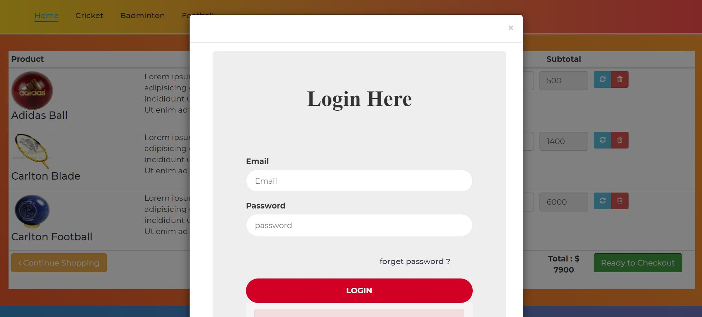

Figure 6.1.1: Login page

2. REGISTER PAGE
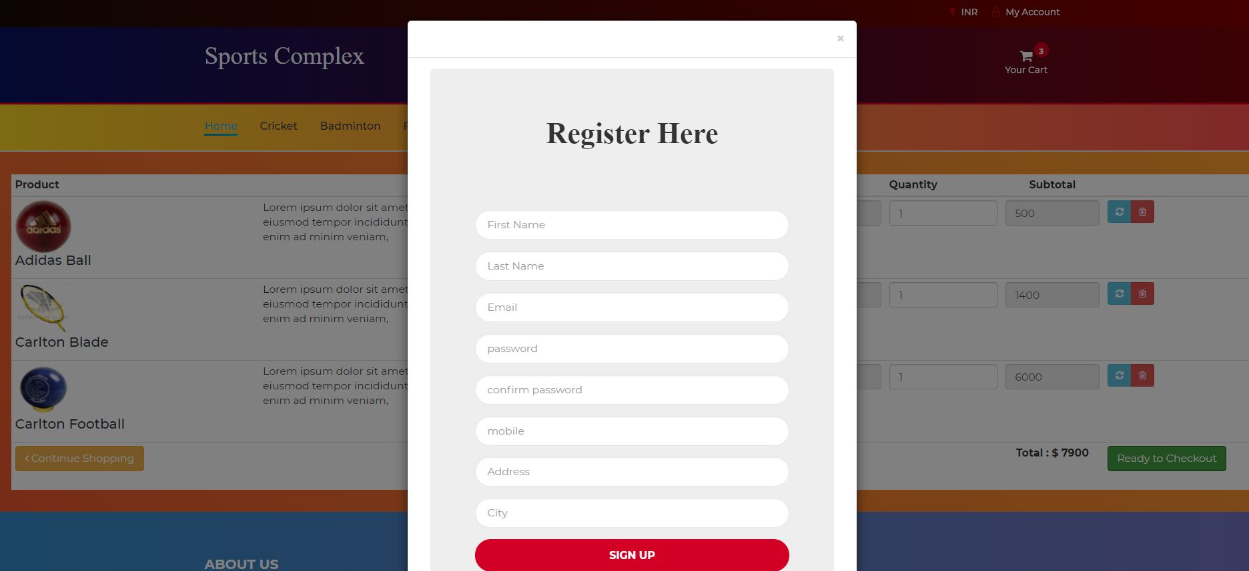

Figure 6.1.2: Registration page

3. HOME
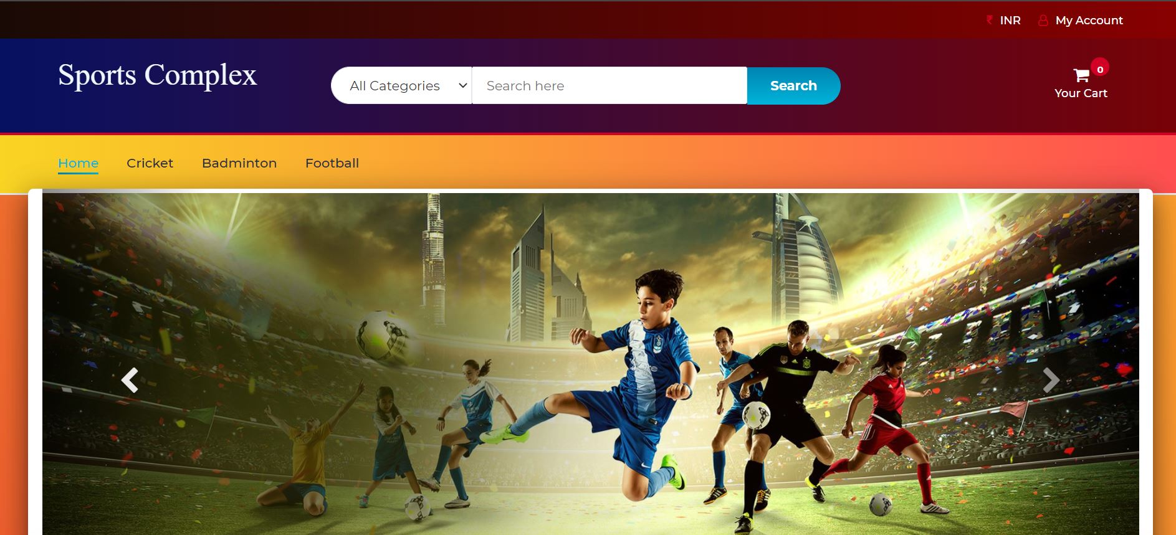

Figure 6.1.3: Home Page

4. CRICKET

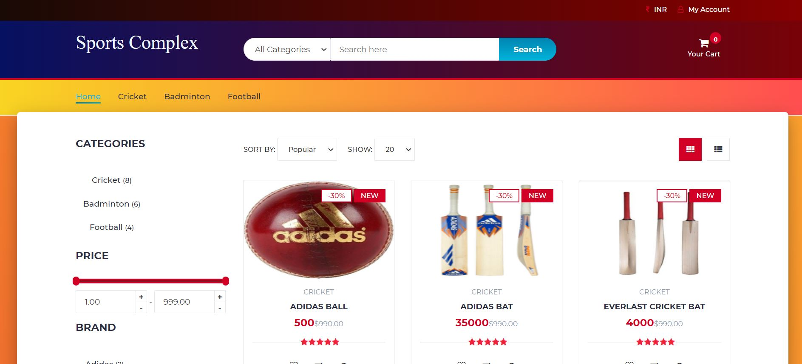

Figure 6.1.4: List of Cricket items

5. BADMINTON

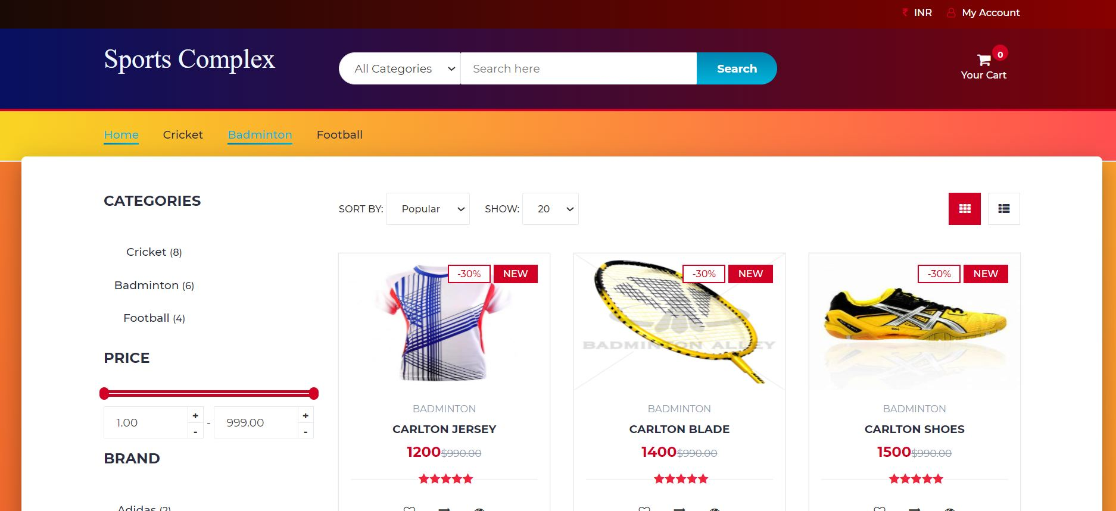
Figure 6.1.5: List of badminton items

6. CART

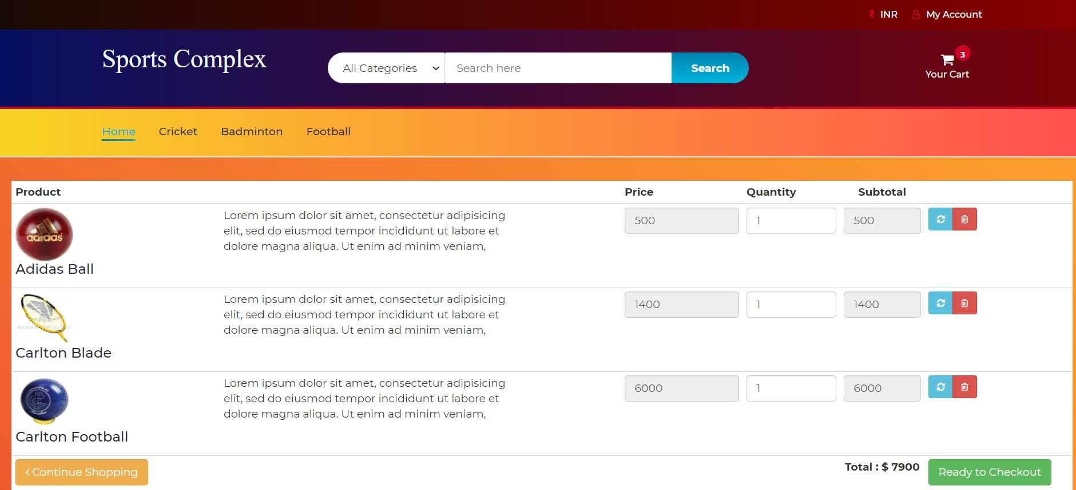

Figure 6.1.6: Cart

CHAPTER 7

APPLICATIONS

APPLICATIONS

7.1 APPLICATIONS

- Direct, personalized communication with your customers

- Improved customer loyalty and retention

- Full access to customer information (email, browsing/purchase history)

- Faster dispute resolution

- Optimized business decisions, operations, products and services

- Complete business autonomy (you set the rules).

CHAPTER 8

CONCLUSION

8.1 CONCLUSION

The Sports complex System provides easier maintenance of various stocks that person will purchase. It allows simplified operation and is a time saving platform with the ability to view product data and thus invest easily and carefully on the various products. The application has been completed successfully and tested with suitable test cases. It is user friendly and contains suitable options for users and shareholders. This is developed using HTML, CSS, PHP and SQL. The goals achieved by this project are:

- Centralized database

- Easier buying, selling of various stocks.

- User friendly environment.

- Efficient management of stocks.

- Ability to view products

