Consider a 2D char array initialized with data as below.
#define MAX_LEN 80

char arr[][MAX_LENGTH]={“Antony:Joseph”, “Lata:Mary”, “Rajesh:Kumar”, “Joly:Akbar”};

Write an application with functions to perform the given operations on input array. Invoke the functions and test the application.

Requirement Tag | Requirement Description | Comments
ARR/01 | int getFirstNames(char arr[][MAX_LENGTH], int rowcount, char *firstnames[]);  should receive input array containing 'n' first name: last name pairs, where n=rowcount,  process each name, extract firstName, store address  in firstname array of pointers. | Should return EXIT_SUCCESS on success else EXIT_FAILURE  Hint: Use strtok() to tokenise
ARR/02 | int getLastNames(char arr[][MAX_LENGTH], int rowcount, char *lastnames[]);  Similar to getFirstName(), but it extracts and stores in lastnames

ARR/01:
#include<stdio.h>
int main() {
char firstname[20], lastname[20];
int bir_year;
printf("Input your firstname: ");
scanf("%s", firstname) ;
printf("Input your lastname: ");
scanf("%s", lastname);
printf("Input your year of birth: ");
scanf("%d", &bir_year);
printf("%s %s %d\n", firstname, lastname, bir_year);
return 0;
}
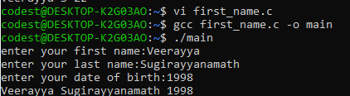
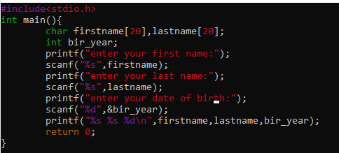

ARR/02:
#include<iostream>
#include<cstring>
using namespace std;
int main() {
char getName[] = "Veerayya";
cout << "String Length = " << strlen(getName);
return 0;
}
