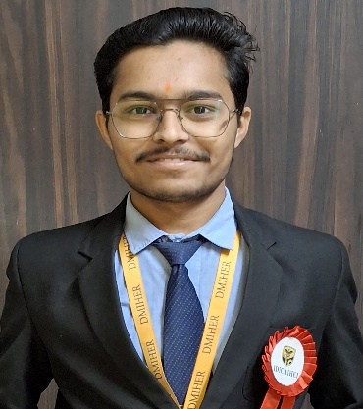

**Mr. Veer Bobade**

**Wardha, Maharashtra**

**• +91 8010836274**

**• veerbobade@gmail.com**

**•**

|  |  |  |  |  |  |  |  |  |  |
| --- | --- | --- | --- | --- | --- | --- | --- | --- | --- |
| **ACADEMIC QUALIFICATIONS** | | | | | | | | | |
| **Year** | **Qualification** | | | | **Institute** | | **CGPA/%** | | |
| 2024-2025 | S.E, B.Tech, Artificial Intelligence And Machine Learning  [Pursuing] | | | | Faculty Of Engineering And Technology (DMIHER) DU, Wardha | | **7.48** | | |
| 2023-2024 | F.E, B.Tech, Artificial Intelligence And Machine Learning | | | | Faculty Of Engineering And Technology (DMIHER) DU, Wardha | | **7.4** | | |
| 2022 | Maharashtra State Board Of Higher Secondary Education | | | | BAJAJ SCIENCE COLLEGE OF WARDHA | | **73.67%** | | |
| 2020 | Maharashtra State Board Of Higher Secondary Education | | | | SUSHIL HIMMATSINGA VIDYALAYA WARDHA | | **88.40%** | | |
| **SUMMER INTERNSHIP** | | | | | | | | | |
| **CodeSoft** | | | **Data Science** | | | **April 2024 – Aug 2024** | | | |
|  | | | | | | | | | |
| **Tata Group - Forage** | | | | **Data Visualization** | | **May 2024 – May 2024** | | | |
| * . | | | | | | | | | |
| **KEY PROJECTS UNDERTAKEN** | | | | | | | | | |
| **Field of Project,**  **Institute.** | | * Predicting ECG Signal Model | | | | | | | (2023) |
| **Field of Project, Institute** | | * Portfolio Application for Making an Attractive Resume | | | | | | | (2024) |
| **POSITIONS OF RESPONSIBILITY** | | | | | | | | | |
| Secretary, Social Welfare And Organ Donation Club At DMIHER (DU) | | * Encouraging Student to be a part of various social Activities and showcasing my participation in social work in a society. | | | | | | | |  |
| Member, Spring Field Club  at DMIHER (DU) | | * Actively participated in cultural and social events, contributing to community engagement and teamwork. Developed interpersonal, organizational, and leadership skills through diverse activities. | | | | | | | | (2013) |
| **Position Name,**  **Institute** | |  | | | | | | | | (2014) |
| **ACHIEVEMENTS & CERTIFICATIONS** | | | | | | | | | |
| **Competitions** | |  | | | | | | (Year)  (Year) | |
| **Certifications** | | * Clinical Decision Support Systems - CDSS 4( Coursera, Virtual ) * **Introduction To Python(** Coursera, Virtual **)** * Programming For Everybody ( Coursera, Virtual) | | | | | | (2024)  (2024) | |
| **Others** | | * Participated in the Google Cloud Arcade, enhancing skills in cloud computing and related technologies | | | | | | (2024) | |
| **SKILLS & INTERESTS** | | | | | | | | | |
| * Python • HTML & CSS * Cricket •e-sports • Badminton | | | | | | | | | |