An Internship Report
Submitted In Partial Fulfillment Of The Requirements For The award of degree of
BACHELOR OF TECHNOLOGY
IN
ARTIFICIAL INTELLIGENCE & MACHINE LEARNING
Submitted by:
PILLA VEERENDRA SWAMI
(23H45A6106)
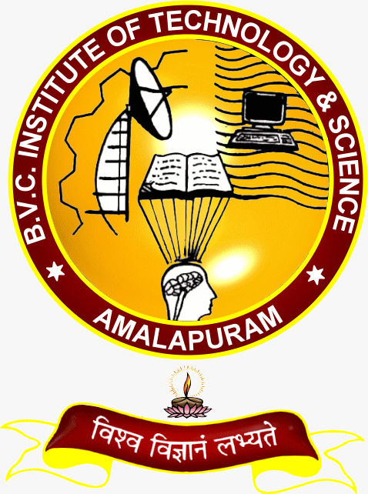

DEPARTMENT OF ARTIFICIAL INTELLIGENCE & MACHINE LEARNING
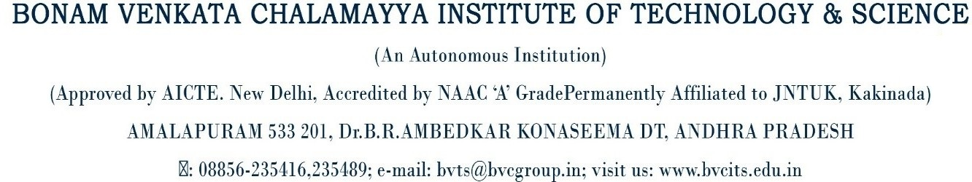
2025-2026
DEPARTMENT OF ARTIFICIAL INTELLIGENCE & MACHINE LEARNING
CERTIFICATE
This is to certify that PILLA VEERENDRA SWAMI Reg. No. 23H45A6106 has completed Internship in TALENT SHINE INDIA Pvt. Ltd as PYTHON DEVELOPMENT as a part of partial fulfillment of the requirement for the Degree of Bachelor of Technology in the Department of ARTIFICIAL INTELLIGENCE & MACHINE LEARNING for the academic year 2025-2026.

Internship Coordinator Head of the Department
Mr.M.Venkatrao, M.Tech Mrs.G.Vijaya kumari (Ph.D), M.Tech
Assistant Professor, HOD &Associate Professor
Department of AI&ML. Department of AI&ML.

External Examiner

DECLARATION
I PILLA VEERENDRA SWAMI a student of Bachelor of Technology, Reg. No. 23H45A6106 of the Department of ARTIFICAL INTELLIGENCE & MACHINE LEARNING , BONAM VENKATA CHALAMAYYA INSTITUTE OF TECHNOLOGY & SCIENCE do hereby declare that I have completed the mandatory internship from 09-06-2025 to 01-08-2025 in TALENT SHINE INDIA Pvt.Ltd on PYTHON DEVELOPMENT under the Faculty Guideship of Mr.M.Venkatrao M.Tech, Department of ARTIFICAL INTELLIGENCE & MACHINE LEARNING, BONAM VENKATA CHALAMAYYA INSTITUTE OF TECHNOLOGY & SCIENCE.

Submitted By:
PILLA VEERENDRA SWAMI
(23H45A6106)

INTERNSHIP COMPLETION CERTIFICATE

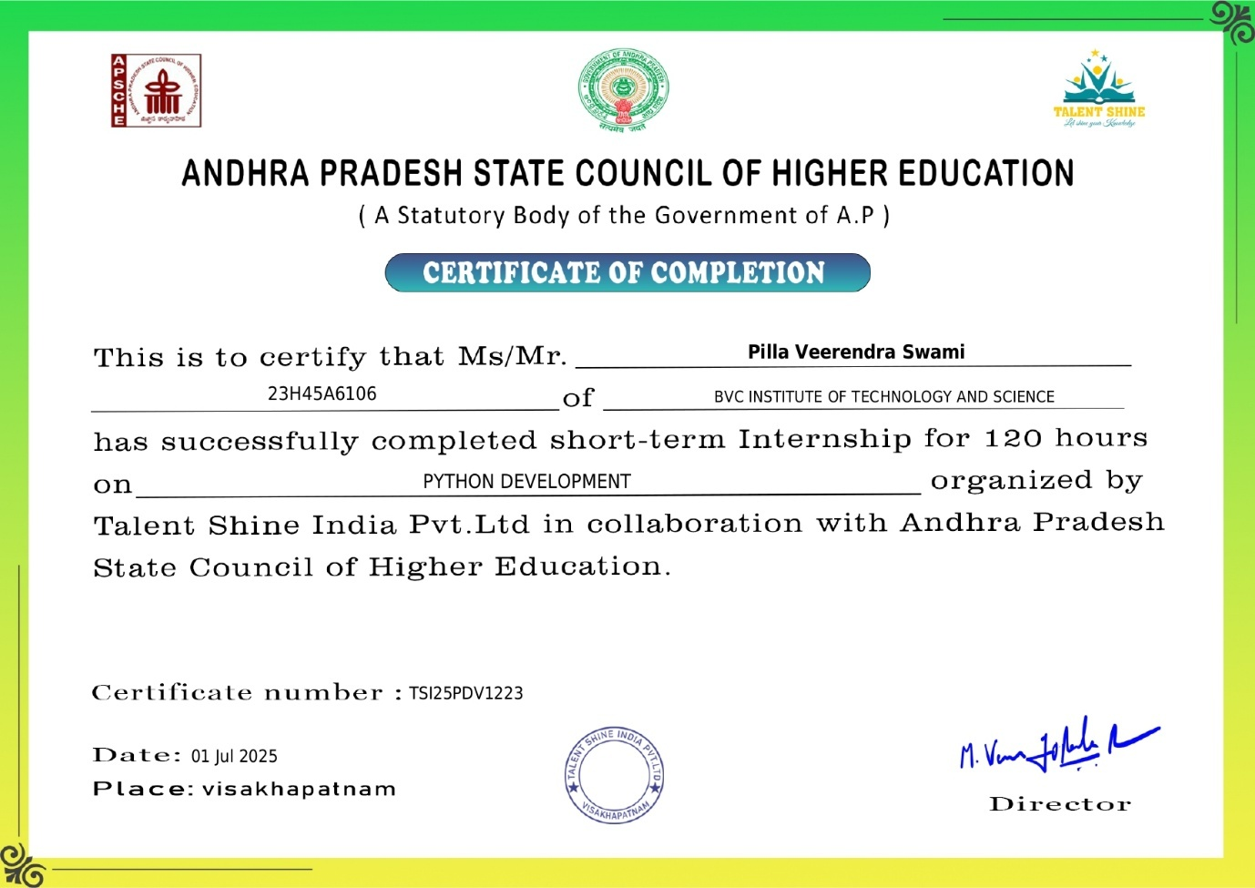

ACKNOWLEDGEMENT

It is with immense pleasure that we would like to express our indebted gratitude to our internship coordinator Mr.M.VENKATRAO M.Tech, Assistant Professor, who has guided us a lot and encouraged us in every step of the intern project work,his valuable moral support and guidance throughout the Intern project helped us to a greater extent.
Our deepest thanks to Mrs. G. VIJAYA KUMARI (Ph.D), M.Tech, Associate Professor & Head of the Department for inspiring us all the way and for arranging all the facilities and resources needed for our Intern.
We owe our sincere gratitude to Dr. J V G RAMA RAO, Principal for providing a great support and forgiving us the opportunity of doing the Internship.
We are thankful to our College Management for providing all the facilities in time to us for completion of our internship.
Not to forget, Faculty, Lab Technicians, non-teaching staff and our friends who have directly or indirectly helped and supported us in completing our internship in time.

ABSTRACT
Python Development:
Python development is a dynamic and versatile field that empowers developers to build a wide range of applications—from simple scripts to complex enterprise systems. Known for its clean syntax and readability, Python supports multiple programming paradigms including procedural, object-oriented, and functional styles. This flexibility makes it ideal for beginners and professionals alike. Developers leverage Python’s extensive standard library and third-party packages to accelerate development across domains such as web development, data science, machine learning, automation, and more. Frameworks like Django and Flask simplify backend development, while libraries like Pandas, NumPy, and Matplotlib enable powerful data analysis and visualization. Python’s interpreted nature allows for rapid prototyping and iterative testing, which is especially valuable in agile environments. Its cross-platform compatibility ensures that code written on one system runs seamlessly on others. The language also supports abstraction through functions, classes, and modules, promoting modularity and code reuse. With tools like virtual environments and package managers, Python developers can manage dependencies efficiently. The vibrant community contributes to a rich ecosystem of tutorials, documentation, and open-source projects. Python’s integration capabilities allow it to interface with databases, APIs, and other languages, making it a glue language in many tech stacks. Whether building RESTful APIs, automating workflows, or training machine learning models, Python provides the tools and clarity needed to deliver robust solutions. Its simplicity doesn’t compromise power—developers can scale applications, optimize performance, and maintain clean architecture with ease. As technology evolves, Python continues to adapt, remaining a top choice for innovation and practical problem-solving.

INDEX
S.NO | TOPIC | PAGE NO
1. | Introduction to python | 08-13
2. | Data structures in python | 14-19
3. | Learning Objectives/Internship objectives | 20
4. | Day To Day Overview of Internship Activites | 21
5. | Weekly Report | 22
6. | Executive Summary | 23
7. | About The company | 24
8. | Internship part | 25
9. | Challenges Faced | 26
10. | About Project | 27-29
11. | Conclusion | 30
12. | Student Self Evaluation Sheet | 31
13. | Photos & Videos Links | 32

- INTRODUCTION
This report is about my 8 weeks internship program with HQL. In this comprehensive report, I have discussed about every major aspect of the company which I observed and perceived during my internship program.
During my internship program, I have learned and mainly worked on how to access the services and virtualization. All the details have been discussed in detail. All the policies and procedures of the company have been discussed in detail.
As the main purpose of the internship is to learn by working in practical environment and to apply the knowledge acquired during the studies in real world scenario in order to tackle the problems using the knowledge and skill learned during the academic process.
Python Development:
Python development focuses on building scalable, readable, and efficient software using Python’s versatile syntax and rich ecosystem. It supports multiple paradigms—object-oriented, procedural, and functional—making it ideal for web development, data science, automation, and more.
Brief History of Python:
Here’s a concise timeline of Python's history:
- 1980s – Conception: Python was conceived in the late 1980s by Guido van Rossum at the Centrum Wiskunde & Informatica (CWI) in the Netherlands. He wanted to create a language that improved upon ABC, especially in exception handling and system interfacing.
- 1989 – Development Begins: Guido began implementing Python during his Christmas holidays in December 1989. His goal was to build a language that was both powerful and easy to learn.
- 1991 – First Release: Python 0.9.0 was released, featuring classes with inheritance, exception handling, and core data types like lists and dictionaries.
- 1994 – Public Release: Python gained wider recognition with its public release, and developers began adopting it for various tasks including scripting and automation.
- 2000 – Python 2.0: This version introduced major features like list comprehensions, garbage collection, and Unicode support. It also marked a shift toward a more community-driven development process.
- 2008 – Python 3.0: A significant overhaul, Python 3 broke backward compatibility to fix long-standing design flaws. It emphasized cleaner syntax and better support for internationalization.
- 2018 – Leadership Transition: Guido van Rossum stepped down as Python’s “Benevolent Dictator for Life” (BDFL), handing over governance to the Python Steering Council.
- 2020s – Modern Growth: Python surged in popularity, becoming a top language for data science, machine learning, web development, and education. Its simplicity and vast ecosystem made it a favorite among developers worldwide.
Introduction to Python:
Python is a high-level, interpreted programming language known for its simplicity, readability, and versatility. It supports multiple programming paradigms and is widely used across domains like web development, data science, automation, and artificial intelligence

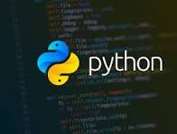
Fig: Introduction to python
Installation Of Python:-
The process of installing and setting up Python involves downloading the installer, running it, and verifying the installation.
1. Download Python:
- Navigate to the official Python website's download page (python.org/downloads).
- Choose the latest stable version of Python 3 for your operating system (Windows, macOS, or Linux).
- Download the appropriate installer file (e.g., .exe for Windows, .pkg for macOS).
2. Run the Installer:
- Windows:
- Locate the downloaded .exe file and double-click it to run the installer.
- Crucially, ensure the "Add Python to PATH" checkbox is selected: during the installation process. This allows you to run Python from the command line from any directory.
- You can choose "Install Now" for a default installation or "Customize installation" for more control over features and location. For most users, "Install Now" with "Add Python to PATH" is sufficient.
- Follow the on-screen prompts to complete the installation.
macOS:
Open the downloaded .pkg file and follow the instructions in the installer wizard. Python is typically added to your PATH automatically.
Linux:
Many Linux distributions come with Python pre-installed. You can check your version by typing python3 --version in the terminal.
- If you need a different version or it's not installed, use your distribution's package manager (e.g., sudo apt install python3 for Debian/Ubuntu, sudo dnf install python3 for Fedora).
3. Verify the Installation:
- Open your command prompt (Windows) or terminal (macOS/Linux).
- Type python --version or python3 --version and press Enter.
- If Python is installed correctly, you will see the version number displayed. For example:
Fig: Python version number

- You can also test the Python interpreter by typing python or python3 and pressing Enter. This will open the interactive Python shell where you can type Python code directly. Type exit() and press Enter to leave the shell.
Optional Setup:
- Integrated Development Environment (IDE):
Consider installing an IDE like VS Code, PyCharm, or IDLE (often included with Python) for a more structured development environment.
- Virtual Environments:
For project isolation and dependency management, learn about creating and using virtual environments (e.g., using venv or conda).
Test Installation:
To test a Python installation, follow these steps:
Open a terminal or command prompt:
- Windows: Open the Command Prompt or PowerShell.
- macOS/Linux: Open the Terminal application.
Check the Python version:
- Type python --version and press Enter.
- If Python 3 is installed, you might need to use python3 --version.
  - A successful installation will display the installed Python version (e.g., Python 3.10.5). If you receive an error like "command not found," Python may not be installed or not added to your system's PATH.
- Enter the Python interactive shell:
  - Type python (or python3) and press Enter.
  - The prompt will change to >>>, indicating you are in the Python interpreter.
- Execute a simple Python command:
  - In the interactive shell, type print("Hello, Python!") and press Enter.
  - The output should be Hello, Python!.
  - You can also try a simple calculation, such as 2 + 2, which should output 4.
- Exit the interactive shell:
  - Type exit() and press Enter, or press Ctrl + Z (on Windows) or Ctrl + D (on macOS/Linux).
These steps confirm that Python is installed, accessible from your command-line environment, and capable of executing basic Python code.
Key Features of python:
Python possesses several key features that contribute to its popularity and versatility:
1.Easy to Learn and Read:
Python's syntax is designed for readability, resembling natural language and utilizing indentation for code blocks, making it accessible for beginners and promoting maintainable code.
2.Interpreted Language:
Python code is executed line by line by an interpreter, eliminating the need for a separate compilation step and facilitating rapid development and testing.
3.Dynamically Typed:
Variable types are determined at runtime, allowing for flexible coding where explicit type declarations are not required, simplifying development.
4.High-Level Language:
Python abstracts away low-level memory management and hardware details, enabling developers to focus on problem-solving rather than intricate system specifics.
5.Object-Oriented Programming (OOP) Support:
Python fully supports OOP concepts like encapsulation, inheritance, and polymorphism, allowing for modular and reusable code structures.
6.Extensive Standard Library:
Python comes with a vast collection of modules and packages for diverse tasks, including web development, data science, networking, and more, reducing the need to write code from scratch.
7.Cross-Platform Compatibility:
Python code can run on various operating systems (Windows, macOS, Linux) without modifications, ensuring broad applicability.
8.Free and Open Source:
Python is freely available and its source code is open, fostering community contributions and continuous improvement.
9.Supports Multiple Programming Paradigms:
Beyond OOP, Python also supports procedural and functional programming styles, offering flexibility in how developers approach problem-solving.
10.Extensible and Embeddable:
Python can be easily integrated with other languages like C, C++, and Java, allowing for performance-critical sections to be written in those languages and called from Python. It can also be embedded within other applications.
Applications of Python:
1.Web Development:
Python frameworks like Django and Flask are widely used for building robust and scalable web applications.
2.Data Science and Analysis:
With libraries such as Pandas, NumPy, and Matplotlib, Python is a primary tool for data manipulation, analysis, and visualization.
3.Machine Learning and Artificial Intelligence:
Frameworks like TensorFlow, PyTorch, and Scikit-learn enable the development of AI and ML models for tasks like image recognition, natural language processing, and predictive analytics.
4.Game Development:
Libraries like Pygame provide tools for creating 2D games and interactive applications.
5.Internet of Things (IoT):
Python, particularly MicroPython, is used in embedded systems and IoT devices for controlling hardware and managing data.

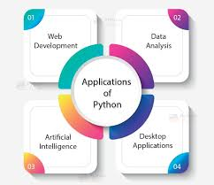

Data Types in Python:
Data types in Python are a way to classify data items. They represent the kind of value, which determines what operations can be performed on that data. Since everything is an object in Python programming, Python data types are classes and variables are instances (objects) of these classes.
The following are standard or built-in data types in Python:
1. Numeric Data Types :
Python numbers represent data that has a numeric value. A numeric value can be an integer, a floating number or even a complex number. These values are defined as int, float and complex classes.
- Integers: value is represented by int class. It contains positive or negative whole numbers (without fractions or decimals). There is no limit to how long an integer value can be.
- Float: value is represented by float class. It is a real number with a floating-point representation. It is specified by a decimal point. Optionally, character e or E followed by a positive or negative integer may be appended to specify scientific notation.
- Complex Numbers: It is represented by a complex class. It is specified as (real part) + (imaginary part) j. For example - 2+3j
2.Sequence Data Types:
A sequence is an ordered collection of items, which can be of similar or different data types. Sequences allow storing of multiple values in an organized and efficient fashion. There are several sequence data types of Python:
String Data Type:
Python Strings are arrays of bytes representing Unicode characters. In Python, there is no character data type, a character is a string of length one. It is represented by str class.
Strings in Python can be created using single quotes, double quotes or even triple quotes. We can access individual characters of a String using index.

List Data Type:
Lists are similar to arrays found in other languages. They are an ordered and mutable collection of items. It is very flexible as items in a list do not need to be of the same type.
Tuple Data Type:
Tuple is an ordered collection of Python objects. The only difference between a tuple and a list is that tuples are immutable. Tuples cannot be modified after it is created.
3. Boolean Data Type:
Python Boolean Data type is one of the two built-in values, True or False. Boolean objects that are equal to True are truthy (true) and those equal to False are falsy (false). However non-Boolean objects can be evaluated in a Boolean context as well and determined to be true or false. It is denoted by class bool.
Truthy and Falsy Values:
In Python, truthy and falsy values are values that evaluate to True or False in a Boolean context. Truthy values behave like True, while falsy values behave like False when used in conditions.
4. Set Data Type:
In Python Data Types, Set is an unordered collection of data types that is iterable, mutable, and has no duplicate elements. The order of elements in a set is undefined though it may consist of various elements.
Create a Set in Python:
Sets can be created by using the built-in set() function with an iterable object or a sequence by placing the sequence inside curly braces, separated by a ‘comma’. The type of elements in a set need not be the same, various mixed-up data type values can also be passed to the set.
5. Dictionary Data Type:
A dictionary in Python is a collection of data values, used to store data values like a map, unlike other Python Data Types, a Dictionary holds a key: value pair. Key-value is provided in dictionary to make it more optimized. Each key-value pair in a Dictionary is separated by a colon : , whereas each key is separated by a ‘comma’.
Create a Dictionary in Python:
Values in a dictionary can be of any datatype and can be duplicated, whereas keys can’t be repeated and must be immutable. The dictionary can also be created by the built-in function dict().
- DATA STRUCTURES
Organizing, managing and storing data is important as it enables easier access and efficient modifications. Data Structures allows you to organize your data in such a way that enables you to store collections of data, relate them and perform operations on them accordingly.
Types of Data Structures in Python:
Python has implicit support for Data Structures which enable you to store and access data. These structures are called List, Dictionary, Tuple and Set.
Python allows its users to create their own Data Structures enabling them to have full control over their functionality. The most prominent Data Structures are Stack, Queue, Tree, Linked List and so on which are also available to you in other programming languages. So now that you know what are the types available to you, why don’t we move ahead to the Data Structures and implement them using Python.

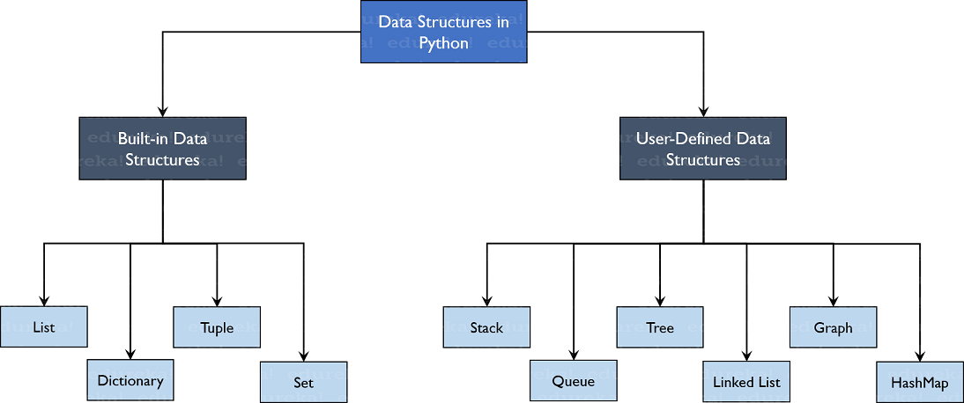
FIG: Data Structures in Python
Built-in Data Structures:
As the name suggests, these Data Structures are built-in with Python which makes programming easier and helps programmers use them to obtain solutions faster.
1.Lists:
Lists are used to store data of different data types in a sequential manner. There are addresses assigned to every element of the list, which is called as Index. The index value starts from 0 and goes on until the last element called the positive index. There is also negative indexing which starts from -1 enabling you to access elements from the last to first.
Creating a list:
To create a list, you use the square brackets and add elements into it accordingly. If you do not pass any elements inside the square brackets, you get an empty list as the output.
Adding Elements:
Adding the elements in the list can be achieved using the append(), extend() and insert() functions.
- The append() function adds all the elements passed to it as a single element.
- The extend() function adds the elements one-by-one into the list.
- The insert() function adds the element passed to the index value and increase the size of the list too.

Deleting Elements:
- To delete elements, use the del keyword which is built-in into Python but this does not return anything back to us.
- If you want the element back, you use the pop() function which takes the index value.
- To remove an element by its value, you use the remove() function.

Accessing Elements:
Accessing elements is the same as accessing Strings in Python. You pass the index values and hence can obtain the values as needed.
Other Functions:
You have several other functions that can be used when working with lists.
- The len() function returns to us the length of the list.
- The index() function finds the index value of value passed where it has been encountered the first time.
- The count() function finds the count of the value passed to it.
- The sorted() and sort() functions do the same thing, that is to sort the values of the list. The sorted() has a return type whereas the sort() modifies the original list.
2.Dictionary:
Dictionaries are used to store key-value pairs. To understand better, think of a phone directory where hundreds and thousands of names and their corresponding numbers have been added. Now the constant values here are Name and the Phone Numbers which are called as the keys. And the various names and phone numbers are the values that have been fed to the keys. If you access the values of the keys, you will obtain all the names and phone numbers. So that is what a key-value pair is.
Creating a Dictionary:
Dictionaries can be created using the flower braces or using the dict() function. You need to add the key-value pairs whenever you work with dictionaries.
Changing and Adding key, value pairs:
To change the values of the dictionary, you need to do that using the keys. So, you firstly access the key and then change the value accordingly. To add values, you simply just add another key-value pair.
Deleting key, value pairs:
- To delete the values, you use the pop() function which returns the value that has been deleted.
- To retrieve the key-value pair, you use the popitem() function which returns a tuple of the key and value.
- To clear the entire dictionary, you use the clear() function.

Accessing Elements:
- You can access elements using the keys only. You can use either the get() function or just pass the key values and you will be retrieving the values.
3.Tuple:
Tuples are the same as lists are with the exception that the data once entered into the tuple cannot be changed no matter what. The only exception is when the data inside the tuple is mutable, only then the tuple data can be changed. The example program will help you understand better.
Creating a Tuple:
You create a tuple using parenthesis or using the tuple() function.
Accessing Elements:
Accessing elements is the same as it is for accessing values in lists.
Appending Elements:
To append the values, you use the ‘+’ operator which will take another tuple to be appended to it.
3.Sets:
Sets are a collection of unordered elements that are unique. Meaning that even if the data is repeated more than one time, it would be entered into the set only once. It resembles the sets that you have learnt in arithmetic. The operations also are the same as is with the arithmetic sets. An example program would help you understand better.
Creating a set:
Sets are created using the flower braces but instead of adding key-value pairs, you just pass values to it.
Adding elements:
To add elements, you use the add() function and pass the value to it.
Operations in sets:
- The union() function combines the data present in both sets.
- The intersection() function finds the data present in both sets only.
- The difference() function deletes the data present in both and outputs data present only in the set passed.
- The symmetric_difference() does the same as the difference() function but outputs the data which is remaining in both sets.
User-Defined Data Structures:
1.Arrays vs. Lists:
Arrays and lists are the same structure with one difference. Lists allow heterogeneous data element storage whereas Arrays allow only homogenous elements to be stored within them.
2.Stack:
Stacks are linear Data Structures which are based on the principle of Last-In-First-Out (LIFO) where data which is entered last will be the first to get accessed. It is built using the array structure and has operations namely, pushing (adding) elements, popping (deleting) elements and accessing elements only from one point in the stack called as the TOP. This TOP is the pointer to the current position of the stack. Stacks are prominently used in applications such as Recursive Programming, reversing words, undo mechanisms in word editors and so forth.
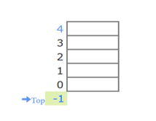
3.Queue:
A queue is also a linear data structure which is based on the principle of First-In-First-Out (FIFO) where the data entered first will be accessed first. It is built using the array structure and has operations which can be performed from both ends of the Queue, that is, head-tail or front-back. Operations such as adding and deleting elements are called En-Queue and De-Queue and accessing the elements can be performed. Queues are used as Network Buffers for traffic congestion management, used in Operating Systems for Job Scheduling and many more.

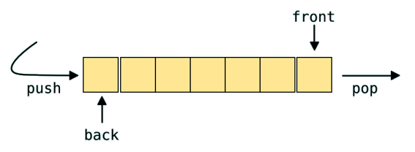
4.Tree:
Trees are non-linear Data Structures which have root and nodes. The root is the node from where the data originates and the nodes are the other data points that are available to us. The node that precedes is the parent and the node after is called the child. There are levels a tree has to show the depth of information. The last nodes are called the leaves. Trees create a hierarchy which can be used in a lot of real-world applications such as the HTML pages use trees to distinguish which tag comes under which block. It is also efficient in searching purposes and much more.
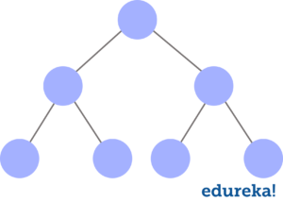
5.Linked List:
Linked lists are linear Data Structures which are not stored consequently but are linked with each other using pointers. The node of a linked list is composed of data and a pointer called next. These structures are most widely used in image viewing applications, music player applications and so forth.
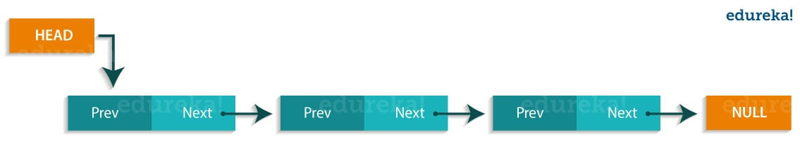

6.Graph:
Graphs are used to store data collection of points called vertices (nodes) and edges (edges). Graphs can be called as the most accurate representation of a real-world map. They are used to find the various cost-to-distance between the various data points called as the nodes and hence find the least path. Many applications such as Google Maps, Uber, and many more use Graphs to find the least distance and increase profits in the best ways.
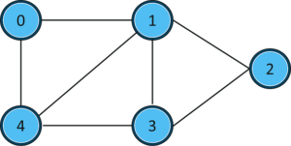
7.HashMaps:
HashMaps are the same as what dictionaries are in Python. They can be used to implement applications such as phonebooks, populate data according to the lists and much more.
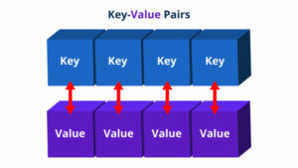

- LEARNING OBJECTIVES/INTERNSHIP OBJECTIVES
- Internships are generally thought of to be reserved for college students looking to gain experience in a particular field. However, a wide array of people can benefit from Training Internships in order to receivereal world experience and develop their skills.
- An objective for this position should emphasize the skills you already possess in the area and your interest in learning more.
- Internships are utilized in a number of different career fields, including architecture, engineering, healthcare, economics, advertising and many more.
- Some internships are used to allow individuals to perform scientific research while others are specificallydesigned to allow people to gain first-hand experience working.
- Utilizing internships is a great way to build your resume and develop skills that can be emphasized in your resume for future jobs. When you are applying for a Training Internship, make sure to highlight any special skills or talents that can make you stand apart from the rest of the applicants so that you havean improved chance of landing the position.

- DAY TO DAY OVERVIEW OF INTERNSHIP ACTIVITIES
Date | Day | Topic | Hours
May 19, 2025 | Monday | Introduction | 1.5
May 20, 2025 | Tuesday | Introduction to Programming | 1.5
May 21, 2025 | Wednesday | Introduction to Python | 1.5
May 22, 2025 | Thursday | Features of Python | 1.5
May 23, 2025 | Friday | Installation & setup | 1.5
May 24, 2025 | Saturday | Data, Literal, Identifier, keyword, variable and Constant | 1.5
May 26, 2025 | Monday | Data Types Practice | 1.5
May 27, 2025 | Tuesday | Input function() | 1.5
May 28, 2025 | Wednesday | Print() function | 1.5
May 29, 2025 | Thursday | End and sep arguments | 1.5
May 30, 2025 | Friday | Common Mistakes in i/p & o/p | 1.5
May 31, 2025 | Saturday | Arithmetic Operators | 1.5
June 2, 2025 | Monday | Assignment Operators | 1.5
June 3, 2025 | Tuesday | Relational Operators | 1.5
June 4, 2025 | Wednesday | Logical Operators | 1.5
June 5, 2025 | Thursday | Bitwise Operators | 1.5
June 6, 2025 | Friday | Membership & Identity Operators | 1.5
June 7, 2025 | Saturday | Operators Program – 1 | 1.5
June 9, 2025 | Monday | OP1 – Debugging | 1.5
June 10, 2025 | Tuesday | Operators Program – 2 | 1.5
June 11, 2025 | Wednesday | OP2 – Debugging | 1.5
June 12, 2025 | Thursday | Operators Program – 3 | 1.5
June 13, 2025 | Friday | Operators Program – 4 | 1.5
June 14, 2025 | Saturday | Operators Program – 5 | 1.5
June 16, 2025 | Monday | Operators Program – 6 | 1.5
June 17, 2025 | Tuesday | Operators Program – 7 | 1.5
June 18, 2025 | Wednesday | Operators Program – 8 | 1.5
June 19, 2025 | Thursday | Operators Program – 9 | 1.5
June 20, 2025 | Friday | Operators Program – 10 | 1.5
June 21, 2025 | Saturday | DCS Theory | 1.5
June 23, 2025 | Monday | While Loop | 1.5
June 24, 2025 | Tuesday | For loop & Range | 1.5
June 25, 2025 | Wednesday | Break, continue & pass | 1.5
June 26, 2025 | Thursday | Introduction to Python and Variables | 1.5
June 27, 2025 | Friday | Operators & Conditional Statements | 1.5
June 28, 2025 | Saturday | Problems on Conditional Statements | 1.5
June 30, 2025 | Monday | Loops in Python | 1.5
July 1, 2025 | Tuesday | Python Session - 5 | 1.5
July 2, 2025 | Wednesday | Strings in Python | 1.5
July 3, 2025 | Thursday | List in Python | 1.5
July 4, 2025 | Friday | Tuple | 1.5
July 5, 2025 | Saturday | OOPS | 1.5
July 7, 2025 | Monday | Inheritance | 1.5
July 8, 2025 | Tuesday | Practice Session | 1.5
July 9, 2025 | Wednesday | Practice Session | 1.5
July 10, 2025 | Thursday | Project Overview | 1.5
July 11, 2025 | Friday | Project Overview | 1.5

- WEEKLY REPORT
Week | Dates | Classes | Total Hours | Topics Covered
Week 1 | May 19 – May 25, 2025 | 3 | 9 | Introduction, Introduction to Programming, Introduction to Python, Features of Python, Installation & setup, Data, Literal, Identifier, Keyword, Variable, and Constant.
Week 2 | May 26 – Jun 1, 2025 | 3 | 9 | Data Types Practice, Input function(), Print() function, end and sep arguments, Common Mistakes in Input & Output, Arithmetic Operators.
Week 3 | Jun 2 - Jun 8,2025 | 3 | 9 | Assignment Operators, Relational Operators, Logical Operators, Bitwise Operators, Membership & Identity Operators, Operators Program – 1.
Week 4 | Jun 9 - Jun 15,2025 | 3 | 9 | OP1 – Debugging, Operators Program – 2, OP2 – Debugging, Operators Program – 3, Operators Program – 4, Operators Program – 5.
Week 5 | Jun 16 – Jun 22, 2025 | 3 | 9 | Operators Program – 6, Operators Program – 7, Operators Program – 8, Operators Program – 9, Operators Program – 10, DCS Theory.
Week 6 | Jun 23 – Jun 29, 2025 | 3 | 9 | While Loop, For loop & Range, Break, Continue & Pass, Introduction to Python and Variables, Operators & Conditional Statements, Problems on Conditional Statements.
Week 7 | June 30 – Jul 6, 2025 | 3 | 9 | Loops in Python, Python Session – 5, Strings in Python, List in Python, Tuple, OOPS.
Week 8 | Jul 7 – Jul 11,2025 | 3 | 9 | Inheritance, Practice Session (2 sessions), Project Overview (2 sessions).

- EXECUTIVE SUMMARY
This report is about my 8 weeks internship program with TALENT SHINE INDIA Pvt.Ltd In this comprehensive report, I have discussed about every major aspect of the company which I observed and perceived during my internship program.
During my internship program, I have learned and mainly worked core java and advanced java. All the details have been discussed in detail. All the policies and procedures of the company have been discussed in detail.
As per TALENT SHINE INDIA Pvt.Ltd., The purpose of the internship is to learn, by working in practical environment and to apply the knowledge acquired during the studies in real world scenario in order to tackle the problems using the knowledge and skill learned during the academic process.

- ABOUT THE COMPANY

FIG: TALENT SHINE INDIA Pvt. Ltd
At TALENT SHINE INDIA Pvt. Ltd, we’re more than just an educational institution; we’re your partners in shaping a successful future in the dynamic world of technology. As one of the pioneers in software and technology education and placement, we’re committed to equipping you with the skills, knowledge, and confidence needed to thrive in the ever-evolving IT landscape. Whether you’re passionate about software development, software testing, or honing your skills on cutting-edge platforms and tools, TALENT SHINE INDIA Pvt.Ltd has a journey tailored just for you. Our expert faculty, who are seasoned professionals and subject matter experts, will guide you every step of the way, ensuring that you not only learn but also excel.
Name of the organization: TALENT SHINE INDIA Pvt.Ltd
Organization id: U74910AP2022PTC122449
Organization Address: 31-29-18, Beside Narayana Junior College, Santhamamidithota, Kurmannapalem, Vadlapudi, Vishakhapatnam, Andhra Pradesh 530046, India.
Organization CEO: Venugopala Rao Macharla
Organization Contact number: 9888888888 ,
Organization Email id: ceo@talentshineindia.com.

- INTERNSHIP PART
Learning Objectives:
- Master the core concepts of Python Programming, including data types, data structures, and python libraries.
- Understand and apply advanced Python topics.
- Practice implementing Python programs across various development environments.
- Participate in trainer-led sessions for enhanced learning and clarification of complex topics.
- Engage in query sessions to troubleshoot and understand coding challenges.
- Complete assigned tasks to solidify learning and build practical skills.
- Receive training in soft skills and communication to excel in professional settings.
- Obtain certification upon successful program completion.
Program Objectives:
- Ensure high availability and accessibility of learning resources.
- Maintain high performance in training modules and practical sessions.
- Prioritize user security and data protection throughout the training and coding practices.
Scalability Features:
- Flexible models where users pay only for the services and resources utilized.
- Backup and disaster recovery solutions to ensure the safety and continuity of learning.

- CHALLENGES FACED
- At the beginning of the internship, I faced difficulty understanding the core concepts of Python and different development tools.
- I struggled with understanding complex Python libraries.
- Managing college and internship timings was challenging, as balancing both responsibilities required strong time management skills.
- I faced difficulty in understanding advanced topics in Python, such as , concurrency, and design patterns.
- Even with these difficulties, I was able to complete the internship, which helped me gain significant knowledge and skills, ultimately leading to securing a new job.

- ABOUT PROJECT
CALCULATOR APP USING PYTHON
Calculator App:
The Calculator App is an easy-to-use program made with Python. It helps users do basic math like adding, subtracting, multiplying, and dividing. You can click buttons to enter numbers and get instant answers on the screen.
Key Operations:
- Enter Numbers: Lets the user input numbers using on-screen buttons.
- Perform Calculations: Allows the user to add, subtract, multiply, or divide numbers.
- Clear Display: Erases the current input or result to start a new calculation.
- Show Result: Calculates and displays the final answer when the equal (=) button is pressed.
- Error Handling: If an invalid expression is entered, “Error” is shown.
Steps to Create the Application:
- Define the Project Structure
Start by creating a Python file and importing the tkinter and tkinter.font libraries.
Set up the main window using Tk() and add an entry box at the top to display numbers and results.
2. Plan the Core Functionalities
Entering Numbers and Operators:
Allow users to click buttons (0–9, +, −, ×, ÷, .) to form mathematical expressions.
Performing Calculations:
When the user presses the “=” button, evaluate the entered expression and show the result.
Clearing the Display:
Use the “C” button to clear all input and reset the display.
Error Handling:
Display “Error” when an invalid input or mathematical operation (like dividing by zero) occurs.
3. Use Functions for Logic
click(): Handles button clicks and updates the display with the entered number or operator.
clear(): Clears the calculator display.
calculate(): Evaluates the current mathematical expression and shows the result.
4. Design the Graphical Interface
Use the Button widget to create buttons for digits, operators, clear, and equals.
Arrange the buttons neatly using the grid layout system.
Apply background colors and bold fonts to make buttons visually appealing and easy to read.
5. Input and Error Handling
Validate expressions using a try-except block in the calculate() function.
Display a clear “Error” message for invalid operations to prevent crashes.
Ensure the calculator resets properly after an error or clear action.
6. Enhance the App
Add keyboard input support.
Include advanced operations like square root or percentage.
Improve the design with custom themes and button styles.

Tools Needed:
1. Python IDEs / Editors:
PyCharm
Visual Studio Code
Thonny
Any text editor that supports Python
- Python Interpreter:
Ensure Python is installed and added to the system PATH.
- GUI Library:
Tkinter (comes pre-installed with standard Python)

Resources to Learn:
Videos
Python GUI Programming with Tkinter by ProgrammingKnowledge
Tkinter Tutorial for Beginners by Tech With Tim
Python Calculator Project Tutorial by Clever Programmer

Documentation
Python Official Documentation
Tkinter Library Documentation
Python eval() Function Documentation

PYTHON CODE:-
import tkinter as tk
import tkinter.font as font

def click(button_text):
current = display.get()
display.delete(0, tk.END)
display.insert(0, current + button_text)

def clear():
display.delete(0, tk.END)

def calculate():
try:
result = eval(display.get())
display.delete(0, tk.END)
display.insert(0, str(result))
except:
display.delete(0, tk.END)
display.insert(0, "Error")

root = tk.Tk()
root.title("Calculator")
bold_font = font.Font(weight="bold", size=14)
display = tk.Entry(root, width=35, borderwidth=10, font=("Arial", 24))
display.grid(row=0, column=0, columnspan=4, padx=10, pady=10)
buttons = [('7',1,0),('8',1,1),('9',1,2),('/',1,3),('4',2,0),('5',2,1),('6',2,2),('*',2,3),
('1',3,0),('2',3,1),('3',3,2),('-',3,3),('0',4,0),('.',4,1),('C',4,2),('+',4,3),
('=',5,0,4)]

for (text, row, col, cs) in [(b[0], b[1], b[2], 1) if len(b)==3 else b for b in buttons]:
if text == 'C':
action = clear
elif text == '=':
action = calculate
else:
action = lambda x=text: click(x)
if text in ['+', '-', '*', '/']:
bg_color = 'crimson'
fg_color = 'white'
elif text == '=':
bg_color = 'seagreen'
fg_color = 'white'
else:
bg_color = 'steelblue'
fg_color = 'white'
button = tk.Button(root, text=text, width=13 if cs==1 else 38, height=3,
command=action,bg=bg_color, fg=fg_color, font=bold_font)
button.grid(row=row, column=col, columnspan=cs)
root.mainloop()
- CONCLUSION
Completing the Calculator App project has been a highly rewarding learning experience, providing practical exposure to Python programming and GUI development using Tkinter. Through this project, I gained hands-on experience in designing an interactive interface, handling button events, performing arithmetic calculations, and managing errors effectively. It strengthened my understanding of core concepts like functions, exception handling, event-driven programming, and the use of built-in Python libraries to create functional applications.

This project also helped improve my problem-solving, logical thinking, and attention to detail while emphasizing the importance of creating a user-friendly interface. Developing the Calculator App enhanced my confidence in building practical software solutions and gave me insight into application design, layout management, and responsive interaction. Overall, it prepared me for more advanced Python projects, improved my coding practices, and contributed significantly to my readiness for real-world programming challenges..

12.STUDENT SELF EVALUATION OF THE SHORT-TERM INTERNSHIP

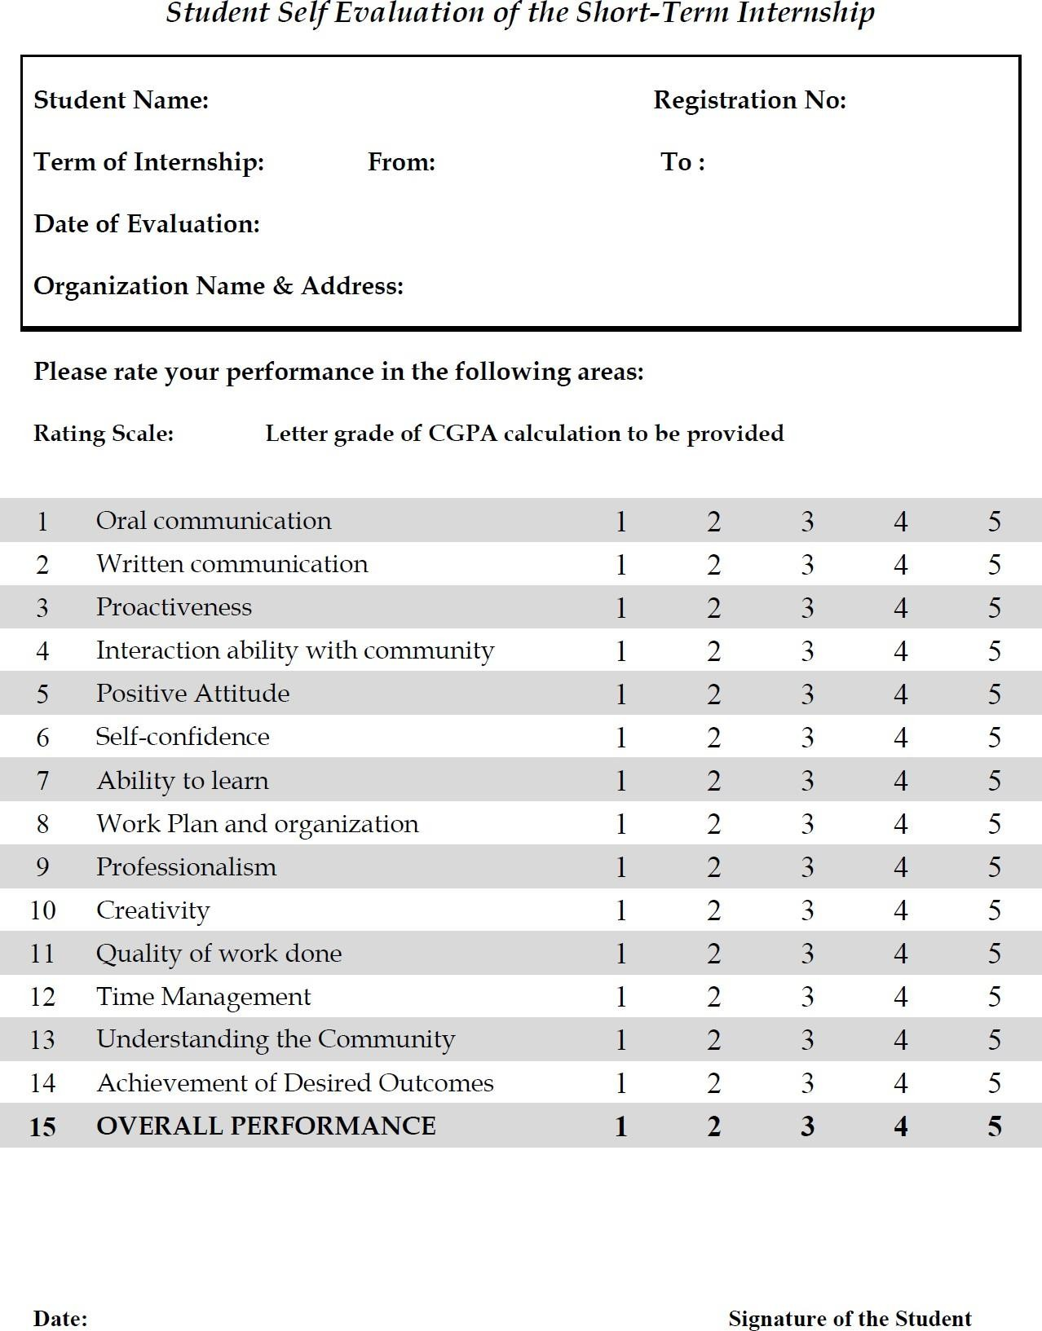

13.PHOTOS & GITHUB LINKS
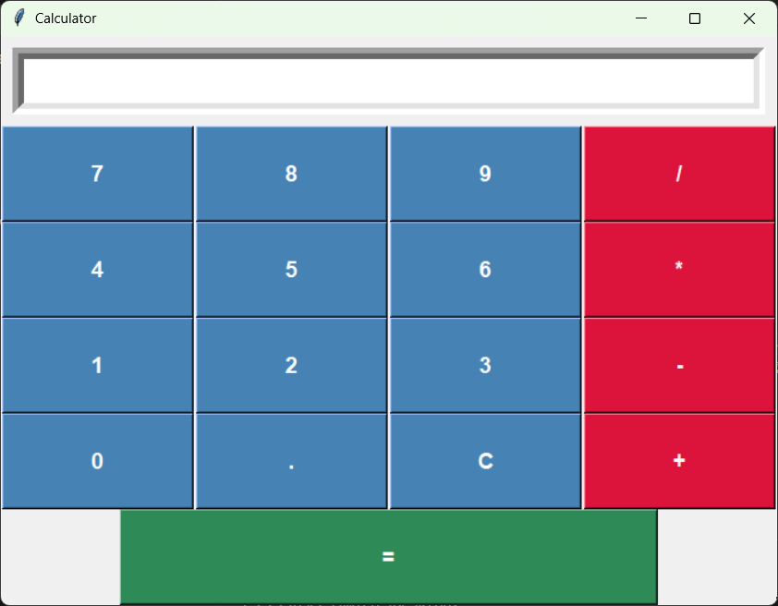

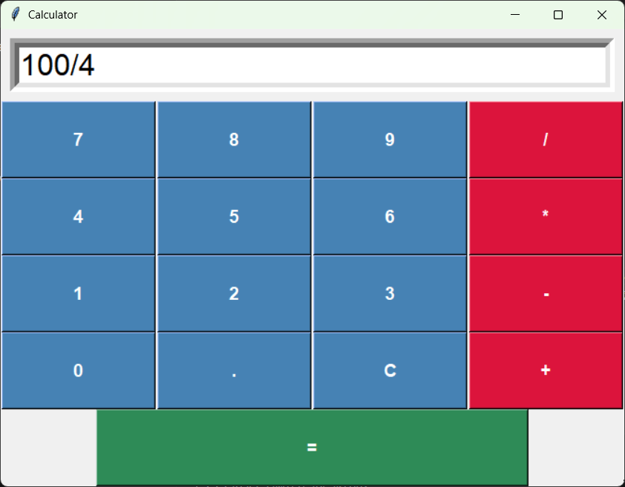

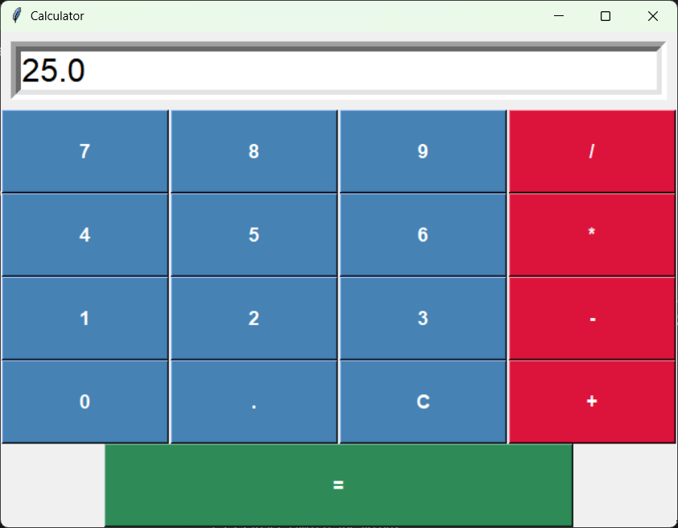
GITHUB LINK: https://github.com/VeerendraSwami/internship

