Lab1 Github Assignment

Sriharsha chowdary Veerepalli

ID no: 16149284

Step 1: create github account.



Step 2: Create Repository.

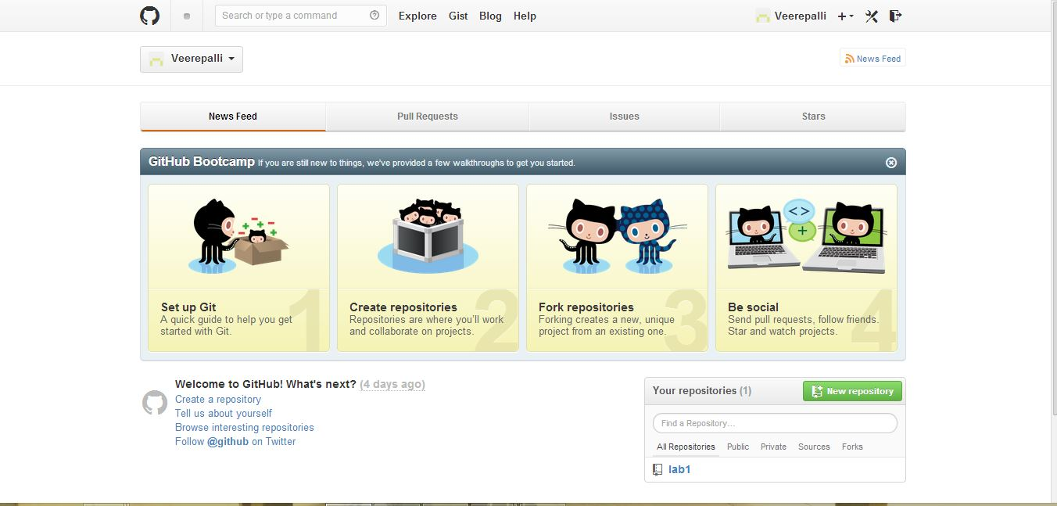

Step 3: Create Repository Name.

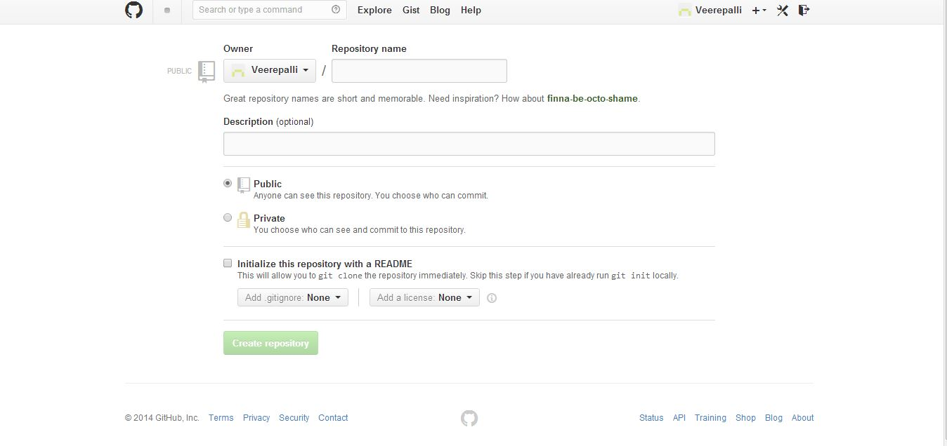

Step 4: Download Github to our windows system.

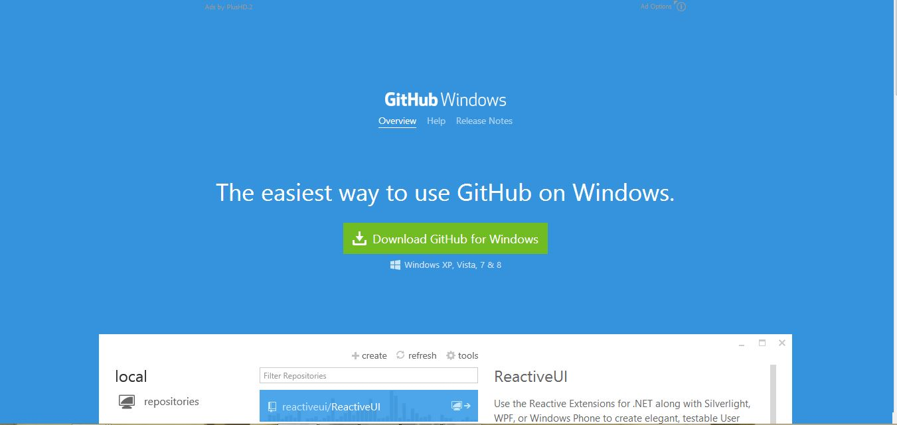

Step 5: Install and connect to your online account.

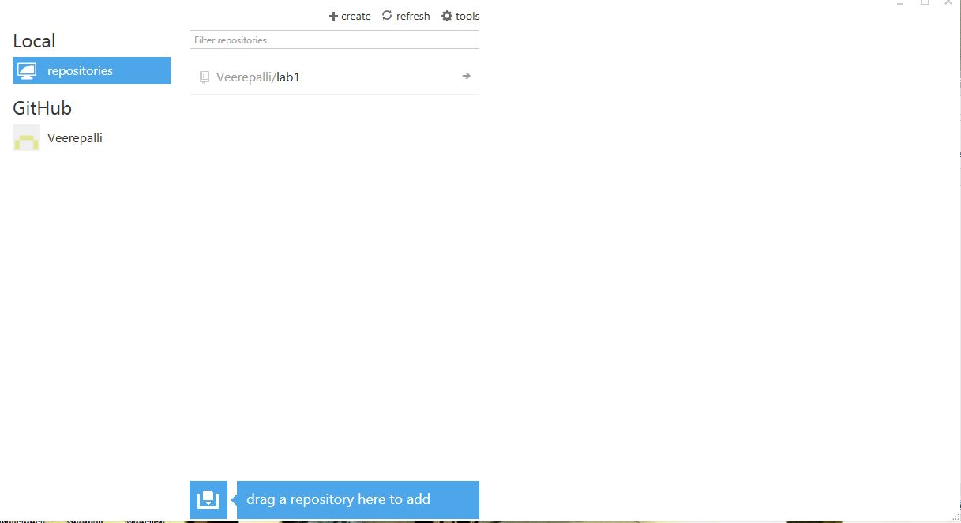

Step 6: Publish and sync your documents in the folder.

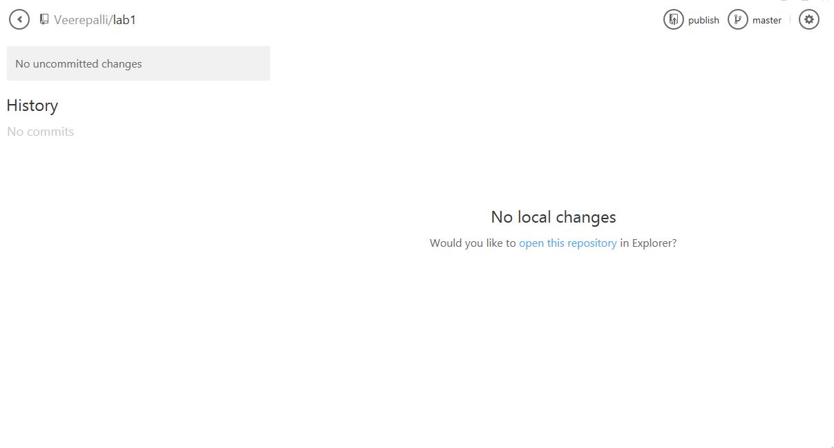

Step 7: Copy the link.

