ScrumDo Assignment/Lab1

Sriharsha Chowdary Veerepalli

ID no: 16149284

Step 1: Create Scrumdo Account

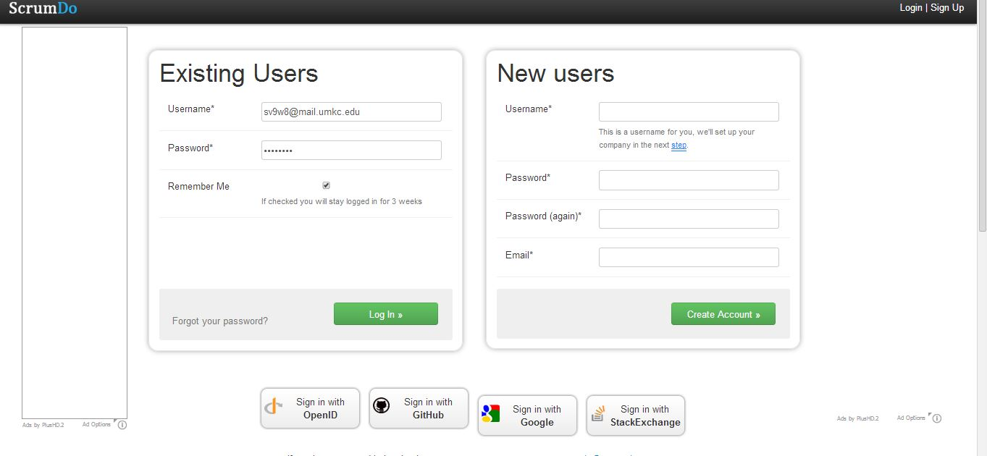

Step2: create Organization Name.

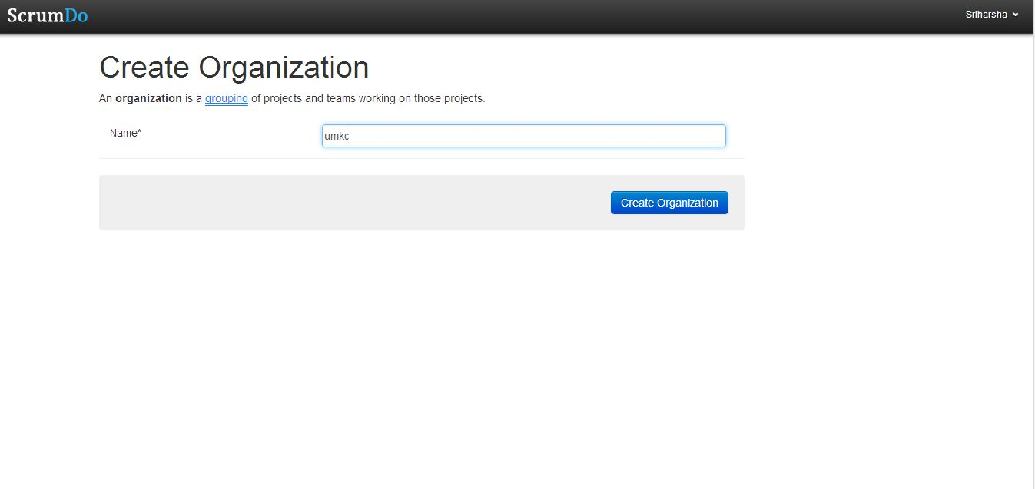

Step 3: Create story

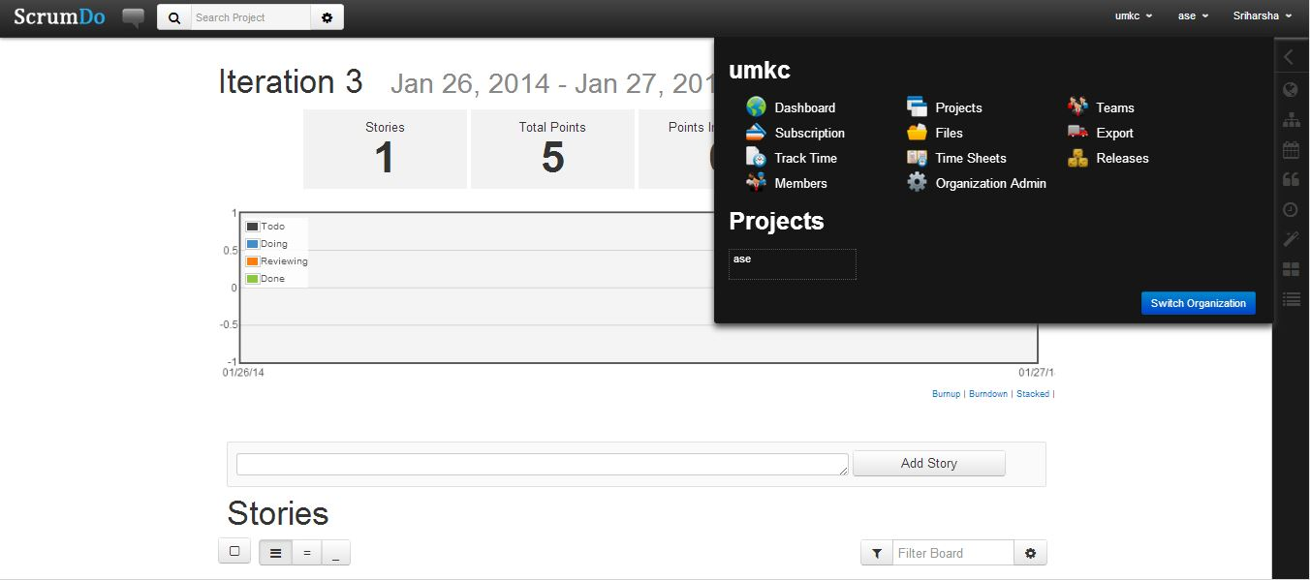

Step 4: create project name.

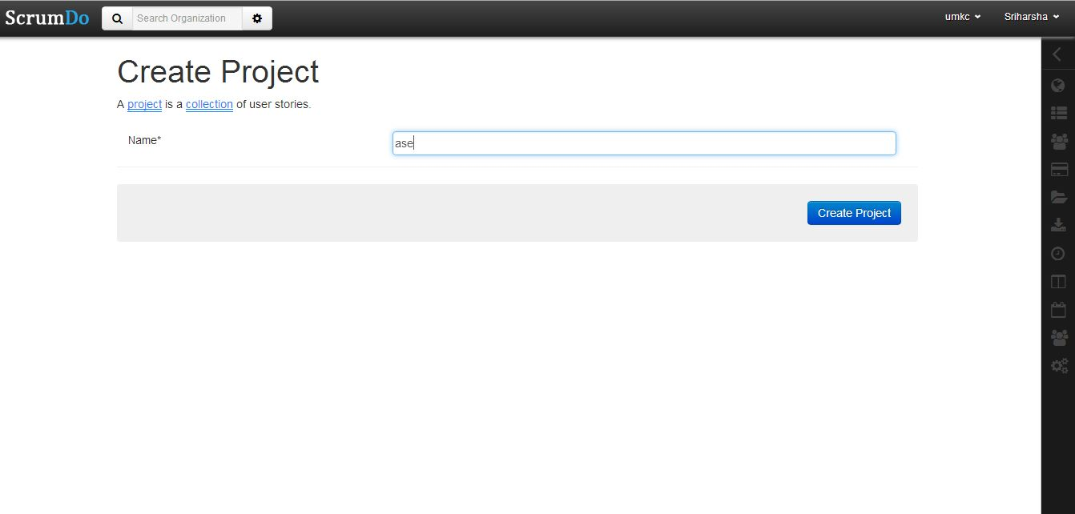

Step 5: Create story

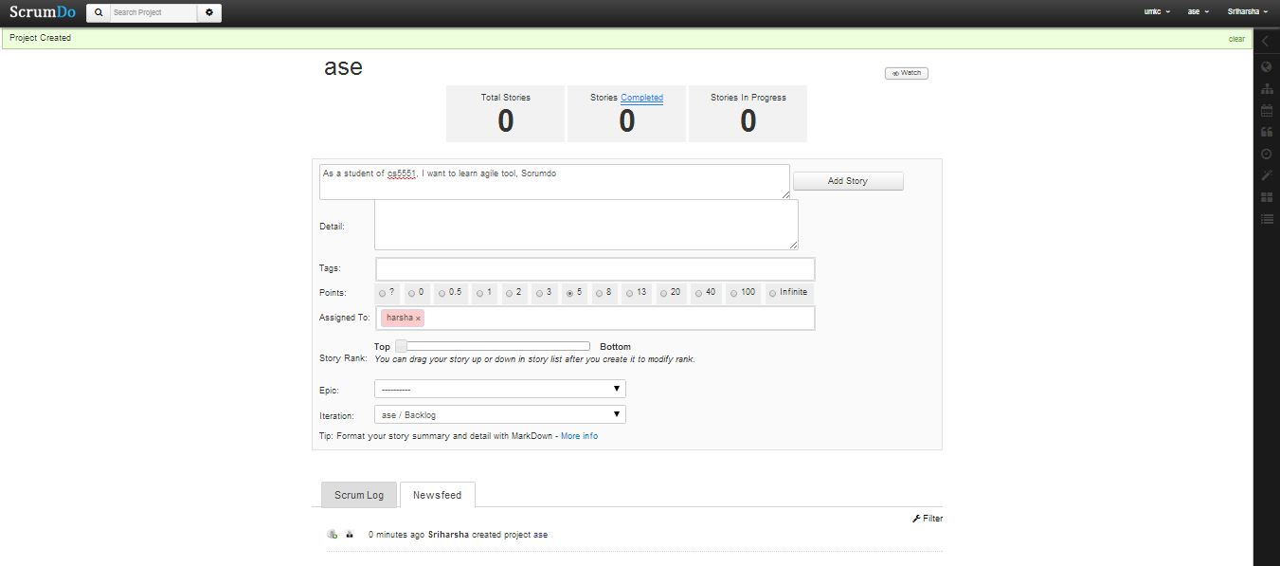

Step 6: Create Iteration

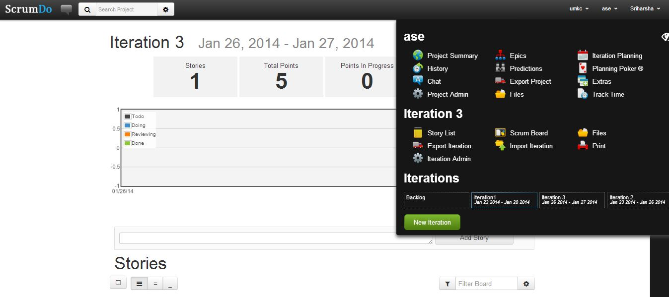

Step 7: Epic story

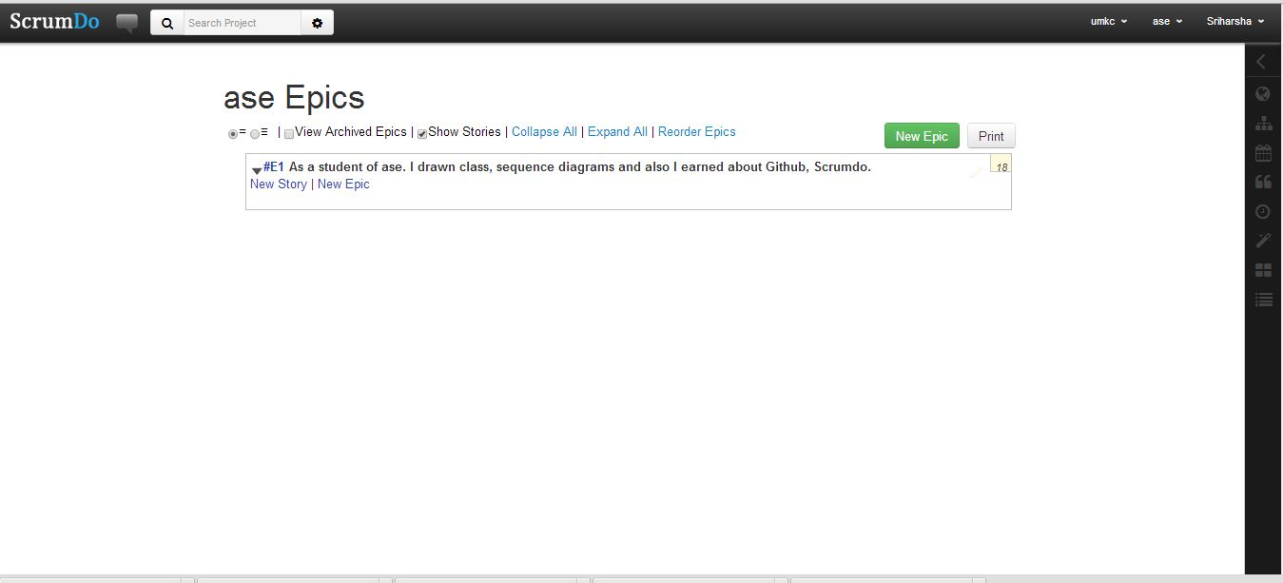

Step 8: Scrum board.

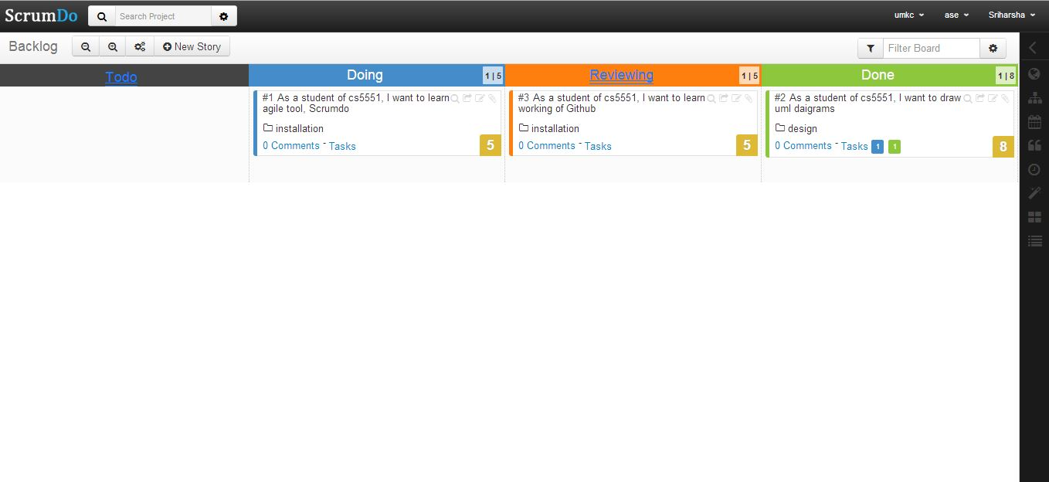

Step 7: For each Task status can be assigned below.



Step 8: History can be seen here.

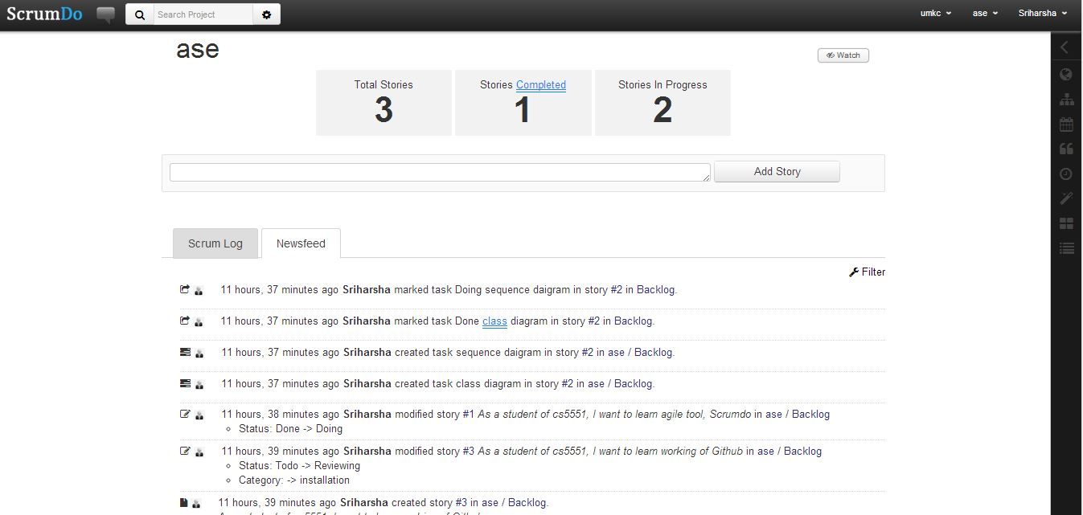

Step 9: Done

