LAB-2

SRIHARSHA CHOWDRAYVEEREPALLI

Id no: 16149284

I have developed a mobile app which gives us the weather report of a particular place when we enter a place name all over the world.

I implemented this mobile web client using HTML, Java script, CSS3 and jQuery mobile

I have taken google weather API and also open weather API to build this application.

Weather API: We can enable the display of weather data or cloud imagery on your map via the weather layer and Cloud layer classes of the google maps weather library. Enabling the cloud layer will add cloud coverage imagery to your map, visible at zoom levels 0 through 6. Enabling the weather layer will show current weather conditions from weather.com on the map, including icons that denote sun, clouds, rain and so on. Clicking on the weather icon for a particular area will open an info window with detailed data such as current humidity and wind conditions, as well as a four-day forecast.

This is my jsfiddle page initially before entering any city

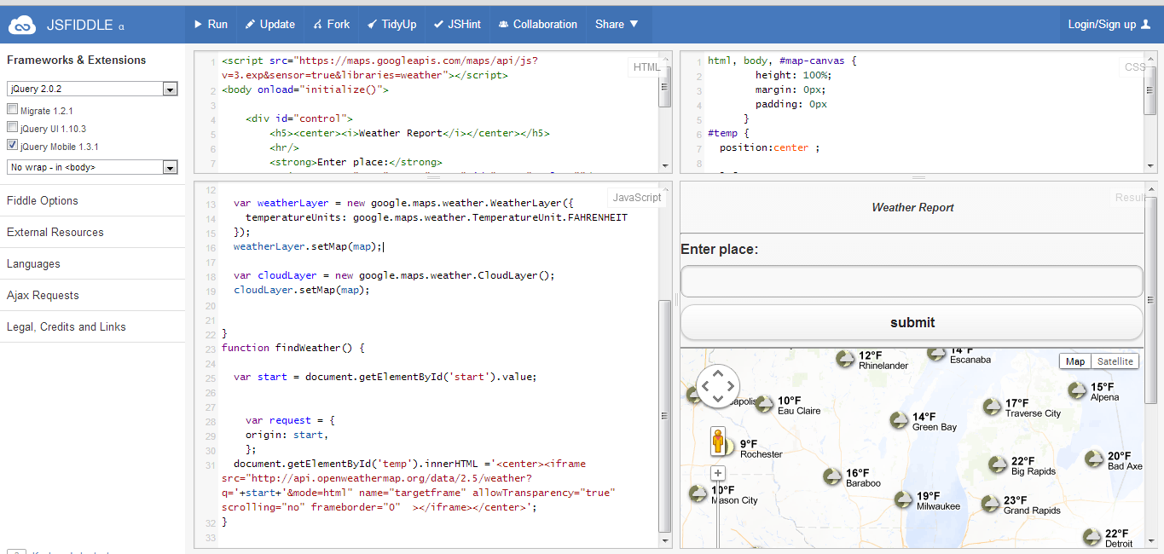

After entering city place and clicking submit we will get the following result.

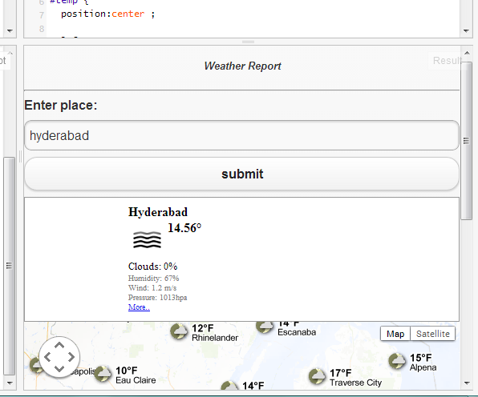

The following is the output jsfiddle link: <http://jsfiddle.net/a82Dc/1/>

HTML:

<script src="https://maps.googleapis.com/maps/api/js?v=3.exp&sensor=true&libraries=weather"></script>

<body onload="initialize()">

<div id="control">

<h5><center><i>Weather Report</i></center></h5>

<hr/>

<strong>Enter place:</strong>

<input type="text" name="start" id="start" value=""/>

<input type="submit" id="submit" value="submit" onclick="findWeather();"/>

</div>

<div id="temp"></div>

<div id="map-canvas" style="height:500px;width:100%;"></div>

</body>

JAVA SCRIPT :

$('#control').ready(function() {

initialize(41.850033, -87.6500523);

});

function initialize(lat,lan) {

var mapOptions = {

zoom: 6,

center: new google.maps.LatLng(lat,lan)

};

var map = new google.maps.Map(document.getElementById('map-canvas'),

mapOptions);

var weatherLayer = new google.maps.weather.WeatherLayer({

temperatureUnits: google.maps.weather.TemperatureUnit.FAHRENHEIT

});

weatherLayer.setMap(map);

var cloudLayer = new google.maps.weather.CloudLayer();

cloudLayer.setMap(map);

}

function findWeather() {

var start = document.getElementById('start').value;

var request = {

origin: start,

};

document.getElementById('temp').innerHTML ='<center><iframe src="http://api.openweathermap.org/data/2.5/weather?q='+start+'&mode=html" name="targetframe" allowTransparency="true" scrolling="no" frameborder="0" ></iframe></center>';

}

Css:

html, body, #map-canvas {

height: 100%;

margin: 0px;

padding: 0px

}

#temp {

position:center ;

left: 100%;

margin-left: 0px;

z-index: 5;

background-color: #fff;

border: 1px solid #999;

}

Thank you.