LAB-3

SRIHARSHA CHOWDRAYVEEREPALLI

Id no: 16149284

1. **Local Storage with HTML5**

I have developed a mobile app which gives us the weather report of a particular place when we enter a place name all over the world.

I implemented this mobile web client using HTML, Java script, CSS3 and jQuery mobile and Local Storage

I have taken google weather API and also open weather API to build this application.

Weather API: We can enable the display of weather data or cloud imagery on your map via the weather layer and Cloud layer classes of the google maps weather library. Enabling the cloud layer will add cloud coverage imagery to your map, visible at zoom levels 0 through 6. Enabling the weather layer will show current weather conditions from weather.com on the map, including icons that denote sun, clouds, rain and so on. Clicking on the weather icon for a particular area will open an info window with detailed data such as current humidity and wind conditions, as well as a four-day forecast.

This is my jsfiddle page initially before entering any city without storage or clear storage.

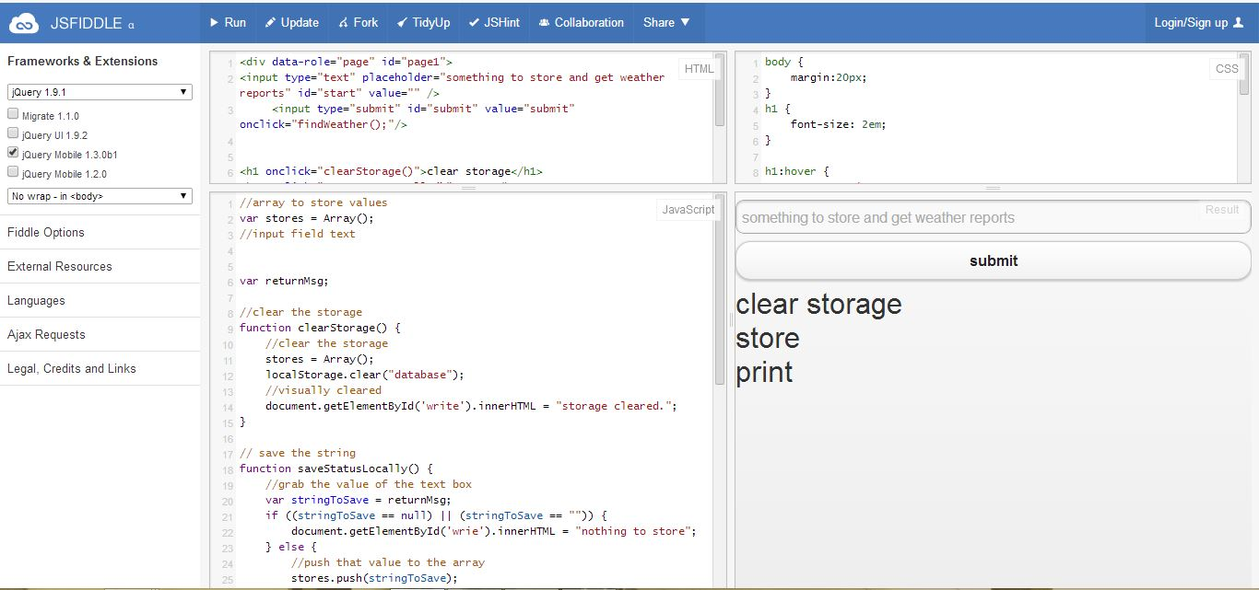

Click store button to store the data. 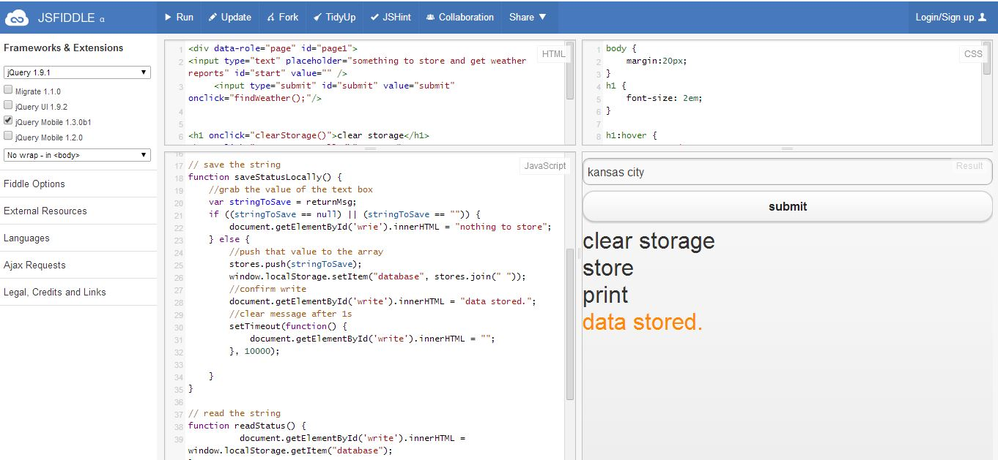

After entering city place and clicking submit or print we will get the following r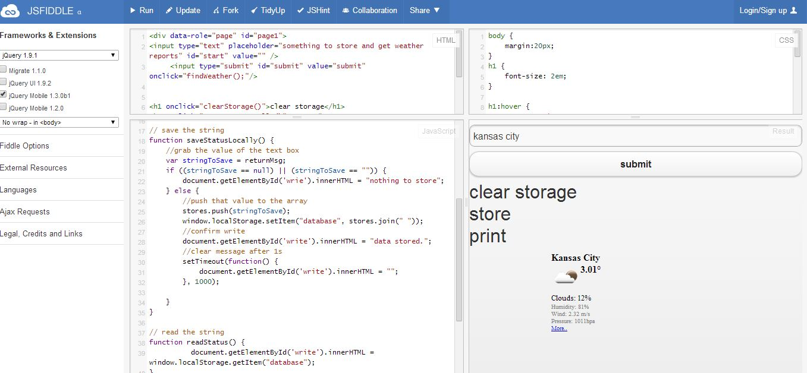esult.

**The following is the output jsfiddle link:** [**http://jsfiddle.net/NT9Rg/68/**](http://jsfiddle.net/NT9Rg/68/)

HTML:

<div data-role="page" id="page1">

<input type="text" placeholder="something to store and get weather reports" id="start" value="" />

<input type="submit" id="submit" value="submit" onclick="findWeather();"/>

<h1 onclick="clearStorage()">clear storage</h1>

<h1 onclick="saveStatusLocally()">store</h1>

<h1 onclick="readStatus()">print</h1>

<div id="write"></div>

</div>

JAVA SCRIPT :

//array to store values

var stores = Array();

//input field text

var returnMsg;

//clear the storage

function clearStorage() {

//clear the storage

stores = Array();

localStorage.clear("database");

//visually cleared

document.getElementById('write').innerHTML = "storage cleared.";

}

// save the string

function saveStatusLocally() {

//grab the value of the text box

var stringToSave = returnMsg;

if ((stringToSave == null) || (stringToSave == "")) {

document.getElementById('wrie').innerHTML = "nothing to store";

} else {

//push that value to the array

stores.push(stringToSave);

window.localStorage.setItem("database", stores.join(" "));

//confirm write

document.getElementById('write').innerHTML = "data stored.";

//clear message after 1s

setTimeout(function() {

document.getElementById('write').innerHTML = "";

}, 1000);

}

}

// read the string

function readStatus() {

document.getElementById('write').innerHTML = window.localStorage.getItem("database");

}

function findWeather() {

var start = document.getElementById('start').value;

returnMsg= document.getElementById('write').innerHTML ='<center><iframe src="http://api.openweathermap.org/data/2.5/weather?q='+start+'&mode=html" name="targetframe" allowTransparency="true" scrolling="no" frameborder="0" ></iframe></center>';

}

Css:

body {

margin:20px;

}

h1 {

font-size: 2em;

}

h1:hover {

cursor: pointer;

color: #f00;

}

h1:active {

color:#555;

}

#write {

font-size: 2em;

color: #ff8800;

}

input {

outline: none;

}

1. **Mash Up**

I put three services in one applicaton.

Service 1: google Map

Service2: weather

Service 3: Directions between two cities.

This is jsfiddle file for my first service in Mashup

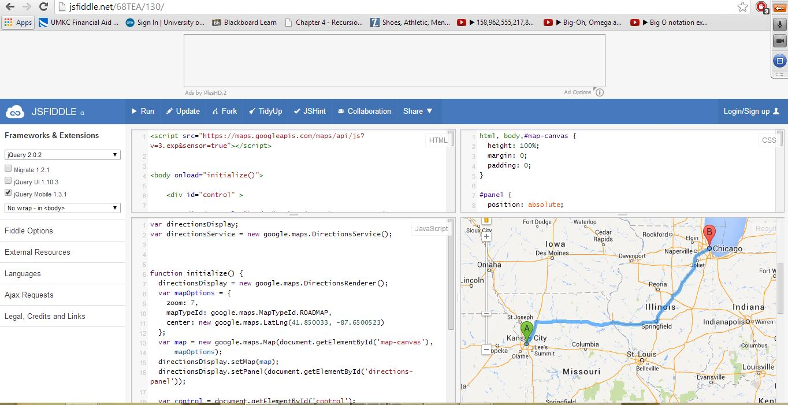

After that the second service will shown in the same jsfiddle by scrolling.

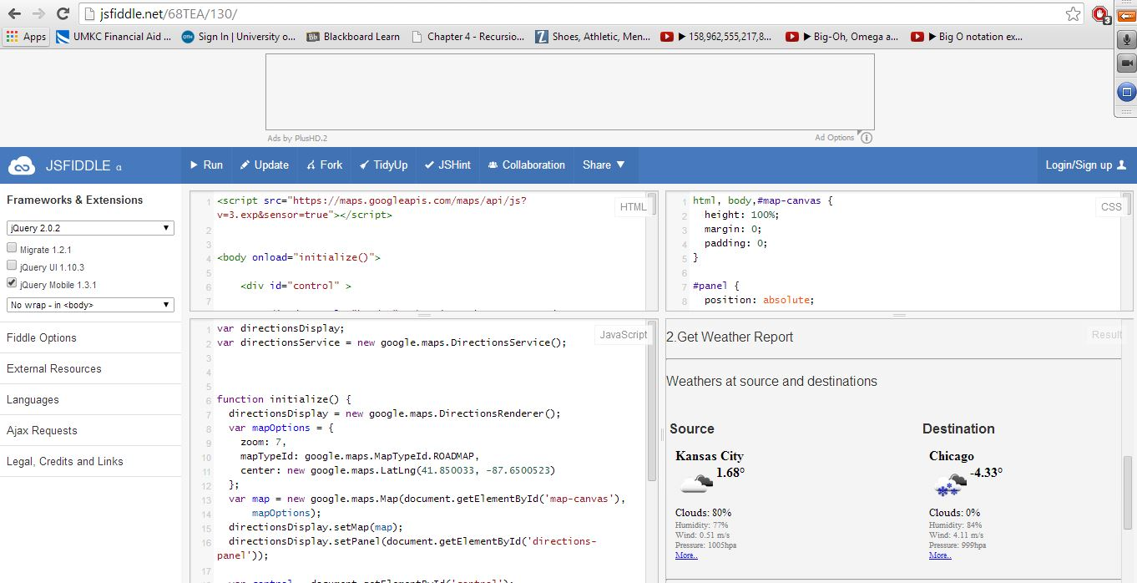

The final application is shown in the same jsfiddle.

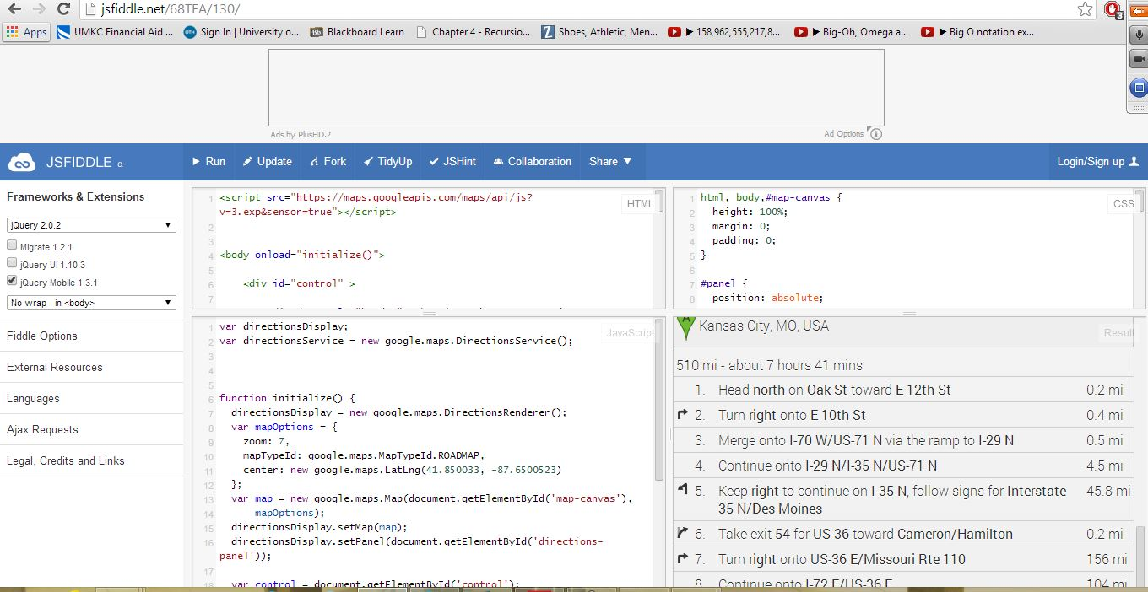

**The output jsfiddle link is:** [**http://jsfiddle.net/68TEA/130/**](http://jsfiddle.net/68TEA/130/)

Code:

HTML:

<script src="https://maps.googleapis.com/maps/api/js?v=3.exp&sensor=true"></script>

<body onload="initialize()">

<div id="control" >

<div data-role="header"> <h5><i>Weather Report and Directions</i></h5></div>

<input type="text" name="start" id="start" value="" placeholder="Source"/>

<input type="text" name="end" id="end" value=""placeholder="Destination"/>

<input type="submit" id="submit" value="submit" data-corners="true" onclick="findWeatherandCalcRoute();"/>

</div>

<p>1.Get Map</p>

<div id="map-canvas" style="height:500px;width:100%;"></div><hr/>

<p>2.Get Weather Report</p>

<div id="temp"></div>

<hr/>

<p>3.Get Directions</p>

<div id="directions-panel"></div> <hr/>

<div data-role="footer">

<p>Posted by: Veerepalli Sriharsha Chowdary</p>

<p>Contact information: <a href="mailto:Sriharsha Chowdary Veerepalli">sv9w8@mail.umkc.edu.</a></p>

</div>

</body>

JAVASCRIPT:

var directionsDisplay;

var directionsService = new google.maps.DirectionsService();

function initialize() {

directionsDisplay = new google.maps.DirectionsRenderer();

var mapOptions = {

zoom: 7,

mapTypeId: google.maps.MapTypeId.ROADMAP,

center: new google.maps.LatLng(41.850033, -87.6500523)

};

var map = new google.maps.Map(document.getElementById('map-canvas'),

mapOptions);

directionsDisplay.setMap(map);

directionsDisplay.setPanel(document.getElementById('directions-panel'));

var control = document.getElementById('control');

control.style.display = 'block';

map.controls[google.maps.ControlPosition.TOP.FULL].push(control);

}

function findWeatherandCalcRoute() {

var start = document.getElementById('start').value;

var end = document.getElementById('end').value;

if (start == '' || end == '') {

// cannot calculate route

$("#temp").hide();

return;

}

else {

var request = {

origin: start,

destination: end,

travelMode: google.maps.TravelMode.DRIVING

}

};

directionsService.route(request, function(response, status) {

if (status == google.maps.DirectionsStatus.OK) {

directionsDisplay.setDirections(response);

$("#temp").show();

}

});

document.getElementById('temp').innerHTML = '<hr/><p>Weathers at source and destinations</p><br/><center><table><tr><td><b>Source</b></td><td><b>Destination</b></td></tr><tr><td><iframe src="http://api.openweathermap.org/data/2.5/weather?q='+start+'&mode=html" name="targetframe" allowTransparency="true" scrolling="no" frameborder="0" ></iframe></td><td><iframe src="http://api.openweathermap.org/data/2.5/weather?q='+end+'&mode=html" name="targetframe" allowTransparency="true" scrolling="no" frameborder="0" ></iframe></td></tr></table></center>';

}

CSS:

html, body,#map-canvas {

height: 100%;

margin: 0;

padding: 0;

}

#panel {

position: absolute;

top: 5px;

left: 50%;

margin-left: -180px;

z-index: 5;

background-color: #fff;

padding: 5px;

border: 1px solid #999;

}

#directions-panel {

height: 100%;

float: center;

width: 100%;

overflow: auto;

}

#map-canvas {

margin-right: 0px;

}

#control {

position: left;

background: #fff;

padding: 1px;

font-size: 14px;

font-family: Arial;

border: 1px solid #ccc;

}

1. **WCF service.**

The WCF service runs by using localhost. Initially without giving any parameters the output is :

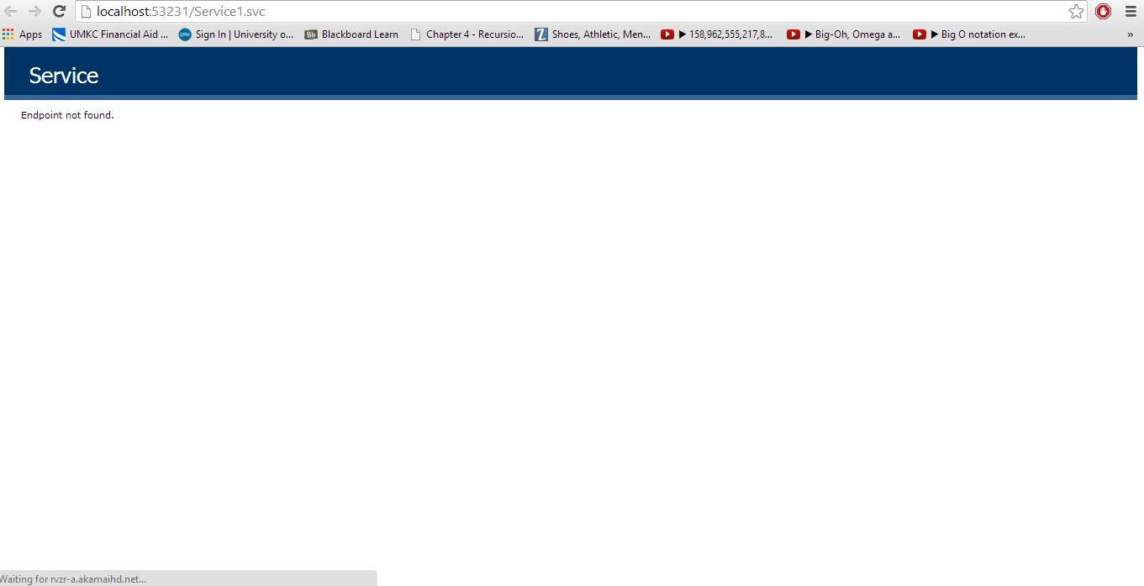

After that by giving the parameters to the local host the output in the local server is:

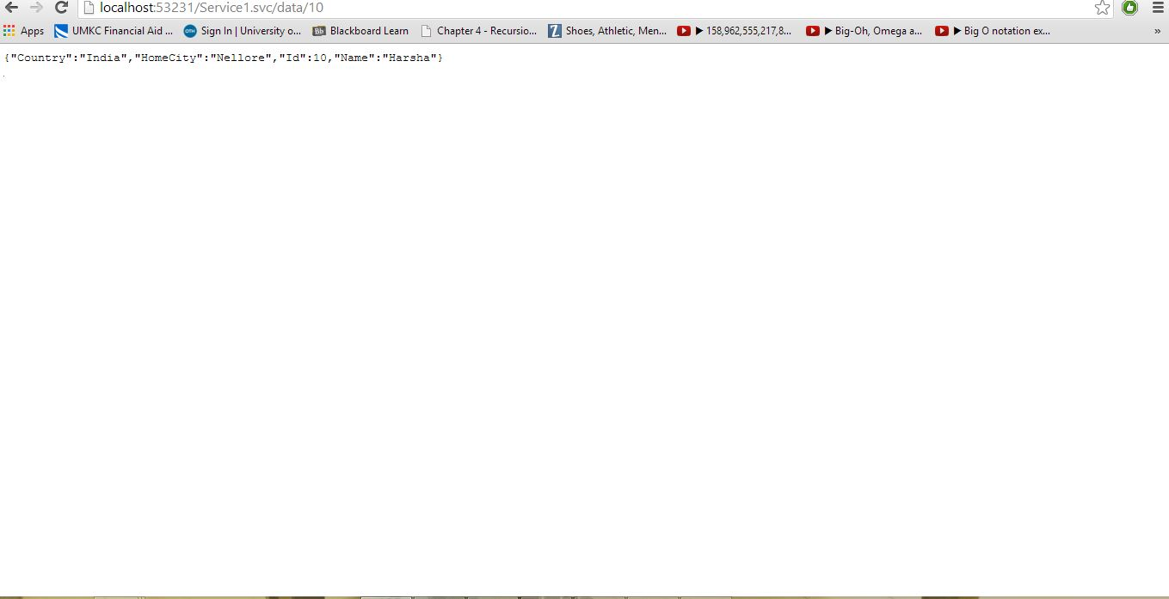

The output wcf service code is:

using System;

using System.Collections.Generic;

using System.Linq;

using System.Runtime.Serialization;

using System.ServiceModel;

using System.ServiceModel.Web;

using System.Text;

namespace WcfService1

{

// NOTE: You can use the "Rename" command on the "Refactor" menu to change the class name "Service1" in code, svc and config file together.

public class Service1 : IService1

{

[WebInvoke(Method = "GET",ResponseFormat = WebMessageFormat.Json,UriTemplate = "data/{id}")]

public Person GetData2(string id)

{

// lookup person with the requested id

return new Person()

{

Id = Convert.ToInt32(id),

Name = "Harsha",

HomeCity="Nellore",

Country="India",

};

}

public string GetData(int value)

{

return string.Format("You entered: {0}", value);

}

public CompositeType GetDataUsingDataContract(CompositeType composite)

{

if (composite == null)

{

throw new ArgumentNullException("composite");

}

if (composite.BoolValue)

{

composite.StringValue += "Suffix";

}

return composite;

}

public string GetDateTime()

{

return DateTime.Now.ToString();

}

}

public class Person

{

public int Id { get; set; }

public string Name { get; set; }

public string HomeCity { get; set; }

public string Country { get; set; }

}

}

Thank you.