LAB -4

Sriharsha Veerepalli ID:16149284.

**PART - 1 RESTFUL Web Service.**

1. I started a new project by choosing WCF service application in visual studio 2010.

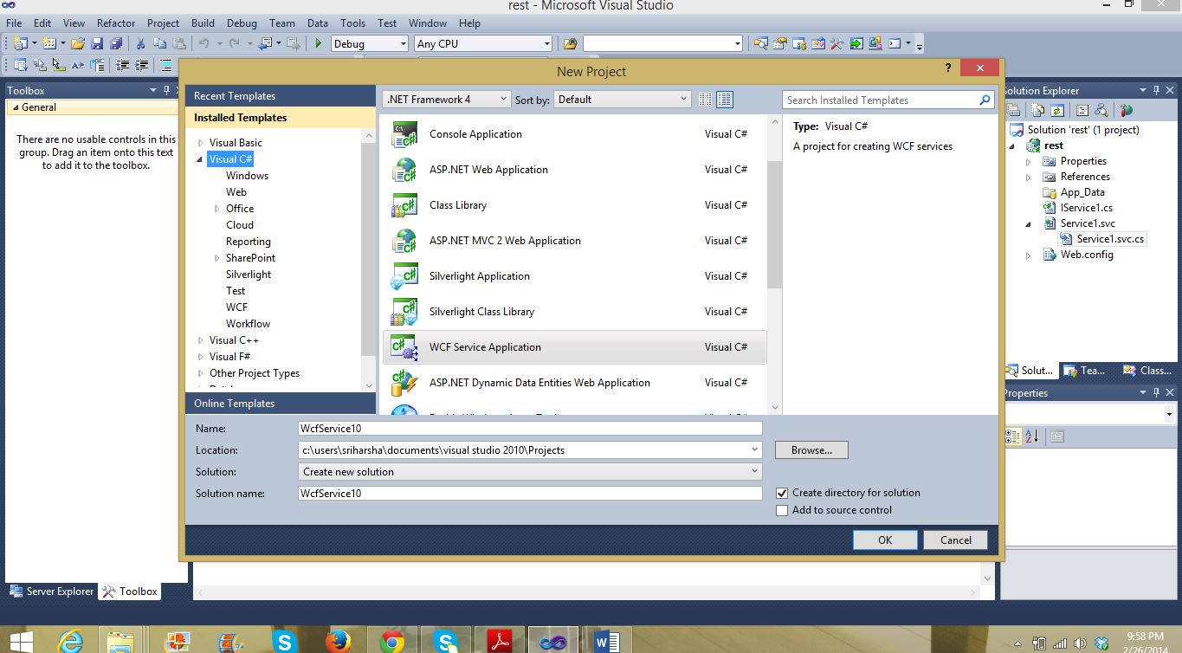

2. In the Iservice1.cs interface file under interface class I defined my methods for arithmetic operations. Below is the Code.

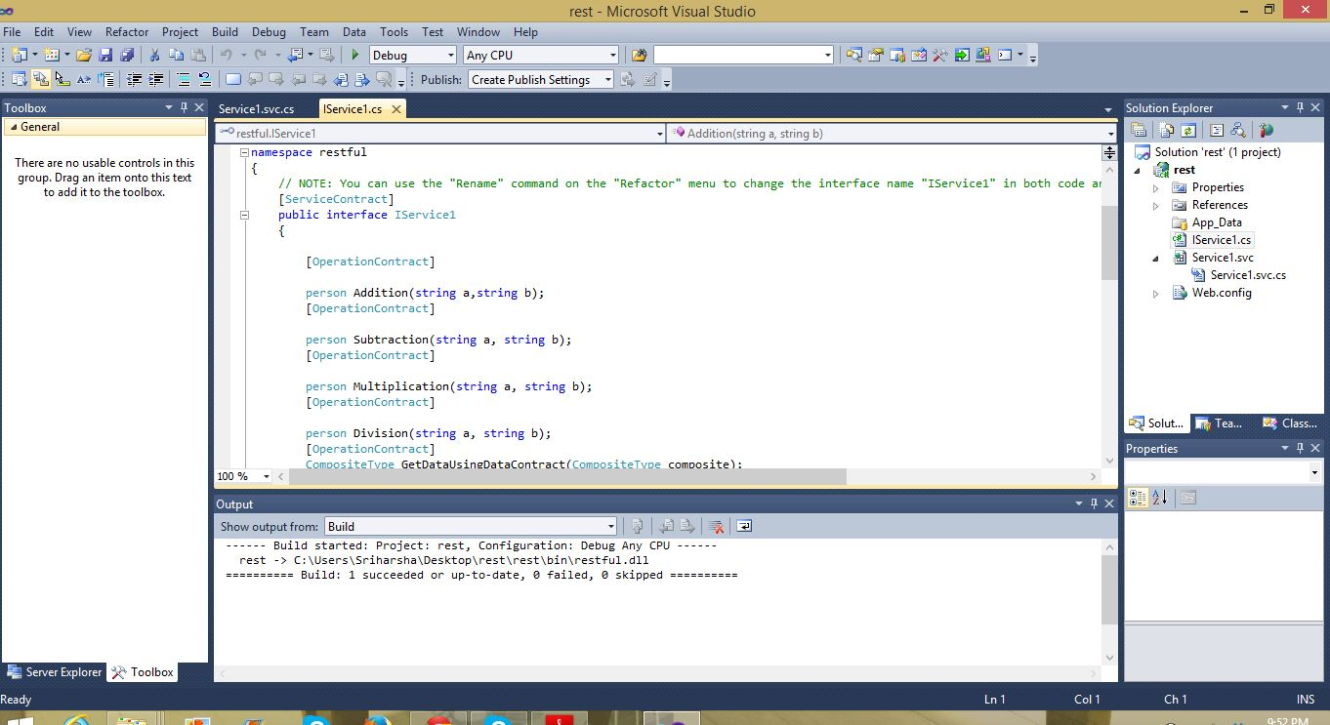

3. In the Service1.svc.cs file I implemented the real functions for the interface. Then I checked the markup for service1.svc file and I added the factory="system.servicemodel.activation.webserviceHostFactor", below is the code.

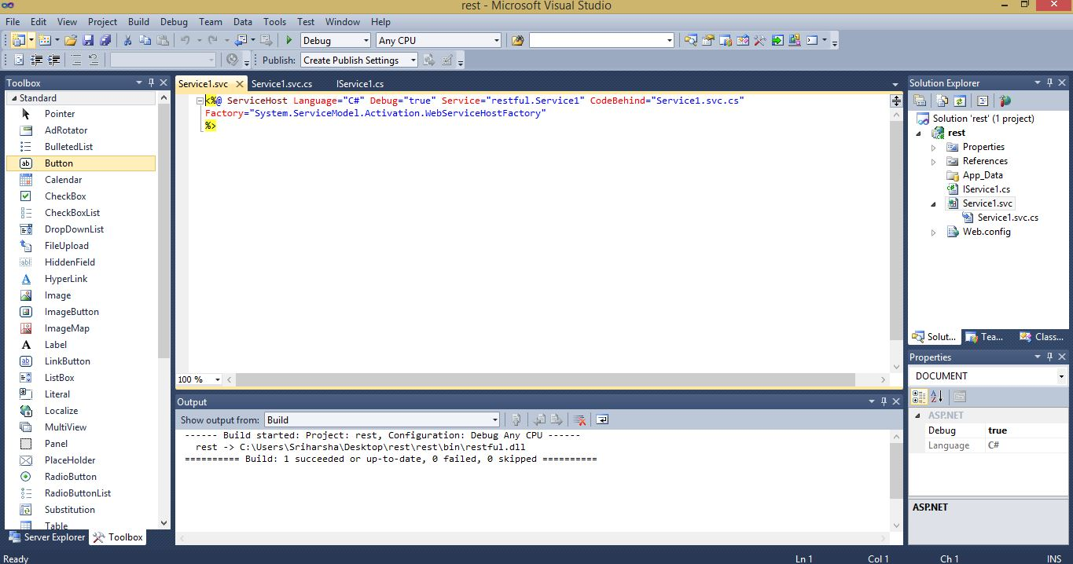

4. Then I viewed in browser for the file service1.svc. Below is the Screen shot.

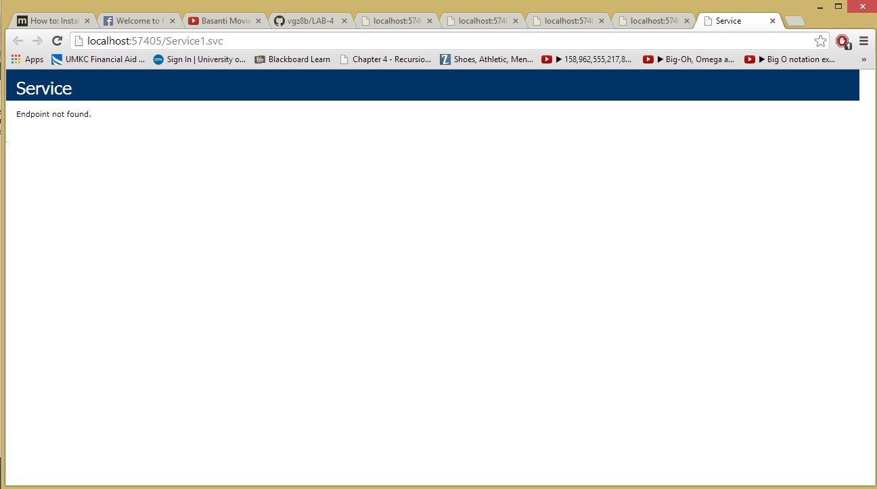

5. Here I got end point not found because I didn't defined the endpoint for the root location. then i added "/addition/4/3" I got the Jason output Below is the Screen shot.

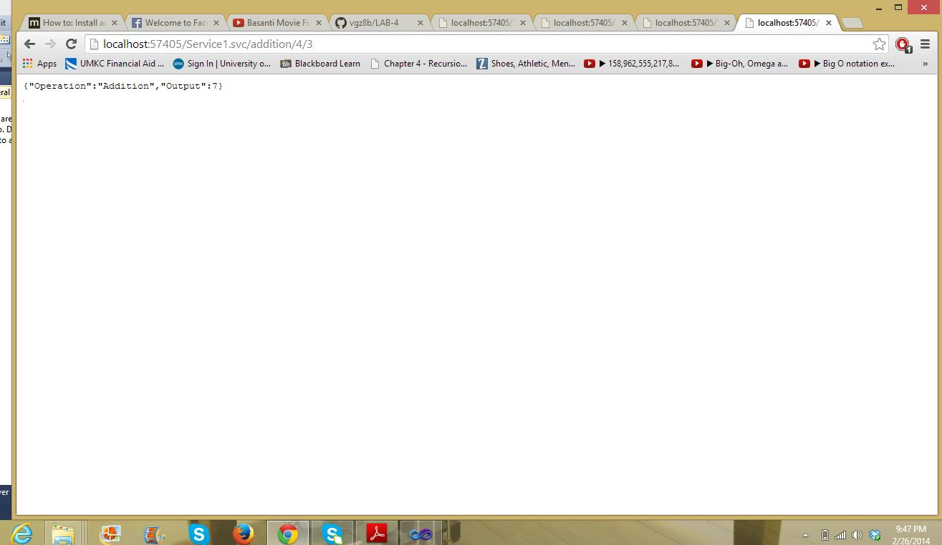

**PART 2: WSDL/SOAP web service**

1.I added a new item (web service) in visual studio 2010 to create a website for SOAP web service. Then in service.cs file I have written four methods for four arithmetic operations Addition, Subtraction, Multiplication and Division. Below is the Screen shot of Service.cs file.

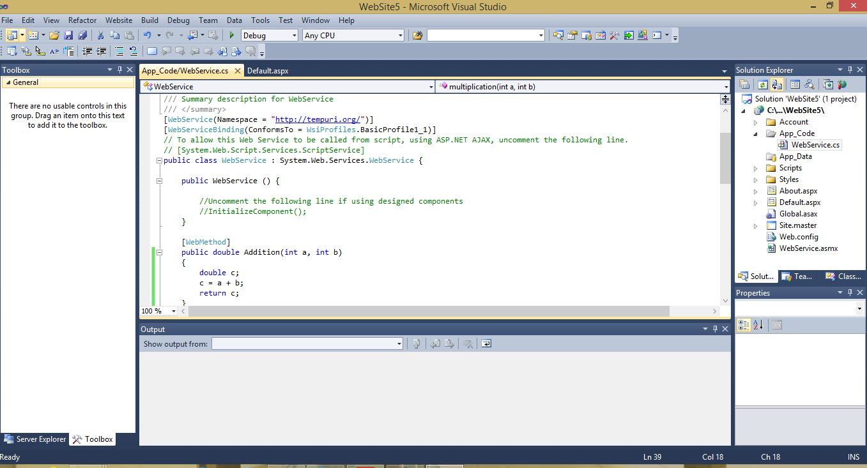

2.Then I checked the output by clicking Start Without Debugging under the Debug tab. then below is the output Screen.

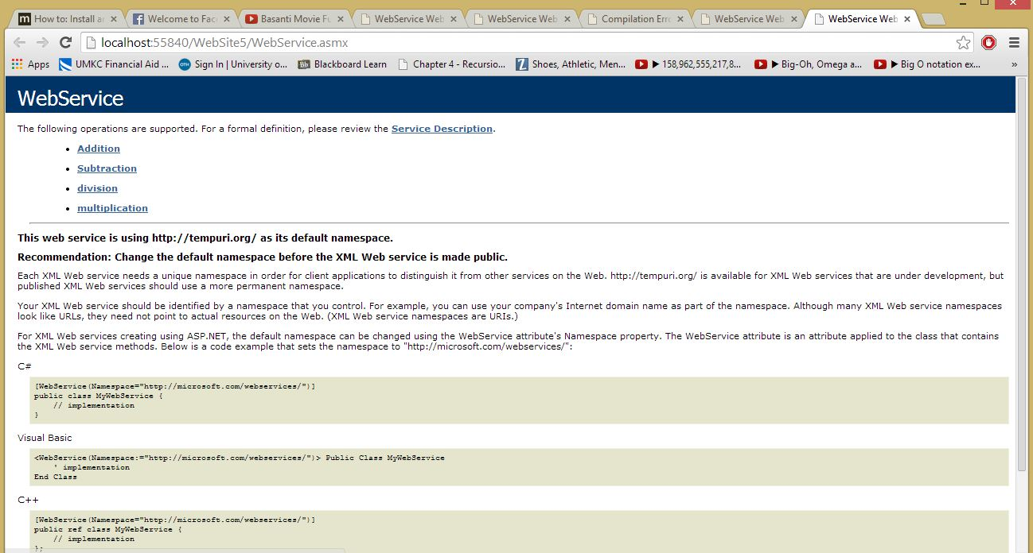

3. Then I checked all methods that i have written in service file. Below is the Screen Shot.

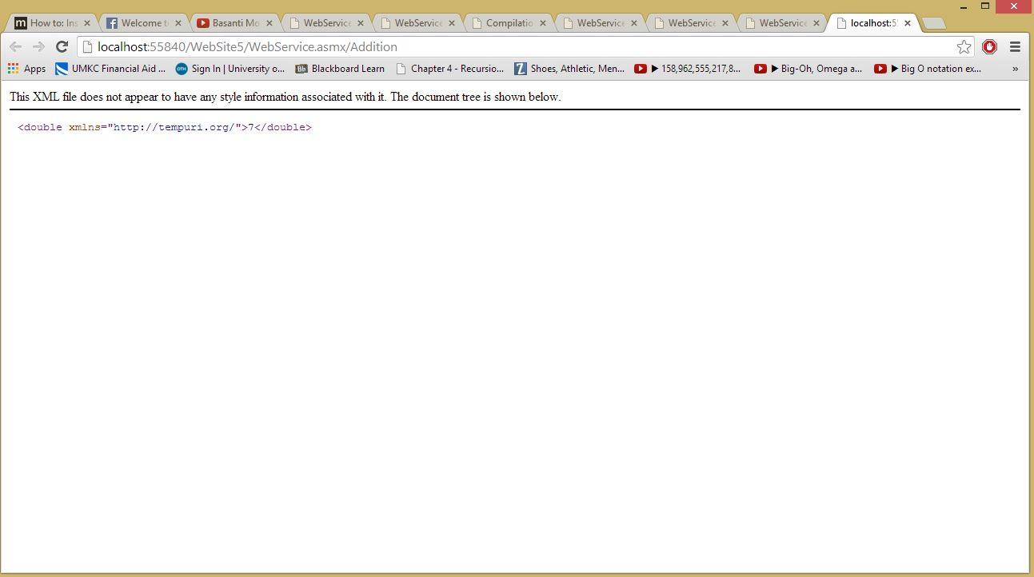

4.I Viewed the Service description page then I copied the link.

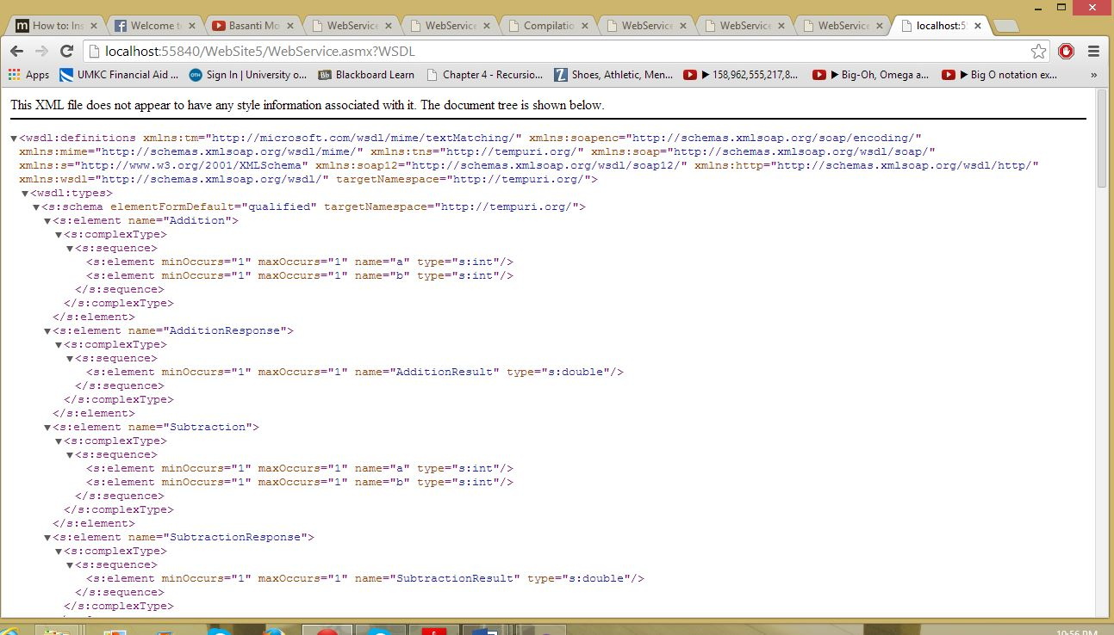

5.I added web reference to the website and Invoke the values to see the output.

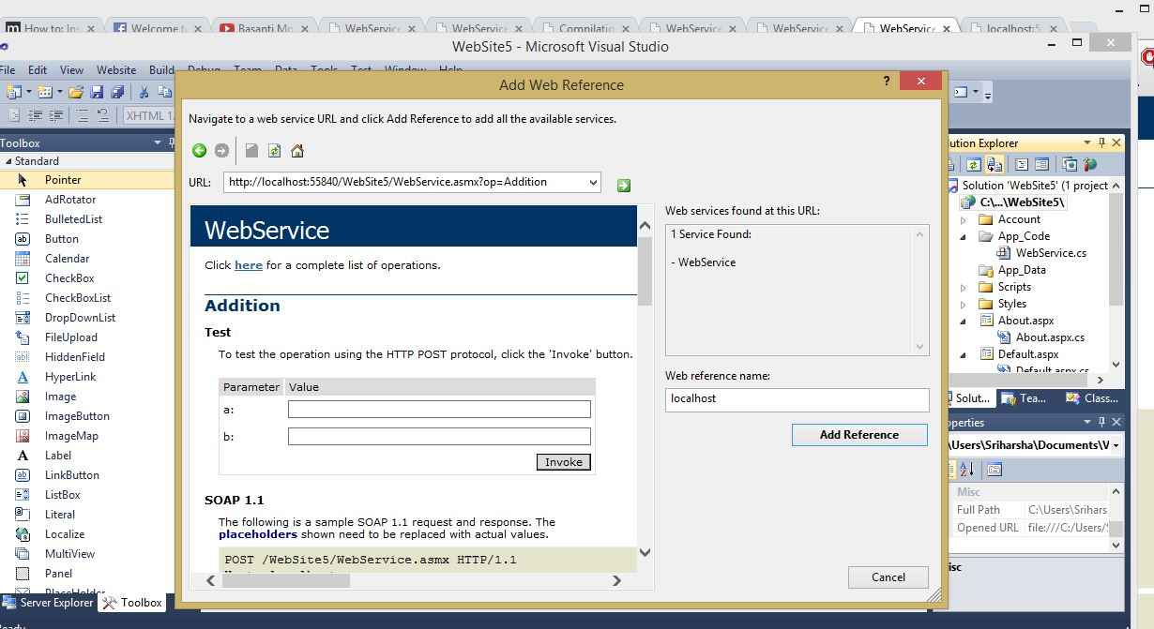

6.I added a web reference with my service description URL that I have copied earlier. Below is the Screen shot.

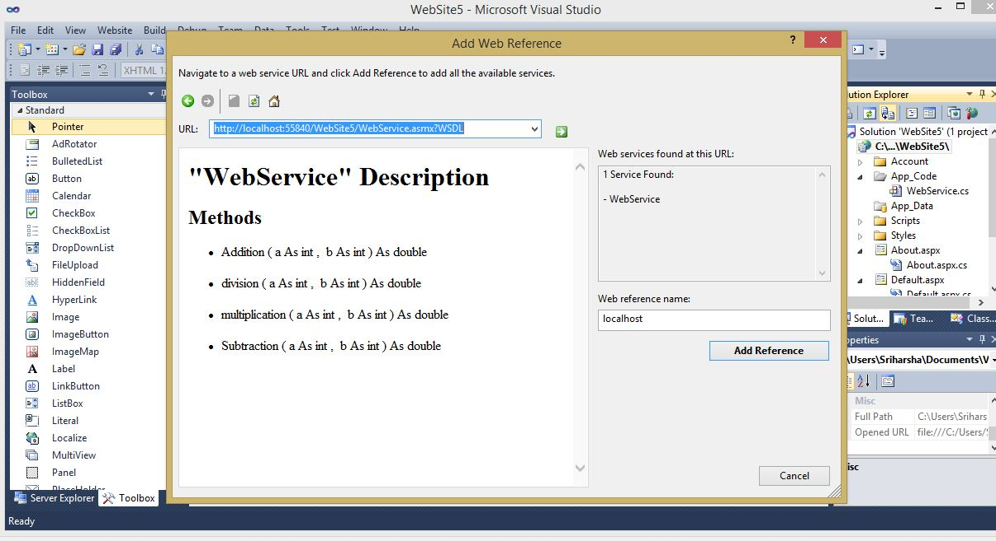

**PART 3 : client implementation of REST and SOAP WEB SERVICES:**

I have written javascript to call my rest web service link and got the json output.Then I stringified that output and saved into two parameters the I displayed through ajax in jsfiddle

**HTML:**

<center><h3><u>RESTFUL Mobile Client</u></h3></center>

<table align="center">

<tr>

<td>Enter Number1</td>

<td><input type="text" name="v1" id="v1" value=""/></td>

</tr>

<tr>

<td>Enter Number2</td>

<td><input type="text" name="v2" id="v2" value=""/></td>

</tr>

</table>

<center><p>

<input type="button" class="add" value="Add"></input>

&nbsp;&nbsp;&nbsp;&nbsp; &nbsp;&nbsp;&nbsp;&nbsp;

<input type="button" class="mul" value="Multiply"></input>

&nbsp;&nbsp;&nbsp;&nbsp; &nbsp;&nbsp;&nbsp;&nbsp;

<input type="button" class="sub" value="Subtract"></input>

&nbsp;&nbsp;&nbsp;&nbsp; &nbsp;&nbsp;&nbsp;&nbsp;

<input type="button" class="divi" value="Divide"></input>

</p></center>

**JavaScript:**

var echo = function(dataPass) {

$.ajax({

type: "POST",

url: "/echo/json/",

data: dataPass,

cache: false,

success: function(json) {

alert("Operation="+json.Operation+"\nResult="+json.Output);

}

});

};

$('.add').live('click', function() {

var url="http://localhost/aspnet_client/restful/Service1.svc/addition/"+document.getElementById('v1').value+"/"+document.getElementById('v2').value ;

$.get(url, function(data) {

var json = {

json: JSON.stringify(data),

delay: 1

};

echo(json);

});

});

$('.sub').live('click', function() {

var url="http://localhost/aspnet_client/restful/Service1.svc/subtraction/"+document.getElementById('v1').value+"/"+document.getElementById('v2').value ;

$.get(url, function(data) {

var json = {

json: JSON.stringify(data),

delay: 1

};

echo(json);

});

});

$('.mul').live('click', function() {

var url="http://localhost/aspnet_client/restful/Service1.svc/multiplication/"+document.getElementById('v1').value+"/"+document.getElementById('v2').value ;

$.get(url, function(data) {

var json = {

json: JSON.stringify(data),

delay: 1

};

echo(json);

});

});

$('.divi').live('click', function() {

var url="http://localhost/aspnet_client/restful/Service1.svc/division/"+document.getElementById('v1').value+"/"+document.getElementById('v2').value ;

$.get(url, function(data) {

var json = {

json: JSON.stringify(data),

delay: 1

};

echo(json);

});

});

**Output:**

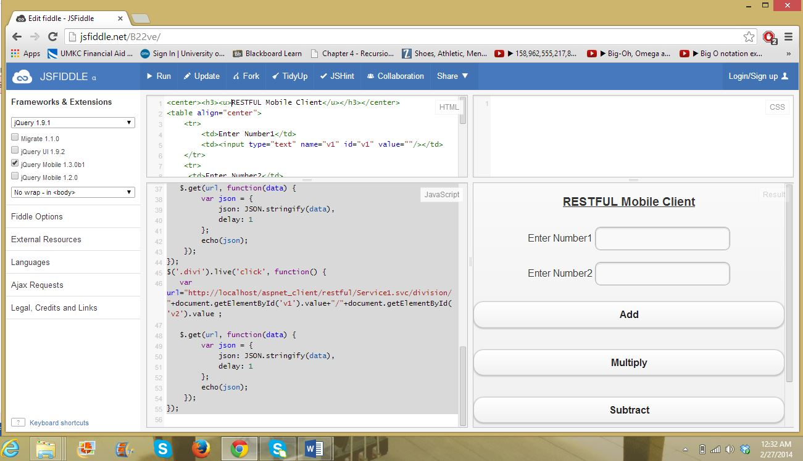

**Js fiddle link :** [**http://jsfiddle.net/B22ve/**](http://jsfiddle.net/B22ve/)