Assignment Questions with Answers - Loops (Python)  
Date: 26-07-2025

# Python Questions

1. 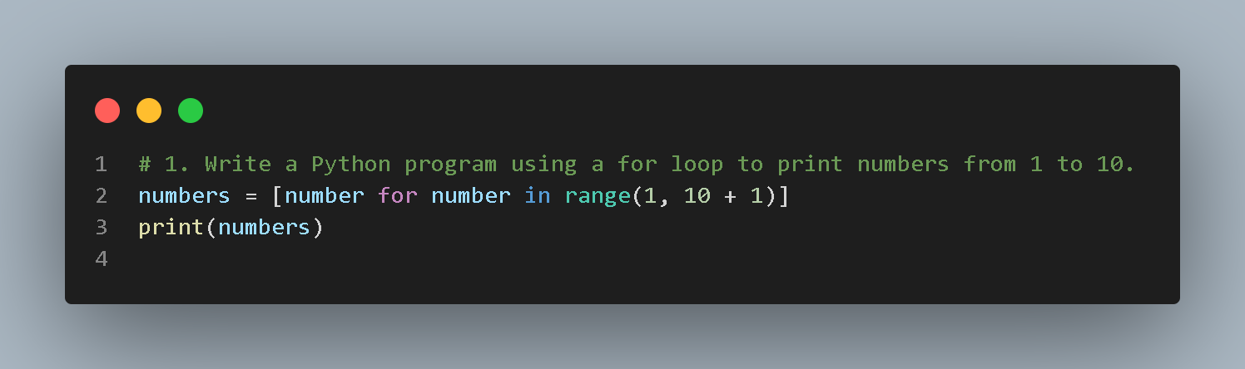Write a Python program using a for loop to print numbers from 1 to 10.
2. 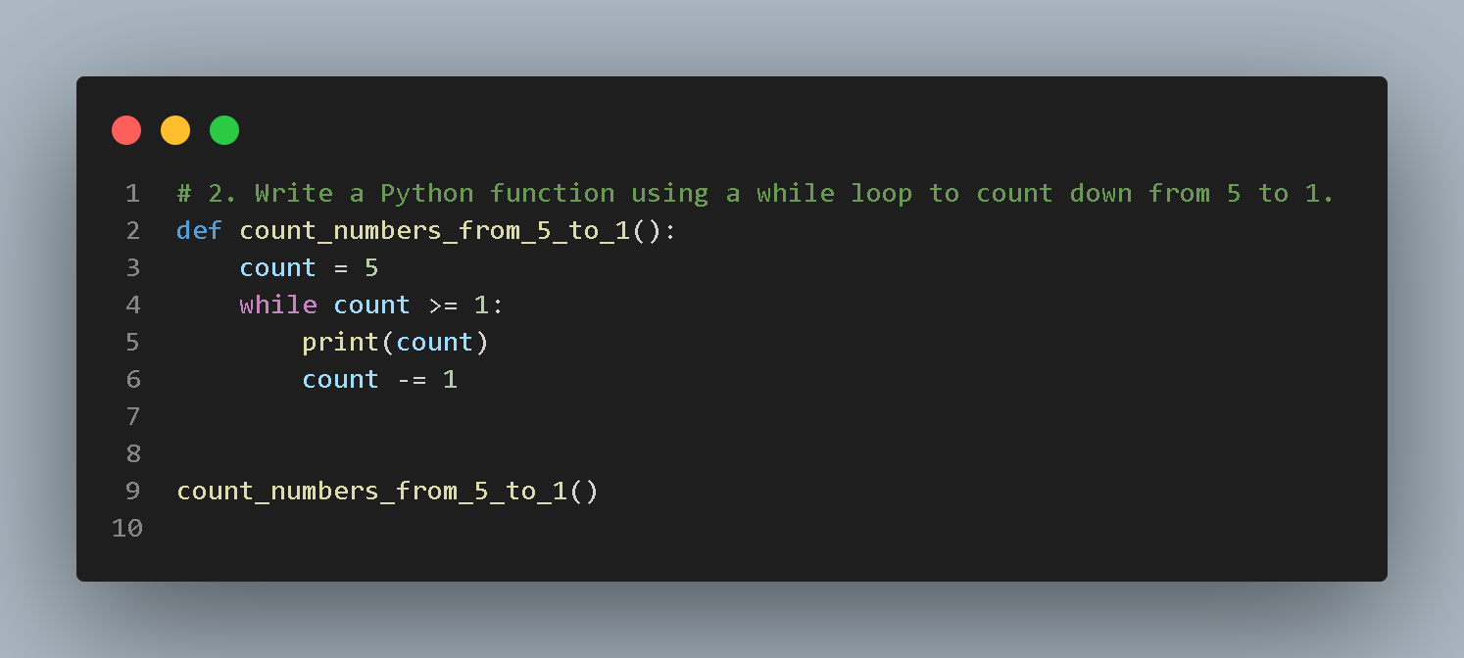Write a Python function using a while loop to count down from 5 to 1.
3. Write a Python function that asks for user input until the word 'exit' is entered.

1. 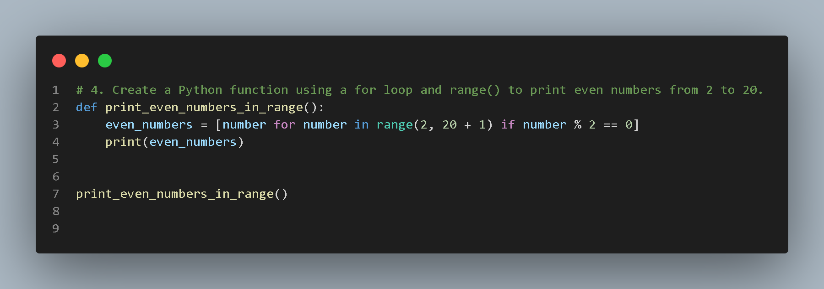Create a Python function using a for loop and range() to print even numbers from 2 to 20.
2. A screenshot of a computer

   AI-generated content may be incorrect.Write a program that iterates over a list of names and prints each with a serial number using enumerate().
3. A computer screen shot of a black screen

   AI-generated content may be incorrect.Simulate a do-while loop in Python that asks for a number until the user enters a negative number.
4. A computer screen with text on it

   AI-generated content may be incorrect.Create a Python program that uses a nested loop to print the multiplication table from 1 to 5.
5. A screenshot of a computer program

   AI-generated content may be incorrect.Write a Python function that breaks the loop when the input number is divisible by 7.
6. A computer screen shot of a program

   AI-generated content may be incorrect.Write a Python program using continue to skip numbers divisible by 3 from 1 to 15.
7. A screenshot of a computer program

   AI-generated content may be incorrect.Write a Python program to iterate over two lists using zip() and print the paired elements.