Table of Contents
Problem Statement 3
Functional Requirements 3
Admin Module 3
Add Product 3
Add Product On Discount 3
Modify Product 3
Delete Product 3
Search Product 4
Get All Products 4
Get Products by Product Name 4
Get Products by Category Code 4
Class Specifications 4
Technology Stack 5
Application Behavior 5
Sample Screen 6
Non-Functional Requirements 6
Guidelines 6
Milestones and Evaluation Criteria

Problem Statement
Design and develop a Console-based Product Inventory Management Application using C# to manage/maintain products for a small-scale business, helping them keep track of the list of products and categories.
Functional Requirements
Admin Module
Add Product
- Accept Product Name, Category Code, Available Quantity and Product Price.
- Product Code is of string type and should be auto-generated. It should contain one character and three digits. (Ex: P001, P002, P003).
- Validations
- Category Code should be an existing category from the Category List.
- Product Name should be of minimum six characters length.
- Price should be greater than zero.
- Available quantity should be greater than zero.
- The Product details should be added to the Products collection.

Add Product On Discount
- Accept the product details along with the discount-related information. i.e., DiscountPercentage and MinimumPickQuantity.
  - Validations Perform the same validations of the ‘Add Product’ described above.
  - DiscountPercentage should be greater than zero.
  - MinimumPickQuantity should be greater than zero.

  - Add the product to the Products collection.

Modify Product
- Search the product based on the product code.
- If the product exists, accept product details (Product Name, Category Code, Available Quantity, Product Price) and update the details in the Products collection.

Delete Product
- Search the product based on the product code.
- If the product exists in the Products collection object, delete the product, after prompting the admin to confirm Deletion.
- If the product does not exist, display the message ‘Product does not exist’.
< / >
Copyright

Search Product
- Search the product based on product code.
- If the product exists, display the details of the product.
- If the product does not exist, display a message ‘Product does not exist’.

Get All Products
- Displays the details of all the products (including Products On Discount).
- Products should be displayed in the sorted order based on price.

Get Products by Product Name
Accept product name (say 3 characters) and display the details of all the products based on the product name.
Get Products by Category Code
Accept category code and display the details of all the products based on category code.

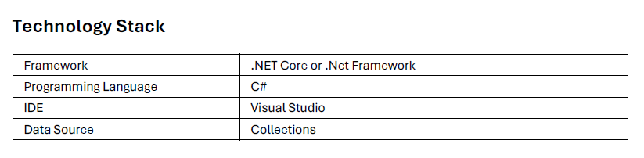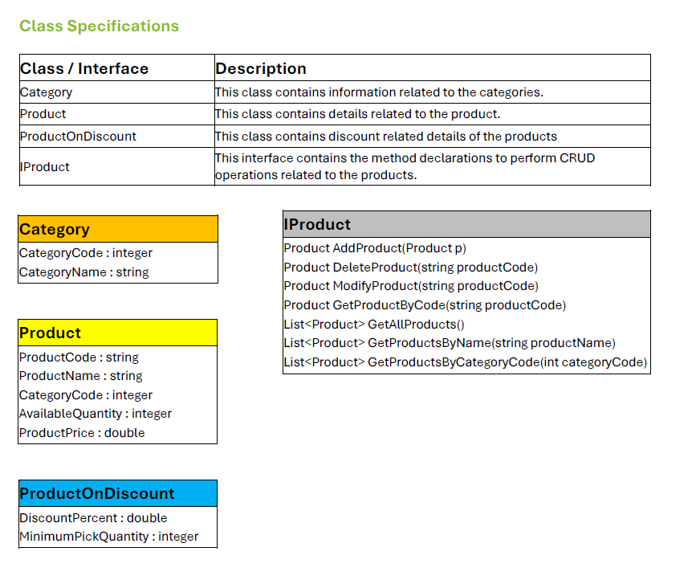

Application Behavior
- OOP concepts such as inheritance, abstract classes, interfaces, properties, methods, polymorphism, etc., can be implemented as per the requirement.
  - The application should Implement IProduct interface to perform necessary CRUD (Create, Retrieve, Update and Delete) operations on the product as required. You are free to add any additional methods in the interface as required.
  - Maintain a collection of all the Products and Categories.
  - Implement ‘HAS-A’ relationship between Product and ProductOnDiscount
  - Implement IComparable<T> interface to sort the list of products based on price.
  - Override ToString() to display the details of the product.
  - Wherever applicable construct a string object using the StringBuilder class.
  - Implement exception handling to gracefully handle errors and provide meaningful error responses.
  - Implement Custom Exception by inheriting ApplicationException class.
  - Log the exception details into a file (.txt file format)
  - All the exception details should be logged into one file.
  - The following details are to be logged into the file:
  - Date & Time
  - ErrorMessage and
  - StackTrace
  - Implement File I/O to log the error messages.
  - Ensure that basic validations are incorporated in the application. Invalid inputs should be prevented.
  - Implement the get and set properties for the attributes with appropriate validations.
  - Participants can also perform CRUD operations on Category. (optional)
  - Participants can keep track of the reorder level and reorder quantity of the product (optional)

  - Participants have a free hand in implementing new classes and functionalities based on assumption

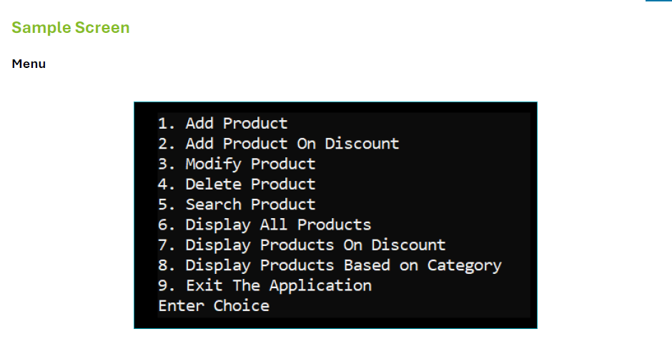
Non-Functional Requirements
- The application should have low latency and high throughput.
- The application and data should be secured by Authentication.
- System should be scalable and maintainable.

Guidelines
- Make use of best coding practices.
- Develop the application in such a way that it facilitates easy plugging of other related modules like Customer Management System, Order Management System, etc. while scaling the application at a later point in time.
- You can make assumptions and incorporate additional features or functionalities.
- Add relevant comments for proper documentation.
- A simple but working prototype is preferred over a non-working but good-looking application.
- Follow proper naming conventions.
- Use Git to maintain project repository, manage pull requests, and resolve conflicts.

