|  |
| --- |
| **Data Structures and Algorithms** |
| Smart City Management System |
| **Course Project Report** |

|  |
| --- |
| **School of Computer Science and Engineering**  **2023-24** |

**Contents**

|  |  |
| --- | --- |
| **Si. No.** | **Topics** |
| 1. | Course and Team Details |
| 2. | Introduction |
| 3. | Problem Definition |
| 4. | Functionality Selection |
| 5. | Functionality Analysis |
| 6. | Conclusion |
| 7. | References |

**1. Course and Team Details**

**1.1 Course details**

|  |  |
| --- | --- |
| **Course Name** | Data Structures and Algorithms |
| **Course Code** | 20ECSC205 |
| **Semester** | III |
| **Division** | D |
| **Year** | 2023-24 |
| **Instructor** | Mallikarjun Akki |

**1.2 Team Details**

|  |  |  |
| --- | --- | --- |
| **Si. No.** | **Roll No.** | **Name** |
| 1. | 440 | Veeresh S Hiremath |
| 2. | 437 | Manoj Pandekamat |
| 3. | 438 | Rahul Pujari |

**1.3 Report Owner**

|  |  |
| --- | --- |
| **Roll No.** | **Name** |
| 440 | Veeresh S Hiremath |

**2. Introduction**

From references of “STREETS” document[1] shared by our instructor having series of problems faced by the individuals of the country due to the various issues. From which we noticed the lack of efficient transportation, shortest distances with minimum cost, lack tourist railway booking guide, homeless issues in India, problems of slum areas etc.

Some of the emerging problems adding to this is

1. **Corruption**: Corruption is a widespread and deep-rooted problem in India, affecting various sectors such as public administration, judiciary, law enforcement, education, health, and business [4].
2. **Illiteracy**: Illiteracy is another major problem in India, especially among the rural and marginalized populations [2].
3. **Pollution**: Pollution is a serious environmental and health issue in India, affecting the quality of air, water, and soil [3].
4. **Poverty**: Poverty is a persistent and multidimensional problem in India, affecting millions of people across the country. According to the World Bank, about 22% of India’s population (more than 270 million people) lived below the national poverty line of $1.90 per day in 2011[5].
5. **Women’s safety**: Women’s safety is a crucial and urgent issue in India, as women and girls face various forms of violence, harassment, and discrimination in their daily lives. According to the National Crime Records Bureau, a crime against women was reported every 1.7 minutes in India in 2019, and the most common crimes were domestic violence, rape, kidnapping, and dowry deaths [6].
6. **Natural disaster [7]**.

**3. Problem Statement**

**3.1 Domain**

Me along with my team after analysing the problems decided to choose some problems of the society and tried provide the best possible efficient solution for the problems which we choose. Problems which we choose are lack of efficient transportation due to which a lot’s of time in a day will be wasted waiting for the buses or the railway for the destination we wanted to reach. While designing the city Tokyo in Japan had also faced the similar issues of the transportation from one end to another and of the city [8]. But they used various method in order to find the efficient method to design the city and one of the famous experiments was on the slime mould. They obtained the solution from nature itself by the way slime moulds extended its branches in order the get reach to the food. So from this we understand how in nature the organisms use their ability in order to get the shortest paths [9].

Hospital problems, in recent times due to the “CORONA” virus attack we noticed a lot to medical failure due to the data unavailability from each and every hospital, no proper elite emergency handling system etc in our country [10]. A well maintained structured of the data of not only the hospital but each and every thing must be maintained, so that any emergency conditions in the country will be handled with efficient ways. Our neighbouring country China handled this situation more better than our country even though it spread the virus all over the world [11]. They are the perfect example to know why the importance of the data in this new era. With the availability of the proper infected patient’s data and the number of hospital, their beds, o2 cylinders etc and with their advance construction technology they build world class hospitals within the days in order to counter the situation [12].

Last but not the least the problem with the local hotels and the tourist’s spots. The tourist spots play a great role in the development of the overall countries’ economy and the tourists spots with beautiful restaurant, hotels will strengthen the near by locality and leads to development. Eg : Maldives is known for its beautiful tourist places i.e. islands where they have all luxury to provide and beyond that they have the proper tourist maps and designs which helps the visitor's to plan their trip with efficiency. Also this they know proper method of advertising. For your knowledge comparing with India, tourism generates only 4.6% of total country GDP [13] in India while in Maldives 25% of its total GDP is from tourism [14].

**3.2 Module Description**

From the problems we planned to divide the problems and individually work on their respective problem statement. I have selected the problem of hospital. As mentioned above the importance of the hospitals in the emergency conditions, I have tried to maintain the data of the places, distance, hospitals, type of hospital, single rating based on the cleanliness, type of advance technology components ,smart way of booking appoints, checking the information about the available beds in total city hospital, sorting the hospital based on rating, searching the hospital based on places, finding nearest hospital, shortest path connecting all hospital for the city etc.

The name of the functionality suggests their work its work in this system. I have used various data structures and algorithms like hashing, heaps, maps, searching nearest hospital(Dijkstra’s), finding shortest path that connects all the hospital in city(prims), Kruskal’s, sorting algorithms (heap sort), efficient hospital search method, BST for appointments storing and searching based on the time and hospital key etc. With supporting function like deleting the hospital from the data, deleting places, searching places, removing entire hospitals from the city, removing entire city places, displaying the hospitals of the city, places etc.

**4. Functionality Selection**

|  |  |  |  |  |  |  |
| --- | --- | --- | --- | --- | --- | --- |
| **Si. No.** | **Functionality Name** | **Known** | **Unknown** | **Principles applicable** | **Algorithms** | **Data Structures** |
|  | Name the functionality within the module | What information do you already know about the module? What kind of data you already have? How much of process information is known? | What are the pain points? What information needs to be explored and understood? What are challenges? | What are the supporting principles and design techniques? | List all the algorithms you will use. | What are the supporting data structures? |
| 1 | Add places | The information of the places are stored in the file we have to retrieve the places with its keys line by line | The concepts of hash function and the files should be known in order to generate the hash table and retrieve the data from the file to the ram stored through hash. | Create file consisting of data and through program access the file data line by line and fill the hash table. | Traversing the file and hashing the value. | Hashing + Linked list |
| 2 | Delete places | After adding the hospital we want to modify the data | We want to check that the places are present in the file and added if yes then delete. | Search for places and delete only from hash table. | Searching. | Hashing + Linked list |
| 3 | Search places | Search places based on their place-key | We want very efficient searching on places. | Usage of Hash function and reducing the traversing length. | Hash function for places . | Hashing + Linked list |
| 4 | Delete complete places(Delete table) | Empty the hash for adding new data | There should not be any memory leak. | Traverse through table and free nodes. | Hash function for places | Hashing + Linked list |
| 5 | Add hospitals | The information of the hospital are stored in the file we have to retrieve the places with its keys line by line. | The concepts of hash function and the files should be known in order to generate the hash table and retrieve the data from the file to the ram stored through hash. | Create file consisting of data and through program access the file data line by line and fill the hash table. | Traversing the file and hashing the value | Hashing |
| 6 | Delete hospitals | After adding the hospital based on the places we wanted to delete hospitals at some places | We must check of places and weather that hospital is present in that places or not | Traverse through table and free nodes | Hash function for places | Hashing |
| 7 | Delete full-city hospitals | After adding what if we want to delete all hospital at once | We should empty the hash without any memory leak. | Free all nodes | Traversing | Hashing |
| 8 | Search hospital | We want to search hospital based on the places with which we hashed | We want very efficient search method to be implemented | Usage of Hash function and reducing the traversing length | Hash function for hospital and checking the place-key is present or not by search places | Hashing |
| 9 | Add paths(graphs). | We want to connect places with distances(wt). They are the routes. | The graph vertices depends on the number of places we added in the hash table | Create the graph using the linked list. | Graph algorithms and linked list. | Graph + Linked list |
| 10 | Sort hospital. | Sorting the hospital based on the rating. | We first create the new structure of the copy of data from the main hash and then perform the heap sort. | First create the heap, and then we use heapify, decrease key, extract min. | Heap sorting | Heap + Hashing |
| 11 | Hospitals near me. | Searching the nearest hospital by giving your current location. | We need to find the shortest distance for all near by hospital from the location of the place provided. | Heap, Maps, Distance array, extract min, decrease key, swaping, heapify with correct synchronization. | Dijkstras algorithm, with heap + map data-structure (Greedy algorithm) | Graph + Heaps + Linked list. |
| 12 | Add appointment | The function name itself suggests that we want to add appintments. | We want to add appointments according to the hospitals and also it should be stored in such a way that the searching also becomes fast. | We first ask the places and hospital for which the appointment is to be booked and we search for the availability in the BST. | Array of BST | List + Array of roots + BST |
| 13 | Shortest route connecting all hospital | Searching the efficient route connecting all the hospital in the city | We want to get the shortest path from the source to all the hospitals it can be even via other places also. | Heap, Maps , Parent array, Extract min, Heapify, Decrease key etc. | Prims algorithm, with heap + Map data-structure  (Greedy algorithm) | Graph + Heaps + Linked list |
| 14 | Add hotels | Add the data of the hotels liked with places from the file to the main memory for storing data | The data in the file should be valid and the places should be added in the hash before the hotels | Create file consisting of data and through program access the file data line by line and fill the hash table | Traversing the file and hashing the value. | Hash with list |
| 15 | Remove appointment | Search weather the appointment is booked at the particular time for the particular hospital and check for the place. | If the the condition match and if the appointment is found only then you must delete the appointment. | We first ask the places and hospital for which the appointment is to be removed and we search for the availability in the BST if we get then remove. | Array of BST | List + Array of roots + BST |
| 16 | Show government hospitals, private hospitals, show the total bed available. | We need to go on checking the hash for every hospital in the city. | The hash of the places and the hash for the hospital is very necessary for this process | Traversal through the array of linked list. | Array of linked list traversal method | Array of linked list. |
| 17 | Search for appointments | If we book the appointment and we want to search weather it booked or not. | It should be implemented which not only serves for its purpose but also for the add appointment and delete appointment are depending on this | Search in the BST | Array of BST. | List + Array of list + BST |
| 18 | Search hotels | Search hotels based on their place-key and hotel key. | The search should be efficient and is based on the places. | Usage of Hash function and reducing the traversing length | Hash function for places | Hashing + Linked list |

**5. Functionality Analysis**

**1.Functional analysis of the hash Places function :(Covering the first four functionality)**

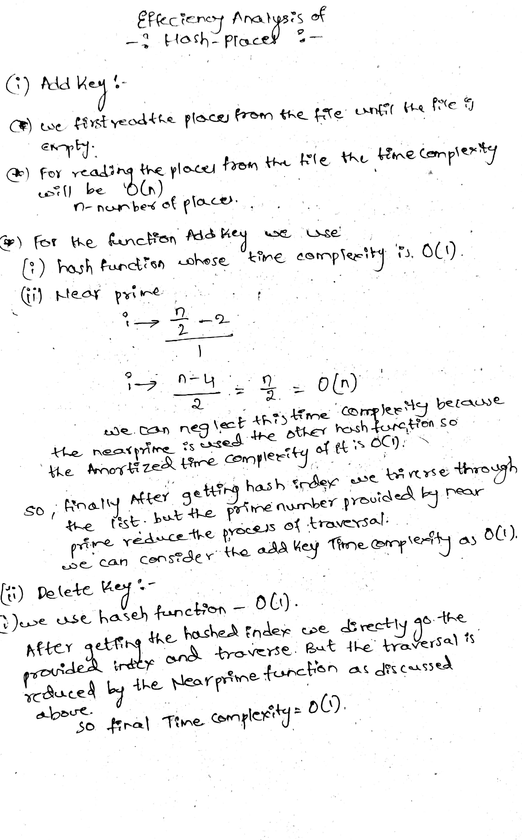 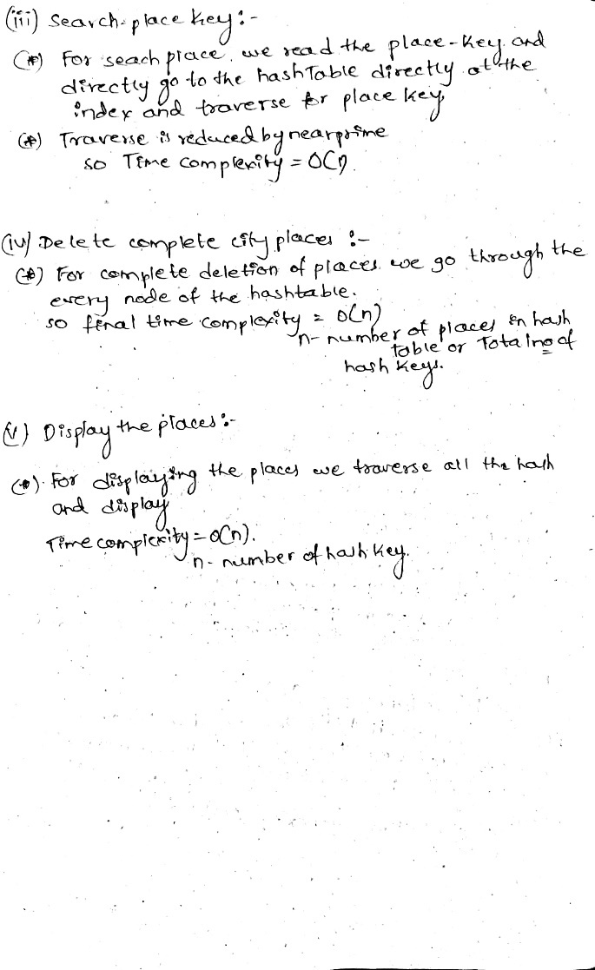

**2.Functional analysis of the hash Hospital function :(Covering the next four functionality)**

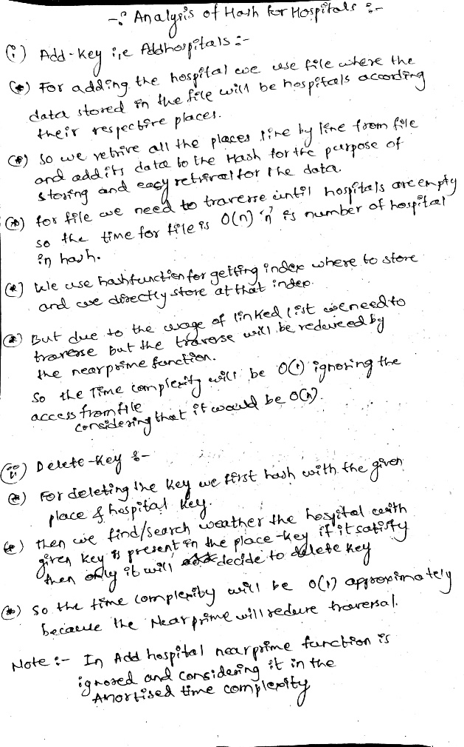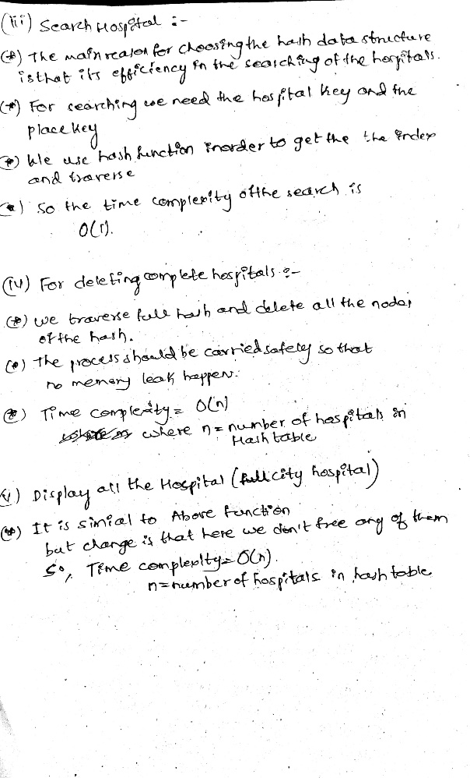

**10. Heap sort:**

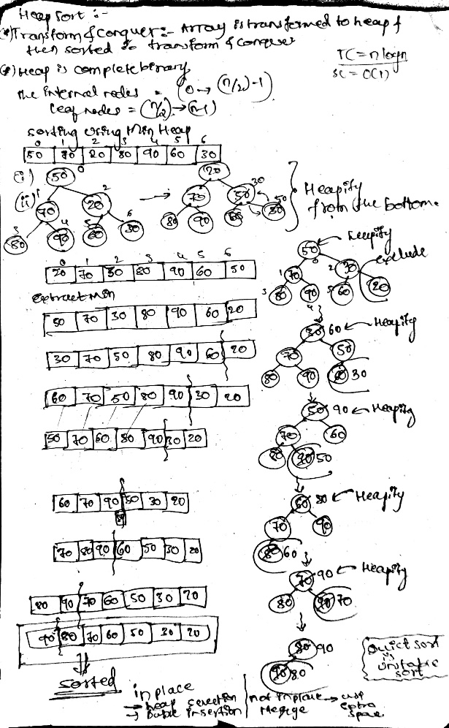 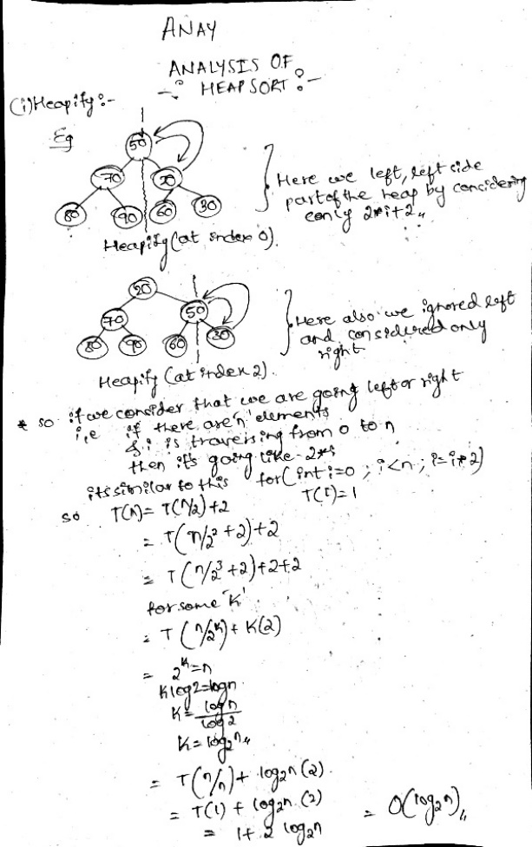

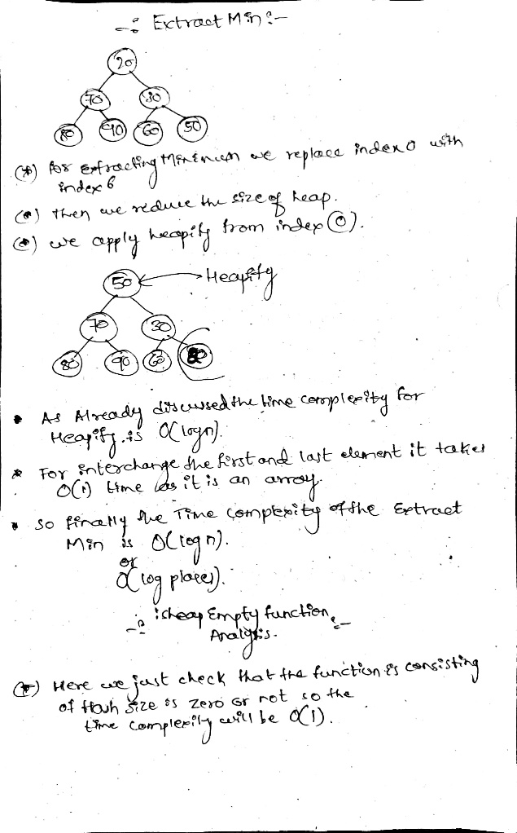 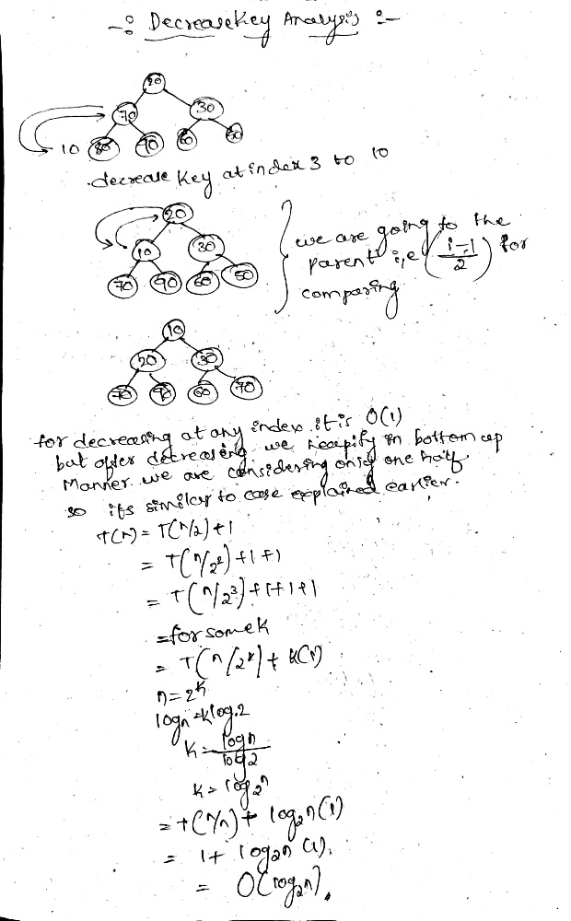

**12. Add appointment:**

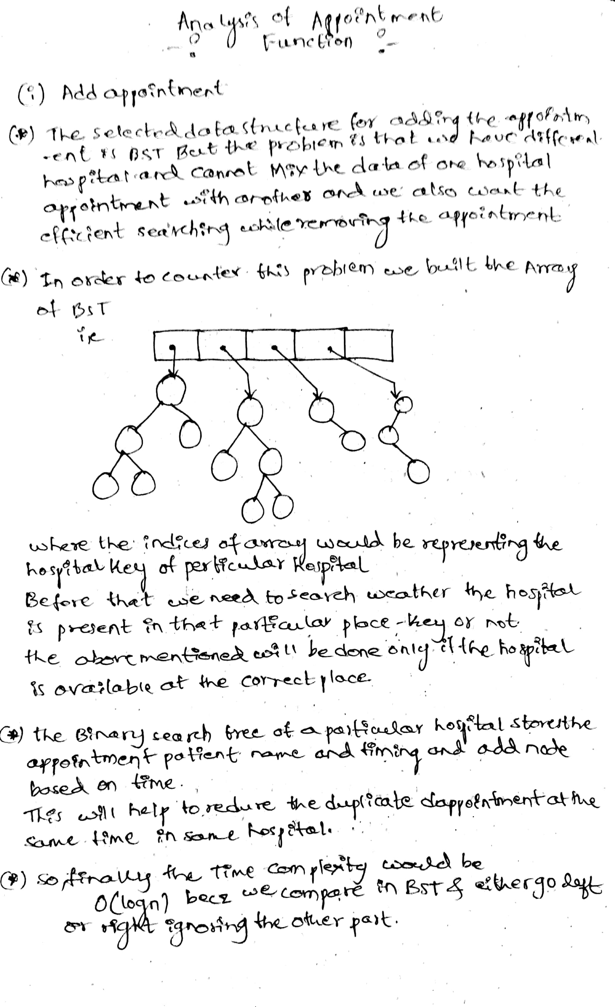

**15. Remove appointment:**

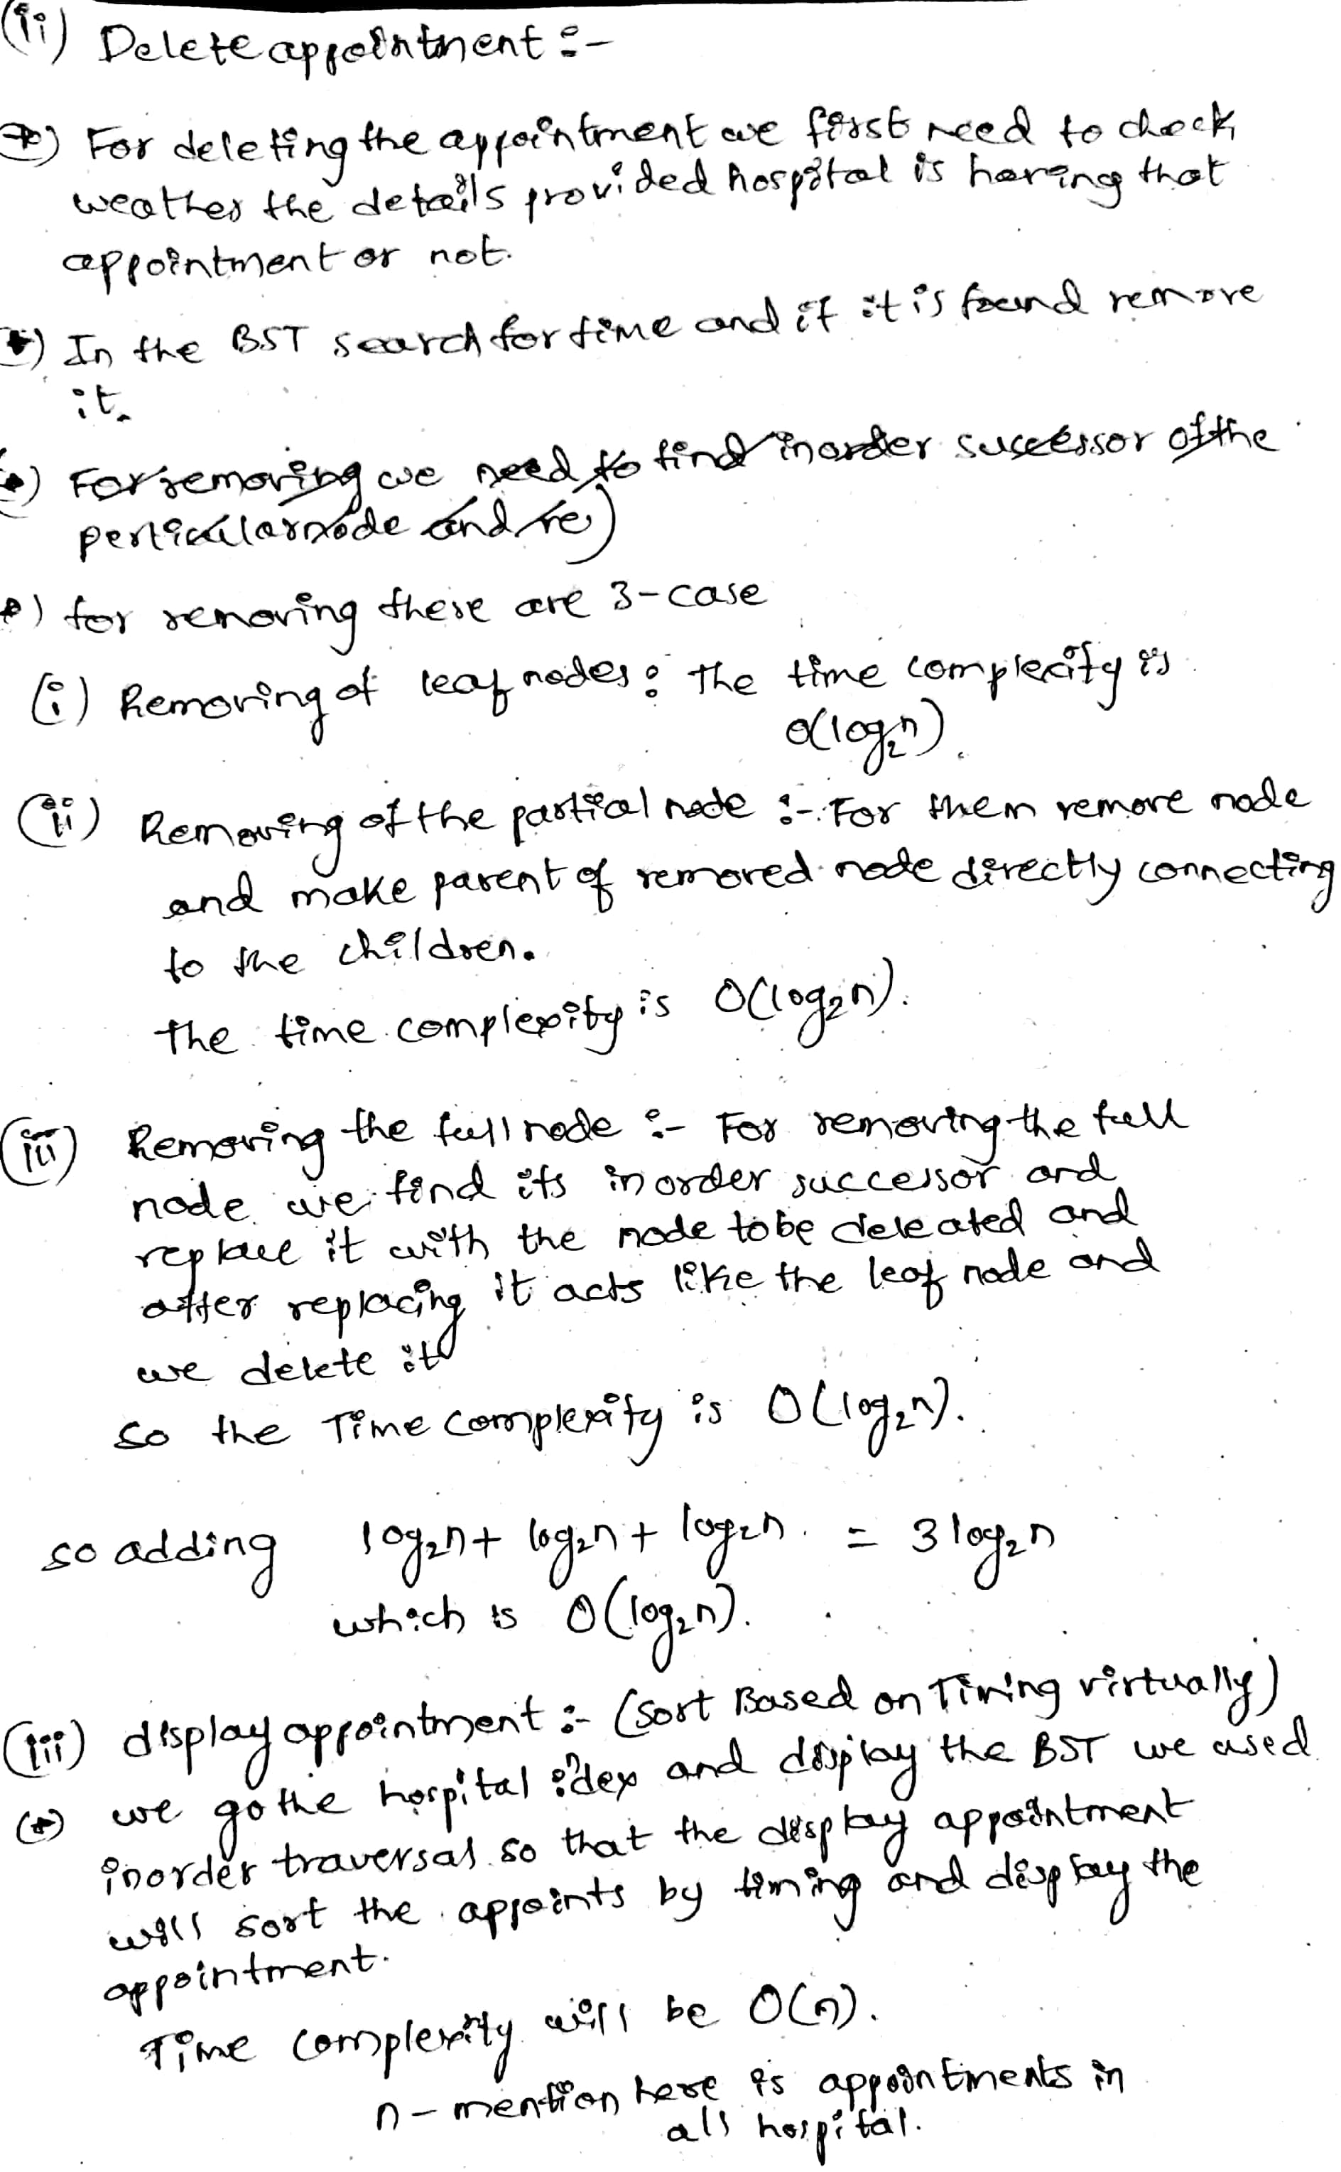

**16. Government hospital/ Private hospital and total beds analysis:**

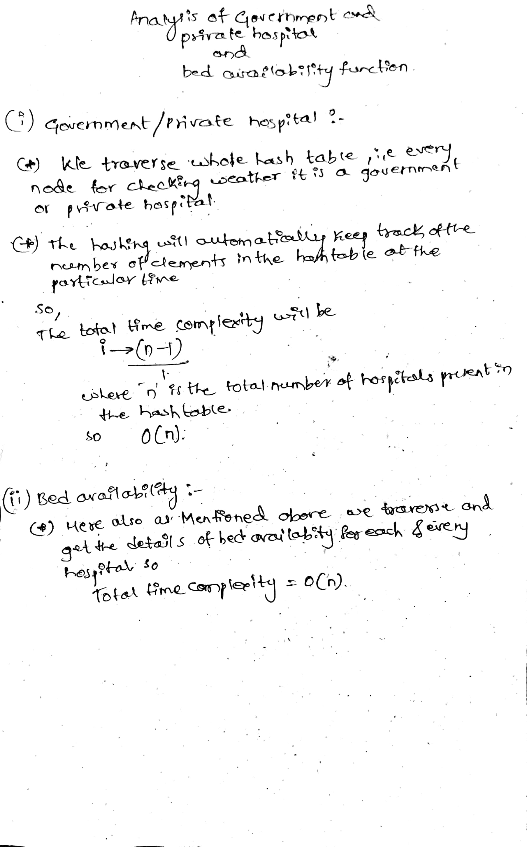

**12. Nearest Hospital:**

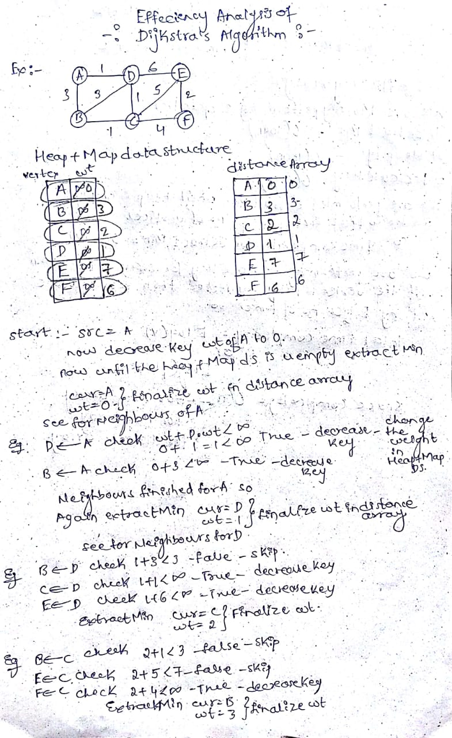 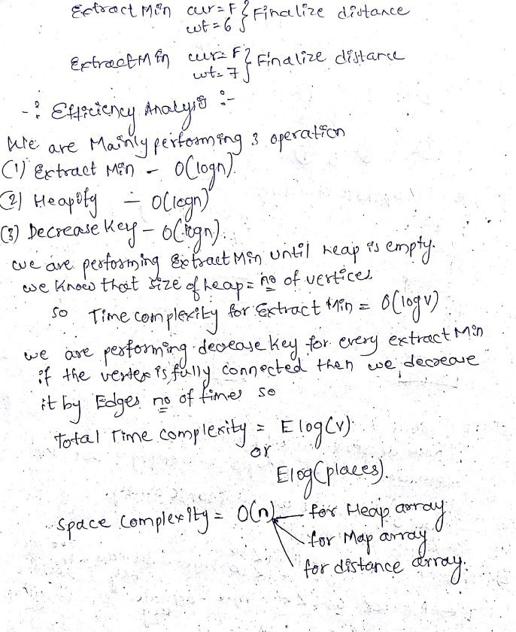

**14. Shortest route connecting all hospital:**

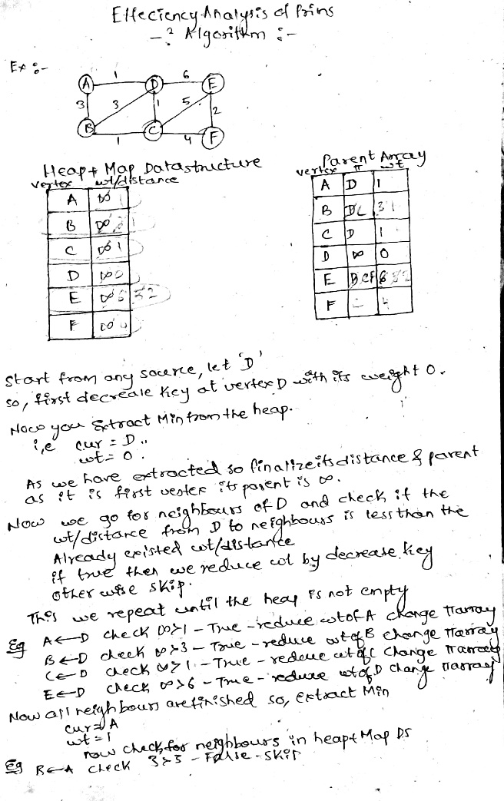 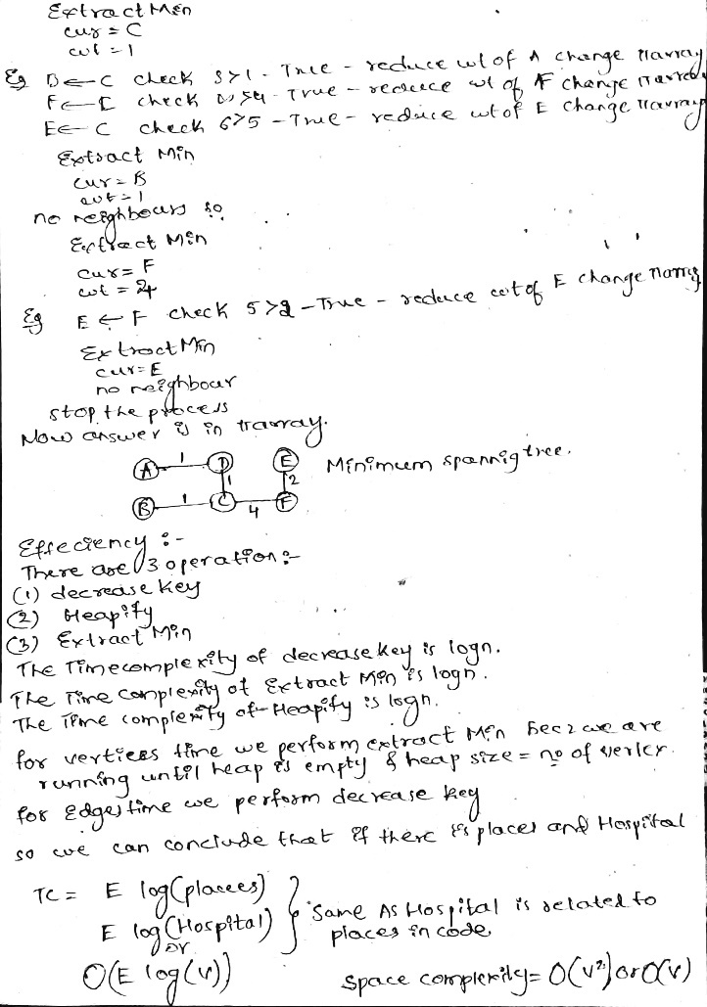

**6. Conclusion**

From the above analysis we can conclude that these data structures and algorithms on the set of data on hospital is efficient. From this we practically came to know how the real-life problems can be solved using the algorithms, natural ways, through coding etc. I learnt how the problem is to be analysed and different views on the single problem statement will helps us to understand the real-world problems. The main learning is that we implemented algorithms what we have learnt and implemented in one or the other way to solve the problems of the society.

**7. References**

[1] Streets pdf, Author Sri. Prakesh Hegde.

[2]  [According to the 2011 census, the literacy rate in India was 74.04%, which means that about 26% of the population (more than 300 million people) were illiterate](https://gulfnews.com/opinion/op-eds/2023-here-are-indias-top-7-challenges-this-year-1.92984950),  [Illiteracy limits the opportunities and potential of individuals and communities, and affects their health, income, and social status](https://bing.com/search?q=active+problems+in+india)

[3] [India is home to 22 of the world’s 30 most polluted cities, according to a 2020 report by IQAir](https://www.theofficepass.com/toppings/real-problems-in-india-that-can-be-solved-by-entrepreneurs.html),  [Water pollution is also a major concern, as more than 70% of India’s surface water resources are contaminated by sewage, industrial waste, and agricultural runoff](https://www.weforum.org/agenda/2014/11/seven-key-priorities-indias-future/)

[4] . [Corruption erodes public trust, undermines democracy, hampers development, and fuels inequality](https://www.adda247.com/school/list-of-major-social-issues-and-problems-in-india/).

[5] [MPI-22_NITI-Aayog20254.pdf](https://www.niti.gov.in/sites/default/files/2024-01/MPI-22_NITI-Aayog20254.pdf).

[6] [[Burning Issue] Women's Safety and India - Civilsdaily](https://www.civilsdaily.com/burning-issue-womens-safety-and-india/).

[7] [31 Causes, Effects & Solutions for Natural Disasters - E&C (environmental-conscience.com)](https://environmental-conscience.com/causes-effects-solutions-for-natural-disasters/).

[8] [Slime Mold Grows Network Just Like Tokyo Rail System | WIRED](https://www.wired.com/2010/01/slime-mold-grows-network-just-like-tokyo-rail-system/), [Ride the Slime Mold Express! | Science | AAAS](https://www.science.org/content/article/ride-slime-mold-express).

[9] [Slime mould attacks simulates Tokyo rail network (nationalgeographic.com)](https://www.nationalgeographic.com/science/article/slime-mould-attacks-simulates-tokyo-rail-network).

[10] [The human costs of COVID-19 policy failures in India | Nature Human Behaviour](https://www.nature.com/articles/s41562-021-01140-6).

[11] [China, India Handled COVID-19 Differently. Results Differed Too : NPR](https://www.npr.org/2020/09/01/908222940/china-india-handled-covid-19-differently-their-results-differed-too).

[12] [China's coronavirus hospital built in 10 days opens its doors, state media says (nbcnews.com)](https://www.nbcnews.com/news/world/china-s-coronavirus-hospital-built-10-days-opens-its-doors-n1128531), [A construction expert broke down how China built an emergency hospital to treat Wuhan coronavirus patients in just 10 days (businessinsider.in)](https://www.businessinsider.in/science/news/a-construction-expert-broke-down-how-china-built-an-emergency-hospital-to-treat-wuhan-coronavirus-patients-in-just-10-days/articleshow/73958777.cms).

[13] [Tourism in India - Wikipedia](https://en.wikipedia.org/wiki/Tourism_in_India#:~:text=Tourism%20in%20India%20is%204.6%25%20of%20the%20country%27s,Most%20Beautiful%20Countries%20In%20The%20World%27%20rankings.%20), [India: contribution of travel and tourism to GDP 2021 | Statista](https://www.statista.com/statistics/1250204/india-contribution-of-travel-and-tourism-to-gdp/).

[14] [India a Key Player in Maldives’ Economic Growth: From Tourism, Hospitality to Infra & Human Resources - News18](https://www.news18.com/india/india-a-key-player-in-maldives-economic-growth-from-tourism-hospitality-to-infra-human-resources-8731333.html), [How Much Maldives Backlash Could Actually Cost The Tourism-Reliant Island Nation - Benzinga](https://in.benzinga.com/content/36528611/how-much-maldives-backlash-could-actually-cost-the-tourism-reliant-island-nation)

**~*~*~*~*~*~*~*~**