Predictive Analysis of Vehicular Emission Pattern: Identifying High-Impact Vehicles and Sustainable Fuel Alternatives

**Abstract.** The detrimental effects of automobile emissions on air quality and public health are becoming more and more obvious as cities throughout the world develop at an accelerated rate. This study examines passenger car emissions critically and highlights the advantages of hybrid cars over fossil fuel-powered ones. Hybrid cars are less prevalent despite having a smaller environmental effect because of their higher pricing and restricted manufacture. A trained Linear Regression Model validates the association between high fuel usage and higher CO2 emissions found in our analysis. These results underline how critical it is to implement laws that promote the purchase and manufacturing of hybrid cars in order to lower vehicle emissions. For stakeholders and legislators working on sustainable transportation solutions, this report provides insightful information.

**Keywords:** Real-time vehicle emissions, environmental pollution, data analysis, mitigation strategies, predictive modeling, sustainable transportation.

1. Introduction

The growth of city populations worldwide has caused a large increase in traffic jams and worsening air pollution. Car emissions, which release harmful pollutants such as carbon monoxide (CO), nitrogen oxides (NO), particulate matter (PM), and volatile organic compounds (VOCs), are a major reason for worsening air quality [2]. These pollutants not only endanger people's health but also contribute to environmental problems such as climate change. In the past, vehicle emissions were mostly checked during inspections or at fixed monitoring stations set up by manufacturers after making their vehicles. However, these methods do not provide a clear picture of how emissions change when cars are actually driven on the road. Owing to new sensor technology (OBFCM), data analysis, and Internet-connected devices (IoT), we can now collect real-time data on vehicle emissions [7][4]. This helps us understand the pollution dynamics on roads much better than before. With this newfound knowledge, we can take proactive steps towards reducing pollution levels and creating cleaner and healthier environments for all.

**1.1 Urbanization has elevated vehicular traffic, prompting critical air contamination from vehicular discharge. The reasons for this are as follows:**

1) *Combustion of Fossil Fuels*: When vehicle burns fossil fuels, it releases pollutants, such as carbon monoxide and nitrogen oxides.

2) *Gridlock*: Unpredictable traffic designs in urban community compound discharges.

3) *Vehicle Age and Upkeep*: Older vehicles produce more pollutants because their emission control systems are no longer up-to-date.

**1.2 The outcomes of vehicular contamination are expansive.**

1) *Effects on respiratory health*: Asthma and bronchitis are more common in humans.

2) *Cardiovascular Sicknesses*: Long-haul openness to contamination increases the risk of coronary failures and hypertension.

3) *Neurological Problems*: Contamination is connected to neurological disorders like Alzheimer's.

4) *Biological system basement*: Contaminations hurt vegetation and water bodies and disturb the environment.

5) *Disrupted wildlife behavior*: Foraging, navigation, and communication patterns are altered by wildlife.

6) *Effects on avian populations:* Changes in migration routes, reproductive issues, and respiratory distress affect birds. For efficient mitigation and long-term urban development, it is essential to understand these effects..

# 2 Literature Review

Both urban air pollution and global greenhouse gas emissions are significantly affected by vehicle emissions. It is necessary to comprehend actual vehicle emissions for effective policies and technologies to reduce these effects. Current research on real-world vehicle emissions is examined in this literature review, which highlights key findings, methods, and literature gaps.

Over the years, research on vehicle emissions has shifted from laboratory tests to real-world measurements. Initially, emissions were measured in labs that did not show a full picture of actual driving situations. However, thanks to portable emission measurement systems (PEMS), we can gather data on real-world emissions. These systems give us a better idea of vehicle emissions in different driving conditions [3][4][6].

**Current Research Status:** Measurements of actual vehicle emissions have been performed using a variety of approaches in recent studies. A Predictive Emission Monitoring System (PEMS) is widely used to measure pollutants such as nitrogen oxides (NOx), particulate matter (PM), carbon monoxide (CO), and carbon dioxide (CO2) while driving. Different methods incorporate remote detection, which distinguishes discharges from passing vehicles, and information investigation from installed indicative frameworks (OBD), which provide bits of knowledge into vehicle execution and outflows [7][2].

**Factors Affecting Emissions:** A Several factors, such as fuel type, driving habits, vehicle maintenance, and environmental conditions, affect actual vehicle emissions. Frequent acceleration and deceleration, together with aggressive driving, can significantly increase the NOx and CO emissions. Pollution emissions from poorly maintained automobiles are often higher than those from well-maintained automobiles. Furthermore, the type of fuel used might affect emissions, and NOx levels from diesel engines are often higher [2][13].

Comparative studies revealed significant discrepancies between laboratory-based emission tests and real-world measurements. For instance, research by T M Indra Mahlia [8] revealed several points.

* *Genuine Drive Emanation (RDE) Regulation*: This page examines the acquaintance of RDE regulation to overcome any issues between lab test discharges and certifiable driving outflows.
* *Portable Emission Measuring Systems (PEMS):* PEMS are used to monitor key pollutants in real time during vehicle operation.
* *Air Quality Impact*: The inclusion of RDE in certification procedures is expected to positively influence global air quality.
* References: This document cites a number of studies and articles on real-world driving emissions and on-road emission factors. The efficacy of emission regulations based solely on laboratory tests has been questioned by these discrepancies.

*Real-world automotive emissions: Monitoring methodologies, and control measures* research paper published by Avinash Kumar Agarwal, NirendraNath Engine Research Laboratory, Department of Mechanical Engineering, Indian Institute of Technology Kanpur, Kanpur, India [7]

The Department of Mechanical Engineering, Rajshahi University of Engineering & Technology, Bangladesh [7] summarized these key points in their paper.

* *Real-world Emissions Monitoring*: The article reviews and compares on-board and laboratory-based methodologies for monitoring vehicular emissions under real-world conditions.
* *Emission Control Technologies:* It latest after-treatment technologies and the role of alternative fuels and advanced engine technologies in reducing greenhouse gas emissions.
* *Transport Planning:* Emphasizes the importance of optimized transport planning for effective traffic management systems.
* *Future Guidelines:* Propose guidelines for the precise monitoring of real-world vehicle emissions to achieve a sustainable road transport system.

*Real world vehicle emissions: Their correlation with driving parameters* research paper published by Sunil Kumar Pathak [9] reveals the following points

* *Emission Simulation:* This study simulated emissions for gasoline light passenger cars using models to estimate the deviation of real-world conditions from WLTP and other cycles.
* *Driving Parameter Correlation:* Different driving parameters were analyzed to correlate the higher emissions observed on the road with laboratory predictions.
* *Real-world vs. WLTC:* Real-world driving patterns, which included lower average speeds and higher frequency of accelerations, resulted in significantly higher emissions than those predicted by the Worldwide Harmonized Light Vehicles Test Procedure (WLTC).
* *Future Work:* This research suggests creating a more realistic driving cycle that represents conditions in Tier-II Indian cities to bridge the gap between real-world driving and the Worldwide Harmonized Light Vehicle Test Procedure (WLTC).

On-road emissions of passenger cars beyond the boundary conditions of the real-driving emissions test Ricardo Suarez-Bertoa [10] provided an explanation of the following points.

* *Real-Driving Emissions Test:* The article examines the presentation of Genuine Driving Outflows (RDE) test methods in the EU to assess discharges from traveler vehicles during on-street activity, explicitly focusing on nitrogen oxides (NOx) and particulate number (PN) emanations.
* *Emission Control Technologies*: It emphasizes the advancements in diesel and gasoline vehicle emission control technologies that have led to more effective emission reductions under real-world driving conditions.
* *Dynamic Driving Conditions:* The study emphasizes the need for additional focus on CO and PN emissions, particularly when driving under dynamic conditions, suggesting that additional work may be required to effectively address these emissions.
* *Technology-Neutral Approach:* The discoveries point towards the significance of an innovation and fuel-impartial way to deal with vehicle emanation norms, guaranteeing that all vehicles follow similar cutoff points for all contaminations.

1. Methodology

**3.0 About Data**

Before the preprocessing of the data there were mainly four different data sets namely Raw data for car and van and Agregated data for car and vans. So we first integrated all the raw and aggregated data for our further analysis. But the challenge is that we should identify the car and van data. So in order to do that we have to add extra column to distinguish between the car and vans.

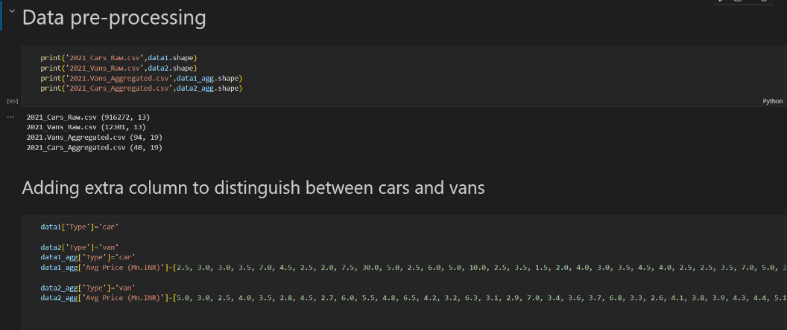

**Fig 0.1.** Data preprocessing.

Once doing this we integrate all the data. So here is the complete aggregated and raw data after integration.

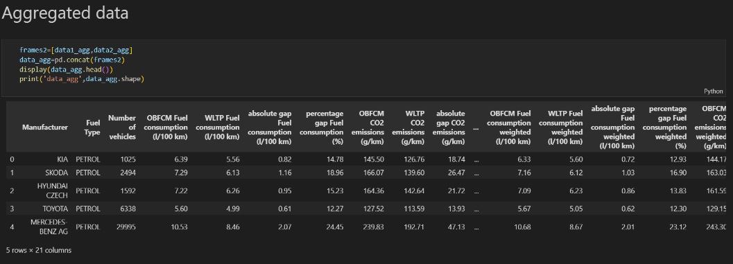

**Fig 0.2**. Aggregated data.

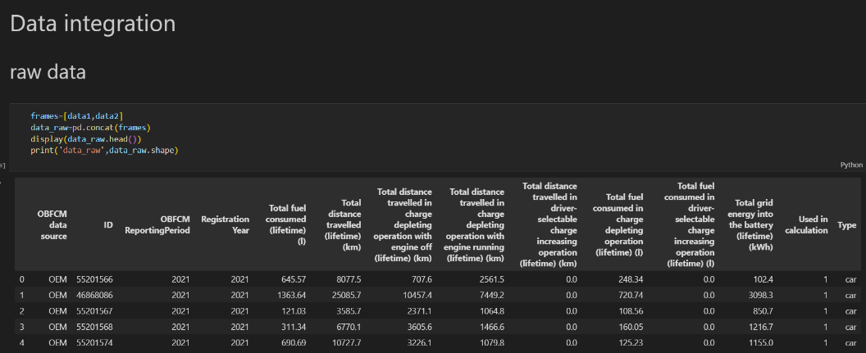

**Fig 0.3.** Data integration.

Four columns from data_raw have null values greater than 50% so instead of imputation and normalization removing the tuples from data is effective. So we have dropped then in order to get correct analysis inference.

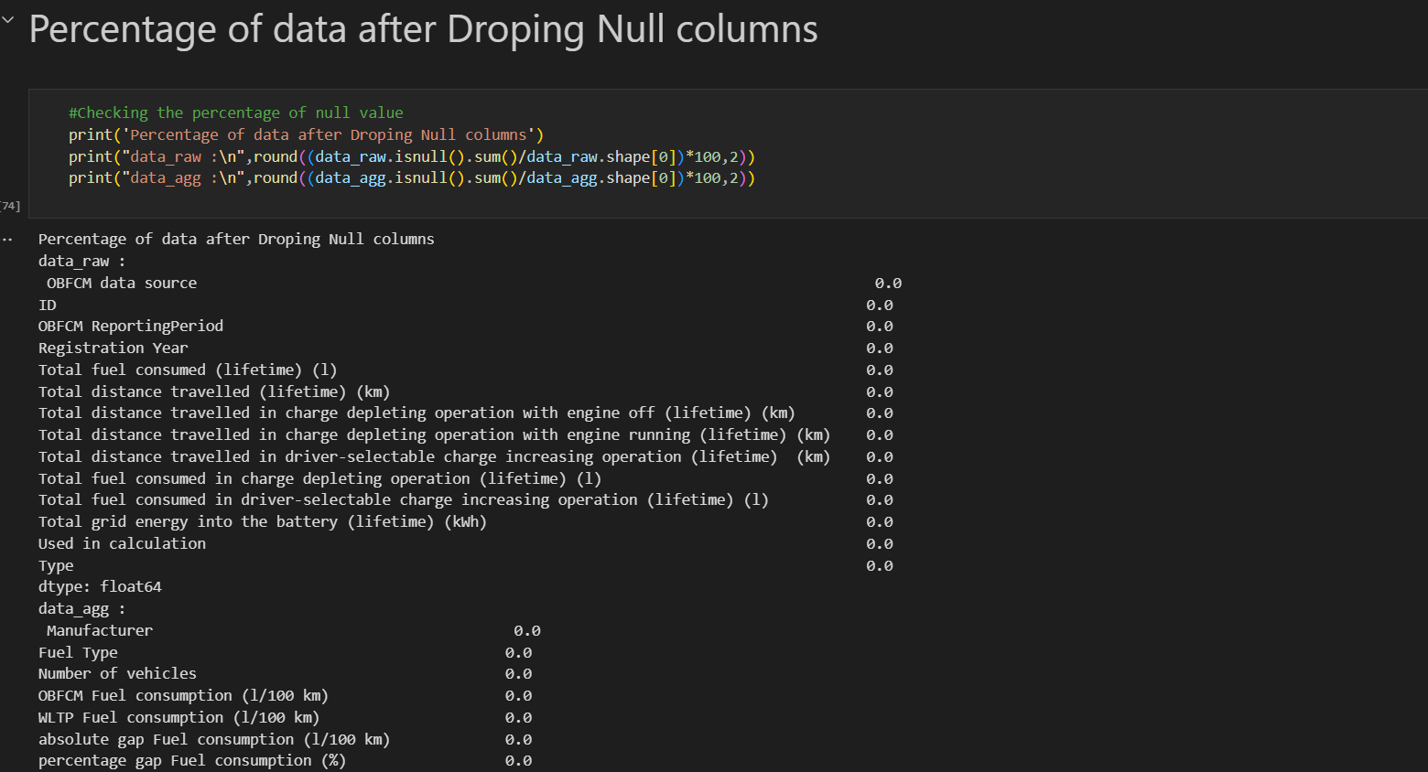

**Fig 0.4.** After dropping null column.

The values like Registration Year,OBFCM ReportingPeriod,Used in calculation are not used for visualisation hence they are droped from data_raw.

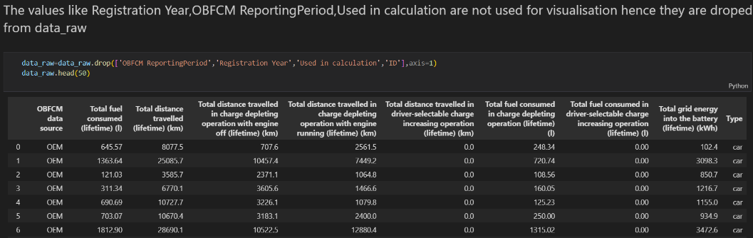

**Fig 0.5.** After dropping redundant attributes.

After doing this finally the data set is ready for the analysis with the following attributes.

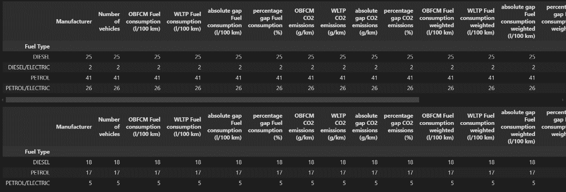

**Fig 0.6.** Final data.

# 3.1 Data Set Description:

The Real-Time Vehicular Emission Dataset is an extensive collection of emission-related data for cars and vans consisting of two distinct datasets. The first dataset, which encompasses raw data for cars and vans, contains 928,573 tuples with 14 attributes and is approximately 55,000 KB in size. This dataset provides comprehensive raw data, including information on fuel consumption, fuel type, vehicle manufacture, CO2 emissions, and other emission-related parameters, serving as a foundational dataset for analyzing the real-time emission characteristics of various vehicles under different conditions.

The second dataset comprised aggregated data for cars and vans, containing 134 tuples with 20 attributes and a file size of 18 KB. This dataset offers aggregated information derived from raw data, including summary statistics and key metrics that encapsulate the overall emission profiles of vehicles. Covering a wider range of parameters provides a holistic view of emission trends, aiding higher-level analysis and reporting.

Some important attributes are as follows.

* *OBFC Monitor:* It stands for "On-Board Fuel Consumption Monitor.” This refers to a system or device installed in vehicles to monitor and display real-time resource consumption/emission rates, typically measured in litres per 100 kilometres (l/100 km).
* *WLTP Measure:* It refers to the resource consumption/emission of a vehicle measured using the Worldwide Harmonized Light Vehicles Test Procedure (WLTP). WLTP is a globally harmonized test cycle for measuring vehicle emissions and fuel consumption, designed to provide more accurate and realistic data compared to previous testing procedures.
* *Absolute gap consumption:* This likely refers to a parameter or measurement related to the difference between the actual fuel consumption of a vehicle and a benchmark or target fuel consumption rate.
* *OBFCM Fuel consumption weighted:* This likely refers to a weighted average of fuel consumption for a group of vehicles or a specific vehicle model.
* *Driver-selectable charge increasing operation:* refers to the value recorded while the driver has chosen to increase the charge of the vehicle’s battery. This typically indicates the value recorded while actively engaging in charging operations manually selected by the driver, such as using regenerative braking, plugging into a charging station, or any other method available to increase the battery charge level. This metric helps gauge the usage of electric or hybrid vehicles in terms of actively replenishing their energy sources over a vehicle's lifetime.
* *In the charge-depleting operation,* this suggests that the vehicle is operating in a mode where it primarily uses the energy stored in its battery (i.e., in electric mode) rather than relying on the internal combustion engine.
* *Total grid energy into the battery (lifetime) (kWh):* The total grid energy transferred into the vehicle's battery over its lifetime, measured in kilowatt-hours.

These datasets are invaluable for analysts focused on studying vehicular emissions, environmental impacts, and fuel efficiency, enabling the development of models for predicting emissions, optimizing fuel consumption, and formulating policies aimed at reducing the environmental footprint of road transportation.

**3.2 DATASET PREROCESSING:**

In this phase of advanced data pre-processing, our aim was to further enhance the predictive power of our model beyond what basic feature engineering was initially provided. Through careful analysis and insights drawn from the Kaggle competition and the research community, we identified the need to handle noisy data and incorporate additional parameters into our dataset. Building on this foundation, we introduced the following set of features:

* ***Vehicle Type:*** distinguishes between cars and vans, which is essential for performing more precise analyses when integrating the raw and aggregated datasets for cars and vans.
* ***Vehicle Price****:* Incorporate the price of each vehicle to allow for a more comprehensive assessment of cost efficiency and economic impact in relation to emissions data. This financial dimension enables a better understanding of the economic implications of various emission levels and fuel consumption rates.
* ***Remove irrelevant attributes:*** Drop-irrelevant attributes, such as the registration year, to streamline the dataset. This will make the dataset more manageable and focus on the attributes that directly influence emission analyses.
* ***Handle Noisy Data:*** Check for duplicate tuples, null values, and the percentage of noisy data in each column and then drop the necessary tuples and attributes. The data were transformed by replacing outliers with mean values to ensure consistency.

**3.3 DATA ANALYSIS:**

With reference to Figure 1. Most cars use environmentally harmful fossil fuels such as petrol and diesel, whereas only 12% of cars are hybrids, which are much more environmentally friendly and help save finite fossil fuels. By contrast, vans have a higher proportion of hybrid vehicles (up to 30 %). Although this is an improvement, the effective regulation of carbon emissions is still insufficient.

**Fig 1.** Distribution of cars and vans categorized by fuel type.

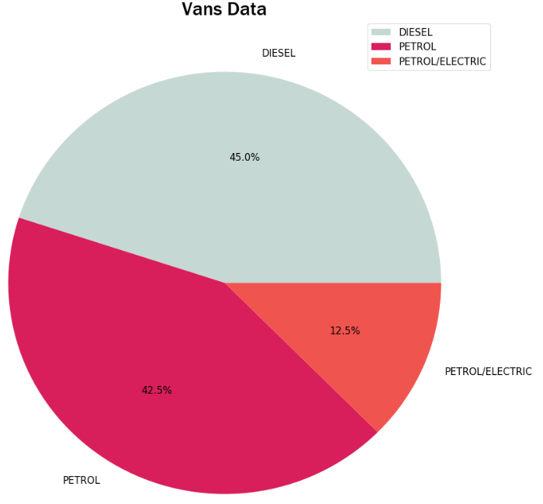

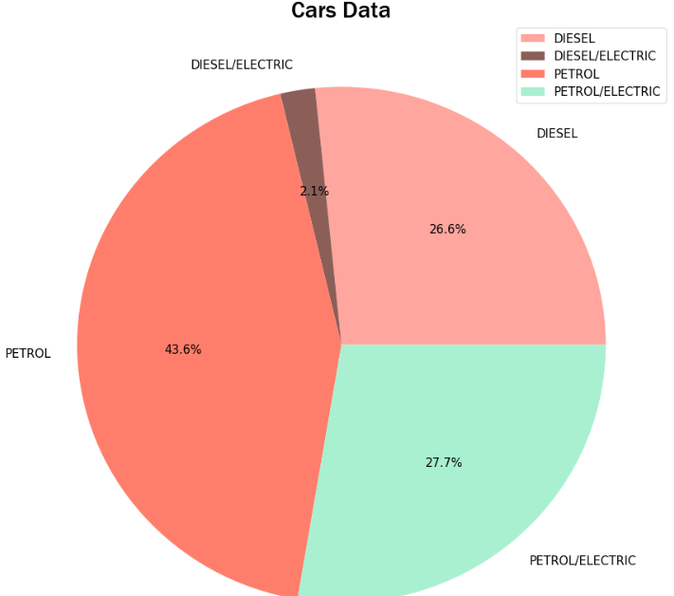

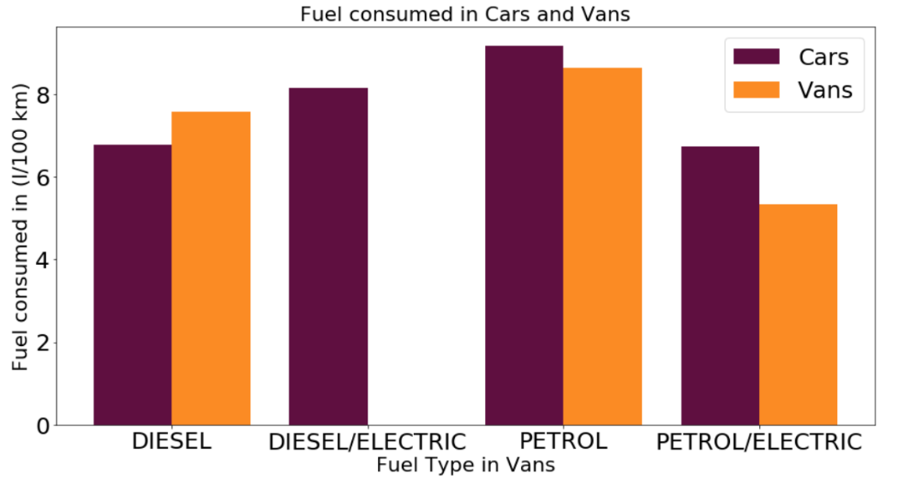

**Fig 2.** Fuel consumed by different types of vehicles to travel a distance of 100 km

Cars fueled by fossil fuels, both petrol and diesel, consume comparatively larger amounts of fuel, whereas hybrid cars exhibit minimal fuel consumption to travel equal distances.

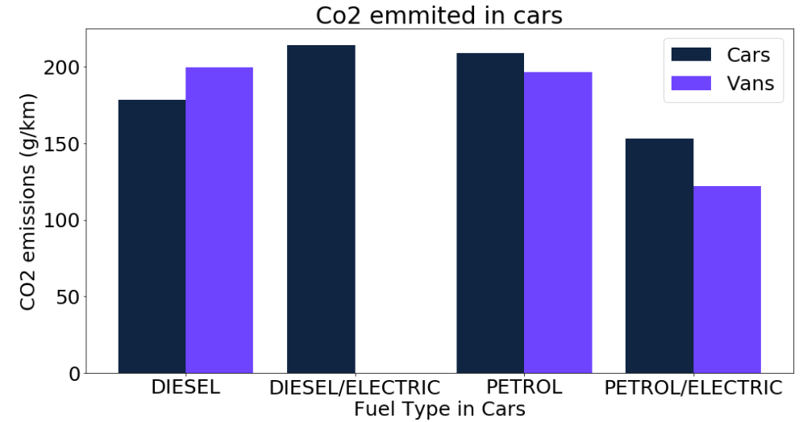

**Fig 3.** Fuel-type vs. CO2 emitted by different vehicles per 100 km.

As shown in the Fig.2.cars fueled by fossil fuels, both petrol and diesel emit comparatively larger amounts of CO2, whereas petrol/electric hybrid cars exhibit minimal CO2 emissions when traveling the same distance.

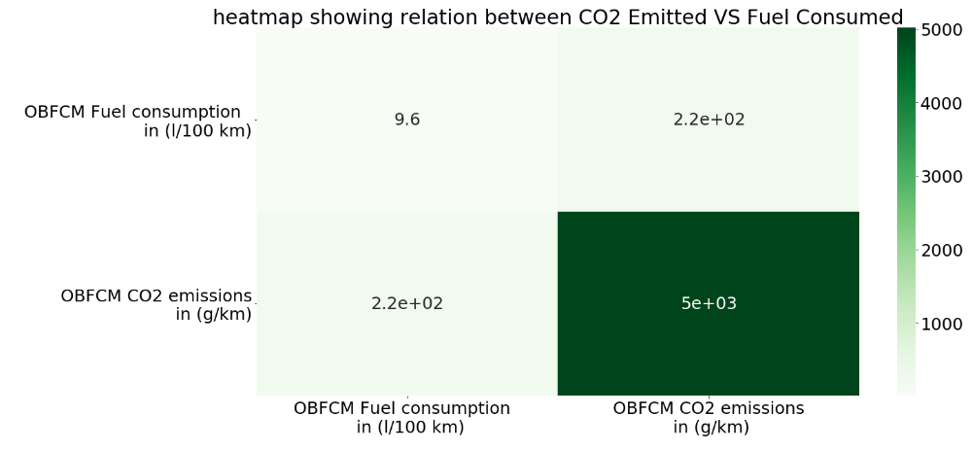

**Fig 4.** Correlation between fuel emissions and CO2 emissions.

It can be observed that both these quantities are positively correlated; that is, as fuel consumption increases, so does the level of CO2 emitted as shown in Fig.4.

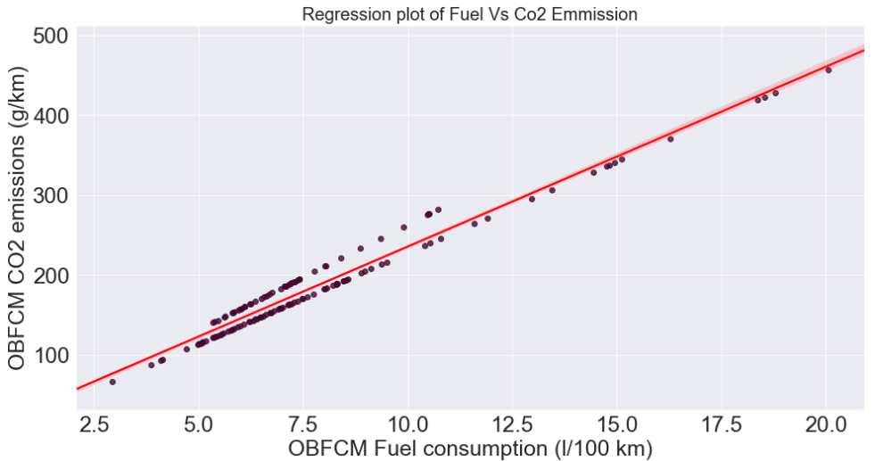

**Fig 5.** Understanding the relationship between Fuel Consumption and CO2 emissions

Based on the analysis of the scatter plot in the Fig.5. there is a clear indication that the relationship between fuel consumption and CO2 follows a linear trend.

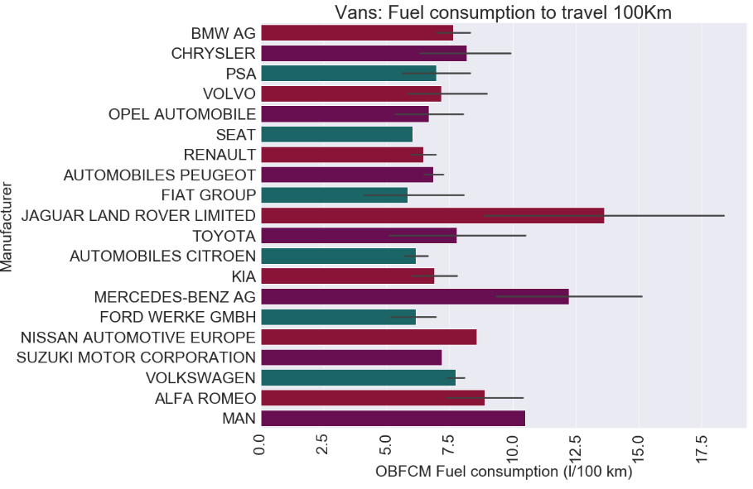

**Fig 6.** The fuel efficiency of vans categorized by the manufacturer and make.

Manufacturers such as Rolls-Royce, Bentley, Ferrari, and Mercedes-Benz have the least fuel-efficient vans because they specialize in producing high-end luxury executive vans that prioritize luxurious features over fuel efficiency. These vehicles often include extravagant and unnecessary amenities, reflecting their emphasis on luxury rather than fuel-saving technology.

By contrast, manufacturers such as CNG Technik, Suzuki, and Toyota prioritize fuel efficiency in their vans.

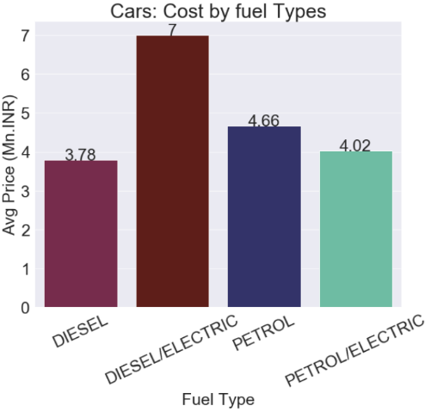

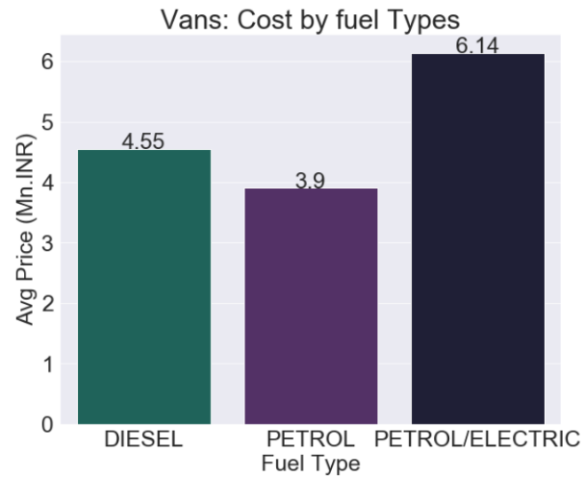

**Fig 7.** Average cost of Vans categorized by fuel type **Fig 7.** Average cost of Vans categorized

by fuel type

Vehicles that operate on traditional fossil fuels are comparatively cheaper compared to the Hybrid Electrical vehicles because of their complex engine design to incorporate different fuel energies.

**3.4 Model Building**

With the completion of our data preprocessing phase, we now possess a clean and structured dataset primed for predictive modeling. Our approach involves utilizing a diverse set of machine-learning models to forecast the desired output. As each new feature is extracted, it is seamlessly integrated into the evolving data frame, thereby enriching our dataset with valuable information.

Our detailed analysis revealed a positive correlation between fuel consumption and CO2 emissions. Further investigation confirmed that this relationship was linear. Consequently, we developed a linear regression model to explore this correlation in-depth. The model was trained using 80% of the data, focusing on fuel consumption and CO2 emissions. The remaining 20% of the data were used to test the model. We then verified the accuracy of the model by comparing the measured and predicted values, confirming its reliability and effectiveness in capturing the linear relationship between fuel consumption and CO2 emissions.

The linear regression equation is,

*y = mx + c + e*

y = CO2_Emitted

x = Fuel_Consumed

e=Standard error

Model for Cars,

*C02_Emmited = 13.89 + (22.05 * Fuel_Consumed)*

Model for Vans*,*

*C02_Emmited = 19.07 + (22.95 * Fuel_Consumed)*

1. Results

Formula to calculate accuracy,

*(Measured value - (Measured value – Calculated value)) /Measured Value*

Measured Value = Value measured by OBFCM device.

Calculated Value = Value Calculated by Model

In terms of Percentage,

*((Measured value - (Measured value – Calculated value)) /Measured Value) * 100*

Formula for error in percentage,

*100 - ((Measured value - (Measured value – Calculated value)) /Measured Value) * 100*

**Table 1.** Fuel consumes measure vs calculated values and accuracy in terms of percentage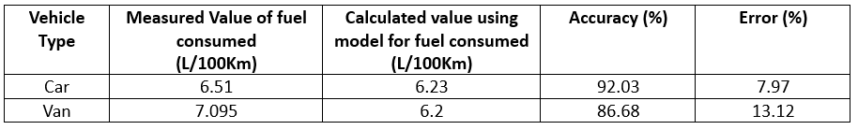

The following Table 1displays the measured and calculated values of fuel consumption for automobiles and large vehicles. For cars, the measured value is 6.51 litters per 100 kilometres, while the modelled value is 6.23 litters per 100 kilometres, with an accuracy of 92.03% and an error of 7.97%. For vans, the measured value is 7.095 litters per 100 kilometres, while the modelled value is 6.2 litters per 100 kilometres, with an accuracy of 86.68% and an error of 13.12%. The model demonstrates a reasonable forecast of fuel consumption for both vehicle types, showing a greater accuracy and lower errors for cars compared to vans.

**Table 2.** For Co2 emitted measure vs calculated values and accuracy in terms of percentage

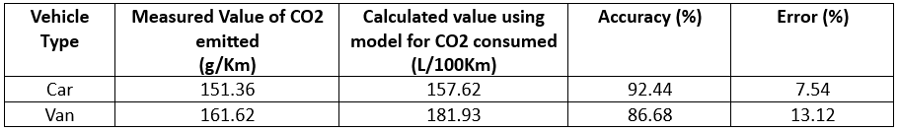

The table provides both the measured and model-calculated values of fuel consumption for cars and vans. For cars, the measured value is 6.51 L/100Km, while the model-calculated value is 6.23 L/100Km, with an accuracy of 92.03% and an error of 7.97%. For vans, the measured value is 7.095 L/100Km, while the model-calculated value is 6.2 L/100Km, with an accuracy of 86.68% and an error of 13.12%. The model demonstrates its ability to accurately predict fuel consumption for both vehicle types, with significantly greater accuracy and lower error rates for cars than for vans.

**5 Conclusion**

In our extensive examination of passenger vehicles' emissions, it is clear that although hybrid vehicles are considerably more eco-friendly, they are not as widely used as conventional vehicles that run on finite fossil fuels. The discrepancy in popularity can be attributed to several factors. There is a clear correlation between fuel consumption and CO2 emissions, where fuel consumption increases, CO2 emissions rise correspondingly. This relationship was confirmed using a Linear Regression Model. Hybrid vehicles are typically more expensive than traditional ones. Additionally, there are fewer companies involved in producing hybrid vehicles since their production rate is substantially higher than that of conventional vehicles.

1. Suggestions

To tackle the environmental challenges and encourage the use of eco-friendly vehicles, there are several crucial steps that must be taken.

First, it is essential to implement strict government regulations on emissions and fuel efficiency, such as the BS6 norms. These policies ensure that vehicles meet lower emission standards, significantly reducing their environmental impact.

Second, manufacturers must be encouraged to innovate and produce environmentally friendly vehicles. By setting ambitious targets for reducing vehicular emissions, the transition towards hybrid and electric vehicles can be accelerated. This shift not only promotes cleaner transportation but also supports India's goal of achieving a net carbon zero status by 2070. Together, these measures pave the way for a sustainable future in the automotive industry. While hybrid vehicles have a smaller number of manufacturers compared to petrol/diesel vehicles, they are still more expensive, with prices ranging from 40-50% higher.

1. References
2. [Kriti Sahroha](https://ieeexplore.ieee.org/author/37089324762) and [Smily Chaudhary](https://ieeexplore.ieee.org/author/37089322741)’s “Real-Time Vehicle Emissions Monitoring Using IoT Sensors.” Available: [Vehicular Pollution Monitoring System using IoT: A Review | IEEE Conference Publication | IEEE Xplore](https://ieeexplore.ieee.org/document/9725694) on (December 2021)
3. “Data Analytics Techniques for Environmental Pollution Analysis.” Written by Paawan Sharma, Anurag Kandya, and Vipin Shukla Available: [Data Analytics Strategies for Assessing Pollution Spread Using Sensor Data (ieee.org)](https://smartcities.ieee.org/newsletter/october-2022/data-analytics-strategies-for-assessing-pollution-spread-using-sensor-data#:~:text=IoT%20enables%20data%20capture%20with%20geo-tagging%20in%20order,in%20policy%20formulation%20to%20check%20pollution%20spread%20further.) (October 2022)
4. “Predictive Modeling for Air Quality Forecasting.” Written by Yong Li, Lixia Wen & Xiaochao Deng Available: [Air quality prediction models based on meteorological factors and real-time data of industrial waste gas | Scientific Reports (nature.com)](https://www.nature.com/articles/s41598-022-13579-2). (Published: 03 June 2022)
5. T. Lakshmi Narayana,  C. Venkatesh, Adarsh Kumar’s “Advances in Sensor Technology for Real-Time Emissions Monitoring.” Available: [Advances in real time smart monitoring of environmental parameters using IoT and sensors - ScienceDirect](https://www.sciencedirect.com/science/article/pii/S2405844024042269) (15 April 2024)
6. P. Gireesh Kumar, P. Lekhana, M. Tejaswi’s “Impact of Vehicle Emissions on Urban Air Quality: A Review.” Available: [Effects of vehicular emissions on the urban environment- a state of the art - ScienceDirect](https://www.sciencedirect.com/science/article/abs/pii/S2214785320383620) (2021)
7. K. Kumar & B. P. Pande’s “Machine Learning Approaches for Predictive Modeling of Air Pollution.” Available: [Air pollution prediction with machine learning: a case study of Indian cities | International Journal of Environmental Science and Technology (springer.com)](https://link.springer.com/article/10.1007/s13762-022-04241-5) (2022)
8. Avinash Kumar Agarwal and Nirendra Nath Mustafis’s “Real-world automotive emissions: Monitoring methodologies, and control measures” Available: [Real-world automotive emissions: Monitoring methodologies, and control measures - ScienceDirect](https://www.sciencedirect.com/science/article/abs/pii/S1364032120309084) (March 2021)
9. [S M Ashrafur Rahman](https://www.researchgate.net/profile/S-M-Ashrafur-Rahman?_tp=eyJjb250ZXh0Ijp7ImZpcnN0UGFnZSI6InB1YmxpY2F0aW9uIiwicGFnZSI6InB1YmxpY2F0aW9uIn19), [I. M. Rizwanul Fattah](https://www.researchgate.net/profile/I-M-Rizwanul-Fattah-2?_tp=eyJjb250ZXh0Ijp7ImZpcnN0UGFnZSI6InB1YmxpY2F0aW9uIiwicGFnZSI6InB1YmxpY2F0aW9uIn19), [T M Indra Mahlia](https://www.researchgate.net/profile/T-M-Indra-Mahlia?_tp=eyJjb250ZXh0Ijp7ImZpcnN0UGFnZSI6InB1YmxpY2F0aW9uIiwicGFnZSI6InB1YmxpY2F0aW9uIn19) and [Fajle Rabbi Ashik](https://www.researchgate.net/profile/Fajle-Ashik?_tp=eyJjb250ZXh0Ijp7ImZpcnN0UGFnZSI6InB1YmxpY2F0aW9uIiwicGFnZSI6InB1YmxpY2F0aW9uIn19)’s “The rise of real drive emission to mitigate difference of lab tests and on-road emission” Available: [(PDF) The rise of real drive emission to mitigate difference of lab tests and on-road emission (researchgate.net)](https://www.researchgate.net/publication/345766742_The_rise_of_real_drive_emission_to_mitigate_difference_of_lab_tests_and_on-road_emission) (November 2020)
10. Sunil Kumar Pathak, Vineet Sood, Yograj Singh and S.A. Channiwala’s “Real world vehicle emissions: Their correlation with driving parameters” Available: [Real world vehicle emissions: Their correlation with driving parameters - ScienceDirect](https://www.sciencedirect.com/science/article/abs/pii/S1361920916000122) (May 2016)
11. Ricardo Suarez-Bertoa, Victor Valverde, Michael Clairotte, Jelica Pavlovic, Barouch Giechaskiel, Vicente Franco’s “On-road emissions of passenger cars beyond the boundary conditions of the real-driving emissions test” Available: [On-road emissions of passenger cars beyond the boundary conditions of the real-driving emissions test - ScienceDirect](https://www.sciencedirect.com/science/article/pii/S001393511930369X) (September 2019)
12. Zuoming Zhang, Hongyang Su, Wenbin Yao, Fujian Wang, Simon Hu, Sheng Jin’s “Uncovering the CO2 emissions of vehicles: A well-to-wheel approach” [Uncovering the CO2 emissions of vehicles: A well-to-wheel approach - ScienceDirect](https://www.sciencedirect.com/science/article/pii/S2667325823001930) (July 2023)
13. Yi Zhang, Ran Zhou, Shitao Peng’s “Development of Vehicle Emission Model Based on Real-Road Test” [Atmosphere | Free Full-Text | Development of Vehicle Emission Model Based on Real-Road Test and Driving Conditions in Tianjin, China (mdpi.com)](https://www.mdpi.com/2073-4433/13/4/595) (7 April 2022)
14. Hung-Ta Wen Jau-Huai Lu and Deng-Siang Jhang’s “ Features Importance Analysis of Diesel Vehicles’ NOx and CO2 Emission Predictions in Real Road Driving Based on Gradient Boosting Regression Model” [IJERPH | Free Full-Text | Features Importance Analysis of Diesel Vehicles&rsquo; NOx and CO2 Emission Predictions in Real Road Driving Based on Gradient Boosting Regression Model (mdpi.com)](https://www.mdpi.com/1660-4601/18/24/13044) (10 December 2021)