AI ASSISTANT CODING
ASSIGNMENT-6
V. Sathvika
2303A52434
Batch-38

Lab 6: AI-Based Code Completion – Classes, Loops, and Conditionals
Lab Objectives:
• To explore AI-powered auto-completion features for core
Python constructs.
• To analyze how AI suggests logic for class definitions, loops,
and conditionals.
• To evaluate the completeness and correctness of code generated
by AI assistants.

Lab Outcomes (LOs):
After completing this lab, students will be able to:
• Use AI tools to generate and complete class definitions and
methods.
• Understand and assess AI-suggested loops for iterative tasks.
• Generate conditional statements through prompt-driven
suggestions.
• Critically evaluate AI-assisted code for correctness and clarity.

Task Description-1 (Classes – Data Validation)
• Prompt AI to generate a Student class with attributes: name,
roll_no, and marks. Add a method is_pass() that returns whether
the student has passed (marks ≥ 40).
Expected Output-1
• Python class with constructor and validation logic
• Clear method implementation returning pass/fail status
• Students analyze correctness and clarity of class design

Prompt:
generate a Student class with attributes: name, roll_no, and marks. Add a method is_pass() that returns whether the student has passed (marks ≥ 40). the exepected output Clear method implementation returning pass/fail status , Students analyze correctness and clarity of class design the input should be from user side

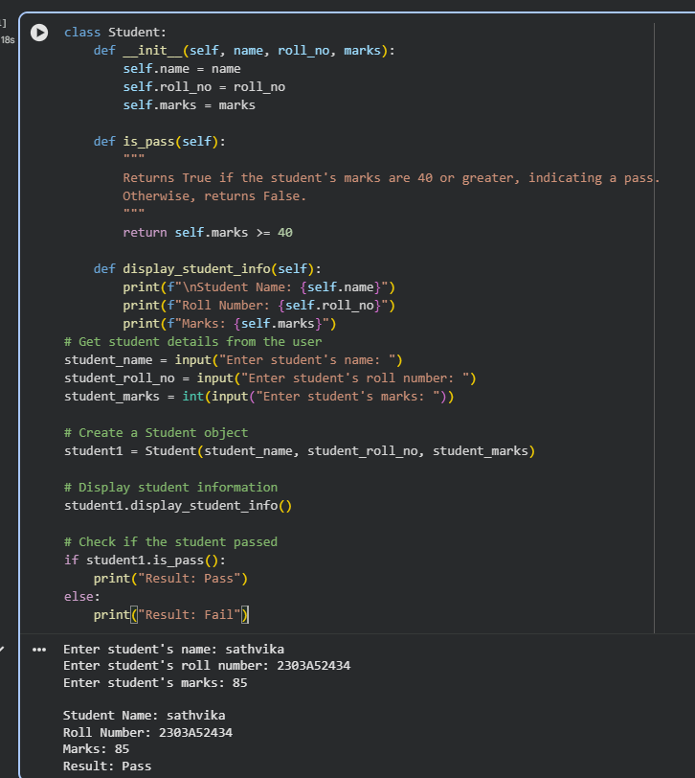

Explanation:
The program creates a Student class to store a student’s name, roll number, and marks. It takes input from the user, checks if the marks are 40 or above using the is_pass() method, and then displays the student details along with the pass or fail result.

Task Description-2 (Loops – Pattern Generation)
• Ask AI to generate a function that prints a right-angled triangle
star pattern using a for loop. Then regenerate the same pattern
using a while loop.
Expected Output-2
• Correct pattern output using both loop types
• Logical loop structure with proper conditions

Prompt:
generate a function that prints a right-angled triangle star pattern using a for loop. Then regenerate the same pattern using a while loop. the input should be user based

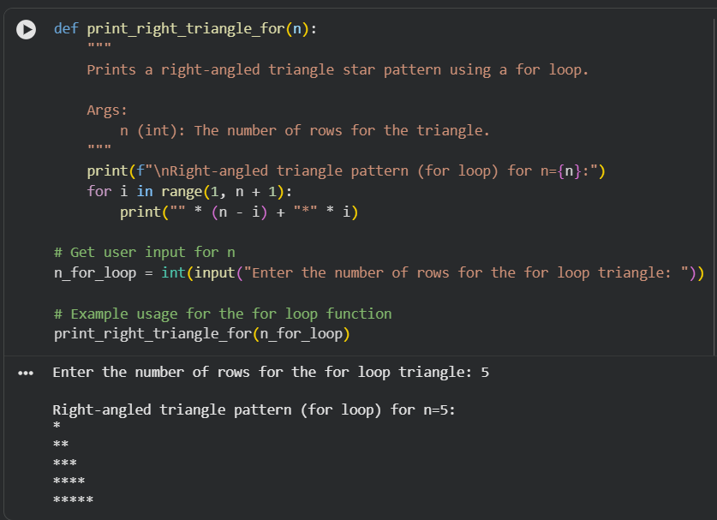

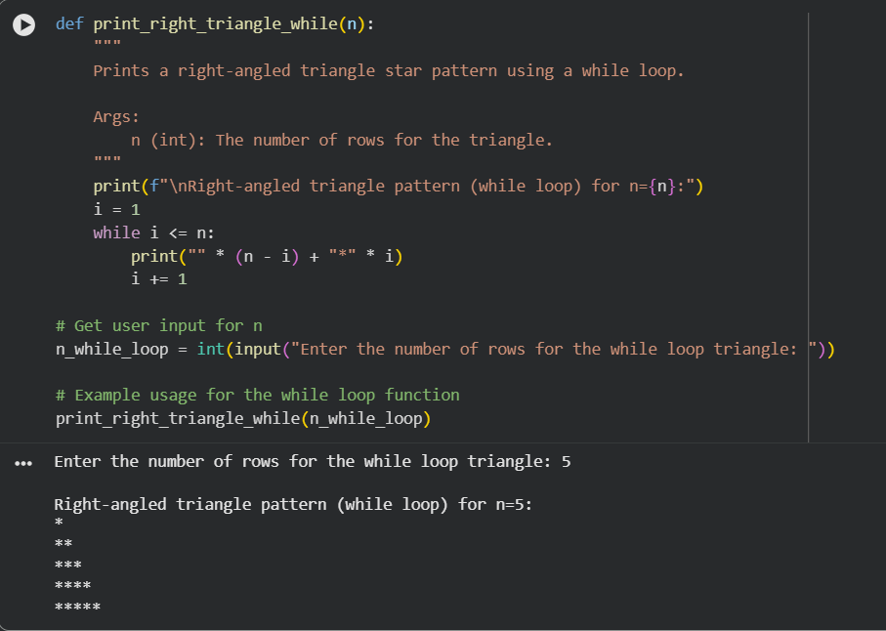
Explanation:
This program defines two separate functions to print a right-angled triangle star pattern: one using a for loop and the other using a while loop. In both cases, the number of rows is taken as input from the user, ensuring user-based input handling. Each loop increases the number of stars per row logically to form the triangle shape. The output confirms that the same correct pattern is generated using both loop structures.

Task Description-3 (Conditional Statements – Number Analysis)
• Ask AI to write a function that checks whether a given number
is positive, negative, or zero using if-elif-else. Test the function
with multiple inputs.
Expected Output-3
• Function correctly classifies numbers
• Proper handling of all conditions
• Students analyze decision logic

Prompt:
generate a code using a function checks whether a given number is positive, negative, or zero using if-elif-else. Test the function with multiple inputs, the inputs should be from user side
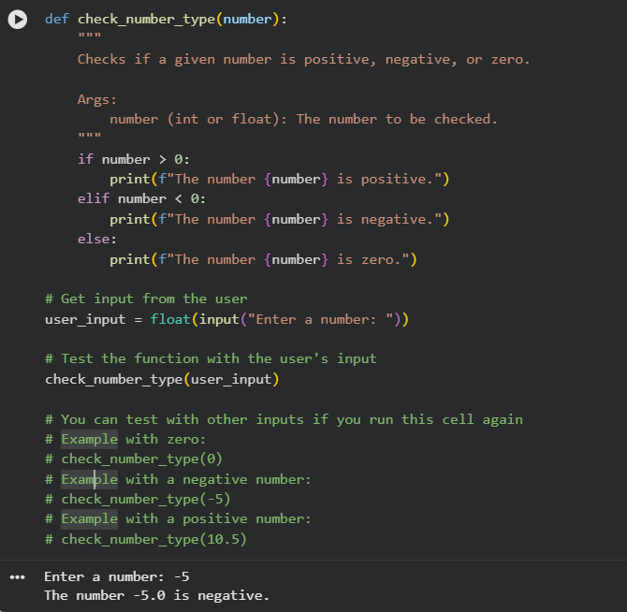
Explanation:
This program defines a function that uses if–elif–else conditions to check whether a given number is positive, negative, or zero. The number is taken as input from the user, making the program interactive. Based on the value entered, the function prints the appropriate result.

Task Description-4 (Nested Conditionals)
• Generate a function check_discount(age, is_member) that
determines discount eligibility:
• Age ≥ 60 → Senior discount
• Member → Additional discount
Use nested if statements.
Expected Output-4
• Python code using nested conditionals
• Clear explanation of decision flow
Prompt:
Generate a function check_discount(age, is_member) that determines discount eligibility: Age ≥ 60 : Senior discount , Member : Additional discount, Use nested if statements.the input should be from user sidw
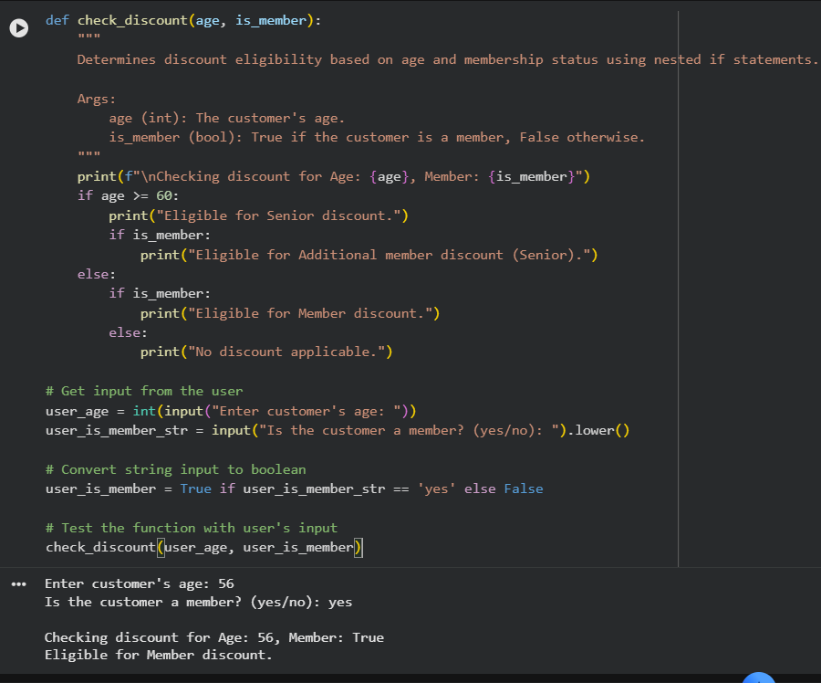
Explanation:
This program defines a check_discount function that uses nested if statements to determine discount eligibility based on the customer’s age and membership status. The user provides their age and whether they are a member as input. If the age is 60 or above, the customer receives a senior discount, and members may get an additional discount. The function clearly displays the applicable discount based on these conditions.

Task Description-5 (Class – Mathematical Opera)
• Ask AI to create a Circle class with methods to calculate area ()
and circumference () given the radius.
Expected Output-5
• Correct mathematical computation
• Well-structured class with methods
• Code explanation provided

Prompt:
create a Circle class with methods to calculate area () and circumference () given the radius. include the code explanation, the input should be user based

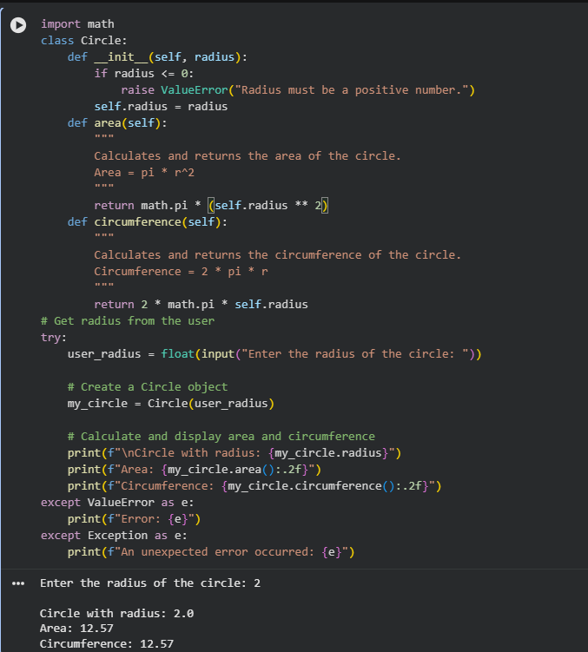

Explanation:
This program defines a Circle class that takes the radius as input from the user and validates that it is a positive value. It includes methods to calculate the area and circumference using standard mathematical formulas. A Circle object is created with the user-entered radius, and the results are displayed. Error handling is used to manage invalid inputs gracefully.

