Course Project Report · Open-Source Technologies
CampusBoard: Role-Based Collaborative Workspace for Academic Projects
An Open-Source Kanban Project Tracker for Students and Faculty, Built with Node.js, Express and MongoDB
Veer Shah Jemil Patel
Roll No.: 24BCE157 Roll No.: 24BCE158
Submitted to – Ajay Patel
Course – Open-Source Technologies
Abstract—CampusBoard is an open-source, full-stack web application that brings the whole university project lifecycle into one workspace. Instead of tracking work across WhatsApp, GitHub, Google Drive, spreadsheets and e-mail, students and faculty share a private Kanban board per project. Accounts are created only by faculty, campus e-mail domains decide each user’s role, and every task passes through a mandatory Under Review stage where faculty award a grade (0–100) and written feedback. The system uses a three-tier architecture—HTML/JavaScript client, Node.js + Express REST API secured with JWT, and MongoDB—and exposes fourteen endpoints over three collections, with task comments stored as embedded sub-documents. It is released under the MIT licence.

I. Introduction
A typical student project today is spread across five tools: chat groups for discussion, GitHub for code, Google Drive for reports, spreadsheets for task tracking and e-mail for faculty review. Faculty cannot see who did what, feedback is lost in long threads, and grades end up in a separate sheet. CampusBoard replaces this fragmentation with a single, closed workspace that both students and their project guide use from the first week of the semester to the final grade.
Objectives
- No public sign-up — only faculty create student and faculty accounts.
- Roles tied to campus e-mail domains: @faculty.campusboard.edu and @student.campusboard.edu.
- Projects visible only to the faculty owner and the enrolled students.
- A four-stage board (To Do → In Progress → Under Review → Completed) where only faculty can mark work Completed.
- Repository and document links, plus a comment thread, attached to every task.
- Faculty grading (0–100 with feedback) and a grading analytics dashboard.
- Fully open-source stack and code, so other departments can self-host and contribute.

II. Technology Stack
Table I. Open-source technologies used in each tier
Tier | Technologies | Licence
Frontend | HTML5, JavaScript (Fetch API), Tailwind CSS, Chart.js, Bootstrap Icons, HTML5 Drag-and-Drop | MIT
Backend | Node.js, Express 5, JSON Web Token (jsonwebtoken), bcryptjs, dotenv | MIT / BSD-2
Database | MongoDB Community Server with Mongoose ODM | SSPL / MIT
Project | CampusBoard source, CONTRIBUTING guide and Code of Conduct | MIT

The interface uses a single brand palette (navy #0d173b, sky #4ab7e0, teal #2d6668, leaf #84ac64, sand #c2c19f and sun #e2d64b) and the Century Gothic typeface, defined once as CSS design tokens and mapped onto Tailwind’s colour scales so every page stays consistent.

III. System Architecture
CampusBoard follows a three-tier architecture (Fig. 1). The browser talks to the Express server only through JSON requests. Every protected request carries a JWT, is checked by the authenticate middleware, optionally by authorizeRoles for faculty-only actions, and—on every task route—by canAccessWorkspace, which confirms that the caller is the project owner, an enrolled student or faculty. Requests then reach one of three routers that read and write MongoDB.
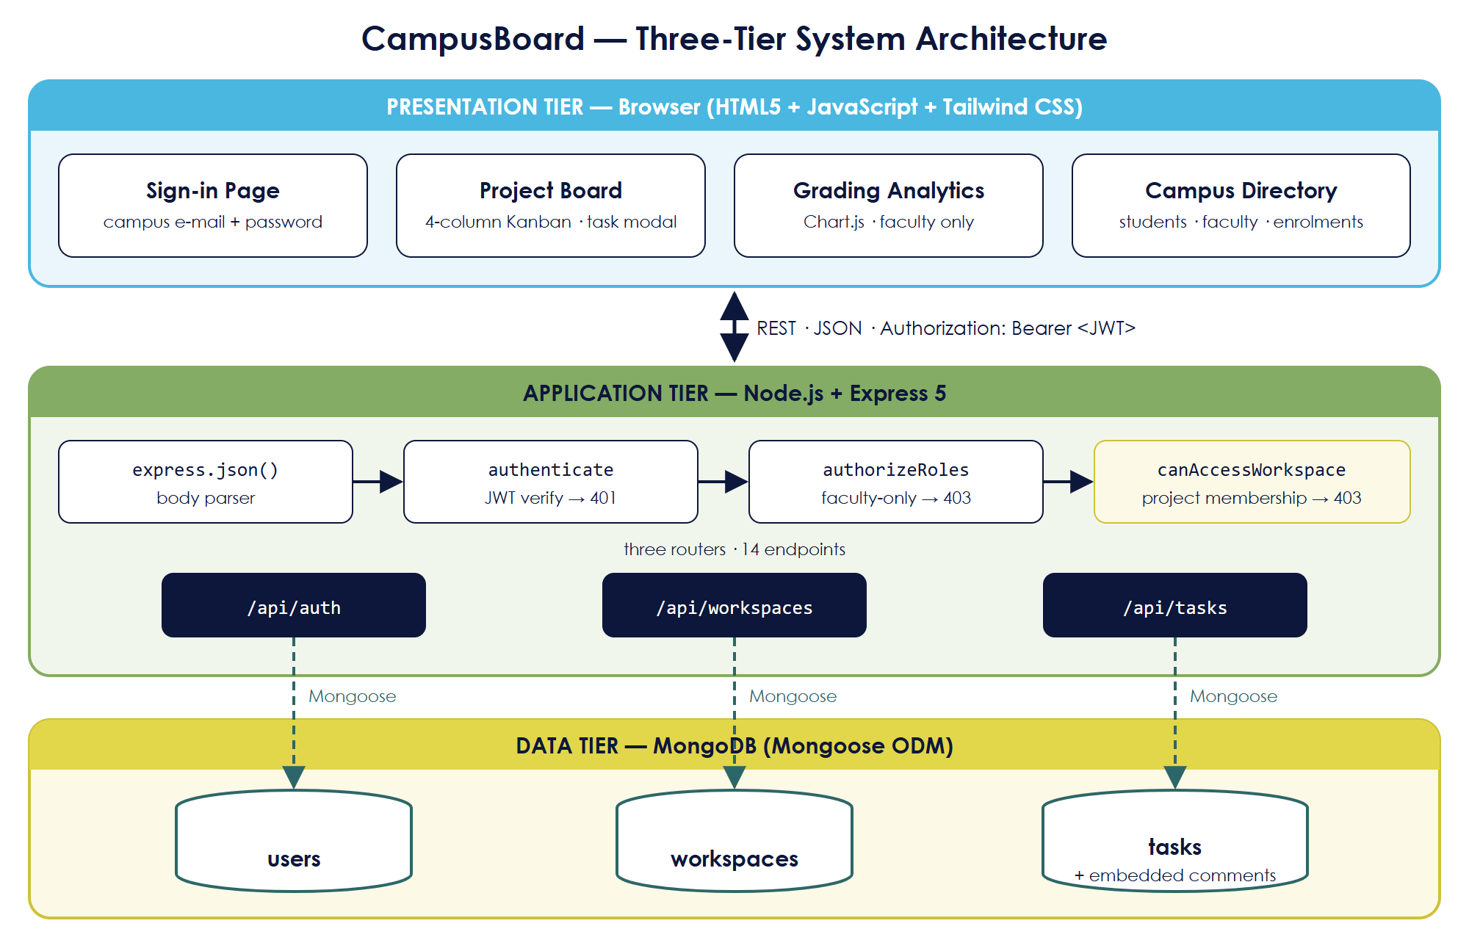
Fig. 1. Three-tier architecture of CampusBoard.

A. Request Flow
Fig. 2 shows how a request is processed: the user signs in and receives a token; later requests pass through authenticate (401 if the token is invalid), authorizeRoles (403 if a student attempts a faculty action) and the project-membership check (403 if the user is not part of the project) before the route handler updates the database.
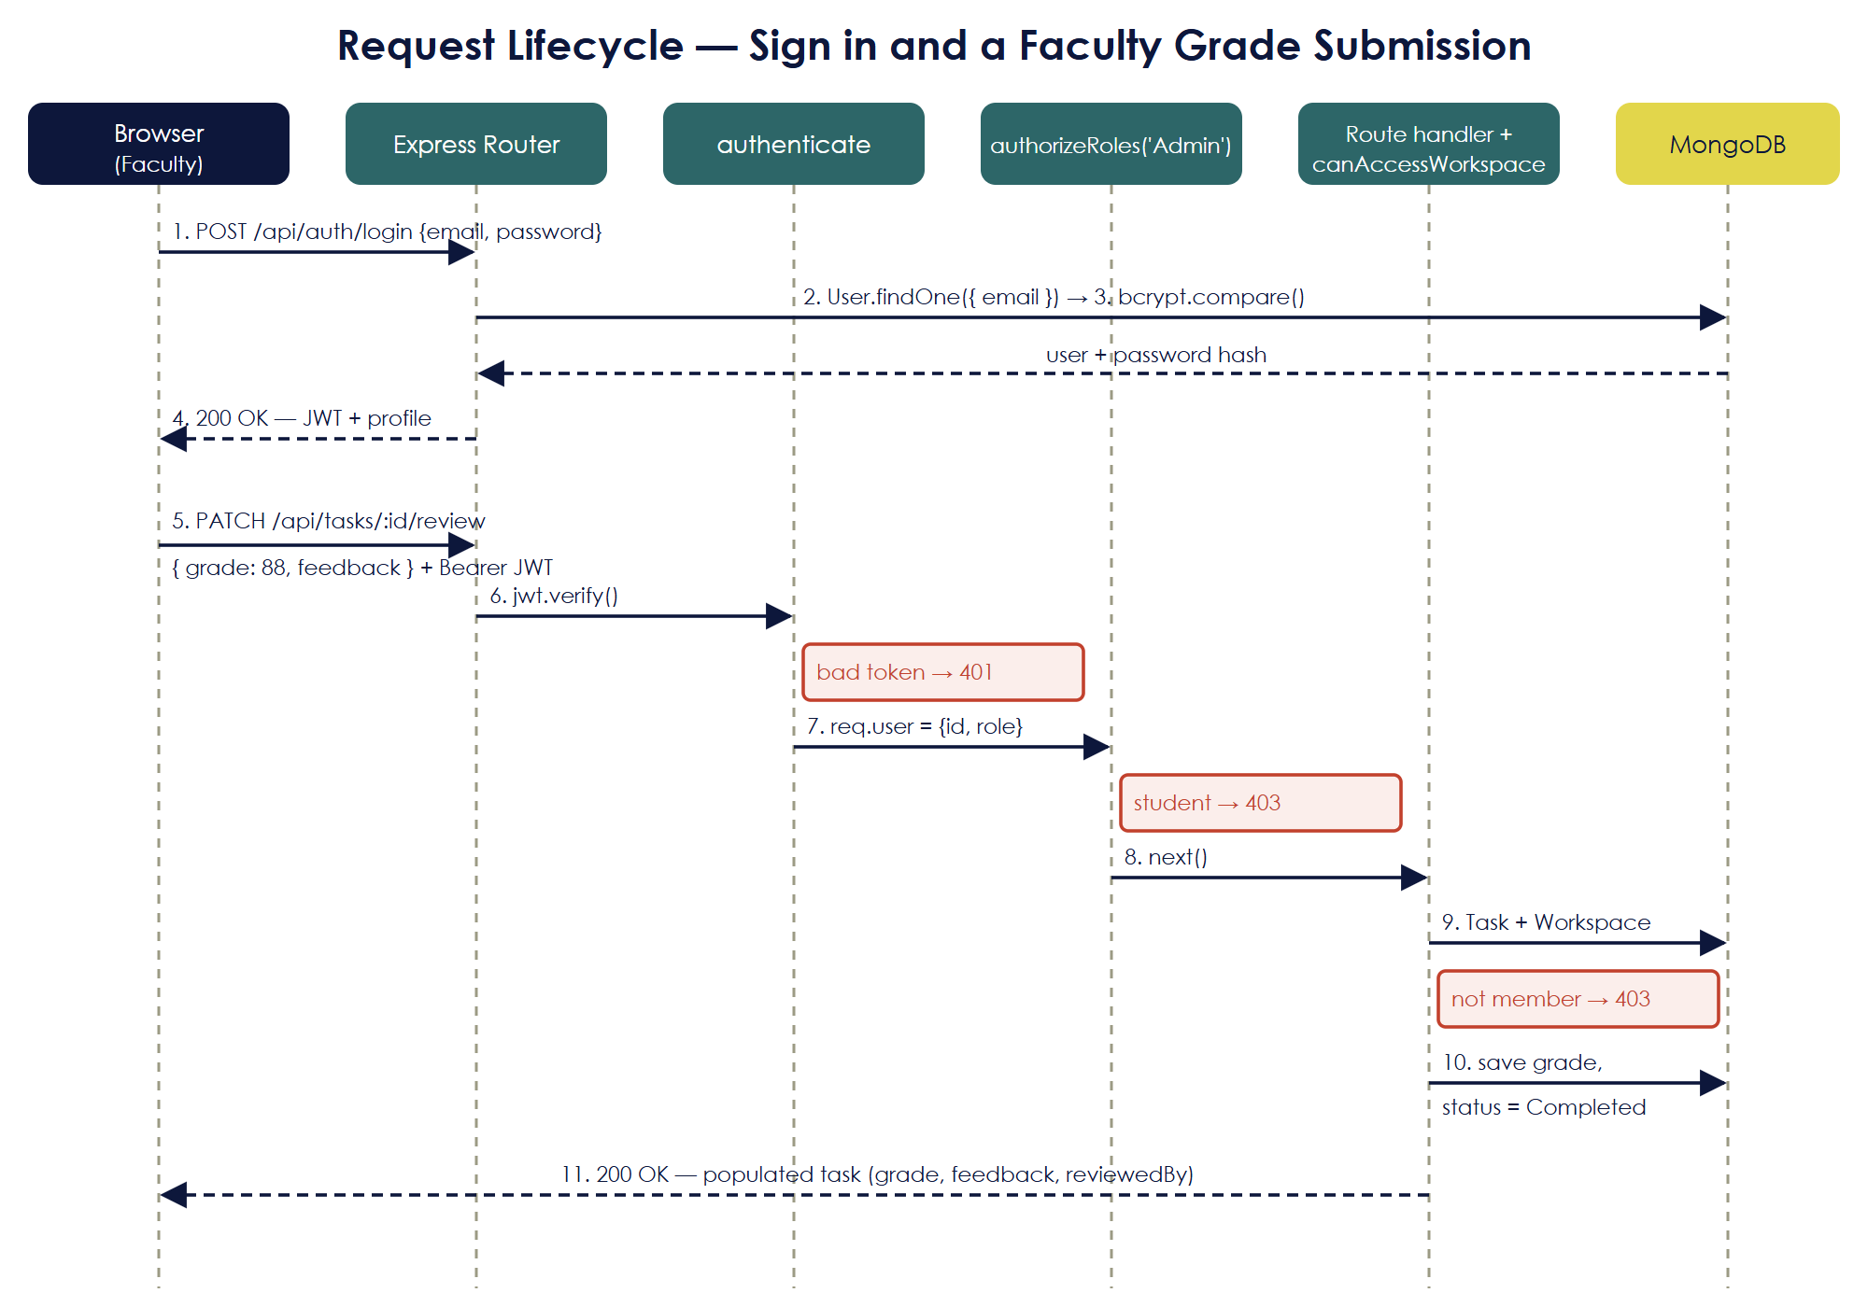
Fig. 2. Request lifecycle for sign-in and a faculty grade submission.

IV. Database Design and Cardinality
The database has three collections—users, workspaces (projects) and tasks. Comments are stored inside each task as an embedded array because they are always read together with their task. Table II and Fig. 3 list the relationships.
Table II. Relationships and cardinality
Relationship | Cardinality | Stored as
User owns Project | 1 : N | owner field in workspace
User is enrolled in Project | M : N | members array in workspace
Project contains Task | 1 : N | workspace field in task
User is assigned Task | 1 : N (optional) | assignedTo field in task
User creates Task | 1 : N | createdBy field in task
Faculty reviews Task | 1 : N (optional) | reviewedBy, grade, feedback in task
Task has Comment | 1 : N (embedded) | comments sub-document array in task
User writes Comment | 1 : N | author field in each comment
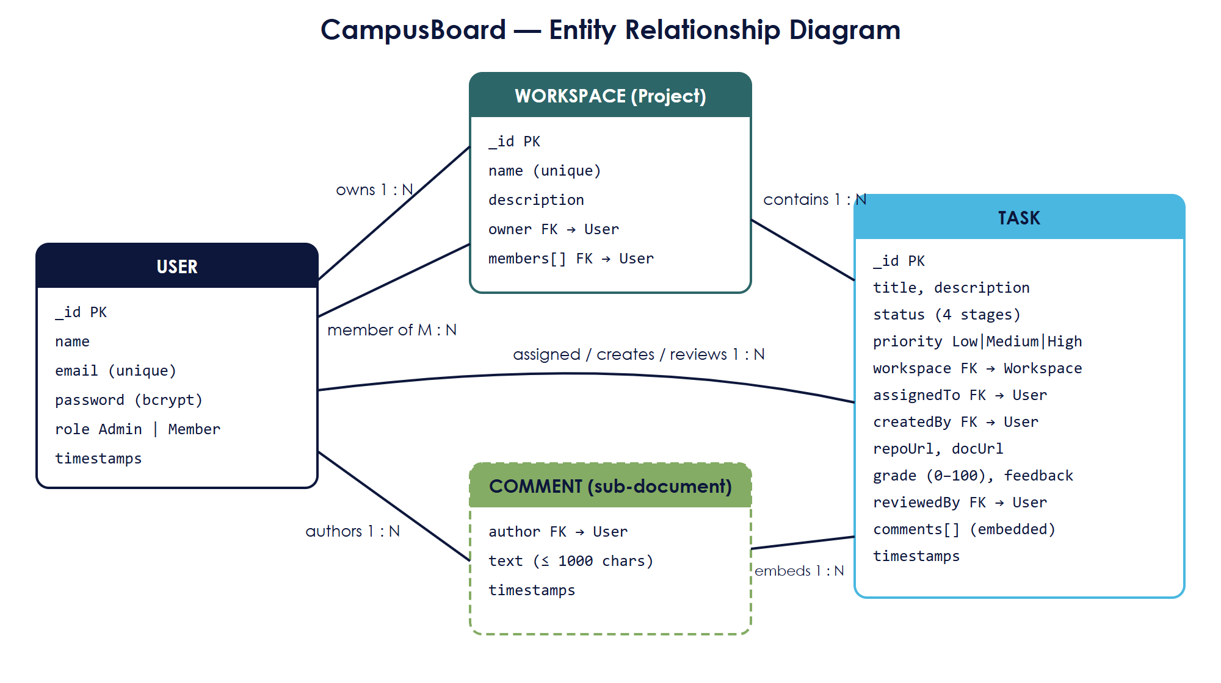
Fig. 3. ER diagram of CampusBoard showing the cardinality of each relationship.

V. REST API Endpoints
The backend exposes fourteen REST endpoints grouped under three routes (Table III). In the code the faculty role is stored as Admin and the student role as Member.
Table III. API endpoints
Method | Endpoint | Access | Purpose
POST | /api/auth/login | Public | Sign in and receive a JWT
POST | /api/auth/provision | Faculty | Create a student or faculty account
GET | /api/auth/users | Signed in | Campus directory
GET | /api/workspaces | Signed in | List my projects
POST | /api/workspaces | Faculty | Create a project
POST | /api/workspaces/:id/members | Owner / Faculty | Enrol a student
GET | /api/tasks/workspace/:id | Project members | Get tasks of a project
POST | /api/tasks | Project members | Create a task or daily progress log
PATCH | /api/tasks/:id/status | Project members | Move a task (only faculty may set Completed)
PATCH | /api/tasks/:id/links | Project members | Attach repository / document links
PATCH | /api/tasks/:id/review | Faculty | Grade (0–100) + feedback, marks Completed
POST | /api/tasks/:id/comments | Project members | Add a comment to the task thread
PUT | /api/tasks/:id | Owner / Faculty | Edit task details
DELETE | /api/tasks/:id | Owner / Faculty | Delete a task

Responses use standard codes: 200/201 success, 400 invalid input (for example a grade outside 0–100 or a link that is not http/https), 401 not signed in, 403 not allowed, 404 not found and 409 duplicate account.

VI. Application Workflow
A task starts in To Do and moves across the board by drag-and-drop (or the move button on mobile); each move calls PATCH /api/tasks/:id/status. Students can take a task as far as Under Review. Only faculty can move it to Completed, which happens automatically when they submit a grade through PATCH /api/tasks/:id/review. If changes are needed, faculty leave a comment and the student moves the task back to In Progress (Fig. 4).
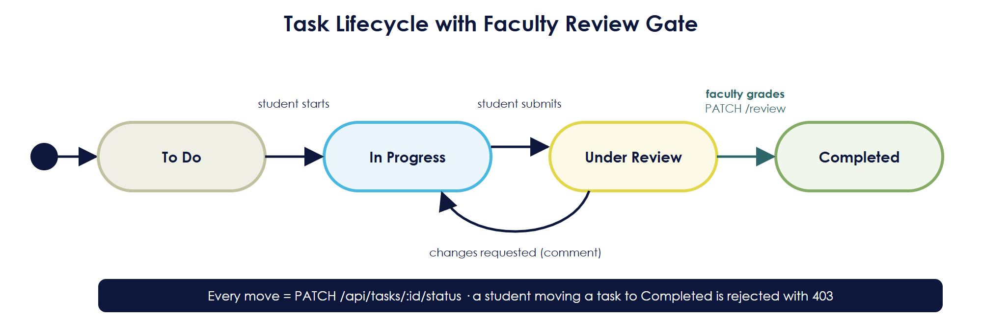
Fig. 4. Task lifecycle with the faculty review gate.
Fig. 5 shows what each type of user can do.
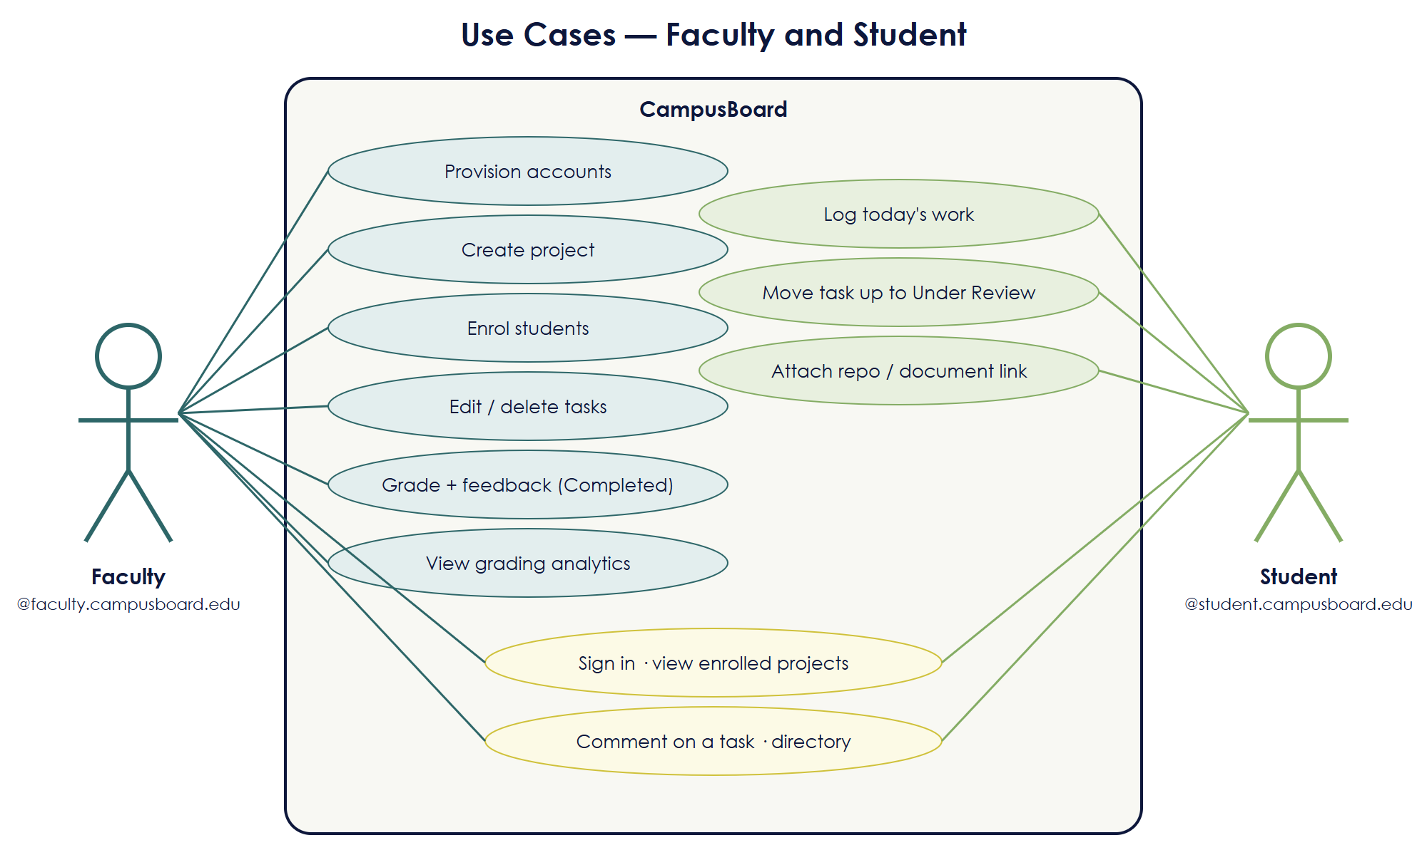
Fig. 5. Use cases for Faculty and Student.

VII. Real-Life Use Case
Scenario: a department runs semester-long team projects, each guided by one faculty member. The faculty guide creates accounts for the team, sets up the project with milestone tasks, and the students update their cards every week while attaching their GitHub repository and report drafts. At each milestone the student submits the task for review and the guide grades it on the same board. Fig. 6 shows this flow and Table IV maps every step to the API.
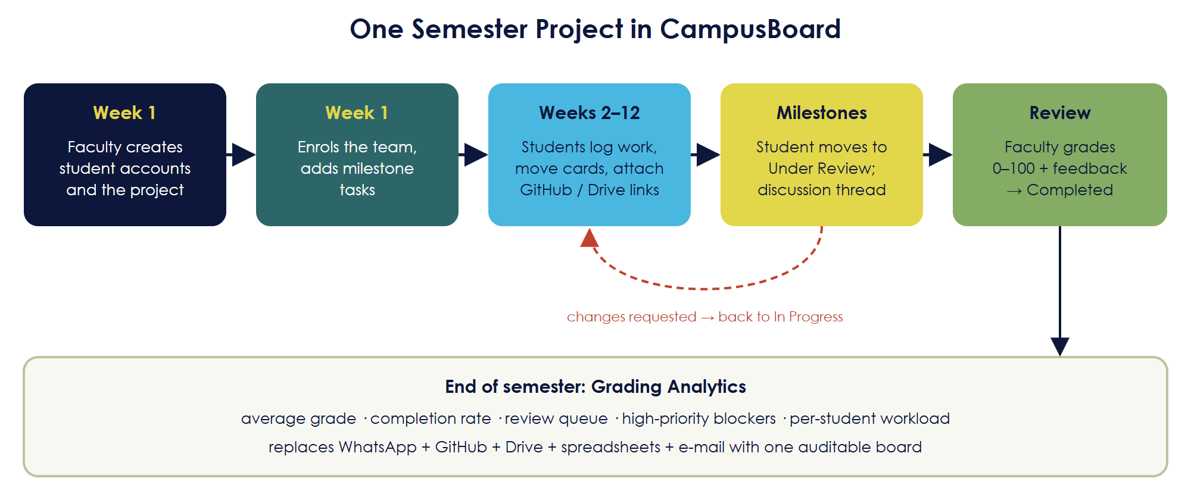
Fig. 6. One semester project in CampusBoard, from onboarding to grading.
Table IV. Semester steps mapped to API calls
Step | Who | API call
Create student accounts | Faculty | POST /api/auth/provision
Create the project | Faculty | POST /api/workspaces
Enrol the team | Faculty | POST /api/workspaces/:id/members
Create and assign milestone tasks | Faculty | POST /api/tasks
Log daily work | Student | POST /api/tasks
Move tasks on the board | Student | PATCH /api/tasks/:id/status
Attach GitHub / Drive links | Student | PATCH /api/tasks/:id/links
Discuss a submission | Both | POST /api/tasks/:id/comments
Grade and give feedback | Faculty | PATCH /api/tasks/:id/review
Review progress in analytics | Faculty | GET /api/tasks/workspace/:id

The same setup suits any course with team assignments—capstone projects, lab work or hackathons—and, because the code is MIT-licensed, any institution can host it on its own domain.

VIII. Results
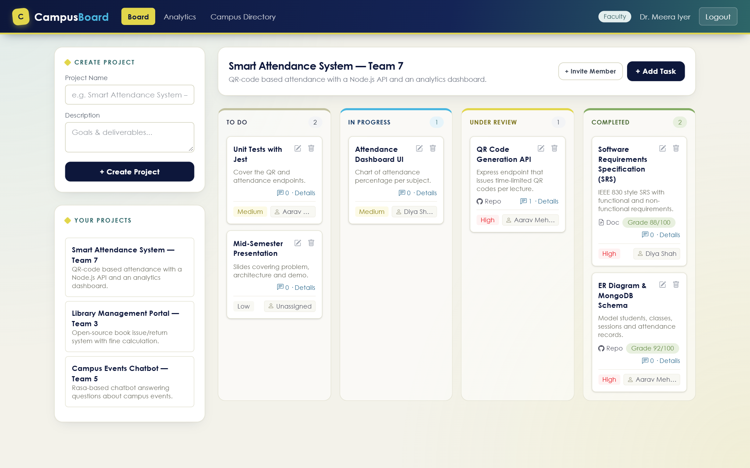
Fig. 7. Project board — faculty view.
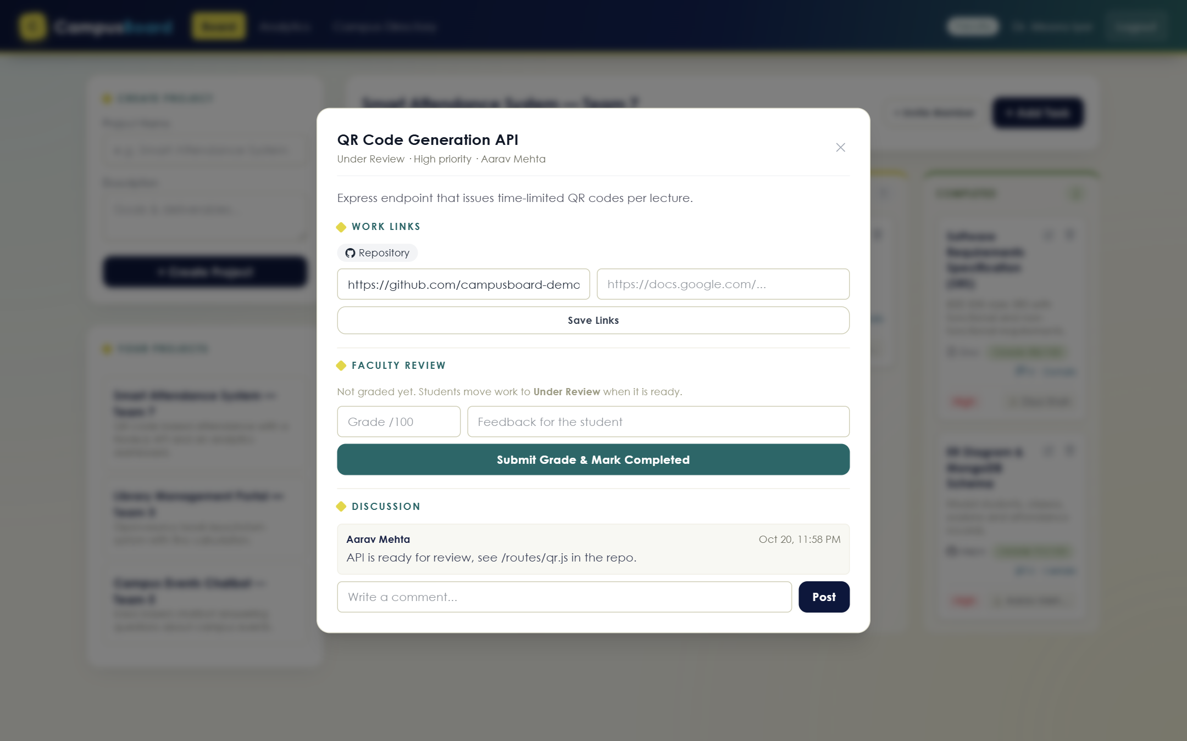
Fig. 8. Task details — work links, faculty review and discussion thread.
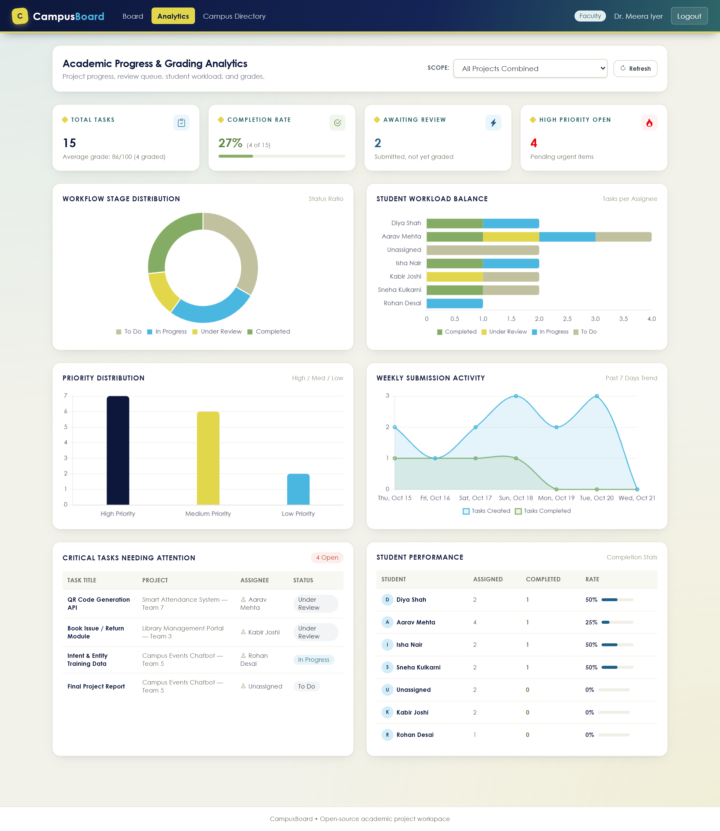
Fig. 9. Academic progress and grading analytics.
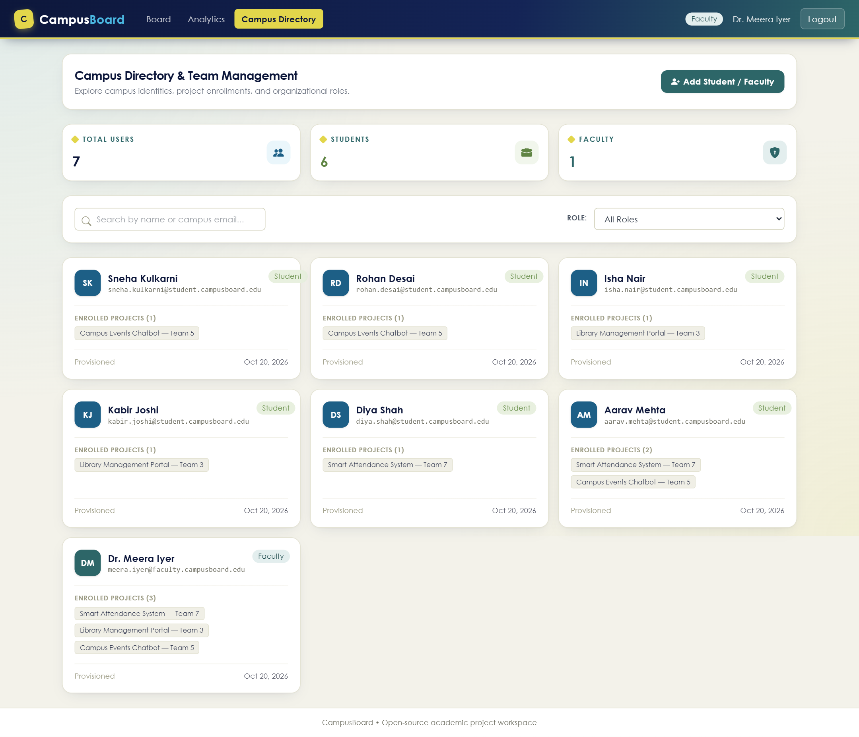
Fig. 10. Campus directory and team management.
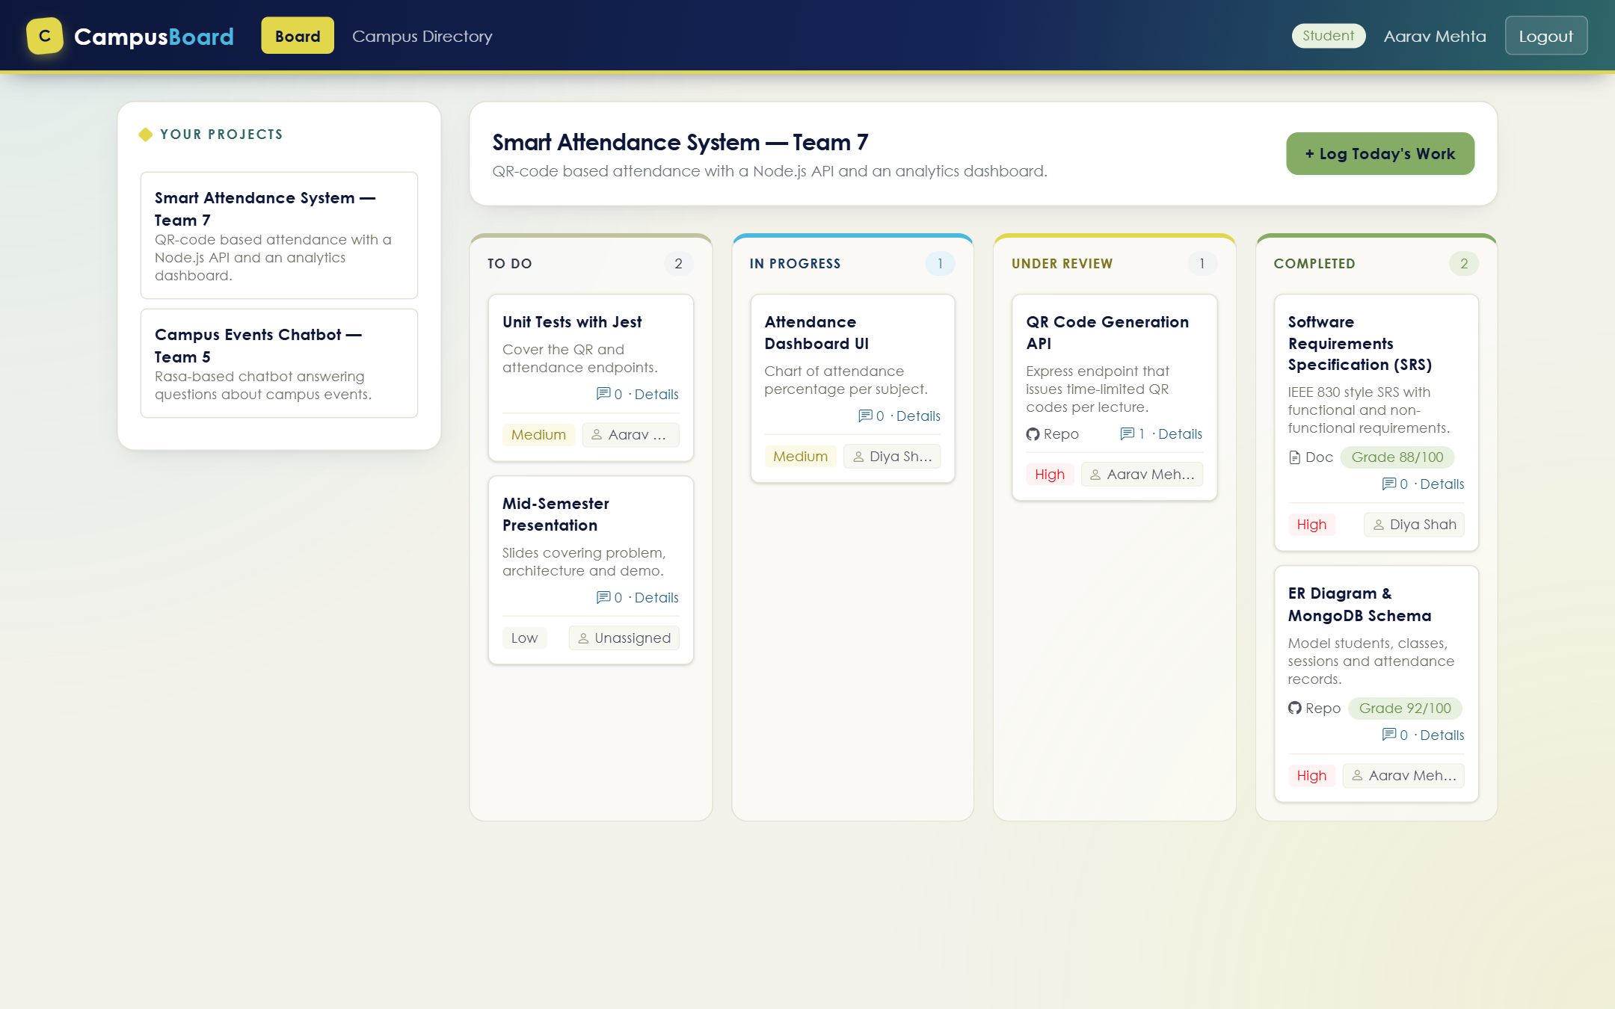
Fig. 11. Project board — student view.
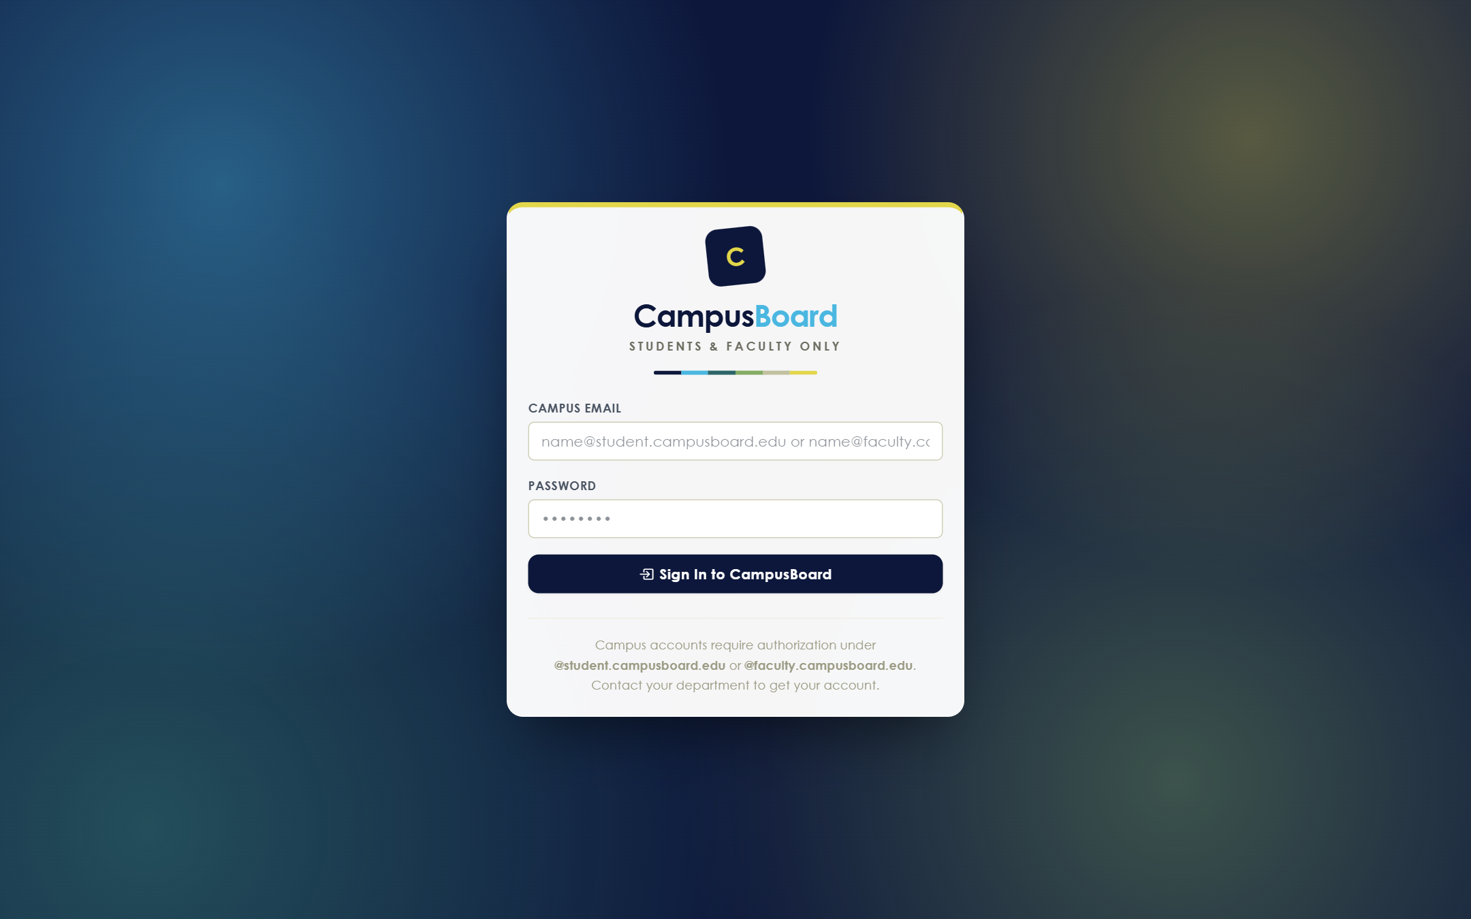
Fig. 12. Sign-in page.
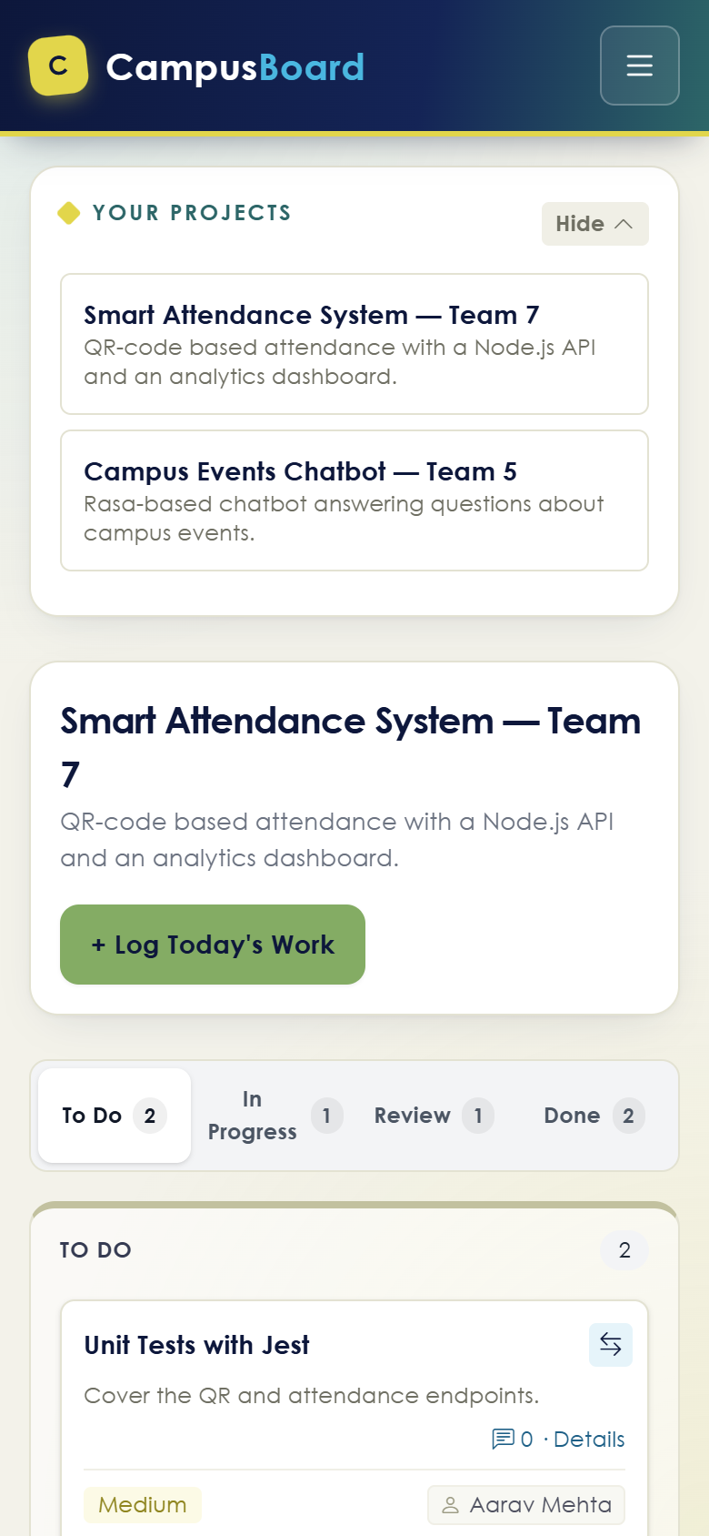
Fig. 13. Responsive mobile layout with column tabs.

IX. Conclusion and Future Work
CampusBoard shows that a small, fully open-source Node.js, Express and MongoDB stack can replace the scattered set of tools used for student projects with one secure, role-based workspace. The review gate, grading and per-task discussion give faculty a clear, auditable record of each student’s contribution.
Future work:
- Real-time board updates and notifications with WebSockets.
- Sign-in through the university’s single sign-on (SSO) and password reset on first login.
- File uploads for reports instead of external links, and rubric-based grading.
- Rate limiting and an audit log of grade changes.

