A Study On Impact Of Social Media On Shopping

Abstract
Social media has revolutionized the way people discover, evaluate, and purchase products. From influencer recommendations to customer reviews and interactive brand content, social platforms like Instagram, Twitter,Youtube, Whatsapp and Facebook play a major role in shaping consumer decisions. This study explores the extent of social media’s influence on shopping behavior, analyzing factors such as trust in influencers, the impact of online reviews, and the effectiveness of social media advertising. Using secondary data from industry reports, academic studies, and market research, we examine how different demographics engage with social media-driven shopping and how businesses leverage these platforms to boost sales. The findings highlight the growing importance of digital engagement and suggest ways businesses can optimize their social media strategies to build trust, increase brand loyalty, and enhance the customer experience. By understanding these dynamics, companies can better connect with their audience and adapt to the rapidly evolving digital marketplace. This study also helps us letting know how much a consumer trusts social media platforms and his or her buying behavior gets influenced by the advertisements on social media.

Introduction
In today’s digital age, social media has become an integral part of everyday life, influencing not just how people communicate but also how they shop. Platforms like Instagram, Twitter, Facebook, and YouTube have transformed traditional shopping experiences, making product discovery, reviews, and purchasing decisions more interactive and personalized. With billions of users worldwide, social media has given rise to new marketing strategies where brands and influencers play a key role in shaping consumer choices. Whether through influencer endorsements, sponsored advertisements, or customer-generated content, social media has become a powerful tool in the retail landscape.
One of the biggest drivers of this shift is the role of influencers. Unlike traditional celebrity endorsements, social media influencers feel more relatable to their audiences, often creating a sense of trust and authenticity. Consumers are more likely to purchase a product when they see someone they follow and trust using it in real-life scenarios. This phenomenon, known as influencer marketing, has skyrocketed in recent years, with brands investing heavily in collaborations with content creators. Whether it’s a fashion blogger showcasing the latest clothing trends, a beauty vlogger reviewing skincare products, or a tech expert demonstrating a new gadget, influencers significantly impact purchasing decisions.
Beyond influencers, social media platforms themselves are shaping shopping behaviors through targeted advertisements, interactive features, and personalized recommendations. Algorithms track user preferences, search history, and interactions, curating a shopping experience tailored to individual needs. Features like Instagram Shopping, Facebook Marketplace, and Youtube Shop make it easier than ever for consumers to discover and buy products without leaving the app. Additionally, the rise of short-form video content (reel) has made marketing more engaging, allowing brands to create visually appealing promotions that resonate with potential buyers.
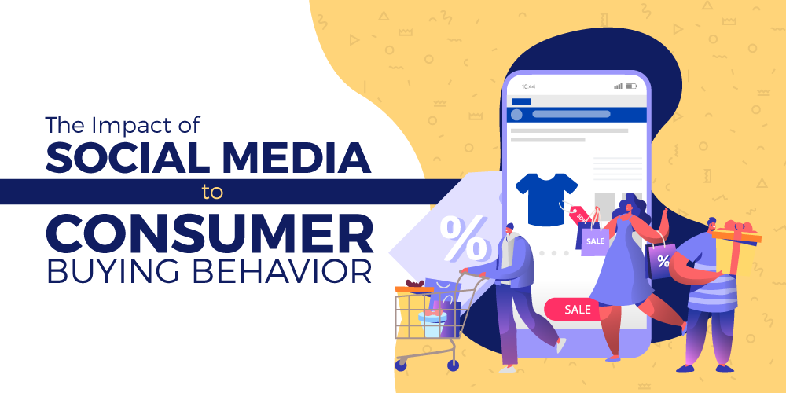
https://www.linkedin.com/pulse/impact-social-media-consumer-buying-behavior-hitesh-kishore

Literature Review
The Role of Social Media in Consumer Behavior
Several studies have established that social media significantly influences how consumers discover, evaluate, and purchase products. According to Kaplan and Haenlein (2010), social media platforms provide an interactive environment where consumers can engage with brands, share experiences, and access peer reviews, making purchasing decisions more informed. Solomon (2017) emphasizes that digital engagement creates a two-way communication channel between businesses and consumers, fostering trust and brand loyalty.
A study by Mangold and Faulds (2009) highlights how social media acts as a hybrid element of marketing communication, blending traditional word-of-mouth marketing with modern digital advertising. Unlike traditional marketing, where information is controlled by brands, social media allows consumers to play an active role in shaping brand perception through reviews, comments, and shared experiences.

Influencer Marketing and Consumer Trust
The rise of influencer marketing has been a major driver of social media’s impact on shopping. Influencers, who range from celebrities to micro-influencers with niche followings, play a crucial role in shaping consumer preferences. According to a study by Djafarova and Rushworth (2017), consumers perceive influencers as more relatable and trustworthy than traditional celebrities, leading to higher engagement and purchase intent. This trust is rooted in the perceived authenticity of influencers, who often share personal experiences and detailed product reviews.
Further research by Lou and Yuan (2019) supports this idea, suggesting that influencer credibility, attractiveness, and expertise significantly impact consumer attitudes toward a product. However, the study also notes that excessive sponsorships and undisclosed paid promotions can erode consumer trust, emphasizing the need for transparency in influencer marketing.

User-Generated Content and Social Proof
Social proof, a psychological concept introduced by Cialdini (1984), plays a crucial role in social media shopping. Consumers tend to rely on the opinions and experiences of others when making purchasing decisions, and social media amplifies this effect. Studies by Erkan and Evans (2016) show that online reviews, testimonials, and user-generated content significantly influence consumer attitudes toward a product. Consumers are more likely to trust recommendations from their peers rather than traditional advertisements.
Pentina, Bailey, and Zhang (2018) further explore the impact of social commerce, where social media platforms integrate shopping features. Their research indicates that interactive content, such as product unboxings, tutorials, and live shopping events, enhances consumer engagement and purchase likelihood.

Targeted Advertising and Algorithmic Influence
Social media platforms utilize advanced algorithms to personalize shopping experiences, targeting users based on their behavior, preferences, and interactions. Research by Bleier and Eisenbeiss (2015) highlights how personalized advertisements improve consumer engagement and conversion rates. However, critics argue that excessive data tracking and targeted ads can lead to privacy concerns and ethical dilemmas (Tucker, 2014).
Furthermore, a study by De Veirman, Cauberghe, and Hudders (2017) suggests that while targeted advertising can increase brand visibility, it must be balanced with organic content to maintain consumer trust. Over-reliance on paid promotions may lead to skepticism among consumers who prefer authentic interactions with brands.

Challenges and Ethical Concerns
Despite its benefits, social media shopping presents several challenges. Impulse buying, driven by visually appealing content and limited-time offers, is a common issue highlighted by Laato, Islam, and Laine (2020). Additionally, misinformation and deceptive marketing tactics can mislead consumers, raising ethical concerns about transparency and accountability in digital advertising.
Researchers such as Hennig-Thurau et al. (2010) suggest that brands should focus on ethical marketing practices, ensuring that influencer partnerships, reviews, and advertisements are transparent and aligned with consumer expectations. Regulatory bodies, including the Federal Trade Commission (FTC), have also introduced guidelines to ensure fair practices in social media marketing.

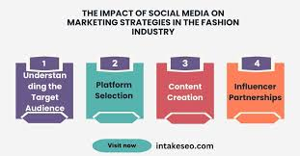
https://www.linkedin.com/pulse/impact-social-media-marketing-strategies-fashion-industry-intakeseo-d3suc

Research and Methodology

This study aims to explore the impact of social media influence on shopping behavior by analyzing how platforms like Instagram, Twitter, Facebook, and YouTube shape consumer decisions. To achieve this, the research relies on a secondary data analysis approach, using existing studies, reports, and industry insights to understand trends, patterns, and consumer responses to social media-driven shopping.
Research Design
The study follows a descriptive research design, which helps in understanding the relationship between social media influence and shopping behavior. By analyzing previously published research, market reports, and consumer behavior studies, this research provides insights into how social media marketing strategies—such as influencer promotions, targeted advertisements, and user-generated content—affect consumer purchasing decisions.
Data Collection Method
Since this study is based on secondary data, information is gathered from a variety of credible sources, including:
- Academic Journals – Research papers and studies from marketing and consumer behavior disciplines.
- Industry Reports – Data from organizations like Statista, Nielsen, and McKinsey on social media and e-commerce trends.
- Case Studies – Real-world examples of brands that have successfully leveraged social media to drive sales.
- Government and Regulatory Reports – Guidelines and policies on influencer marketing and digital advertising.
- Social Media Insights – Reports and analytics from platforms like Meta (Facebook & Instagram), Twitter, and YouTube regarding user engagement and shopping trends.

Data Analysis Method
The collected data is analyzed using qualitative and quantitative methods:
- Qualitative Analysis – Reviewing consumer behavior trends, case studies, and previous research to understand key themes and patterns.
- Quantitative Analysis – Examining statistical data from market reports, such as the percentage of users influenced by social media when making purchases, engagement rates of influencer marketing campaigns, and conversion rates from social media advertisements.

Scope and Limitations
While this study provides valuable insights into social media’s impact on shopping behavior, there are some limitations:
- Dependence on Secondary Data – The study does not involve primary data collection through surveys or interviews, limiting real-time consumer perspectives.
- Rapidly Changing Trends – Social media trends evolve quickly, meaning some data may become outdated over time.
- Platform-Specific Variations – Different platforms have unique user behaviors, and findings may not apply universally across all social media sites.

Ethical Considerations
This research ensures ethical integrity by using only publicly available and credible sources. No personal or confidential consumer data is used. Additionally, sources are properly cited to maintain academic and research credibility.

Conclusion

Social media has transformed how people shop, making product discovery and purchasing more interactive and personalized. Platforms like Instagram, TikTok, and Facebook influence consumer decisions through influencer marketing, targeted ads, and user-generated content. Unlike traditional advertising, social media fosters trust and engagement, making shopping a more immersive experience.
A key factor driving this shift is influencer marketing. Consumers trust recommendations from influencers more than traditional ads, and social proof—such as reviews and viral trends—reinforces their buying decisions. Additionally, social media algorithms personalize shopping experiences, increasing the likelihood of purchases.
However, the rise of social media shopping also presents challenges. Impulse buying, misleading promotions, and privacy concerns highlight the need for ethical marketing. Consumers expect transparency, and brands that prioritize authenticity and meaningful engagement will gain long-term customer trust.
In conclusion, social media’s influence on shopping is undeniable and continues to grow. Businesses must adapt by leveraging data-driven strategies and ethical marketing to stay relevant. As technology evolves, brands that focus on genuine connections and consumer expectations will thrive in the competitive digital marketplace.

References

- Apriliya, S., 2013. Analisis Strategi Online Marketing dan Pengaruhnya Terhadap Purchase Intentions Konsumen Produk Clean and Clear. Jurnal Ilmu & Riset Manajemen. 2(9), 1-22

- Hasan, J., 2011. Analysis of E-marketing Strategies. Studia Commercialia Bratislavensia. 4(4), 201-208

- Kalyanam, K., Mcintyre S., 2002. The E-marketing Mix: a Contribution of the E-tailing Wars. Academy of Marketing Science Journal. 30(4), 487-499

- Kaplan, A.M., Haenlein M., 2010. Users of the World, Unite! The Challenges and Opportunities of Social Media. Business Horizons

- Kotler, P., Keller, K.L., 2009. Manajemen Pemasaran. Edisi ke-13. Jakarta (ID): Penerbit Erlangga Khrishnamurthy, S., Singh, N., 2005. Identifying the Building Blocks for Future Global E- marketing Research. International Marketing Review. 22(6), 605-610

- So, WCM., Wong, TND., Sculli, D., 2005. Factors Affecting Intentions to Purchase via the Internet. Industrial Management & Data System. 105(9), 1225-1244

- Schiffman, Leslie, L.G., Kanuk, L., 2004. Perilaku Konsumen. Terjemahan Zoelkifli Kasip. Edisi ke-7. Jakarta (ID): PT. Indeks Gramedia

- Selim, H.M., 2011. Content Evaluation Criteria for General Website: Analysis and Comparison. UAE University Working Paper Series. 2011 (3), 12-28

- Mangold, W. G., & Faulds, D. J. (2009). Social media: The new hybrid element of the promotion mix. Business Horizons, 52(4), 357-365.
- Djafarova, E., & Rushworth, C. (2017). Exploring the credibility of online celebrities' Instagram profiles in influencing the purchase decisions of young female users. Computers in Human Behavior, 68, 1-7.

- Lou, C., & Yuan, S. (2019). Influencer marketing: How message value and credibility affect consumer trust of branded content on social media. Journal of Interactive Advertising, 19(1), 58-73.

- Erkan, I., & Evans, C. (2016). The influence of eWOM in social media on consumers’ purchase intentions: An extended approach to information adoption. Computers in Human Behavior, 61, 47-55.

