**Task1:**

Install Jupyter notebook and run the first program and share the screenshot of the output.

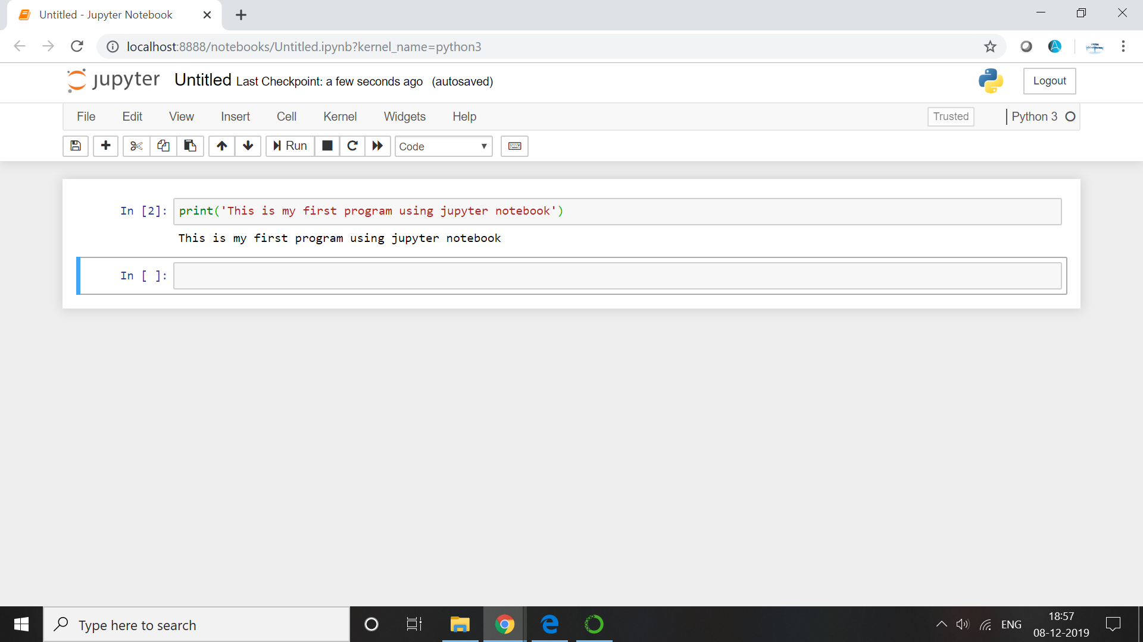

**Task 2:**

Write a program which will find all such numbers which are divisible by 7 but are not a multiple of 5, between 2000 and 3200 (both included). The numbers obtained should be printed in a comma-separated sequence on a single line.

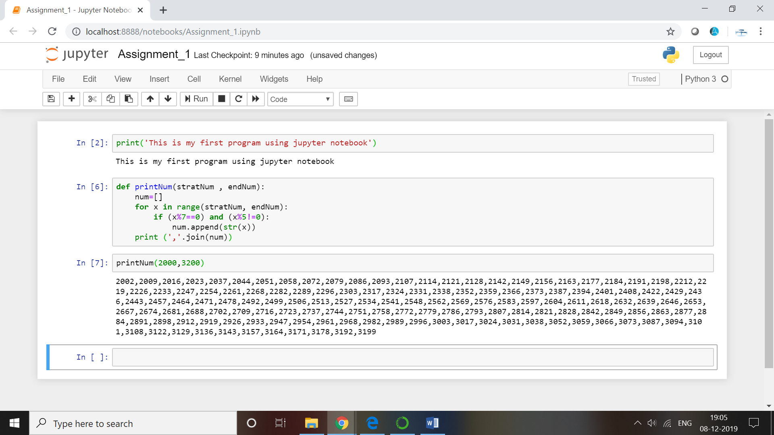

**Task 3:**

Write a Python program to accept the user's first and last name and then getting them printed in the the reverse order with a space between first name and last name

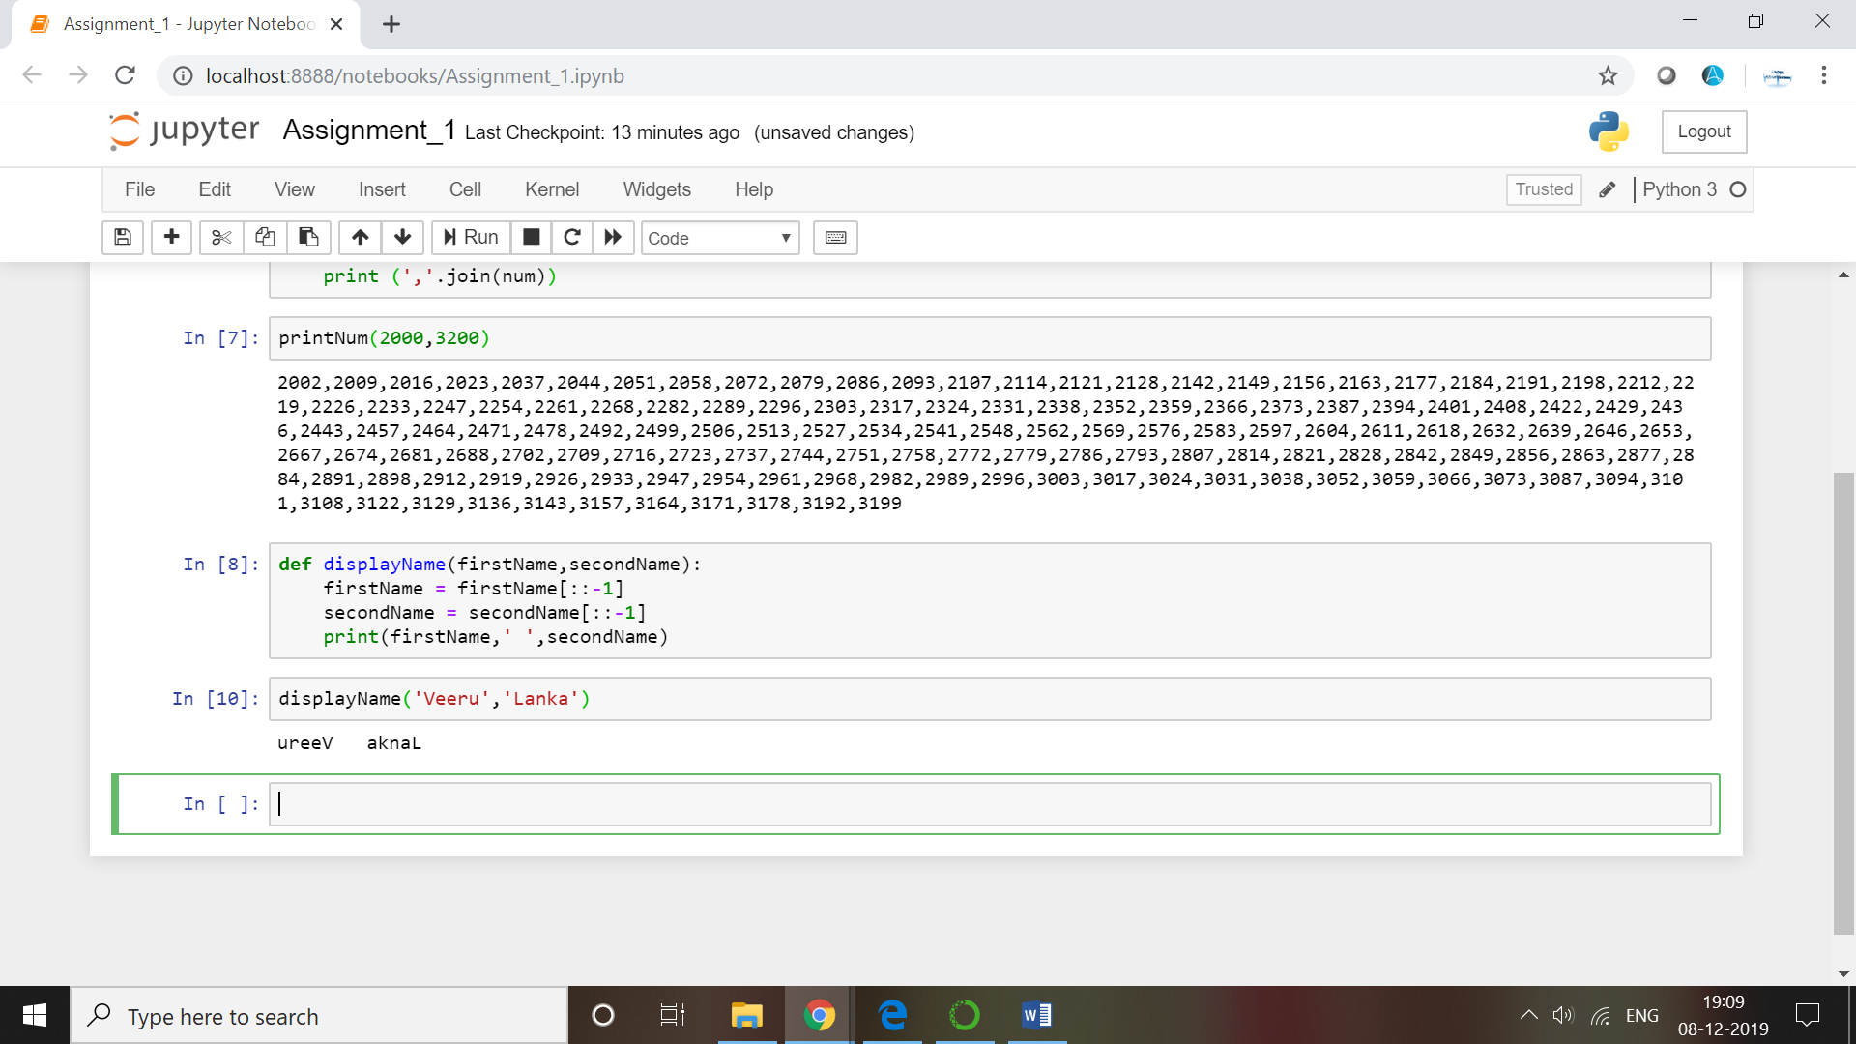

**Task 4:**

Write a Python program to find the volume of a sphere with diameter 12 cm.

radius = diameter/2

Formula: V=4/3 * π * r 3

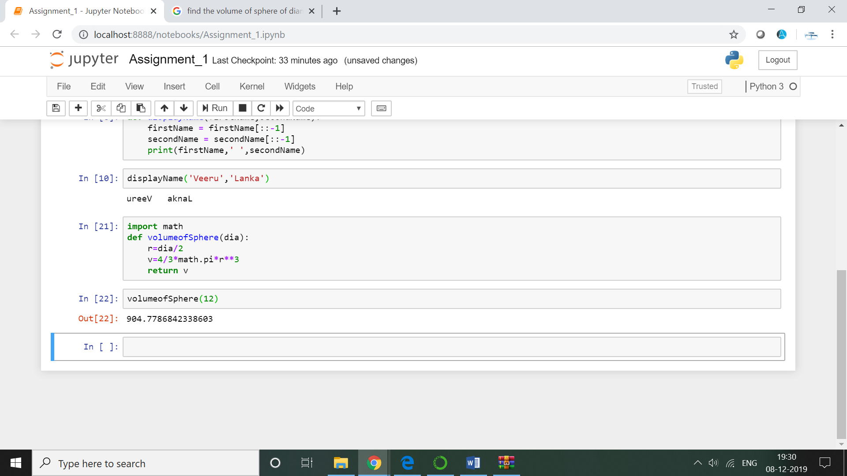

**Task5:**Write a program which accepts a sequence of comma-separated numbers from console and generate a list.

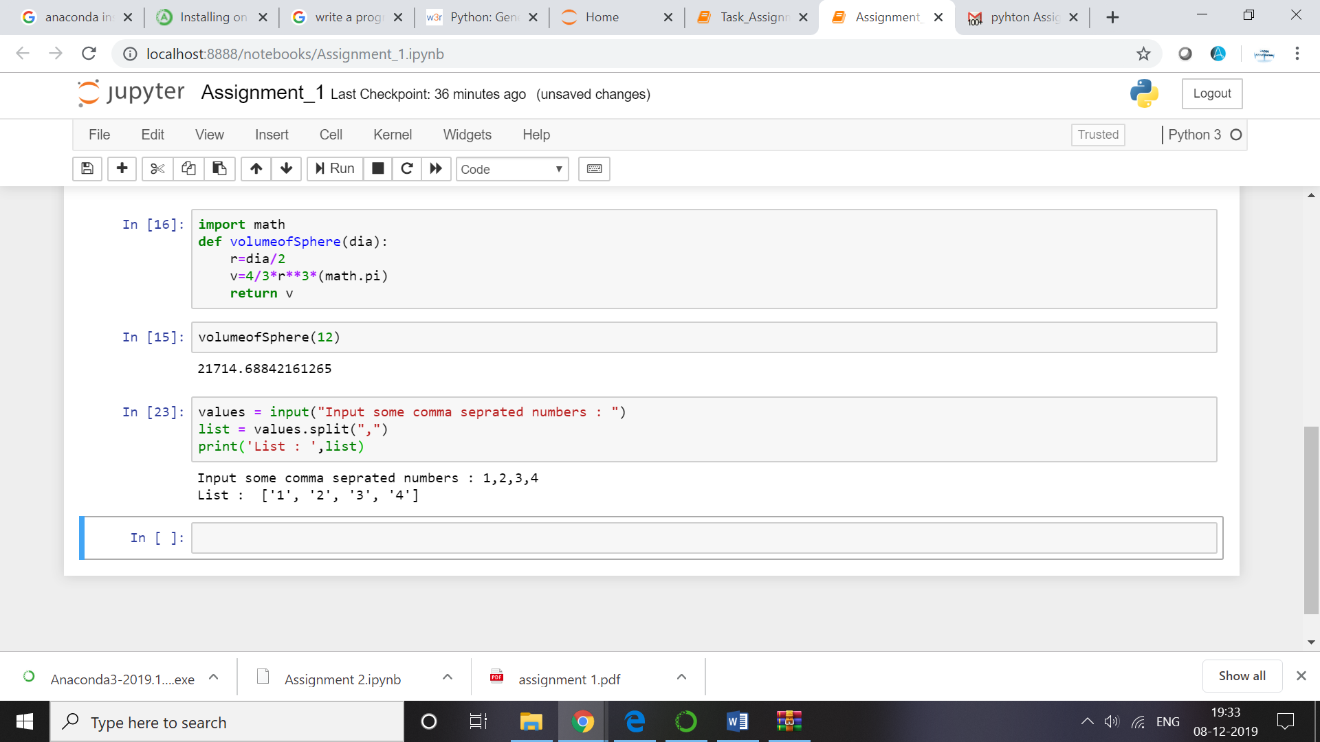

**Task6:**

**Create the below pattern using nested for loop in Python.**

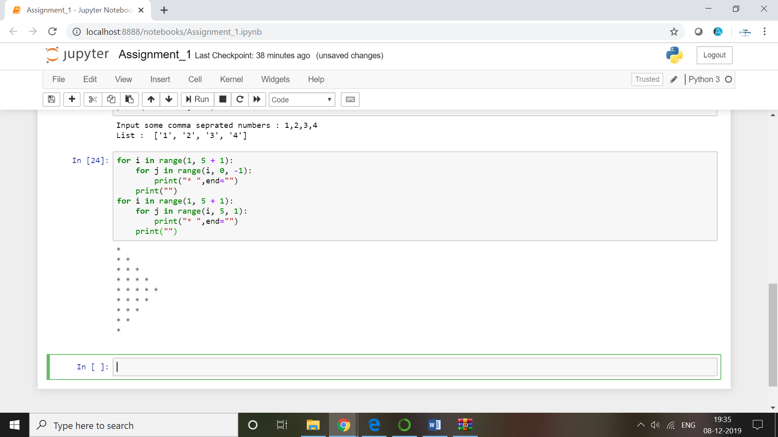

**Task 7:**

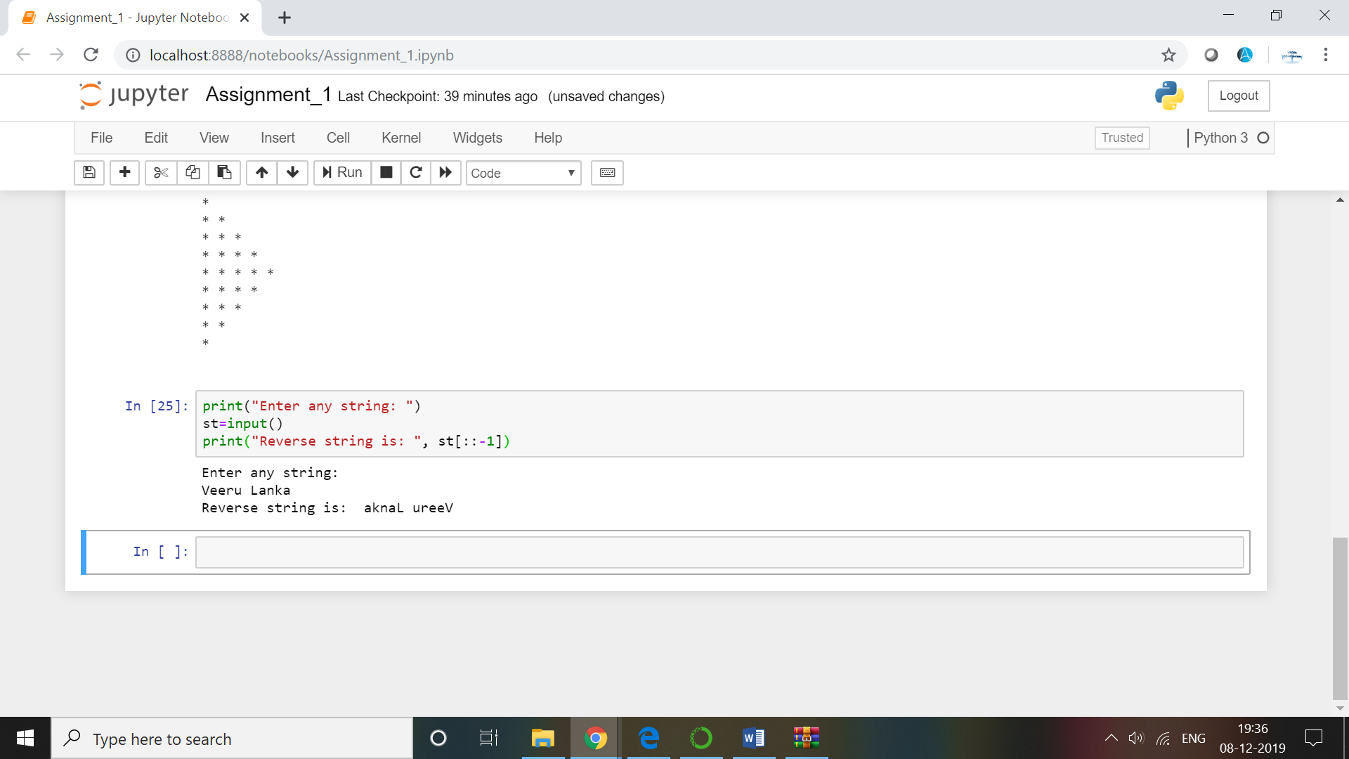

**Task 8:**

Write a Python Program to print the given string in the format specified in the ​sample output.

WE, THE PEOPLE OF INDIA, having solemnly resolved to constitute India into a SOVEREIGN, SOCIALIST, SECULAR, DEMOCRATIC REPUBLIC and to secure to all its citizensWrite a Python Program to print the given string in the format specified in the ​sample output.

