**Gebze Technical University**

**Computer Engineering**

**CSE 222 - 2018 Spring**

**HOMEWORK 5 REPORT**

**STUDENT NAME**

**STUDENT NUMBER**

Course Assistant:

# Double Hashing Map

This part about Question1 in HW5

## Pseudocode and Explanation

Write pseudocode and explanation about code design. Indicate what you are using that interfaces, classes, structures, etc.

## Test Cases

Try this code least 2 different hash table size and 2 different sequence of keys. Report all of situations.

# Recursive Hashing Set

This part about Question2 in HW5

## Pseudocode and Explanation

Write pseudocode and explanation about code design. Indicate what you are using that interfaces, classes, structures, etc.

## Test Cases

Try this code least 2 different hash table size and 2 different sequence of keys. Report all of situations.

# Sorting Algortihms

## MergeSort with DoubleLinkedList

This part about Question3 in HW5

### Pseudocode and Explanation

Write pseudocode and explanation about code design. Indicate what you are using that interfaces, classes, structures, etc.

### Average Run Time Analysis

This part about Question4 in HW5

### Wort-case Performance Analysis

This part about Question5 in HW5

## MergeSort

This part about code in course book.

### Average Run Time Analysis

This part about Question4 in HW5

### Wort-case Performance Analysis

This part about Question5 in HW5

## Insertion Sort

### Average Run Time Analysis

This part about Question4 in HW5

### Wort-case Performance Analysis

This part about Question5 in HW5

## Quick Sort

### Average Run Time Analysis

This part about Question4 in HW5

### Wort-case Performance Analysis

This part about Question5 in HW5

## Heap Sort

### Average Run Time Analysis

This part about Question4 in HW5

### Wort-case Performance Analysis

This part about Question5 in HW5

# Comparison the Analysis Results

This part about Question5 in HW5. Using before analysis results in show that section 3. Show that one graphic (like Figure 4.1) include 5 sorting algorithm worst-case analysis cases. 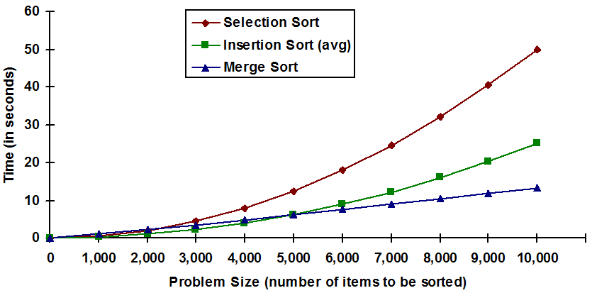

Figure 4.1. Comparison of sorting algorithms ( this figure just a example)