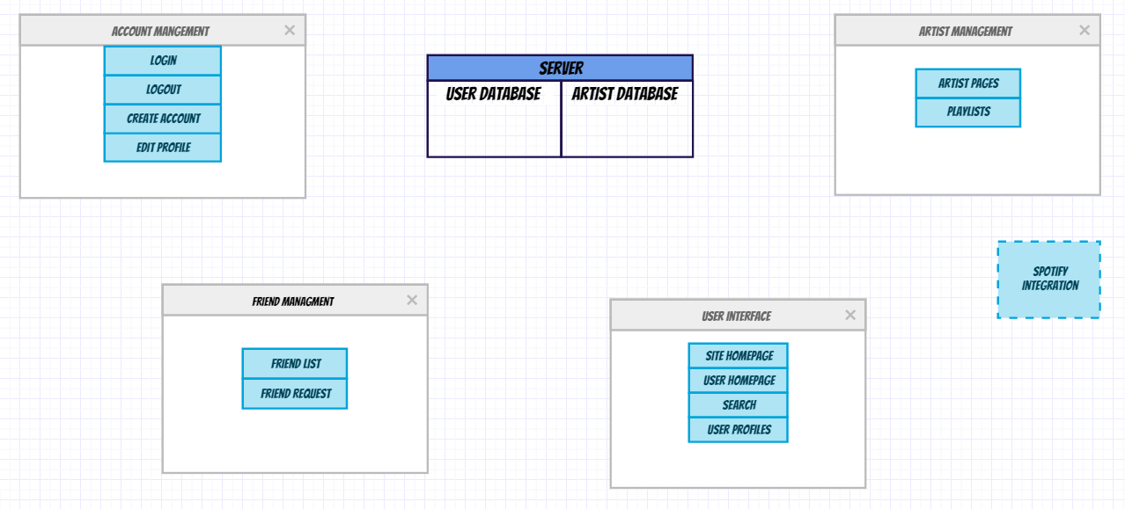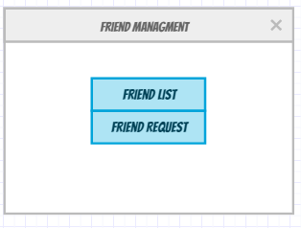

Account Management (Component):

* Login function: User logins to account
* Logout function: User logs out of account
* Create account function: User creates an account if they don’t have one
* Edit profile function: User can edit personal info, change background color, edit favorite Artists

Spotify Integration

* We will be using Spotify API to enable playback of songs. We believe it is a component on its own but it won’t directly talk to any of the other components

User Interface (Component):

* User homepage function: goes to the user’s homepage
* Site homepage function: Main webpage if not logged in
* Search function: search for artists and songs
* User profiles function: search for other users.

Friend Management (Component):

* Friends list function: Edit/View friends list
* Friend Request function: Accept/delete requests

Artist Management (Component):

* Artist Pages function: View artist page and favorite artist
* Playlist function: Create playlists

Server:

* Contains User database and Artist database