**WEEK – 1**

**Step – 1:**

The very first step is we need to extract our data set in to power BI.

Open power BI 🡪 click get data 🡪 choose option text/CSV 🡪 choose our file and click open.

It will show preview of our data then press Load.

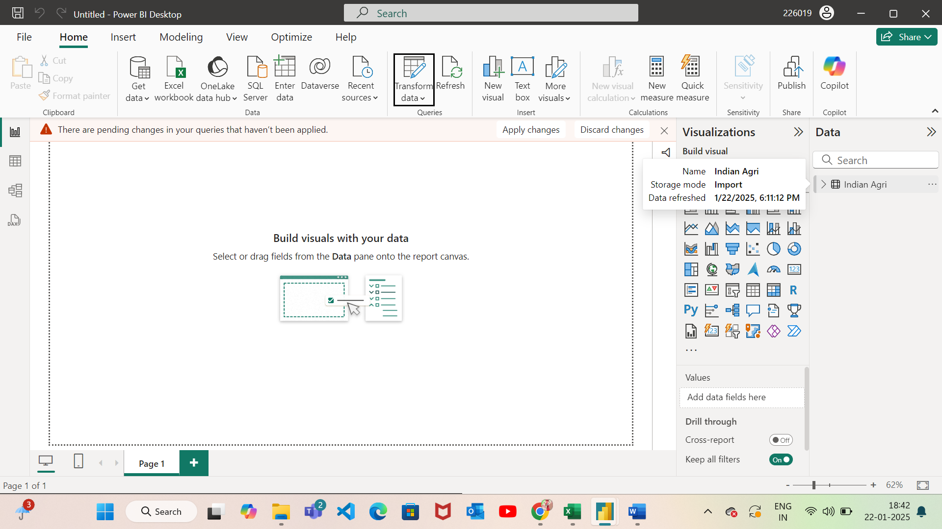

We can see our data in right most corner tab named Data.

**Step – 2:**

If our data contains some error or missing values we need to transform it.

Transform: when we want to process our data.

For this process we need to click ‘Transform data’ on the home tab.

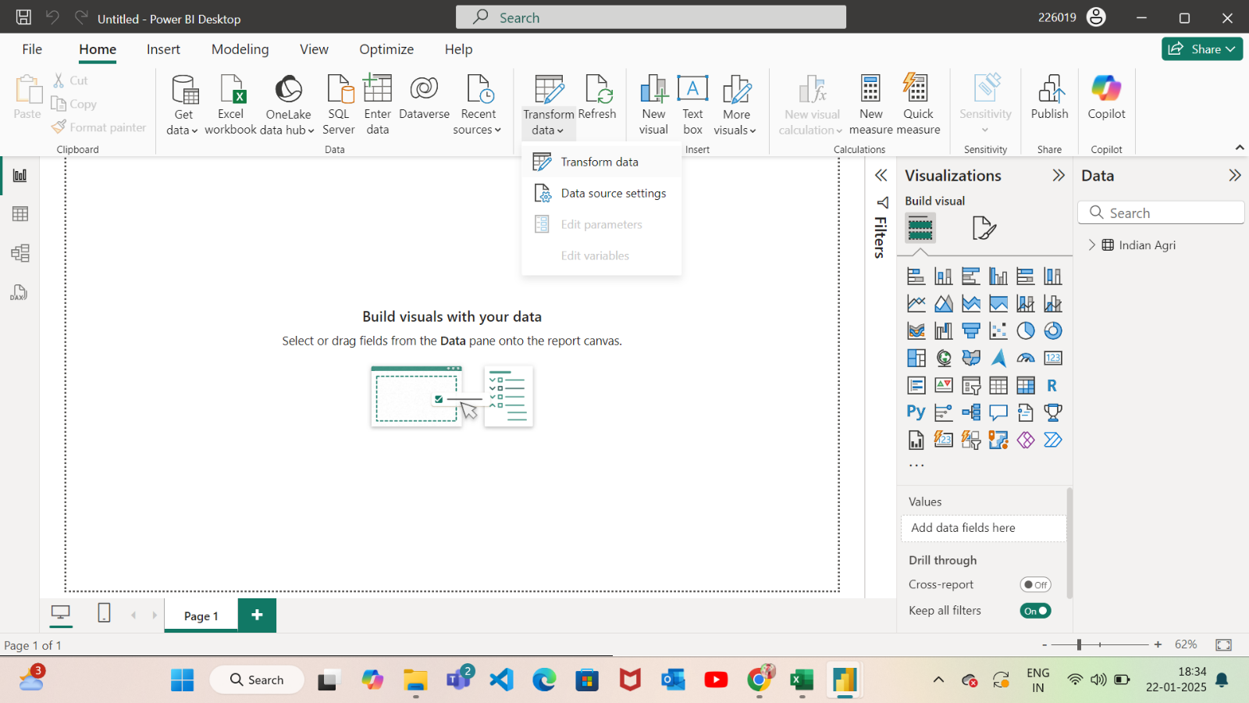

It will open a new window called “Power Query Editor”

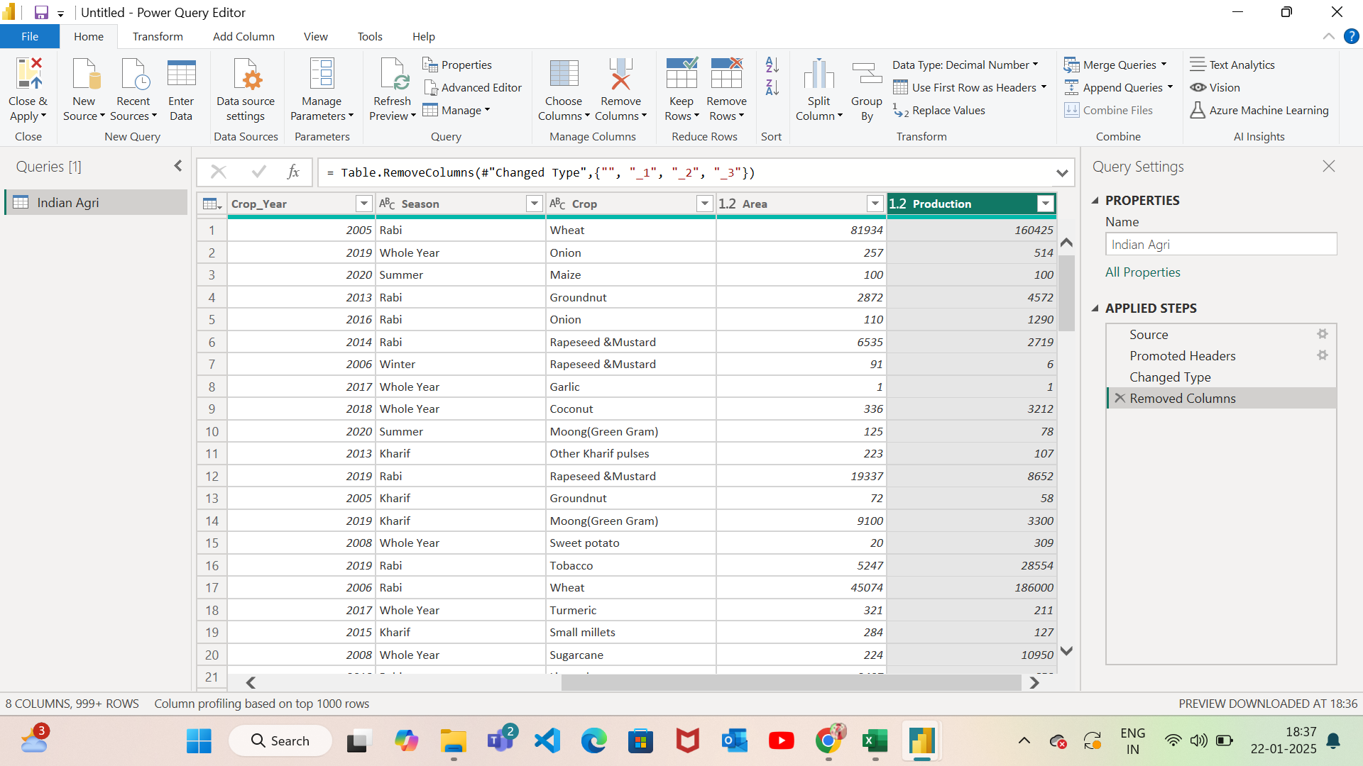

In this we have some blank values that cannot be used so we need to remove it.

**Step – 3:**

To remove a column,

Place a cursor on the top of the column name and right click it then select “Remove”

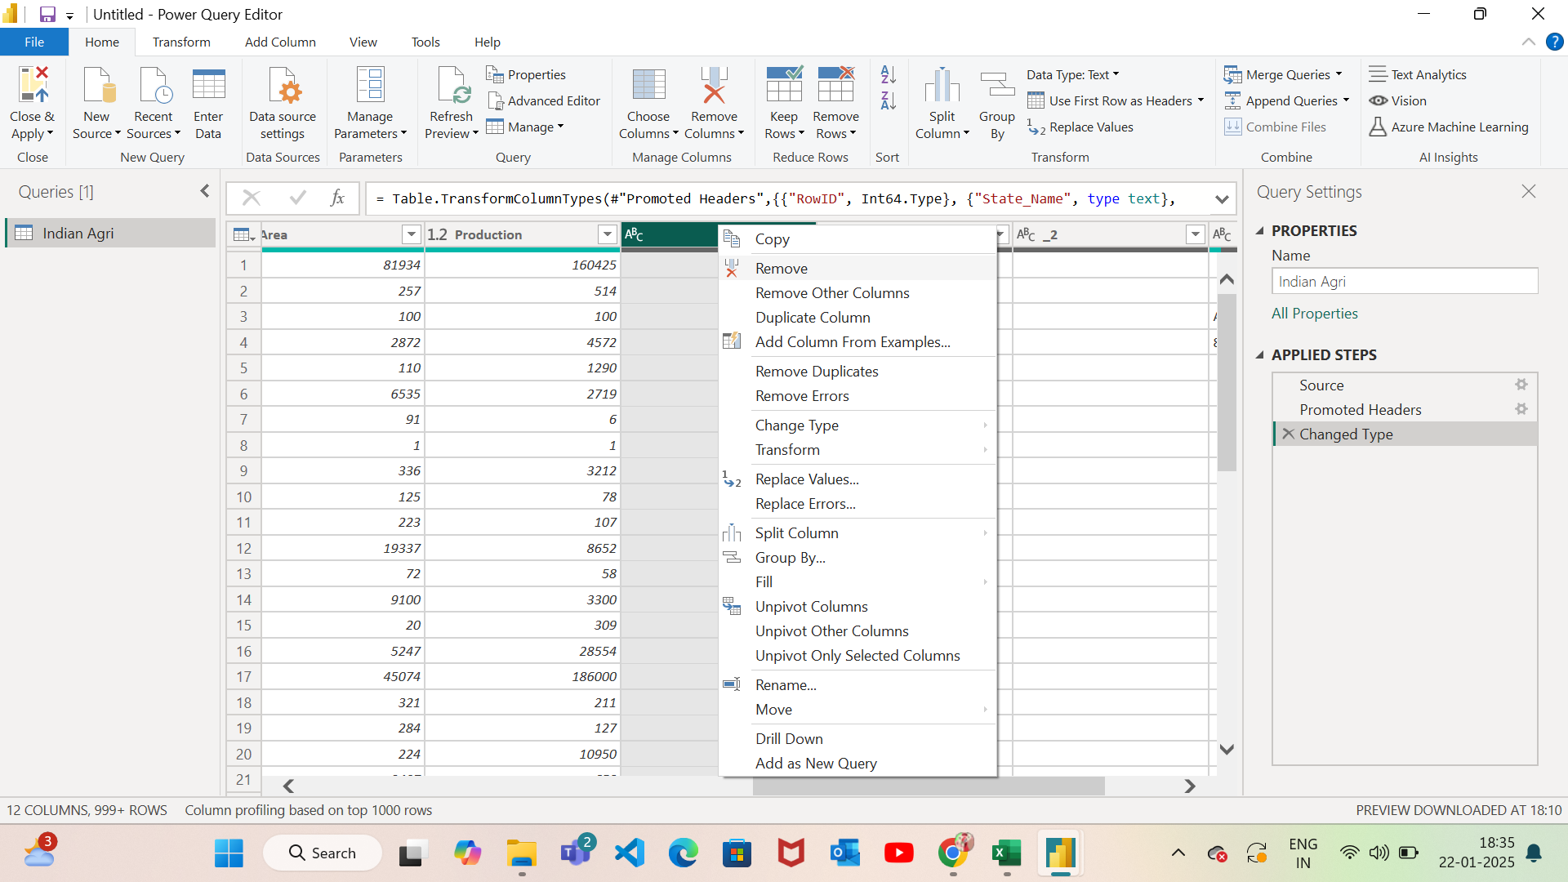

Now out data has no blank column.

**Step – 4:**

We can observe that all the steps which has been made by us is saved in the space called “Applied Steps”.

To undo our works we need to click the red cross present near the name.

In our case, if we want get back our columns we have to click cross near the “Removed Columns”

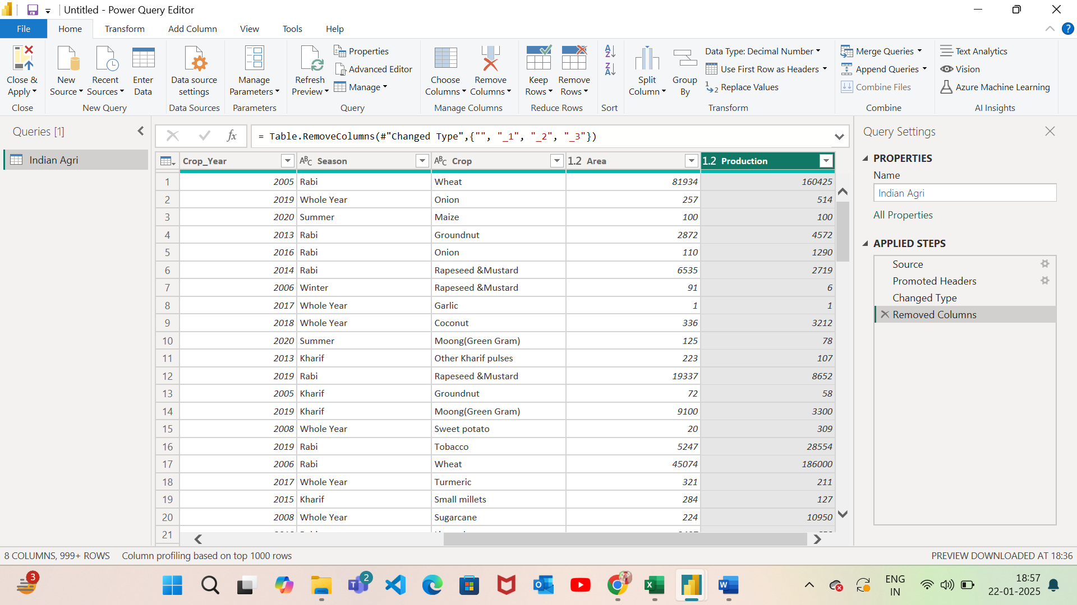

Step – 5:

If we want know about errors or missing values present in our columns,

Go to view 🡪 select Column quality

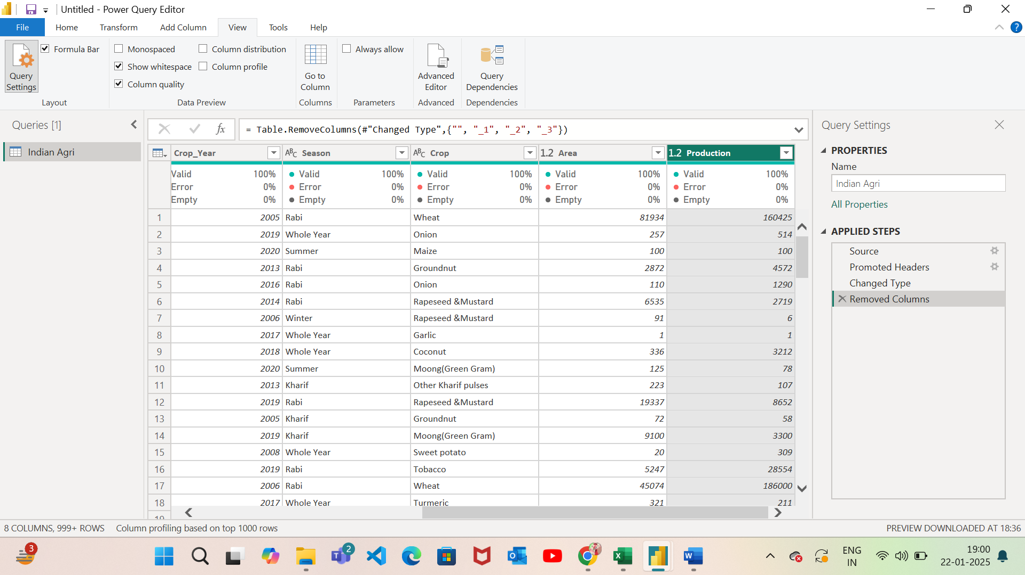

Now it clearly shows valid, error and empty data in each column.

**Step – 6 :**

If our data contains any missing or null values then we can remove it by,

Go to home tab 🡪 Remove rows 🡪 click Remove blank rows

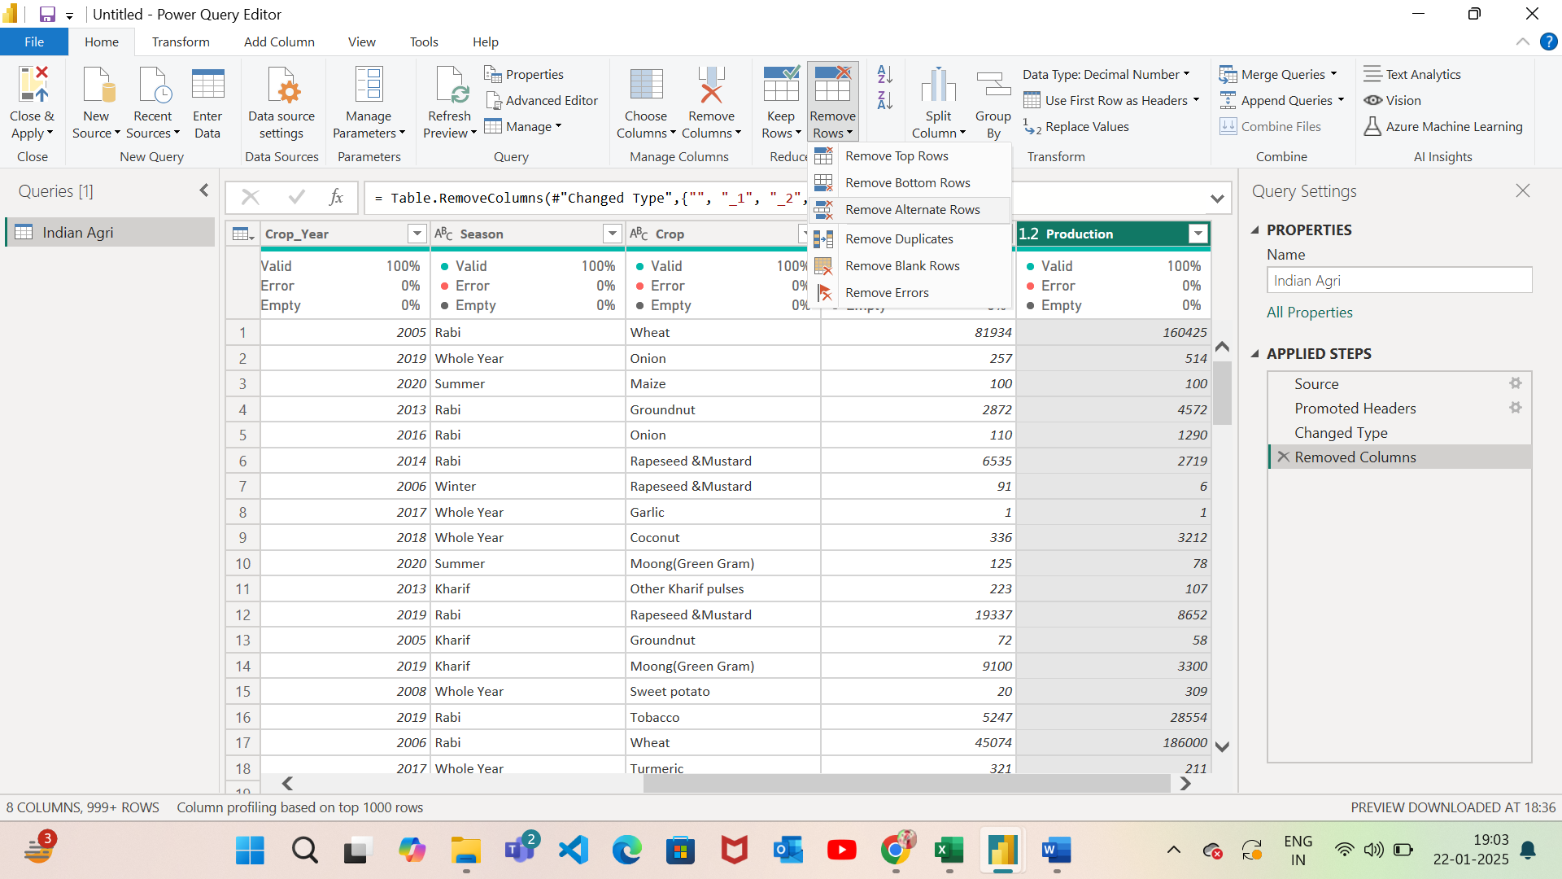

Now we finish our transformations works.

**Step – 7:**

After we finish our transformation work we need to apply all changes that we have done.

To apply, go to home tab 🡪 close & apply

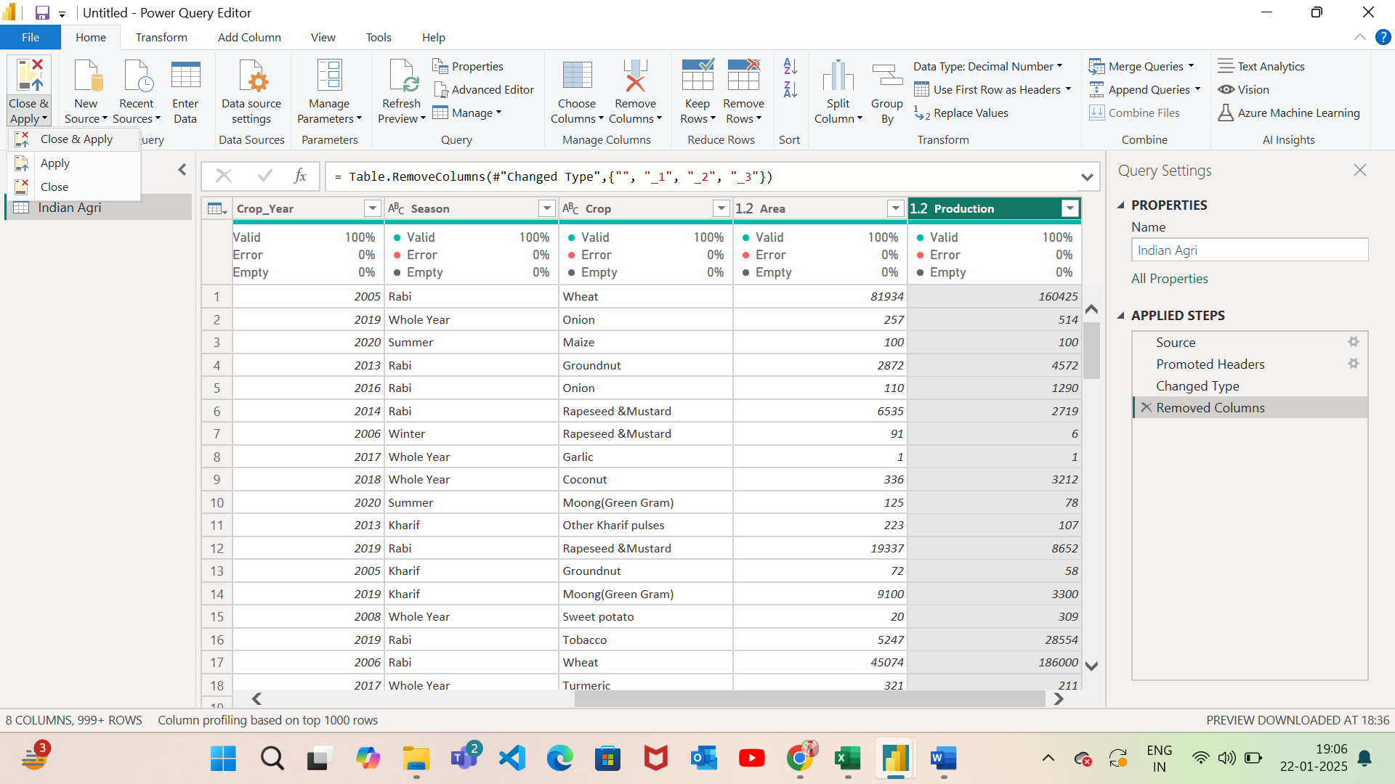

Now our data looks error free and has no missing or null values and ready to use it.

