CLOUD COMPUTING PROJECT REPORT
AI-Driven Cloud Platform for Personalized Drug Response Prediction using Multi-Omics Data
Submitted by:
Abhijeet Sinha (23BIT0157)
Sarthak Pathak (23BIT0187)
Shriyans Pratihari (23BIT0219)

Programme / Branch / Year: B.Tech. Information Technology, IV Year
Course Code and Name: BITE412L, Cloud Computing
Institution: School of Computer Science and Engineering, Vellore Institute of Technology, Vellore
Course Instructor / Guide: Dr. Priya V
Team Number:
Cloud Provider: Amazon Web Services (AWS), region ap-southeast-2 (Asia Pacific, Sydney)
Git Repository URL: https://github.com/Vegeta290/AIDrugResponsePrediction_AWS_Cloud_Project_2026
Date of Submission: 16/10/2026

Abstract
Predicting how an individual tumour will respond to an anti-cancer drug is difficult because response depends on several interacting molecular layers, and most published deep-learning predictors are released as research code rather than as secure, usable services. This project designs, implements and deploys a cloud platform that predicts drug sensitivity, expressed as the natural logarithm of the half-maximal inhibitory concentration (ln IC50), from gene expression, copy-number, mutation and proteomics profiles together with each drug's molecular graph. The model, DrugResponseNet, turns each omics layer into a token, encodes the drug with a three-layer residual graph convolutional network over RDKit atom graphs, and fuses all tokens with a Transformer. Attention weights and gradient-times-input attributions give per-modality and per-gene explanations for every prediction. The platform runs on Amazon Web Services (ap-southeast-2) and is provisioned by one AWS CloudFormation template covering Amazon VPC, Amazon EC2, Amazon RDS for PostgreSQL, Amazon S3, AWS Lambda, Amazon API Gateway, AWS Systems Manager, Amazon CloudWatch, Amazon SNS, AWS CloudTrail and least-privilege IAM roles, within the AWS Free plan. On a synthetic dataset of 500 cell lines and 12 drugs, evaluated on cell lines never seen in training, the model reached a test Pearson correlation of 0.837, an RMSE of 1.077 and a ROC-AUC of 0.866. It outperformed global ridge-regression and random-forest baselines, but a per-drug ridge baseline scored higher (Pearson 0.908) on this linearly generated data. The deployed service returned explained predictions for 12 drugs in a median of 1.07 s end to end, with about 0.18 s of server-side inference, and passed all authentication and access-control tests. Validation on real DepMap/GDSC and TCGA data is planned and is required before any biological claim is made.

Keywords
Cloud computing; Amazon Web Services; Drug response prediction; Multi-omics integration; Graph neural networks; Explainable AI
Table of Contents
Abstract 2
Keywords 2
1. Introduction 5
1.1 Background 5
1.2 Problem Statement 5
1.3 Motivation and Significance 6
1.4 Scope 6
1.5 Report Organisation 6
2. Literature Survey / Related Work 7
2.1 Comparative Synthesis 9
2.2 Individual Research Gap Analysis 9
2.3 Consolidated Research Gap 11
3. Project Objectives 12
3.1 Expected Outcomes 12
4. Novelty Summary 13
5. Proposed System and Architecture 14
5.1 System Overview 14
5.2 Diagram 1 – Cloud Deployment Architecture (Mandatory) 14
5.3 Diagram 2 – Complete System Architecture / Workflow (Mandatory) 16
5.4 Workflow and Use Cases 18
5.5 Security, Availability and Scalability 19
6. Dataset / Input Data Description 20
6.1 Data Preparation 20
7. Cloud Platform and Services Planning 22
7.1 Deployment and Network Design 23
7.2 Cost Estimation 23
7.3 Portability / Provider-Specific Choices 24
8. Methodology and Implementation Plan 25
8.1 Overall Methodology 25
8.2 Tools and Technologies 25
8.3 Step-by-Step Implementation Plan 26
8.4 Evaluation Metrics 26
9. Implementation / Development 28
9.1 Implemented Modules 28
9.2 Screenshots and Configuration Evidence 29
9.3 Repository and Project Structure 31
9.4 Version Control Workflow 31
10. Testing, Results and Observations 33
10.1 Test Plan and Test Cases 33
10.2 Results 33
10.3 Baseline Comparison 35
10.4 Results Summary 35
11. Discussion, Limitations and Risk Analysis 37
11.1 Discussion 37
11.2 Limitations 37
11.3 Risks and Mitigation 38
12. Team Contribution and Project Management 39
12.1 Individual Contribution Evidence 39
13. Conclusion and Future Enhancements 40
13.1 Conclusion 40
13.2 Future Enhancements 40
References 41
Appendix A – Project Timeline 45
Appendix B – Final Review Checklist 45

1. Introduction

1.1 Background
Precision oncology aims to choose the treatment most likely to work for a particular tumour. Large pharmacogenomic screens such as the Genomics of Drug Sensitivity in Cancer (GDSC) and the Cancer Cell Line Encyclopedia/DepMap have measured the response of hundreds of molecularly profiled cancer cell lines to hundreds of compounds (Yang et al., 2013; Iorio et al., 2016; Ghandi et al., 2019). These resources made drug response prediction (DRP) a standard machine-learning task, and a recent review catalogued 61 deep-learning DRP models (Partin et al., 2023).
DRP is a natural fit for cloud computing. Multi-omics matrices are large and grow with every data release, model training benefits from elastic compute, and a prediction service must be reachable by several kinds of users while protecting their data. Managed cloud services provide versioned object storage for datasets and models, managed relational databases for results, event-driven serverless functions for bursty preprocessing, and built-in identity, encryption, logging and monitoring. Serverless and cloud platforms have already been shown to shorten bioinformatics workloads substantially (Cinaglia et al., 2023; Carretero & Krefting, 2024).

1.2 Problem Statement
The stakeholders are cancer researchers who want to screen molecular profiles against a drug panel, clinicians who need understandable decision support for research use, and administrators who must control access and cost. Existing approaches fall short in four ways:
- Research code, not services. Most DRP models are published as offline scripts with no authentication, storage, audit trail or monitoring, so they cannot be used safely by a team.
- Partial use of the data. Many models use one or two omics layers or represent drugs as strings, and few handle samples in which a modality is missing.
- Limited explanations. Deep models are hard to interpret, which limits trust in a clinical setting (Gimeno et al., 2023).
- Optimistic evaluation. Random train/test splits leak cell lines between sets; cross-dataset benchmarks show that performance drops sharply on unseen data (Partin et al., 2026).

1.3 Motivation and Significance
A secure, explainable and inexpensive DRP service would let a small research team move from a trained model to a shared tool without building infrastructure by hand. Operating machine learning in health care is still rare: a 2025 scoping review found only 19 studies that implemented an MLOps pipeline in a health-care setting (Li et al., 2025). Reproducible infrastructure as code, least-privilege security and per-prediction explanations are therefore practical contributions, even before the model is validated on patients.

1.4 Scope
Included and implemented: multi-omics preprocessing; a graph neural network and Transformer model; cell-line-blind training and evaluation; per-prediction explanations; a REST API with JWT authentication and role-based access control; a web dashboard; S3-triggered Lambda preprocessing; and a complete AWS deployment through CloudFormation with monitoring, alarms and audit logging.
Implemented in code but not deployed or run: Amazon SageMaker training jobs and endpoints (disabled to stay within the free tier), TCGA patient validation, the DepMap/GDSC data converter, and an Amazon EKS manifest. Excluded: clinical use, real patient data, multi-region high availability and Amazon QuickSight analytics.

1.5 Report Organisation
Section 2 reviews 15 recent papers and analyses their gaps. Sections 3 and 4 state the objectives and the novelty. Section 5 presents the architecture, and Section 6 the dataset. Sections 7 and 8 cover cloud services, cost and methodology. Section 9 documents the implementation, and Section 10 the tests and measured results. Sections 11 to 13 discuss limitations, team contributions and conclusions, followed by references and appendices.

2. Literature Survey / Related Work
Fifteen papers published between 2023 and 2026 were reviewed. They cover deep-learning DRP models (P2, P6–P10, P12, P13), reviews and benchmarks (P1, P3, P14, P15), and cloud, serverless and MLOps work relevant to deploying such models (P4, P5, P11). Every citation and DOI was checked against Crossref.
Paper ID | Full citation / DOI | Problem addressed | Method / architecture | Dataset / evaluation | Key findings
P1 | Partin et al. (2023). Frontiers in Medicine, 10, 1086097. doi:10.3389/fmed.2023.1086097 | Survey of deep-learning methods for cancer DRP | Systematic review; models grouped by omics features, drug representation and architecture | 61 curated models trained mainly on CCLE, GDSC and CTRP screens | Graph and Transformer drug encoders are an emerging trend; inconsistent benchmarks make models hard to compare
P2 | Yang & Li (2023). BMC Bioinformatics, 24, 484. doi:10.1186/s12859-023-05618-0 | Drugs treated as strings; pathway effects ignored | GPDRP: drug molecular graph encoded by a GNN with Graph Transformer; cell lines as pathway activity scores in a DNN | Bulk RNA-seq of hundreds of cancer cell lines; unknown drug–cell pairs; xenografts | Graph Transformer variant performed best and beat several recent models; pathways add interpretability
P3 | Gimeno et al. (2023). Briefings in Bioinformatics, 24(4), bbad200. doi:10.1093/bib/bbad200 | Interpretability of ML for precision oncology | Comparison of six methods: tree-, regression- and kernel-based plus two explainable methods | Accuracy, multi-omics capability, explainability and implementability | No significant accuracy differences; expression beat mutation inputs; tree-based methods most interpretable
P4 | Cinaglia et al. (2023). Big Data and Cognitive Computing, 7(2), 98. doi:10.3390/bdcc7020098 | Read alignment is the costliest RNA-seq step | Massively parallel alignment of RNA-seq reads on serverless computing | Reads mapped to GRCh38; runtime vs local machines with 16, 8 and 4 virtual cores | About 80%, 90% and 96% shorter runtimes than the respective local machines; serverless limits discussed
P5 | Carretero & Krefting (2024). Future Generation Computer Systems, 152, 254–256. doi:10.1016/j.future.2023.10.016 | State of cluster and cloud computing for life sciences | Editorial overview of a special issue | Not applicable (editorial) | Highlights security, performance optimisation for genomics and ML for bioinformatics as open cloud challenges
P6 | Kim et al. (2024). Briefings in Bioinformatics, 25(2), bbae088. doi:10.1093/bib/bbae088 | Models trained on cell lines do not transfer to patients | PANCDR: adversarial sub-model aligns preclinical and clinical data; a second sub-model predicts response | Labelled preclinical data plus unlabelled clinical data; tested on TCGA and brain-tumour patients | Outperformed other ML models on external clinical test data
P7 | Li et al. (2024). Briefings in Bioinformatics, 25(3), bbae153. doi:10.1093/bib/bbae153 | Tumour heterogeneity limits DRP accuracy | DIPK: self-supervised integration of gene-interaction networks, expression and molecular topology | Known and novel cells and drugs; single-cell RNA-seq; clinical paclitaxel cohort | Better than existing methods; predicted stronger paclitaxel response in the pathological complete response group
P8 | Bang et al. (2024). Bioinformatics, 40(Suppl. 1), i130–i139. doi:10.1093/bioinformatics/btae249 | Linking gene-level and cell-level drug response | Transfer learning from LINCS L1000 perturbations to GDSC using condition-specific gene–gene attention (CSG2A) | LINCS L1000 pre-training; GDSC cell-line responses | Transferred perturbation knowledge improved prediction and gave gene-interaction interpretations
P9 | Chen et al. (2024). Journal of Personalized Medicine, 14(7), 694. doi:10.3390/jpm14070694 | Information mismatch when fusing omics types | Latent alignment plus attention over mutation, CNV, methylation and expression | Cell-line drug response; MSE, F1 and AUROC | MSE 1.133, F1 0.534, AUROC 0.578; alignment improved AUROC by 6.1% over the baseline
P10 | Xia et al. (2024). BMC Biology, 22, 227. doi:10.1186/s12915-024-02023-8 | Poor generalisation to new scaffolds and cell lines | TransCDR: transfer-learned drug encoders and self-attention fusion of drug and cell features | Trained on GDSC; external CCLE test; applied to 7,675 TCGA patients | Beat 8 state-of-the-art models on novel scaffolds; external Pearson 0.63–0.89 by cancer type
P11 | Li et al. (2025). Journal of Medical Internet Research, 27, e66559. doi:10.2196/66559 | Few ML models reach clinical production | Scoping review of MLOps in health care and a proposed maturity framework | 19 studies from MEDLINE, Embase, Web of Science and Scopus | All studies covered data extraction, but later MLOps stages were reported far less consistently
P12 | Zhou et al. (2025). npj Precision Oncology, 9, 282. doi:10.1038/s41698-025-01082-6 | Organoid drug testing is slow and costly | PharmaFormer: Transformer pre-trained on cell lines, fine-tuned on tumour-specific organoid data | GDSC expression and drug sensitivity for 2D cell lines; patient-derived organoids | Combining pan-cancer cell lines with organoids markedly improved clinical response prediction
P13 | Wu et al. (2025). PLOS Computational Biology, 21(3), e1012905. doi:10.1371/journal.pcbi.1012905 | Individual response prediction remains imprecise | PASO: pathway difference features plus SMILES via Transformer encoder, multi-scale CNN and attention | Cancer cell-line omics and drug SMILES | Higher accuracy than compared methods; attention captures cell–drug interactions
P14 | Partin et al. (2026). Briefings in Bioinformatics, 27(1), bbaf667. doi:10.1093/bib/bbaf667 | No common way to test cross-dataset generalisation | Benchmark framework: 5 public screening datasets, 7 standardised models, scalable workflow | Cross-dataset train/test across all dataset pairs | Large drops on unseen datasets; no single model best everywhere; CTRPv2 the best training source
P15 | Sada Del Real et al. (2026). Briefings in Bioinformatics, 27(3), bbag225. doi:10.1093/bib/bbag225 | Unclear evaluation of deep and foundation models for DRP | Review of data, metrics and validation; proposes a unified testing framework | Evaluation of foundation and deep-learning models | Cell lines lack tumour heterogeneity; validation must test new patients and new drugs with clinical metrics
Table 1. Summary of the 15 reviewed papers.

2.1 Comparative Synthesis
Approaches. Three design patterns dominate. Graph-based drug encoders replace string or fingerprint inputs (P2, P10). Attention and Transformer fusion combines omics and drug features (P9, P12, P13). Prior biological knowledge, such as pathways or gene-interaction networks, is injected to improve accuracy and interpretability (P2, P7, P8, P13). A fourth line of work transfers knowledge from cell lines to patients or organoids through adversarial alignment or transfer learning (P6, P10, P12).
Evaluation and generalisation. The benchmark and reviews (P1, P14, P15) agree that results reported on random splits overstate real performance. Accuracy drops on unseen datasets, cell lines and drugs. Only some papers report blind splits or external cohorts (P6, P10, P14).
Explainability. Interpretability ranges from pathway-level features (P2, P13) and attention maps (P8, P9) to classical interpretable models (P3). P3 shows that simple models are often as accurate as complex ones and easier to trust, which argues for always comparing against simple baselines.
Cloud platform, security, scalability and cost. None of the DRP papers describes a deployed, multi-user service, its security controls or its running cost. The cloud papers show the benefits of serverless and cloud execution for life-science workloads (P4, P5), while P11 shows that complete MLOps pipelines with deployment and monitoring are still rare in health care. Security, access control and cost are therefore the least reported dimensions in the reviewed work.

2.2 Individual Research Gap Analysis
Each student analysed five assigned papers: Abhijeet Sinha the model papers (P2, P7, P10, P12, P13), Sarthak Pathak the review, benchmark and cloud papers (P1, P4, P5, P11, P14), and Shriyans Pratihari the explainability and clinical-translation papers (P3, P6, P8, P9, P15).

Abhijeet Sinha (23BIT0157)
Paper ID | Existing method | Advantages | Limitations | Research gap identified | Possible improvement
P2 | Graph Transformer drug encoder + pathway scores | Natural molecular representation; pathway-level interpretation | Expression-derived pathways only; no CNV, mutation or proteomics | Does not fuse several omics layers or handle missing ones | Token-per-modality fusion with masking for absent layers
P7 | Self-supervised gene-interaction priors (DIPK) | Strong on novel cells and drugs; works on single-cell data | Depends on curated interaction networks; heavy pre-training | No lightweight deployable variant or serving cost reported | Compact model served on CPU with measured latency
P10 | Transfer-learned drug encoders + self-attention (TransCDR) | Generalises to new scaffolds; external CCLE validation | Large pre-trained encoders; mutation-centred cell features | Explanations are not delivered per prediction to users | Return modality and gene attributions with every prediction
P12 | Transformer pre-trained on cell lines, fine-tuned on organoids | Bridges cell lines and clinical response | Needs organoid data that most labs lack | Expression-only input; no multi-omics fusion | Multi-omics tokens with transfer to organoid or patient data
P13 | Pathway difference features + SMILES Transformer/CNN (PASO) | Rich drug representation; attention over cell–drug interactions | SMILES strings rather than graphs; random splits | Unclear performance on unseen cell lines | Molecular graphs and cell-line-blind evaluation

Sarthak Pathak (23BIT0187)
Paper ID | Existing method | Advantages | Limitations | Research gap identified | Possible improvement
P1 | Systematic review of 61 DL DRP models | Broad map of features, drug encodings and architectures | Literature-level; no new experiments | Deployment and usability of models are not covered | Evaluate DRP as a deployed service, not only as a model
P4 | Serverless parallel RNA-seq alignment | Large runtime savings; pay-per-use | Function time and memory limits; alignment only | Serverless not applied to downstream ML pre- or post-processing | Event-driven Lambda cleaning of uploaded omics files
P5 | Editorial on cloud for life sciences | Identifies security and performance as key themes | No experiments or architectures | Few concrete, reproducible secure cloud designs | Publish the full infrastructure as one versioned template
P11 | Scoping review and MLOps maturity framework | Clear stage-by-stage view of health-care MLOps | 19 heterogeneous studies; later stages seldom verified | Monitoring and redeployment rarely implemented | Metrics, alarms, audit logs and a human-reviewed retraining loop
P14 | Cross-dataset benchmark of 7 models on 5 datasets | Standardised, reproducible evaluation | Offline evaluation only | Results not tied to a serving environment or cost | Report model metrics together with latency, throughput and cost

Shriyans Pratihari (23BIT0219)
Paper ID | Existing method | Advantages | Limitations | Research gap identified | Possible improvement
P3 | Comparison of six interpretable ML methods | Clinician-oriented criteria including implementability | Classical models only; no deep fusion models | Little evidence on explaining deep multi-omics models | Combine attention (modality level) with gradient attribution (gene level)
P6 | Adversarial preclinical-to-clinical alignment (PANCDR) | Better external clinical performance | Needs unlabelled clinical data; complex training | No secure platform for handling patient profiles | Encrypted storage, access control and audit for uploaded samples
P8 | Condition-specific gene–gene attention (CSG2A) | Gene-interaction interpretation | Expression-centred; extra LINCS data required | Explanations not exposed to end users | Interactive explanation views in a dashboard
P9 | Latent alignment + attention across four omics | Handles omics mismatch; ablations reported | Modest AUROC (0.578); no drug structure | Drug chemistry and missing modalities not modelled | Add a molecular-graph drug encoder and modality masking
P15 | Review of evaluation for foundation and deep models | Proposes a unified, clinically focused test framework | Review; framework not yet a running service | Validation for new patients and drugs rarely automated | Cell-line-blind splits now; planned TCGA validation
Table 2. Individual research gap analysis of the assigned papers.

2.3 Consolidated Research Gap
The reviewed work concentrates on model accuracy, while the steps needed to use a model safely are rarely addressed. These steps are leakage-free evaluation on unseen cell lines, explanations returned with each prediction, secure multi-user access, monitoring and controlled cost. The benchmark and review papers (P1, P14, P15) show that evaluation practice is inconsistent. The interpretability work (P3, P8) shows that explanations matter but are seldom delivered to users. The cloud and MLOps papers (P4, P5, P11) show that deployment, monitoring and security are rarely reported in health care. This project addresses the combined gap: an explainable multi-omics DRP model delivered as a reproducible, secure and low-cost cloud service, evaluated both for prediction quality and for service quality.

3. Project Objectives
- O1 – Leakage-free multi-omics preprocessing. Clean, select and normalise four omics layers with all statistics fitted on training cell lines only. Success: normalisation fitted on the training split; pipeline unit tests pass.
- O2 – Multimodal GNN + Transformer model. Predict ln IC50 for each cell line–drug pair. Success: on cell lines unseen in training, Pearson r ≥ 0.80 and ROC-AUC ≥ 0.85 on the synthetic benchmark, compared against at least three baselines on the same split.
- O3 – Explainable predictions. Success: every prediction returns modality-level attention weights and the top gene-level attributions.
- O4 – Secure cloud deployment as code. Deploy the platform on AWS from one CloudFormation template with HTTPS, JWT authentication, role-based access, a private database and no secrets in code. _Success: stack reaches CREATE_COMPLETE; all authentication and access-control tests pass._
- O5 – Performance and observability. Success: median end-to-end latency ≤ 2 s for a 12-drug prediction; CloudWatch metrics, logs and alarms active.
- O6 – Cost control. Success: the deployment runs within the AWS Free plan without SageMaker, and the estimated on-demand cost is ≤ US$50 per month.

3.1 Expected Outcomes
The deliverables are the source code and infrastructure template in the Git repository, a trained model with its evaluation report, a live HTTPS dashboard and API, the two architecture diagrams, and this report. Objectives O1–O3 are assessed with the held-out test metrics, the baseline comparison and the unit tests. O4 and O5 are assessed with the deployment tests in Section 10 and CloudWatch data. O6 is assessed with the cost estimate in Section 7.2 and the account's Free plan status.

4. Novelty Summary
Dimension | Existing approach / limitation | Proposed difference | Evidence / evaluation
New feature | DRP models released as offline research code (P1, P14) | Multi-user web platform: upload, predict, explanations, history and user administration | Live deployment; end-to-end test T04; screenshots in Section 9.2
Algorithm / processing | Single-modality inputs, concatenated features or string drug encodings (P2, P9, P13) | One token per omics layer plus a GCN drug token, fused by a Transformer with masking for missing modalities and modality dropout | Cell-line-blind test metrics and comparison with four baselines (Section 10.3)
Cloud architecture / integration | Cloud work targets bioinformatics compute (P4, P5); full MLOps rare (P11) | Entire stack in one CloudFormation template; S3-triggered Lambda preprocessing; agentless deployment through SSM; free-tier design | 43 resources created; latency and throughput tests; cost estimate (Section 7.2)
Security / automation / scalability | Security and cost of DRP services rarely reported | Private database subnets, SecureString secrets, HTTPS-only bucket, IMDSv2, CloudTrail, least-privilege roles, CloudWatch alarms | Access-control tests T05–T12; CloudTrail and alarm configuration
Table 3. Novelty compared with existing work.
The project's contribution is the integration of an explainable multi-omics drug-response model with a secure, reproducible and low-cost cloud deployment, evaluated for both prediction quality and service quality. The model itself combines known components: graph convolution over molecules and Transformer fusion. Its distinguishing features are token-level modality masking and explanations returned with every prediction. The cloud design is distinctive in delivering the full stack, including network isolation, secrets, monitoring, alarms and audit logging, as one template that a team can recreate and delete with a single command. No claim is made that any single component is new.

5. Proposed System and Architecture

5.1 System Overview
Users are administrators, researchers and clinicians, each with a role that controls what they can see. Inputs are multi-omics profiles uploaded as CSV files (modality, feature, value), bulk cohort files dropped into Amazon S3, and the training data. Processing consists of validation and normalisation, inference by DrugResponseNet and explanation generation. Outputs are predicted ln IC50 and IC50 values, a sensitive or resistant call for each of the 12 drugs, modality attention weights, the top contributing genes and a stored prediction history. The main components are the web dashboard, the FastAPI backend with the embedded model, the PostgreSQL database, S3 storage, the Lambda batch pipeline, and the monitoring and audit services.

5.2 Diagram 1 – Cloud Deployment Architecture (Mandatory)
Figure 1 is shown on the next page in landscape orientation for legibility; the full-resolution file is architecture/fig1_cloud_deployment_architecture.png in the repository.
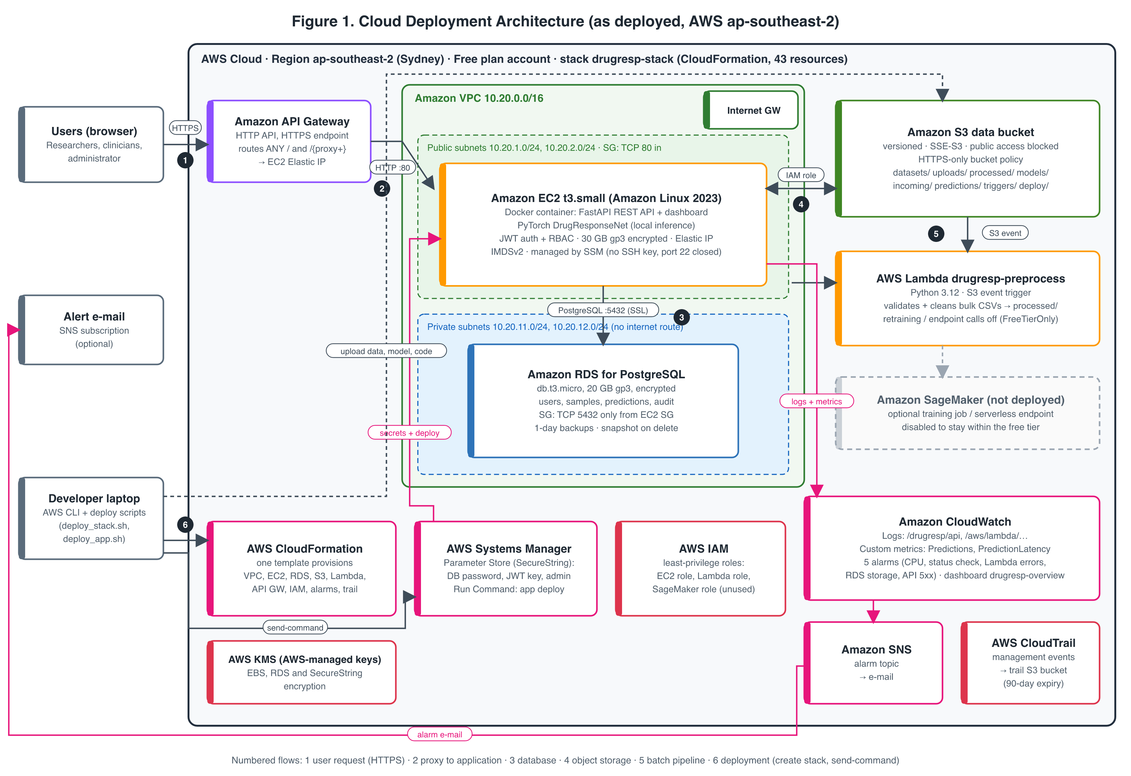
Figure 1. Cloud Deployment Architecture.
All resources run in the AWS ap-southeast-2 region and are created by the CloudFormation stack drugresp-stack. The numbered flows in Figure 1 are as follows:
- Users reach Amazon API Gateway (HTTP API) over HTTPS.
- API Gateway proxies every route to the Elastic IP of the EC2 instance on port 80.
- The FastAPI application, running in Docker on an EC2 t3.small instance in a public subnet, stores users, samples and predictions in Amazon RDS for PostgreSQL. RDS sits in private subnets with no internet route, and its security group admits TCP 5432 only from the EC2 security group.
- Uploaded files, processed samples and model artefacts are stored in a versioned, encrypted Amazon S3 bucket that blocks public access and rejects non-HTTPS requests. The instance reaches S3 through its IAM role, with no stored keys.
- Files written to incoming/*.csv trigger the AWS Lambda function drugresp-preprocess, which validates and cleans them into processed/. Calls to SageMaker are switched off by the FreeTierOnly parameter.
- The developer creates the stack with CloudFormation and deploys the application through AWS Systems Manager Run Command, so no SSH key or open port 22 is needed. Secrets (database password, JWT signing key and admin login) are SecureString parameters in SSM Parameter Store, encrypted with an AWS-managed KMS key.
Amazon CloudWatch collects application and Lambda logs, the custom metrics Predictions and PredictionLatency, five alarms and the drugresp-overview dashboard. Alarms publish to an Amazon SNS topic. AWS CloudTrail records management events to a separate bucket with 90-day expiry.

5.3 Diagram 2 – Complete System Architecture / Workflow (Mandatory)
Figure 2 is shown on the next page in landscape orientation; the full-resolution file is architecture/fig2_system_architecture_workflow.png.
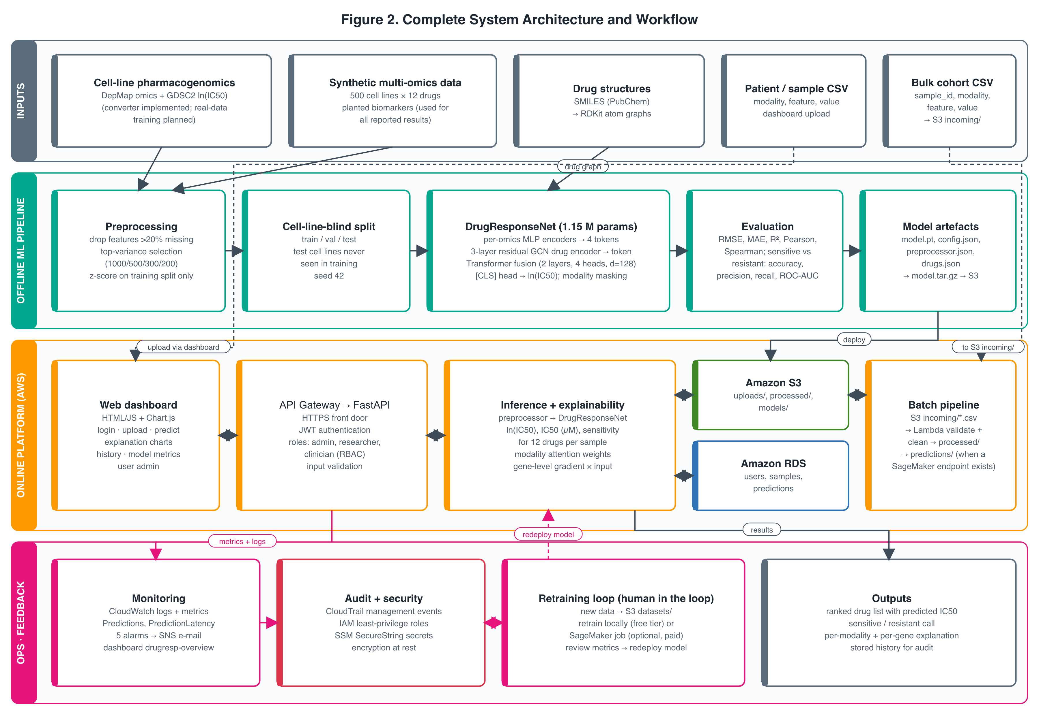
Figure 2. Complete System Architecture / Workflow.
Data moves through four layers. Inputs: synthetic multi-omics data (used for all reported results), a converter for real DepMap and GDSC data, drug SMILES converted to RDKit atom graphs, and user-uploaded sample files. Offline ML pipeline: preprocessing fitted on training cell lines, a cell-line-blind split, DrugResponseNet training and evaluation, and packaging of the model artefacts to S3. Online platform: the dashboard calls the API through API Gateway; the API authenticates the user, stores the sample in S3, runs inference and explanation, and writes results to RDS, and the dashboard renders them. Operations and feedback: CloudWatch and CloudTrail provide monitoring and audit, and a human-reviewed retraining loop produces a new model that is redeployed.

5.4 Workflow and Use Cases
Prediction workflow (researcher or clinician):
- The user signs in; the API verifies the password hash and returns a signed JWT.
- The user uploads a CSV profile; the API validates modalities, drops invalid values and binarises mutations.
- The raw and processed sample are written to S3 (uploads/ and processed/), and a sample record is created in RDS.
- The user selects the sample and drugs, then requests a prediction.
- The API checks that the sample belongs to the user (administrators may see all samples).
- The preprocessor aligns the sample to the model's features; missing modalities are masked.
- DrugResponseNet predicts ln IC50 for each drug; the API derives IC50 in µM and a sensitive or resistant call against each drug's training median.
- The explainer returns modality attention weights and the top gene attributions (gradient × input).
- Predictions are stored in RDS, metrics are sent to CloudWatch, and the dashboard shows the ranked chart, table and explanation.
Other use cases: an administrator creates researcher and clinician accounts (self sign-up is disabled in the cloud); a researcher drops a bulk cohort file into S3 incoming/ for automatic cleaning by Lambda; a researcher reviews prediction history and model metrics; the team retrains the model on new data, reviews the metrics and redeploys.

5.5 Security, Availability and Scalability
- Identity and access: JWT authentication; three roles (admin, researcher, clinician); sample ownership enforced on every query; self sign-up disabled. AWS access uses IAM roles with scoped permissions for EC2 and Lambda; the EC2 role can read only the project's parameters and bucket.
- Network: RDS in private subnets with no internet route; database port open only to the application security group; no SSH (management through SSM); IMDSv2 required on the instance.
- Encryption: HTTPS at API Gateway; S3 SSE-S3 with an HTTPS-only bucket policy; encrypted EBS and RDS storage; PostgreSQL connections with sslmode=require; secrets as KMS-encrypted SecureString parameters, never stored in code.
- Audit and monitoring: CloudTrail management events; CloudWatch logs, metrics and alarms for CPU, failed status checks, Lambda errors, low RDS storage and API 5xx errors.
- Backups and fault handling: S3 versioning (old versions expire after 30 days); RDS automated backups (1 day) and a final snapshot on deletion; the container restarts automatically, and the API retries the database connection at start-up.
- Scalability: the API is stateless (state lives in RDS and S3), so it can be placed behind an Auto Scaling group or moved to the included Kubernetes manifest. Inference can be offloaded to a serverless SageMaker endpoint by setting INFERENCE_MODE=sagemaker.
Known weaknesses (see Section 11): the deployment is a single instance in a single Availability Zone; API Gateway reaches EC2 over plain HTTP; and port 80 of the instance is open to the internet by default, so the API can also be reached directly without HTTPS (test T12).

6. Dataset / Input Data Description
Attribute | Details
Dataset / input name | Synthetic multi-omics drug-response dataset (canonical project format). Real-data path: DepMap omics + GDSC2 dose response (converter implemented, not yet run).
Source / organisation | Generated by the project script datasets/scripts/generate_synthetic.py. Real data: Broad Institute DepMap portal; Wellcome Sanger Institute GDSC.
URL / access method | Created locally and uploaded to s3://drugresp-data-384635610125-ap-southeast-2/datasets/canonical/. Real data: depmap.org/portal and cancerrxgene.org bulk downloads.
Size | 10.8 MB in 7 CSV files (expression 4.2 MB, CNV 4.6 MB, mutation 1.4 MB, proteomics 0.3 MB, responses 0.2 MB, metadata, drugs)
Number of records / samples | 500 cell lines across 8 lineages; 12 drugs; 5,101 cell line–drug response pairs; proteomics available for 258 cell lines
Number of features | 1,500 genes each for expression, CNV and mutation; 200 proteins. After selection: 1,000 / 500 / 300 / 200 features (2,000 in total)
Data type / format | CSV, wide format (rows = cell lines, columns = genes); responses as long-format CSV (cell_line_id, drug_id, ln_ic50, auc); drugs with SMILES
License / restrictions | Synthetic data created by the team, no restrictions. DepMap and GDSC are subject to their providers' terms of use, to be checked before any redistribution.
Purpose | Training, validation and testing of DrugResponseNet; functional and performance testing of the cloud platform
Preprocessing | Drop features with more than 20% missing values; select top-variance features per modality; z-score using training cell lines only; binarise mutations; RDKit atom graphs for drugs
Privacy / ethics | Contains no personal data. The data include planted biomarker effects (EGFR → erlotinib, BRCA1 → olaparib, ABCB1 → doxorubicin resistance), so results show that the pipeline works, not biological validity. Uploaded samples are stored encrypted with per-user access; controlled-access patient data (for example TCGA) must not be uploaded.
Table 4. Dataset description.
The eight lineages and their cell-line counts are Brain 70, Ovary 66, Pancreas 65, Skin 64, Breast 64, Blood 63, Lung 58 and Colorectal 50. The 12 drugs are erlotinib, gefitinib, lapatinib, imatinib, dasatinib, sorafenib, olaparib, 5-fluorouracil, gemcitabine, methotrexate, vorinostat and doxorubicin, chosen to match GDSC2 compounds.

6.1 Data Preparation
Input files are validated for required columns and known modalities, and non-numeric or missing values are removed. Response pairs are kept only where omics data and drug structures exist. The data are split by cell line with GroupShuffleSplit (seed 42): about 70% of cell lines for training and 15% each for validation and testing, giving 3,566, 763 and 772 response pairs. Leakage prevention: no cell line appears in more than one split; feature selection, means and standard deviations are fitted on training cell lines only; the sensitive/resistant threshold for each drug is the median ln IC50 of the training pairs; and the target is standardised with training statistics.

7. Cloud Platform and Services Planning
The platform runs on Amazon Web Services. Status values: Deployed (running in account 384635610125), Tested (exercised by the tests in Section 10), Configured (deployed but not exercised) and Planned (code exists but not deployed).
Platform / service | Purpose | Integration / data flow | Status | Security / cost considerations
AWS CloudFormation | Infrastructure as code for the whole stack | One template creates 43 resources; outputs feed the deploy scripts | Deployed, tested | Repeatable create and delete; no direct cost
Amazon VPC | Network isolation | 2 public and 2 private subnets, internet gateway, security groups | Deployed | No NAT gateway (saves cost); database not internet-reachable
Amazon EC2 (t3.small) | Runs the API, dashboard and model in Docker | API Gateway → EC2; EC2 → RDS and S3 | Deployed, tested | Free-tier-eligible type; IMDSv2; encrypted gp3; managed by SSM
Amazon API Gateway (HTTP API) | HTTPS front door | Proxies ANY / and /{proxy+} to EC2 | Deployed, tested | TLS for clients; pay-per-request
Amazon RDS for PostgreSQL 18.3 | Users, samples, predictions, reporting views | EC2 ↔ RDS on 5432 with SSL | Deployed, tested | Private subnets; encrypted; 1-day backups; db.t3.micro
Amazon S3 | Datasets, uploads, processed samples, models, deploy bundles | API, Lambda and deploy scripts read and write by prefix | Deployed, tested | Versioned; SSE-S3; public access blocked; HTTPS-only
AWS Lambda | Validate and clean bulk cohort CSVs | S3 incoming/*.csv → Lambda → processed/, predictions/ | Deployed; unit-tested only | Pay-per-invocation; SageMaker calls disabled
AWS Systems Manager | SecureString secrets; Run Command deployment | deploy_app.sh → Run Command → setup script on EC2 | Deployed, tested | Replaces Secrets Manager (free); no SSH
AWS IAM | Least-privilege roles for EC2, Lambda and SageMaker | Instance profile and Lambda execution role | Deployed | No access keys on servers; scoped resources
Amazon CloudWatch | Logs, custom metrics, 5 alarms, dashboard | Docker awslogs driver; boto3 PutMetricData | Deployed, tested | Within the free tier (fewer than 10 alarms and metrics)
Amazon SNS | Alarm notifications | Alarms → topic → e-mail | Configured (no subscriber set) | Set ALERT_EMAIL to receive alerts
AWS CloudTrail | Audit of API activity | Management events → trail bucket (90-day expiry) | Deployed | First trail free; S3 data events off to avoid cost
AWS KMS (AWS-managed keys) | Encryption at rest | EBS, RDS, SecureString parameters | Deployed | No charge for AWS-managed keys
Amazon SageMaker | Optional training jobs and serverless endpoint | launch_training.py, deploy_endpoint.py | Planned (implemented, not deployed) | Disabled by FreeTierOnly=true because it is billed
Amazon EKS, Amazon QuickSight | Optional container orchestration and BI | k8s manifest; RDS reporting views | Planned | Not deployed (cost)
Table 5. AWS services used, with purpose, integration and status.

7.1 Deployment and Network Design
Region: ap-southeast-2 (Sydney). The account was created through AWS's projects-based sign-up, which limits each project to one home region; ap-south-1 (Mumbai) was preferred for latency but is blocked by the project's service control policy. Network: VPC 10.20.0.0/16 with public subnets 10.20.1.0/24 and 10.20.2.0/24 for EC2, and private subnets 10.20.11.0/24 and 10.20.12.0/24 for RDS. The web security group admits TCP 80 (configurable through HttpAllowedCidr); the database security group admits TCP 5432 only from the web security group.
Secrets and configuration: deploy_stack.sh creates random SecureString parameters (/drugresp/db-password, jwt-secret, admin-email, admin-password) once. CloudFormation passes the database password to RDS through an ssm-secure dynamic reference, and the setup script on EC2 writes them to a root-only environment file. Deployment method: three commands: deploy_stack.sh (CloudFormation), upload_data.sh (S3) and deploy_app.sh, which packages the code and model, uploads them to S3 and runs the setup script on the instance through SSM Run Command to build and start the container.

7.2 Cost Estimation
The estimate below uses on-demand list prices for ap-southeast-2 taken from the AWS public price lists on 16/10/2026 (EC2 price list published 15/10/2026; RDS price list published 06/10/2026), with the instances running 24 hours a day (730 hours per month). These are estimates, not actual expenditure.
Item | Unit price (USD) | Usage assumption | Est. monthly (USD)
EC2 t3.small (Linux) | 0.0264 per hour | 730 h | 19.27
EBS gp3 volume | 0.096 per GB-month | 30 GB | 2.88
RDS db.t3.micro PostgreSQL, Single-AZ | 0.028 per hour | 730 h | 20.44
RDS gp3 storage | 0.138 per GB-month | 20 GB | 2.76
Public IPv4 address (Elastic IP) | 0.005 per hour (AWS VPC pricing) | 730 h | 3.65
S3, Lambda, API Gateway, CloudWatch, SSM, CloudTrail, KMS | Pay-per-use / free allowances | Demo scale: < 20 MB stored, < 1,000 requests | < 0.10
Total (on-demand equivalent) |  |  | ≈ 49.10
Table 6. Estimated monthly cost (on-demand list prices, ap-southeast-2).
Actual expenditure: the account is on the AWS Free plan, under which AWS does not charge the payment method; usage is deducted from promotional credits. On 16/10/2026 the Free plan API reported US$140 of credits remaining, with the deployment created the same day, so no deduction had yet been recorded. Cost controls: the Free plan itself; FreeTierOnly=true, which removes SageMaker; free-tier-eligible instance types; no NAT gateway; Parameter Store instead of Secrets Manager; CloudTrail without S3 data events; stopping EC2 and RDS between sessions; and deleting the stack after evaluation. At the estimated rate, the credits cover about two to three months of continuous running.

7.3 Portability / Provider-Specific Choices
AWS-specific: CloudFormation, API Gateway, Systems Manager (secrets and deployment), Lambda S3 event triggers, CloudWatch metrics and CloudTrail. Portable: the application is a Docker container; the database is standard PostgreSQL; storage is behind a STORAGE_BACKEND switch (local or S3), so any S3-compatible store works; and the model is plain PyTorch. A docker-compose file runs the whole system locally, and a Kubernetes manifest is provided for EKS or any Kubernetes cluster. Moving to Azure or Google Cloud would mainly mean rewriting the template (for example in Bicep or Terraform), replacing the secrets store and replacing the Lambda trigger.

8. Methodology and Implementation Plan

8.1 Overall Methodology
The project followed an iterative process: (1) requirements and success criteria from the course proposal; (2) a literature review of 15 papers to find gaps; (3) data preparation with a synthetic generator and a converter for real data; (4) design of the model and the cloud architecture; (5) implementation of the model, API, dashboard, Lambda function and infrastructure template; (6) integration, local tests and deployment to AWS; and (7) evaluation of model quality against baselines and of service quality through security, latency and throughput tests.

8.2 Tools and Technologies
Tool / technology | Purpose | Version / configuration
AWS (CloudFormation, EC2, RDS, S3, Lambda, API Gateway, SSM, CloudWatch, SNS, CloudTrail, IAM) | Cloud hosting, storage, security and monitoring | Region ap-southeast-2; Free plan; AWS CLI 2.38.1
Python | Model, API and Lambda | 3.11 (container), 3.12 (Lambda runtime), 3.9 (local development)
PyTorch | DrugResponseNet training and inference | 2.3.1 CPU (container); 2.5.1 (local training)
RDKit, scikit-learn, pandas, NumPy | Molecular graphs, splits and metrics, data handling | RDKit 2025.09.2; scikit-learn 1.6.1
FastAPI, Uvicorn, SQLAlchemy, PyJWT | REST API, ORM and authentication | FastAPI 0.128.8 (local); ≥ 0.110 pinned
PostgreSQL | Relational database | Amazon RDS for PostgreSQL 18.3
HTML, JavaScript, Chart.js | Dashboard | Chart.js 4.4.1
Docker | Packaging and runtime | python:3.11-slim base image on Amazon Linux 2023
pytest | Unit and API tests | 12 tests
Git / GitHub | Version control and collaboration | https://github.com/Vegeta290/AIDrugResponsePrediction_AWS_Cloud_Project_2026 (branch main)
Table 7. Tools and technologies.

8.3 Step-by-Step Implementation Plan
- Requirements and measurable success criteria: objectives O1–O6 (Section 3) defined from the proposal, with numerical thresholds for accuracy, latency and cost.
- Data/input preparation: synthetic generator with planted biomarkers; DepMap/GDSC converter; PubChem SMILES fetcher; canonical CSV format.
- Cloud resource and architecture setup: CloudFormation template for VPC, EC2, RDS, S3, Lambda, API Gateway, IAM, SSM, CloudWatch, SNS and CloudTrail, with a FreeTierOnly switch.
- Application/backend/model development: preprocessing, GNN drug encoder, Transformer fusion, training loop with early stopping, explainer, FastAPI backend with RBAC, dashboard and Lambda handler.
- Integration and security configuration: SecureString secrets, IAM roles, private subnets, HTTPS-only bucket policy, IMDSv2, SSM-based deployment.
- Testing and performance evaluation: unit tests; baseline comparison on the same split; authentication and access-control tests; latency and concurrency tests against the live deployment.
- Deployment, monitoring and documentation: three-command deployment; CloudWatch dashboard and alarms; README, deployment guide, architecture diagrams and this report.

8.4 Evaluation Metrics
- Prediction accuracy (regression): RMSE, MAE, R², and Pearson and Spearman correlation between predicted and measured ln IC50 on test cell lines; mean per-drug Pearson correlation.
- Sensitivity classification: a pair is labelled sensitive when ln IC50 is below the drug's training median. Metrics are accuracy, precision, recall, F1 and ROC-AUC, with the predicted margin from the median as the score.
- Latency: client-measured end-to-end time (curl time_total) for /health and for a 12-drug prediction with explanations; server-side PredictionLatency from CloudWatch.
- Throughput and reliability: requests per second and success rate with 10 concurrent clients; EC2 CPU utilisation from CloudWatch.
- Security: HTTP status codes for unauthenticated, wrongly authenticated and unauthorised requests; network reachability of ports 22 and 80.
- Cost: monthly on-demand estimate from AWS price lists and the Free plan credit balance.

9. Implementation / Development

9.1 Implemented Modules
Module | Implementation details | Platform / services / tools | Evidence | Status
Preprocessing | Missing-value filter, top-variance selection, train-only z-scoring, saved as preprocessor.json | Python, pandas | src/ai_model/preprocess.py; tests/test_pipeline.py | Completed
Drug features | RDKit atom graphs (26 atom features) with normalised adjacency | RDKit | src/ai_model/drug_features.py | Completed
DrugResponseNet | Per-omics encoders, 3-layer residual GCN, 2-layer Transformer, [CLS] head; 1,147,649 parameters | PyTorch | src/ai_model/model.py | Completed
Training and evaluation | Cell-line-blind split, AdamW, early stopping, modality dropout 0.15; SageMaker-compatible | PyTorch, scikit-learn | src/ai_model/train.py; results/metrics.json | Completed (synthetic data)
Inference and explanation | Prediction for selected drugs; attention weights; gradient × input gene attribution | PyTorch | src/ai_model/predictor.py | Completed
Backend API | Auth, users, samples, predictions, stats; RBAC; S3 or local storage; CloudWatch metrics | FastAPI, SQLAlchemy, PostgreSQL | src/backend/app/ | Completed, deployed
Dashboard | Login, upload, prediction chart and table, explanation, history, model metrics, user admin | HTML, JavaScript, Chart.js | src/frontend/; Figures 3–7 | Completed, deployed
Batch Lambda | S3-triggered validation and cleaning; optional endpoint scoring and retraining | AWS Lambda, S3 | src/aws/lambda_preprocess/handler.py; tests/test_lambda.py | Deployed (unit-tested)
Infrastructure | VPC, EC2, RDS, S3, Lambda, API Gateway, IAM, alarms, trail; FreeTierOnly switch | AWS CloudFormation | src/aws/cloudformation/drugresponse-stack.yaml | Deployed (43 resources)
Deployment scripts | Stack, data upload, app deploy through SSM, retrain trigger | Bash, AWS CLI, SSM | src/aws/*.sh, src/aws/ec2/ | Completed, used
SageMaker training and endpoint | Training job launcher, serverless endpoint deploy and test | Amazon SageMaker | src/aws/sagemaker/ | Implemented, not run
TCGA validation | Responder vs non-responder AUC after re-centring | Python | src/ai_model/validate_tcga.py | Implemented, not run
Table 8. Implemented modules and their status (commit 218e4cb).

9.2 Screenshots and Configuration Evidence
All screenshots were captured from the live deployment at https://q6oovdd9rc.execute-api.ap-southeast-2.amazonaws.com/ on 16/10/2026. No passwords, keys or tokens are shown.
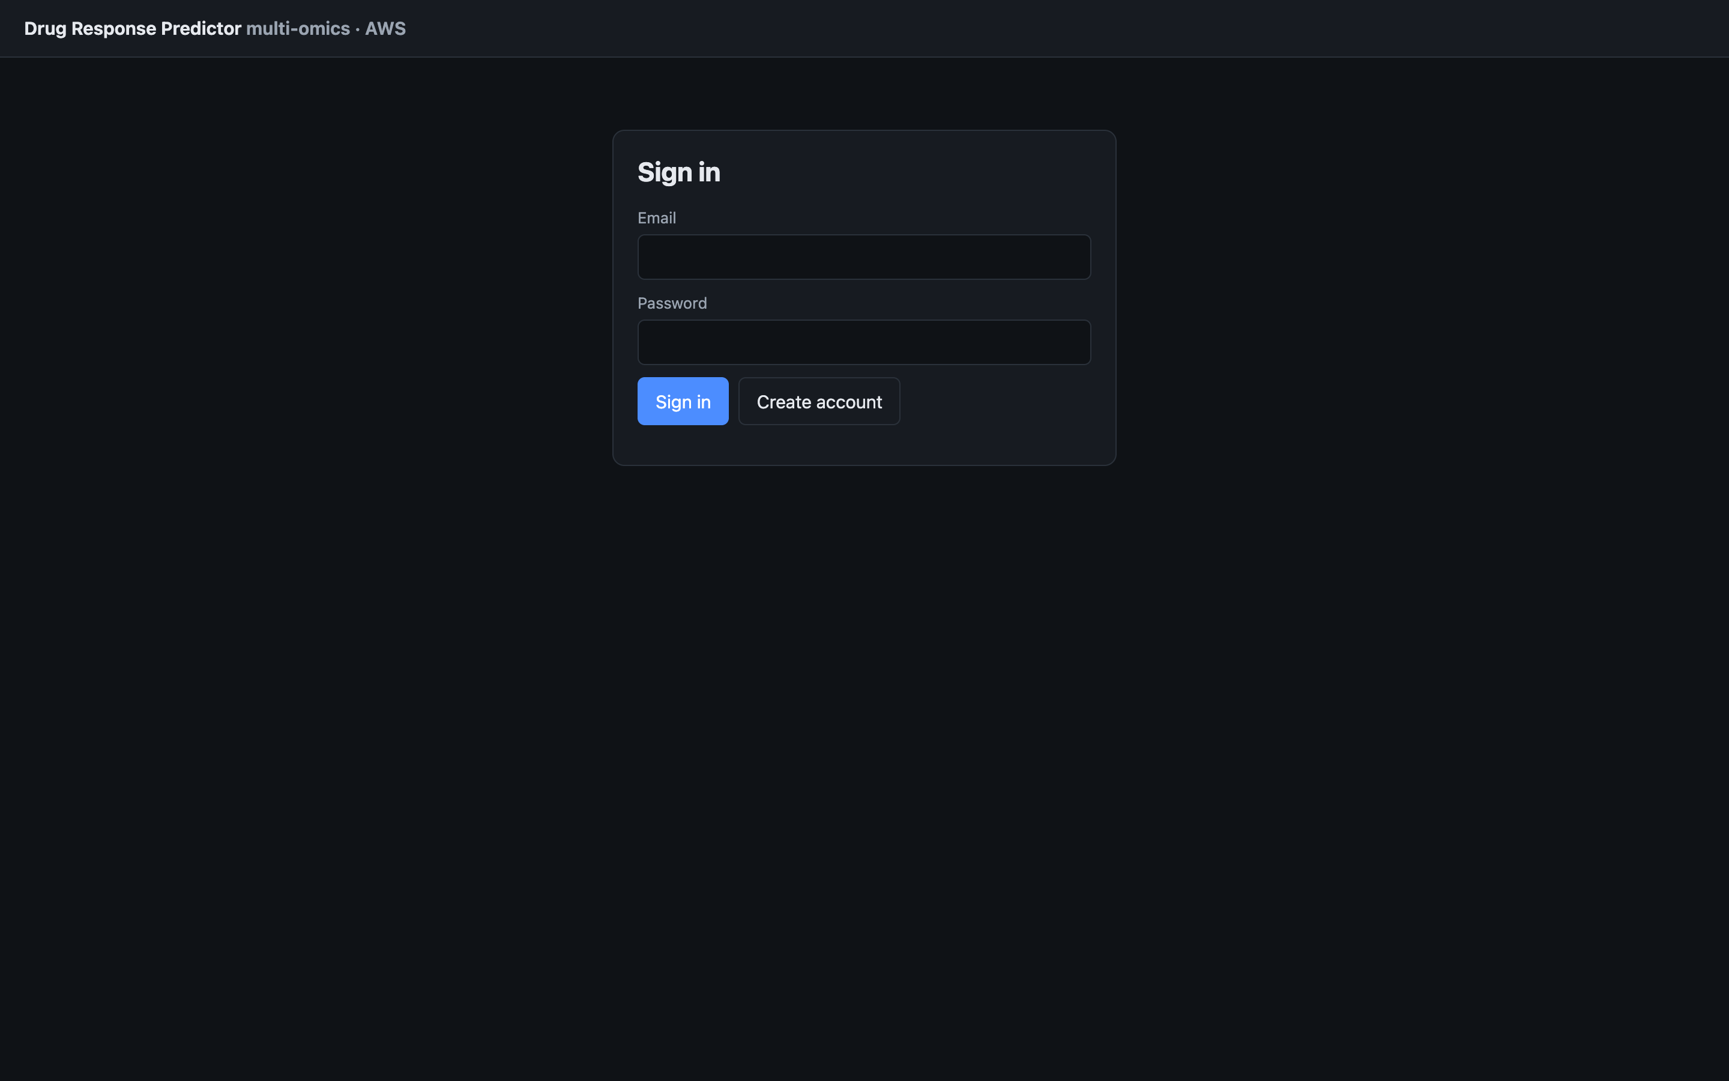
Figure 3. Sign-in page served over HTTPS through API Gateway (16/10/2026).
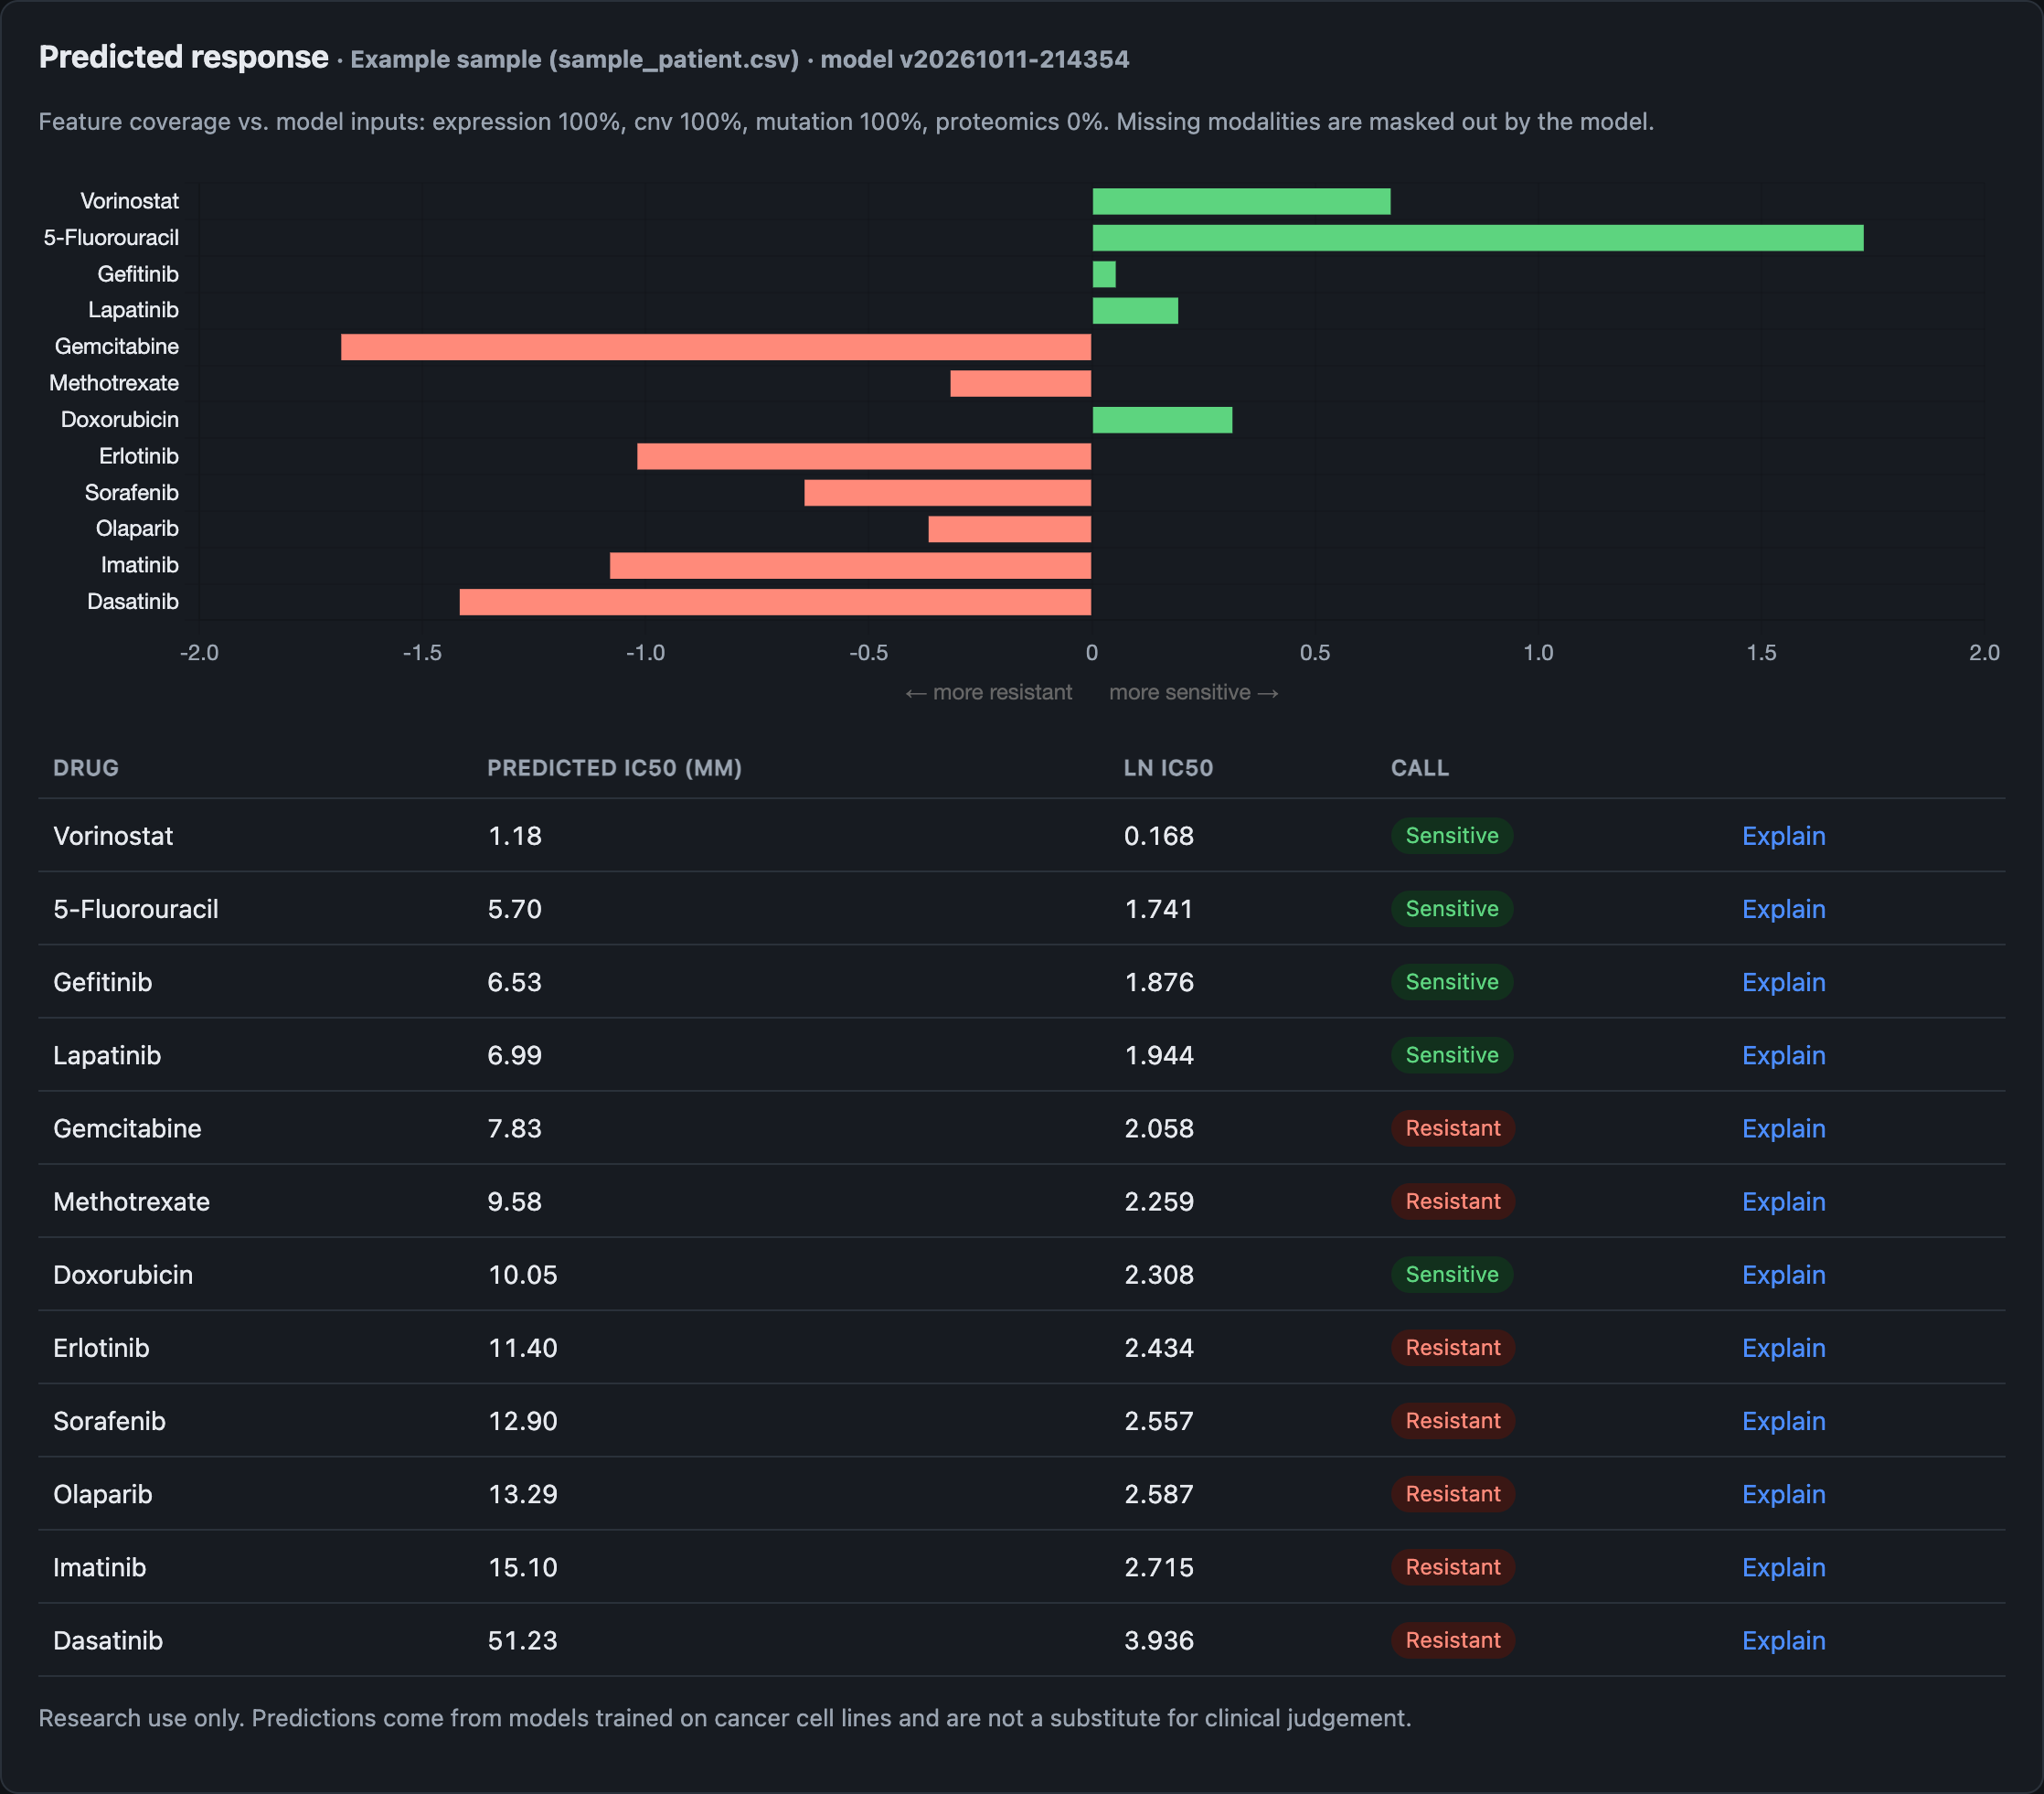
Figure 4. Predicted response for the example sample: sensitivity score chart, IC50 table and sensitive/resistant calls for 12 drugs (16/10/2026).
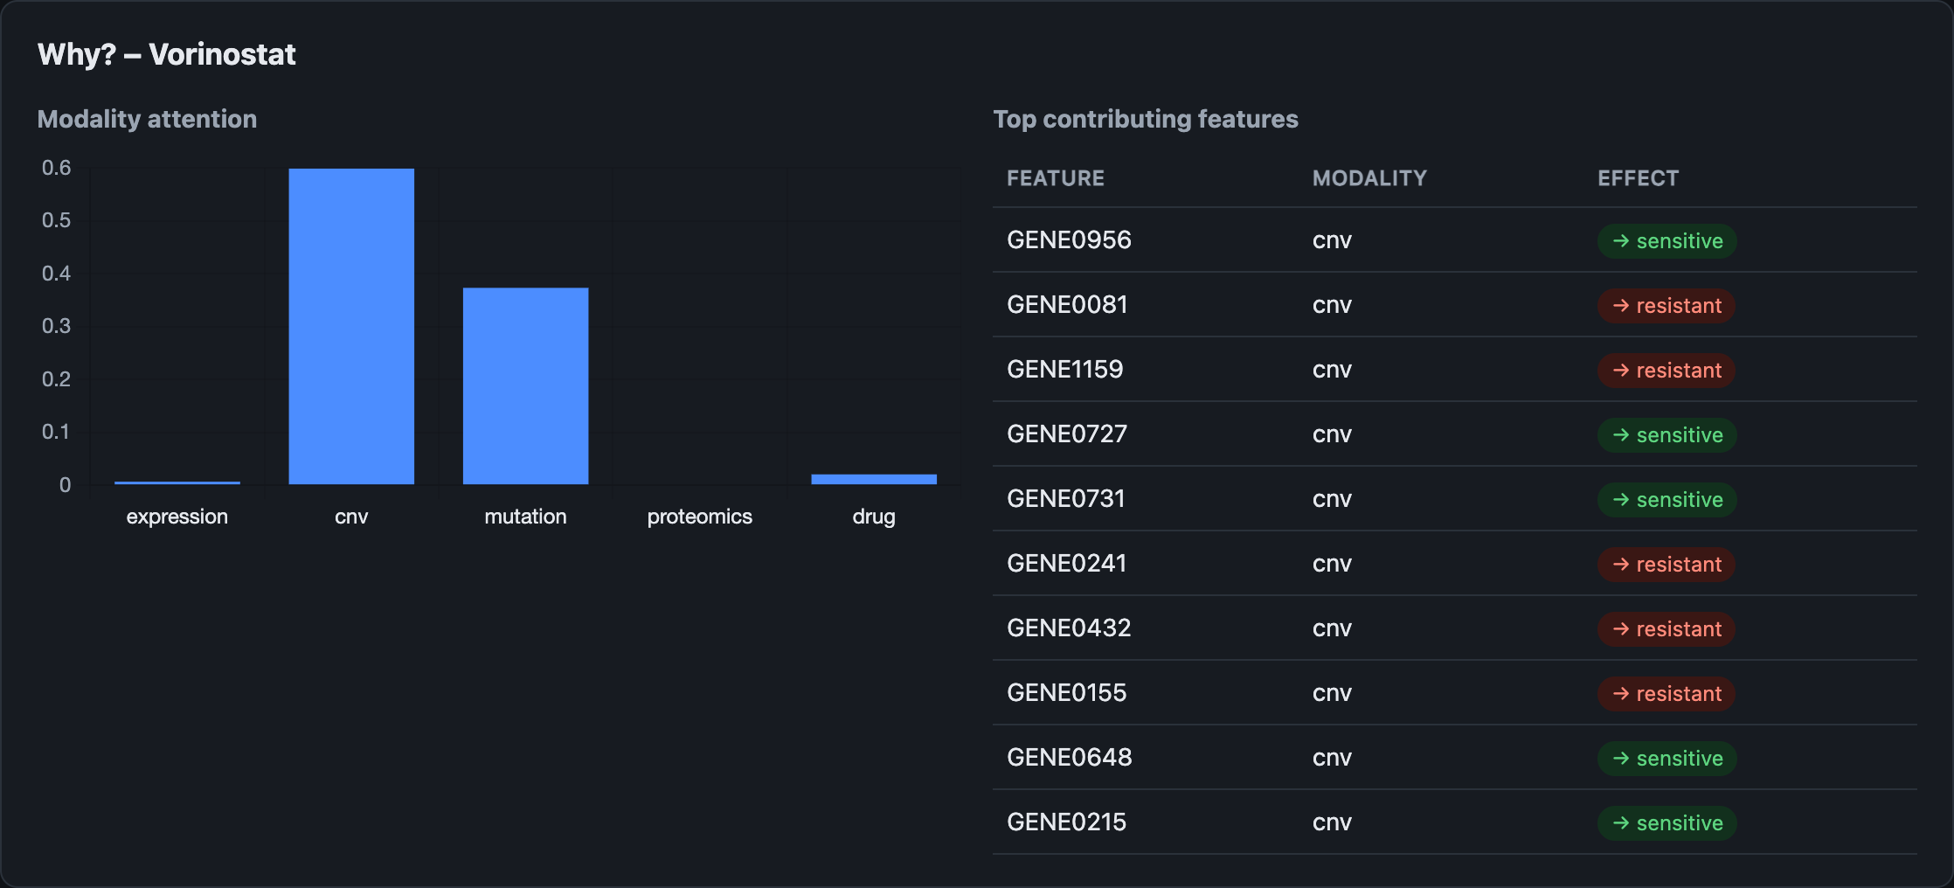
Figure 5. Explanation for vorinostat: modality attention weights and the top contributing genes (16/10/2026).
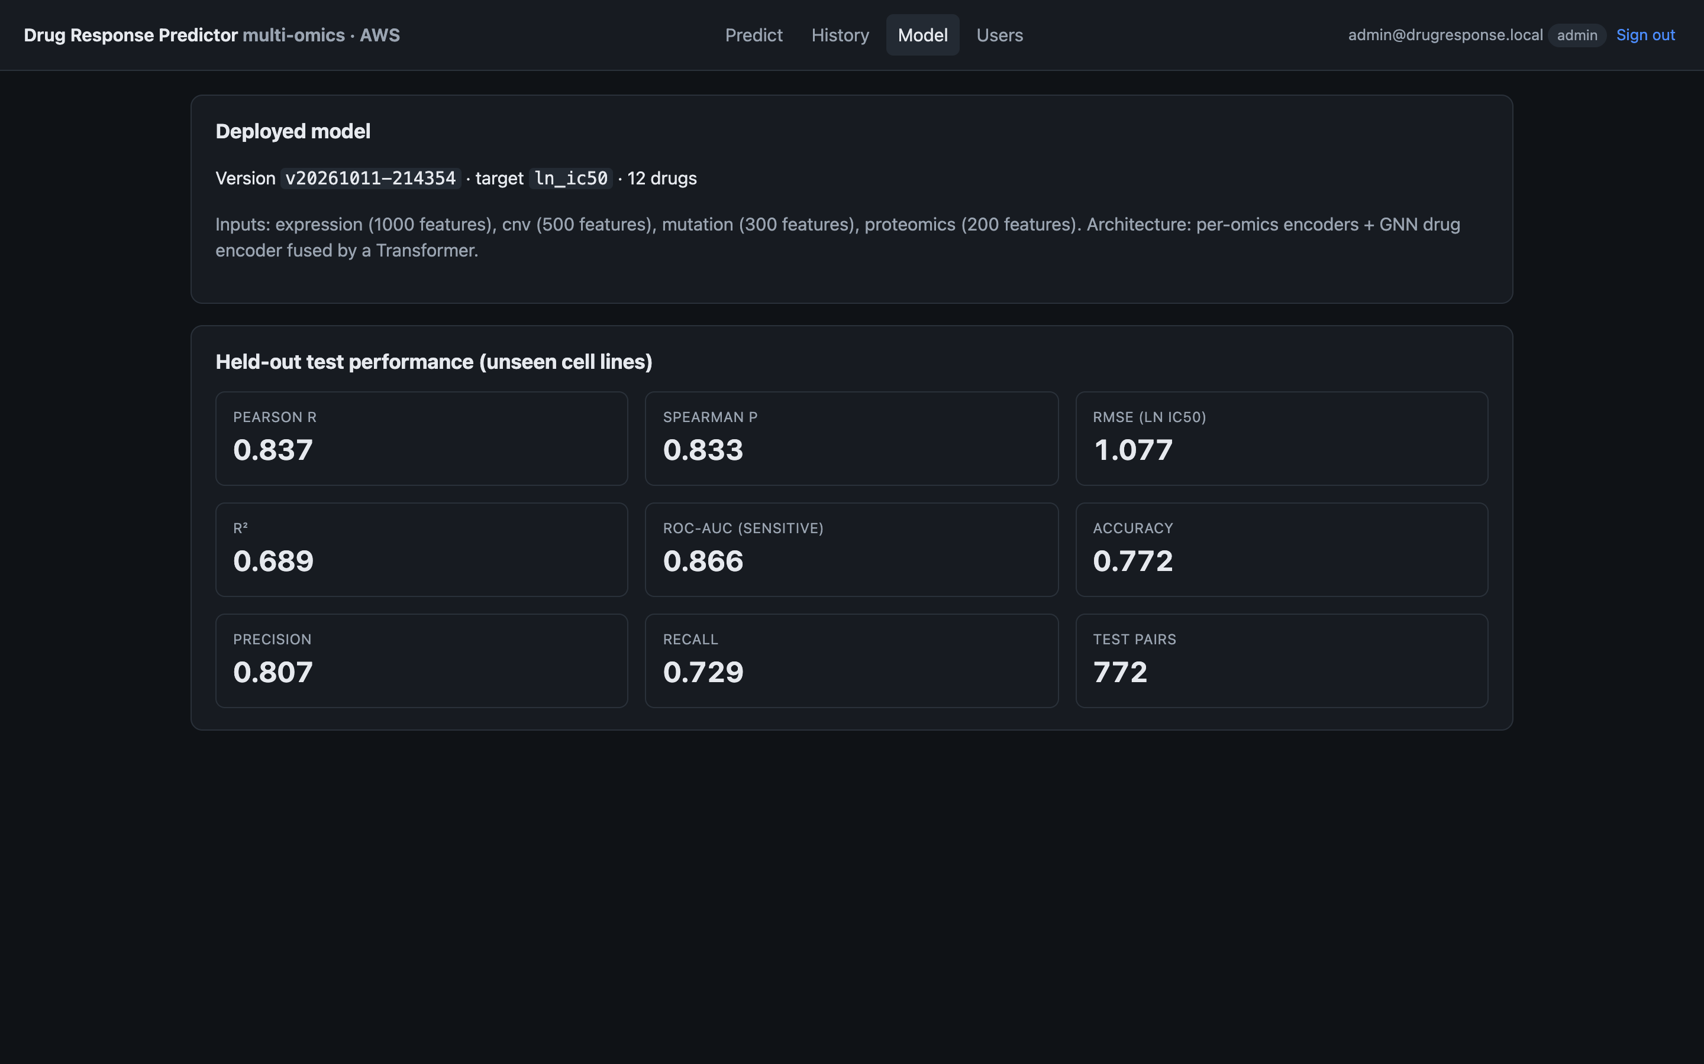
Figure 6. Model page showing the deployed model version and its held-out test metrics (16/10/2026).
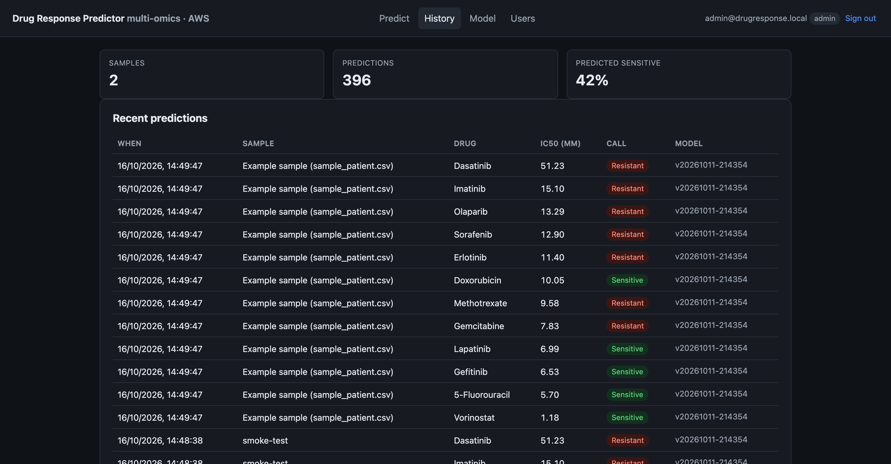
Figure 7. Prediction history with summary tiles; the history includes the predictions made during load testing (16/10/2026).
Cloud configuration evidence (AWS CLI, 16/10/2026):
Resource | Observed configuration
CloudFormation stack drugresp-stack | CREATE_COMPLETE at 08:24 UTC; 43 resources
EC2 i-0da421044665c40e1 | t3.small, running, IMDSv2 required, SSM agent Online
RDS drugresp-db | PostgreSQL 18.3, available, encrypted, not publicly accessible, Single-AZ
S3 datasets/canonical/ | 7 objects, 10.8 MB uploaded
Lambda drugresp-preprocess | python3.12, 1,024 MB, ENABLE_SAGEMAKER=false
CloudWatch DrugResponse/PredictionLatency | 31 samples during testing; average 179.7 ms, minimum 30.0 ms, maximum 447.3 ms
AWS Free plan | Plan FREE, status ACTIVE, US$140 credits remaining
Table 9. Configuration evidence collected with the AWS CLI.

9.3 Repository and Project Structure
Repository: https://github.com/Vegeta290/AIDrugResponsePrediction_AWS_Cloud_Project_2026.
Folder | Contents
src/ai_model/ | Preprocessing, drug features, model, training (SageMaker-ready), inference and explanations, TCGA validation
src/backend/ | FastAPI application and Dockerfile
src/frontend/ | Dashboard (HTML, CSS, JavaScript, Chart.js)
src/aws/ | CloudFormation template, deploy scripts, Lambda handler, SageMaker scripts, EC2 setup, Kubernetes manifest
datasets/ | Synthetic generator, DepMap/GDSC converter, SMILES fetcher, sample patient file (raw data not committed)
tests/ | Pipeline, API and Lambda tests (pytest)
results/ | Test metrics and test-set predictions
docs/ | AWS deployment guide
architecture/, presentation/, literature_survey/, references/ | Diagrams, slides and survey material (being added)
Table 10. Repository structure.

9.4 Version Control Workflow
The repository is hosted on GitHub with main as the default branch. At the time of writing, the history contains one commit (218e4cb, 16/10/2026) that imports the complete project. Generated data, local databases, uploads, virtual environments and model weights are excluded through .gitignore, and the commit was scanned for credentials before pushing. The agreed workflow for the remaining work is: a develop branch for integration; feature branches named feature/abhijeet-…, feature/sarthak-… and feature/shriyans-… for each student's work; pull requests into develop reviewed by at least one other team member; merge conflicts resolved by the pull-request author after rebasing on develop; and release tags (for example v1.0-final) on main for the evaluated version.

10. Testing, Results and Observations

10.1 Test Plan and Test Cases
Tests T03–T14 ran on 16/10/2026 against the live deployment from a client laptop in India; T01 ran locally.
Test ID | Scenario | Input / setup | Expected result | Observed result | Pass/Fail
T01 | Functional: unit and API tests | pytest (12 tests) | All pass | 12 passed | Pass
T02 | Functional: infrastructure provisioning | deploy_stack.sh | CREATE_COMPLETE | CREATE_COMPLETE, 43 resources | Pass
T03 | Functional: health check | GET /health | status ok, model loaded | {"status":"ok","model_loaded":true} | Pass
T04 | Functional: end-to-end prediction | Login, upload sample_patient.csv, predict | 12 drugs with explanations | 12 drugs, attention and gene attributions returned | Pass
T05 | Security: no token | GET /api/samples without JWT | 401 | 401 | Pass
T06 | Security: forged token | Bearer abc.def.ghi | 401 | 401 | Pass
T07 | Security: wrong password | POST /api/auth/login | 401 | 401 | Pass
T08 | Security: self sign-up disabled | POST /api/auth/signup | 403 | 403 | Pass
T09 | Access control: role | Researcher calls GET /api/users (admin only) | 403 | 403 | Pass
T10 | Access control: ownership | Researcher predicts on admin's sample 1 | Denied | 404; researcher's sample list empty | Pass
T11 | Security: SSH | TCP 22 on the Elastic IP | Closed | Closed | Pass
T12 | Security: bypass of HTTPS | HTTP GET /health directly on the EC2 Elastic IP | Blocked; HTTPS only | 200 (reachable without TLS) | Fail
T13 | Performance: latency | 10 sequential 12-drug predictions | Median ≤ 2 s | Median 1,072 ms; p90 1,143 ms | Pass
T14 | Scalability: concurrency | 20 predictions, 10 concurrent clients | No errors | 20/20 succeeded; 6.6 requests/s; median 1,356 ms | Pass
Table 11. Test cases and results.

10.2 Results
Model quality. The model was trained for up to 25 epochs (batch size 256, learning rate 0.001, early-stopping patience 6, seed 42) on 3,566 pairs from the synthetic dataset, and evaluated once on the validation (763 pairs) and test (772 pairs) cell lines, which were not seen in training. These are single-run results; repeated runs with different seeds have not yet been done.
Metric | Validation | Test
RMSE (ln IC50) | 1.100 | 1.077
MAE | 0.837 | 0.861
R² | 0.674 | 0.689
Pearson r | 0.822 | 0.837
Spearman ρ | 0.818 | 0.833
Mean per-drug Pearson r | 0.770 | 0.785
Accuracy (sensitive vs resistant) | 0.810 | 0.772
Precision | 0.842 | 0.807
Recall | 0.790 | 0.729
F1 | 0.815 | 0.766
ROC-AUC | 0.883 | 0.866
Table 12. DrugResponseNet results on unseen cell lines (synthetic data).
Per-drug test Pearson correlation ranged from 0.603 to 0.869 across the 12 drugs (Table 13).
Drug ID | Drug | Test Pearson r
1079 | Imatinib | 0.869
51 | Dasatinib | 0.860
1085 | Sorafenib | 0.848
1012 | Vorinostat | 0.843
1190 | Gemcitabine | 0.839
1017 | Olaparib | 0.821
1010 | Gefitinib | 0.804
1073 | 5-Fluorouracil | 0.787
1006 | Erlotinib | 0.782
133 | Doxorubicin | 0.685
1558 | Lapatinib | 0.682
1008 | Methotrexate | 0.603
Table 13. Test Pearson correlation for each drug.
Service performance. The test environment was the deployed stack (EC2 t3.small, RDS db.t3.micro, Sydney) with the client in India, so client-measured times include about 0.85 s of network round trip and TLS set-up (median /health time 853 ms over 20 requests).
Measurement | Sample size | Result
GET /health, end to end | 20 sequential requests | mean 855 ms; median 853 ms; min 836 ms; max 892 ms
12-drug prediction with explanations, end to end | 10 sequential requests | mean 1,053 ms; median 1,072 ms; min 933 ms; max 1,163 ms
12-drug prediction, 10 concurrent clients | 20 requests | 20/20 HTTP 200; 6.6 requests/s; median 1,356 ms; max 1,636 ms
Server-side PredictionLatency (CloudWatch) | 31 predictions | average 179.7 ms; min 30.0 ms; max 447.3 ms
EC2 CPU utilisation during tests (CloudWatch) | 3-hour window | average 5.6%; maximum 47.6%
Table 14. Measured service performance on 16/10/2026.

10.3 Baseline Comparison
Four baselines were trained and evaluated on exactly the same cell-line-blind split, selected features and sensitivity thresholds: (a) the training mean of each drug; (b) a single ridge regression (α = 100) on all omics features plus a one-hot drug encoding; (c) a separate ridge regression for each drug; and (d) a random forest (300 trees) on the same features as (b).
Model (test set, 772 pairs) | RMSE | Pearson r | Spearman ρ | ROC-AUC | F1
Per-drug mean | 1.742 | 0.434 | 0.429 | 0.495 | 0.538
Ridge, global (omics + drug one-hot) | 1.669 | 0.516 | 0.491 | 0.605 | 0.591
Random forest, global | 1.334 | 0.772 | 0.765 | 0.848 | 0.767
Ridge, one model per drug | 0.810 | 0.908 | 0.898 | 0.919 | 0.840
DrugResponseNet (this work) | 1.077 | 0.837 | 0.833 | 0.866 | 0.766
Table 15. Baseline comparison on the same test cell lines.
DrugResponseNet clearly outperforms the per-drug mean, the global ridge model and the global random forest, which, like it, use one model for all drugs. However, the per-drug ridge baseline performs better (Pearson 0.908 vs 0.837; ROC-AUC 0.919 vs 0.866). The synthetic generator plants mostly linear, drug-specific biomarker effects, which is exactly what a separate linear model per drug captures. A per-drug model cannot score a new drug, while DrugResponseNet uses the molecular graph and in principle can; this advantage has not yet been tested. A fair conclusion requires real DepMap/GDSC data, an unseen-drug split and repeated runs.

10.4 Results Summary
Objective | Status | Evidence
O1 Leakage-free preprocessing | Achieved | Train-only fitting (Section 6.1); T01
O2 Multimodal model | Partly achieved | Test Pearson 0.837 (≥ 0.80) and ROC-AUC 0.866 (≥ 0.85); beats 3 of 4 baselines; a per-drug ridge model scores higher
O3 Explainable predictions | Achieved | T04; Figure 5
O4 Secure deployment as code | Achieved, with one finding | T02, T05–T11 pass; T12 shows direct HTTP access to EC2
O5 Performance and observability | Achieved | Median 1.07 s (T13); 6.6 requests/s (T14); CloudWatch metrics and 5 alarms (no SNS subscriber yet)
O6 Cost control | Achieved (estimate) | ≈ US$49 per month on-demand equivalent; Free plan; no SageMaker; actual spend not yet reported
Table 16. Objectives mapped to status and evidence.

11. Discussion, Limitations and Risk Analysis

11.1 Discussion
The results show that the complete pipeline works end to end. A multi-omics profile uploaded through the browser is stored securely, scored for 12 drugs and explained in about one second, and the server-side model time is under 0.2 s on average. Most of the client-side time is network distance between India and Sydney, so a deployment in Mumbai would be noticeably faster. The service handled 10 concurrent clients with no errors at about 6.6 predictions per second on a single small instance, which is sufficient for a research team. Peak CPU utilisation was below 50%.
The model result is encouraging but must be read carefully. On unseen cell lines it clearly beats the global baselines, but a simple per-drug ridge model does better on this synthetic data. This agrees with the reviewed literature: P3 found simple interpretable models often match complex ones, and P14 and P15 warn that results depend strongly on the dataset and split. The value of the deep model, namely one model for all drugs, handling of missing modalities, use of drug structure and built-in explanations, has to be confirmed on real data and on unseen drugs.

11.2 Limitations
- Data: all model results use synthetic data with planted, largely linear effects; no real DepMap/GDSC training or TCGA validation has been run yet.
- Evaluation: single training run with one seed; no confidence intervals; no unseen-drug or cross-dataset evaluation.
- Technical: a single EC2 instance and a Single-AZ database (no high availability); API Gateway reaches EC2 over plain HTTP; port 80 is open to the internet (T12); the Lambda function has been tested only with unit tests, not with a real S3 event.
- Cloud account: the projects-based account restricts work to ap-southeast-2, which adds network latency from India; SNS alarm e-mail is not yet subscribed.
- Cost: only estimates are available because the Free plan had not yet reported any credit usage at the time of writing.
- Time: the SageMaker, EKS and QuickSight paths are implemented or documented but were not exercised.

11.3 Risks and Mitigation
Risk | Likelihood / impact | Mitigation | Residual risk
Unexpected cloud cost | Low / Medium | Free plan (no card charges); FreeTierOnly switch; budget alerts; stop EC2/RDS between sessions; delete stack after evaluation | Low
Credential exposure / misconfiguration | Medium / High | Least-privilege roles; SecureString secrets; no secrets in Git (scanned); rotate long-lived IAM access keys used for deployment and prefer short-term credentials | Low–Medium
Direct HTTP access bypassing API Gateway | High / Medium | Restrict HttpAllowedCidr to API Gateway, or use a VPC link with a private integration, or terminate TLS on the instance | Low after fix
Data quality / availability | Medium / High | Input validation; leakage-free preprocessing; S3 versioning and RDS backups; real DepMap/GDSC data as the next source | Medium
Provider dependency / service outage | Low / High | Infrastructure as code for fast re-creation; Docker image portable to other hosts; documented dependencies | Medium (single AZ)
Model over-fitting to synthetic data | High / High | Report baselines honestly; retrain and validate on real data and TCGA before any claim; research-use-only notice | Medium
Table 17. Risks and mitigation.

12. Team Contribution and Project Management
Activity | Abhijeet Sinha (23BIT0157) | Sarthak Pathak (23BIT0187) | Shriyans Pratihari (23BIT0219)
Literature survey and assigned paper analysis | P2, P7, P10, P12, P13 (model papers) | P1, P4, P5, P11, P14 (reviews, cloud, MLOps) | P3, P6, P8, P9, P15 (explainability, clinical translation)
Research gap and novelty | Model and algorithm gaps | Cloud, MLOps and evaluation gaps | Explainability and clinical-use gaps
Frontend / application | Explanation views (model outputs) | – | Dashboard: upload, prediction, history, admin views
Backend / API / database | Inference and explanation integration | FastAPI, RBAC, PostgreSQL schema, S3 storage | API integration with the dashboard
Cloud services and security | SageMaker training scripts | CloudFormation, IAM, VPC, SSM, monitoring, deployment | CloudWatch dashboard review, end-to-end deployment testing
Dataset / AI-ML | Synthetic data, preprocessing, DrugResponseNet, training, baselines | Data upload pipeline to S3 | Sample file format and validation
Testing and results | Model metrics and baseline comparison | Security, latency and concurrency tests | Functional end-to-end and UI tests
Documentation and presentation | Model sections | Cloud sections and diagrams | Introduction, results presentation, slides
Table 18. Division of work among team members.

12.1 Individual Contribution Evidence
Repository: https://github.com/Vegeta290/AIDrugResponsePrediction_AWS_Cloud_Project_2026. The repository was pushed on 16/10/2026 as a single initial commit (218e4cb on main, author account Vegeta290), so per-student commits, pull requests and reviews are not yet visible in the history. To meet the course guidelines, each student will add their remaining work (literature notes, slides, diagrams and the fixes listed in Section 13.2) on their own feature branch and merge it through a reviewed pull request. The resulting commit and pull-request links will be listed here in the final version.

13. Conclusion and Future Enhancements

13.1 Conclusion
This project addressed the gap between accurate but offline drug-response models and the secure, explainable services that research teams need. It delivered an explainable multi-omics GNN + Transformer model, a role-based web platform and a complete AWS deployment, created from one CloudFormation template and run within the AWS Free plan. On synthetic data, the model met its accuracy targets on unseen cell lines (Pearson 0.837, ROC-AUC 0.866) and beat three of four baselines, although a per-drug ridge model scored higher. The deployed service returned explained 12-drug predictions in a median of 1.07 s, handled concurrent users without errors, and passed all authentication and access-control tests except one network-exposure finding. Objectives O1, O3, O5 and O6 were achieved, O4 was achieved with one finding to fix, and O2 was partly achieved.

13.2 Future Enhancements
- Train on real DepMap and GDSC data, evaluate on unseen cell lines and unseen drugs with several seeds, and run the TCGA responder validation.
- Close the T12 finding: restrict port 80 to API Gateway or use a private VPC-link integration, and enable TLS between API Gateway and the application.
- Subscribe an e-mail address to the SNS alarm topic and add an AWS Budgets alert.
- Test the Lambda batch pipeline with real S3 events, and enable the SageMaker serverless endpoint when credits allow.
- Improve availability with an Auto Scaling group across two Availability Zones and Multi-AZ RDS, or move to the provided Kubernetes manifest.
- Move the deployment to ap-south-1 (Mumbai) to reduce latency for users in India once the account allows more regions.
- Add CI/CD (tests and deployment on each merge) and model versioning with a human approval step.

References
Reviewed papers (Table 1):
[1] Bang, D., Koo, B., & Kim, S. (2024). Transfer learning of condition-specific perturbation in gene interactions improves drug response prediction. Bioinformatics, 40(Supplement_1), i130–i139. https://doi.org/10.1093/bioinformatics/btae249
[2] Carretero, J., & Krefting, D. (2024). Cluster and cloud computing for life sciences. Future Generation Computer Systems, 152, 254–256. https://doi.org/10.1016/j.future.2023.10.016
[3] Chen, H. O., Cui, Y. C., Lin, P. C., & Chiang, J. H. (2024). An innovative multi-omics model integrating latent alignment and attention mechanism for drug response prediction. Journal of Personalized Medicine, 14(7), 694. https://doi.org/10.3390/jpm14070694
[4] Cinaglia, P., Vázquez-Poletti, J. L., & Cannataro, M. (2023). Massive parallel alignment of RNA-seq reads in serverless computing. Big Data and Cognitive Computing, 7(2), 98. https://doi.org/10.3390/bdcc7020098
[5] Gimeno, M., Sada del Real, K., & Rubio, A. (2023). Precision oncology: A review to assess interpretability in several explainable methods. Briefings in Bioinformatics, 24(4), bbad200. https://doi.org/10.1093/bib/bbad200
[6] Kim, J., Park, S. H., & Lee, H. (2024). PANCDR: Precise medicine prediction using an adversarial network for cancer drug response. Briefings in Bioinformatics, 25(2), bbae088. https://doi.org/10.1093/bib/bbae088
[7] Li, P., Jiang, Z., Liu, T., Liu, X., Qiao, H., & Yao, X. (2024). Improving drug response prediction via integrating gene relationships with deep learning. Briefings in Bioinformatics, 25(3), bbae153. https://doi.org/10.1093/bib/bbae153
[8] Li, Y., Tian, J., Xu, A., Greiner, R., Hayward, J., Greenshaw, A. J., & Cao, B. (2025). Maturity framework for operationalizing machine learning applications in health care: Scoping review. Journal of Medical Internet Research, 27, e66559. https://doi.org/10.2196/66559
[9] Partin, A., Brettin, T. S., Zhu, Y., Narykov, O., Clyde, A., Overbeek, J., & Stevens, R. L. (2023). Deep learning methods for drug response prediction in cancer: Predominant and emerging trends. Frontiers in Medicine, 10, 1086097. https://doi.org/10.3389/fmed.2023.1086097
[10] Partin, A., Vasanthakumari, P., Narykov, O., Wilke, A., Koussa, N., Jones, S. E., Zhu, Y., Overbeek, J. C., Jain, R., Fernando, G. D., Sanchez-Villalobos, C., Garcia-Cardona, C., Mohd-Yusof, J., Chia, N., Wozniak, J. M., Ghosh, S., Pal, R., Brettin, T. S., Weil, M. R., & Stevens, R. L. (2026). Benchmarking community drug response prediction models: Datasets, models, tools, and metrics for cross-dataset generalization analysis. Briefings in Bioinformatics, 27(1), bbaf667. https://doi.org/10.1093/bib/bbaf667
[11] Sada Del Real, K., Swamy, V. S., Arcagni, J., Wang, E., Rabadan, R., & Rubio, A. (2026). Foundation models and deep learning for cancer drug response prediction: A framework for data, metrics, and validation. Briefings in Bioinformatics, 27(3), bbag225. https://doi.org/10.1093/bib/bbag225
[12] Wu, Y., Chen, M., & Qin, Y. (2025). Anticancer drug response prediction integrating multi-omics pathway-based difference features and multiple deep learning techniques. PLOS Computational Biology, 21(3), e1012905. https://doi.org/10.1371/journal.pcbi.1012905
[13] Xia, X., Zhu, C., Zhong, F., & Liu, L. (2024). TransCDR: A deep learning model for enhancing the generalizability of drug activity prediction through transfer learning and multimodal data fusion. BMC Biology, 22, 227. https://doi.org/10.1186/s12915-024-02023-8
[14] Yang, Y., & Li, P. (2023). GPDRP: A multimodal framework for drug response prediction with graph transformer. BMC Bioinformatics, 24, 484. https://doi.org/10.1186/s12859-023-05618-0
[15] Zhou, Y., Dai, Q., Xu, Y., Wu, S., Cheng, M., & Zhao, B. (2025). PharmaFormer predicts clinical drug responses through transfer learning guided by patient derived organoid. npj Precision Oncology, 9, 282. https://doi.org/10.1038/s41698-025-01082-6
Datasets, methods, cloud documentation and tools:
[16] Amazon Web Services. (2026). Choosing an AWS Free Tier plan. AWS Billing User Guide. https://docs.aws.amazon.com/awsaccountbilling/latest/aboutv2/free-tier-plans.html
[17] Amazon Web Services. (2026). AWS CloudFormation user guide. https://docs.aws.amazon.com/AWSCloudFormation/latest/UserGuide/
[18] Amazon Web Services. (2026). Working with HTTP APIs. Amazon API Gateway Developer Guide. https://docs.aws.amazon.com/apigateway/latest/developerguide/http-api.html
[19] Amazon Web Services. (2026). AWS Systems Manager Parameter Store. https://docs.aws.amazon.com/systems-manager/latest/userguide/systems-manager-parameter-store.html
[20] Amazon Web Services. (2026). AWS price list bulk API: Amazon EC2 and Amazon RDS offer files, ap-southeast-2 [Data set]. Retrieved October 16, 2026, from https://pricing.us-east-1.amazonaws.com/offers/v1.0/aws/index.json
[21] Ghandi, M., Huang, F. W., Jané-Valbuena, J., Kryukov, G. V., Lo, C. C., McDonald, E. R., … Sellers, W. R. (2019). Next-generation characterization of the Cancer Cell Line Encyclopedia. Nature, 569(7757), 503–508. https://doi.org/10.1038/s41586-019-1186-3
[22] Iorio, F., Knijnenburg, T. A., Vis, D. J., Bignell, G. R., Menden, M. P., Schubert, M., … Garnett, M. J. (2016). A landscape of pharmacogenomic interactions in cancer. Cell, 166(3), 740–754. https://doi.org/10.1016/j.cell.2016.06.017
[23] Kipf, T. N., & Welling, M. (2017). Semi-supervised classification with graph convolutional networks. International Conference on Learning Representations. https://arxiv.org/abs/1609.02907
[24] Landrum, G. (2025). RDKit: Open-source cheminformatics (Version 2025.09.2) [Computer software]. https://www.rdkit.org
[25] Paszke, A., Gross, S., Massa, F., Lerer, A., Bradbury, J., Chanan, G., … Chintala, S. (2019). PyTorch: An imperative style, high-performance deep learning library. Advances in Neural Information Processing Systems, 32. https://arxiv.org/abs/1912.01703
[26] Ramírez, S. (2026). FastAPI [Computer software]. https://fastapi.tiangolo.com
[27] Vaswani, A., Shazeer, N., Parmar, N., Uszkoreit, J., Jones, L., Gomez, A. N., Kaiser, Ł., & Polosukhin, I. (2017). Attention is all you need. Advances in Neural Information Processing Systems, 30. https://arxiv.org/abs/1706.03762
[28] Yang, W., Soares, J., Greninger, P., Edelman, E. J., Lightfoot, H., Forbes, S., … Garnett, M. J. (2013). Genomics of Drug Sensitivity in Cancer (GDSC): A resource for therapeutic biomarker discovery in cancer cells. Nucleic Acids Research, 41(D1), D955–D961. https://doi.org/10.1093/nar/gks1111

Appendix A – Project Timeline
Task | Planned start | Planned end | Owner(s) | Status / evidence
Literature survey | 20/07/2026 | 31/08/2026 | All three students | Completed – Section 2
Research gap and novelty | 01/09/2026 | 15/09/2026 | All three students | Completed – Sections 2.2–4
Architecture design | 16/09/2026 | 30/09/2026 | Sarthak Pathak, Abhijeet Sinha | Completed – Figures 1–2
Implementation and integration | 01/10/2026 | 16/10/2026 | All three students | Completed – code dated 11/10/2026; AWS deployment 16/10/2026
Testing and report | 14/10/2026 | 16/10/2026 | All three students | Completed – Section 10; this report
Table 19. Project timeline.

Appendix B – Final Review Checklist
☑ Abstract is 200–300 words.
☑ 15 research papers are reviewed and cited.
☑ Each student has completed an independent research gap analysis for assigned papers.
☑ 4–6 measurable objectives are stated.
☑ Novelty is clearly differentiated from existing work and supported by evidence.
☑ Both cloud deployment and complete system architecture diagrams are included.
☑ Dataset/input source, size, format, license, purpose, and preprocessing are documented where applicable.
☑ Cloud provider, services, purpose, status, security, monitoring, and estimated cost are documented.
☑ Implementation evidence and test cases are included; planned work is distinguished from completed work.
☑ Results are genuine, reproducible where possible, and mapped to objectives.
☐ Repository, version-control workflow, and individual contributions are documented (per-student commits and pull requests pending; see Section 12.1).
☑ APA references and in-text citations are consistent.
☑ No credentials or confidential data appear in the report or repository.
☑ Required formatting is applied and placeholders have been removed (Team Number left blank as instructed).

