**Creating Collection in DB------------------------------**

1.

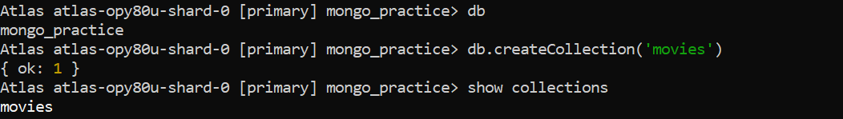

Inserting document in collection



Inserting many document at once in collection

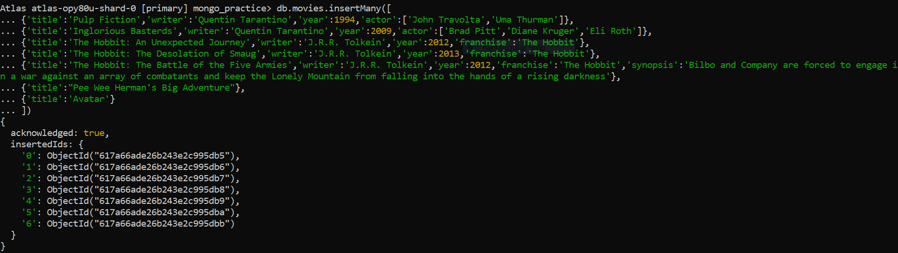

**QUERY/FIND DOCUMENTS:------**

1.

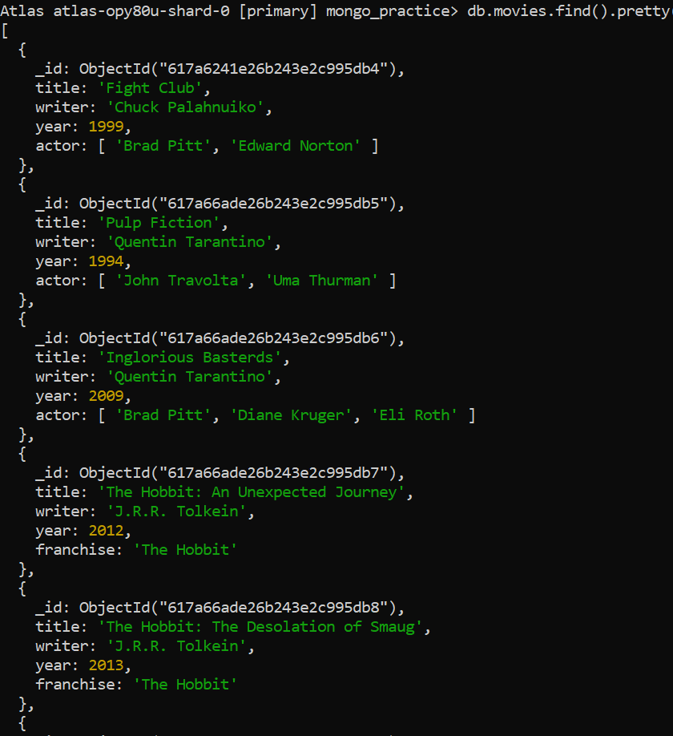

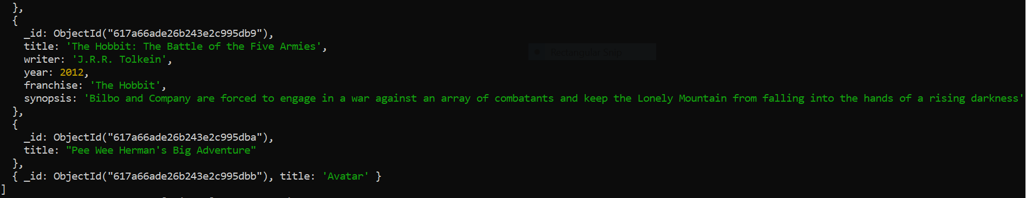

2.

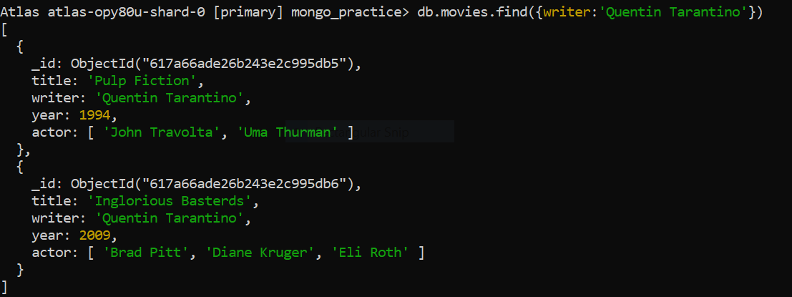

3.

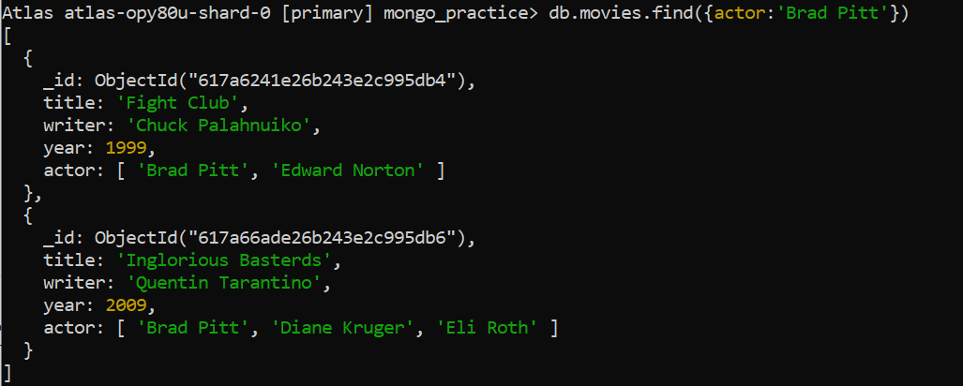

4.

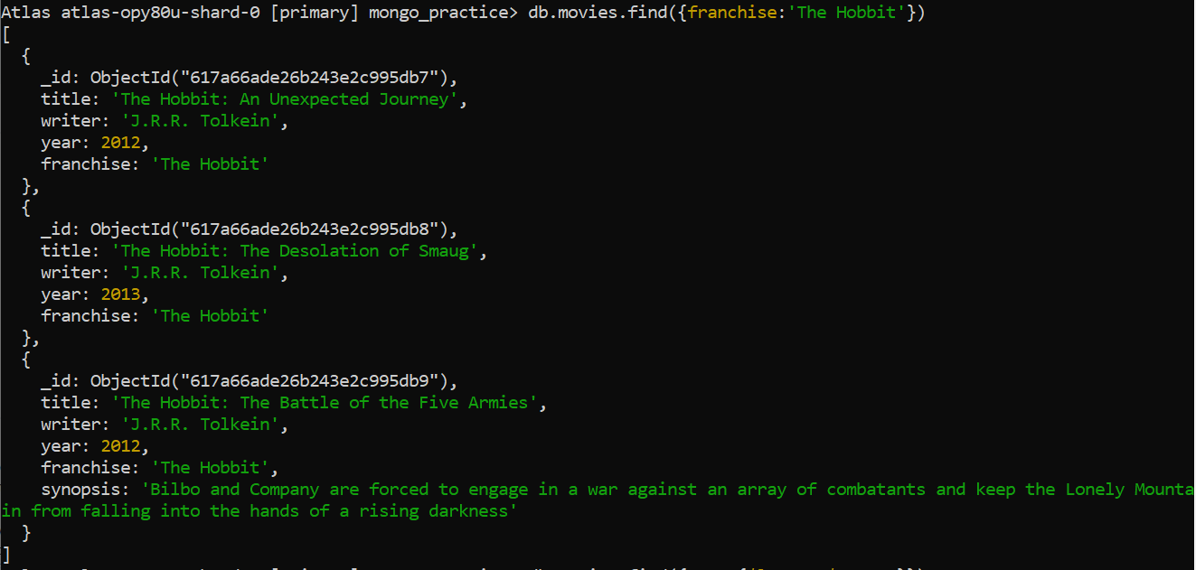

5.

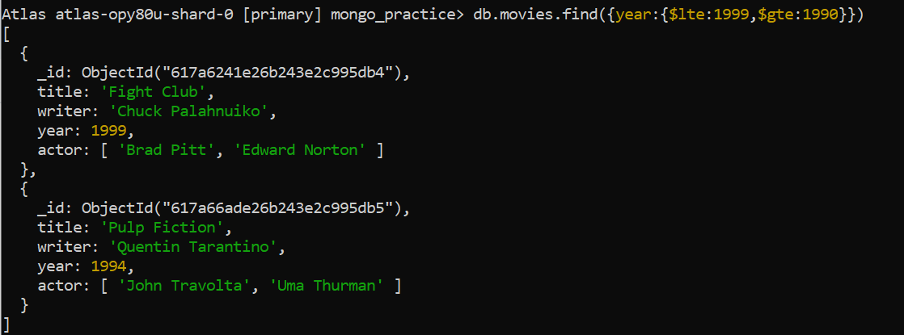

6.

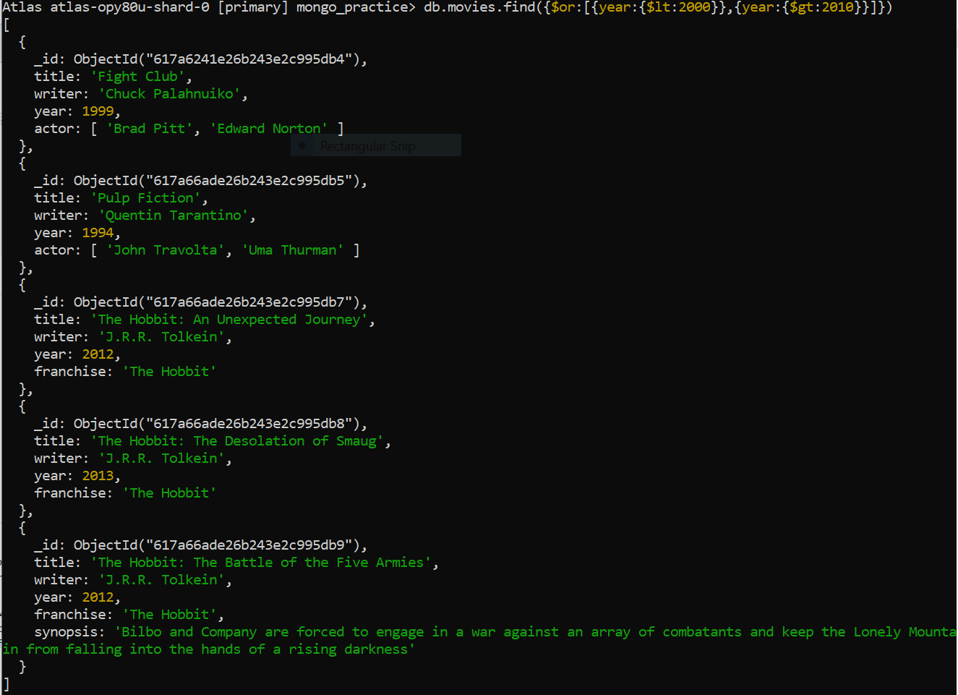

**UPDATE DOCUMENTS:-----**

1.

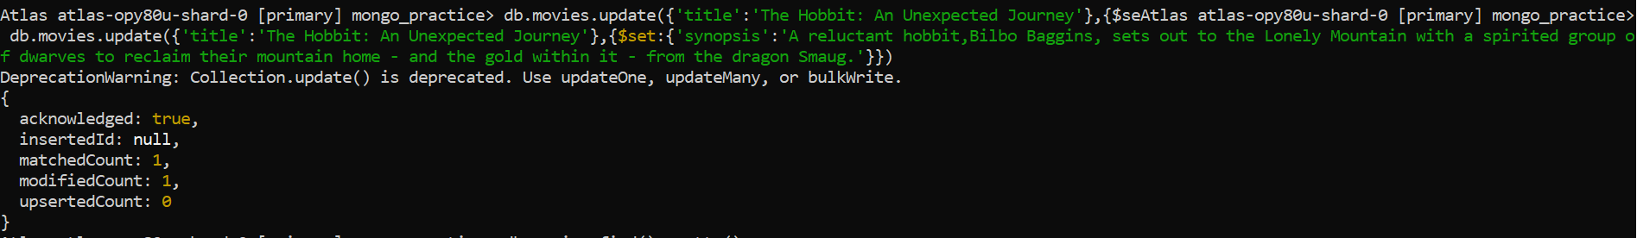

2.

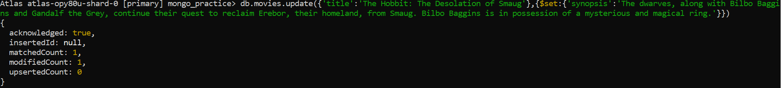

3.

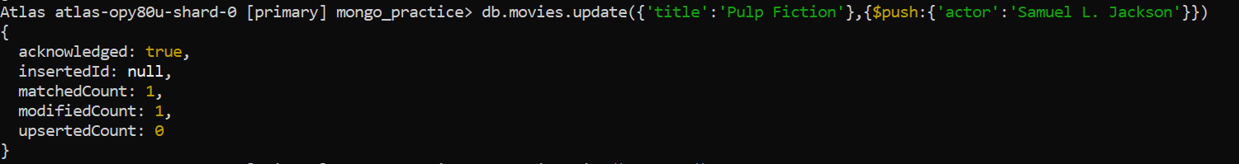

**TEXT SEARCH:-----**

1.

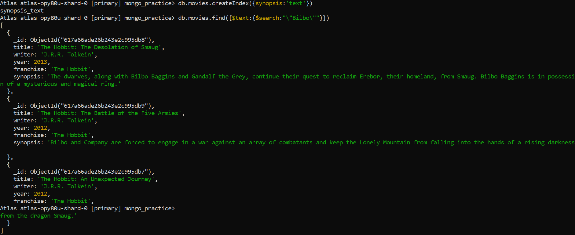

2.

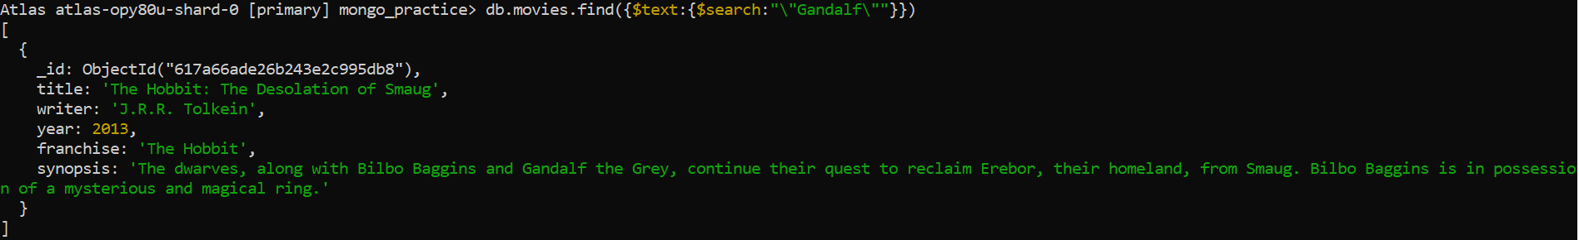

3.

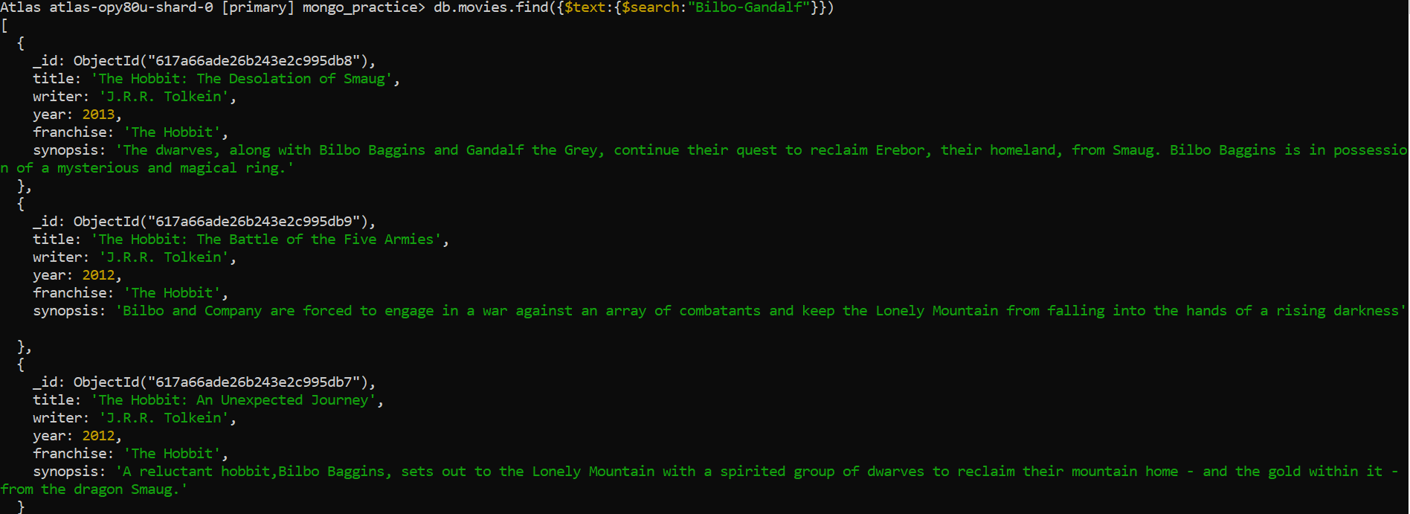

4.

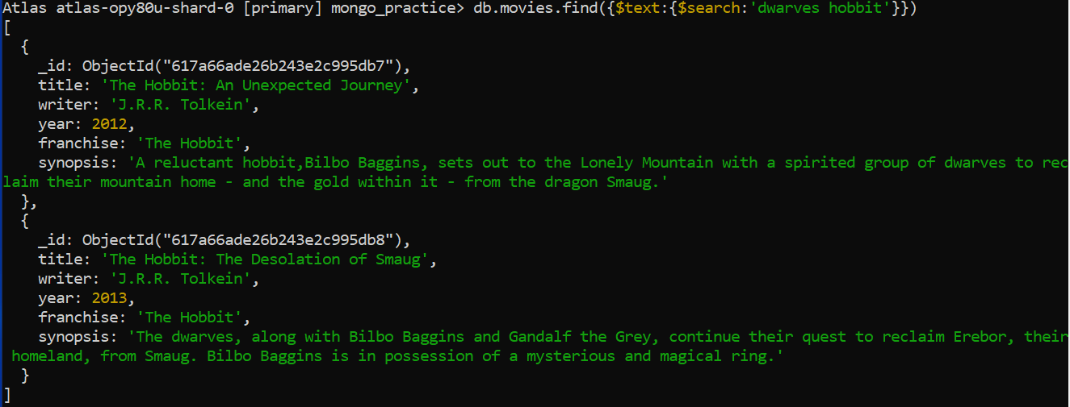

5.

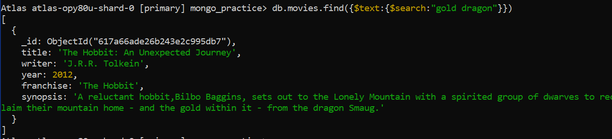

**DELETE DOCUMENTS:-----**

1.



**RELATIONSHIPS:--------------------------------------------------------**

Inserting in ‘users’

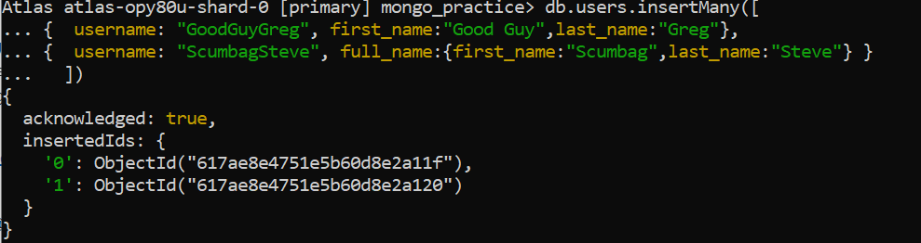

Inserting in ‘posts’

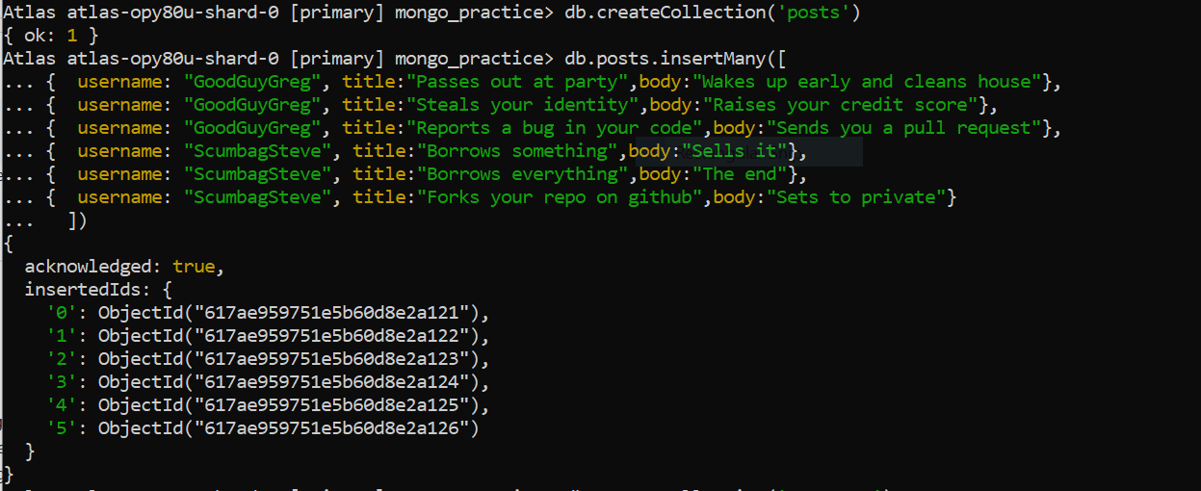

Inserting in comments

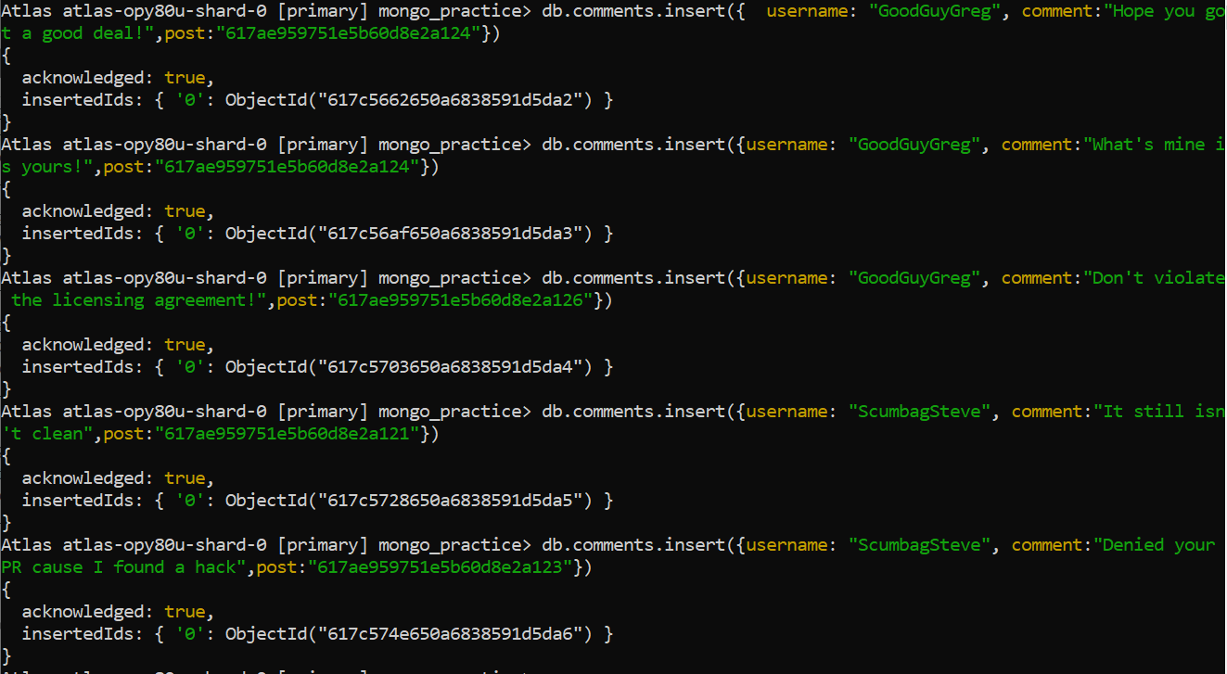

**QUERY RELATED COLLECTIONS:------**

1.

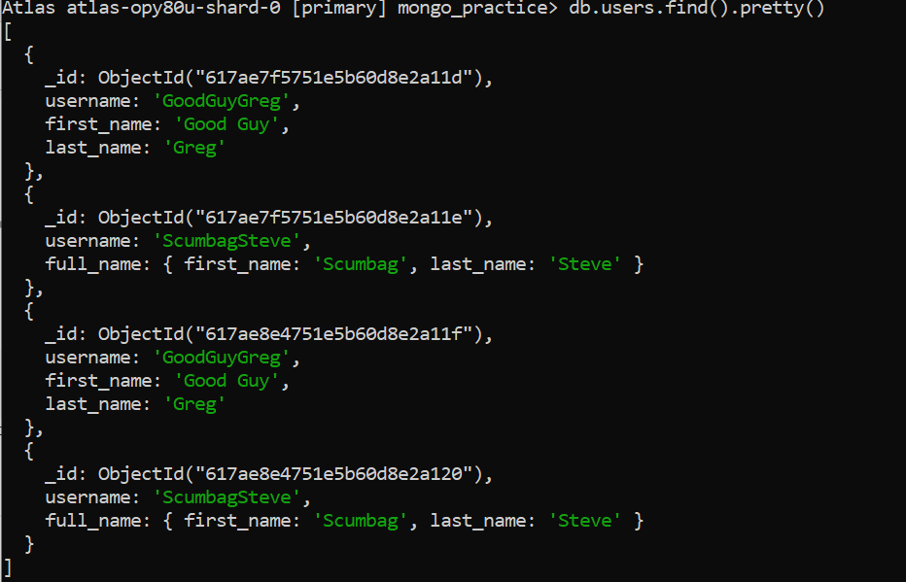

2.

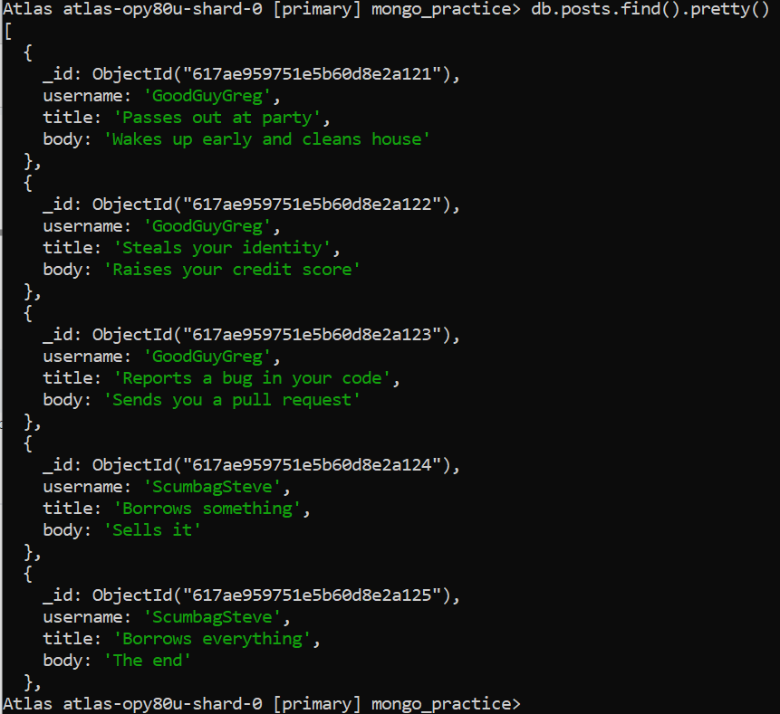

3.

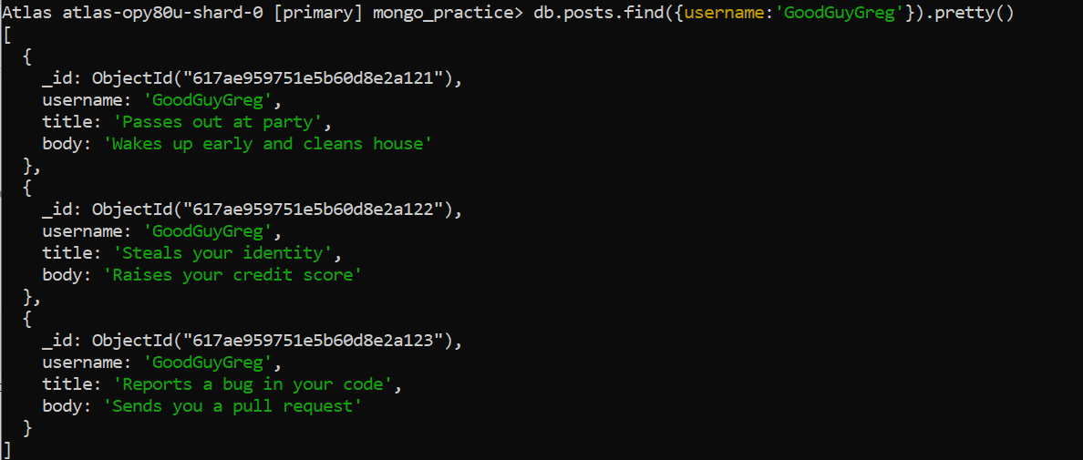

4.

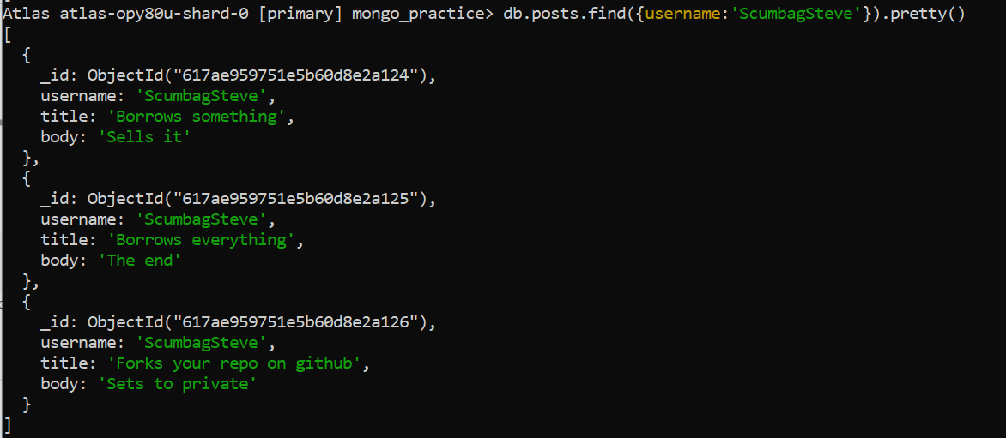

5.

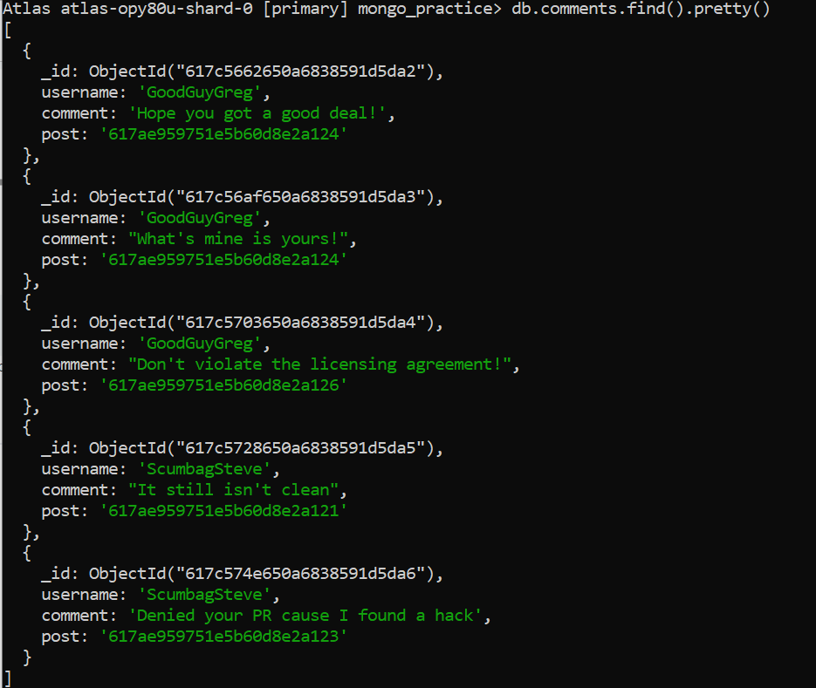

6.

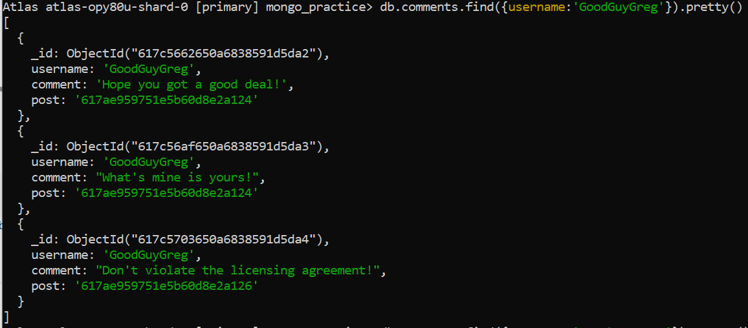

7.

