**ATTLANTA POPULATION:-------------------------------**

1.

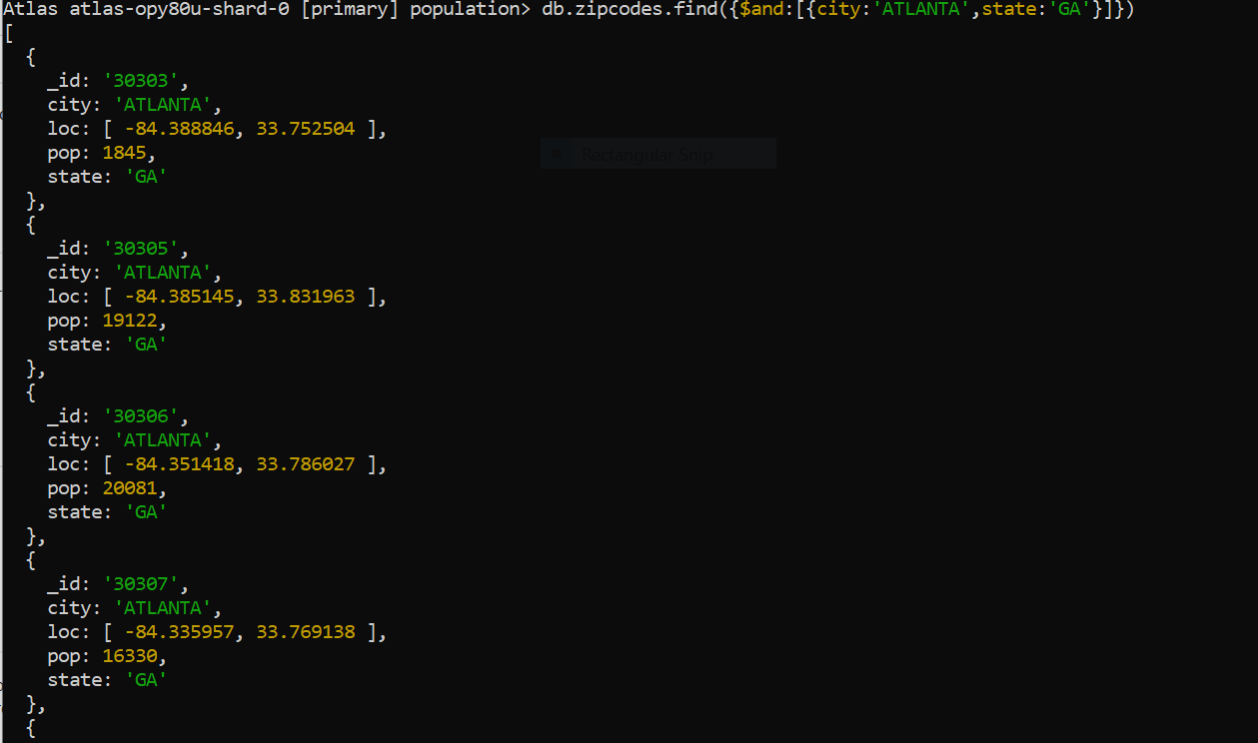

2.

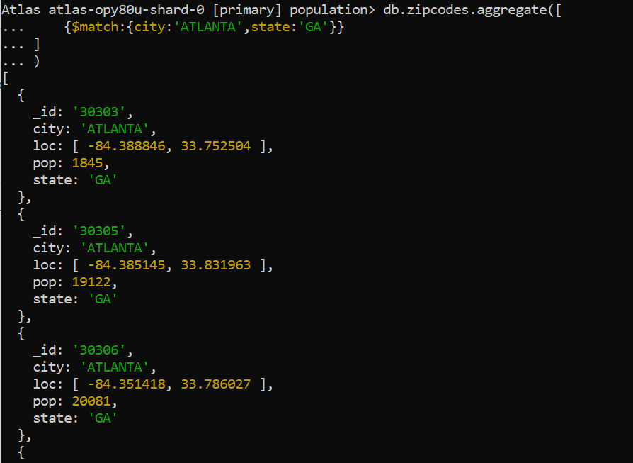

3.

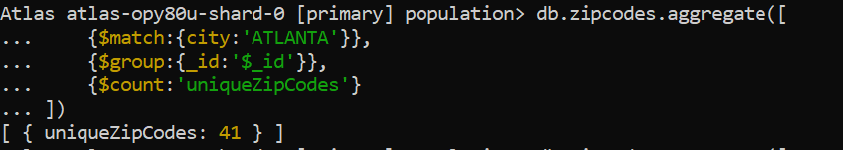

4.

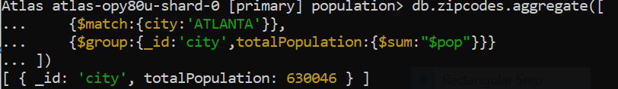

**POPULATIONS BY STATE:-----------------------------**

1.

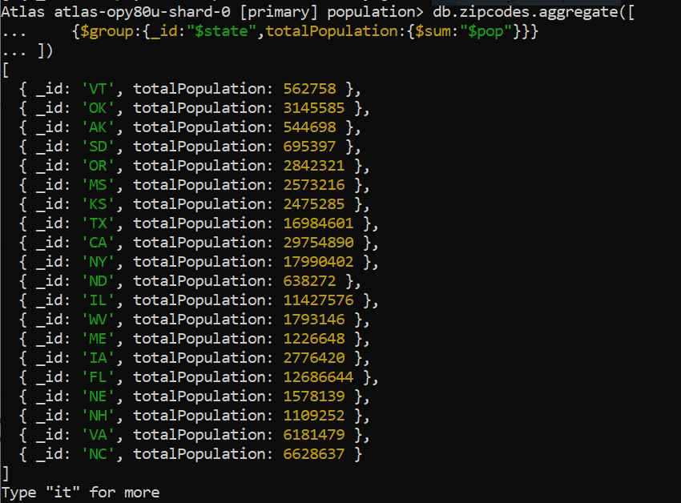

2.

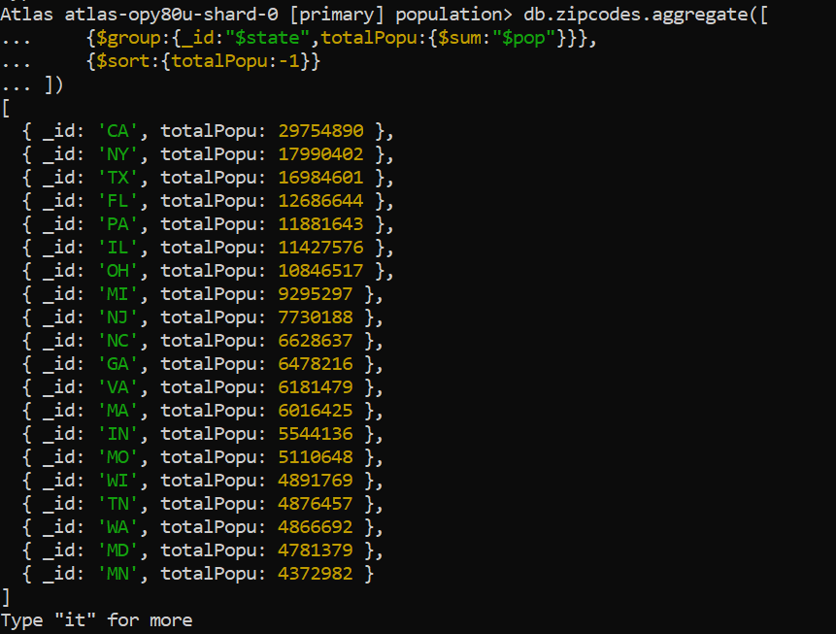

3.

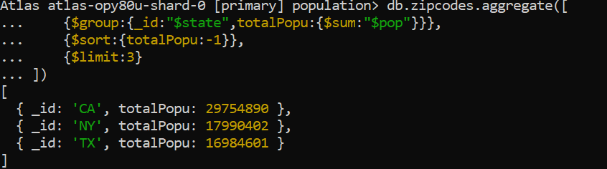

**POPULATIONS BY CITY:--------------------------------**

1.

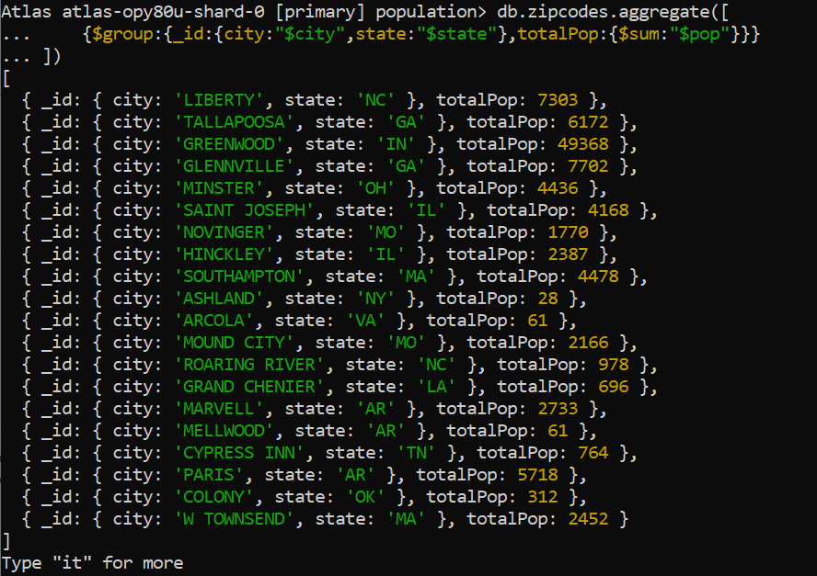

2.

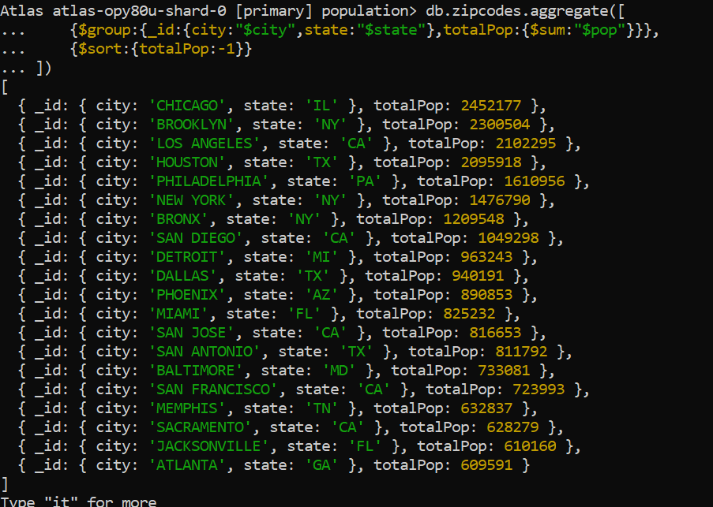

3.

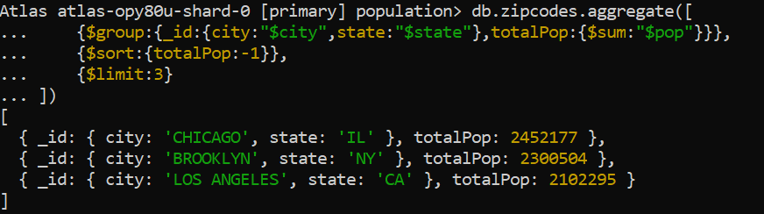

4.

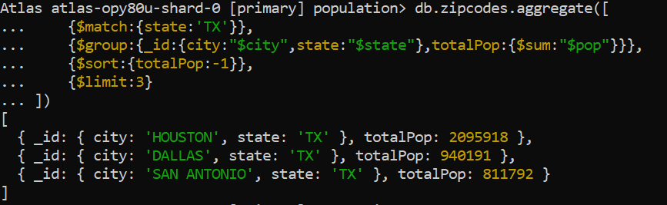

**BONUS:---------------------**

1.

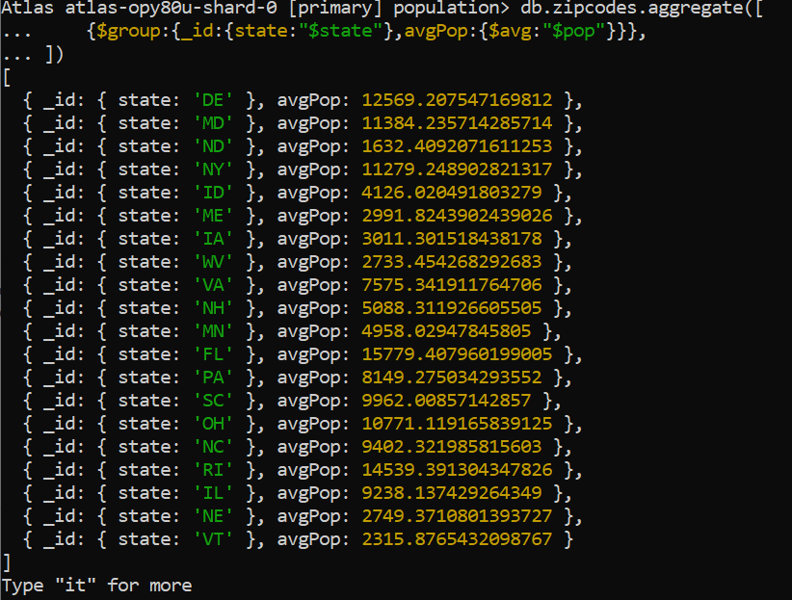

2.

