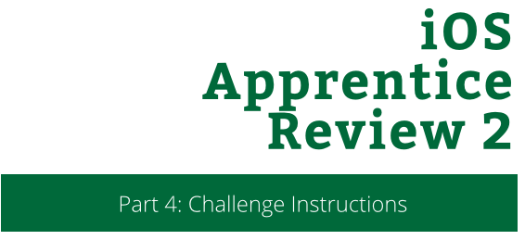

iOS Apprentice Review 2

Part 4: Challenge Instructions

Copyright © 2014 Razeware LLC.

All rights reserved. No part of this book or corresponding materials (such as text, images, or source code) may be reproduced or distributed by any means without prior written per- mission of the copyright owner.

This book and all corresponding materials (such as source code) are provided on an "as is" basis, without warranty of any kind, express or implied, including but not limited to the warranties of merchantability, fitness for a particular purpose, and noninfringement. In no event shall the authors or copyright holders be liable for any claim, damages or other liability, whether in action of contract, tort or otherwise, arising from, out of or in connec- tion with the software or the use or other dealings in the software.

All trademarks and registered trademarks appearing in this book are the property of their respective owners.

# Viva la Challenge!

So you actually thought you were done with the StoryTime app, eh? The following document contains not one, but three challenges!

Chances are, you will not be able to finish before the closing bell, but that doesn’t mean you have to actually stop working on the challenge. Bring it home with you, find a quiet corner, and keep hammering away.

If you are still catching up from the demo or lab, then by all means, keep working on it and return to the challenge when you are all caught up

## Challenge 1: Editing Your Stories

While creating new stories is really nice, unfortunately, there’s no way edit them. Say for instance, you wanted to correct a misspelling or trim a few sentences, there’s no way to do that.

Your challenge is to “make it so”.

To let the user know that he or she can edit a row, make sure all the Table View Cell’s have a Detail accessory. You can find this in the Attributes Inspector for the particular cell.

Once the user taps this accessory, the New Story View Controller should be modally presented with all the fields populated. Once the user saves the story, the view controller is dimissed and the Story Selection View Controller should reflect any changes.

That means if a user changes the title, that new title should appear in the story listings. If a user changes a story from vampire to zombie, then the listing should reflect this as well.

## Challenge 2: Deleting Your Stories

Let’s face it, not every story is worth keeping around. Table Views come with a nice little feature that allows users to swipe to delete. Look up the documentation for this feature and implement it.

## Challenge 3: Never Stop Learning

The final challenge is a life long one. Never be content with your skillsket. Keep pushing yourself to learn and understand. Technology moves fast and you want to keep moving with it. By keeping your tools sharp and well maintained, you’ll be well prepared to capitalize on any whatever new tech the future brings.