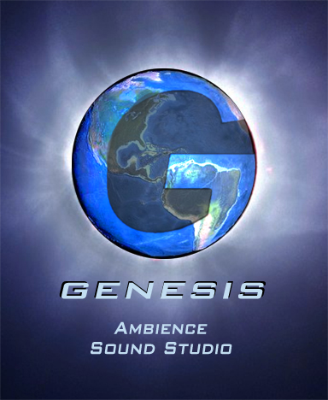
PREFACE

Ambience Sound Studio is an application that allows a GM to emulate the type of environmental ambience that one might get from the music and sound effects in a movie or video game. Its interface provides a game-independent way of easily constructing a sound environment that is appropriate and responsive to events in your game.

Let’s begin with a typical scenario in a Game of Imagination, and see how the ambience of the scene might be captured if it were in a movie or video game.

Cue the eerie Swamp Theme tune.

The hero stands knee-deep in the bog, wading as silently as possible along the path shown on the map given to him by the old miser from town. The constant gurgle of the swamp is disquieting. His lantern only illuminates a few feet around him, not revealing the sources of the recurrent chirps and growls of unknown creatures lurking in the darkness.

There is a sudden splash as the hero trips over an obstacle hidden beneath the murky surface. This is what he was looking for: the secret hatch leading into the underground dungeon. After sloshing around for a minute or so, the hero turns the activation latch with a clank. A mechanical grinding resounds through the swamp, and the hatch rises above the surface and swings open, revealing a ladder into darkness.

Cue the puzzling Gear Room Theme music.

After descending the ladder and traversing a short flight of stone steps, the hero emerges into a dimly lit, yet massive chamber. The bounds of the room remain unseen beyond the thousands of metal gears of all shapes and sizes filling the extremes of the space, perpetually turning and clanking. The sound fills every corner of the room.

The hero stands on a metal landing, cantilevered over the expanse and overlooking the deadly gears below. A small platform on the tip of the landing can be seen. A large array of levers sits on the platform, presumably a control console. Fortunately, the hero has been instructed on which levers to pull to get to the idol he seeks.

Unfortunately, his sleeve catches and pulls the wrong lever.

A sickening rumble resounds. From above, seemingly hidden between two gigantic gears, a large Spider-like machine drops with a thud onto the landing and blocks the hero’s path of escape. He must fight.

Cue the Spider Fight Theme music. The sound of gears continues in the background, although subdued.
Let us analyze the above tale in terms of the types of audio events that help to set the “mood”, and how we might organize them. The significant phrases have been bolded.

SCENES AND STATES

It is clear that the tale takes place over the course of two different locations with significantly different types of audio events. If it were being filmed, the script would probably label these two locations as different scenes, and they would be filmed accordingly.

Furthermore, we can see that the second scene goes from a sort of puzzle state to a battle state. In the former, the attitude of the scene is different than in the latter, and this change in attitude also changes what audio events are important.

Because audio events can be formed into this natural hierarchy, Ambience Sound Studio utilizes it. Within an Ambience project, you can create a number of scenes. In each scene, a number of states can exist. Each state contains a collection of audio events that can be utilized.

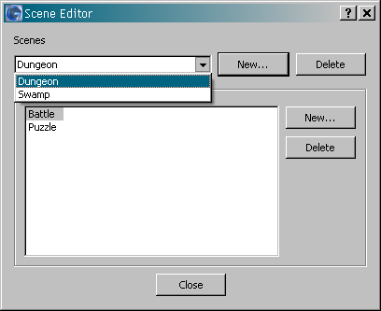
The Scene Editor

Upon creating a new project, or by selecting Scenes & States from the Edit menu, you are presented with the Scene Editor dialog. This allows you to create and delete scenes, as well as the states within each scene. You can then view the audio control panel for a particular state by switching to it via the Scene/State Selection Bar at the bottom of the main window.

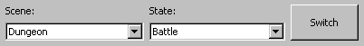
The Scene/State Selection Bar

MUSIC

Three times in the story we “cue music”. This isn’t really part of the tale, but it would be part of the production script in a film. Often a viewer’s emotions are stirred by appropriate background music.

Ambience allows you to create a playlist for each state. This playlist is then cycled through randomly, playing songs one at a time. You may also manually select a song from the playlist at any time.

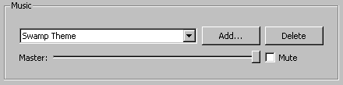
The Music Control Panel

The control panel also allows you remove a song, adjust the volume of the soundtrack, and pause it by checking the Mute option.

BACKGROUND SOUNDS

Whether it is the “constant gurgle” of the swamp, or the “perpetual clanking” in the gear room, areas are often identifiable by the continuous background noise. In Ambience, this can be implemented using the Background Control Panel.

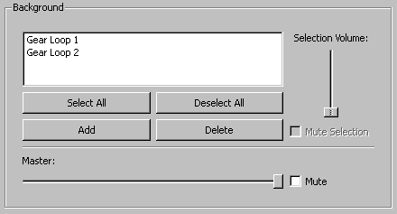
The Background Control Panel

There can be many background sounds, and thus, many can be simultaneously layered in this panel. Master controls for the panel are similar to those in the Music Panel. Individual controls can be used for subtle changes to specific sounds.

RANDOM SOUND EVENTS

The Random Control Panel functions in a similar fashion to the Background Control Panel. However, this panel is for sounds such as the “recurrent chirps and growls” of the swamp. It is meant for short sounds that happen every now and again. You can configure the relative frequency of these occurrences.

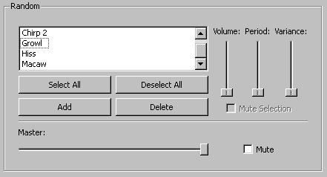
The Random Control Panel

The Period is a relative measure of the time between one sound-off and the next. The variance is a measure of how closely the timing sticks to the given period, being that the time interval is randomly determined.

THE SOUND BOARD

Ambience provides a configurable Sound Board to allow for instant audio events. These are one-time events that happen as a result of an action in-game. Many of these were used in the swamp scene.

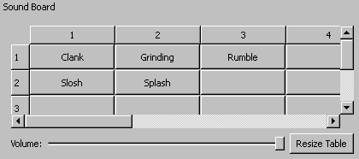
The Sound Board

The board can be resized to fit the number of events you might want. Simply clicking on a blank button allows you to assign a sound to it. From then on, that button will play the assigned sound on command. There is a volume control as in the other panels.

THE SOUND MODEL

Ambience uses two models for importing sounds: Streamed and Sampled. These may also be referred to as Long and Short sounds, respectively. Streamed sounds are streamed directly from the source file because they are meant to be longer. Sampled sounds are loaded into memory because they are shorter, and thus smaller. Ambience allows you to assign Streamed sounds to either the Music playlist or the Background list. Sampled sounds are used for the Random list and the Sound Board.

When adding a new sound to any panel, or when selecting the import options in the Edit menu, you are presented with an Import Selection dialog.

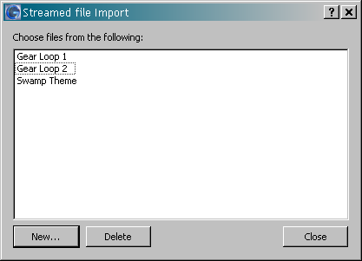
An Import Selection Dialog
This dialog displays all currently imported sounds in that category. You can also import new sounds by clicking the New… button, or remove sounds by making a selection and clicking the Delete button. Any deleted sounds will be removed from all panels they are used in, but the files will not be deleted from the file system.

CLOSING

Clearly, Ambience Sound Studio provides all of the mechanisms required to create a project that emulates the given story, and many more. Hopefully, it can add a new dimension to the experience of your role-playing games.

