<https://tomee.apache.org/download.html>

download Apache TomEE 8.0 , Tom EE Plus Server.

Windows – download TomEE Plus Zip. Click on the name and it will take you to download page

1. Unzip it and go to eclipse – server option – add it
2. Server option – select tomcat v9.0

**Java EE : Java Enterprise Edition**

Oracle Glassfish App Server

Java EE 7 Specification was the last released by Oracle Corporation.

Eclipse is Managing a new generation of Java EE technology under the brand name

Jakarta EE

Java EE Specification

* Web Application
* Enterprise Application
* Distributed Application
* Other APIs
  + Connector API
  + Messaging API

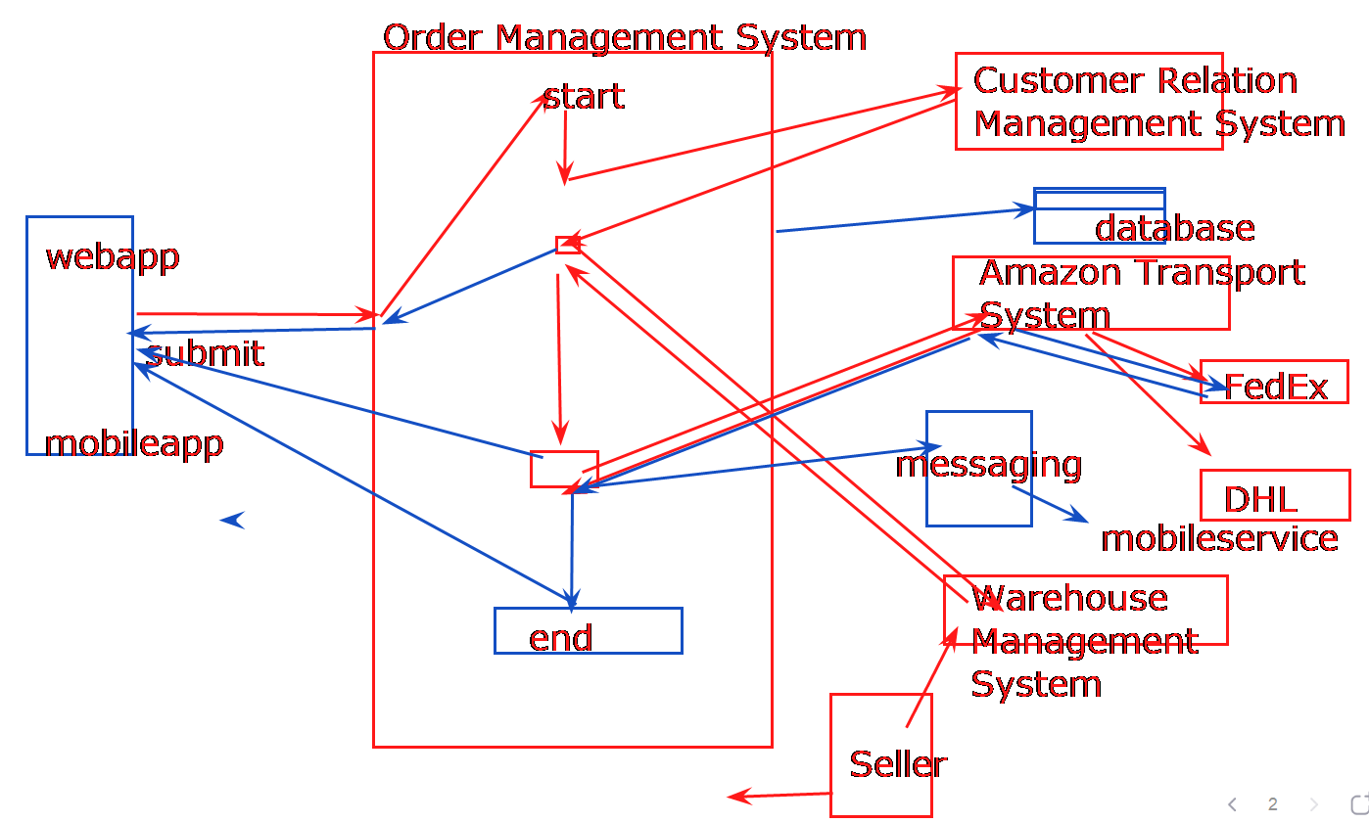

1. Web Application
   1. Servlet
   2. JSP
2. Enterprise Application
   1. EJB
   2. Web Services
      1. JAX-RS
      2. JAX-WS
3. JPA [ Skip ]
4. **Hibernate** is an implementation of JPA

**Servlet API**

HTML is used for presentation logic only. [ Java Script & CSS or Bootstrap ]

Before Servlet, we were using CGI ( command gateway interface ) scripting language.

Servlet is an API that provides many interfaces and classes including documentation. Servlet is an interfaces. It is used to develop dynamic web pages as well.

Web Page :

**Static :** HTML

**Dynamic :** Content can be changed as per client request.

Tomcat/Jetty/Undertow Server is web server that can host only Servlet & JSP.

HTTP is the web-protocol.

GenericServlet implements Servlet

HttpServlet extends GenericServlet

Http Request Methods

* GET [ default ]
  + Any request submitted through the browser address bar
  + It submits the data by appending it to the target URL as query string.
  + Can be bookmarked

<https://www.google.com/search?q=Microsoft+Azure>

* POST
  + It submits the data internally without exposing it to the address bar.
  + You need to use HTML form or javascript to submit post request.

Servlet

service(request, response)

* + - doGet(request, response) if HTTP method is get type
    - doPost(request, response) if HTTP method is post type.

http://localhost:8080/JOR2-HelloWorldWeb/HelloWorld

Servlet can be used for presentation logic, but you need to embed HTML into Java coding.

**Servlet Life Cycle**

* Servlet is a singleton. Web Container is responsible for Servlet life-cycle management.

**Revisiting Exception : try with resource statement**

try(Resource Open Statement) // close the resources whenever you get out from try block

}catch(Exception ex){

} // no need to write finally

Resource Statement are statement that uses objects from the classes that implements AutoCloseable or Closeable interface.

package java.lang;

Interface AutoCloseable{

void close();

}

Interface Closeable extends AutoCloseable{

}

--- Java 7 , all the API that deals with I/O or database/network connection were refactored to use AutoCloseable or Closeable.

**Model – View – Controller [ MVC ] Design Pattern**

**Java Server Page: JSP**

JSP is used to create web pages for User Interfaces. JSP is a server-side component and it is a servlet-based component.

JSP page consists of HTML and JSP tags. It is easier to maintain than servlet because we can separate designing & development.

JSP is an extension to Servlet. In fact, If I say it is Servlet, it will not be wrong.

<%

//scriptlet

// java coding

%>

JSP has many implicit objects.

Request , response , session, out

<%@ page language=*"java"* contentType=*"text/html; charset=ISO-8859-1"*

pageEncoding=*"ISO-8859-1"*%>

<%@ page import=*"com.example.pojos.Employee"*%>

<!DOCTYPE html>

<html>

<head>

<meta charset=*"ISO-8859-1"*>

<title>Employee Details</title>

</head>

<body>

<h1 align=*"center"*> <u>Employee Details</u> </h1>

<%

Employee e=(Employee) session.getAttribute("emp");

**int** id=(Integer) session.getAttribute("empid");

**if**(e!=**null**) {

out.println("<p><b>Employee Id : </b>"+e.getId());

out.println("<p><b>Name : </b>"+e.getName());

out.println("<p><b>Salary : </b>"+e.getSalary());

out.println("<p><b>Dept Id : </b>"+e.getDeptId());

}**else** {

out.println("<p><b> Employee with Id "+ id+" doesnt exist");

}

%>

</body>

</html>

**JSP life cycle**

1. **First time when a request is made** to JSP page,
   1. JSP page is translated to Java Source File [ internally done by container]. This source file is a servlet file.
   2. Compile the Java Source File
   3. Class Loading loads .class file
   4. Instantiation of .class file [ A servlet object is created ]
   5. Initialization : jspInit() is invoked ---> mapped with servlet init()
   6. Request processing : jspService() ---> mapped with servlet service()
      1. Service method delegates the call to doGet or doPost
   7. Destroy method is invoked : jspDestroy() --- mapped to servlet destroy() // during garbage collection/
2. **Second Request onwards, it repeats step f.**

**Refactoring #1 emp-details.jsp page.**

<body>

<h1 align=*"center"*> <u>Employee Details</u> </h1>

<jsp:useBean id=*"emp"* scope=*"session"* class=*"com.example.pojos.Employee"*></jsp:useBean>

<jsp:useBean id=*"empid"* scope=*"session"* type=*"java.lang.Integer"*></jsp:useBean>

<%

**if**(emp!=**null**) {

out.println("<p><b>Employee Id : </b>"+emp.getId());

out.println("<p><b>Name : </b>"+emp.getName());

out.println("<p><b>Salary : </b>"+emp.getSalary());

out.println("<p><b>Dept Id : </b>"+emp.getDeptId());

}**else** {

out.println("<p><b> Employee with Id "+ empid+" doesnt exist");

}

%>

</body>

**Refactoring #2 emp-details.jsp page.**

<body>

<h1 align=*"center"*> <u>Employee Details</u> </h1>

<jsp:useBean id=*"emp"* scope=*"session"* class=*"com.example.pojos.Employee"*></jsp:useBean>

<jsp:useBean id=*"empid"* scope=*"session"* type=*"java.lang.Integer"*></jsp:useBean>

<p><b>Employee Id : </b> <%=emp.getId()%> </p>

<p><b>Name : </b><%=emp.getName()%> </p>

<p><b>Salary : </b><%=emp.getSalary()%> </p>

<p><b>Dept Id : </b><%=emp.getDeptId()%> </p>

<!-- //comment -->

</body>

**JSP Expression Language: JSP EL**

**${object}**

**EL Operator + - / % == < > <= >= && ! empty**

**div mod eq ne lt gt le ge and or not**

**Refactoring #3 emp-details.jsp page.**

<body>

<h1 align=*"center"*> <u>Employee Details [ EL ]</u> </h1>

<p><b>Employee Id : </b> ${emp.id} </p>

<p><b>Name : </b> ${emp.name} </p>

<p><b>Salary : </b> ${emp.salary} </p>

<p><b>Dept Id : </b>${emp.deptId} </p>

<!-- //comment -->

</body>

emp.id = emp.getId();

emp.deptId = emp.getDeptId();

emp.totalSalary= emp.getTotalSalary();

**Debugging JSP page may be a tedious process.**

**JSTL : Java Standard Tag Library**

**Tag Name Location prefix**

Core Tags <http://java.sun.com/jsp/jstl/core> c

Function Tags <http://java.sun.com/jsp/jstl/functions> fn

Formatting Tags <http://java.sun.com/jsp/jstl/fmt> fmt

XML Tags <http://java.sun.com/jsp/jstl/xml> x

SQL Tags <http://java.sun.com/jsp/jstl/sql> sql

Java EE 7 onwards = replace java.sun.com as jcp.org

Core Tags <http://java.sun.com/jsp/jstl/core> c

**<c:out>**

**<c:import>**

**<c:catch>**

**<c:if>**

**<c:forEach>**

**<c:choose>**

**<c:when test=””>**

**</c:when>**

**<c:otherwise>**

**</c:otherwise>**

**</c:choose>**

**Enterprise Java Bean: EJB**

* EJB’s lifecycles are managed by the EJB container [ instantiation to destruction ]. You don’t need to use a new keyword to create the object.
* EJB containers maintain all EJB instances into a common pool. i.e EJB pool.
* Client can obtain reference of EJB instances by requesting to EJB container.
* **This client can be local client [other apps in same JVM ] or remote client [ app running on different JVM ]**
* **Must use interface**

1. Session Bean
   1. Stateless
   2. Stateful Local or Remote // distributed programming
   3. Singleton
2. Message-Driven Bean // Java Messaging Service // JMS

EJB lite:

* EJB’s lifecycles are managed by the EJB container [ instantiation to destruction ]. You don’t need to use a new keyword to create the object.
* EJB containers maintain all EJB instances into a common pool. i.e EJB pool.
* **Client to access it , can be from the same application.**
* **Doesn’t have interface implementation and this is why “No Interface View”**

1. Stateless

1. Stateful

@Local

**public** **interface** EmployeeDao {

**public** List<Employee> findAll() **throws** EmployeeException;

**public** String register(Employee e) **throws** EmployeeException;

**public** Employee findById(**int** id) **throws** EmployeeException;

//public int remove(int id) throws EmployeeException();

//public String update(Employee e) throws EmployeeException;

}

**@Stateless**

**public** **class** EmployeeDaoImpl **implements** EmployeeDao{

**public** Connection getConnection() **throws** SQLException{

String jdbcURL="jdbc:mysql://localhost:3306/javaoursoul2";

Connection con=DriverManager.*getConnection*(jdbcURL,"root","admin#123");

**return** con;

}

// methods

}

**public** **class** EmployeeServlet **extends** HttpServlet{

@EJB

**private** EmployeeDao dao;

**private** **static** **final** **long** ***serialVersionUID*** = 1L;

/*

*

*/

**public** **void** doGet(HttpServletRequest req, HttpServletResponse res)**throws** ServletException, IOException {

HttpSession s=req.getSession();

**Deleted the EmployeeFactory**

**Deleted the attached Library**

**Web Services**

Web Service is an appropriate medium to propagate communication between the client and server.

Web Service is something that can expose business functionalities and let other applications [ built on same or different technologies] consume those services.

**Assignment**

