Assignment

Introduction
SEM = (wait[1..2] -> signal[1..2] -> SEM).
P1 = (s1.wait[1] -> s2.wait[1] -> s2.signal[1] -> s1.signal[1] -> P1).
P2 = (s2.wait[2] -> s1.wait[2] -> s1.signal[2] -> s2.signal[2] -> P2).
||SEMS = (s1:SEM || s2:SEM || P1 || P2).
Deadlock:
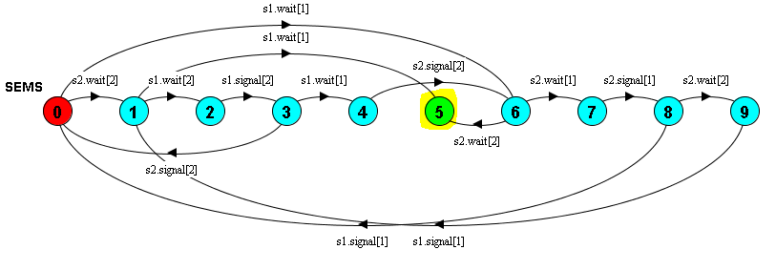
Can only be shown by “simulating” either mentally or digitally.

Dining Philosophers
Two philosophers: Paper
Three philosophers:
P1 = (p1lockF1 -> p1lockF2 -> p1freeF2 -> p1freeF1 -> P1).
P2 = (p2lockF2 -> p2lockF3 -> p2freeF3 -> p2freeF2 -> P2).
P3 = (p3lockF3 -> p3lockF1 -> p3freeF1 -> p3freeF3 -> P3).
F1 = (p1lockF1 -> p1freeF1 -> F1
| p3lockF1 -> p3freeF1 -> F1).
F2 = (p2lockF2 -> p2freeF2 -> F2
| p1lockF2 -> p1freeF2 -> F2).
F3 = (p3lockF3 -> p3freeF3 -> F3
| p2lockF3 -> p2freeF3 -> F3).
||SYSTEM = (P1 || P2 || P3 || F1 || F2 || F3).
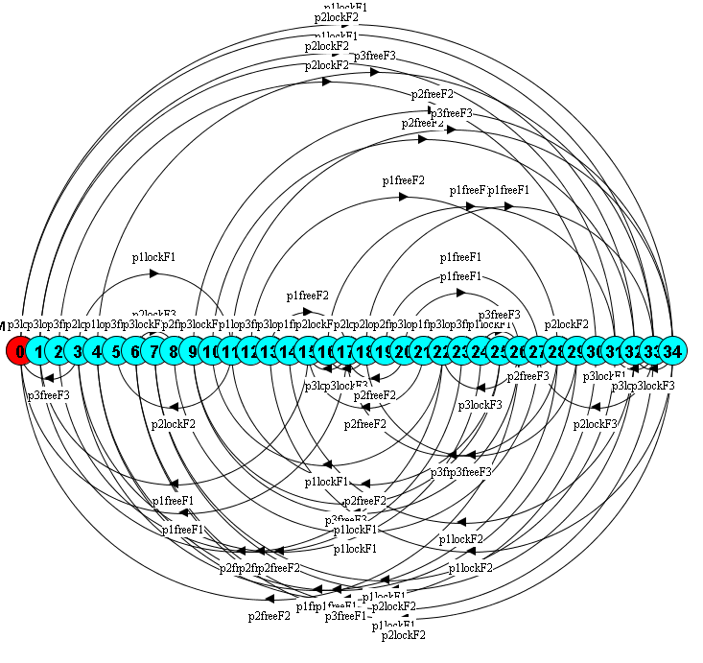
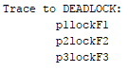

Communication
Synchronous:
T1 = (ch1->ch2->T1).
T2 = (ch1->ch2->T2).

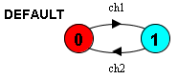

2 states.

Asynchronous:

Need to differ between send and receive (put and get)

